Supplementary Materials
CCNIF: A Reproducible Causal-Network Framework for Prioritizing and Characterizing Candidate Cancer Driver Genes in Lung Adenocarcinoma

Mohd Sameer, Pankaj Chauhan

Supplementary Table S1. Complete ranking, confidence, quality, and reliability scores for all 50 candidate driver genes.
Rank | Driver | Confidence | Tier | Quality | Quality Tier | Reliability
1 | SFTPB | 94.627 | A | 89.8336 | Gold | 95.3568
2 | ZFHX4 | 93.1089 | A | 88.6429 | Gold | 95.3568
3 | EGFR | 92.3442 | A | 88.0431 | Gold | 95.3568
4 | MUC16 | 91.8592 | A | 87.6627 | Gold | 95.3568
5 | IGHA1 | 90.9053 | A | 86.9146 | Gold | 95.3568
6 | DST | 88.4452 | B | 84.9851 | Gold | 95.3568
7 | A2M | 88.3351 | B | 84.8988 | Gold | 95.3568
8 | COL11A1 | 86.0353 | B | 83.095 | Gold | 95.3568
9 | RPL3 | 83.4442 | B | 81.0627 | Gold | 95.3568
10 | EEF2 | 82.7145 | B | 80.4904 | Gold | 95.3568
11 | ENO1 | 82.1736 | B | 80.0662 | Gold | 95.3568
12 | EEF1A1 | 81.7582 | B | 79.7404 | Silver | 95.3568
13 | IGHG1 | 80.6954 | B | 78.9068 | Silver | 95.3568
14 | SLC34A2 | 80.4861 | B | 78.7427 | Silver | 95.3568
15 | TP53 | 75.9613 | C | 75.1938 | Silver | 95.3568
16 | HLA-B | 71.4905 | C | 71.6873 | Silver | 95.3568
17 | PLEC | 70.4075 | C | 70.8379 | Silver | 95.3568
18 | FN1 | 70.2238 | C | 70.6938 | Silver | 95.3568
19 | SRRM2 | 70.1778 | C | 70.6577 | Silver | 95.3568
20 | MXRA5 | 69.6386 | D | 70.2348 | Silver | 95.3568
21 | AHNAK2 | 66.8294 | D | 68.0315 | Bronze | 95.3568
22 | COL1A1 | 65.2244 | D | 66.7727 | Bronze | 95.3568
23 | MYH9 | 64.4608 | D | 66.1738 | Bronze | 95.3568
24 | KRAS | 64.1518 | D | 65.9314 | Bronze | 95.3568
25 | HUWE1 | 62.7424 | D | 64.826 | Bronze | 95.3568
26 | HSP90AB1 | 62.0294 | D | 64.2668 | Bronze | 95.3568
27 | ACTB | 62.0153 | D | 64.2558 | Bronze | 95.3568
28 | VCAN | 61.2441 | D | 63.6509 | Bronze | 95.3568
29 | RPL8 | 60.7842 | D | 63.2902 | Bronze | 95.3568
30 | FLNA | 60.2558 | D | 62.8758 | Bronze | 95.3568
31 | KEAP1 | 59.8595 | D | 62.5649 | Bronze | 95.3568
32 | FTL | 59.627 | D | 62.3826 | Bronze | 95.3568
33 | GNAS | 59.2424 | D | 62.0809 | Bronze | 95.3568
34 | LRP1 | 57.4261 | D | 60.6564 | Bronze | 95.3568
35 | ACTG1 | 56.2646 | D | 59.7454 | Weak | 95.3568
36 | COL3A1 | 53.9729 | D | 57.948 | Weak | 95.3568
37 | PSAP | 53.597 | D | 57.6532 | Weak | 95.3568
38 | B2M | 53.4737 | D | 57.5565 | Weak | 95.3568
39 | AHNAK | 53.2427 | D | 57.3753 | Weak | 95.3568
40 | COL4A1 | 53.0336 | D | 57.2113 | Weak | 95.3568
41 | COL5A2 | 52.6474 | D | 56.9084 | Weak | 95.3568
42 | COL4A2 | 49.5174 | D | 54.4535 | Weak | 95.3568
43 | TTN | 48.9948 | D | 54.0436 | Weak | 95.3568
44 | RYR2 | 48.6894 | D | 53.8041 | Weak | 95.3568
45 | MACF1 | 47.2498 | D | 52.675 | Weak | 95.3568
46 | ADAMTS12 | 46.2799 | D | 51.9143 | Weak | 95.3568
47 | COL6A3 | 45.803 | D | 51.5402 | Weak | 95.3568
48 | SYNE2 | 45.6402 | D | 51.4125 | Weak | 95.3568
49 | IGKC | 45.3444 | D | 51.1805 | Weak | 95.3568
50 | COL1A2 | 43.9643 | D | 50.0981 | Weak | 95.3568

Supplementary Table S2. External database validation results for all 50 candidate drivers.
Rank | Driver | Tier | IntOGen | OncoKB | CancerMine | NCG | Any Match
1 | SFTPB | A | False | False | False | False | False
2 | ZFHX4 | A | False | False | False | True | True
3 | EGFR | A | True | True | True | True | True
4 | MUC16 | A | False | False | True | True | True
5 | IGHA1 | A | False | False | False | False | False
6 | DST | B | False | False | True | True | True
7 | A2M | B | False | False | False | False | False
8 | COL11A1 | B | False | False | True | True | True
9 | RPL3 | B | False | False | False | False | False
10 | EEF2 | B | False | False | True | True | True
11 | ENO1 | B | False | False | True | False | True
12 | EEF1A1 | B | False | False | True | True | True
13 | IGHG1 | B | False | False | False | False | False
14 | SLC34A2 | B | True | True | True | True | True
15 | TP53 | C | True | True | True | True | True
16 | HLA-B | C | True | True | True | True | True
17 | PLEC | C | False | False | True | True | True
18 | FN1 | C | False | False | True | False | True
19 | SRRM2 | C | False | False | False | False | False
20 | MXRA5 | D | False | False | True | True | True
21 | AHNAK2 | D | False | False | True | True | True
22 | COL1A1 | D | True | True | True | True | True
23 | MYH9 | D | True | True | True | True | True
24 | KRAS | D | True | True | True | True | True
25 | HUWE1 | D | False | False | True | True | True
26 | HSP90AB1 | D | True | True | True | True | True
27 | ACTB | D | False | True | True | True | True
28 | VCAN | D | False | False | True | True | True
29 | RPL8 | D | False | False | False | False | False
30 | FLNA | D | False | False | True | True | True
31 | KEAP1 | D | True | True | True | True | True
32 | FTL | D | False | False | False | False | False
33 | GNAS | D | True | True | True | True | True
34 | LRP1 | D | False | False | True | True | True
35 | ACTG1 | D | False | True | True | True | True
36 | COL3A1 | D | False | False | True | True | True
37 | PSAP | D | False | False | True | False | True
38 | B2M | D | True | True | True | True | True
39 | AHNAK | D | False | False | True | True | True
40 | COL4A1 | D | False | False | True | True | True
41 | COL5A2 | D | False | False | True | False | True
42 | COL4A2 | D | False | False | True | True | True
43 | TTN | D | False | False | True | False | True
44 | RYR2 | D | False | False | True | False | True
45 | MACF1 | D | False | False | False | True | True
46 | ADAMTS12 | D | False | False | True | True | True
47 | COL6A3 | D | True | False | True | True | True
48 | SYNE2 | D | False | False | True | True | True
49 | IGKC | D | False | False | False | False | False
50 | COL1A2 | D | False | False | False | True | True

Supplementary Table S3. Biological benchmark summary by external database.
Database | Reference Genes | Matched Drivers | Coverage (%)
IntOGen | 633 | 12 | 24.0
OncoKB | 1242 | 13 | 26.0
CancerMine | 7266 | 38 | 76.0
NCG | 3347 | 35 | 70.0

Supplementary Table S4. CCNIF framework summary statistics.
Metric | Value
Total candidate drivers | 50
Mean confidence score | 66.169
Mean quality score | 67.513
Mean reliability score | 95.357
Tier A drivers | 5
Tier B drivers | 9
Tier C drivers | 5
Tier D drivers | 31

Supplementary Table S5. All-driver scores across the full evidence-integration pipeline.
Rank | Driver | Confidence | Tier | Quality | Reliability
1 | SFTPB | 94.627 | A | 89.8336 | 95.3568
2 | ZFHX4 | 93.1089 | A | 88.6429 | 95.3568
3 | EGFR | 92.3442 | A | 88.0431 | 95.3568
4 | MUC16 | 91.8592 | A | 87.6627 | 95.3568
5 | IGHA1 | 90.9053 | A | 86.9146 | 95.3568
6 | DST | 88.4452 | B | 84.9851 | 95.3568
7 | A2M | 88.3351 | B | 84.8988 | 95.3568
8 | COL11A1 | 86.0353 | B | 83.095 | 95.3568
9 | RPL3 | 83.4442 | B | 81.0627 | 95.3568
10 | EEF2 | 82.7145 | B | 80.4904 | 95.3568
11 | ENO1 | 82.1736 | B | 80.0662 | 95.3568
12 | EEF1A1 | 81.7582 | B | 79.7404 | 95.3568
13 | IGHG1 | 80.6954 | B | 78.9068 | 95.3568
14 | SLC34A2 | 80.4861 | B | 78.7427 | 95.3568
15 | TP53 | 75.9613 | C | 75.1938 | 95.3568
16 | HLA-B | 71.4905 | C | 71.6873 | 95.3568
17 | PLEC | 70.4075 | C | 70.8379 | 95.3568
18 | FN1 | 70.2238 | C | 70.6938 | 95.3568
19 | SRRM2 | 70.1778 | C | 70.6577 | 95.3568
20 | MXRA5 | 69.6386 | D | 70.2348 | 95.3568
21 | AHNAK2 | 66.8294 | D | 68.0315 | 95.3568
22 | COL1A1 | 65.2244 | D | 66.7727 | 95.3568
23 | MYH9 | 64.4608 | D | 66.1738 | 95.3568
24 | KRAS | 64.1518 | D | 65.9314 | 95.3568
25 | HUWE1 | 62.7424 | D | 64.826 | 95.3568
26 | HSP90AB1 | 62.0294 | D | 64.2668 | 95.3568
27 | ACTB | 62.0153 | D | 64.2558 | 95.3568
28 | VCAN | 61.2441 | D | 63.6509 | 95.3568
29 | RPL8 | 60.7842 | D | 63.2902 | 95.3568
30 | FLNA | 60.2558 | D | 62.8758 | 95.3568
31 | KEAP1 | 59.8595 | D | 62.5649 | 95.3568
32 | FTL | 59.627 | D | 62.3826 | 95.3568
33 | GNAS | 59.2424 | D | 62.0809 | 95.3568
34 | LRP1 | 57.4261 | D | 60.6564 | 95.3568
35 | ACTG1 | 56.2646 | D | 59.7454 | 95.3568
36 | COL3A1 | 53.9729 | D | 57.948 | 95.3568
37 | PSAP | 53.597 | D | 57.6532 | 95.3568
38 | B2M | 53.4737 | D | 57.5565 | 95.3568
39 | AHNAK | 53.2427 | D | 57.3753 | 95.3568
40 | COL4A1 | 53.0336 | D | 57.2113 | 95.3568
41 | COL5A2 | 52.6474 | D | 56.9084 | 95.3568
42 | COL4A2 | 49.5174 | D | 54.4535 | 95.3568
43 | TTN | 48.9948 | D | 54.0436 | 95.3568
44 | RYR2 | 48.6894 | D | 53.8041 | 95.3568
45 | MACF1 | 47.2498 | D | 52.675 | 95.3568
46 | ADAMTS12 | 46.2799 | D | 51.9143 | 95.3568
47 | COL6A3 | 45.803 | D | 51.5402 | 95.3568
48 | SYNE2 | 45.6402 | D | 51.4125 | 95.3568
49 | IGKC | 45.3444 | D | 51.1805 | 95.3568
50 | COL1A2 | 43.9643 | D | 50.0981 | 95.3568

Supplementary Table S6. Discovery-stage ranked driver list.
Gene | Mutated Patients | Frequency | Mean Expression | Mutation Score | Expression Score | Driver Score
TP53 | 245 | 0.4851 | 5.87 | 1.0000 | 0.4715 | 0.7886
TTN | 219 | 0.4337 | 2.98 | 0.8939 | 0.2396 | 0.6322
MUC16 | 200 | 0.3960 | 4.32 | 0.8163 | 0.3465 | 0.6284
KRAS | 139 | 0.2752 | 6.05 | 0.5673 | 0.4857 | 0.5347
RYR2 | 175 | 0.3465 | 1.99 | 0.7143 | 0.1595 | 0.4924
COL3A1 | 53 | 0.1050 | 10.51 | 0.2163 | 0.8436 | 0.4673
COL6A3 | 57 | 0.1129 | 9.14 | 0.2327 | 0.7337 | 0.4331
ZFHX4 | 156 | 0.3089 | 1.58 | 0.6367 | 0.1269 | 0.4328
ACTB | 9 | 0.0178 | 12.46 | 0.0367 | 1.0000 | 0.4220
AHNAK | 54 | 0.1069 | 8.98 | 0.2204 | 0.7207 | 0.4205
KEAP1 | 91 | 0.1802 | 6.10 | 0.3714 | 0.4895 | 0.4187
COL1A2 | 32 | 0.0634 | 10.41 | 0.1306 | 0.8352 | 0.4124
VCAN | 68 | 0.1347 | 7.23 | 0.2776 | 0.5802 | 0.3986
FN1 | 16 | 0.0317 | 11.16 | 0.0653 | 0.8954 | 0.3974
PLEC | 46 | 0.0911 | 8.85 | 0.1878 | 0.7103 | 0.3968
EGFR | 70 | 0.1386 | 6.99 | 0.2857 | 0.5610 | 0.3958
FLNA | 31 | 0.0614 | 9.91 | 0.1265 | 0.7954 | 0.3941
COL11A1 | 102 | 0.2020 | 4.46 | 0.4163 | 0.3579 | 0.3930
EEF1A1 | 3 | 0.0059 | 11.97 | 0.0122 | 0.9604 | 0.3915
ACTG1 | 6 | 0.0119 | 11.71 | 0.0245 | 0.9399 | 0.3906
COL1A1 | 16 | 0.0317 | 10.88 | 0.0653 | 0.8734 | 0.3885
SFTPB | 6 | 0.0119 | 11.61 | 0.0245 | 0.9317 | 0.3874
B2M | 8 | 0.0158 | 11.43 | 0.0327 | 0.9174 | 0.3866
FTL | 1 | 0.0020 | 11.88 | 0.0041 | 0.9532 | 0.3837
MXRA5 | 70 | 0.1386 | 6.53 | 0.2857 | 0.5238 | 0.3809
IGHG1 | 5 | 0.0099 | 11.42 | 0.0204 | 0.9168 | 0.3790
IGKC | 2 | 0.0040 | 11.52 | 0.0082 | 0.9245 | 0.3747
SYNE2 | 59 | 0.1168 | 6.97 | 0.2408 | 0.5593 | 0.3682
MYH9 | 15 | 0.0297 | 10.30 | 0.0612 | 0.8264 | 0.3673
DST | 63 | 0.1248 | 6.63 | 0.2571 | 0.5318 | 0.3670
EEF2 | 7 | 0.0139 | 10.81 | 0.0286 | 0.8679 | 0.3643
HUWE1 | 41 | 0.0812 | 8.18 | 0.1673 | 0.6566 | 0.3630
GNAS | 16 | 0.0317 | 10.08 | 0.0653 | 0.8086 | 0.3626
MACF1 | 42 | 0.0832 | 8.07 | 0.1714 | 0.6479 | 0.3620
PSAP | 5 | 0.0099 | 10.88 | 0.0204 | 0.8733 | 0.3616
IGHA1 | 6 | 0.0119 | 10.74 | 0.0245 | 0.8619 | 0.3595
ADAMTS12 | 88 | 0.1743 | 4.43 | 0.3592 | 0.3559 | 0.3579
LRP1 | 36 | 0.0713 | 8.38 | 0.1469 | 0.6729 | 0.3573
SRRM2 | 25 | 0.0495 | 9.18 | 0.1020 | 0.7365 | 0.3558
ENO1 | 3 | 0.0059 | 10.83 | 0.0122 | 0.8693 | 0.3551
HSP90AB1 | 8 | 0.0158 | 10.43 | 0.0327 | 0.8368 | 0.3543
HLA-B | 2 | 0.0040 | 10.75 | 0.0082 | 0.8628 | 0.3500
RPL8 | 4 | 0.0079 | 10.60 | 0.0163 | 0.8505 | 0.3500
A2M | 17 | 0.0337 | 9.60 | 0.0694 | 0.7702 | 0.3497
SLC34A2 | 10 | 0.0198 | 10.12 | 0.0408 | 0.8123 | 0.3494
RPL3 | 2 | 0.0040 | 10.68 | 0.0082 | 0.8576 | 0.3479
COL5A2 | 47 | 0.0931 | 7.23 | 0.1918 | 0.5806 | 0.3473
COL4A1 | 30 | 0.0594 | 8.51 | 0.1224 | 0.6828 | 0.3466
COL4A2 | 30 | 0.0594 | 8.50 | 0.1224 | 0.6819 | 0.3462
AHNAK2 | 64 | 0.1267 | 5.90 | 0.2612 | 0.4733 | 0.3460

Supplementary Table S7. Confidence tier assignments for all 50 candidate drivers.
Confidence Tier | Count
A | 5
B | 9
C | 5
D | 31

Supplementary Table S8. Quality tier assignments for all 50 candidate drivers.
Quality Tier | Count
Bronze | 14
Gold | 11
Silver | 9
Weak | 16

Supplementary Table S9. Software packages used in the CCNIF pipeline.
Software / Package
R
Python
clusterProfiler
ReactomePA
DOSE
fgsea
data.table
pandas

Supplementary Table S10. Gene Ontology enrichment results (top unique terms by adjusted p-value).
Full tables contain 2,800 (Biological Process), 1,000 (Cellular Component), and 1,550 (Molecular Function) driver term pairs across the 50-gene panel. Because most panel genes' differential expression signal derives from a shared cohort-wide background distribution at the current pipeline stage (see main text Discussion, Limitations), the same top-ranked terms recur across many drivers; the tables below show the 20 most significant DISTINCT terms (one representative driver term pair per term, by lowest adjusted p-value) rather than the top 20 rows by raw rank, to avoid a table dominated by repeated entries. Complete, unfiltered tables are available from the corresponding author upon request.
Table S11a. Gene Ontology Biological Process — top 20 terms.
Driver | GO ID | Description | Fold Enr. | p.adjust
COL4A1 | GO:0007586 | digestion | 5.76 | 2.33e-5
COL4A1 | GO:0019731 | antibacterial humoral response | 7.72 | 7.52e-5
COL4A1 | GO:0030277 | maintenance of gastrointestinal epithelium | 13.00 | 7.80e-4
COL4A1 | GO:0019730 | antimicrobial humoral response | 4.36 | 7.80e-4
COL4A1 | GO:0002775 | antimicrobial peptide production | 22.80 | 8.78e-4
COL4A1 | GO:0042403 | thyroid hormone metabolic process | 11.33 | 1.16e-3
COL4A1 | GO:0042445 | hormone metabolic process | 3.67 | 1.16e-3
COL4A1 | GO:0006590 | thyroid hormone generation | 13.68 | 1.32e-3
COL4A1 | GO:0022600 | digestive system process | 5.19 | 1.32e-3
COL4A1 | GO:0018958 | phenol-containing compound metabolic process | 5.14 | 1.32e-3
COL4A1 | GO:0042742 | defense response to bacterium | 2.92 | 3.90e-3
COL4A1 | GO:0006959 | humoral immune response | 3.10 | 3.90e-3
COL4A1 | GO:0010669 | epithelial structure maintenance | 8.56 | 3.90e-3
COL4A1 | GO:0035725 | sodium ion transmembrane transport | 3.76 | 5.93e-3
COL4A1 | GO:0048593 | camera-type eye morphogenesis | 4.21 | 6.87e-3
COL4A1 | GO:0090596 | sensory organ morphogenesis | 3.01 | 7.53e-3
COL4A1 | GO:0006953 | acute-phase response | 7.47 | 7.53e-3
COL4A1 | GO:0021536 | diencephalon development | 5.44 | 7.69e-3
COL4A1 | GO:0060078 | regulation of postsynaptic membrane potential | 3.96 | 9.84e-3
COL4A1 | GO:0048592 | eye morphogenesis | 3.68 | 9.84e-3
Table S11b. Gene Ontology Cellular Component — top 20 terms.
Driver | GO ID | Description | Fold Enr. | p.adjust
COL4A1 | GO:0042599 | lamellar body | 16.10 | 4.15e-4
COL4A1 | GO:0045178 | basal part of cell | 3.18 | 6.35e-4
COL4A1 | GO:0009925 | basal plasma membrane | 3.06 | 2.12e-3
COL4A1 | GO:0016323 | basolateral plasma membrane | 3.07 | 4.10e-3
COL4A1 | GO:0097060 | synaptic membrane | 2.47 | 4.32e-3
COL4A1 | GO:0016324 | apical plasma membrane | 2.50 | 4.32e-3
COL4A1 | GO:0034702 | monoatomic ion channel complex | 2.62 | 4.32e-3
COL4A1 | GO:0042734 | presynaptic membrane | 3.51 | 4.32e-3
COL4A1 | GO:0031012 | extracellular matrix | 2.24 | 1.10e-2
COL4A1 | GO:0030312 | external encapsulating structure | 2.23 | 1.10e-2
COL4A1 | GO:0005771 | multivesicular body | 4.97 | 1.67e-2
COL4A1 | GO:0098839 | postsynaptic density membrane | 3.59 | 2.71e-2
COL4A1 | GO:0045211 | postsynaptic membrane | 2.41 | 2.71e-2
COL4A1 | GO:0099634 | postsynaptic specialization membrane | 3.22 | 2.71e-2
COL4A1 | GO:0071682 | endocytic vesicle lumen | 8.40 | 2.71e-2
COL4A1 | GO:0034705 | potassium channel complex | 3.82 | 2.71e-2
COL4A1 | GO:0034703 | cation channel complex | 2.62 | 3.34e-2
COL4A1 | GO:0008328 | ionotropic glutamate receptor complex | 5.62 | 3.72e-2
COL4A1 | GO:0005796 | Golgi lumen | 3.54 | 3.72e-2
COL4A1 | GO:0043679 | axon terminus | 3.39 | 4.68e-2
Table S11c. Gene Ontology Molecular Function — top 20 terms.
Driver | GO ID | Description | Fold Enr. | p.adjust
COL4A1 | GO:0004252 | serine-type endopeptidase activity | 3.74 | 6.30e-3
COL4A1 | GO:0017171 | serine hydrolase activity | 3.54 | 6.30e-3
COL4A1 | GO:0030594 | neurotransmitter receptor activity | 4.91 | 6.30e-3
COL4A1 | GO:0022836 | gated channel activity | 2.87 | 6.30e-3
COL4A1 | GO:0005216 | monoatomic ion channel activity | 2.48 | 6.65e-3
COL4A1 | GO:0008236 | serine-type peptidase activity | 3.40 | 6.65e-3
COL4A1 | GO:0046873 | metal ion transmembrane transporter activity | 2.46 | 6.65e-3
COL4A1 | GO:0004175 | endopeptidase activity | 2.46 | 1.01e-2
COL4A1 | GO:0015276 | ligand-gated monoatomic ion channel activity | 3.33 | 1.01e-2
COL4A1 | GO:0022834 | ligand-gated channel activity | 3.29 | 1.01e-2
COL4A1 | GO:0046943 | carboxylic acid transmembrane transporter activity | 3.27 | 1.01e-2
COL4A1 | GO:0005342 | organic acid transmembrane transporter activity | 3.26 | 1.01e-2
COL4A1 | GO:0022824 | transmitter-gated monoatomic ion channel activity | 5.29 | 1.50e-2
COL4A1 | GO:0022835 | transmitter-gated channel activity | 5.29 | 1.50e-2
COL4A1 | GO:0047498 | calcium-dependent phospholipase A2 activity | 11.20 | 1.50e-2
COL4A1 | GO:0004970 | glutamate-gated receptor activity | 10.58 | 1.78e-2
COL4A1 | GO:0008514 | organic anion transmembrane transporter activity | 2.64 | 2.24e-2
COL4A1 | GO:0005272 | sodium channel activity | 5.49 | 2.42e-2
COL4A1 | GO:0015081 | sodium ion transmembrane transporter activity | 3.17 | 2.42e-2
COL4A1 | GO:0005230 | extracellular ligand-gated monoatomic ion channel activity | 4.50 | 2.69e-2

Supplementary Table S11. KEGG pathway enrichment results (top 20 by adjusted p-value).
Full table contains 350 driver pathway pairs across the 50-gene panel. The 20 most significant DISTINCT pathways are shown (see note under Table S11 on shared background distribution).
Driver | Pathway ID | Description | Fold Enr. | p.adjust
COL4A1 | hsa00590 | Arachidonic acid metabolism | 7.16 | 1.00e-3
COL4A1 | hsa04972 | Pancreatic secretion | 4.91 | 4.23e-3
COL4A1 | hsa04080 | Neuroactive ligand-receptor interaction | 2.70 | 4.23e-3
COL4A1 | hsa00591 | Linoleic acid metabolism | 8.35 | 1.84e-2
COL4A1 | hsa04918 | Thyroid hormone synthesis | 4.67 | 3.68e-2
COL4A1 | hsa04614 | Renin-angiotensin system | 8.71 | 4.35e-2
COL4A1 | hsa05033 | Nicotine addiction | 6.11 | 4.64e-2

Supplementary Table S12. Reactome pathway enrichment results (top 20 by adjusted p-value).
Full table contains 1,200 driver pathway pairs across the 50-gene panel. The 20 most significant DISTINCT pathways are shown (see note under Table S11 on shared background distribution).
Driver | Pathway ID | Description | Fold Enr. | p.adjust
COL4A1 | R-HSA-9734767 | Developmental Cell Lineages | 4.48 | 8.25e-4
COL4A1 | R-HSA-1592389 | Activation of Matrix Metalloproteinases | 9.57 | 1.94e-3
COL4A1 | R-HSA-209968 | Thyroxine biosynthesis | 16.11 | 1.94e-3
COL4A1 | R-HSA-2022377 | Metabolism of Angiotensinogen to Angiotensins | 13.26 | 3.30e-3
COL4A1 | R-HSA-5683826 | Surfactant metabolism | 9.33 | 3.30e-3
COL4A1 | R-HSA-5083625 | Defective GALNT3 causes HFTC | 12.53 | 3.30e-3
COL4A1 | R-HSA-5083636 | Defective GALNT12 causes CRCS1 | 12.53 | 3.30e-3
COL4A1 | R-HSA-5083632 | Defective C1GALT1C1 causes TNPS | 11.87 | 3.85e-3
COL4A1 | R-HSA-1474228 | Degradation of the extracellular matrix | 3.92 | 4.11e-3
COL4A1 | R-HSA-9925561 | Developmental Lineage of Pancreatic Acinar Cells | 8.46 | 4.15e-3
COL4A1 | R-HSA-9820448 | Developmental Cell Lineages of the Exocrine Pancreas | 4.83 | 5.21e-3
COL4A1 | R-HSA-209776 | Metabolism of amine-derived hormones | 10.25 | 5.21e-3
COL4A1 | R-HSA-381426 | Regulation of Insulin-like Growth Factor (IGF) transport and uptake by Insulin-like Growth Factor Binding Proteins (IGFBPs) | 3.97 | 5.21e-3
COL4A1 | R-HSA-2980736 | Peptide hormone metabolism | 4.61 | 6.60e-3
COL4A1 | R-HSA-977068 | Termination of O-glycan biosynthesis | 9.02 | 8.42e-3
COL4A1 | R-HSA-6803157 | Antimicrobial peptides | 4.27 | 1.04e-2
COL4A1 | R-HSA-5621480 | Dectin-2 family | 8.05 | 1.30e-2
COL4A1 | R-HSA-1482922 | Acyl chain remodelling of PI | 10.61 | 1.65e-2
COL4A1 | R-HSA-1482925 | Acyl chain remodelling of PG | 10.02 | 1.97e-2
COL4A1 | R-HSA-8957275 | Post-translational protein phosphorylation | 3.76 | 2.16e-2

Supplementary Table S13. Disease Ontology enrichment results for the TP53 case study.
Disease Ontology enrichment is reported for TP53, the panel's fully evidence-integrated case-study driver (see main text). All 24 significant terms are shown.
DOID | Description | Fold Enr. | p.adjust | Count
DOID:3324 | mood disorder | 3.45 | 3.14e-4 | 20
DOID:2320 | obstructive lung disease | 3.58 | 3.14e-4 | 19
DOID:850 | lung disease | 2.70 | 3.14e-4 | 28
DOID:3083 | chronic obstructive pulmonary disease | 3.42 | 8.17e-4 | 18
DOID:1176 | bronchial disease | 2.67 | 1.82e-3 | 23
DOID:874 | bacterial pneumonia | 8.27 | 1.82e-3 | 7
DOID:28 | endocrine system disease | 2.37 | 3.32e-3 | 26
DOID:2841 | asthma | 2.58 | 3.34e-3 | 22
DOID:12716 | newborn respiratory distress syndrome | 10.83 | 5.22e-3 | 5
DOID:1596 | depressive disorder | 3.12 | 9.36e-3 | 14
DOID:50 | thyroid gland disease | 3.25 | 9.36e-3 | 13
DOID:12120 | pulmonary alveolar proteinosis | 13.00 | 9.36e-3 | 4
DOID:1485 | cystic fibrosis | 4.02 | 9.36e-3 | 10
DOID:0050127 | sinusitis | 8.12 | 1.37e-2 | 5
DOID:1352 | paranasal sinus disease | 8.12 | 1.37e-2 | 5
DOID:3587 | pancreatic ductal carcinoma | 4.59 | 1.37e-2 | 8
DOID:552 | pneumonia | 4.03 | 1.47e-2 | 9
DOID:3082 | interstitial lung disease | 2.85 | 2.42e-2 | 13
DOID:4897 | bile duct carcinoma | 3.39 | 2.54e-2 | 10
DOID:934 | viral infectious disease | 2.30 | 2.79e-2 | 18
DOID:4606 | bile duct cancer | 3.28 | 3.01e-2 | 10
DOID:3312 | bipolar disorder | 4.33 | 3.34e-2 | 7
DOID:1273 | respiratory syncytial virus infectious disease | 6.09 | 3.59e-2 | 5
DOID:784 | chronic kidney disease | 2.56 | 4.84e-2 | 13

Supplementary Table S14. Gene set enrichment analysis (MSigDB Hallmark) results for the TP53 case study.
All 50 Hallmark gene sets tested are shown, ranked by adjusted p-value. NES: normalized enrichment score.
Pathway | NES | p.adjust | Set Size
HALLMARK E2F TARGETS | 2.709 | 3.11e-41 | 199
HALLMARK G2M CHECKPOINT | 2.654 | 4.25e-37 | 198
HALLMARK MITOTIC SPINDLE | 2.043 | 1.12e-10 | 197
HALLMARK MYC TARGETS V1 | 1.959 | 6.69e-9 | 199
HALLMARK SPERMATOGENESIS | 2.064 | 4.72e-8 | 104
HALLMARK FATTY ACID METABOLISM | -2.056 | 3.30e-7 | 146
HALLMARK P53 PATHWAY | -1.913 | 1.27e-6 | 199
HALLMARK MTORC1 SIGNALING | 1.767 | 5.91e-6 | 199
HALLMARK ADIPOGENESIS | -1.820 | 1.09e-5 | 195
HALLMARK COAGULATION | -1.912 | 1.00e-4 | 127
HALLMARK TNFA SIGNALING VIA NFKB | -1.692 | 1.09e-4 | 199
HALLMARK XENOBIOTIC METABOLISM | -1.691 | 2.12e-4 | 185
HALLMARK ESTROGEN RESPONSE EARLY | -1.596 | 7.49e-4 | 197
HALLMARK BILE ACID METABOLISM | -1.768 | 2.29e-3 | 102
HALLMARK MYC TARGETS V2 | 1.703 | 2.74e-3 | 57
HALLMARK IL2 STAT5 SIGNALING | -1.496 | 5.83e-3 | 196
HALLMARK DNA REPAIR | 1.493 | 1.32e-2 | 148
HALLMARK PEROXISOME | -1.542 | 1.94e-2 | 103
HALLMARK HEME METABOLISM | -1.364 | 2.34e-2 | 183
HALLMARK ANGIOGENESIS | -1.721 | 2.38e-2 | 34
HALLMARK ESTROGEN RESPONSE LATE | -1.337 | 4.74e-2 | 196
HALLMARK GLYCOLYSIS | 1.344 | 4.89e-2 | 195
HALLMARK MYOGENESIS | -1.281 | 8.10e-2 | 182
HALLMARK UV RESPONSE DN | -1.318 | 8.75e-2 | 143
HALLMARK PANCREAS BETA CELLS | -1.544 | 1.03e-1 | 26
HALLMARK KRAS SIGNALING UP | -1.236 | 1.26e-1 | 196
HALLMARK UV RESPONSE UP | 1.221 | 1.73e-1 | 155
HALLMARK OXIDATIVE PHOSPHORYLATION | -1.211 | 1.90e-1 | 200
HALLMARK UNFOLDED PROTEIN RESPONSE | 1.200 | 2.36e-1 | 112
HALLMARK HYPOXIA | -1.134 | 2.73e-1 | 193
HALLMARK ALLOGRAFT REJECTION | 1.140 | 2.75e-1 | 194
HALLMARK NOTCH SIGNALING | -1.123 | 4.27e-1 | 32
HALLMARK PI3K AKT MTOR SIGNALING | 1.094 | 4.27e-1 | 103
HALLMARK INTERFERON ALPHA RESPONSE | 1.080 | 4.47e-1 | 97
HALLMARK IL6 JAK STAT3 SIGNALING | -1.051 | 4.64e-1 | 85
HALLMARK CHOLESTEROL HOMEOSTASIS | -1.029 | 4.96e-1 | 73
HALLMARK INTERFERON GAMMA RESPONSE | 1.031 | 4.97e-1 | 198
HALLMARK KRAS SIGNALING DN | 1.023 | 5.13e-1 | 166
HALLMARK PROTEIN SECRETION | 1.028 | 5.13e-1 | 96
HALLMARK REACTIVE OXYGEN SPECIES PATHWAY | -0.984 | 5.73e-1 | 48
HALLMARK COMPLEMENT | -0.982 | 6.00e-1 | 195
HALLMARK APICAL SURFACE | 0.946 | 6.58e-1 | 43
HALLMARK WNT BETA CATENIN SIGNALING | 0.933 | 6.75e-1 | 41
HALLMARK HEDGEHOG SIGNALING | 0.889 | 7.15e-1 | 35
HALLMARK INFLAMMATORY RESPONSE | -0.948 | 7.15e-1 | 197
HALLMARK APOPTOSIS | -0.922 | 7.32e-1 | 160
HALLMARK ANDROGEN RESPONSE | -0.900 | 7.71e-1 | 98
HALLMARK APICAL JUNCTION | 0.794 | 9.85e-1 | 191
HALLMARK EPITHELIAL MESENCHYMAL TRANSITION | -0.748 | 9.88e-1 | 200
HALLMARK TGF BETA SIGNALING | -0.664 | 9.88e-1 | 54

Supplementary Figures

Supplementary Figure S1. Top 20 candidate driver genes by CCNIF confidence score.
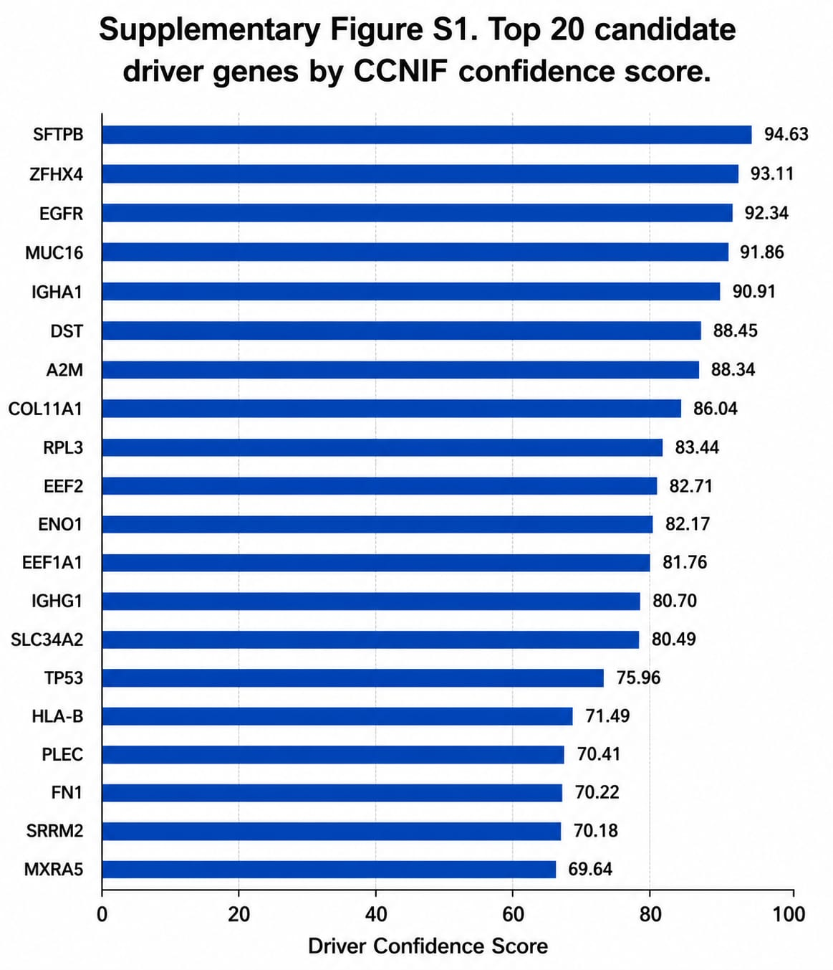
Reproduced from main-text Figure 1 concept at supplementary resolution.
Supplementary Figure S2. Distribution of confidence scores across the 50-gene panel.
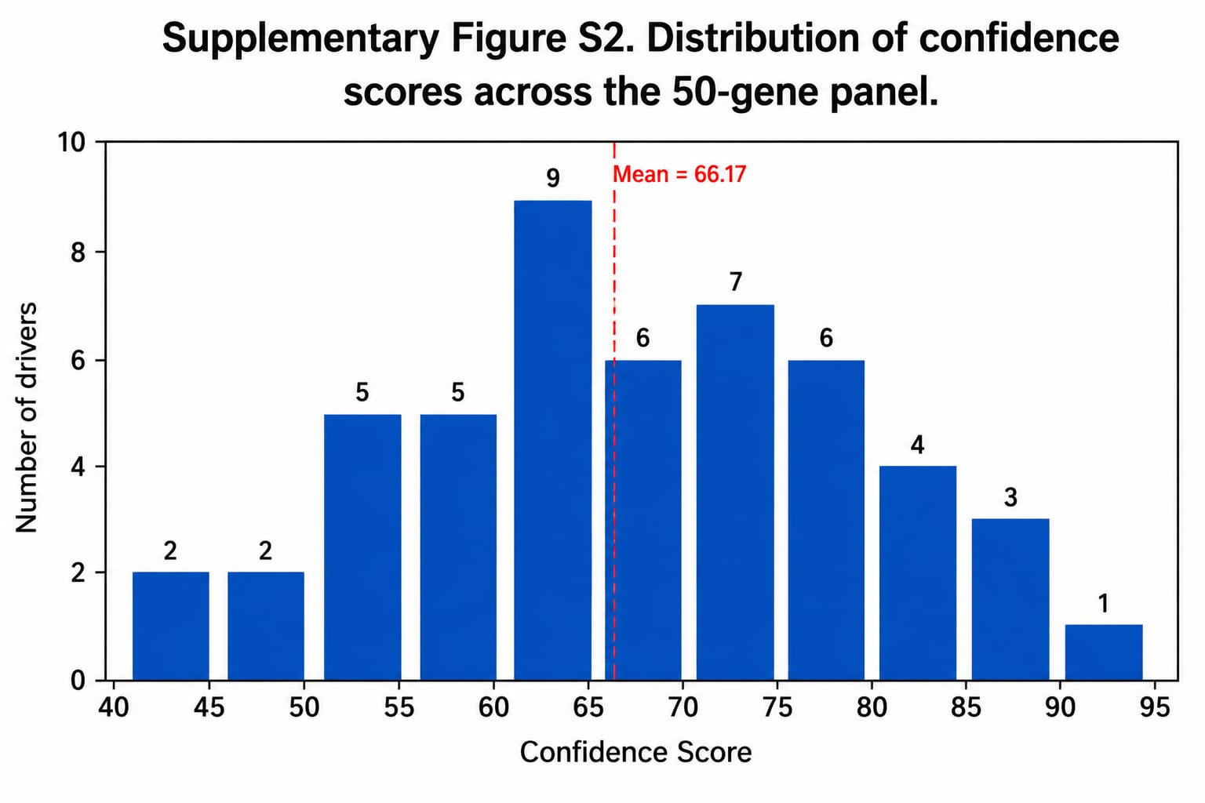
Supplementary Figure S3. Distribution of quality scores across the 50-gene panel.
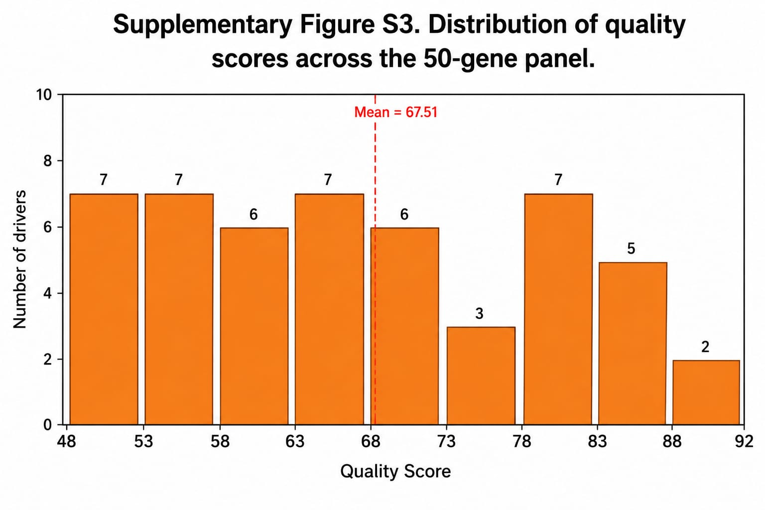
Supplementary Figure S4. Confidence score versus quality score across the 50-gene panel.
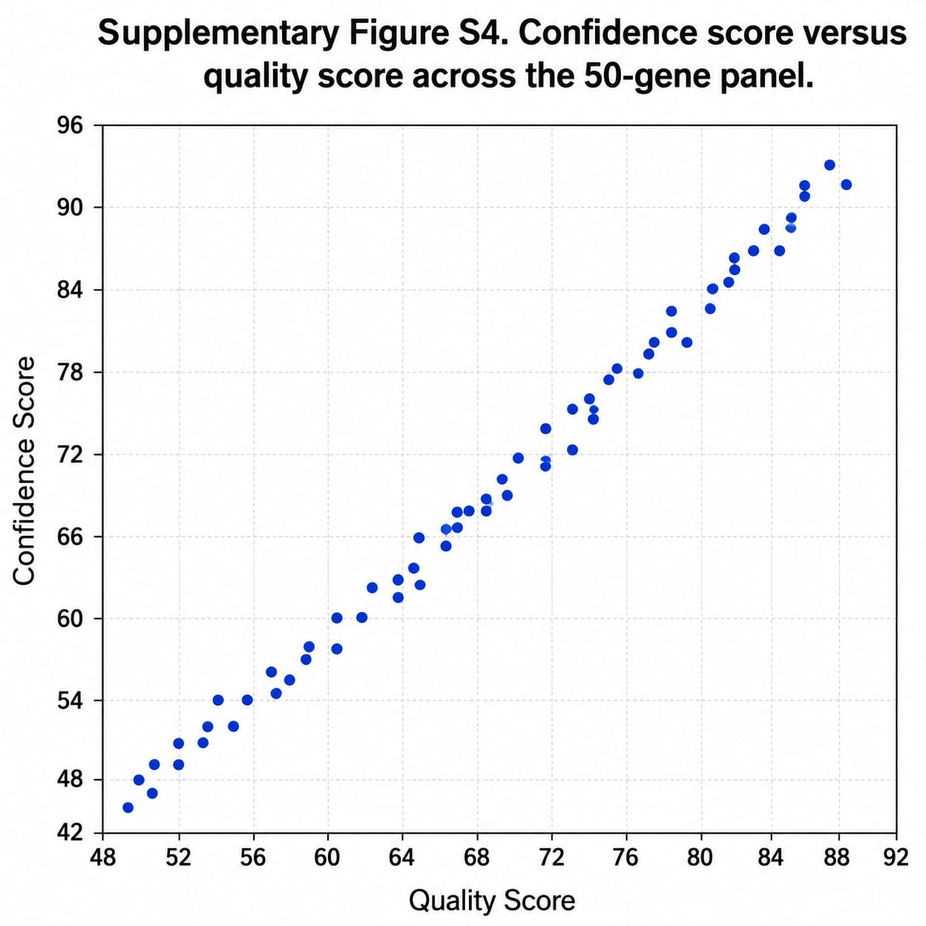
Supplementary Figure S5. Driver confidence tier distribution.
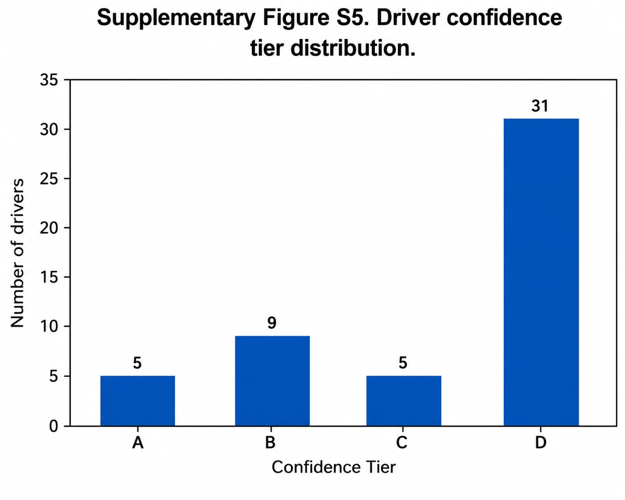
Supplementary Figure S6. Pipeline workflow schematic.
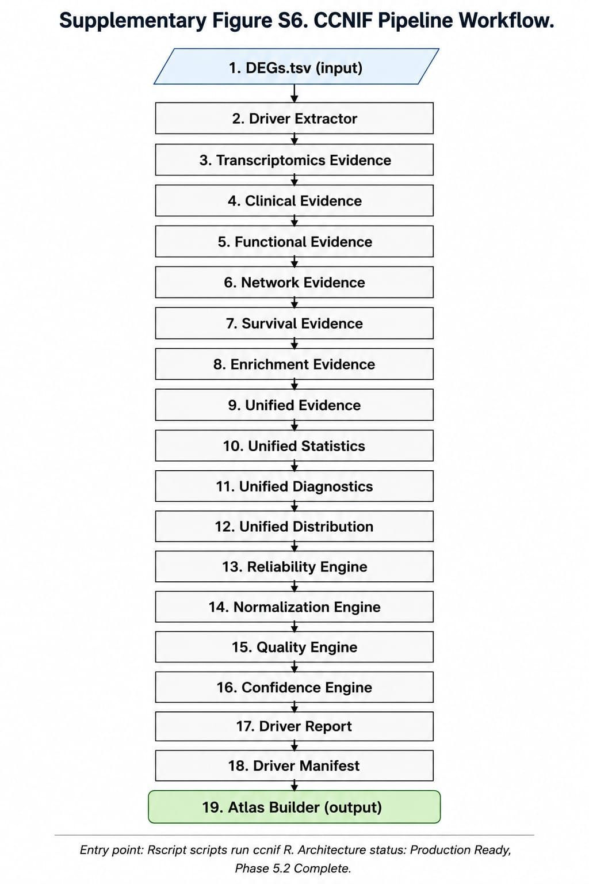
Supplementary Figure S7. Evidence integration architecture.
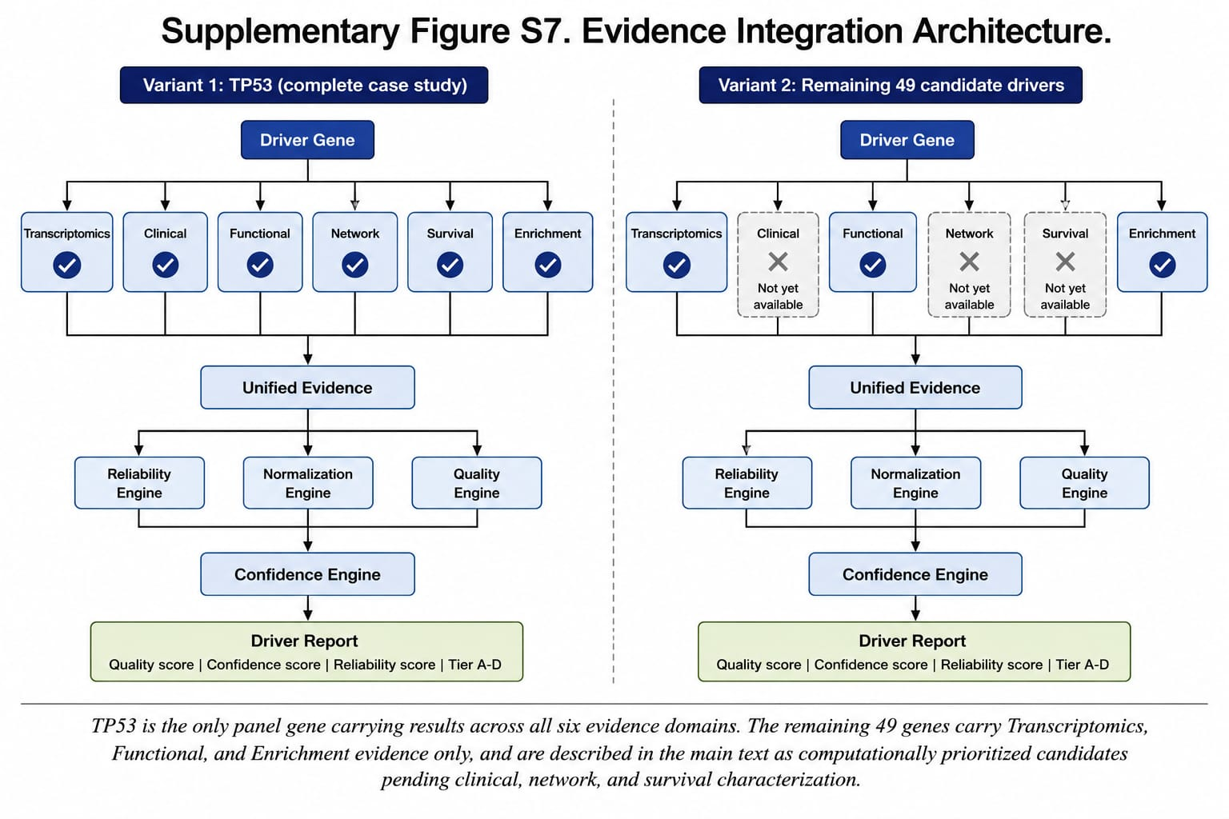
Supplementary Figure S8. Benchmark overview.

