Table S1: cross-sectional univariate comparisons of blood analytes in people with Parkinson’s disease and non-PD manifesting people without LRRK2 or GBA1 mutations at two separate time points
 | Time Point 1 |  |  | Time Point 2
Blood Parameter | PD  (n = 175) | NMNC  (n = 87) | Corrected p value | PD  (n = 175) | NMNC  (n = 87) | Corrected p value
WBC  (10⁹ cells/L) | 6.9  [5.62–7.98] | 6.75  [6–7.95] | 0.96 | 7.2  [5.9–8.5] | 6.95  [5.5–8.28] | 0.75
Neutrophils  (10⁹ cells/L) | 4.5  [3.5–5.2] | 4  [3.32–5.08] | 0.33 | 4.6  [3.72–5.68] | 4.3  [3.2–5.4] | 0.18
Lymphocytes  (10⁹ cells/L) | 1.6 [1.3–2] | 1.9  [1.6–2.3] | 0.001 | 1.6  [1.22–2.08] | 1.8  [1.58–2.2] | 0.04
Triglycerides  (mg/dL) | 112  [78–156] | 143.5  [100.75–187.75] | 0.005 | 112  [79.5–151] | 127  [89–174.5] | 0.1
LDL-C  (mg/dL) | 99  [84–123.5] | 116  [88–134] | 0.06 | 96  [76.5–115] | 105.5  [83.25–130.25] | 0.27
HDL-C  (mg/dL) | 54.8  [45.7–65.7] | 56.2  [47.28–66.15] | 0.75 | 54.5 [44.62–67.3] | 56.9  [46.9–71.15] | 0.75
Total Cholesterol  (mg/dL) | 182  [156–208.75] | 201  [169.25–231] | 0.009 | 179  [151–204] | 194.5  [163–223.5] | 0.11
ALT (U/L) | 17  [12–23] | 21.5  [17–26] | 0.0011 | 13  [8–20.75] | 22  [16.75–27.25] | 2.6 × 10⁻¹⁰
AST (U/L) | 23  [19–26] | 23  [20–25] | 0.75 | 22  [19–26] | 24  [20.75–29] | 0.08
GGT (U/L) | 19  [14–27] | 18.5  [13.25–25.75] | 0.75 | 17  [12.5–25] | 16 [10–22] | 0.42
Total bilirubin (mg/dL) | 0.54  [0.46–0.7] | 0.52  [0.43–0.68] | 0.58 | 0.58  [0.45–0.76] | 0.55  [0.44–0.77] | 0.75
Uric Acid  (mg/dL) | 5.2  [4.3–6.2] | 5.15  [4.42–5.88] | 0.75 | 5.2  [4.2-6.1] | 4.95  [4.2-5.7] | 0.59
Creatinine  (mg/dL) | 0.86  [0.75–0.97] | 0.78  [0.69–0.9] | 0.007 | 0.93  [0.82–1.06] | 0.82  [0.72–0.92] | <0.001
HbA1c (%) | 5.6  [5.4–5.9] | 5.6  [5.4–5.98] | 0.75 | 5.8 [5.5–6] | 5.7  [5.5–6.1] | 0.84
NLR | 2.69  [2–3.61] | 2.07  [1.64–2.62] | 0.00077 | 2.8  [2.12–3.75] | 2.32  [1.75–3] | 0.0067
UACR | 6.02  [5.26–7.03] | 6.55  [5.61–7.45] | 0.14 | 5.63  [4.95–6.51] | 5.92  [5.35–6.84] | 0.11
All values for PD and NMNC are reported as “median [Q1-Q3].”
p values: based on a t-test or Mann-Whitney U test, based on the Shapiro-Wilk test for each parameter. p values were corrected for multiple comparisons using the false discovery rate procedure of Benjamini and Hochberg.
PD: Parkinson’s disease group, NMNC: non-PD-manifesting, non-mutation-carrier group.
LDL-C: low-density lipoprotein cholesterol, HDL-C: high-density lipoprotein cholesterol, ALT: alanine aminotransferase, AST: aspartate aminotransferase, GGT: gamma-glutamyl transferase, HbA1c: glycated hemoglobin, NLR: neutrophil to lymphocyte ratio, UACR: uric acid to creatinine ratio.

Table S2: longitudinal univariate comparisons of blood analytes in people with Parkinson’s disease and non-PD manifesting people without LRRK2 or GBA1 mutations at two separate time points
Blood Parameter | PD (n = 175) | NMNC (n = 87) | p value
WBC  (10⁹ cells/L) | 0.3 [-0.5–1.12] | 0.05 [-0.42–0.9] | 0.75
Neutrophils  (10⁹ cells/L) | 0.3 [-0.4–0.9] | 0 [-0.4–0.6] | 0.6
Lymphocytes  (10⁹ cells/L) | 0 [-0.28–0.2] | -0.05 [-0.2–0.1] | 0.46
Triglycerides  (mg/dL) | -2 [-40.8–33] | -9.5 [-48–26.25] | 0.75
LDL-C  (mg/dL) | -4 [-18–12] | -4 [-19–9.5] | 0.75
HDL-C  (mg/dL) | 1 [-5.1–4.98] | -0.2 [-5.72–4.4] | 0.76
Total Cholesterol  (mg/dL) | -3 [-18.5–15.5] | -3.5 [-21.75–11.25] | 0.75
ALT (U/L) | -2 [-7–2] | 1 [-1–4.25] | 0.00053
AST (U/L) | 0 [-4–4] | 2 [-2–5] | 0.11
GGT (U/L) | -2 [-6–1.5] | -1 [-5–0] | 0.95
Total bilirubin (mg/dL) | 0.02 [-0.07–0.1] | 0.015 [-0.05–0.16] | 0.75
Uric Acid  (mg/dL) | 0 [-0.5–0.4] | 0 [-0.4–0.4] | 0.95
Creatinine  (mg/dL) | 0.04 [-0.01–0.12] | 0.03 [-0.01–0.07] | 0.34
HbA1c (%) | 0.1 [0–0.3] | 0.1 [0–0.3] | 0.87
NLR | 0.12 [-0.36–0.7] | 0.12 [-0.24–0.59] | 0.95
UACR | -0.38 [-0.89–0.99] | -0.38 [-0.84–0.24] | 0.75
All values for PD and NMNC are reported as “median [Q1-Q3].”
p values: based on a t-test or Mann-Whitney U test, based on the Shapiro-Wilk test for each parameter. p values were corrected for multiple comparisons using the false discovery rate procedure of Benjamini and Hochberg.
PD: Parkinson’s disease group, NMNC: non-PD-manifesting, non-mutation-carrier group.
LDL-C: low-density lipoprotein cholesterol, HDL-C: high-density lipoprotein cholesterol, ALT: alanine aminotransferase, AST: aspartate aminotransferase, GGT: gamma-glutamyl transferase, HbA1c: glycated hemoglobin, NLR: neutrophil to lymphocyte ratio, UACR: uric acid to creatinine ratio.

Figure S1: Spearman correlations and LOWESS between AST levels and several PD characteristics in people with PD at two evaluation time points
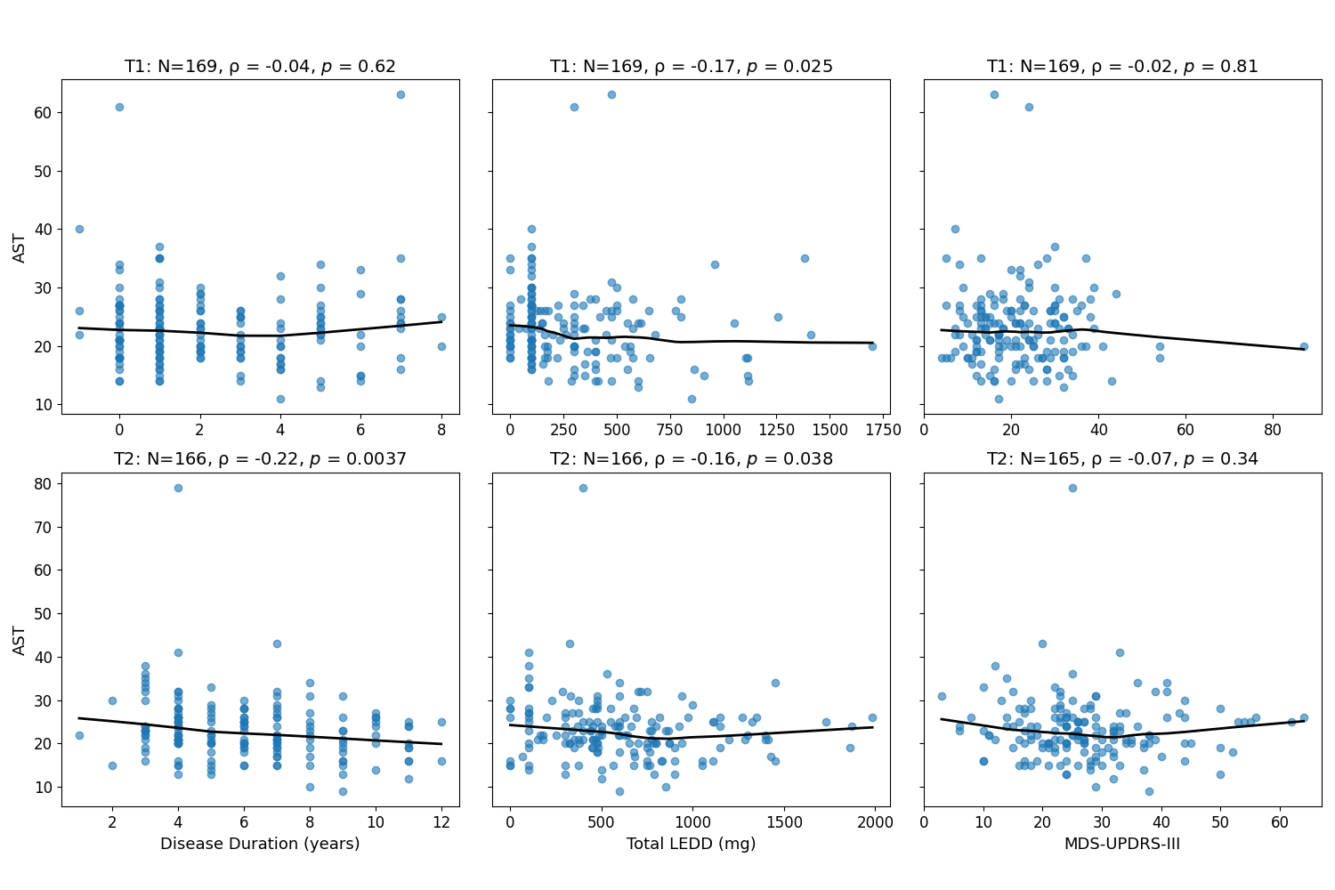

LOWESS: locally weighted scatterplot smoothing, PD: Parkinson’s disease, AST: aspartate aminotransferase, LEDD: levodopa-equivalent daily dose, MDS-UPDRS: Movement Disorders Society-Unified Parkinson's Disease Rating Scale, T1 and T2: evaluation time points 1 and 2, respectively.
Negative disease durations indicate participants who were diagnosed with PD between time points T1 and T2.
Figure S2: Spearman correlations and LOWESS between NLR levels and several PD characteristics in people with PD at two evaluation time points
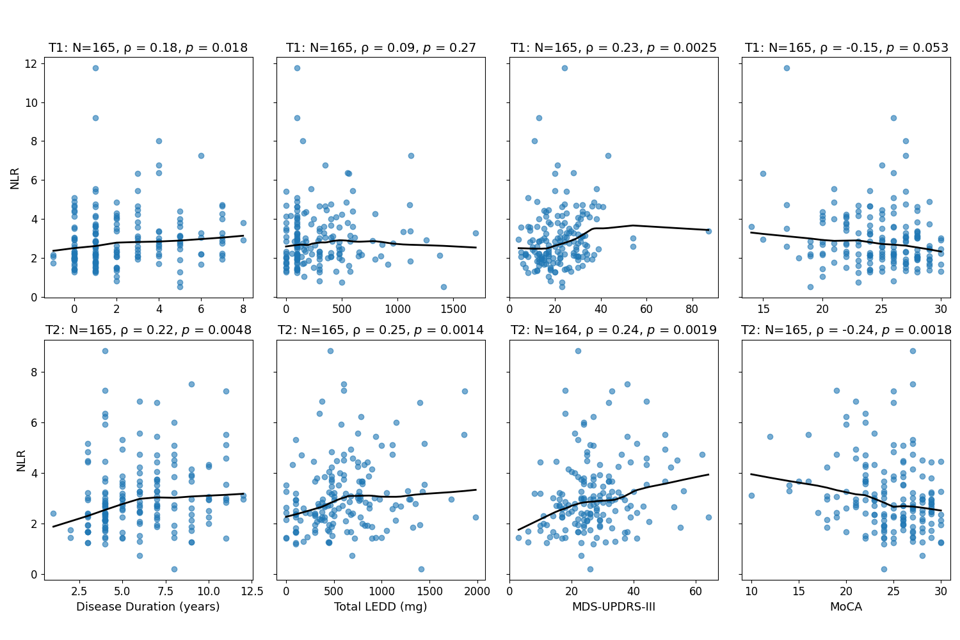

LOWESS: locally weighted scatterplot smoothing, PD: Parkinson’s disease, NLR: neutrophil to lymphocyte ratio, LEDD: levodopa-equivalent daily dose, MDS-UPDRS: Movement Disorders Society-Unified Parkinson's Disease Rating Scale, MoCA: Montreal Cognitive Assessment, T1 and T2: evaluation time points 1 and 2, respectively.
Negative disease durations indicate participants who were diagnosed with PD between time points T1 and T2.

