Supplementary Information
International Used Electric Vehicle Trade: Enabling Conditions and Justice Considerations
This Supplementary Information accompanies the manuscript submitted to Nature Sustainability and follows the analytical flow of the main text. Part I presents summary statistics and primary regression results (Supplementary Tables 1–7); Part II presents data construction and additional regression results referenced in the Methods (Supplementary Tables 8–10); Part III reports robustness analyses (Supplementary Methods 1–9 and Supplementary Tables 11–19); Part IV presents Supplementary Figures 1–4; and Part V contains Supplementary Notes 1–3. Supplementary Tables, Figures, Methods, and Notes are numbered sequentially in order of appearance.

Contents
Part I — Summary statistics and primary regression tables
Supplementary Table 1 | Summary statistics
Supplementary Table 2 | Baseline PPML: used ICE vs used EV (side-by-side)
Supplementary Table 3 | Stacked PPML and formal test of structural difference
Supplementary Table 4 | Extensive vs intensive margin decomposition
Supplementary Table 5 | Cross-sectional UNEP regulatory-ranking
Supplementary Table 6 | Heterogeneity by importer income group (full + interactions)
Supplementary Table 7 | Heckman sample-selection model
Part II — Additional regression tables
Supplementary Table 8 | Manual ISO3 country-name crosswalk
Supplementary Table 9 | PPML coefficient stability across six steps
Supplementary Table 10 | Lagged charging-infrastructure specification
Part III — Robustness analyses (Supplementary Methods 1–9)
Supplementary Methods 1 + Supplementary Table 11 | Alternative fixed-effect structures
Supplementary Methods 2 + Supplementary Table 12 | Alternative clustering
Supplementary Methods 3 + Supplementary Table 13 | Functional form
Supplementary Methods 4 + Supplementary Table 14 | BNEF subsample
Supplementary Methods 5 + Supplementary Table 15 | Sample exclusions
Supplementary Methods 6 + Supplementary Table 16 | Temporal stability
Supplementary Methods 7 (Heckman; reported as Supplementary Table 7 in Part I)
Supplementary Methods 8 + Supplementary Table 17 | Within–between (Mundlak/CRE)
Supplementary Methods 9 + Supplementary Tables 18–19 | Brexit interaction
Part IV — Supplementary Figures 1–4
Part V — Supplementary Notes 1–3 and Supplementary Tables 20–21

Part I | Summary statistics and primary regression tables
Part I presents the seven summary-statistics, regression, and descriptive tables referenced in the main text.

Supplementary Table 1 | Summary statistics
Supplementary Table 1 reports descriptive statistics for the bilateral trade variables (Panel A) and the importer-level characteristics used as covariates throughout the analysis (Panel B). The sample covers 208 importing countries and five exporters (EU, Japan, South Korea, UK, USA) over 2015–2022; used EV flows are observed from 2017 onward.
Panel A: Trade Variables
Variable | Mean | SD | Min | Max | N
Used vehicles (total) | 3,500.67 | 14,495.16 | 0.00 | 418,176 | 6,547
Used ICE vehicles | 3,478.05 | 14,408.69 | 0.00 | 414,074 | 6,547
Used EVs | 39.84 | 607.17 | 0.00 | 28,802 | 3,717
EV share of used imports (%) | 1.35 | 8.01 | 0.00 | 100.00 | 2,543
Any used EV trade (=1) | 0.19 | 0.39 | 0.00 | 1.00 | 3,717
Panel B: Importer Characteristics
Variable | Mean | SD | Min | Max | N
Log GDP per capita (PPP) | 9.36 | 1.09 | 6.90 | 11.80 | 5,994
Log population | 15.31 | 2.43 | 9.21 | 21.08 | 6,327
Government effectiveness | −0.14 | 0.88 | −2.24 | 2.25 | 6,253
Log charging connectors | 1.00 | 2.17 | 0.00 | 14.40 | 6,549
Connectors per million pop. | 44.71 | 259.63 | 0.00 | 4,438 | 6,327
Electricity access (%) | 82.02 | 26.84 | 4.20 | 100.00 | 6,327
CO₂ per capita | 4.25 | 7.90 | 0.00 | 78.73 | 6,068
Fossil fuel electricity (%) | 64.08 | 33.85 | 0.00 | 100.00 | 5,926
Log bilateral distance | 8.97 | 0.58 | 5.87 | 9.88 | 6,216
Contiguity | 0.01 | 0.07 | 0.00 | 1.00 | 6,290
Common language | 0.13 | 0.33 | 0.00 | 1.00 | 6,290
Colonial relationship | 0.07 | 0.25 | 0.00 | 1.00 | 6,290
Notes: Sample: 177 importing economies (after excluding exporter jurisdictions as importers), 5 exporters (EU, Japan, South Korea, UK, USA), 2015–2022; 6,549 bilateral exporter–importer–year observations. Trade-variable Ns are 6,547 rather than 6,549 because two observations (Pitcairn–EU, 2021 and 2022) lack reported totals. The used-EV subsample (2017–2022; the United States does not report used-EV exports) comprises 3,717 observations.

Supplementary Table 2 | Baseline PPML gravity: used ICE vs used EV
This table reports baseline gravity-model estimates for used ICE vehicle and used EV trade. Column 1 presents PPML estimates for used ICE vehicle trade (2015–2022), and Column 2 presents PPML estimates for used EV trade (2017–2022). Both models include exporter × year, importer, and UNEP region × year fixed effects. The table reports coefficients for distance, common language, colonial ties, governance, connectors, and the interaction terms.
Variable | (1) Used ICE | (2) Used EV
Log GDP per capita | 0.295 | −4.550*
 | (0.505) | (2.542)
Log population | −0.050 | 9.134
 | (1.570) | (7.547)
Gov. effectiveness | 0.600* | 1.310
 | (0.337) | (1.832)
Log connectors | 0.042 | −0.202***
 | (0.029) | (0.057)
CO₂ per capita | −0.048 | −0.483*
 | (0.061) | (0.271)
Fossil electricity (%) | −0.006 | −0.024
 | (0.005) | (0.035)
GDP × Connectors | 0.044 | 0.535***
 | (0.029) | (0.133)
GDP × Gov. effectiveness | 0.110 | 1.079
 | (0.259) | (1.054)
Connectors × Gov. eff. | −0.068* | −0.363***
 | (0.035) | (0.088)
Log distance | −1.376*** | −1.090
 | (0.241) | (0.958)
Common language | −0.689 | 4.612***
 | (0.616) | (1.383)
Colonial relationship | 1.633*** | −1.582**
 | (0.510) | (0.723)
Observations | 4,831 | 2,166
Pseudo R² | 0.647 | 0.846
Notes: PPML estimates. DV: count of used vehicles. FE: exporter×year + importer + UNEP-region×year. SE clustered by importer. ICE: 2015–2022. EV: 2017–2022 with three two-way interactions. * P < 0.10; ** P < 0.05; *** P < 0.01.

Supplementary Table 3 | Stacked PPML with formal test of structural difference
This table reports pooled gravity-model estimates comparing used ICE vehicle and used EV trade. ICE and EV observations are combined into a single panel, and each covariate is interacted with an EV indicator. Column 1 presents a specification with six covariates, and Column 2 presents the full specification. The EV × covariate interaction terms indicate whether the estimated coefficients differ between vehicle types. Joint Wald tests reported at the bottom of the table reject equality of the coefficient vectors across the two specifications. These results are referenced in the Results section of the main text.
Variable | (1) Key interactions | (2) Full interactions
EV × Log GDP per capita | −3.260*** | −2.933
 | (1.149) | (2.552)
EV × Gov. effectiveness | 1.203 | 0.112
 | (1.682) | (1.854)
EV × Log connectors | −0.019 | −0.045
 | (0.074) | (0.074)
EV × Log distance | 0.447 | 1.617
 | (0.859) | (1.102)
EV × Colonial relationship | −1.315* | −2.084***
 | (0.711) | (0.668)
EV × Common language | 5.797*** | 2.787**
 | (1.743) | (1.325)
EV × CO₂ per capita | — | 0.148
 |  | (0.350)
EV × Fossil electricity | — | −0.050
 |  | (0.041)
Joint Wald test | χ²(6) = 34.17*** | χ²(8) = 29.95***
Observations | 5,914 | 4,885
Pseudo R² | 0.763 | 0.765
Notes: Stacked dataset pools ICE and EV observations; EV indicator interacted with all covariates. Only EV interaction terms shown; base (ICE) coefficients suppressed. Joint Wald test: H₀ all EV interactions = 0. * P < 0.10; ** P < 0.05; *** P < 0.01.

Supplementary Table 4 | Extensive vs intensive margin decomposition
This table examines the determinants of the extensive and intensive margins of used EV trade. Column 1 reports probit average marginal effects on the probability of any used-EV trade, while Column 2 reports PPML estimates of trade volume conditional on a positive trade flow.
Variable | (1) Probit AME | (2) PPML Intensive
Log GDP per capita | 0.062*** | −6.370***
 | (0.022) | (1.955)
Log population | 0.021*** | —
 | (0.007)
Gov. effectiveness | 0.047* | 0.918
 | (0.027) | (1.515)
Log connectors | 0.014** | −0.335***
 | (0.007) | (0.040)
Import ban (UNEP) | −0.040 | —
 | (0.043)
CO₂ per capita | −0.004 | 0.157
 | (0.003) | (0.241)
Fossil electricity (%) | 0.000 | −0.047
 | (0.000) | (0.031)
Log distance | −0.159*** | −6.082**
 | (0.032) | (2.450)
Common language | 0.225*** | −2.129
 | (0.087) | (1.787)
Colonial relationship | 0.064 | 4.193**
 | (0.058) | (2.029)
Observations | 2,719 | 489
Pseudo R² | — | 0.946
Notes: Col 1: probit average marginal effects on Pr(any used EV trade = 1), full EV sample. Col 2: PPML conditional on positive trade (uevs > 0), includes GDP×Connectors, GDP×Gov, Connectors×Gov interactions. ‘—’ = absorbed by FE or not included. * P < 0.10; ** P < 0.05; *** P < 0.01.

Supplementary Table 5 | Cross-sectional recovery of UNEP regulatory-category coefficients
The importer fixed effects included in the baseline panel PPML specification (Supplementary Table 2) absorb time-invariant importer characteristics and therefore prevent estimation of the UNEP regulatory categories. This table reports alternative specifications that identify these coefficients using cross-sectional variation. Columns 1–3 present 2022 cross-sectional estimates with exporter fixed effects for total used-vehicle, used ICE vehicle, and used EV trade, respectively. Column 4 presents pooled used EV estimates for 2017–2022 with exporter × year and UNEP-region fixed effects. The results indicate larger negative associations between import restrictions and used EV trade than for total used-vehicle or used ICE vehicle trade.
Variable | (1) Total 2022 | (2) ICE 2022 | (3) EV 2022 | (4) EV pooled
Log GDP per capita | −0.834** | −0.872** | −0.512 | −0.057
 | (0.331) | (0.340) | (0.460) | (0.812)
Log population | 0.122 | 0.108 | 0.585** | 0.953***
 | (0.120) | (0.122) | (0.253) | (0.238)
Gov. effectiveness | 0.057 | 0.076 | 1.112 | 2.620***
 | (0.568) | (0.576) | (1.066) | (0.716)
Log connectors | 0.222*** | 0.210*** | 0.794*** | 0.511***
 | (0.067) | (0.068) | (0.141) | (0.115)
GDP × Connectors | 0.145** | 0.150** | 0.048 | −0.037
 | (0.071) | (0.071) | (0.228) | (0.182)
GDP × Gov. eff. | −0.684*** | −0.692*** | −1.340 | 0.263
 | (0.236) | (0.236) | (0.826) | (0.407)
Conn. × Gov. eff. | 0.156 | 0.152 | 0.228 | −0.285*
 | (0.132) | (0.133) | (0.337) | (0.149)
Import ban | −1.670** | −1.572** | −8.487*** | −5.833***
 | (0.676) | (0.677) | (2.136) | (1.363)
Weak regulation | −0.227 | −0.250 | 0.263 | 0.362
 | (0.416) | (0.422) | (0.950) | (0.685)
Good regulation | −0.270 | −0.288 | −0.306 | 0.609
 | (0.460) | (0.442) | (0.782) | (0.589)
Very Good regulation | 0.560 | 0.615 | −0.731 | −2.077***
 | (0.447) | (0.455) | (0.850) | (0.635)
CO₂ per capita | 0.110*** | 0.115*** | 0.008 | −0.084
 | (0.034) | (0.035) | (0.135) | (0.081)
Fossil electricity (%) | −0.010** | −0.010** | −0.002 | −0.025***
 | (0.005) | (0.005) | (0.003) | (0.008)
Log distance | −1.364*** | −1.432*** | 0.067 | −0.285
 | (0.292) | (0.300) | (0.832) | (0.927)
Common language | −0.764 | −0.748 | — | 3.438***
 | (0.941) | (0.943) |  | (1.252)
Colonial relationship | −2.858*** | −2.838*** | −3.847*** | −1.016
 | (0.691) | (0.693) | (1.347) | (0.820)
Observations | 396 | 396 | 297 | 2,719
Pseudo R² | 0.465 | 0.463 | 0.769 | 0.735
Notes: PPML. No importer FE; UNEP ranking dummies as cross-sectional covariates. Cols 1–3: single-year 2022, exporter FE. Col 4: pooled 2017–2022, exporter×year + region FE. Descriptive, not causal. * P < 0.10; ** P < 0.05; *** P < 0.01.

Supplementary Table 6 | Heterogeneity by importer income group (full specification with interactions)
This table reports heterogeneity in governance and charging connector effects across importer income groups. Separate specifications are estimated for high-income, upper-middle-income, and lower-middle- and low-income countries. Government effectiveness is positively associated with used EV trade across all income groups, while the estimated charging connector effects and connector × governance interactions vary across subsamples. These results are discussed in the main text.
Variable | (1) High | (2) Upper-mid | (3) Lower-mid & Low
Log GDP per capita | 4.295 | 2.373 | 0.946
 | (3.840) | (3.470) | (0.610)
Log population | −0.002 | 0.024 | 0.360***
 | (0.125) | (0.333) | (0.130)
Gov. effectiveness | 15.15*** | 7.352** | 1.131***
 | (4.388) | (3.209) | (0.328)
Log connectors | −1.253 | 1.173*** | 0.137
 | (1.010) | (0.236) | (0.112)
CO₂ per capita | 0.183*** | 0.551*** | 0.075
 | (0.036) | (0.175) | (0.230)
Fossil electricity (%) | −0.066*** | 0.006 | −0.016***
 | (0.006) | (0.013) | (0.005)
GDP × Connectors | 0.805*** | −0.220 | −0.122
 | (0.290) | (0.371) | (0.171)
GDP × Gov. eff. | −7.194** | −3.189 | 0.808*
 | (3.644) | (4.500) | (0.482)
Conn. × Gov. eff. | 0.105 | −1.561*** | −0.404***
 | (0.391) | (0.344) | (0.110)
Log distance | −3.254*** | 2.251 | −2.122***
 | (0.557) | (2.822) | (0.672)
Common language | 11.57*** | 2.938 | 1.509
 | (1.459) | (2.610) | (1.391)
Colonial relationship | — | −1.177 | 0.622
 |  | (2.960) | (1.060)
Observations | 489 | 983 | 1,300
Pseudo R² | 0.937 | 0.847 | 0.808
Notes: PPML, DV: used EV count. Full covariates with interactions, no UNEP dummies. FE: exporter×year + region×year. SE clustered by importer. Income groups per World Bank classification. ‘—’ = singleton absorption. * P < 0.10; ** P < 0.05; *** P < 0.01.

Supplementary Table 7 | Heckman sample-selection model
This table reports Heckman two-step and maximum-likelihood selection models for used EV trade. The selection equation estimates the probability of any bilateral trade relationship, and the outcome equation estimates trade volumes conditional on a positive trade flow. Identification relies on two exclusion restrictions included only in the selection equation: an indicator for used ICE vehicle trade and the number of alternative used-EV exporters serving the importing country. The results provide evidence of sample selection and are referenced in the main text.
Panel A: Outcome — ln(used EVs)
Variable | (1) Two-step | (2) MLE
Log GDP per capita | −0.126 | −0.125
 | (0.211) | (0.284)
Gov. effectiveness | 0.325* | 0.333*
 | (0.191) | (0.198)
Log connectors | 0.152** | 0.153
 | (0.066) | (0.105)
Log distance | −0.216 | −0.208
 | (0.218) | (0.274)
Common language | 1.140 | 1.133**
 | (0.868) | (0.507)
Colonial relationship | −1.703** | −1.726***
 | (0.768) | (0.409)
Panel B: Selection — Pr(any EV trade)
Variable | (1) Two-step | (2) MLE
Pair trades used ICE (=1) | 1.819*** | 1.776***
 | (0.185) | (0.207)
No. other EV partners | 0.048 | 0.091
 | (0.050) | (0.074)
Log connectors | 0.107*** | 0.107***
 | (0.019) | (0.029)
Log GDP per capita | 0.247*** | 0.250***
 | (0.061) | (0.074)
Log population | 0.057*** | 0.069**
 | (0.021) | (0.031)
Log distance | −0.471*** | −0.455***
 | (0.060) | (0.113)
Panel C: Diagnostics
Variable | (1) Two-step | (2) MLE
Lambda (IMR) | −1.088** | —
 | (0.515)
rho | — | −0.538
Wald test (rho = 0) | — | p = 0.0003
Observations | 2,683 | 2,683
Censored observations | 2,107 | 2,107
Notes: DV (outcome): ln(used EVs) for positive observations. Exclusion restrictions: (i) whether the same exporter–importer pair trades used ICE vehicles; (ii) number of other exporters the importer trades used EVs with. UNEP ranking dummies in selection equation only. No high-dimensional FE. SE clustered by importer. * P < 0.10; ** P < 0.05; *** P < 0.01.

Part II | Additional descriptive and regression tables
Part II presents three data-construction and supplementary regression tables referenced in the Methods. These tables document the ISO-country-code crosswalk used to resolve missing country identifiers and report the stepwise and lagged-infrastructure specifications.

Supplementary Table 8 | Manual ISO3 country-name crosswalk for blank UNEP codes
This table reports the crosswalk used to assign ISO country codes to 23 UNEP country-name entries lacking machine-readable identifiers. The resulting harmonized codes were matched to the UN M49 classifications used in the analysis dataset. After applying the crosswalk, all observations in the merged dataset contained valid importer-country codes.
UNEP country name (raw) | Assigned ISO3 | Source / Note
CROATIA | HRV | ISO 3166-1 alpha-3
CURACAO | CUW | ISO 3166-1 alpha-3
DENMARK | DNK | ISO 3166-1 alpha-3
FAROE ISLANDS | FRO | ISO 3166-1 alpha-3
FRENCH GUIANA | GUF | ISO 3166-1 alpha-3
FRENCH POLYNESIA | PYF | ISO 3166-1 alpha-3
GIBRALTAR | GIB | ISO 3166-1 alpha-3
GREENLAND | GRL | ISO 3166-1 alpha-3
HONG KONG | HKG | ISO 3166-1 alpha-3 (SAR of China)
KOREA, DEMOCRATIC* | PRK | ISO 3166-1 alpha-3 (DPRK; wildcard match on raw name)
MALTA | MLT | ISO 3166-1 alpha-3
MARSHALL ISLANDS | MHL | ISO 3166-1 alpha-3
MARTINIQUE | MTQ | ISO 3166-1 alpha-3
MOLDOVA, REPUBLIC OF | MDA | ISO 3166-1 alpha-3
PITCAIRN | PCN | ISO 3166-1 alpha-3
SAN MARINO | SMR | ISO 3166-1 alpha-3
SERBIA | SRB | ISO 3166-1 alpha-3
SINT MAARTEN* | SXM | ISO 3166-1 alpha-3 (Dutch part; wildcard match on raw name)
SOLOMON ISLANDS | SLB | ISO 3166-1 alpha-3
SWITZERLAND | CHE | ISO 3166-1 alpha-3
TAIWAN | TWN | ISO 3166-1 alpha-3 (Taiwan, Province of China)
TONGA | TON | ISO 3166-1 alpha-3
VIRGIN ISLANDS (US) | VIR | ISO 3166-1 alpha-3 (U.S. Virgin Islands)
UNITED STATES | USA | Source-data error: row carried code UZB (Uzbekistan); corrected to USA
Notes: Twenty-three country-name strings in the UNEP raw data lacked machine-readable ISO3 codes. Each blank was resolved through a manual country-name crosswalk.

Supplementary Table 9 | PPML coefficient stability across six specification steps
This table reports a sequence of PPML specifications illustrating the sensitivity of the estimated coefficients to the inclusion of additional covariates. Step 1 includes gravity variables and measures of economic size. Subsequent specifications sequentially add government effectiveness (step 2), charging infrastructure (step 3), UNEP regulatory categories (step 4), environmental controls (step 5), and interaction terms (step 6). The estimated coefficients for common language and geographic distance remain broadly stable across specifications, while the estimated effect of charging infrastructure varies with the inclusion of interaction terms. The final specification corresponds to the baseline model discussed in the main text.
Variable | (1) Step 1 | (2) Step 2 | (3) Step 3 | (4) Step 4 | (5) Step 5 | (6) Step 6
Log GDP per capita (centered) | −6.102*** | −6.245*** | −6.276*** | −5.930** | −4.797* | −4.550*
 | (2.055) | (2.237) | (2.104) | (2.484) | (2.847) | (2.542)
Log population | 15.33** | 13.80** | 15.76** | 12.72 | 11.12 | 9.134
 | (6.587) | (6.229) | (6.177) | (7.900) | (7.264) | (7.547)
Govt. effectiveness (centered) |  | 0.971 | 0.731 | 0.260 | 0.377 | 1.310
 |  | (1.734) | (1.674) | (1.884) | (1.880) | (1.832)
Log connectors (centered) |  |  | 0.0804 | 0.0555 | 0.0380 | −0.202***
 |  |  | (0.0582) | (0.0623) | (0.0657) | (0.0574)
Import ban (UNEP 2021) |  |  |  | 0 | 0 | 0
 |  |  |  | (.) | (.) | (.)
Weak regulation (UNEP 2021) |  |  |  | 0 | 0 | 0
 |  |  |  | (.) | (.) | (.)
Good regulation (UNEP 2021) |  |  |  | 0 | 0 | 0
 |  |  |  | (.) | (.) | (.)
Very Good regulation (UNEP 2021) |  |  |  | 0 | 0 | 0
 |  |  |  | (.) | (.) | (.)
CO2 per capita |  |  |  |  | −0.0551 | −0.483*
 |  |  |  |  | (0.311) | (0.271)
Electricity from fossil fuels (%) |  |  |  |  | −0.0448 | −0.0240
 |  |  |  |  | (0.0394) | (0.0354)
GDP × Connectors (centered) |  |  |  |  |  | 0.535***
 |  |  |  |  |  | (0.133)
GDP × Govt. effectiveness (centered) |  |  |  |  |  | 1.079
 |  |  |  |  |  | (1.054)
Connectors × Govt. effectiveness (centered) |  |  |  |  |  | −0.363***
 |  |  |  |  |  | (0.0879)
GDP × Connectors (2y lag, centered)
Connectors × Govt. effectiveness (2y lag, centered)
Log bilateral distance | −1.999*** | −1.997*** | −1.999*** | −1.104 | −1.070 | −1.090
 | (0.643) | (0.644) | (0.643) | (0.925) | (0.952) | (0.958)
Contiguity | 0 | 0 | 0 | 0 | 0 | 0
 | (.) | (.) | (.) | (.) | (.) | (.)
Common language | 7.579*** | 7.527*** | 7.529*** | 4.715*** | 4.488*** | 4.612***
 | (1.832) | (1.826) | (1.817) | (1.527) | (1.376) | (1.383)
Colonial relationship | −0.823 | −0.783 | −0.808 | −1.433* | −1.509** | −1.582**
 | (0.722) | (0.726) | (0.739) | (0.750) | (0.767) | (0.723)
Constant | −226.6** | −201.7** | −235.0** | −200.2 | −170.8 | −135.8
 | (108.4) | (102.3) | (101.4) | (134.0) | (123.2) | (129.3)
Observations | 2686 | 2644 | 2644 | 2436 | 2166 | 2166
Pseudo R2 | 0.861 | 0.861 | 0.861 | 0.843 | 0.844 | 0.846
Notes: PPML estimates of used-EV trade (2017–2022) across stepwise additions of covariates. Fixed effects: exporter × year, importer × region × year. Standard errors clustered by importer. * P<0.10; ** P<0.05; *** P<0.01.

Supplementary Table 10 | Lagged charging-infrastructure specification
This table reports robustness checks using lagged measures of charging infrastructure. Columns 2 and 3 replace the contemporaneous charging-infrastructure variable with one-year and two-year lags, respectively. The estimated coefficients for charging infrastructure, GDP × charging infrastructure, and charging infrastructure × governance remain similar across specifications. These results indicate that the baseline findings are robust to alternative lag structures.
Variable | (1) Contemporaneous | (2) 1-year lag | (3) 2-year lag
Log GDP per capita (centered) | −4.550* | −2.801 | −6.180**
 | (2.542) | (2.533) | (3.055)
Log population | 9.134 | 5.220 | 8.782
 | (7.547) | (7.336) | (7.586)
Govt. effectiveness (centered) | 1.310 | 0.517 | 0.128
 | (1.832) | (1.720) | (2.072)
Log connectors (centered) | −0.202***
 | (0.0574)
Import ban (UNEP 2021) | 0 | 0 | 0
 | (.) | (.) | (.)
Weak regulation (UNEP 2021) | 0 | 0 | 0
 | (.) | (.) | (.)
Good regulation (UNEP 2021) | 0 | 0 | 0
 | (.) | (.) | (.)
Very Good regulation (UNEP 2021) | 0 | 0 | 0
 | (.) | (.) | (.)
CO2 per capita | −0.483* | −0.343 | −0.0850
 | (0.271) | (0.366) | (0.261)
Electricity from fossil fuels (%) | −0.0240 | −0.0246 | −0.0442
 | (0.0354) | (0.0420) | (0.0368)
GDP × Connectors (centered) | 0.535***
 | (0.133)
GDP × Govt. effectiveness (centered) | 1.079 | 0.237 | 0.206
 | (1.054) | (1.250) | (1.455)
Connectors × Govt. effectiveness (centered) | −0.363***
 | (0.0879)
Log bilateral distance | −1.090 | −1.072 | −1.086
 | (0.958) | (0.956) | (0.963)
Contiguity | 0 | 0 | 0
 | (.) | (.) | (.)
Common language | 4.612*** | 4.461*** | 4.529***
 | (1.383) | (1.290) | (1.370)
Colonial relationship | −1.582** | −1.400** | −1.497*
 | (0.723) | (0.657) | (0.767)
Log connectors (1y lag, centered) |  | −0.131*
 |  | (0.0739)
GDP × Connectors (1y lag, centered) |  | 0.262***
 |  | (0.0727)
Connectors × Govt. effectiveness (1y lag, centered) |  | −0.226***
 |  | (0.0604)
Log connectors (2y lag, centered) |  |  | −0.0887
 |  |  | (0.0849)
GDP × Connectors (2y lag, centered) |  |  | 0.0821
 |  |  | (0.0923)
Connectors × Govt. effectiveness (2y lag, centered) |  |  | 0.0208
 |  |  | (0.107)
Constant | −135.8 | −68.64 | −128.3
 | (129.3) | (125.6) | (129.6)
Observations | 2166 | 2166 | 2166
Pseudo R2 | 0.846 | 0.846 | 0.845

Notes: Lagged specifications address reverse causality. Column 1: contemporaneous; column 2: 1-year lag; column 3: 2-year lag. Standard errors clustered by importer. * P<0.10; ** P<0.05; *** P<0.01.

Part III | Robustness analyses (Supplementary Methods 1–9)
Part III presents the analyses referenced under “Identification and sensitivity analyses” in the Methods. Each subsection contains a brief methodological description followed by the corresponding Supplementary Table(s). The nine analyses are reported in Supplementary Methods 1–9 and Supplementary Tables 11–19.

Supplementary Methods 1 | Alternative fixed-effect structures
To assess the sensitivity of the baseline specification to alternative fixed-effect structures, we re-estimate the gravity model using several commonly employed panel-data specifications. These include a saturated specification with exporter × year and importer × year fixed effects (FE-A), a specification with exporter × year, importer, and year fixed effects (FE-B), and a specification with bilateral-pair fixed effects (FE-C). The bilateral-pair specification absorbs all time-invariant dyadic characteristics and therefore identifies effects from within-pair variation over time.
Across specifications, the estimated coefficient on charging infrastructure varies in magnitude and statistical significance, reflecting differences in the variation available for identification under alternative fixed-effect structures. By contrast, the estimated common-language effect remains positive and statistically significant whenever identified.
Supplementary Table 11 | Alternative fixed-effect structures.
Variable | (1) Baseline | (2) FE-A: exp×year + imp×year (saturated) | (3) FE-B: exp×year + imp + year (global) | (4) FE-C: exp×year + pair (pair FE)
Log GDP per capita (centered) | −4.550* |  | −1.428 | −3.345
 | (2.542) |  | (3.122) | (2.760)
Log population | 9.134 |  | 21.80* | 13.29
 | (7.547) |  | (12.71) | (9.048)
Govt. effectiveness (centered) | 1.310 |  | 1.097 | 0.220
 | (1.832) |  | (2.251) | (2.602)
Log connectors (centered) | −0.202*** |  | 0.147 | 0.122
 | (0.0574) |  | (0.249) | (0.160)
Import ban (UNEP 2021) | 0 |  | 0
 | (.) |  | (.)
Weak regulation (UNEP 2021) | 0 |  | 0
 | (.) |  | (.)
Good regulation (UNEP 2021) | 0 |  | 0
 | (.) |  | (.)
Very Good regulation (UNEP 2021) | 0 |  | 0
 | (.) |  | (.)
CO2 per capita | −0.483* |  | 0.0290 | 0.664
 | (0.271) |  | (0.608) | (0.532)
Electricity from fossil fuels (%) | −0.0240 |  | −0.141 | −0.135**
 | (0.0354) |  | (0.0881) | (0.0549)
GDP × Connectors (centered) | 0.535*** |  | −0.0200 | 0.00993
 | (0.133) |  | (0.411) | (0.309)
GDP × Govt. effectiveness (centered) | 1.079 |  | 0.610 | 2.275
 | (1.054) |  | (2.159) | (1.729)
Connectors × Govt. effectiveness (centered) | −0.363*** |  | −0.147 | −0.0815
 | (0.0879) |  | (0.214) | (0.166)
Log bilateral distance | −1.090 | −2.113*** | −0.703
 | (0.958) | (0.690) | (0.882)
Contiguity | 0 | 0 | 0
 | (.) | (.) | (.)
Common language | 4.612*** | 9.098*** | 4.636***
 | (1.383) | (2.174) | (1.639)
Colonial relationship | −1.582** | −2.039** | −1.633
 | (0.723) | (1.035) | (1.021)
Constant | −135.8 | 25.29*** | −359.7 | −215.5
 | (129.3) | (5.716) | (219.1) | (152.8)
Observations | 2166 | 1619 | 2166 | 1135
Pseudo R2 | 0.846 | 0.865 | 0.804 | 0.951

Notes: PPML estimates under alternative fixed-effect designs. Standard errors clustered by importer. * P<0.10; ** P<0.05; *** P<0.01.

Supplementary Methods 2 | Alternative clustering of standard errors
To assess the sensitivity of statistical inference to the clustering structure, we re-estimate standard errors using alternative clustering schemes. In addition to importer-level clustering used in the baseline specification, we consider clustering at the exporter level, two-way clustering by importer and year, and clustering at the bilateral-pair level.
Overall, the results indicate that the principal inferences are broadly robust to alternative clustering assumptions.
Supplementary Table 12 | Alternative standard-error clustering.
Variable | (1) Importer (baseline) | (2) Pair | (3) Exporter (4 clusters) | (4) Importer + Year
Log GDP per capita (centered) | −4.550* | −1.428 | −4.550*** | −4.550**
 | (2.542) | (.) | (0.384) | (2.052)
Log population | 9.134 | 21.80 | 9.134* | 9.134
 | (7.547) | (.) | (4.866) | (8.314)
Govt. effectiveness (centered) | 1.310 | 1.097 | 1.310 | 1.310
 | (1.832) | (.) | (1.986) | (1.744)
Log connectors (centered) | −0.202*** | 0.147 | −0.202* | −0.202***
 | (0.0574) | (.) | (0.109) | (0.0722)
Import ban (UNEP 2021) | 0 | 0 | 0 | 0
 | (.) | (.) | (.) | (.)
Weak regulation (UNEP 2021) | 0 | 0 | 0 | 0
 | (.) | (.) | (.) | (.)
Good regulation (UNEP 2021) | 0 | 0 | 0 | 0
 | (.) | (.) | (.) | (.)
Very Good regulation (UNEP 2021) | 0 | 0 | 0 | 0
 | (.) | (.) | (.) | (.)
CO2 per capita | −0.483* | 0.0290 | −0.483 | −0.483*
 | (0.271) | (.) | (0.445) | (0.249)
Electricity from fossil fuels (%) | −0.0240 | −0.141 | −0.0240 | −0.0240
 | (0.0354) | (.) | (0.0597) | (0.0360)
GDP × Connectors (centered) | 0.535*** | −0.0200 | 0.535*** | 0.535***
 | (0.133) | (.) | (0.202) | (0.182)
GDP × Govt. effectiveness (centered) | 1.079 | 0.610 | 1.079 | 1.079
 | (1.054) | (.) | (0.866) | (1.177)
Connectors × Govt. effectiveness (centered) | −0.363*** | −0.147 | −0.363*** | −0.363**
 | (0.0879) | (.) | (0.109) | (0.143)
Log bilateral distance | −1.090 | −0.703 | −1.090** | −1.090
 | (0.958) | (.) | (0.537) | (0.994)
Contiguity | 0 | 0 | 0 | 0
 | (.) | (.) | (.) | (.)
Common language | 4.612*** | 4.636 | 4.612*** | 4.612***
 | (1.383) | (.) | (1.085) | (1.366)
Colonial relationship | −1.582** | −1.633 | −1.582* | −1.582
 | (0.723) | (.) | (0.927) | (0.993)
Constant | −135.8 | −359.7 | −135.8* | −135.8
 | (129.3) | (.) | (81.93) | (146.4)
Observations | 2166 | 2166 | 2166 | 2166
Pseudo R2 | 0.846 | 0.804 | 0.846 | 0.846
Notes: Columns report the same specification under different clustering schemes, except column 2: the pair-clustered column reports a reduced specification (region-by-year effects omitted) because the baseline pair-clustered variance matrix is singular; its standard errors are reported as “.” and the column is for reference only. * P<0.10; ** P<0.05; *** P<0.01.

Supplementary Methods 3 | Functional form
To assess the sensitivity of the results to alternative functional forms and estimators, we conduct two sets of robustness checks. First, the charging-infrastructure variable is transformed using the inverse hyperbolic sine (IHS) function in place of the logarithmic transformation. Second, the baseline PPML specification is compared with OLS estimates using ln(used EV trade + 1) as the dependent variable.
Across specifications, the IHS specification yields qualitatively similar results to the baseline model. Although coefficient magnitudes differ across estimation approaches, the direction and statistical significance of the principal relationships are generally preserved.
Supplementary Table 13 | Functional-form sensitivity (PPML vs OLS; IHS vs log).
Panel A contrasts PPML and OLS on ln(used EVs + 1) for the full used-EV baseline specification. Panel B substitutes the IHS-transformed connector variable. Panel C reproduces the probit AME with the IHS connector. Panel D reproduces the stacked specification with the IHS connector.
Supplementary Table 13 — Panel A | PPML versus OLS on ln(used EVs + 1).
Variable | (1) PPML (baseline) | (2) OLS ln(trade+1)
Log GDP per capita (centered) | −4.550* | 0.618*
 | (2.542) | (0.367)
Log population | 9.134 | 1.072
 | (7.547) | (1.751)
Govt. effectiveness (centered) | 1.310 | −0.0208
 | (1.832) | (0.189)
Log connectors (centered) | −0.202*** | −0.0265
 | (0.0574) | (0.0427)
Import ban (UNEP 2021) | 0 | 0
 | (.) | (.)
Weak regulation (UNEP 2021) | 0 | 0
 | (.) | (.)
Good regulation (UNEP 2021) | 0 | 0
 | (.) | (.)
Very Good regulation (UNEP 2021) | 0 | 0
 | (.) | (.)
CO2 per capita | −0.483* | −0.136***
 | (0.271) | (0.0504)
Electricity from fossil fuels (%) | −0.0240 | −0.00378
 | (0.0354) | (0.00391)
GDP × Connectors (centered) | 0.535*** | 0.246***
 | (0.133) | (0.0692)
GDP × Govt. effectiveness (centered) | 1.079 | −0.00708
 | (1.054) | (0.204)
Connectors × Govt. effectiveness (centered) | −0.363*** | −0.177***
 | (0.0879) | (0.0545)
Log bilateral distance | −1.090 | −0.591***
 | (0.958) | (0.137)
Contiguity | 0 | 0
 | (.) | (.)
Common language | 4.612*** | 0.246*
 | (1.383) | (0.137)
Colonial relationship | −1.582** | −0.0220
 | (0.723) | (0.128)
Constant | −135.8 | −10.50
 | (129.3) | (27.66)
Observations | 2166 | 2719
Pseudo R2 | 0.846
Adjusted R2 |  | 0.378
Notes: OLS log(x+1) is biased under heteroskedasticity (Santos Silva and Tenreyro 2006). Reported as a sensitivity check. * P<0.10; ** P<0.05; *** P<0.01.
Supplementary Table 13 — Panel B | the full used-EV baseline with IHS-transformed connectors.
Variable | (1) Used EVs
Log GDP per capita (centered) | −4.762*
 | (2.642)
Log population | 9.290
 | (7.509)
Govt. effectiveness (centered) | 1.362
 | (1.868)
Connectors (IHS, centered) | −0.178***
 | (0.0490)
Import ban (UNEP 2021) | 0
 | (.)
Weak regulation (UNEP 2021) | 0
 | (.)
Good regulation (UNEP 2021) | 0
 | (.)
Very Good regulation (UNEP 2021) | 0
 | (.)
CO2 per capita | −0.439
 | (0.273)
Electricity from fossil fuels (%) | −0.0257
 | (0.0360)
GDP × Connectors (IHS, centered) | 0.480***
 | (0.118)
GDP × Govt. effectiveness (centered) | 0.987
 | (1.060)
Connectors (IHS) × Govt. effectiveness (centered) | −0.323***
 | (0.0773)
Log bilateral distance | −1.087
 | (0.957)
Contiguity | 0
 | (.)
Common language | 4.609***
 | (1.385)
Colonial relationship | −1.584**
 | (0.728)
Constant | −138.6
 | (128.6)
Observations | 2166
Pseudo R2 | 0.846
Notes: IHS-transformed connectors replace log(x+1). Same fixed effects and sample as the baseline. * P<0.10; ** P<0.05; *** P<0.01.
Supplementary Table 13 — Panel C | Probit AME with IHS connectors.
Variable | (1) Pr(any used-EV trade)
Log GDP per capita (centered) | 0.0622***
 | (0.0219)
Log population | 0.0213***
 | (0.00699)
Govt. effectiveness (centered) | 0.0476*
 | (0.0268)
Connectors (IHS, centered) | 0.0125**
 | (0.00621)
Import ban (UNEP 2021) | −0.0401
 | (0.0434)
Weak regulation (UNEP 2021) | 0.0291
 | (0.0504)
Good regulation (UNEP 2021) | −0.0000921
 | (0.0302)
Very Good regulation (UNEP 2021) | 0.0212
 | (0.0568)
CO2 per capita | −0.00378
 | (0.00263)
Electricity from fossil fuels (%) | 0.0000658
 | (0.000396)
Log bilateral distance | −0.158***
 | (0.0316)
Contiguity | 0
 | (.)
Common language | 0.225**
 | (0.0872)
Colonial relationship | 0.0643
 | (0.0580)
Observations | 2719
Notes: Probit average marginal effects on Pr(any used-EV trade); IHS-transformed connector variable. * P<0.10; ** P<0.05; *** P<0.01.
Supplementary Table 13 — Panel D | Stacked specification with IHS connectors.
Variable | (1) trade_value
ev_dummy | 0
 | (.)
Log GDP per capita (centered) | 0.383
 | (0.550)
Log population | −1.072
 | (2.407)
Govt. effectiveness (centered) | 0.145
 | (0.306)
Connectors (IHS, centered) | 0.0626**
 | (0.0293)
Log bilateral distance | −2.418***
 | (0.643)
Contiguity | −0.288
 | (0.966)
Common language | 1.256*
 | (0.698)
Colonial relationship | 0.974
 | (0.688)
ev_x_gdp | −3.263***
 | (1.163)
ev_x_goveff | 1.213
 | (1.689)
ev_x_conn_ihs | −0.0191
 | (0.0659)
ev_x_dist | 0.448
 | (0.859)
ev_x_colony | −1.314*
 | (0.711)
ev_x_comlang | 5.798***
 | (1.744)
Constant | 48.24
 | (41.95)
Observations | 5914
Pseudo R2 | 0.763
Notes: Stacked PPML pooling used-ICE and used-EV flows; IHS-transformed connector variable. * P<0.10; ** P<0.05; *** P<0.01.

Supplementary Methods 4 | BNEF subsample
To assess the sensitivity of the results to the treatment of missing charging-infrastructure data, we re-estimate the baseline specification using only importer-year observations with reported BloombergNEF (BNEF) charging-infrastructure data. In the full dataset, importer-year observations without reported BNEF values are assigned a value of zero following the BNEF coding convention.
The estimated coefficients for charging infrastructure and its interaction terms are similar in sign, magnitude, and statistical significance to those obtained from the full sample. In particular, the interaction terms between charging infrastructure and GDP per capita, and between charging infrastructure and government effectiveness, remain positive and negative, respectively. These results indicate that the main findings are not sensitive to the treatment of importer-year observations with missing BNEF charging-infrastructure data.
Supplementary Table 14 | BNEF non-imputed subsample.
Variable | (1) Full sample | (2) BNEF-covered only
Log GDP per capita (centered) | −4.550* | −5.232***
 | (2.542) | (1.510)
Log population | 9.134 | 0
 | (7.547) | (.)
Govt. effectiveness (centered) | 1.310 | 3.244**
 | (1.832) | (1.604)
Log connectors (centered) | −0.202*** | −0.278***
 | (0.0574) | (0.0828)
Import ban (UNEP 2021) | 0 | 0
 | (.) | (.)
Weak regulation (UNEP 2021) | 0 | 0
 | (.) | (.)
Good regulation (UNEP 2021) | 0 | 0
 | (.) | (.)
Very Good regulation (UNEP 2021) | 0 | 0
 | (.) | (.)
CO2 per capita | −0.483* | −0.406
 | (0.271) | (0.280)
Electricity from fossil fuels (%) | −0.0240 | −0.0264
 | (0.0354) | (0.0374)
GDP × Connectors (centered) | 0.535*** | 0.649***
 | (0.133) | (0.141)
GDP × Govt. effectiveness (centered) | 1.079 | −0.382
 | (1.054) | (1.082)
Connectors × Govt. effectiveness (centered) | −0.363*** | −0.462***
 | (0.0879) | (0.0821)
Log bilateral distance | −1.090 | −1.138
 | (0.958) | (1.026)
Contiguity | 0 | 0
 | (.) | (.)
Common language | 4.612*** | 4.367***
 | (1.383) | (1.466)
Colonial relationship | −1.582** | −1.250*
 | (0.723) | (0.669)
Constant | −135.8 | 24.63***
 | (129.3) | (8.781)
Observations | 2166 | 1086
Pseudo R2 | 0.846 | 0.833
Notes: Column 1: full sample (includes 105 importer-year cells with bnef_imputed = 1, where connectors are imputed to zero). Column 2: BNEF-covered importer-year cells only (bnef_imputed = 0). * P<0.10; ** P<0.05; *** P<0.01.

Supplementary Methods 5 | Sample exclusions
To assess the sensitivity of the results to potentially influential observations, we conduct two sample-restriction exercises. First, we exclude countries classified by UNEP (2021) as maintaining used-vehicle import bans but that nevertheless record positive trade flows. Second, we exclude the largest observed trade flow in the dataset (EU-to-Mexico used EV trade in 2022).
Across both restricted samples, the estimated coefficients remain similar in sign, magnitude, and statistical significance to those reported in the baseline specification. The estimated effects of charging infrastructure, common language, and the charging infrastructure × governance interaction are broadly unchanged. These results indicate that the baseline findings are not driven by countries classified as import-ban jurisdictions with positive trade flows or by a single large trade observation.
Supplementary Table 15 — Panel A | Drop UNEP-Banned countries.
Variable | (1) Full baseline (drop UNEP-Banned) | (2) Stacked ICE + EV (drop UNEP-Banned)
Log GDP per capita (centered) | −4.776* | 0.454
 | (2.540) | (0.547)
Log population | 8.636 | −0.530
 | (7.903) | (2.370)
Govt. effectiveness (centered) | 1.455 | −0.0559
 | (1.902) | (0.309)
Log connectors (centered) | −0.199*** | 0.0858***
 | (0.0598) | (0.0330)
Import ban (UNEP 2021) | 0
 | (.)
Weak regulation (UNEP 2021) | 0
 | (.)
Good regulation (UNEP 2021) | 0
 | (.)
Very Good regulation (UNEP 2021) | 0
 | (.)
CO2 per capita | −0.457
 | (0.288)
Electricity from fossil fuels (%) | −0.0230
 | (0.0367)
GDP × Connectors (centered) | 0.529***
 | (0.135)
GDP × Govt. effectiveness (centered) | 0.946
 | (1.092)
Connectors × Govt. effectiveness (centered) | −0.358***
 | (0.0907)
Log bilateral distance | −1.112 | −2.314***
 | (0.987) | (0.676)
Contiguity | 0 | −0.585
 | (.) | (1.060)
Common language | 4.827*** | 1.427*
 | (1.474) | (0.835)
Colonial relationship | −1.768** | 1.202
 | (0.750) | (0.844)
ev_dummy |  | 0
 |  | (.)
ev_x_gdp |  | −3.508***
 |  | (1.146)
ev_x_goveff |  | 1.433
 |  | (1.719)
ev_x_conn |  | −0.0290
 |  | (0.0753)
ev_x_dist |  | 0.317
 |  | (0.890)
ev_x_colony |  | −1.661**
 |  | (0.813)
ev_x_comlang |  | 5.804***
 |  | (1.853)
Constant | −126.8 | 38.07
 | (135.2) | (41.53)
Observations | 1854 | 5221
Pseudo R2 | 0.844 | 0.762
Notes: Panel A: exclude the eighteen UNEP-2021 Banned countries (several are known transit hubs reporting positive flows). Column 1: full used-EV baseline. Column 2: stacked specification. Standard errors clustered by importer. * P<0.10; ** P<0.05; *** P<0.01.
Supplementary Table 15 — Panel B | Drop EU → Mexico 2022 outlier.
Variable | (1) Used EVs
Log GDP per capita (centered) | −3.810
 | (3.373)
Log population | 3.210
 | (8.164)
Govt. effectiveness (centered) | 1.310
 | (1.902)
Log connectors (centered) | −0.215***
 | (0.0592)
Import ban (UNEP 2021) | 0
 | (.)
Weak regulation (UNEP 2021) | 0
 | (.)
Good regulation (UNEP 2021) | 0
 | (.)
Very Good regulation (UNEP 2021) | 0
 | (.)
CO2 per capita | −0.519*
 | (0.277)
Electricity from fossil fuels (%) | −0.0116
 | (0.0311)
GDP × Connectors (centered) | 0.523***
 | (0.149)
GDP × Govt. effectiveness (centered) | 1.162
 | (0.990)
Connectors × Govt. effectiveness (centered) | −0.350***
 | (0.0783)
Log bilateral distance | −5.995***
 | (1.628)
Contiguity | 0
 | (.)
Common language | 4.710***
 | (1.125)
Colonial relationship | 0.166
 | (1.192)
Constant | 10.50
 | (142.9)
Observations | 2165
Pseudo R2 | 0.884
Notes: Same as the baseline specification, dropping the single EU → Mexico 2022 cell. Standard errors clustered by importer. * P<0.10; ** P<0.05; *** P<0.01.

Supplementary Methods 6 | Temporal stability and post-2020 structural-break test
To assess the temporal stability of the estimated relationships, we conduct two complementary analyses. First, the sample is divided into pre-2020 (2017–2019) and post-2020 (2020–2022) periods, and the baseline specification is estimated separately for each subsample. Second, the full 2017–2022 sample is used to estimate specifications that interact key covariates with a post-2020 indicator.
Across both approaches, the estimated post-2020 interaction terms are not statistically significant, and the principal coefficients remain broadly comparable across time periods. These results do not indicate substantial changes in the estimated relationships following 2020. We also estimate the baseline specification on a pre-Brexit subsample (2017–2019), which yields qualitatively similar results to the full-sample estimates.
Supplementary Table 16 | Pre-COVID vs post-COVID temporal stability.
Variable | (1) 2017–2019 (pre-COVID) | (2) 2020–2022 (post-COVID) | (3) Full + COVID interactions
Log GDP per capita (centered) | 5.321 | 1.131 | −4.602*
 | (6.052) | (4.233) | (2.433)
Log population | 0 | 0 | 6.403
 | (.) | (.) | (8.356)
Govt. effectiveness (centered) | 5.850*** | −0.713 | 1.442
 | (2.138) | (2.000) | (1.774)
Log connectors (centered) | −0.0419 | 0.0764 | −0.202**
 | (0.204) | (0.406) | (0.102)
Import ban (UNEP 2021) | 0 | 0 | 0
 | (.) | (.) | (.)
Weak regulation (UNEP 2021) | 0 | 0 | 0
 | (.) | (.) | (.)
Good regulation (UNEP 2021) | 0 | 0 | 0
 | (.) | (.) | (.)
Very Good regulation (UNEP 2021) | 0 | 0 | 0
 | (.) | (.) | (.)
CO2 per capita | −1.164** | −0.673 | −0.518*
 | (0.501) | (0.509) | (0.290)
Electricity from fossil fuels (%) | 0.0217 | 0.0288 | −0.0269
 | (0.0341) | (0.0296) | (0.0374)
GDP × Connectors (centered) | 0.228 | −0.0183 | 0.718***
 | (0.425) | (0.339) | (0.182)
GDP × Govt. effectiveness (centered) | −2.402 | −0.0282 | 1.094
 | (2.851) | (1.784) | (1.116)
Connectors × Govt. effectiveness (centered) | 0.228 | −0.00615 | −0.427***
 | (0.281) | (0.353) | (0.115)
Log bilateral distance | −4.908** | −0.784 | −1.092
 | (2.360) | (1.000) | (0.960)
Contiguity | 0 | 0 | 0
 | (.) | (.) | (.)
Common language | 5.420*** | 0 | 4.598***
 | (1.348) | (.) | (1.367)
Colonial relationship | −0.216 | −2.917*** | −1.549**
 | (1.266) | (0.877) | (0.696)
Post-COVID (2020+) |  |  | 0
 |  |  | (.)
Post-COVID x Conne~s |  |  | −0.171
 |  |  | (0.148)
Post-COVID x GDP |  |  | −0.0925
 |  |  | (0.399)
Constant | 50.58** | 16.36** | −87.49
 | (21.20) | (8.244) | (143.8)
Observations | 972 | 831 | 2166
Pseudo R2 | 0.926 | 0.822 | 0.846
Notes: Columns 1–2: split sample by COVID period. Column 3: full sample with post-COVID × X interactions. Small post-COVID sample (N = 831) is under-powered; the interaction-term test in column 3 is the better-powered structural-break test. Standard errors clustered by importer. * P<0.10; ** P<0.05; *** P<0.01.

Supplementary Methods 7 | Sample-selection correction (Heckman)
To assess the potential influence of sample selection arising from the large share of zero trade flows, we estimate Heckman two-step and maximum-likelihood selection models. The selection equation models the probability of observing a positive used EV trade flow, while the outcome equation models trade volumes conditional on positive trade. Identification relies on two exclusion restrictions included only in the selection equation.
The estimated selection parameters indicate the presence of non-random sample selection. The exclusion restrictions are significantly associated with the probability of observing a trade relationship, supporting their relevance for identification. The estimated coefficients for charging infrastructure and governance in the outcome equation remain positive following selection correction. Full estimation results are reported in Supplementary Table 7 and are not reproduced here.

Supplementary Methods 8 | Within–between decomposition (Mundlak/CRE)
To distinguish between within-importer and between-importer sources of variation, we estimate a correlated random effects (CRE) specification that decomposes each time-varying covariate into its within-importer deviation and importer-specific mean. This approach allows the estimated associations to be separated into within-unit and between-unit components.
The results clarify the negative charging-connector coefficient in the baseline PPML model. The within-importer connector effect is positive but statistically insignificant, while the between-importer connector mean is also insignificant and changes sign across estimators. Thus, the baseline negative association does not appear to reflect countries importing fewer used EVs as their charging networks expand. Instead, it likely reflects a composition effect: high-connector countries are often wealthy early EV adopters whose used-EV import demand may be limited by new-EV demand, stricter standards, or more mature domestic markets.
Supplementary Table 17 | Mundlak CRE decomposition.
Variable | (1) CRE-PPML | (2) CRE-Gamma
Within-importer effects
Log GDP pc | −8.807*** | −0.860
 | (2.047) | (1.421)
Gov. effectiveness | 4.792*** | 1.713
 | (1.472) | (1.202)
Log connectors | 0.230 | 0.098
 | (0.235) | (0.174)
Between-importer means
Mean log connectors | −0.208 | 0.249
 | (0.286) | (0.295)
Mean log GDP pc | 8.996*** | 1.134
 | (2.029) | (1.482)
Mean gov. effectiveness | −1.873 | −1.289
 | (1.904) | (1.212)
Bilateral controls
Log distance | −1.310*** | −0.863**
 | (0.472) | (0.409)
Contiguity | −9.567*** | −6.072***
 | (2.074) | (1.077)
Common language | 7.018*** | 2.955***
 | (1.880) | (0.888)
Colonial relationship | −0.711 | −1.142
 | (0.721) | (0.791)
Observations | 3,023 | 576
Notes: Mundlak means (m_*) capture between-importer variation; original variables capture within-importer variation. Standard errors clustered by importer. * P<0.10; ** P<0.05; *** P<0.01.

Supplementary Methods 9 | Brexit interaction (difference-in-differences)
To assess whether the estimated effects of common language and colonial ties vary across the Brexit transition, we augment the baseline specification with interactions between a post-2020 indicator and the corresponding bilateral relationship variables. The analysis is motivated by the change in UK trade reporting after 2019, as UK exports are no longer separately observed in the dataset from 2020 onward.
The interaction terms between the post-2020 indicator and both common language and colonial ties are statistically significant, indicating changes in the estimated associations of these variables over time. We also estimate the baseline specification on the pre-2020 subsample (2017–2019), where the common-language coefficient remains positive and statistically significant. Together, these results provide additional evidence on the temporal stability of the bilateral relationship variables and their contribution to the baseline estimates.

Supplementary Table 18 | Brexit difference-in-differences interaction — full panel (2017–2022).
Variable | Used EVs
Common language | 5.537***
 | (1.259)
Colonial relationship | 1.038
 | (0.641)
Post-Brexit × Common lang. | 1.588***
 | (0.153)
Post-Brexit × Colony | −4.037***
 | (1.120)
Observations | 2,344
Notes: Full 2017–2022 panel with post-Brexit × common-language and post-Brexit × colonial-relationship interactions. Standard errors clustered by importer. * P<0.10; ** P<0.05; *** P<0.01.
Supplementary Table 19 | Brexit pre-period sub-sample (2017–2019).
Variable | Used EVs
Log GDP pc | −20.10
 | (12.22)
Gov. effectiveness | 9.902***
 | (3.282)
Log connectors | −0.593
 | (0.491)
CO₂ per capita | −2.118**
 | (1.027)
Fossil elec. (%) | −0.161
 | (0.109)
GDP × Connectors | 1.129
 | (0.924)
GDP × Gov. eff. | −5.134**
 | (2.216)
Conn. × Gov. eff. | −0.540
 | (0.478)
Log distance | −3.423***
 | (1.230)
Common language | 7.060***
 | (1.779)
Colonial relationship | 2.233*
 | (1.346)
Observations | 1,063
Notes: Restricted to 2017–2019. The common-language coefficient remains positive and significant in the pre-Brexit window. * P<0.10; ** P<0.05; *** P<0.01.

Part IV | Supplementary Figures
Part IV presents four supplementary figures that provide context for the empirical analyses.

(a)
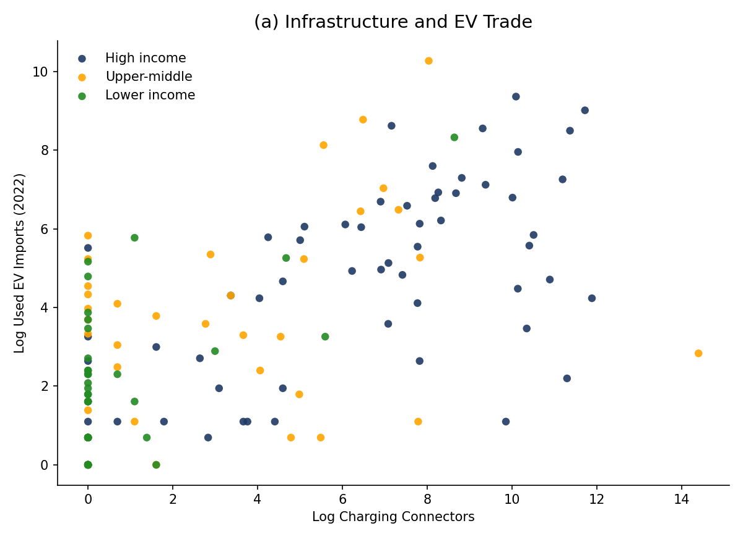
(b)
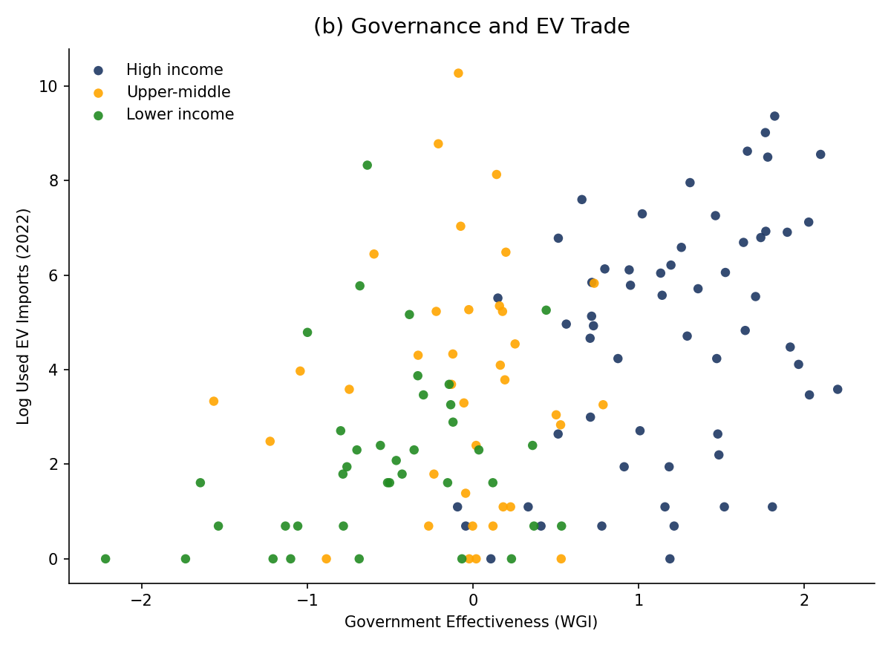
Supplementary Fig. 1 | Importer preparedness and used EV trade. Bivariate scatter plots of used-EV imports against two preparedness indicators, coloured by World Bank income group. (a) Publicly accessible EV connector stock in the importing economy. (b) World Governance Indicators composite (governance quality). Source: UNEP Used Vehicles Database; authors’ calculations.

(a)
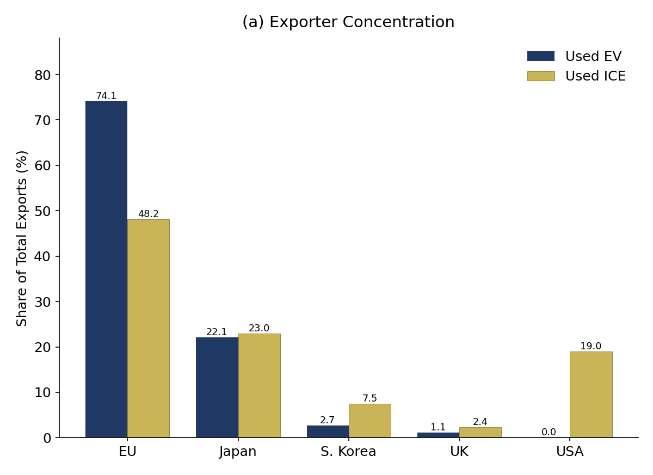
(b)
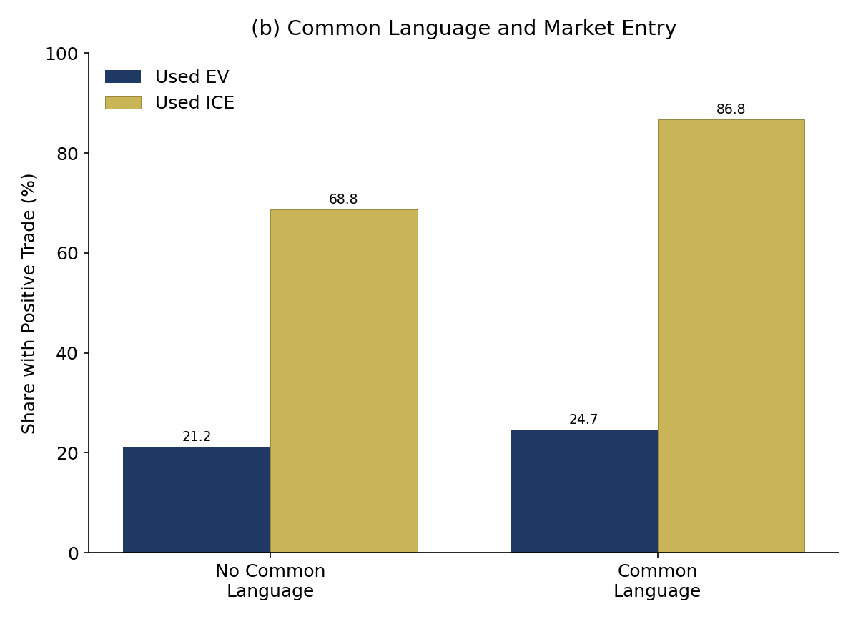
Supplementary Fig. 2 | Structural difference between used EV and used ICE exports. (a) Exporter concentration. Used EV exports are dominated by the EU, followed by Japan. (b) Share of country pairs reporting positive used EV trade, by common-language status. The market-entry rate is higher among country pairs sharing a common language (24.7%) than among pairs without a common language (21.2%). This panel shows the raw, unconditional market-entry gap; the large common-language effect reported in the main text (a coefficient of 4.612 in Supplementary Table 2) is the fixed-effects-adjusted regression estimate, which conditions on importer, exporter-year and region-year effects and is therefore far larger than the descriptive difference shown here. Source data are from the UNEP Used Vehicles Database; calculations by the authors.

(a)
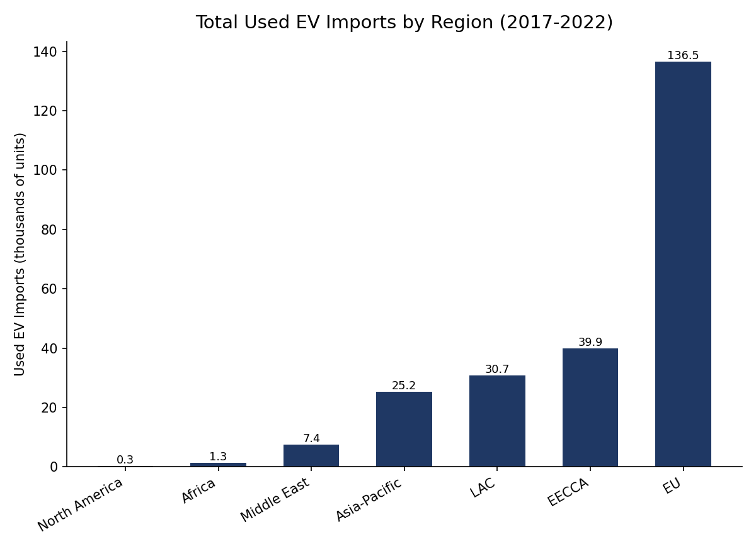
(b)
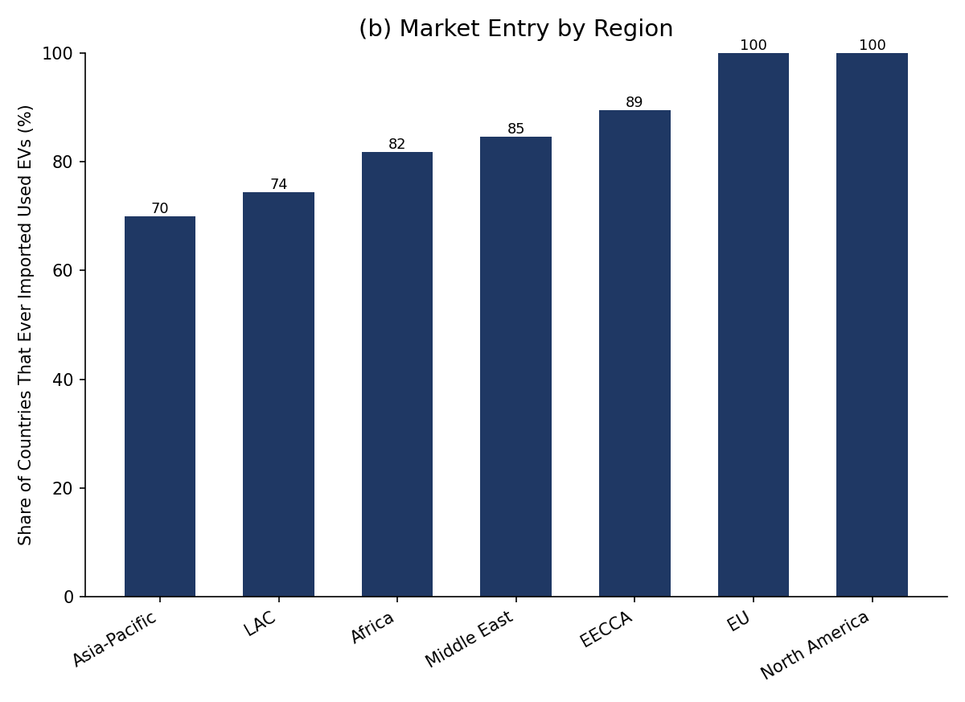
Supplementary Fig. 3 | Regional variation in used EV trade. (a) Volume of used-EV imports by UNEP importer region. (b) Extensive margin—share of importing countries in each UNEP region that ever recorded positive used-EV imports during 2017–2022. Source: UNEP Used Vehicles Database; authors’ calculations.

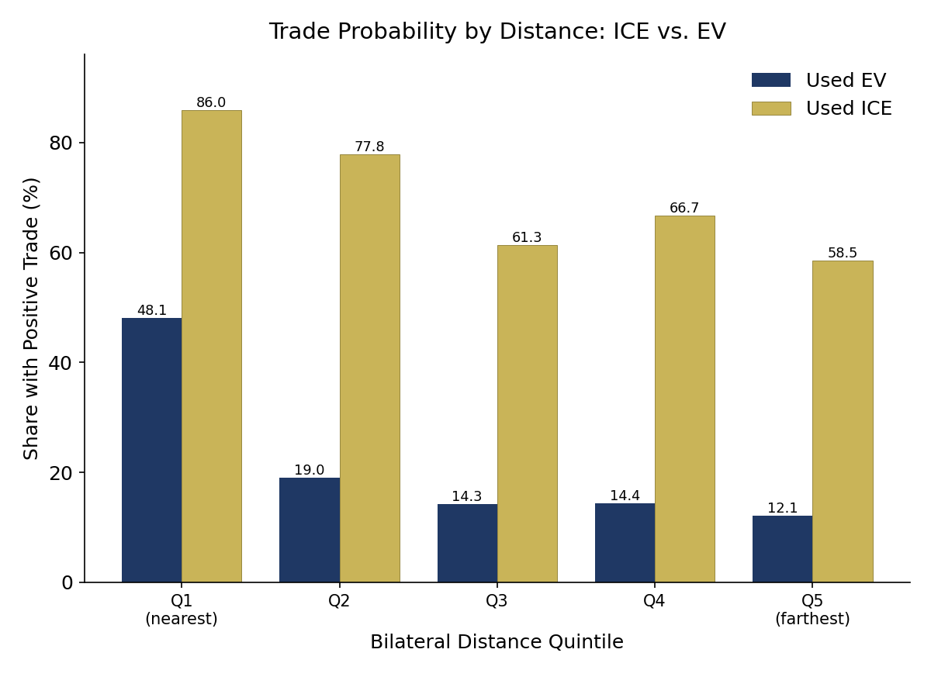
Supplementary Fig. 4 | Distance decay of used EV trade. Used EV and used ICE extensive-margin trade rates by quintile of great-circle distance between importer and exporter. Distance decay is sharper for EVs than for ICE used vehicles. Source: UNEP Used Vehicles Database; authors’ calculations.

Part V | Supplementary Notes

Supplementary Note 1 | Data construction and quality controls
The empirical analysis uses the UNEP Used Vehicles Database, a bilateral panel of country-pair vehicle trade flows constructed from harmonized customs records covering 2015–2022, with used EV trade reported from 2017 onward. The raw dataset contains 7,696 importer–exporter–year observations spanning 208 importing economies and five principal exporting economies (European Union member states aggregated, Japan, South Korea, the United Kingdom, and the United States).
Several data-processing steps were undertaken to construct the estimation sample used in the regression analyses. First, observations in which the importing economy was also one of the five principal exporters were excluded (1,147 observations: 37 each for the United States, Japan, South Korea and the United Kingdom as importers, and 999 for the 27 EU member states), because internal re-exports within the exporter bloc are not the object of theoretical interest and would otherwise inflate extensive-margin rates. Second, 63 observations in the raw panel showed reported used EV trade exceeding total used-vehicle trade; 48 of these remain after the exporter-as-importer exclusions and—a logical impossibility attributable to transcription error —were adjusted by setting used EV trade equal to total used-vehicle trade. Third, observations with missing or malformed ISO3 country codes were harmonized to ISO 3166-1 alpha-3 codes using the manual crosswalk documented in Supplementary Table 8. Fourth, importer-year observations lacking BloombergNEF charging-infrastructure data were assigned a value of zero in accordance with BloombergNEF reporting conventions. Sensitivity analyses examining this treatment are reported in Supplementary Methods 4.
The resulting estimation sample contains 6,549 observations.
Data sources
The analysis combines data from the following sources:
- Used-vehicle and used EV trade flows: UNEP Used Vehicles Database (2015–2022; version dated 20 September 2024).
- Importer regulatory categories: UNEP Used Vehicles Regulatory Ranking (2021 release).
- Charging infrastructure: BloombergNEF Global Public Charging Infrastructure Dashboard (15 January 2026 release).
- GDP per capita, population, electricity access, and fossil-fuel electricity share: World Bank World Development Indicators (2015–2023 extract).
- Government effectiveness: Worldwide Governance Indicators (2025 release).
- CO₂ emissions per capita: Global Carbon Budget data compiled by Our World in Data.
- Bilateral distance, contiguity, common language, and colonial ties: CEPII GeoDist database.
All public datasets are available from their respective providers.

Supplementary Note 2 | Qualitative interview methodology
The qualitative component of this study consisted of 49 in-depth semi-structured interviews conducted between 21 June 2024 and 15 August 2025. Interview participants were selected using a purposive sampling strategy designed to capture a diverse range of perspectives on the international trade in used electric vehicles. Initial participants were identified through targeted searches for stakeholders relevant to used EV markets, trade, regulation, infrastructure, and related policies using Google, Google Scholar, LinkedIn, organization websites, and relevant reports. Additional participants were recruited through snowball sampling, whereby interviewees recommended other individuals with relevant experience (Noy, 2008). Interview recruitment proceeded iteratively, with participant selection informed by emerging findings and identified gaps in stakeholder representation.
All interviews were conducted remotely via Zoom or Microsoft Teams. Interviews were conducted by at least one member of the author team using a semi-structured interview guide (Supplementary Note 3). While a common set of core questions was used across interviews, follow-up questions were adapted to respondents’ expertise, organizational affiliations, and geographic contexts. A trained research assistant assisted with participant recruitment, attended a subset of interviews, and conducted transcript coding under the supervision of both members of the author team.
Interviewees represented a broad range of stakeholder groups relevant to the used EV trade, including local and national government agencies, non-governmental organizations, international and regional civil society organizations, academic institutions, industry associations, and private-sector actors (Supplementary Table 20). Participants also represented a diverse set of geographic contexts, including Australia, Brazil, Ethiopia, Europe, Fiji, Japan, Kenya, Mexico, Mongolia, New Zealand, Nigeria, Tanzania, Tunisia, the United States, Zambia, and International (representing more than one country) (Supplementary Table 21). This diversity allowed the study to capture points of view from both leading and emerging vehicle-exporting and vehicle-importing regions, as well as related organizational perspectives.
Interviews were conducted until both code saturation and meaning saturation were achieved (Hennink et al., 2017). Saturation was assessed continuously throughout the data collection process, with later interviews yielding fewer novel codes and limited additional insights on existing themes. All interviews were audio-recorded with participant consent, transcribed, and reviewed for accuracy prior to analysis.
Interview transcripts were imported into NVivo 15 and analyzed using an inductive thematic analysis approach (Braun and Clarke, 2006). Initial coding was conducted iteratively by a trained research assistant, with ongoing review, revision, and further iterations by a member of the author team. Preliminary codes were developed from early interviews and continuously refined as additional transcripts were analyzed. Rather than applying a predetermined coding framework, themes were allowed to emerge from recurring patterns and concepts identified within the interview data. New codes and subthemes were added as they emerged, while existing codes were revised to improve conceptual clarity and analytical rigor.
To further improve analytical rigor, coding decisions and theme development were discussed by the research team throughout the analysis process. Discrepancies and ambiguities were resolved through iterative examinations of the interview data, resulting in a shared coding framework that was applied across the dataset.
The coding process resulted in 43 preliminary first-order themes. Theme occurrence ranged from three interviews to forty-one interviews. Nine themes also contained one or more subthemes, ranging from one to eighteen subthemes. Through rounds of review and revision, related themes were grouped into broader analytical categories, the latter of which inform the final structure of the Results section.
All participants provided informed consent prior to participation. To preserve confidentiality, interviewees are identified by stakeholder category and general organizational type rather than by name or institution. Preliminary findings were also shared with selected participants to verify interpretation analytical rigor. Additional information on interview participants, coding procedures, and the interview protocol is provided in Supplementary Note 3 and Supplementary Tables 20 and 21.
This study received ethics approval from Tufts University (STUDY00004745).
Supplementary Table 20 | Interviewees by Industry Type
Industry Type | Quantity
Academia | 14
Government | 6
International/Regional Organization | 13
Nongovernmental Organization | 4
Private Sector | 12
Total | 49

Supplementary Table 21 | Interviewees by Country/Region of Focus
Country/Region of Focus | Quantity
Australia | 1
Brazil | 1
Ethiopia | 1
Europe | 1
Fiji | 1
International | 11
Japan | 1
Kenya | 4
Mexico | 3
Mongolia | 5
New Zealand | 12
Nigeria | 1
Tanzania | 1
Tunisia | 2
United States | 2
Zambia | 2
Total | 49

Enabling Conditions for the International Trade in Used Electric Vehicles:
Semi-Structured Interview Guide

[Note: This guide represents anticipated core questions for interviews. As this is an in-depth semi-structured interview, specific questions may vary. However, all questions will relate to the major themes outlined in the below guide.]

For this research, we’re interested in learning more about the enabling conditions related to the importation of used electric vehicles—including battery electric vehicles and hybrid vehicles—in [country name(s).] Given your experience with this sector, we’d appreciate the opportunity to hear your thoughts on this subject.

This interview is organized into several main sections: First, we’ll ask you a couple of introductory questions about yourself. Then, we’ll ask some general questions about the major enabling conditions related to used EV imports in [country name(s)], after which we’ll hone in on a handful of specific aspects: economic viability, infrastructure, trade and logistics, governance and legitimacy, and bilateral networks. After that, we’ll turn to end-of-life considerations for used EVs, and we’ll close with your vision for the future of the international used EV trade. If that sounds good to you, we’ll begin.
- Introduction

  - To start out, can you please tell me your name, the name of your organization, and your position in your organization?
  - Has [name of position] always been your role at [name of organization]?
  - How long have you worked in this industry?
  - How does your work, or your organization’s work, relate to the world of used electric vehicles in [country name(s)]?

- Enabling Conditions (General)

  - What do you think are the conditions that enable the [import/export] of used EVs in [country name(s)]?
  - How about the conditions that constrain the [import/export] of used EVs in [country name(s)]?
  - Which of these conditions do you think is most important?
  - Do you think these conditions are different for used hybrid EVs vs. plug-in EVs?
  - Do you think the used EV trade is similar to or different from the used ICE trade in [country name(s)]? Why?
  - Are any of these conditions changing over time? How?

- Economic Viability

  - How would you describe the affordability of a used EV for a buyer in [country name(s)]
  - What are the most important cost considerations for a used EV buyer in [country name(s)]?
  - Who in [country name(s)] is most likely to buy a used EV (e.g. income level, urban/rural, regional differences, etc.)? Who would be least likely?
  - Do you think fiscal incentives, such as subsidies, relate to the used EV trade? Why or why not?
  - Do you think non-fiscal incentives, such as priority use in bus lanes, relate to the used EV trade? Why or why not?
  - Do you think the relative cost of gasoline v. electricity relates to the used EV trade? Why or why not?

- Infrastructure

  - How does the availability and placement of charging infrastructure relate to the used EV trade in [country name(s)]?
  - How does transportation infrastructure more generally relate to the used EV trade in [country name(s)]?
  - Are there other key infrastructure considerations that relate to the used EV trade in [country name(s)]?

- Trade and Logistics

  - Do you think [country name(s)]’s existing trade relationships for used ICE vehicles have influenced its used EV trade? Why or why not?
  - What key similarities or differences do you see between trade and logistics for used EVs in relation to used ICEs?
  - How do import or export regulations on used EVs relate to the used EV trade in [country name(s)]?
  - Do you think [country name(s)]’s proximity to [major used EV exporting country] might relate to the trend in used EV imports? Why or why not?

- Governance and Legitimacy

  - How would you describe the quality of regulatory frameworks and institutions relevant to the used EV trade in [country name(s)]?
  - Could you identify specific policies that promote or hinder the international trade in used EVs?
  - How would you describe the perceived legitimacy of used EVs in [country name(s)], and what factors contribute to that?

- Bilateral Networks

  - What types of networks connect buyers and sellers in the international used EV trade in [country name(s)]?
  - How significant are these relationships for facilitating the used EV trade?
  - Are there situations in which these relationships act as constraints on the used EV trade? Why or why not?
  - How were these networks established, and how have they changed over time?

- End-of-Life Considerations

  - Next, we’re interested in learning a little more about the end-of-life aspect and used EV imports. Do you see this end-of-life aspect as either a driver or barrier for used EV trade in [country name]? Why?
  - Is the government or other actors in [country name] currently doing anything to address what happens to used EVs when they die?
  - What do you think should happen with used EVs in [country name] once they’ve reached their end of life?

- Future

  - Overall, do you see used EV imports as a positive or negative trend for [country name]? Why?
  - What would you like the world of EVs, and vehicles more generally, in [country name] to look like in ten years?
  - Is there anything else you’d like to add about used EV imports that we haven’t discussed?
  - Is there anyone else you’d recommend we contact for this research project?

Thank you for your time.

