Additional files

Table 1. Analysis by items (n=404)

Item | Question | Pre-online training correct answers n (%) | Post-online training correct answers n (%) | Absolute increase (%)
p1 | What is the main reason why each country should adapt the concept of pharmacovigilance to fit its national health system? | 298 (73.3%) | 389 (95.8%) | 22.5% ***
p2 | What is the main lesson we learned from the thalidomide tragedy? | 232 (57.1%) | 361 (88.9%) | 31.8% ***
p3 | What characterizes case-by-case assessment in pharmacovigilance? | 188 (46.3%) | 372 (91.6%) | 45.3%
p4 | What is the sequence of steps in pharmacovigilance case analysis for older adults? | 259 (63.7%) | 390 (96%) | 46.3% *
p5 | What is the first step in reviewing a report of a suspected adverse drug reaction? | 192 (47.2%) | 380 (93.5%) | 46.3%
p6 | Which stage of case-by-case analysis in older adults is primarily based on medical best practice? | 111 (27.3%) | 278 (68.4%) | 41.1% ***
p7 | Is the following statement true or false? “To identify signals based on event frequency, it is necessary to include all notifications in the database, even if some of them are missing information.” | 273 (67.2%) | 373 (91.8%) | 24.6% *
p8 | What type of report describes a situation related to prescribing in which there was not necessarily a specific adverse event BUT which poses a potential risk and should therefore be reported? | 214 (52.7%) | 379 (93.3%) | 40.6%
p9 | Why is it important to have a clear objective when creating additional variables in a pharmacovigilance database for older adults? | 210 (51.7%) | 353 (86.9%) | 35.2%
p10 | Who should participate in the National Pharmacovigilance System? | 217 (53.4%) | 390 (96%) | 42.6%
p <0.001***; p <0.01 **; p<0.05*

Table 2. Sensitivity analysis with imputed results (n=406)

Variable | Pre-intervention mean (SD) | Post-intervention mean (SD) | Mean difference (SD)
Imputed with highest score | 5.3 (2.13) | 9.1 (1.0) | 3.7 (2.2)***
Imputed with lowest score | 5.3 (2.13) | 6.6 (3.5) | 1.3 (4.0)***
Imputed with LOCF | 5.3 (2.13) | 7.8 (2.11) | 2.4 (2.4)***
Imputed with mean score | 5.3 (2.13) | 8.7 (0.8) | 3.4 (2.1)***
p <0.001***; p <0.01 **; p<0.05*

Figure 1. Sensitivity analysis imputed with the highest score (score = 10)
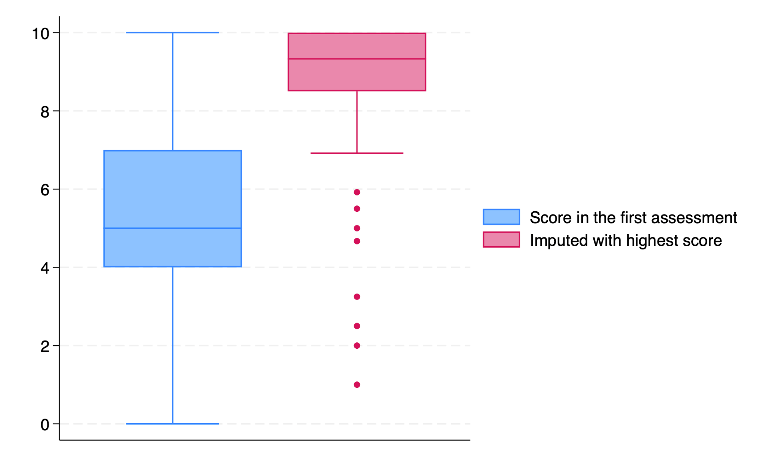

Figure 2. Sensitivity analysis imputed with the lowest score (score = 0)
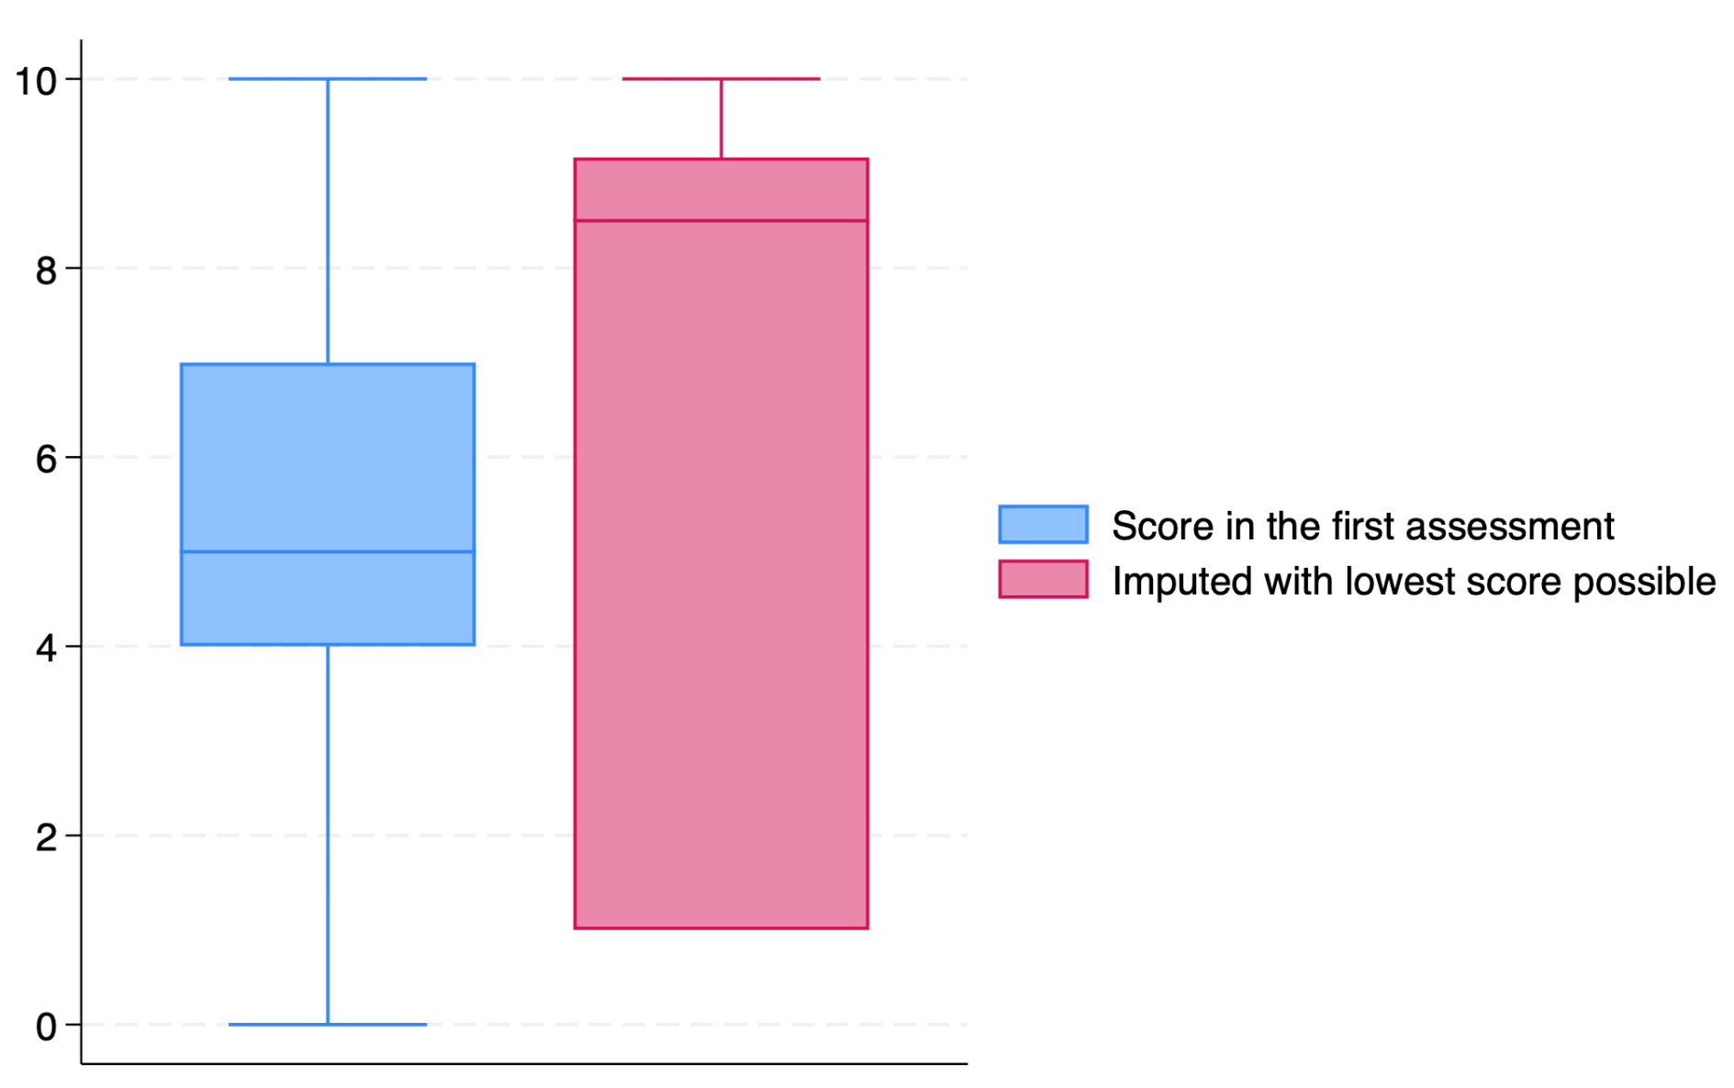

Figure 3. Sensitivity analysis imputed with the last observation carried forward
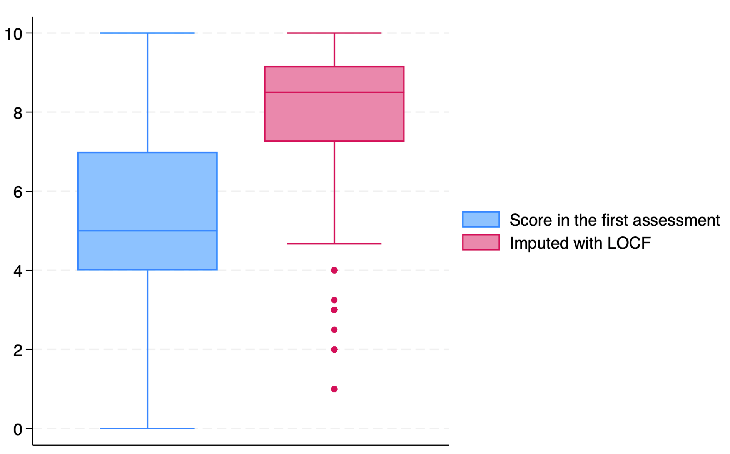
LOCF: last observation carried forward

Figure 4. Sensitivity analysis imputed with the mean-score
