Supplementary Information

Zhang H, Ward DF. Bee-plant interactions and network structure across land cover types in New Zealand.

Supplementary Information 1. Counts of genera for records with bee-plant interactions and geocoordinates; coloured by family.

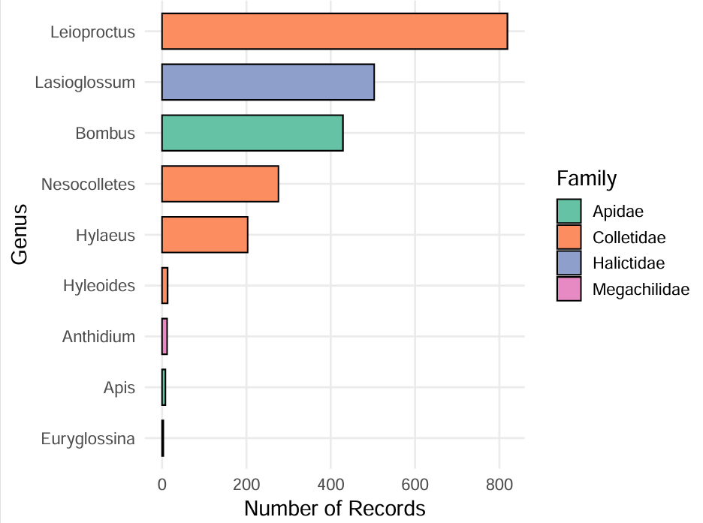

Supplementary Information 2. Examples of how plant names were extracted from free-text fields in the dataset (habitat, substrate et al.) and standardized to valid scientific names for analysis.
Field Source | Example Entry | Plant Name
habitat | ex wild carrot | Daucus carota
substrate | on flowering Kunzea ericoides | Kunzea ericoides

Supplementary Information 3. The number of interaction records for each plant family based on GBIF downloaded records. There are three columns in the table.
Plant family | Records | Plant family | Records | Plant family | Records
Myrtaceae | 372 | Polygonaceae | 13 | Aizoaceae | 2
Asteraceae | 272 | Rhamnaceae | 13 | Argophyllaceae | 2
Plantaginaceae | 246 | Hypericaceae | 12 | Caprifoliaceae | 2
Actinidiaceae | 216 | Lamiaceae | 10 | Cruciferae | 2
Ericaceae | 190 | Urticaceae | 10 | Cyperaceae | 2
Fabaceae | 168 | Rousseaceae | 9 | Grossulariaceae | 2
Nothofagaceae | 147 | Faboideae | 8 | Musaceae | 2
Cupressaceae | 112 | Boraginaceae | 7 | Podocarpaceae | 2
Rosaceae | 41 | Apiaceae | 6 | Polemoniaceae | 2
Compositae | 36 | Brassicaceae | 6 | Proteaceae | 2
Asphodelaceae | 32 | Campanulaceae | 6 | Rutaceae | 2
Asparagaceae | 29 | Caryophyllaceae | 6 | Asteliaceae | 1
Labiatae | 27 | Fagaceae | 6 | Berberidaceae | 1
Leguminosae | 26 | Loranthaceae | 6 | Buddlejaceae | 1
Salicaceae | 24 | Araliaceae | 5 | Gramineae | 1
Asteraceae | 22 | Araucariaceae | 5 | Hydrangeaceae | 1
Phrymaceae | 20 | Bignoniaceae | 5 | Lamiales | 1
Ranunculaceae | 19 | Iridaceae | 5 | Pennantiaceae | 1
Umbelliferae | 19 | Nymphaeaceae | 4 | Pinaceae | 1
Goodeniaceae | 18 | Onagraceae | 4 | Rubiaceae | 1
Gentianaceae | 14 | Lauraceae | 3 | Sapindaceae | 1
Poaceae | 14 | Oleaceae | 3 | Thymelaeaceae | 1
Malvaceae | 13 | Scrophulariaceae | 3 | Winteraceae | 1

Supplementary Information 4. Number of records for the top 9 plant families in the interaction dataset, the remaining families are combined into “Other”.

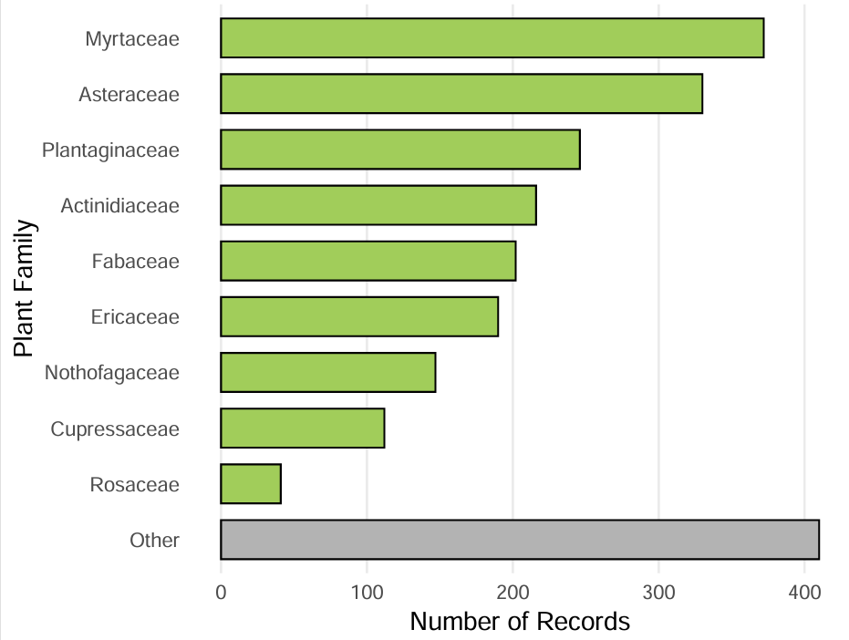

Supplementary Information 5. Geographic distribution across New Zealand of all occurrence records of bees. Each point represents a coordinate at which one or more records were collected. Insert is the Chatham Islands. Data from GBIF download [https://doi.org/10.15468/dl.q98yf3] and subsequently modified to incorporate georeferences.

