 |  | irAEs⁺ | irAEs⁻
 | n=37 | n=22 (59%) | n=15 (41%)
Age
Mean (sd) | 68.2 (13.8) | 66.5 (11.2) | 70.5 (17.1)
min - max | 40 - 90 | 45 - 82 | 40 - 90
Gender
Female | 14 (38%) | 9 (41%/irAEs⁺) (64%/women) | 5 (33%/irAE⁻)  (36%/women)
Male | 23 (62%) | 13 (59%/irAEs⁺)  (57%/men) | 10 (67%/ irAEs⁻)  (43%/men)
ICI Treatment
Nivolumab | 6 (16%) | 2 (9% /irAEs⁺) | 4 (27%/irAEs⁻)
Nivolumab + Ipilimumab | 31 (84%) | 20 (91%/irAEs⁺) | 11 (73%/irAEs⁻)
Melanoma stage
III | 12 (32%) | 5 (23%/irAEs⁺) | 7 (47%/irAEs⁻)
IV | 25 (68%) | 17 (77%/irAEs⁺) | 8 (53%/irAEs⁻)
Melanoma histology
Superficial Spreading Melanoma | 15 (40%) | 9 (41%/irAEs⁺) | 6 (40%/ irAEs⁻)
Nodular Melanoma | 9 (24%) | 4 (18%/irAEs⁺) | 5 (33%/irAEs⁻)
Acral Lentiginous Melanoma | 4 (11%) | 3 (14%/irAEs⁺) | 1 (7%/irAEs⁻)
Lentigo Maligna Melanoma | 1 (3%) | 1 (4.5%/irAEs⁺) | -
Malignant Lentiginous Melanoma | 1 (3%) | 1 (4.5%/irAEs⁺) | -
Undetermined | 7 (19%) | 4 (18%/irAEs⁺) | 3 (20%/irAEs⁻)
Type of toxicity*
Endocrine | 7 (32%/irAEs⁺)
Hepatic | 5 (23%/irAEs⁺)
Dermatologic | 5 (23%/irAES⁺)
Gastrointestinal | 3 (14%/irAEs⁺)
Cardiac/muscular | 2 (9%/irAEs⁺)
Renal failure | 2 (9%/irAEs⁺)
General disorders | 1 (4.5%/irAEs⁺)
Hematologic | 1 (4.5%/irAEs⁺)
Neurologic | 1 (4.5%/irAEs⁺)
Severity grade of first irAEs
1-2 | 17 (77%/irAEs⁺)
≥3 | 5 (23%/irAEs⁺)
Supplementary Table 1. PRED_1 patient characteristics

* Some patients exhibit different type of irAEs

Supplementary Table 2. PRED_2 patient characteristics

 |  | irAEs⁺ | irAEs⁻
 | n=25 | n=19 | n=6
Age
Mean (sd) | 65.3 (12.8) | 64 (12.9) | 69.5 (12)
min - max | 37 - 85 | 37 - 78 | 54 - 85
Type of toxicity*
Hepatic | 10 (53.6%/irAEs⁺)
Gastrointestinal | 5 (26.3%/irAEs⁺)
Dermatologic | 4 (21%/irAEs⁺)
Neurologic | 2 (10.5%/irAEs⁺)
Pancreatic | 1 (5.3%/irAEs⁺)
Renal failure | 1 (5.3%/irAEs⁺)
Severity grade of irAEs
1-2 | 4 (21%/irAEs⁺)
≥3 | 15 (79%/irAEs⁺)
* Some patients exhibit different type of irAEs

Supplementary Table 3. AMICI patient characteristics
 |  | irAEs⁺ | irAEs⁻
 | n=45 | n=31 (69%) | n=14 (31%)
Age
Mean (sd) | 66.88 (11.18) | 66.74 (11.28) | 67.21 (11.38)
min - max | 32 - 92 | 32 - 85 | 53 - 92
Gender
F | 11 (24.4%) | 6 (19.4%/irAEs⁺)  (54.5%/women) | 5 (35.7%/irAEs⁻)  (45.5%/women)
M | 34 (75.6%) | 25 (80.6%/ irAEs⁺)  (73.5%/men) | 9 (64.3%/ irAEs⁻)  (26.5%/men)
Cancer
Renal | 21 (46.7%) | 15 (48.4%/irAEs⁺) | 6 (42.8%/ irAEs⁻)
Lung | 15 (33.3%) | 11 (35.5%/ irAEs⁺) | 4 (28.6%/irAEs⁻)
Bladder | 4 (8.9%) | 4 (12.9%/ irAEs⁺) | -
Head and neck | 3 (6.7%) | 1 (3.2%/ irAEs⁺) | 2 (14.3%/irAEs⁻)
Gastrointestinal | 2 (4.4%) | - | 2 (14.3%/ irAEs⁻)
Treatment
PD1 | 6 (13%) | 3 (9.7%/irAEs⁺) | 3 (21.4%/irAEs⁻)
PD1+chemotherapy | 11 (24.4%) | 7 (22.6%/irAEs⁺) | 4 (28.6%/irAEs⁻)
PD1+CTLA4 | 4 (8.9%) | 4 (12.9%/irAEs⁺) | -
PD1+TKI | 16 (36%) | 10 (32.3%/irAEs⁺) | 6 (42.9%/irAEs⁻)
PDL1 | 6 (13.3%) | 6 (19.3%irAEs⁺) | -
PDL1+chemotherapy | 2 (4.4%) | 1 (3.2%/irAEs⁺) | 1 (7.1%/ irAEs⁻)
Type of toxicity*
Cardiac (clinical and subclinical symptoms) | 14 (45.2%/irAEs⁺)
Endocrine | 10 (32.2%/irAEs⁺)
Dermatologic | 3 (9.7%/irAEs⁺)
Pulmonary/respiratory | 3 (9.7%/irAEs⁺)
Gastro-intestinal | 2 (6.4%/irAEs⁺)
Hepatic | 2 (6.4%/irAEs⁺)
General disorders | 1 (3.2%/irAEs⁺)
Severity grade of irAEs
1-2 | 6 (19.3%/irAEs⁺)
≥3 | 11 (35.5%/irAEs⁺)
ND | 14 (45.2%/irAEs⁺)
* Some patients exhibit different type of irAEs
TKI: Tyrosine Kinase Inhibitor; ND: not determined

Supplementary Table 4. Panels of antibodies used for spectral flow cytometry
Panel 1 | Panel 2 | Panel 3 | Panel 4 | Panel 5
- | CD45 FITC | CD32 FITC | CXCR5 AF488 | LAG3 FITC
CD138 PE | CD80 PE | FcRL5 PE | CXCR4 PE | CD38 PE
CD95 PECF594 | CD11c PECF594 | CD11c PECF594 | CD11c PECF594 | CD11c PECF594
 |  |  | CCR7 PerCP-Cy5.5
- | - | - | - | CD24 PE AF610
- | CD40 PerCp eF710 | CD22 PerCp eF710 | CCR6 PerCp eF710 | PD-1 PerCp eF710
IgD PeCy7 | IgD PeCy7 | CD85j PeCy7 | CXCR3 PeCy7 | PD-L1 PeCy7
CD11c BV421 | HLA-DR BV421 | IgD BV421 | IgD BV421 | IgD BV421
CD19 V450 | CD19 V450 | CD19 V450 | CD19 V450 | CD19 V450
CD27 BV510 | CD27 BV510 | CD27 BV510 | CD27 BV510 | CD27 BV510
CD20 BV570 | CD20 BV570 | CD20 BV570 | CD20 BV570 | CD20 BV570
CD38 BV605 | CD38 BV605 | CD38 BV605 | CD38 BV605 | -
CD24 APC | CD24 APC | CD24 APC | CD24 APC | LAIR1 AF647
CD45 AF700 | CD86 AF700 | CD45 AF700 | CD45 AF700 | CD45 AF700
CD21 BV786 | CD21 BV786 | CD21 BV786 | CD21 BV786 | CD21 BV786
Live Dead Near IR/ CD3 APC-Cy7/ CD14 APC-Cy7 | Live Dead Near IR/ CD3 APC-Cy7/ CD14 APC-Cy7 | Live Dead Near IR/ CD3 APC-Cy7/ CD14 APC-Cy7 | Live Dead Near IR/ CD3 APC-Cy7/ CD14 APC-Cy7 | Live Dead Near IR/ CD3 APC-Cy7/ CD14 APC-Cy7
Highlighted in grey and italicized, the canonical markers of B-cell subsets [24]common to the five different panels (CD19, CD20, CD27, IgD, CD24, CD38, CD21 and CD11c)

Supplementary Table 5. List of reagents for flow cytometry, providers and identifiers

Reagent or resource | clone | source | Catalog Number (RRID)
Fcblock | - | BD | 564219 (RRID:AB_2728082)
LIVE/DEAD Fixable Near-IR Dead cell stain kit | - | Thermofisher | #L10119
anti-human CD3 APC-Cy7 | OKT3 | BioLegend | 317342  (RRID:AB_2563410)
anti-human CD11c BV421 | 3.9 | BD | 565806  (RRID:AB_2869718)
anti-human CD11c PE-CF594 | B-ly6 | BD | 562393 (RRID:AB_11153662)
Anti-human CD11c BUV395 | B-ly6 | BD | 563787  (RRID:AB_2744274)
anti-human CD14 APC-Cy7 | HCD14 | BioLegend | 325620  (RRID:AB_830693)
anti-human CD19 V450 | HIB19 | BD | 560353  (RRID:AB_1645564)
anti-human CD20 BV570 | 2H7 | BioLegend | 302332 (RRID:AB_2563805)
anti-human CD20 PE | 2H7 | BD | 555623  (RRID:AB_395989)
anti-human CD21 BV786 | B-ly4 | BD | 740969 (RRID:AB_2740594)
anti-human CD22 PerCP-eF710 | eBio4KB128 | eBioscience | 46-0229-42
anti-human CD24 APC | ML5 | BioLegend | 311117 (RRID:AB_1877150)
anti-human CD24 PE-AF610 | SN3 | Invitrogen | MHCD2422
anti-human CD27 BV510 | L128 | BD | 563092 (RRID:AB_2313577)
anti-human CD32 FITC | FLI8.26 | BD | 555448  (RRID:AB_395841)
anti-human CD38 BV605 | HB7 | BD | 562665 (RRID:AB_2313578)
anti-human CD38 PE | HB7 | eBioscience | 12-0388-42
anti-human CD40 PerCP-eF710 | 5C3 | eBioscience | 46-0409-42
anti-human CD45 FITC | J33 | Beckman Coulter | A07782 (RRID:AB_10645157)
anti-human CD45 RB705 | HI30 | BD | 757307 (RRID:AB_3689469)
Anti-human CD45 PerCP | 2D1 | BD | 345809 (RRID:AB_2868830)
anti-human CD45 AF700 | HI30 | BioLegend | 304024  (RRID:AB_493761)
anti-human CD80 PE | L307.4 | BD | 557227  (RRID:AB_396606)
anti-human CD85j PE-Cy7 | GHI/75 | BioLegend | 333712 (RRID:AB_2564606)
anti-human CD86 AF700 | 2331 | BD | 561124 (RRID:AB_10564087)
anti-human CD95 PE-CF594 | DX2 | BD | 562395 (RRID:AB_11153666)
anti-human CD138 PE | Mi15 | BD | 552026 (RRID:AB_394323)
anti-human IgD PE-Cy7 | IA6-2 | BD | 561314 (RRID:AB_10642457)
anti-human IgD BV421 | IA6-2 | BD | 562518 (RRID:AB_11153121)
anti-human IgA (Fab'2) AF488 | polyclonal | Jackson ImmunoResearch | 109-546-011 (RRID:AB_2337846)
anti-human IgG PE | IS11-3B2.2.3 | Miltenyi Biotec | 130-093-193 (RRID:AB_1036187)
anti-human HLA-DR BV421 | G46-6 | BD | 562805
anti-human FcRL5 PE | 509f6 | BioLegend | 340304 (RRID:AB_2104588)
anti-human CXCR3 (CD183) PE-Cy7 | 1C6/CXCR3 | BD | 560831 (RRID:AB_2033944)
anti-human CXCR4 (CD184) PE | 12G5 | BioLegend | 306506 (RRID:AB_314612)
anti-human CXCR5 (CD185) AF488 | RF8B2 | BD | 558112 (RRID:AB_397034)
anti-human CCR6 (CD196) PerCP-eF710 | R6H1 | eBioscience | 46-1969-42
anti-human CCR7 PerCP-Cy5.5 | G043H7 | BioLegend | 353219 (RRID:AB_10915275)
anti-human LAG3 FITC | polyclonal | R&D | FAB2319F (RRID:AB_2133352)
anti-human PD-1 PerCP-eF710 | eBioJ105 | eBioscience | 46-2799-42
anti-human PD-L1 PE-Cy7 | 29E.2A3 | BioLegend | 329718 (RRID:AB_2561687)
anti-human LAIR-1 AF647 | NKTA255 | BioLegend | 342802 (RRID:AB_2133480)
anti-human ZAP70 Phospho (Tyr319)/Syk Phospho (Tyr352) AF594 | 1503310 | BioLegend | 683714
Anti-human PLC-γ2 (pY759) AF647 | K86-689.37 | BD | 558498 (RRID:AB_647139)

Supplementary Table 6. Association of merged and unmerged clusters to metaclusters

Merged clusters | Corresponding clusters for each panel | B-cell subsets (metaclusters)
1 | P3_13, P5_09 | naive
2 | P1_12, P2_09, P4_03 | naive
3 | P1_04, P2_02, P4_04 | naive
4 | P1_03, P2_04, P5_07 | IgD⁺ memory
5 | P3_05, P4_08 | IgD⁺ memory
6 | P1_10, P2_08, P3_12, P5_14 | naive
7 | P3_04, P4_10 | IgD⁺ memory
8 | P1_02, P2_07, P3_03, P4_14 | IgD⁺ memory
9 | P1_14, P2_13, P3_11, P5_10 | naive
10 | P2_05, P3_01, P4_15 | IgD⁻ memory
11 | P1_06, P5_02 | IgD⁻ memory
12 | P1_08, P2_14, P3_06 | IgD⁻ memory
13 | P1_17, P3_10, P5_08 | IgD⁻ activated memory
14 | P1_05, P2_06, P3_18, P4_09, P5_16 | naive activated
15 | P3_16, P4_12 | double negative
16 | P1_15, P2_12, P3_19, P4_05 | undefined
17 | P2_20, P3_17, P4_17, P5_01 | double negative
18 | P1_16, P3_14, P4_01 | transitional
19 | P2_11, P3_07 | IgD⁻ memory
20 | P1_20, P2_18, P3_15, P4_16 | plasmablast
21 | P1_18, P2_19, P3_09, P4_18, P5_06 | pre-plasmablast
22 | P1_07, P2_01 | naive activated
23 | P3_20, P5_19 | naive activated
24 | P1_09, P2_10, P3_08, P5_17 | undefined
25 | P1_11, P2_03 | undefined
26 | P1_01, P2_15, P3_02, P4_20, P5_11, P5_15 | undefined
Unmerged cluster | - | B-cell subsets (metaclusters)
P1_13 | - | IgD⁻ memory
P1_19 | - | double negative
P2_16 | - | IgD⁻ activated memory
P2_17 | - | plasmablast
P4_02 | - | transitional
P4_06 | - | naive
P4_07 | - | naive
P4_11 | - | IgD⁻ activated memory
P4_13 | - | IgD⁺ memory
P4_19 | - | IgD⁻ memory
P5_03 | - | IgD⁻ memory
P5_04 | - | double negative
P5_05 | - | double negative
P5_12 | - | IgD⁺ memory
P5_13 | - | plasmablast
P5_18 | - | naive
P5_20 | - | IgD⁺ memory

Supplementary Table 7. Phenotypic characterization and frequencies of B-cell metaclusters

Metacluster | Phenotype | Before ICI  Median percentage  (%min -%max) | Post ICI  Median percentage  (%min -%max) | Toxicity  Median percentage  (%min -%max)
Transitional | CD19⁺ CD20⁺ IgD⁺ CD27⁻ CD24^{hi} CD38^{hi} CD21⁺ | 0.35 (0 - 2.59) | 0.49 (0 - 3.59) | 0.14 (0 - 2.08)
Naive | CD19⁺ CD20⁺ IgD⁺ CD27⁻ CD24⁺ CD38⁺ CD21⁺ | 72.11 (8.87 - 92.77) | 75.94 (8.12 - 91.50) | 69.81 (19.44 - 88.91)
Activated naive | CD19⁺ CD20⁺ IgD⁺ CD27⁻ CD24⁻ CD38⁻ CD21^{low} CD11c⁺ | 0.22 (0.04 - 17.51) | 0.35 (0.02 - 24.73) | 0.4 (0.10 - 1.93)
Double negative | CD19⁺ CD20⁺ IgD⁻ CD27⁻CD24⁻ CD38⁻ CD21^{low} CD11c⁺ | 0.24 (0.02 - 3.01) | 0.25 (0 - 3.34) | 0.32 (0.02 - 3.29)
IgD⁺ memory B | CD19⁺ CD20⁺ IgD⁺ CD27⁺ CD24^{high} CD38⁻ CD21⁺ | 8.66 (2.49 - 68.05) | 6.07 (1.78 - 66.59) | 8.95 (2.50 - 57.49)
IgD⁻ memory B | CD19⁺ CD20⁺ IgD⁻ CD27⁺ CD24^{high} CD38⁻ CD21⁺ | 10.73 (2.70 - 42.1) | 10.1 (1.49 - 42.46) | 11.78 (2.78 - 32.06)
Activated IgD⁻memory | CD19⁺ CD20⁺ IgD⁻ CD27⁺ CD24^{low/-} CD38⁻ CD21⁺ CD95⁺ | 2.08 (0.37 - 7.02) | 2.23 (0.18 - 9.11) | 2.1 (0.02 - 8.88)
Pre-plasmablasts | CD19⁺ CD20⁺ IgD⁻ CD27⁺ CD24⁻ CD38⁺ CD21⁺ | 0.32 (0.02 - 1.66) | 0.44 (0 - 1.83) | 0.25 (0.01 - 2.39)
Plasmablasts | CD19⁺ CD20⁻ IgD⁻ CD27⁺ CD24⁻ CD38^{high} CD21^{low} | 0.18 (0 - 1.8) | 0.39 (0 - 1.69) | 0.19 (0 - 2.04)

Supplementary Table 8. Statistical analysis of activation and inhibitory marker expression across B-cell metaclusters in PRED_1 cohort

CD95 | DN | IgD⁻AMB | IgD⁻MB | IgD⁺Mem | Naive | Naive activated | Plasmablast | Pre-plasmablast
IgD⁻AMB | 6.71x10⁻⁸
IgD⁻MB | 0.16 | 3.35x10⁻⁸
IgD⁺Mem | 1.68x10⁻⁷ | 3.35x10⁻⁸ | 3.35x10⁻⁸
Naive | 3.35x10⁻⁸ | 3.35x10⁻⁸ | 4.44x10⁻⁵ | 3.35x10⁻⁸
Naive activated | 0.11 | 3.35x10⁻⁸ | 1 | 0.0043 | 4.59x10⁻⁶
Plasmablast | 4.23x10⁻⁵ | 1 | 1.44x10⁻⁶ | 2.35x10⁻⁷ | 1.01x10⁻⁷ | 2.35x10⁻⁶
Pre-plasmablast | 3.35x10⁻⁸ | 1.11x10⁻⁶ | 3.35x10⁻⁸ | 3.35x10⁻⁸ | 3.35x10⁻⁸ | 3.35x10⁻⁸ | 3.35x10⁻⁷
Transitional | 3.35x10⁻⁸ | 3.35x10⁻⁸ | 4.90x10⁻⁵ | 5.83x10⁻⁵ | 0.0008 | 2.35x10⁻⁶ | 1.01x10⁻⁷ | 3.35x10⁻⁸
CD86 | DN | IgD⁻AMB | IgD⁻MB | IgD⁺Mem | Naive | Naive activated | Plasmablast | Pre-plasmablast
IgD⁻AMB | 0.014
IgD⁻MB | 3.69x10⁻⁶ | 0.1044
IgD⁺Mem | 1.01x10⁻⁷ | 3.03x10⁻⁵ | 0.0001
Naive | 3.35x10⁻⁸ | 4.44x10⁻⁵ | 4.69x10⁻⁷ | 0.0007
Naive activated | 0.0006 | 1 | 1 | 1 | 0.007
Plasmablast | 6.71x10⁻⁸ | 6.71x10⁻⁸ | 3.35x10⁻⁸ | 3.35x10⁻⁸ | 3.35x10⁻⁸ | 6.71x10⁻⁸
Pre-plasmablast | 0.6004 | 0.0001 | 1.11x10⁻⁶ | 6.71x10⁻⁸ | 3.35x10⁻⁸ | 0.0011 | 3.35x10⁻⁷
Transitional | 0.0002 | 3.03x10⁻⁵ | 0.0001 | 0.0022 | 1 | 0.0252 | 3.35x10⁻⁸ | 2.95x10⁻⁶
CD80 | DN | IgD⁻AMB | IgD⁻MB | IgD⁺Mem | Naive | Naive activated | Plasmablast | Pre-plasmablast
IgD⁻AMB | 4.97x10⁻⁵
IgD⁻MB | 6.82x10⁻⁵ | 3.35x10⁻⁸
IgD⁺Mem | 3.35x10⁻⁸ | 3.35x10⁻⁸ | 3.35x10⁻⁸
Naive | 3.35x10⁻⁸ | 3.35x10⁻⁸ | 3.35x10⁻⁸ | 0.0085
Naive activated | 9.27x10⁻⁵ | 5.83x10⁻⁵ | 0.1831 | 3.35x10⁻⁸ | 3.35x10⁻⁸
Plasmablast | 4.69x10⁻⁷ | 3.35x10⁻⁸ | 0.002 | 0.1710 | 0.0028 | 0.0571
Pre-plasmablast | 6.71x10⁻⁸ | 1.11x10⁻⁶ | 3.35x10⁻⁸ | 3.35x10⁻⁸ | 3.35x10⁻⁸ | 3.69x10⁻⁶ | 3.35x10⁻⁸
Transitional | 3.35x10⁻⁸ | 3.35x10⁻⁸ | 3.35x10⁻⁸ | 1 | 0.2551 | 4.44x10⁻⁵ | 0.0025 | 3.35x10⁻⁸
HLA-DR | DN | IgD⁻AMB | IgD⁻MB | IgD⁺Mem | Naive | Naive activated | Plasmablast | Pre-plasmablast
IgD⁻AMB | 4.97x10⁻⁵
IgD⁻MB | 0.0008 | 0.0901
IgD⁺Mem | 1.84x10⁻⁶ | 1 | 8.38x10⁻⁷
Naive | 0.5346 | 6.71x10⁻⁸ | 3.35x10⁻⁸ | 3.35x10⁻⁸
Naive activated | 1 | 0.0001 | 5.83x10⁻⁵ | 6.71x10⁻⁸ | 1
Plasmablast | 1 | 0.0618 | 0.3965 | 0.0113 | 1 | 1
Pre-plasmablast | 0.0901 | 4.69x10⁻⁷ | 8.38x10⁻⁷ | 2.35x10⁻⁷ | 1 | 1 | 1
Transitional | 1 | 4.59x10⁻⁶ | 7.96x10⁻⁵ | 3.35x10⁻⁸ | 1.11x10⁻⁶ | 0.3965 | 1 | 0.0002
CD32 | DN | IgD⁻AMB | IgD⁻MB | IgD⁺Mem | Naive | Naive activated | Plasmablast | Pre-plasmablast
IgD⁻AMB | 1.68x10⁻⁸
IgD⁻MB | 1.68x10⁻⁸ | 3.35x10⁻⁸
IgD⁺Mem | 8.38x10⁻⁸ | 1.68x10⁻⁸ | 1.68x10⁻⁸
Naive | 1.68x10⁻⁸ | 2.11x10⁻⁵ | 1.68x10⁻⁸ | 1.68x10⁻⁸
Naive activated | 1 | 1.68x10⁻⁸ | 1.68x10⁻⁸ | 4.19x10⁻⁷ | 1.68x10⁻⁸
Plasmablast | 1.68x10⁻⁸ | 1 | 2.49x10⁻⁵ | 1.68x10⁻⁸ | 1 | 1.68x10⁻⁸
Pre-plasmablast | 1.68x10⁻⁸ | 0.0923 | 1.68x10⁻⁸ | 1.68x10⁻⁸ | 1.84x10⁻⁶ | 1.68x10⁻⁸ | 0.0014
Transitional | 1.68x10⁻⁸ | 0.3362 | 1.68x10⁻⁸ | 1.68x10⁻⁸ | 0.0064 | 1.68x10⁻⁸ | 1 | 0.0301
CD85j | DN | IgD⁻AMB | IgD⁻MB | IgD⁺Mem | Naive | Naive activated | Plasmablast | Pre-plasmablast
IgD⁻AMB | 1.68x10⁻⁸
IgD⁻MB | 1.68x10⁻⁸ | 8.38x10⁻⁸
IgD⁺Mem | 1.68x10⁻⁸ | 5.30x10⁻⁵ | 0.5016
Naive | 1.68x10⁻⁸ | 1 | 5.03x10⁻⁸ | 1.68x10⁻⁸
Naive activated | 1 | 1.68x10⁻⁸ | 8.38x10⁻⁸ | 8.38x10⁻⁸ | 3.35x10⁻⁸
Plasmablast | 1.68x10⁻⁸ | 1 | 1.28x10⁻⁵ | 6.22x10⁻⁶ | 1 | 1.68x10⁻⁸
Pre-plasmablast | 4.64x10⁻⁵ | 1 | 0.0003 | 0.0024 | 1 | 4.64x10⁻⁵ | 1
Transitional | 1.68x10⁻⁸ | 1.68x10⁻⁸ | 1.68x10⁻⁸ | 3x10⁻⁵ | 3.35x10⁻⁸ | 1.68x10⁻⁸ | 0.0001 | 1.68x10⁻⁸
CD22 | DN | IgD⁻AMB | IgD⁻MB | IgD⁺Mem | Naive | Naive activated | Plasmablast | Pre-plasmablast
IgD⁻AMB | 3x10⁻⁵
IgD⁻MB | 1.68x10⁻⁸ | 0.007
IgD⁺Mem | 1.68x10⁻⁸ | 1 | 0.0044
Naive | 7.21x10⁻⁷ | 1.68x10⁻⁸ | 3x10⁻⁵ | 1.68x10⁻⁸
Naive activated | 1 | 1.68x10⁻⁸ | 1.68x10⁻⁸ | 1.68x10⁻⁸ | 9.22x10⁻⁷
Plasmablast | 1.68x10⁻⁸ | 1.68x10⁻⁸ | 1.68x10⁻⁸ | 1.68x10⁻⁸ | 1.68x10⁻⁸ | 1.68x10⁻⁸
Pre-plasmablast | 3.35x10⁻⁸ | 0.0301 | 1 | 0.2332 | 5.03x10⁻⁸ | 1.68x10⁻⁸ | 1.68x10⁻⁸
Transitional | 1.68x10⁻⁸ | 1.84x10⁻⁶ | 5.03x10⁻⁸ | 1.68x10⁻⁸ | 1.68x10⁻⁸ | 1.68x10⁻⁸ | 3.35x10⁻⁸ | 4.19x10⁻⁷
LAIR-1 | DN | IgD⁻AMB | IgD⁻MB | IgD⁺Mem | Naive | Naive activated | Plasmablast | Pre-plasmablast
IgD⁻AMB | 2.10x10⁻⁹
IgD⁻MB | 2.1x10⁻⁹ | 2.1x10⁻⁹
IgD⁺Mem | 1.05x10⁻⁸ | 9.31x10⁻⁶ | 0.0021
Naive | 4.26x10⁻⁶ | 2.1x10⁻⁹ | 2.1x10⁻⁹ | 2.1x10⁻⁹
Naive activated | 2.1x10⁻⁹ | 2.1x10⁻⁹ | 2.1x10⁻⁹ | 2.1x10⁻⁹ | 6.92x10⁻⁸
Plasmablast | 4.19x10⁻⁹ | 3.54x10⁻⁷ | 0.0213 | 0.0064 | 2.1x10⁻⁹ | 2.1x10⁻⁹
Pre-plasmablast | 2.1x10⁻⁹ | 0.203 | 2.1x10⁻⁹ | 2.1x10⁻⁹ | 2.1x10⁻⁹ | 2.1x10⁻⁹ | 0.0002
Transitional | 3.11x10⁻⁶ | 9.31x10⁻⁶ | 2.1x10⁻⁹ | 2.1x10⁻⁹ | 0.1218 | 2.242x10⁻⁶ | 2.1x10⁻⁹ | 2.1x10⁻⁹
P-values from two-tailed Wilcoxon signed-rank tests comparing marker expression across defined B-cell metaclusters. P-values were adjusted for multiple comparisons using Bonferroni correction. Statistically significant values (adjusted p < 0.05) are highlighted in yellow. Corresponding data are visualized as violin plots in Fig. 3A.

Supplementary Table 9. Anti-nuclear antibody (ANA) status in irAEs⁺ and irAEs⁻ patients from PRED_1 cohort
 | Patients assessed (n) | ANA positive n (%) | Clinically significant* ANA n (%) | Nuclear (Speckled) | Nuclear (Homogenous) | Nuclear (Nucleolar) | Nuclear (Centromere) | Cytoplasmic | Mixed nuclear/cytoplasmic | Negative
irAE⁻
T1 | 14 | 11 (79) | 8 (57) | 6 | 1 | - | - | 2 | 2 | 3
T2 | 13 | 9 (69) | 7 (54) | 4 | - | 1 | - | 2 | 2 | 4
irAE⁺
T1 | 12 | 9 (75) | 7 (58) | 4 | 1 | 2 | - | 2 | - | 3
T2 | 13 | 9 (69) | 8 (62) | 3 | 1 | 2 | 1 | 2 | - | 4
Tox | 13 | 9 (69) | 7 (54) | 5 | 1 | 1 | 1 | 1 | - | 4

* Patients were considered ANA-positive for titers ≥1:80, and clinically significant ANAs were defined as titers ≥1:160.

Supplementary Table 10. Statistical analysis of activation and inhibitory marker expression across B-cell metaclusters in irAES⁺ and irAEs⁻ patients from PRED_1 cohort

CD95 | MFI median irAEs⁻ T1 | MFI median irAE⁺ T1 | p value T1 | MFI median irAEs⁻ T2 | MFI median irAE⁺ T2 | p value T2
IgD⁻MB | 5224 | 5491 | 0.587 | 5685 | 6638 | 0.628
IgD⁻AMB | 22119 | 21721 | 0.61 | 24471 | 24395 | 0.823
Pre-plasmablast | 35221 | 33561.5 | 0.521 | 33447 | 36105.5 | 0.599
Plasmablast | 17449.5 | 21671 | 0.872 | 20953 | 24390 | 0.0192
Transitional | 201 | 409 | 0.873 | 137 | 253 | 0.624
Naive | 985 | 917 | 0.894 | 1255 | 1217 | 0.852
IgD⁺Mem | 2066 | 2006 | 0.934 | 1965 | 2094 | 0.941
Double negative | 6746 | 6892.5 | 0.831 | 7962 | 8602.5 | 0.275
Naive activated | 3608 | 6329 | 0.023 | 4419 | 4597 | 0.71
CD86 | MFI median irAEs⁻ T1 | MFI median irAE⁺ T1 | p value T1 | MFI median irAEs⁻ T2 | MFI median irAE⁺ T2 | p value T2
IgD⁻MB | 2181 | 1738 | 0.0989 | 2162 | 1948 | 0.433
IgD⁻AMB | 2255 | 1989 | 0.364 | 2419 | 2541 | 0.97
Pre-plasmablast | 3854 | 3038.5 | 0.166 | 3543 | 3308.5 | 0.951
Plasmablast | 8018 | 6721 | 0.254 | 5420.5 | 7173 | 0.423
Transitional | 1642 | 761.5 | 0.0926 | 1583 | 1060 | 0.295
Naive | 1364 | 944.5 | 0.419 | 1303 | 1172 | 0.497
IgD⁺Mem | 1751 | 1494.5 | 0.24 | 1887 | 1675 | 0.88
Double negative | 2913.5 | 2650 | 0.478 | 2500 | 3313.5 | 0.156
Naive activated | 2017 | 1643 | 0.537 | 1635 | 2029.5 | 0.329
CD80 | MFI median irAEs⁻ T1 | MFI median irAE⁺ T1 | p value T1 | MFI median irAEs⁻ T2 | MFI median irAE⁺ T2 | p value T2
IgD⁻MB | 3306 | 3131.5 | 0.987 | 3190 | 3514 | 0.576
IgD⁻AMB | 7399 | 7027 | 0.882 | 7016 | 7109 | 0.97
Pre-plasmablast | 9124 | 9267.5 | 0.735 | 8465 | 9752 | 0.12
Plasmablast | 1960 | 1495 | 0.479 | 1731.5 | 1851.5 | 0.79
Transitional | 537 | 789.5 | 0.283 | 520 | 729 | 0.558
Naive | 326 | 468 | 0.264 | 562 | 578 | 0.71
IgD⁺Mem | 799 | 804 | 0.805 | 746 | 793 | 0.261
Double negative | 4433 | 4170.5 | 0.796 | 3935 | 5406.5 | 0.0755
Naive activated | 2407 | 2510 | 1 | 1788 | 2841 | 0.503
HLA-DR | MFI median irAEs⁻ T1 | MFI median irAE⁺ T1 | p value T1 | MFI median irAEs⁻ T2 | MFI median irAE⁺ T2 | p value T2
IgD⁻MB | 161942 | 169712 | 0.987 | 192055 | 171138 | 0.502
IgD⁻AMB | 147533 | 158902 | 0.364 | 150884 | 138979 | 0.852
Pre-plasmablast | 289915 | 256305 | 0.202 | 339302 | 305939 | 0.552
Plasmablast | 302367 | 242798.5 | 0.33 | 20648.5 | 226401 | 0.79
Transitional | 200042 | 193432 | 0.4 | 223294 | 204750 | 0.278
Naive | 266678 | 249929 | 0.633 | 316141 | 301435 | 0.794
IgD⁺Mem | 137732 | 140212.5 | 0.934 | 144006 | 140447 | 0.941
Double negative | 248422 | 228670.5 | 0.377 | 250169 | 215286 | 0.184
Naive activated | 245758 | 220001 | 0.811 | 207645 | 210541 | 0.779
CD32 | MFI median irAEs⁻ T1 | MFI median irAE⁺ T1 | p value T1 | MFI median irAEs⁻ T2 | MFI median irAE⁺ T2 | p value T2
IgD⁻MB | 24697 | 20197.5 | 0.00845 | 24277 | 20840 | 0.0244
IgD⁻AMB | 10672 | 11174.5 | 0.755 | 9579 | 12476 | 0.576
Pre-plasmablast | 9124 | 6701 | 0.00999 | 9820 | 9464 | 0.576
Plasmablast | 17567 | 12278 | 0.0522 | 17413.5 | 12995 | 0.161
Transitional | 13823 | 13610 | 0.391 | 15028.5 | 12042.5 | 0.166
Naive | 17898 | 15884 | 0.0689 | 16811 | 14950 | 0.0637
IgD⁺Mem | 35506 | 30847.5 | 0.00489 | 33861 | 31087 | 0.0244
Double negative | 61895 | 50088 | 0.00142 | 57252.5 | 52349 | 0.11
Naive activated | 66739 | 55277 | 0.0638 | 58498 | 50219 | 0.336
FcRL5 | MFI median irAEs⁻ T1 | MFI median irAE⁺ T1 | p value T1 | MFI median irAEs⁻ T2 | MFI median irAE⁺ T2 | p value T2
IgD⁻MB | 612 | 727 | 0.294 | 568 | 726 | 0.0637
IgD⁻AMB | 613 | 805 | 0.0743 | 445 | 852 | 0.0894
Pre-plasmablast | 1981 | 2566 | 0.391 | 2296 | 3527 | 0.0583
Plasmablast | 1022 | 540.5 | 0.532 | 571 | 796 | 0.356
Transitional | 668 | 1173 | 0.395 | 627 | 1141 | 0.11
Naive | 231 | 658.5 | 0.149 | 266 | 724 | 0.0823
IgD⁺Mem | 580 | 504.5 | 0.542 | 398 | 679 | 0.123
Double negative | 6410 | 5208.5 | 0.33 | 4814.5 | 7132 | 0.313
Naive activated | 2929 | 3984 | 0.934 | 3435.5 | 4642 | 0.246
CD85j | MFI median irAEs⁻ T1 | MFI median irAE⁺ T1 | p value T1 | MFI median irAEs⁻ T2 | MFI median irAE⁺ T2 | p value T2
IgD⁻MB | 13062 | 11165.5 | 0.4 | 11521 | 11897 | 0.941
IgD⁻AMB | 9160 | 9166 | 0.908 | 8372 | 9055 | 0.655
Pre-plasmablast | 10103 | 8088 | 0.104 | 11408 | 10200 | 0.882
Plasmablast | 9847 | 8360 | 0.464 | 9396.5 | 10993 | 0.468
Transitional | 4581 | 4959 | 0.891 | 4628.5 | 3496.5 | 0.552
Naive | 9465 | 8372 | 0.227 | 9024 | 9135 | 0.852
IgD⁺Mem | 13488 | 12053 | 0.227 | 11329 | 11809 | 0.97
Double negative | 29062 | 22837.5 | 0.08 | 26745 | 28130 | 0.423
Naive activated | 28300 | 23228.5 | 0.122 | 24841.5 | 23717 | 0.984
CD22 | MFI median irAEs⁻ T1 | MFI median irAE⁺ T1 | p value T1 | MFI median irAEs⁻ T2 | MFI median irAE⁺ T2 | p value T2
IgD⁻MB | 22166 | 22768.5 | 0.657 | 22860 | 24028 | 0.23
IgD⁻AMB | 19491 | 20021 | 0.831 | 19880 | 20200 | 0.71
Pre-plasmablast | 22717 | 25638 | 0.179 | 20906 | 22576 | 0.132
Plasmablast | 1341 | 1213.5 | 0.929 | 1556 | 1334 | 0.648
Transitional | 10524 | 10248 | 0.784 | 11193.5 | 10590 | 0.525
Naive | 32894 | 34910.5 | 0.587 | 35910 | 36642 | 0.823
IgD⁺Mem | 20671 | 19842 | 0.831 | 18488 | 22081 | 0.0442
Double negative | 67741 | 64289.5 | 0.268 | 60062 | 70489.5 | 0.498
Naive activated | 64069 | 53554 | 0.61 | 60571.5 | 65272 | 0.173
CXCR5 | MFI median irAEs⁻ T1 | MFI median irAE⁺ T1 | p value T1 | MFI median irAEs⁻ T2 | MFI median irAE⁺ T2 | p value T2
IgD⁻MB | 27399 | 30728 | 0.882 | 29978 | 27522 | 0.97
IgD⁻AMB | 29911 | 30315 | 0.755 | 29001 | 27572 | 0.911
Pre-plasmablast | 16075 | 16506.5 | 0.987 | 14079 | 15217,5 | 0.423
Plasmablast | 706 | 1057 | 0.657 | 679 | 786 | 0.97
Transitional | 25185 | 20523.5 | 0.158 | 19537 | 21253 | 0.576
Naive | 41460 | 41504 | 0.78 | 39779 | 38738 | 0.852
IgD⁺Mem | 26014 | 29588.5 | 0.755 | 23949 | 26482 | 1
Double negative | 5265 | 7119 | 0.227 | 5366.5 | 7238 | 0.109
Naive activated | 5019 | 4614 | 0.864 | 5326.5 | 5643 | 0.377
CXCR4 | MFI median irAEs⁻ T1 | MFI median irAE⁺ T1 | p value T1 | MFI median irAEs⁻ T2 | MFI median irAE⁺ T2 | p value T2
IgD⁻MB | 25467 | 25375 | 0.499 | 22091 | 28005 | 0.576
IgD⁻AMB | 19482 | 18157.5 | 0.755 | 18965 | 22389 | 0.526
Pre-plasmablast | 8238 | 8260 | 0.78 | 8971 | 9881.5 | 1
Plasmablast | 6320 | 7085 | 0.268 | 6374 | 5860 | 0.576
Transitional | 27494 | 34145 | 0.587 | 34590 | 33996 | 0.941
Naive | 56905 | 63437 | 0.755 | 54267 | 64011 | 0.882
IgD⁺Mem | 36079 | 35524.5 | 0.521 | 28975 | 40424 | 0.71
Double negative | 10267 | 10122.5 | 0.605 | 9680 | 11370 | 0.149
Naive activated | 10080 | 9751 | 0.451 | 9113 | 11343.5 | 0.667
LAIR1-1 | MFI median irAEs⁻ T1 | MFI median irAE⁺ T1 | p value T1 | MFI median irAEs⁻ T2 | MFI median irAE⁺ T2 | p value T2
IgD⁻MB | 11428 | 10594 | 0.268 | 11301 | 10395 | 0.655
IgD⁻AMB | 1749 | 1923 | 0.657 | 1511 | 1124 | 0.882
Pre-plasmablast | 2223 | 2680.5 | 0.33 | 2681 | 2678 | 0.823
Plasmablast | 7502 | 5944 | 0.08 | 8261 | 6507 | 0.433
Transitional | 44643 | 43301 | 0.542 | 41146 | 44650 | 0.246
Naive | 44973 | 39381.5 | 0.202 | 42008 | 43709 | 0.37
IgD⁺Mem | 15060 | 12949 | 0.298 | 13622 | 14347 | 0.526
Double negative | 33399 | 24403 | 0.00108 | 26913 | 24528 | 0.261
Naive activated | 64158 | 57608 | 0.419 | 62441 | 55379 | 0.336
P-values from two-tailed Mann–Whitney–Wilcoxon tests Statistically significant values (p < 0.05) are highlighted in yellow. T1 : timepoint prior treatment initiation; T2: timepoint post-ICI; MFI : mean fluorescent intensity

Supplementary Table 11. Differential expression analysis of FGCR genes in single-cell data from ICI-treated patients with colitis

Gene | Cell Type | Percent | Avg Log2C | Log2 FC | CI L | CI R | P-value | FDR
FCGR1A | Tissue Myeloid | 17.6 | 2.91 | 2.24 | 1.35 | 3.13 | 0.0000128 | 0.00422
FCGR1A | Blood CD8 | 0.0247 | 0.742 | -0.357 | -1.2 | 0.481 | 0.385 | 0.998
FCGR1A | Blood myeloid | 24 | 8.64 | 0.169 | -0.533 | 0.871 | 0.622 | 1
FCGR1B | Tissue myeloid | 7.67 | 1.72 | 2.01 | 1.4 | 2.63 | 1.43e-7 | 0.000197
FCGR1B | Blood myeloid | 10.3 | 7.19 | 0.165 | -0.44 | 0.769 | 0.577 | 1
FCGR2A | Tissue myeloid | 35.4 | 4.89 | 0.89 | 0.0966 | 1.68 | 0.029 | 0.267
FCGR2A | Tissue B | 0.793 | 2.7 | -1.1 | -2.03 | -0.162 | 0.023 | 0.503
FCGR2A | Tissue epithelial | 0.269 | 2.39 | 0.201 | -0.905 | 1.31 | 0.712 | 0.855
FCGR2A | Blood CD8 | 0.196 | 2.96 | -0.753 | -1.78 | 0.27 | 0.141 | 0.998
FCGR2A | Blood B | 0.404 | 0.676 | 0.171 | -0.546 | 0.887 | 0.626 | 0.999
FCGR2A | Blood myeloid | 36.7 | 9.37 | -0.19 | -0.48 | 0.0991 | 0.186 | 1
FCGR2B | Tissue CD8 | 0.288 | 1.36 | -0.629 | -1.31 | 0.0575 | 0.071 | 0.288
FCGR2B | Tissue myeloid | 15.2 | 3.99 | -0.261 | -1.07 | 0.549 | 0.516 | 0.823
FCGR2B | Tissue B | 15.3 | 7.13 | -0.14 | -1.02 | 0.743 | 0.748 | 0.919
FCGR2B | Tissue epithelial | 0.0783 | 1.41 | 0.0896 | -0.759 | 0.938 | 0.83 | 0.92
FCGR2B | Blood CD8 | 1.04 | 5.03 | -0.595 | -1.49 | 0.303 | 0.183 | 0.998
FCGR2B | Blood B | 22.5 | 5.79 | -0.473 | -0.928 | -0.0177 | 0.0424 | 0.999
FCGR2B | Blood myeloid | 10.5 | 7.64 | -0.538 | -1.33 | 0.258 | 0.175 | 1
FCGR3A | Tissue Myeloid | 28.5 | 4.49 | 2 | 1.25 | 2.76 | 5.57e-06 | 0.00263
FCGR3A | Tissue epithelial | 0.0575 | 0.533 | 0.558 | -0.107 | 1.22 | 0.0965 | 0.269
FCGR3A | Tissue CD8 T | 3.71 | 4.93 | 0.091 | -0.91 | 1.09 | 0.854 | 0.944
FCGR3A | Blood CD8 T | 33.7 | 11 | -0.0425 | -0.802 | 0.717 | 0.908 | 0.998
FCGR3A | Blood B | 0.53 | 0.926 | -0.602 | -1.48 | 0.272 | 0.167 | 0.999
FCGR3A | Blood CD4 T | 0.597 | 2 | -0.354 | -1.35 | 0.647 | 0.471 | 1
FCGR3A | Blood Myeloid | 30.2 | 11.2 | 0.0335 | -0.617 | 0.684 | 0.916 | 1
FCGR3B | Tissue myeloid | 1.65 | 0.527 | 0.98 | 0.488 | 1.47 | 0.000293 | 0.0246
FCGR3B | Tissue CD8 | 0.193 | 0.947 | -0.268 | -1.04 | 0.504 | 0.483 | 0.734
FCGR3B | Blood CD8 | 0.731 | 4.64 | -0.0503 | -0.73 | 0.63 | 0.879 | 0.998
FCGR3B | Blood myeloid | 3.94 | 5.69 | 0.232 | -0.575 | 1.04 | 0.557 | 1
Differential gene expression analysis of Fcγ receptor genes across indicated cell types from publicly available single-cell multi-omic data of ICI-treated patients with colitis (Gene Contrasts; https://villani.mgh.harvard.edu/ircolitis/). Cases correspond to ICI-treated patients with colitis, while controls correspond to ICI-treated patients without colitis and/or healthy donors, as defined in the original study. Displayed values include the percentage of expressing cells (Percent), average log2-normalized expression (Avg Log2C), log2 fold change (Log2FC), corresponding confidence intervals (CI L and CI R), p values, and false discovery rate (FDR)-adjusted p-values. Log2FC values represent the difference between cases and controls, with positive values indicating higher expression in cases.

Supplementary Table 12a. Statistical analysis of B-cell cluster abundance following BCR stimulation

 |  |  | Fab’2 (μg/ml) |  |  |  |  | IgG (μg/ml)
 | w/o stim |  | 10 | 25 | 50 | 100 |  | 10 | 25 | 50 | 100
cluster 1 | 0.189 |  | 0.754 | 0.649 | 0.493 | 0.66 |  | 0.695 | 0.359 | 0.208 | 0.173
cluster 2 | 0.031 |  | 0.0501 | 0.0121 | 0.0246 | 0.0059 |  | 0.0246 | 0.0063 | 0.0194 | 0.0231
cluster 3 | 0.88 |  | 0.649 | 0.493 | 0.543 | 0.354 |  | 0.0706 | 0.031 | 0.153 | 0.0616
cluster 4 | 0.0151 |  | 0.0193 | 0.0501 | 0.0715 | 0.275 |  | 0.00456 | 0.189 | 0.432 | 0.905
cluster 5 | 0.82 |  | 0.649 | 0.249 | 0.0583 | 0.0194 |  | 0.695 | 0.0715 | 0.148 | 0.05
cluster 6 | 0.0005 |  | 0.0047 | 0.0022 | 0.08 | 0.029 |  | 0.00249 | 0.0229 | 0.966 | 0.320
cluster 7 | 0.0706 |  | 0.218 | 0.433 | 0.875 | 0.301 |  | 1 | 0.327 | 0.109 | 0.372
cluster 8 | 0.0032 |  | 0.0121 | 0.0053 | 0.0047 | 0.0033 |  | 0.0121 | 0.0009 | 0.009 | 0.0029
cluster 9 | 0.0378 |  | 0.0998 | 0.0998 | 0.117 | 0.0757 |  | 0.0706 | 0.0501 | 0.0904 | 0.126
cluster 10 | 0.367 |  | 0.189 | 0.06 | 0.557 | 0.148 |  | 0.543 | 0.158 | 0.148 | 0.2
P-values from two-tailed Mann–Whitney–Wilcoxon tests comparing the abundance of the ten clusters among CD19⁺ cells between irAEs⁻ and irAEs⁺ patients (PRED_2 cohort) for each stimulation condition. Statistically significant values (p ≤ 0.05) are highlighted in yellow. w/o indicates unstimulated cells. Corresponding data are shown in Fig. 5C and 5D.

Supplementary Table 12b. Statistical analysis of p-PLCγ2⁺ and p-Syk⁺ cells across B-cell subsets following BCR stimulation assay.

 |  |  | Fab’2 (μg/ml) |  |  |  |  | IgG (μg/ml)
 | w/o stim |  | 10 | 25 | 50 | 100 |  | 10 | 25 | 50 | 100
PLcγ2
Total B cells | 0.5046 |  | 0.7043 | 0.8795 | 0.1893 | 0.8201 |  | 0.2177 | 0.1594 | 0.4456 | 0.5946
Naive B cells | 0.1203 |  | 0.8681 | 1 | 1 | 0.7043 |  | 0.5426 | 0.1163 | 0.6486 | 0.2177
Memory B cells | 0.5781 |  | 0.0849 | 0.0849 | 0.1893 | 0.0583 |  | 0.0086 | 0.015 | 0.0321 | 0.0849
Syk
Total B cells | 0.8349 |  | 0.9396 | 0.5426 | 0.6046 | 0.5946 |  | 0.4008 | 0.0706 | 0.3587 | 0.4008
Naive B cells | 0.8942 |  | 0.8201 | 0.1162 | 0.2177 | 0.0706 |  | 0.2827 | 0.031 | 0.0706 | 0.0849
Memory B cells | 0.0728 |  | 0.2488 | 0.02 | 0.031 | 0.032 |  | 0.03 | 0.0086 | 0.0144 | 0.0114
P-values from two-tailed Mann–Whitney–Wilcoxon tests comparing irAEs⁺ and irAEs⁻ patients prior to treatment initiation (PRED_2 cohort). Displayed values correspond to differences in the frequency of p-PLCγ2⁺ and p-Syk⁺ cells across manually gated B-cell subsets following BCR stimulation. B-cell subsets were defined as total B cells (CD19⁺), naive B cells (CD19⁺CD27⁻IgD⁺), and memory B cells (CD19⁺CD27⁺IgD⁻). Statistically significant values (p < 0.05) are highlighted in yellow. w/o indicates unstimulated cells. Corresponding data are shown in Fig. 5F.

Supplementary Table 13. Statistical analysis of activation and inhibitory marker expression across B-cell metaclusters in the AMICI cohort

 | All cancers |  |  | Lung cancer |  |  | Renal cancer
CD95 | MFI median irAEs⁻ | MFI median irAE⁺ | p value | MFI median irAEs⁻ | MFI median irAE⁺ | p value | MFI median irAEs⁻ | MFI median irAE⁺ | p value
IgD⁻MB | 5378.5 | 6872 | 0.00788 | 4472 | 9604 | 0.0396 | 5984.5 | 6650 | 0.302
IgD⁻AMB | 17315.5 | 22266 | 0.00995 | 13898 | 27165 | 0.0176 | 19150.5 | 20203 | 0.569
Pre-plasmablast | 32946 | 39009 | 0.0393 | 30561 | 44618 | 0.0557 | 33140.5 | 35769 | 0.547
Plasmablast | 22432.5 | 22569 | 0.813 | 21522 | 22951 | 1 | 20655.5 | 19951 | 0.444
Transitional | 1828.5 | 1903 | 0.626 | 1608.5 | 2182 | 0.635 | 1611 | 1859.5 | 0.718
Naive | 1764 | 1916 | 0.505 | 1764 | 2027 | 0.104 | 1819.5 | 1756 | 0.97
IgD⁺Mem | 3248 | 3233 | 0.961 | 2996 | 4556 | 0.177 | 3342.5 | 2816 | 0.0663
Double negative | 5056.5 | 6773 | 0.209 | 4924.5 | 10032 | 0.104 | 6749 | 5521 | 0.791
Naive activated | 3885 | 4138 | 0.576 | 5396 | 9013 | 0.456 | 4381 | 3309 | 0.424
CD86 | MFI median irAEs⁻ | MFI median irAE⁺ | p value | MFI median irAEs⁻ | MFI median irAE⁺ | p value | MFI median irAEs⁻ | MFI median irAE⁺ | p value
IgD⁻MB | 2186 | 1882 | 0.135 | 3018 | 1757 | 0.138 | 2264.5 | 1900 | 0.243
IgD⁻AMB | 2679.5 | 1904 | 0.192 | 3425 | 1904 | 0.226 | 2201.5 | 1846 | 0.733
Pre-plasmablast | 4242 | 3829 | 0.362 | 4325.5 | 4238 | 0.753 | 4376 | 3658 | 0.178
Plasmablast | 5528 | 5407 | 0.552 | 6135.5 | 6255 | 0.949 | 5265 | 4576 | 0.569
Transitional | 695.5 | 566 | 0.592 | 1034 | 542 | 0.661 | 758.5 | 756.5 | 0.547
Naive | 1107.5 | 917 | 0.279 | 1955.5 | 677 | 0.0557 | 1148.5 | 996 | 0.569
IgD⁺Mem | 1617.5 | 1422 | 0.228 | 3263.5 | 1312 | 0.104 | 2084.5 | 1628 | 0.235
Double negative | 2732.5 | 2230 | 0.115 | 5707.5 | 2258 | 0.177 | 2732.5 | 2244 | 0.205
Naive activated | 1449.5 | 1415.5 | 0.681 | 4325.5 | 1391 | 0.142 | 1640 | 1434 | 0.47
CD80 | MFI median irAEs⁻ | MFI median irAE⁺ | p value | MFI median irAEs⁻ | MFI median irAE⁺ | p value | MFI median irAEs⁻ | MFI median irAE⁺ | p value
IgD⁻MB | 3928 | 4832 | 0.119 | 3928 | 5897 | 0.343 | 4677.5 | 4895 | 0.791
IgD⁻AMB | 6453.5 | 7287 | 0.192 | 6633.5 | 7287 | 0.226 | 6260.5 | 7289 | 0.205
Pre-plasmablast | 10868.5 | 12497 | 0.153 | 9250.5 | 12497 | 0.28 | 11228 | 12761 | 0.569
Plasmablast | 1524.5 | 1214 | 0.279 | 1229.5 | 1465 | 0.571 | 1941 | 1065 | 0.132
Transitional | 510.5 | 335 | 0.417 | 569 | 839 | 0.949 | 957.5 | 245.5 | 0.153
Naive | 671.5 | 343 | 0.337 | 856.5 | 485 | 0.412 | 638.5 | 164 | 0.235
IgD⁺Mem | 1202.5 | 1067 | 0.536 | 1184 | 1226 | 0.949 | 1792 | 998 | 0.267
Double negative | 4453 | 5276 | 0.181 | 3582 | 5276 | 0.226 | 6433.5 | 5292 | 0.846
Naive activated | 2818.5 | 2644.5 | 0.7 | 3381.5 | 2496 | 0.635 | 2954.5 | 2611 | 0.91
HLA-DR | MFI median irAEs⁻ | MFI median irAE⁺ | p value | MFI median irAEs⁻ | MFI median irAE⁺ | p value | MFI median irAEs⁻ | MFI median irAE⁺ | p value
IgD⁻MB | 119933 | 121271 | 0.837 | 118290.5 | 125921 | 0.412 | 185184.5 | 103490 | 0.0548
IgD⁻AMB | 120099 | 147080 | 0.389 | 111197.5 | 147080 | 0.28 | 204561 | 137981 | 0.132
Pre-plasmablast | 268382 | 246779 | 0.689 | 182802 | 301608 | 0.489 | 340416.5 | 210658 | 0.0143
Plasmablast | 98591.5 | 82005 | 0.416 | 66154.5 | 94892 | 0.851 | 89374.5 | 60021 | 0.205
Transitional | 108914.5 | 111388.5 | 0.97 | 107690.5 | 121193 | 0.753 | 132529 | 90920 | 0.0913
Naive | 187167 | 226072 | 0.636 | 231647.5 | 322773 | 0.226 | 242134 | 183280 | 0.235
IgD⁺Mem | 126770 | 139016 | 0.781 | 126770 | 165639 | 0.489 | 155801 | 109176 | 0.205
Double negative | 237033 | 180286 | 0.536 | 202132.5 | 199467 | 0.753 | 273605.5 | 155857 | 0.0233
Naive activated | 167175.5 | 167086 | 0.95 | 183259 | 143183 | 0.635 | 216853 | 167431 | 0.112
CD32 | MFI median irAEs⁻ | MFI median irAE⁺ | p value | MFI median irAEs⁻ | MFI median irAE⁺ | p value | MFI median irAEs⁻ | MFI median irAE⁺ | p value
IgD⁻MB | 22963.5 | 23967 | 0.602 | 22695.5 | 24800 | 0.851 | 23796 | 24160 | 0.97
IgD⁻AMB | 10740.5 | 9893 | 0.99 | 10673 | 11263 | 0.851 | 10569 | 9639 | 0.85
Pre-plasmablast | 9569 | 13392 | 0.0375 | 12081 | 12489 | 0.864 | 10420 | 13392 | 0.0233
Plasmablast | 22432 | 17545.5 | 0.3 | 22477 | 14387 | 0.28 | 19156 | 17545.5 | 0.659
Transitional | 15489 | 16298 | 0.445 | 15892 | 17212 | 0.851 | 14503.5 | 15023 | 0.733
Naive | 17918.5 | 17326 | 0.875 | 17454.5 | 17873 | 0.851 | 18005.5 | 16786 | 0.733
IgD⁺Mem | 35780 | 34850 | 0.99 | 35345.5 | 41077 | 0.753 | 37204.5 | 34850 | 0.622
Double negative | 50891.5 | 49192 | 0.97 | 52009 | 60651 | 0.571 | 51558 | 48497 | 0.381
Naive activated | 51729.5 | 55275.5 | 0.432 | 53392 | 55575 | 0.571 | 51729.5 | 52758 | 0.97
FcRL5 | MFI median irAEs⁻ | MFI median irAE⁺ | p value | MFI median irAEs⁻ | MFI median irAE⁺ | p value | MFI median irAEs⁻ | MFI median irAE⁺ | p value
IgD⁻MB | 941.5 | 804 | 0.279 | 1154.5 | 864 | 0.489 | 654 | 690 | 0.97
IgD⁻AMB | 912.5 | 797 | 0.325 | 1267.5 | 842 | 0.343 | 761.5 | 648 | 0.622
Pre-plasmablast | 2610 | 2216 | 0.484 | 2476 | 3166 | 0.864 | 2440.5 | 2518 | 0.569
Plasmablast | 756.5 | 799.5 | 0.509 | 955.5 | 1105 | 1 | 429.5 | 677.5 | 0.353
Transitional | 1049.5 | 795 | 0.389 | 1475.5 | 1112 | 0.343 | 973.5 | 506 | 0.569
Naive | 631 | 644 | 0.744 | 752 | 665 | 0.661 | 542.5 | 465 | 0.85
IgD⁺Mem | 958.5 | 785 | 0.119 | 1028 | 785 | 0.104 | 822.5 | 960 | 0.726
Double negative | 5374.5 | 4481.5 | 0.324 | 7966.5 | 4696 | 0.343 | 5303.5 | 4050 | 0.178
Naive activated | 3447.5 | 2816 | 0.891 | 3283.5 | 4333 | 0.489 | 3961.5 | 2501 | 0.0293
CD85j | MFI median irAEs⁻ | MFI median irAE⁺ | p value | MFI median irAEs⁻ | MFI median irAE⁺ | p value | MFI median irAEs⁻ | MFI median irAE⁺ | p value
IgD⁻MB | 16422.5 | 18934 | 0.474 | 12206 | 18934 | 0.489 | 16422.5 | 19150 | 0.0948
IgD⁻AMB | 10451.5 | 11693 | 0.585 | 8988 | 11578 | 0.343 | 11003.5 | 11872 | 0.424
Pre-plasmablast | 13250 | 15127 | 0.61 | 13030 | 17757 | 0.864 | 13172 | 14362 | 0.267
Plasmablast | 14371 | 16315.5 | 0.558 | 9667.5 | 17251 | 0.412 | 11299 | 15836 | 0.444
Transitional | 11803 | 12308 | 0.672 | 9401.5 | 11894 | 0.28 | 11803 | 14127 | 0.34
Naive | 13946 | 15384 | 0.445 | 11308 | 14520 | 0.343 | 13465.5 | 15802 | 0.112
IgD⁺Mem | 19504.5 | 19989 | 1 | 12996.5 | 18035 | 0.343 | 19504.5 | 20689 | 0.302
Double negative | 32850.5 | 34986.5 | 0.493 | 25711.5 | 32490 | 0.226 | 33663 | 35548 | 0.267
Naive activated | 31762 | 31043 | 0.681 | 26376 | 32085 | 0.489 | 31079.5 | 30949 | 1
CD22 | MFI median irAEs⁻ | MFI median irAE⁺ | p value | MFI median irAEs⁻ | MFI median irAE⁺ | p value | MFI median irAEs⁻ | MFI median irAE⁺ | p value
IgD⁻MB | 18402.5 | 20077 | 0.569 | 17281 | 20490 | 0.0396 | 19276 | 19098 | 0.85
IgD⁻AMB | 17542.5 | 18909 | 0.474 | 16651.5 | 18700 | 0.343 | 18850.5 | 19249 | 0.97
Pre-plasmablast | 22265 | 19679 | 0.435 | 21545 | 22266 | 1 | 23534.5 | 19679 | 0.622
Plasmablast | 1355 | 1609.5 | 0.324 | 1517 | 1410 | 0.851 | 1360.5 | 1525 | 0.444
Transitional | 25031 | 27132 | 0.16 | 25465 | 25006 | 0.851 | 25100.5 | 28099 | 0.132
Naive | 34340.5 | 35843 | 0.238 | 31916.5 | 38568 | 0.226 | 34896 | 33483 | 0.85
IgD⁺Mem | 19533.5 | 17908 | 0.875 | 17933 | 17908 | 0.753 | 18510 | 18306 | 0.85
Double negative | 53433 | 56107.5 | 0.794 | 53433 | 57017 | 0.489 | 60180.5 | 52449 | 0.519
Naive activated | 45688 | 49235 | 0.775 | 48115.5 | 59694 | 0.489 | 40273.5 | 39278 | 0.622
CXCR5 | MFI median irAEs⁻ | MFI median irAE⁺ | p value | MFI median irAEs⁻ | MFI median irAE⁺ | p value | MFI median irAEs⁻ | MFI median irAE⁺ | p value
IgD⁻MB | 32752 | 29960 | 0.875 | 9740.5 | 25381 | 0.0264 | 35140.5 | 29960 | 0.235
IgD⁻AMB | 18451 | 18321 | 0.952 | 7092 | 14951 | 0.0396 | 21834 | 20745 | 0.47
Pre-plasmablast | 14305.5 | 14003 | 0.913 | 4916 | 10715 | 0.0176 | 19740 | 15670 | 0.302
Plasmablast | 2533 | 2461 | 0.552 | 2240.5 | 2435 | 0.489 | 2291 | 2547 | 0.519
Transitional | 36811 | 35924 | 0.744 | 17072.5 | 26093 | 0.226 | 41562 | 41684 | 0.85
Naive | 42375 | 40892 | 0.799 | 15666.5 | 32084 | 0.0264 | 48641 | 43967 | 0.424
IgD⁺Mem | 30329.5 | 26265 | 0.894 | 7777.5 | 20640 | 0.0264 | 32722.5 | 29697 | 0.424
Double negative | 2793 | 3211 | 0.536 | 1653 | 2999 | 0.0264 | 3490.5 | 3578 | 1
Naive activated | 5553 | 6194 | 0.348 | 2805.5 | 5531 | 0.0176 | 6109.5 | 7709 | 0.274
CXCR4 | MFI median irAEs⁻ | MFI median irAE⁺ | p value | MFI median irAEs⁻ | MFI median irAE⁺ | p value | MFI median irAEs⁻ | MFI median irAE⁺ | p value
IgD⁻MB | 18690.5 | 18908 | 0.818 | 16491 | 14068 | 1 | 19715 | 19384 | 0.733
IgD⁻AMB | 10842.5 | 10618 | 0.744 | 9673 | 10320 | 1 | 12183 | 13227 | 0.97
Pre-plasmablast | 8081 | 8497 | 0.725 | 6319.5 | 6883 | 0.412 | 8228 | 9068 | 0.569
Plasmablast | 7220 | 5526 | 0.127 | 6568.5 | 5564 | 0.661 | 7681 | 5198 | 0.424
Transitional | 35573 | 37964 | 0.932 | 32312 | 23252 | 0.753 | 41518.5 | 46111 | 0.791
Naive | 48337.5 | 53224 | 0.489 | 42438.5 | 49126 | 0.489 | 54495.5 | 54350 | 0.791
IgD⁺Mem | 26074 | 23747 | 0.873 | 19649 | 19780 | 0.851 | 26074 | 27064 | 0.559
Double negative | 7206 | 11186 | 0.0535 | 5316.5 | 10040 | 0.177 | 8032 | 12161 | 0.205
Naive activated | 10830 | 13868 | 0.419 | 9432.5 | 10751 | 0.661 | 11698.5 | 14241 | 0.444
LAIR1-1 | MFI median irAEs⁻ | MFI median irAE⁺ | p value | MFI median irAEs⁻ | MFI median irAE⁺ | p value | MFI median irAEs⁻ | MFI median irAE⁺ | p value
IgD⁻MB | 12675 | 10096 | 0.952 | 10724 | 10279 | 0.571 | 14079.5 | 9375 | 0.178
IgD⁻AMB | 2100.5 | 2091 | 0.99 | 2175 | 2295 | 0.489 | 2100.5 | 1943 | 0.424
Pre-plasmablast | 5563 | 4963 | 0.707 | 5617.5 | 6500 | 0.489 | 6085.5 | 4017 | 0.34
Plasmablast | 10651 | 8629 | 0.952 | 10721 | 7467 | 0.138 | 12011 | 14688 | 0.519
Transitional | 46609.5 | 41089 | 0.337 | 38051 | 40851 | 1 | 48215 | 41292 | 0.0365
Naive | 39182 | 37896 | 0.894 | 32583.5 | 40262 | 0.343 | 43612 | 36872 | 0.112
IgD⁺Mem | 14699.5 | 12864 | 0.818 | 14917.5 | 13788 | 0.753 | 15127.5 | 12864 | 0.47
Double negative | 48055.5 | 44216 | 0.781 | 42724 | 46347 | 0.661 | 51175.5 | 44216 | 0.47
Naive activated | 45762 | 42997 | 0.725 | 40968.5 | 46188 | 0.412 | 48217.5 | 42057 | 0.519
P-values from two-tailed Mann–Whitney–Wilcoxon tests comparing irAEs⁺ and irAEs⁻ patients across the AMICI cohort (all cancers), as well as within lung and renal cancer subgroups. Displayed values correspond to differences in activation and inhibitory marker expression across defined B-cell metaclusters. Statistically significant values (p ≤ 0.05) are highlighted in yellow. Corresponding data are shown in Fig. 6B–C. MFI, mean fluorescence intensity.

Supplementary Fig. S1

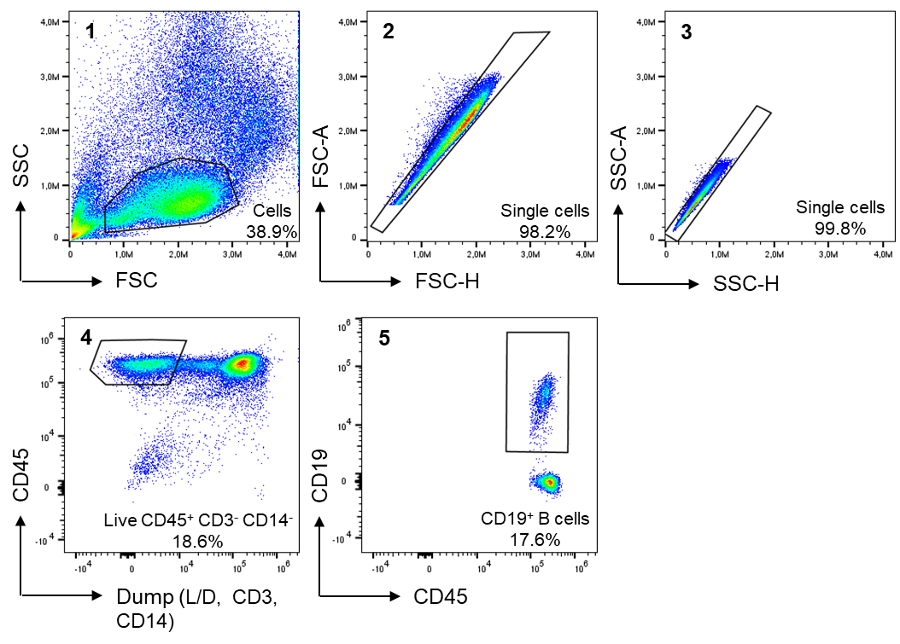

Fig. S1 Gating strategy for total CD19⁺ B cells in PBMCs from melanoma patients. Debris, doublets and cells positive for the dump channel (LiveDead⁺, CD3⁺ and CD14⁺ cells) were excluded. CD45⁺ CD19⁺ cells corresponding to B lymphocytes were subsequently used for B-cell phenotype analysis.

Supplementary Fig. S2

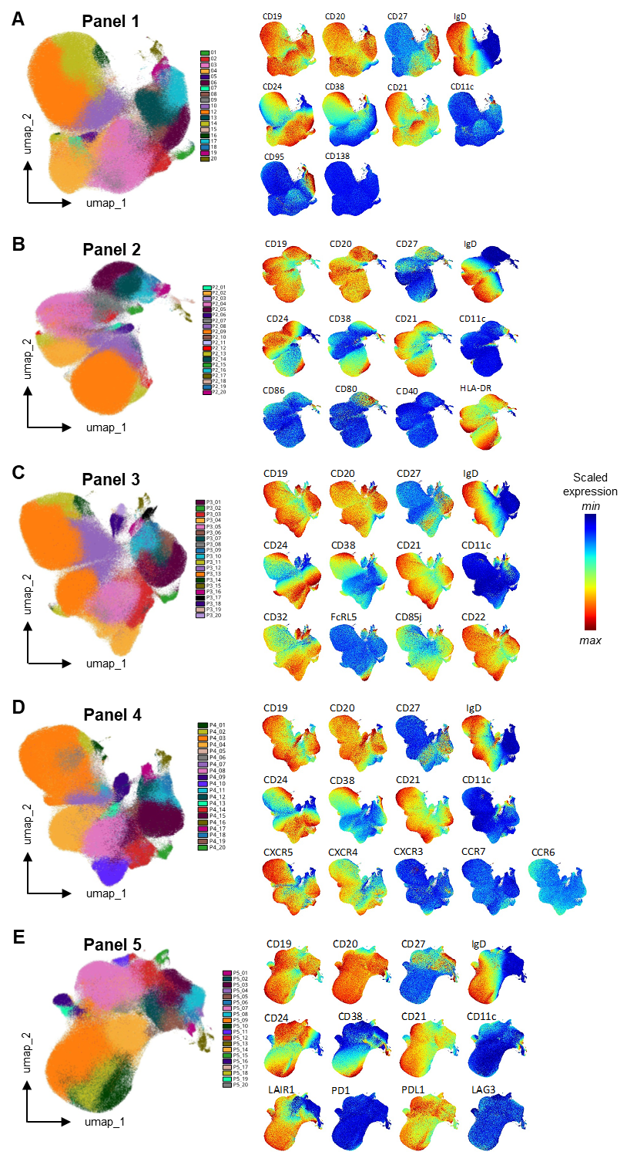

Fig. S2 Phenotypes of peripheral B-cell clusters generated from the analysis of five flow cytometry panels. A-E, left: UMAP representation of twenty B-cell clusters identified in each panel using the FlowSOM clustering algorithm. PBMCs were stained with the corresponding antibody cocktail (panels 1 to 5) and acquired by spectral flow cytometry. Cells were gated as single, live CD45⁺CD3⁻CD14⁻CD19⁺ cells before unsupervised clustering, which identified 20 clusters per panel characterized by distinct phenotypes. A-E, right: Bulk expression UMAPs stratified by markers included in each panel. Patient samples (PRED_1, n=37) collected longitudinally at the three timepoints (before treatment, post-ICI and at irAEs onset) were concatenated for this visualization. Scaled marker expression is shown, with red indicating higher fluorescence intensity and blue lower intensity.

Supplementary Fig. S3
A


IgD⁻ MB
Plasmablast
IgD⁻ AMB
Pre-plasmablast
IgD⁺ memory
Naive
Transitional
Naive
activated
DN

B
C

Clusters | Phenotype
12 | CD19⁺ CD20⁺ CD27⁺ IgD⁻ CD24⁺ CD38^{low} CD21⁺ CD11c⁻ CD95⁻ HLADR⁺ FcRL5⁻ CD86⁻ CD80⁻ CD85j^{low} CD32^{low} CD22⁺
13 | CD19⁺ CD20⁺ CD27⁺ IgD⁻ CD24^{low} CD38⁻ CD21⁺ CD11c⁻ CD95⁺ FcRL5⁻ CD85j^{low} CD32^{low} CD22⁺ LAIR1⁻ PDL1⁺ PD1⁻
19 | CD19⁺ CD20⁺ CD27⁺ IgD⁻ CD24⁺ CD38^{low} CD21⁺ CD11c⁺ HLADR⁺ CD86⁻ CD80⁺ FcRL5⁻ CD85j⁺ CD32⁺ CD22⁺  B-cell subsets (metacluster)
P5_03 | CD19⁺ CD20⁺ CD27⁺ IgD⁻ CD24⁺ CD38⁻ CD21⁺ CD11c⁻ LAIR1⁻ PDL1⁺ PD1⁻
P2_16 | CD19⁺ CD20⁺ CD27⁺ IgD⁻ CD24⁻ CD38⁻ CD21⁺ CD11c⁻ HLADR⁺ CD86⁻ CD80⁺
P4_11 | CD19⁺ CD20⁺ CD27⁺ IgD⁻ CD24⁻ CD38⁻ CD21⁺ CD11c⁻ CXCR5⁺ CXCR4^{low} CXCR3⁻ CCR7⁻ CCR6⁻
P5_04 | CD19^{hi} CD20^{hi} CD27⁻ IgD⁻ CD24⁻ CD38⁻ CD21⁺ CD11c⁺ LAIR1⁻ PDL1⁺ PD1⁻
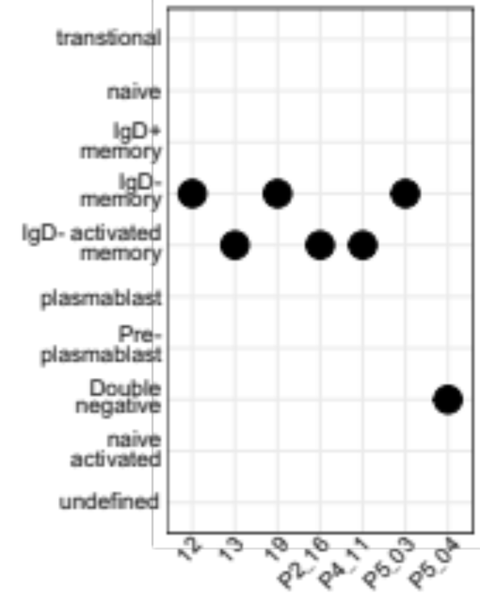

Clusters

Fig. S3 Phenotype and metacluster annotations of peripheral B cells analyzed by spectral flow cytometry. A, UMAP visualization of B-cell metaclusters from a representative panel. B, Detailed phenotype of clusters that are differentially abundant between irAEs⁺ and irAEs⁻ patients in PRED_1 cohort, as identified in Fig 2A, B. Marker expression levels were determined based on comparisons with isotype controls. C, Assignment of the differentially abundant clusters identified in Fig. 2A,B to B-cell metaclusters. IgD- Activated memory B cells (AMB); IgD- memory B cells (MB); Double negative B cells (DN).

Supplementary Fig. S4

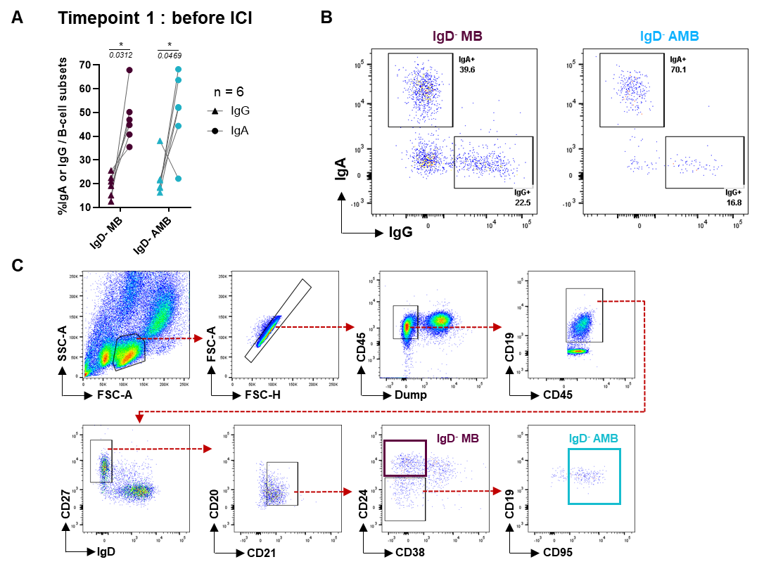

Fig. S4 Functional features of IgD⁻ MB and IgD⁻ AMB subsets. A, Percentages of IgG⁺ and IgA⁺ cells among IgD⁻ MB and IgD⁻ AMB subsets from six PRED_1 melanoma patients at timepoint 1 (before ICI) as assessed by flow cytometry. IgG and IgA values from the same patient are connected by lines. Statistical analysis was performed using paired Wilcoxon tests. B, Representative dot plots illustrating IgG and IgA surface staining on IgD⁻ MB and IgD⁻ AMB cells. Percentages of IgG⁺ and IgA⁺ cells within each subset are indicated. C, Sorting strategy of IgD⁻ MB (purple) and IgD⁻ AMB (blue) from PBMCs of PRED_1 melanoma patients at timepoint 1.

Supplementary Fig. S5

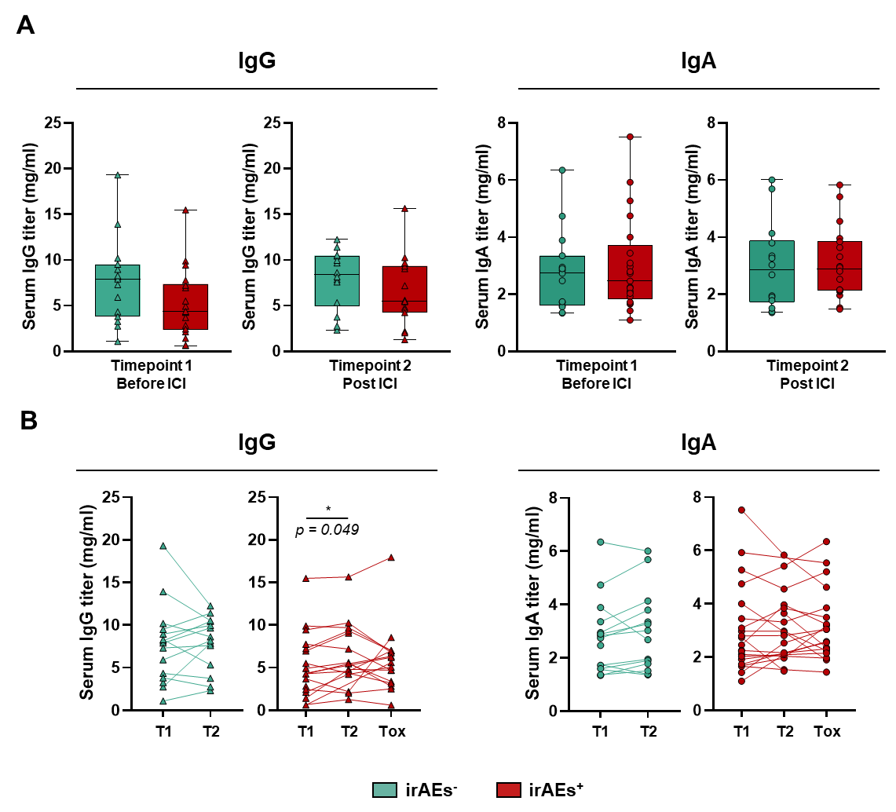

Fig. S5 Serum IgG and IgA levels in PRED_1 melanoma patients with or without irAEs. A, IgG and IgA concentrations (mg/mL) were measured by ELISA assays in the serum of irAEs⁻ (n = 15, green) and irAEs⁺ (n = 22, red) patients at timepoint 1 (before ICI) and timepoint 2 (post-ICI). Mann-Whitney-Wilcoxon tests were used to compare irAEs⁻ and irAEs⁺ patients, and no statistically significant differences were observed across all comparisons. B, Longitudinal analysis of serum IgG and IgA in irAEs⁻ (n = 15, green) and irAEs⁺ (n = 22, red) patients at T1 (before ICI), T2 (post-ICI) and Tox (onset of irAE). Wilcoxon signed-rank tests were performed, and significant p-value is indicated on the plot.

