ADDITIONAL FILE 1: APPENDIX FIGURES & TABLES

Title: A Multidisciplinary Consensus-Driven Outpatient Hyperkalemia Care Pathway: Development, Rationale, and Clinical Recommendations

Authors & Affiliations:

Ankeet Bhatt, MD, MBA, ScM,¹ A.J. Blood, MD, MSc,² Amin Yehya, MD, MS,³ Eric Wright, PharmD, MPH,⁴ Latif Bikak, MD,⁵ Sharad Virmani, MD,^{6,7} Lauren Feeney, NP-C,³ Cecilia McAlear, MS-BME,⁸ Holly Jain, MD, MHA,⁸ Kurt Sowers, MD⁹

- Kaiser Permanente San Francisco Medical Center: 2425 Geary Blvd Oakland, CA 94115
- Newton-Wellesley Hospital: 2014 Washington St Newton, MA 02462
- Sentara Norfolk General Hospital: 600 Gresham Dr Norfolk, VA 23507
- Geisinger Center for Pharmacy Innovation and Outcomes: 100 N Academy Ave Danville, PA 17822
- Wellstar Cardiology: 175 White St NW Ste 100 Marietta, GA 300600
- Georgia Nephrology: 6335 Hospital Pkwy #208 Johns Creek, GA 30097
- Emory Johns Creek Hospital: 6325 Hospital Pkwy, Johns Creek, GA 30097
- Petauri Kinect: 29 Broadway 26th floor, New York, NY 10006
- Appalachian Regional Healthcare: 100 Medical Center Dr, Hazard, KY 41701

Table of Contents

Appendix Figure 1: Step B: Diagnose and Risk-Stratify Hyperkalemia…….…………...….2
Appendix Table 1: Diuretic Considerations…………………………………………………3
Appendix Table 2: Management of Patients With Hyperkalemia and Metabolic Acidosis…4

Supplementary Figure 1: Diagnose and Risk-Stratify Hyperkalemia^{1,2,3,4,5,6}
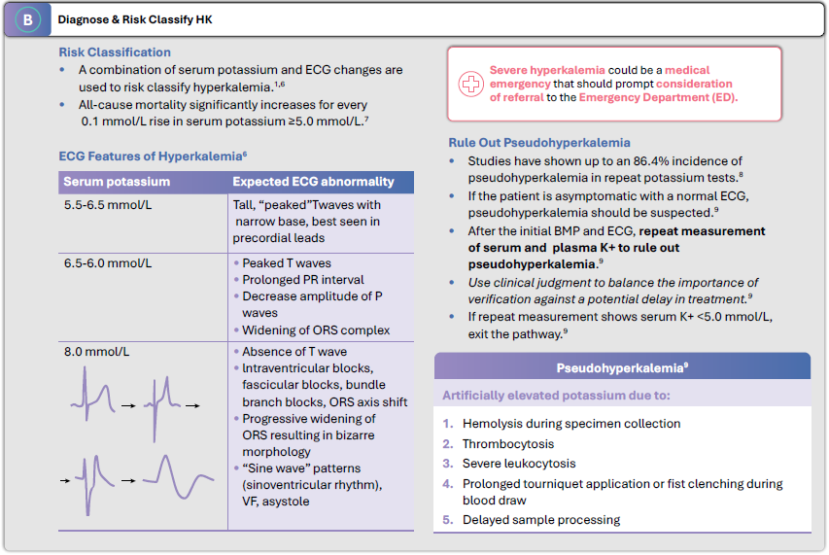
BMP, basic metabolic panel  ECG, echocardiogram  ED, emergency department | HK, hyperkalemia  K+, potassium

Supplementary Table 1: Diuretic Considerations^{7,8,9,10}
 | Bumex® (bumetanide)⁷ | Lasix® (furosemide)⁸ | Demadex® (torsemide)⁹
Label Information | Dosage Forms and Strengths: 0.5 mg, 1 mg, or 2 mg tablet  Starting Dose: 0.5-10 mg PO  - If needed, a second or third dose may be given at 4- to 5-hour intervals up to a maximum daily dose of 10 mg  Maintenance Dose: Intermittent dose schedule; tablets are given on alternate days or for 3-4 days with rest periods of 1-2 days in between | Dosage Forms and Strengths: 20 mg, 40 mg, or 80 mg tablet  Starting Dose:  - Hypertension (HT): 40 mg PO 2x daily  - If needed, add other antihypertensive agents  - Edema: 20-80 mg PO 1x daily  - If needed, the same dose can be administered 6-8 hours later, or the dose may be increased. The dose may be increased by 20 or 40 mg and given not sooner than 6-8 hours after the previous dose until the desired diuretic effect  Maintenance Dose: For edema, individually determined single dose PO  1-2x daily. Safest results dosing on 2-4 consecutive days per week | Dosage Forms and Strengths: 5 mg, 10 mg,  20 mg, or 100 mg tablet  Starting Dose:  - Congestive Heart Failure (CHF): 10-20 mg PO 1x daily  - Chronic Renal Failure (CRF): 20 mg PO 1x daily  - HT: 5 mg PO 1x daily  Maintenance Dose:  - CHF and CRF: If needed, the dose should be titrated by doubling until the desired response is obtained  - HT: If a 5 mg dose is not adequate, the dose may be increased to 10 mg once daily after 4-6 weeks. If 10 mg is insufficient, an additional antihypertensive agent should be added
Key Considerations | Bumetanide can be substituted for furosemide at approximately a 1:40 ratio | - Doses exceeding  80 mg/day for prolonged periods require careful clinical observation  - Furosemide has variable oral bioavailability | Single doses higher than  200 mg have not been adequately studied
Key Considerations | Patients with eGFR <30 mL/min/1.73 m² often require higher or more frequent dosing.  Repeat serum K+ measurement within 7 days of initiating diuretics.¹⁰
eGFR, estimated glomerular filtration rate
K+, potassium
PO, per os (orally)

Supplementary Table 2: Management of Patients With Hyperkalemia and Metabolic Acidosis¹¹
Condition | Sodium Bicarbonate (NaHCO₃) ​​
Chronic Metabolic Acidosis | - Chronic renal failure: 1625 to 2925 mg/day PO divided every 4 to 6 hours  - Dose adjustments are based on serum HCO₃ levels  - Distal renal tubular acidosis: 48 to 168 mg/kg/day PO divided every 4 to 6 hours  - Dose adjustments are based on serum HCO₃ levels  - Proximal renal tubular acidosis: 420 to 840 mg/kg/day PO divided every 4 to 6 hours
Acute Metabolic Acidosis | - Initiation: 2 to 5 mEq/kg/dose IV for a single dose  - Subsequent dosing is based on patient response and acid-base status
Severe Hyperkalemia ​  (K+ >6 mmol/L)​ | - Dose adjustments are based on serum HCO₃ levels  - The dose needed is empirical and unpredictable  - Initiation: 150 mEq of NaHCO₃ can be given in 1 L of 5% dextrose over 4 hours  - More can be provided if acidosis is not corrected with this regimen  If K+ must be reduced emergently: 50 mEq of NaHCO₃ IV can be given over 5 minutes
IV, intravenous
K+, potassium
PO, per os (orally)

References
- Kreitzer N, Albert NM, Amin AN, et al. EMCREG-International Multidisciplinary Consensus Panel on Management of Hyperkalemia in Chronic Kidney Disease and Heart Failure. Cardiorenal Med. 2025;15(1):133-152. doi: 10.1159/000543385
- Collins AJ, Pitt B, Reaven N, et al. Association of serum potassium with all-cause mortality in patients with and without heart failure, chronic kidney disease, and/or diabetes. Am J Nephrol. 2017;46(3):213-221. doi: 10.1159/000479802
- Boima V. Approach to the patient with hyperkalaemia. Presented at: Cameroon Society of Nephrology Conference. April 3-5, 2025; Yaoundé, Cameroon. Accessed June 1, 2026. https://kdigo.org/wp-content/uploads/2025/04/Approach-to-management-of-hyperalaemia-Cameroon-Society-of-Nephrology.pdf
- International Society of Nephrology. Hyperkalemia management: distinguishing acute, chronic, and pseudo-hyperkalemia [infographic]. n.d. International Society of Nephrology RAASi Toolkit. https://www.theisn.org/initiatives/toolkits/raasi-toolkit/
- Boo AYY, Koh YLE, Hu PL, Tan NC. Prevalence and factors associated with false hyperkalaemia in Asians in primary care: a cross-sectional study (the Unlysed Hyperkalaemia - the Unseen Burden (UHUB) study). BMJ Open. 2020;10(9):e033755. doi: 10.1136/bmjopen-2019-033755
- Clase CM, Carrero JJ, Ellison DH, et al. Potassium homeostasis and management of dyskalemia in kidney diseases: conclusions from a Kidney Disease: Improving Global Outcomes (KDIGO) Controversies Conference. Kidney Int. 2020;97(1):42-61. doi: 10.1016/j.kint.2019.09.018
- Bumex. Prescribing information. Validus Pharmaceuticals; 2024. Accessed June 1, 2026. https://www.accessdata.fda.gov/drugsatfda_docs/label/2024/018225Orig1s029lbl.pdf
- Lasix. Prescribing information. Sanofi-Aventis; 2010. Accessed June 1, 2026. https://www.accessdata.fda.gov/drugsatfda_docs/label/2010/016273s061lbl.pdf
- Demadex. Prescribing information. Meda Pharmaceuticals Inc; 2010. Accessed June 1, 2026. https://www.accessdata.fda.gov/drugsatfda_docs/label/2010/020136s023lbl.pdf
- National Kidney Foundation. NKF KDOQI Guidelines. KDOQI Clinical Practice Guidelines on Hypertension and Antihypertensive Agents in Chronic Kidney Disease. 2004. Accessed June 1, 2026. https://kidneyfoundation.cachefly.net/professionals/KDOQI/guidelines_bp/guide_12.htm#table149
- Senewiratne NL, Woodall A, Can AS. Sodium Bicarbonate. In: StatPearls [Internet]. Treasure Island (FL): StatPearls Publishing. Updated February 12, 2024. Accessed June 1, 2026. https://www.ncbi.nlm.nih.gov/books/NBK559139/

