Supplementary Figures
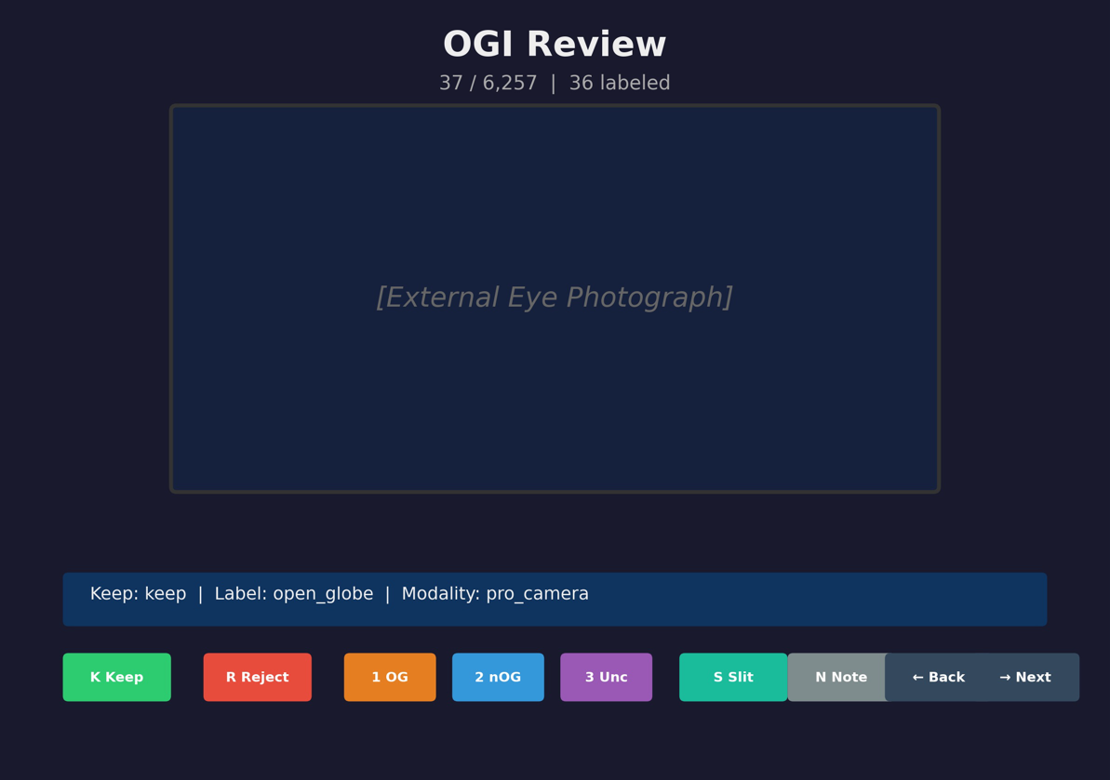
Supplementary Figure S1. Reviewer interface used for manual grading of external-eye images.
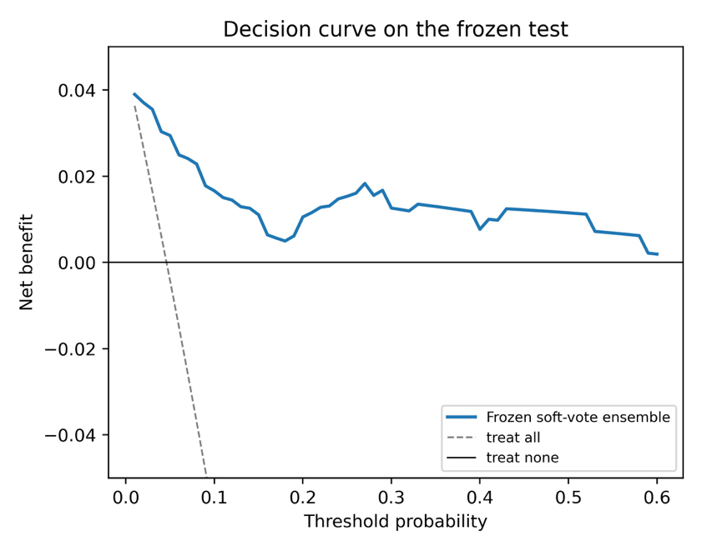
Supplementary Figure S2. Decision-curve analysis on the frozen held-out test: net benefit of the deployable model across a range of referral threshold probabilities, against treat-all and treat-none.
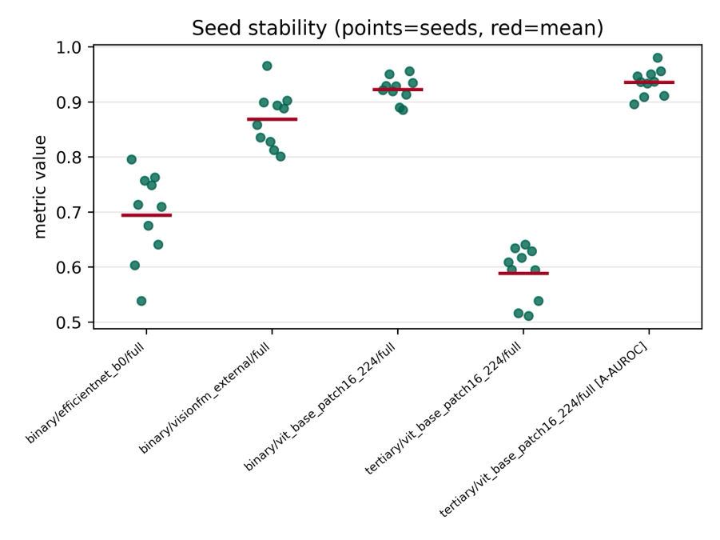
Supplementary Figure S3. Run-to-run stability of the fine-tune AUROC across ten random seeds. Each point is one seed and the bar is the mean; this reflects training stability and does not narrow the frozen-test confidence intervals.

Supplementary table
Supplementary Table S1. Robustness and shortcut audits (train+val cross-validation).
Audit | Metric | Value
Leave-one-tier-out AUROC (tier A / B / X) | AUROC | 0.65 / 0.71 / 0.64
Tier-stratified AUROC (tier A / B / X) | AUROC | 0.745 / 0.712 / 0.632
Face-exclusion invariance | AUROC all vs faces excluded | 0.780 vs 0.780 (0 flagged)
Caption-only text baseline | AUROC | 0.816
Source-tier decodability from embeddings | CV accuracy vs majority | 0.925 vs 0.936
Cross-fold near-duplicate leakage | images >0.99 / >0.97 cosine | 2 / 8
Supplementary Table S1. Robustness and shortcut audits computed on the train+val set. Leave-one-tier-out and tier-stratified AUROC remain above chance across source tiers; excluding face-containing images does not change AUROC; source tier is not strongly decodable from embeddings (accuracy at the majority baseline); residual cross-fold near-duplicates are minimal after removing 52 duplicate images (2 exceed 0.99 cosine). A caption-only text baseline reaches AUROC 0.82, so captions carry some label signal, but the image model uses no captions at inference.

