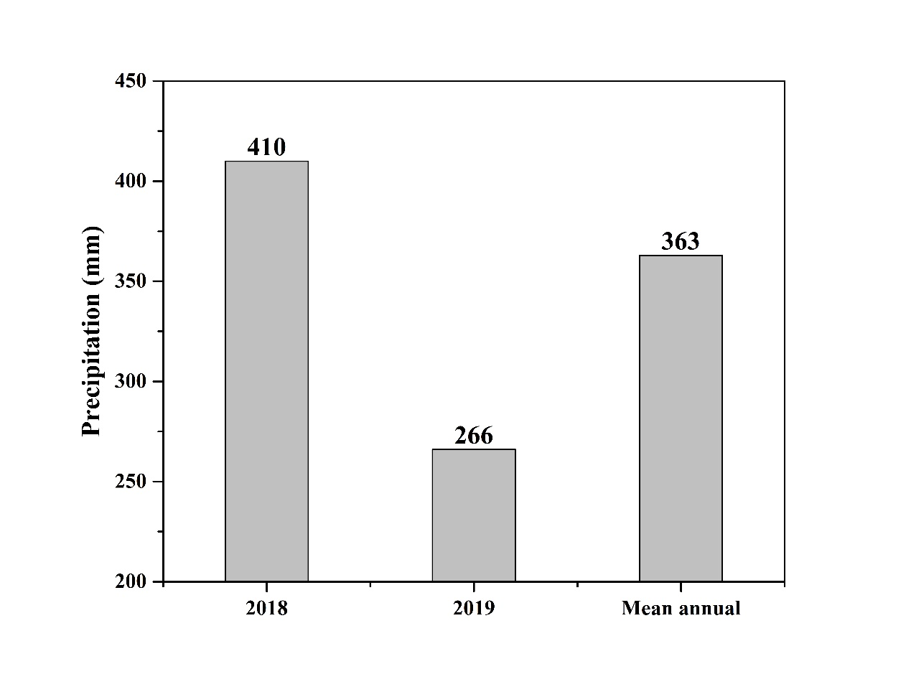
Figure S1 Precipitation of the wet year (2018) and the dry year (2019) and long-term mean annual precipitation of the studied meadow grassland.

Table S1 Effects of sulfur (S) addition on soil pH, soil NH₄⁺ concentration, soil NO₃⁻ concentration, plant available phosphorus (P), and plant available sulfur (S) in two sampling years.
Soil parameters | Year | S addition rate (g S m⁻² yr⁻¹)
Soil parameters | Year | 0 | 1 | 2 | 5 | 10 | 15 | 20 | 50
Soil pH | 2018 | 6.98a | 6.77ab | 6.88a | 6.76ab | 6.59bc | 6.48c | 6.50c | 5.99d
Soil pH |  | (0.12) | (0.05) | (0.04) | (0.08) | (0.05) | (0.02) | (0.09) | (0.07)
Soil pH | 2019 | 6.95a | 6.80a | 6.69a | 6.70a | 6.77a | 6.47ab | 6.17b | 5.19c
Soil pH |  | (0.06) | (0.14) | (0.06) | (0.07) | (0.17) | (0.11) | (0.31) | (0.20)
NH₄⁺ (mg kg⁻¹) | 2018 | 4.04ab | 4.29ab | 4.76a | 4.01ab | 3.72ab | 4.26ab | 3.42b | 4.47ab
NH₄⁺ (mg kg⁻¹) |  | (0.24) | (0.38) | (0.50) | (0.25) | (0.35) | (0.20) | (0.24) | (0.36)
NH₄⁺ (mg kg⁻¹) | 2019 | 4.76b | 4.45b | 4.78b | 4.36b | 4.92b | 5.19b | 4.67b | 8.33a
NH₄⁺ (mg kg⁻¹) |  | (0.31) | (0.25) | (0.25) | (0.08) | (0.68) | (0.35) | (0.22) | (1.73)
NO₃⁻ (mg kg⁻¹) | 2018 | 2.07ab | 2.30a | 2.03ab | 1.86abc | 1.81abc | 1.91abc | 1.47bc | 1.23c
NO₃⁻ (mg kg⁻¹) |  | (0.29) | (0.18) | (0.16) | (0.27) | (0.29) | (0.21) | (0.15) | (0.10)
NO₃⁻ (mg kg⁻¹) | 2019 | 4.88a | 6.83a | 5.46a | 5.44a | 5.45a | 5.75a | 4.60a | 1.41b
NO₃⁻ (mg kg⁻¹) |  | (0.42) | (0.56) | (0.58) | (0.73) | (1.01) | (0.67) | (0.95) | (0.31)
Available P  (mg kg⁻¹) | 2018 | 3.01bc | 3.22bc | 2.77c | 3.23bc | 3.26bc | 3.22bc | 3.76ab | 4.35a
Available P  (mg kg⁻¹) |  | (0.15) | (0.15) | (0.13) | (0.32) | (0.25) | (0.27) | (0.38) | (0.20)
Available P  (mg kg⁻¹) | 2019 | 5.20b | 4.98b | 4.94b | 5.27b | 4.58b | 8.05a | 6.94a | 7.08a
Available P  (mg kg⁻¹) |  | (0.64) | (0.69) | (0.41) | (0.71) | (0.35) | (0.41) | (0.60) | (0.38)
Available S  (mg kg⁻¹) | 2018 | 11.41c | 19.72c | 20.83c | 17.59c | 21.61c | 51.40b | 64.49b | 148.30a
Available S  (mg kg⁻¹) |  | (1.68) | (7.54) | (5.38) | (2.15) | (4.08) | (5.04) | (2.47) | (11.81)
Available S  (mg kg⁻¹) | 2019 | 8.78c | 9.62c | 12.91c | 10.30c | 15.09c | 30.37b | 40.64b | 114.41a
Available S  (mg kg⁻¹) |  | (0.78) | (1.56) | (2.09) | (1.33) | (1.89) | (5.96) | (8.56) | (6.85)
Values are means ± standard error (in parentheses), and different lowercase letters in the same line indicate significant differences among S-addition rates at the level of P < 0.05.

Table S2 Results (F-value) of two-way ANOVAs on the main effects of year (Y), S addition rate (S) and their interactions on nutrient resorption efficiency of N, P, and S (NRE, PRE, and SRE, respectively) of two dominant species.
Species |  | NRE | PRE | SRE
L. chinensis | Year (Y) | 435** | 649** | 38.8**
 | Sulfur(S) | 3.23** | 2.63* | 4.01**
 | Y × S | 0.97 | 1.31 | 1.67
C.duriuscula | Year (Y) | 6.09* | 76.5** | 3.15
 | Sulfur(S) | 2.44* | 0.74 | 5.48**
 | Y × S | 1.78 | 0.22 | 2.98**
*, P < 0.05; **, P < 0.01

Table S3 Relationships between green leaf nutrient concentrations and plant available N (i.e., NH₄⁺ and NO₃⁻), P, and S for two species in two sampling years.
Species | Year | NH₄⁺ | NO₃⁻ | Available P | Available S
L. chinensis | 2018 | 0.09 | 0.18 | -0.17 | -0.05
L. chinensis | 2018 | -0.06 | 0.20 | 0.24 | 0.03
L. chinensis | 2018 | 0.22 | -0.10 | 0.51** | 0.52**
L. chinensis | 2019 | -0.24 | 0.37* | -0.24 | -0.29
L. chinensis | 2019 | -0.12 | 0.21 | 0.02 | -0.01
L. chinensis | 2019 | 0.07 | 0.22 | 0.24 | 0.15
C. duriuscula | 2018 | -0.18 | -0.15 | 0.40* | 0.38*
C. duriuscula | 2018 | -0.05 | -0.31 | 0.60** | 0.42**
C. duriuscula | 2018 | 0.01 | -0.40** | 0.63** | 0.65**
C. duriuscula | 2019 | -0.05 | 0.19 | -0.18 | -0.14
C. duriuscula | 2019 | -0.07 | 0.01 | 0.21 | 0.34*
C. duriuscula | 2019 | 0.16 | 0.02 | 0.22 | 0.44**
*, P < 0.05; **, P < 0.01

Table S4 Relationships between leaf nutrient resorption efficiency and plant available nutrients of nitrogen (N), phosphorus (P) and sulfur (S) for two dominant species in two sampling years.
Species | Year |  | Available N | Available P | Available S
L. chinensis | 2018 | NRE | 0.04 | -0.20 | -0.06
 |  | PRE | 0.00 | -0.04 | -0.34*
 |  | SRE | 0.31 | -0.15 | -0.32*
 | 2019 | NRE | 0.26 | -0.02 | -0.30
 |  | PRE | -0.09 | -0.28 | -0.07
 |  | SRE | 0.20 | -0.36* | -0.41**
C. duriuscula | 2018 | NRE | -0.33* | -0.14 | -0.27
 |  | PRE | -0.21 | 0.01 | -0.06
 |  | SRE | 0.11 | 0.04 | -0.30
 | 2019 | NRE | -0.14 | -0.24 | -0.34*
 |  | PRE | -0.14 | 0.07 | 0.13
 |  | SRE | -0.07 | -0.45** | -0.48**
* and**, P < 0.05 and 0.01, respectively.

