Supplementary Figure 1. External calibration before and after intercept-only recalibration of the main perioperative model.
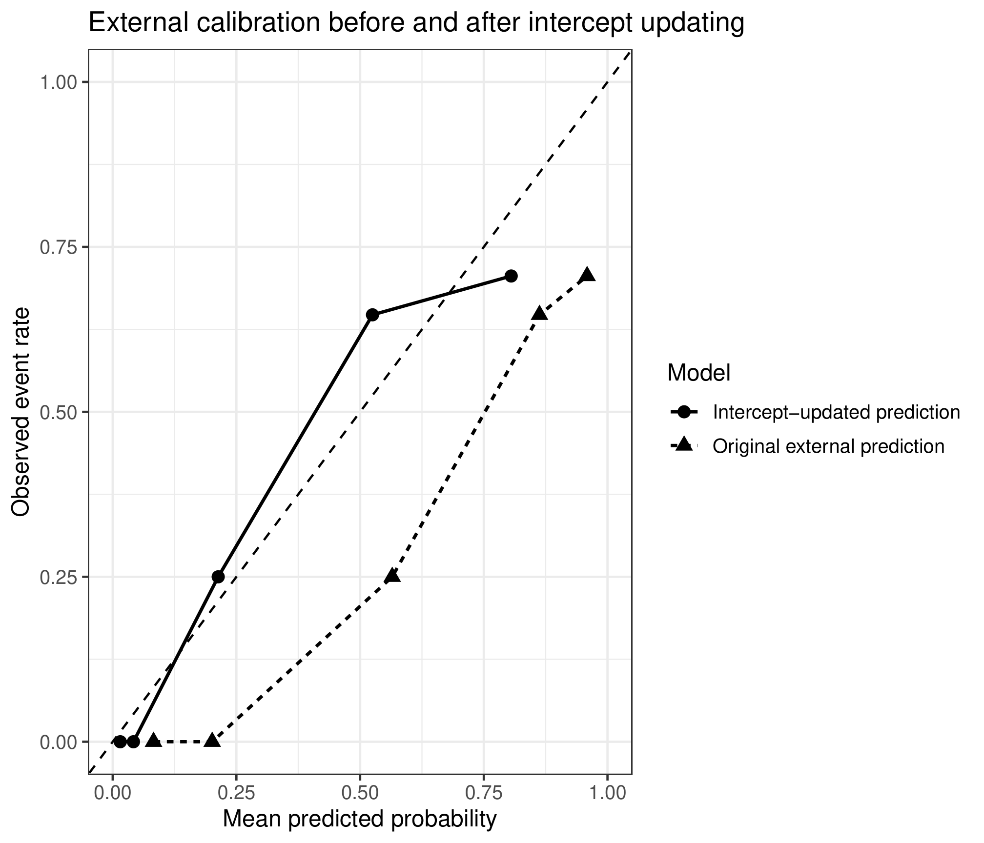

Supplementary Figure 2. Nomogram of the supplementary preoperative model.


