Suplementary Material

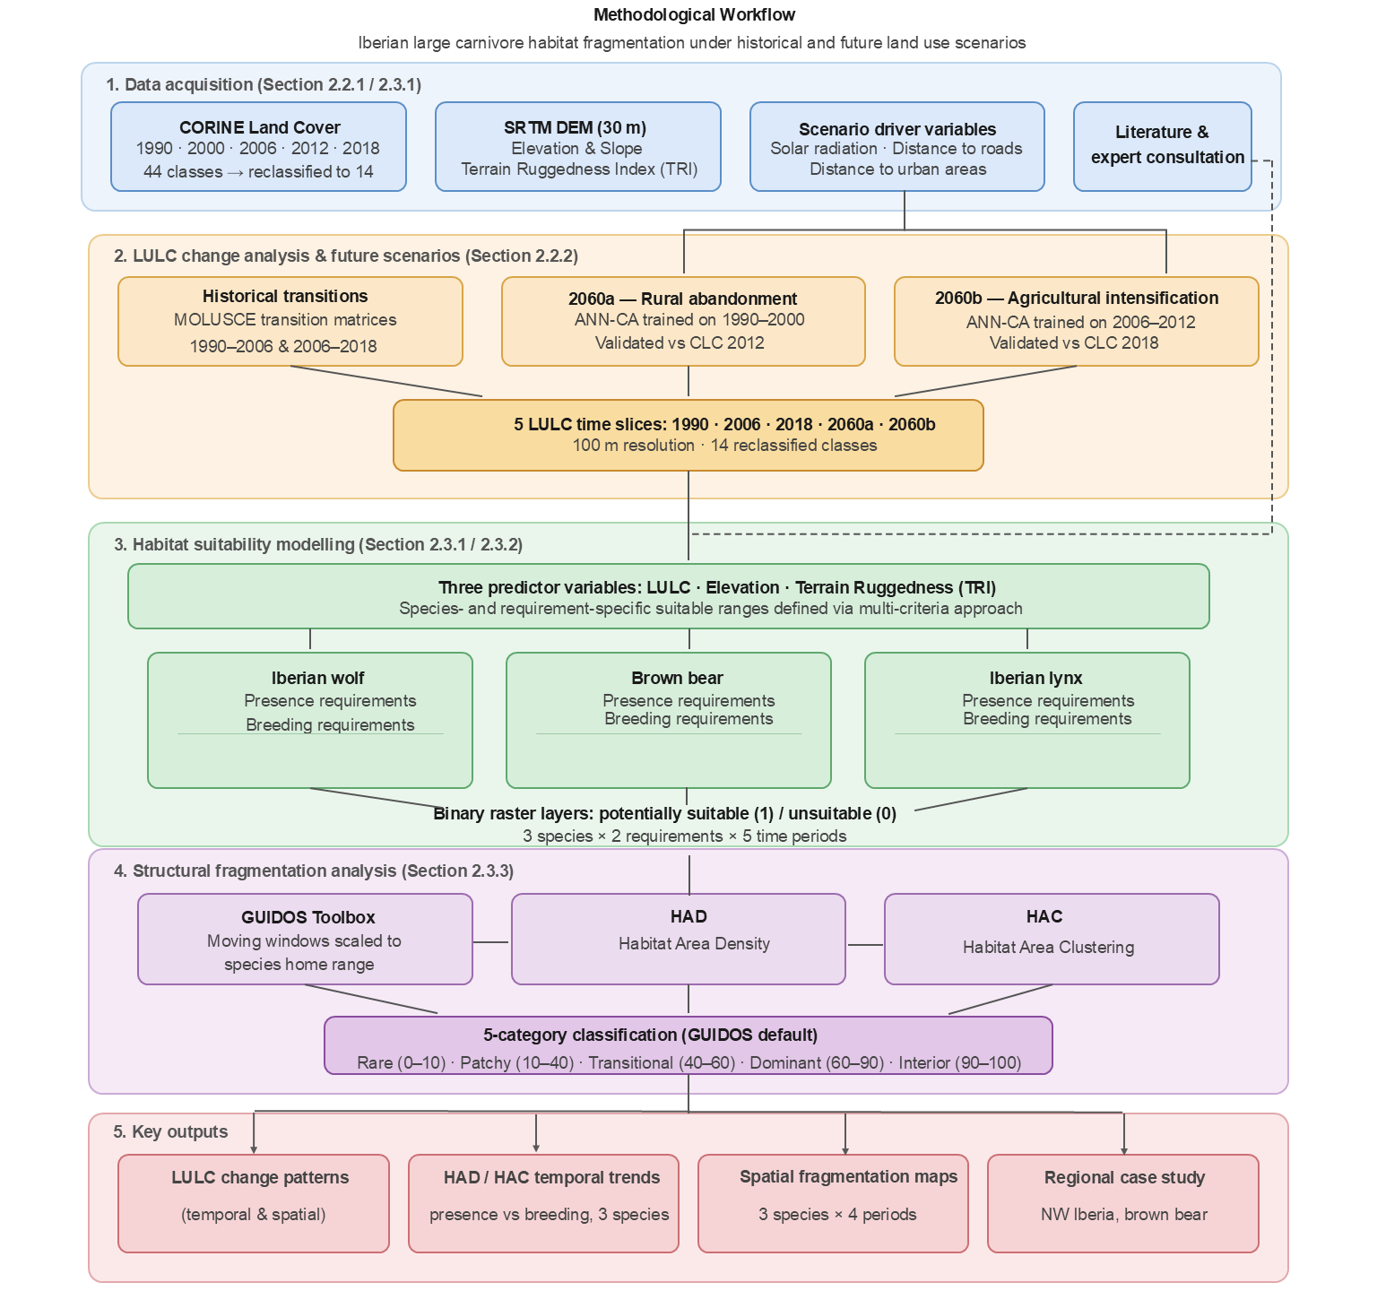
Fig. S1 Flowchart of the research process applied in the study of landscape change and habitat fragmentation of three large carnivore species in the Iberian Peninsula

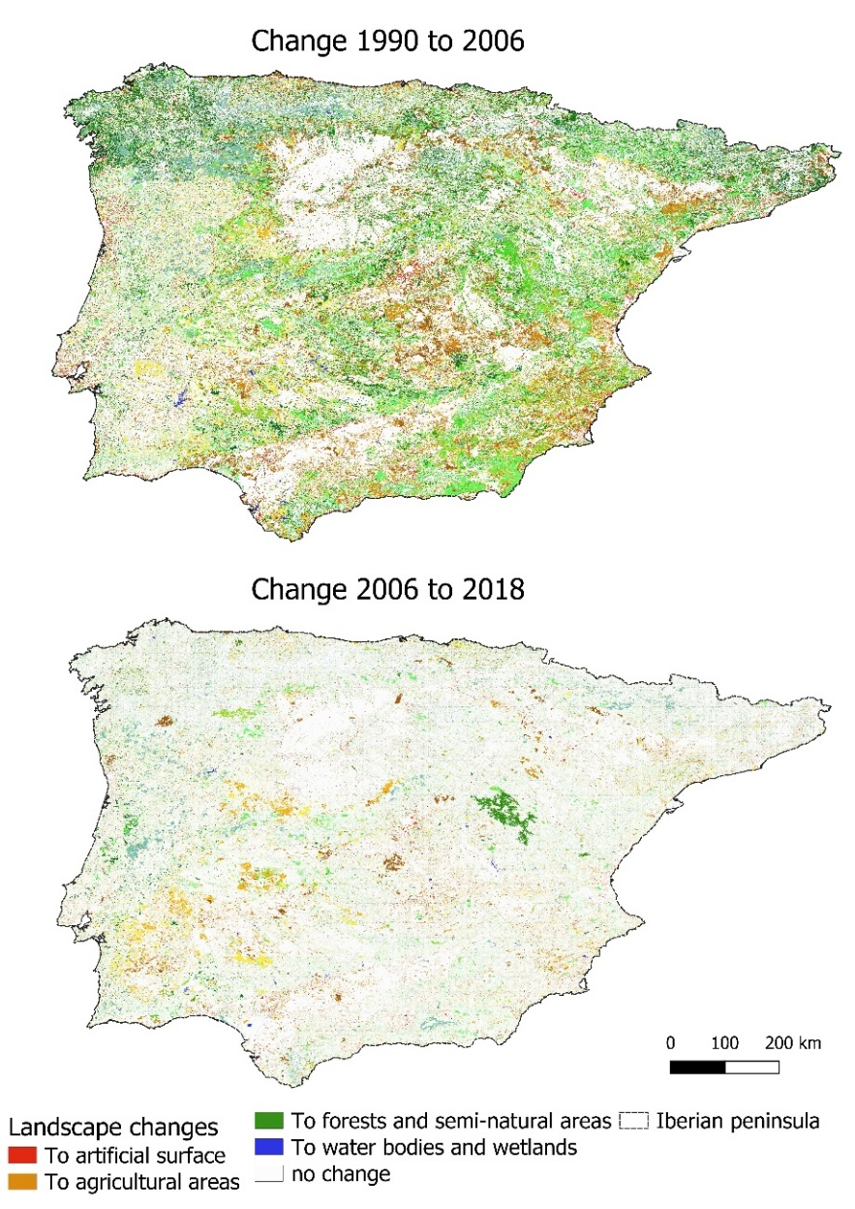
Fig. S2 Spatial distribution of LULC transitions in the Iberian Peninsula between 1990–2006 (top) and 2006–2018 (bottom), derived from CORINE Land Cover data. Each pixel color represents the broad land-cover category (artificial surface, agricultural, forest, semi-natural, or water) to which a transition occurred; pixels with no color indicate areas where no change was detected. Note the substantially higher density of transitions in the first period compared to the second, reflecting greater landscape dynamism between 1990 and 2006

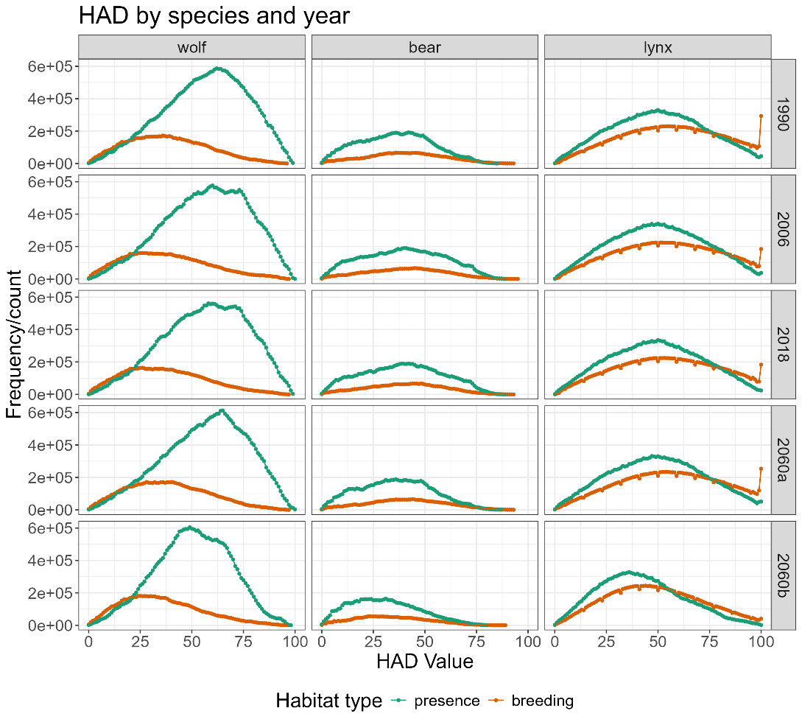
Fig. S3 Density graph of HAD for wolf, brown bear and Iberian lynx over time (1990-2018) and for projected LULC scenarios (2060a and 2060b) in the Iberian Peninsula. HAD was calculated using moving windows of sizes corresponding to each species' home ranges

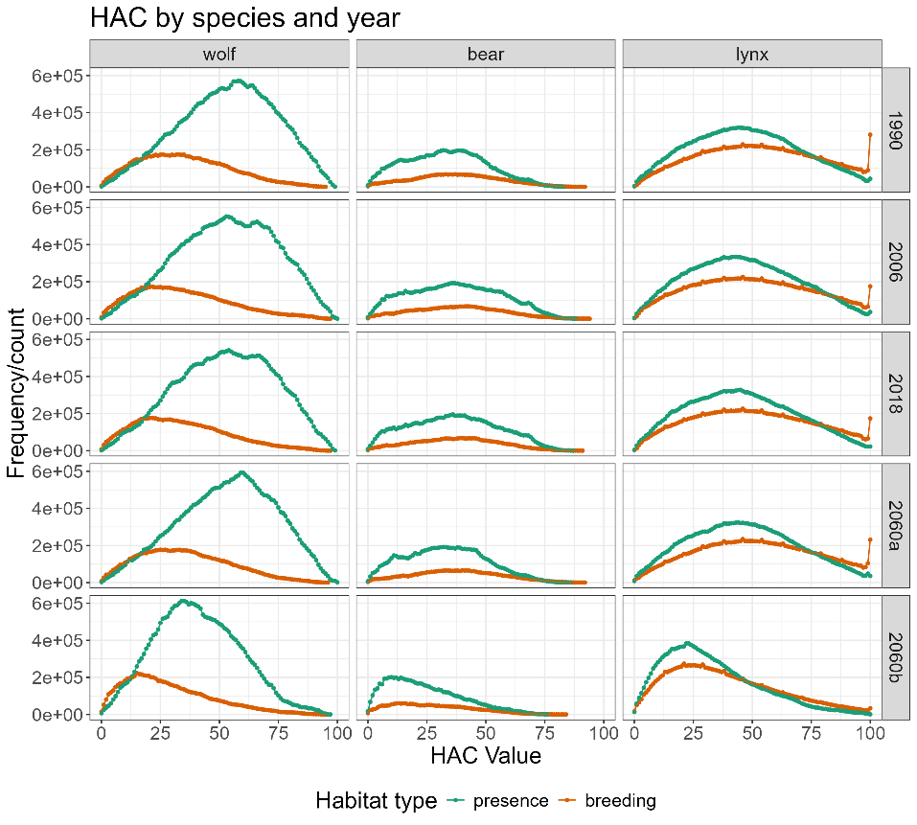
Fig. S4 Histogram of HAC for wolf, brown bear and Iberian lynx over time (1990-2018) and for projected LULC scenarios (2060a and 2060b) in the Iberian Peninsula. HACs were calculated using moving windows of variable size (see Table S3 appendix)

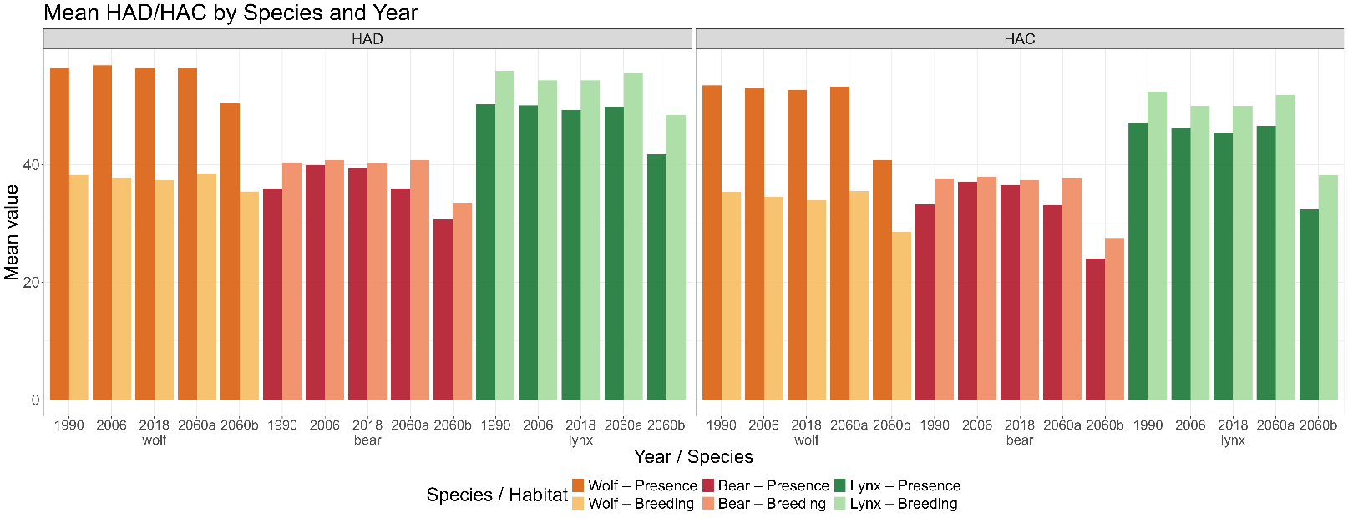
Fig. S5 Average HAD/HAC metrics for each year, in both types of habitat requirements (presence with dark colors and reproduction with light colors) for wolf (orange), brown bear (red), and Iberian lynx (green) in the Iberian Peninsula. Future scenarios correspond to rural abandonment (2060a) and agriculture intensification (2060b)

Table S1 CLC classification system including three hierarchical levels (left) and reclassification based on level 3 classes
CORINE Land Cover original dataset |  |  |  | Reclassification group
Level 1 | Level 2 | Level 3 | CODE | Land use - 14 classes
Artificial surfaces | Urban fabric | Continuous urban fabric | 111 | Artificial surface (AS)
Artificial surfaces | Urban fabric | Discontinuous urban fabric | 112
Artificial surfaces | Industrial, commercial, and transport units | Industrial or commercial units | 121
Artificial surfaces | Industrial, commercial, and transport units | Road and rail networks and associated land | 122
Artificial surfaces | Industrial, commercial, and transport units | Port areas | 123
Artificial surfaces | Industrial, commercial, and transport units | Airports | 124
Artificial surfaces | Mine, dump, and construction sites | Mineral extraction sites | 131
Artificial surfaces | Mine, dump, and construction sites | Dump sites  Construction sites | 132  133
Artificial surfaces | Artificial, non-agricultural vegetated areas | Green urban areas  Sport and leisure facilities | 141  142
Agricultural areas | Arable land | Non-irrigated arable land | 211 | Agri- Arable land (AL)
Agricultural areas | Arable land | Permanently irrigated land | 212
Agricultural areas | Arable land | Rice fields | 213
Agricultural areas | Permanent crops | Vineyards | 221 | Agri- Permanent crops (PC)
Agricultural areas | Permanent crops | Fruit trees and berry plantations | 222
Agricultural areas | Permanent crops | Olive groves | 223
Agricultural areas | Pastures | Pastures | 231 | Agri- Pastures (P)
Agricultural areas | Heterogeneous agricultural areas | Annual crops associated with permanent crops | 241 | Agri- annual crops, complex cultivation (AC, CC)
Agricultural areas | Heterogeneous agricultural areas | Complex cultivation patterns | 242
Agricultural areas | Heterogeneous agricultural areas | Land principally occupied by agriculture, with significant areas of natural vegetation | 243
Agricultural areas | Heterogeneous agricultural areas | Agro-forestry areas | 244
Forest and semi-natural areas | Forests | Broad-leaved forest | 311 | Broad-leaved (BL)
Forest and semi-natural areas | Forests | Coniferous forest | 312 | Coniferous forest (CF)
Forest and semi-natural areas | Forests | Mixed forest | 313 | Mixed forest (MF)
Forest and semi-natural areas | Scrub and herbaceous vegetation associations | Natural grasslands | 321 | Natural grasslands (NG)  Sclerophyllous forest (SF)  Transitional woodland forest (TW)
Forest and semi-natural areas | Scrub and herbaceous vegetation associations | Moors and heathland | 322
Forest and semi-natural areas | Scrub and herbaceous vegetation associations | Sclerophyllous vegetation | 323
Forest and semi-natural areas | Scrub and herbaceous vegetation associations | Transitional woodland-shrub | 324
Forest and semi-natural areas | Open spaces with little or no vegetation | Beaches, dunes, sands | 331 | Open areas with little or no vegetation areas (OALNV)  322; 331; 332; 334; 335
Forest and semi-natural areas | Open spaces with little or no vegetation | Bare rocks | 332
Forest and semi-natural areas | Open spaces with little or no vegetation | Sparsely vegetated areas | 333 | Sparsely vegetated areas forest (SVA)
Forest and semi-natural areas | Open spaces with little or no vegetation | Burnt areas | 334
Forest and semi-natural areas | Open spaces with little or no vegetation | Glaciers and perpetual snow | 335
Wetlands | Inland wetlands | Inland marshes | 411 | Water bodies and wetlands (WBW)
Wetlands | Inland wetlands | Peat bogs | 412
Wetlands | Maritime wetlands | Salt marshes | 421
Wetlands | Maritime wetlands | Salines | 422
Wetlands | Maritime wetlands | Intertidal flats | 423
Water bodies | Inland waters | Watercourses | 511
Water bodies | Inland waters | Water bodies | 512
Water bodies | Marine waters | Coastal lagoons | 521
Water bodies | Marine waters | Estuaries | 522
Water bodies | Marine waters | Sea and ocean | 523

Table S2 Parameters for projections of future scenarios 2060a (rural abandonment) and 2060b (agriculture intensification) in the Molusce plugin
Future scenarios | Analysis periods (initial/final) | Molusce parameters (ANN-CA methods)
Future scenarios | Analysis periods (initial/final) | CLC to validation | Learning rate | Hidden layers | Momentum | Nº of training interaction | Overall and location kappa | Neighborhood (window size)
2060a | 1990 / 2000 | 2012 | 0.003 | 15 | 0.009 | 800 | 0.45 – 0.51 | 3x3
2060b | 2006 / 2012 | 2018 | 0.001 | 12 | 0.018 | 1000 | 0.74 – 0.75 | 3x3

Table S3 Description of selected variables (with range values) for modeling suitable habitats for presence and breeding for each large carnivore species in the Iberian Peninsula, based on available literature and expert consultation
Species | Habitat  Requirements | Description | Suitable classes | Elevation (m) | Terrain Ruggedness - TRI  (unitless) | References
Iberian wolf | Presence | Areas with diverse land cover types, including native forests, exotic production forests, shrublands, and pastureland, covering coastal areas, plateaus, or mountains, where livestock and other prey are available, and refuge conditions are present. | Broad-leaved, Coniferous, and Mixed (Forests).  - Natural grassland (Scrubland).  - Pastureland (Agricultural areas).  - Transitional woodland; Sclerophyllous (Shrubland).  - Sparsely vegetated areas (Open spaces with little or no vegetation). | 0 - 1400 | Low to High | (Álvares 2011; Llaneza et al. 2012; Grilo et al. 2019; Di Bernardi et al. 2025)
Iberian wolf | Breeding | Areas dominated by dense vegetation covers, composed of exotic and native forests, and dense scrublands, generally with low human activity, high elevation, and rugged terrain, which are favorable for shelter and pup nursing. | Broad-leaved, Mixed, and Coniferous (Forests). Transitional woodland-shrub (Scrubland). | 300 - 1400 | Moderate to High | (Sazatornil et al. 2016; Álvares et al. 2017; Lino et al. 2019; Rio-Maior et al. 2019)
Brown bear | Presence | Mountainous areas with intermediate to high ruggedness, including extensive native forests, mountain pastures, and shrublands, with high food availability (wild fruits, nuts, and seeds), and low human activity. | - Broad-leaved, Coniferous, and Mixed (Forests).  - Natural grasslands,  Sclerophyllous vegetation (Scrubland). | 500 - 1800 | Moderate to High | (Naves et al. 2003; Martin et al. 2012; García-Vázquez et al. 2023; Nogueira et al. 2024)
Brown bear | Breeding | Mountainous areas dominated by extensive native and mature forests, high elevation, and rugged terrain, with low human activity, are suitable for hibernation periods (births) and cub nursing. | - Broad-leaved, Coniferous, and Mixed (Forests).  - Natural grasslands and Sclerophyllous vegetation (Scrublands). | 1100 – 1800 | High to Very high | (Clevenger et al. 1997; Naves et al. 2003; Palomero et al. 2007; Martin et al. 2012; Mateo-Sánchez et al. 2014)
Iberian lynx | Presence | Areas characterized by a mosaic of dense shrubs and open spaces, with low canopy cover, typical of Mediterranean forests and scrublands, with slight elevation and ruggedness, but high prey density (mostly rabbits). | - Broad-leaved, Coniferous, and Mixed (Forests).  - Natural grassland, Sclerophylous vegetation, and Transitional woodland vegetation (Scrubland). | 0 – 1300 | Low to Moderate | (Palma et al. 1999; Fernández et al. 2003a; Fernández et al. 2006; Gastón et al. 2016; Alfaya et al. 2020; Garrote et al. 2020)
Iberian lynx | Breeding | Areas with dense vegetation and shelter (burrows or tree holes), at low to medium altitudes and ruggedness, with low human activity. | - Broad-leaved, Coniferous, and Mixed (Forests).  - Sclerophyllous vegetation, and Transitional woodland vegetation (Scrubland). | 100 - 1300 | Low to Moderate | (Fernández and Palomares 2000; Fernández et al. 2003b; Fernández et al. 2006; Gastón et al. 2019; Jiménez et al. 2025)

Table S4 Coverage of suitable habitat for presence and breeding of three large carnivores in the Iberian Peninsula over time
Carnivores | Habitat requirements | Suitable habitat (% of total study area)
Carnivores | Habitat requirements | 1990 | 2006 | 2018 | 2060a | 2060b
Iberian wolf | presence | 39.67 | 40.76 | 40.28 | 39.78 | 36.74
Iberian wolf | breeding | 11.53 | 11.11 | 11.11 | 11.68 | 11.26
Brown bear | presence | 11.67 | 13.10 | 12.75 | 11.67 | 9.46
 | breeding | 4.13 | 4.16 | 4.12 | 4.09 | 3.24
Iberian lynx | presence | 25.78 | 26.79 | 25.74 | 26.05 | 21.67
Iberian lynx | breeding | 20.57 | 20.28 | 20.19 | 20.82 | 19.00

Table S5 Degree of habitat fragmentation based on five classes of both HAD/HAC metrics, ranging from very low to very high (adapted from Vogt et al., 2024)
Foreground cover | HAD/HAC (%) | Fragmentation | Connectivity
Rare | 0 - 10 | Very high | Very low
Patchy | 10 - 40 | High | Low
Transitional | 40 - 60 | Intermediate | Intermediate
Dominant | 60 - 90 | Low | High
Interior | 90 - 100 | Very low | Very high

Table S6 Absolute area for 1990, 2006, and 2018 and area variation (in km²) by land use class for the periods 1990-2006, 2006-2018, and 1990-2018
LULC - classes |  | Area (km²) |  |  |  | Variation (km²)
 |  | 1990 | 2006 | 2018 |  | Δ 1990-2006 | Δ 2006-2018 | Δ 1990-2018
Artificial surface | Artificial surface (AS) | 7767.33 | 14113.81 | 15534.66 |  | 6346.47 | 1420.85 | 7767.33
Agriculture areas | Agri - arable land  (AL) | 136970.26 | 137633.33 | 135928.31 |  | 663.04 | -1705.02 | -1041.95
Agriculture areas | Agri - permanent crops  (PC) | 38173.59 | 48972.08 | 50866.55 |  | 10798.48 | 1894.47 | 12692.96
Agriculture areas | Agri – pasture  (P) | 7104.26 | 9661.8 | 14113.81 |  | 2557.53 | 4452.01 | 7009.55
Agriculture areas | Agri - annual crops, complex cultivation, and agroforestry  (AC, CC) | 110637.11 | 79473.06 | 80230.86 |  | -31164.05 | 757.79 | -30406.3
Forest and semi-natural areas | Broad-leaved forest  (BL) | 49540.42 | 61286.14 | 58444.44 |  | 11745.72 | -2841.71 | 8904.02
Forest and semi-natural areas | Coniferous forest  (CF) | 47077.60 | 50677.10 | 50014.04 |  | 3599.49 | -663.06 | 2936.44
Forest and semi-natural areas | Mixed forest  (MF) | 20270.84 | 18944.71 | 16671.35 |  | -1326.12 | -2273.37 | -3599.49
Forest and semi-natural areas | Natural grassland  (NG) | 29174.85 | 40257.51 | 34668.82 |  | 11082.65 | -5588.69 | 5493.97
Forest and semi-natural areas | Open areas with little or no vegetation areas  (OALNV) | 17334.41 | 27280.38 | 27754.00 |  | 9945.97 | 473.62 | 10419.59
Forest and semi-natural areas | Sclerophyllous forest  (SF) | 53518.81 | 50203.48 | 48972.08 |  | -3315.32 | -1231.41 | -4546.73
Forest and semi-natural areas | Transitional woodland forest  (TW) | 52571.57 | 34574.09 | 39878.62 |  | -17997.47 | 5304.52 | -12693
Forest and semi-natural areas | Sparsely vegetated areas forest  (SVA) | 9472.35 | 5778.13 | 5683.41 |  | -3694.21 | -94.72 | -3788.94
Water bodies | Water bodies and wetlands  (WBW) | 4546.73 | 5020.34 | 5493.97 |  | 473.61 | 473.62 | 947.24

Table S7 Area in km² of each Land cover class for 2018 and both future scenarios, variation between recent and future scenarios, and between the two future scenarios. 2060a reflects a trend of rural abandonment, and 2060b a trend of agricultural intensification
LULC - classes |  | Area (km²) |  |  |  | Variation (km²)
 |  | 2018 | 2060a | 2060b |  | Δ2018 - 2060a | Δ2018 - 2060b | Δ2060a - 2060b
Artificial surface | Artificial surface (AS) | 15534.66 | 13640.19 | 25225.51 |  | -1894.47 | 9690.85 | 11585.32
Agriculture areas | Agri - arable land  (AL) | 135928.31 | 136307.20 | 131718.81 |  | 378.89 | -4209.50 | -4588.39
Agriculture areas | Agri - permanent crops  (PC) | 50866.55 | 38552.49 | 50203.88 |  | -12314.06 | -662.67 | 11651.39
Agriculture areas | Agri – pasture  (P) | 14113.81 | 3788.94 | 31249.55 |  | -10324.87 | 17135.74 | 27460.61
Agriculture areas | Agri - annual crops, complex cultivation, and agroforestry  (AC, CC) | 80230.86 | 108458.48 | 89802.38 |  | 28227.62 | 9571.52 | -18656.10
Forest and semi-natural areas | Broad-leaved forest  (BL) | 58444.44 | 50677.10 | 44672.56 |  | -7767.33 | -13771.88 | -6004.54
Forest and semi-natural areas | Coniferous forest  (CF) | 50014.04 | 46319.82 | 51028.69 |  | -3694.22 | 1014.65 | 4708.87
Forest and semi-natural areas | Mixed forest  (MF) | 16671.35 | 20270.84 | 16669.80 |  | 3599.50 | -1.54 | -3601.04
Forest and semi-natural areas | Natural grassland  (NG) | 34668.82 | 28038.17 | 12033.29 |  | -6630.65 | -22635.53 | -16004.88
Forest and semi-natural areas | Open areas with little or no vegetation areas  (OALNV) | 27754.00 | 13640.19 | 32725.10 |  | -14113.81 | 4971.09 | 19084.90
Forest and semi-natural areas | Sclerophyllous forest  (SF) | 48972.08 | 55413.28 | 26699.12 |  | 6441.20 | -22272.96 | -28714.17
Forest and semi-natural areas | Transitional woodland forest  (TW) | 39878.62 | 55318.56 | 57229.60 |  | 15439.94 | 17350.99 | 1911.05
Forest and semi-natural areas | Sparsely vegetated areas forest  (SVA) | 5683.41 | 9282.91 | 6236.43 |  | 3599.50 | 553.02 | -3046.48
Water bodies | Water bodies and wetlands  (WBW) | 5493.97 | 4452.01 | 8855.48 |  | -1041.96 | 3361.51 | 4403.47

