Table of Contents
Supplementary Methods. Calculation of cumulative troponin exposure using the troponin area under the concentration–time curve (T-AUC) 36
Figure S1. Spearman correlation matrix of candidate variables included in the exploratory analysis 39
Table S1. Final multivariable time-dependent Cox model diagnostics 41
Supplementary Figure S2. Scaled Schoenfeld residuals for the final multivariable time-dependent Cox model 43
Supplementary Figure S3. Discriminative performance of individual biomarkers for predicting tMCS weaning failure 45
Supplementary Methods. Detailed methodology for ROC and logistic regression analyses 47
Table S2. Sensitivity analyses 49

Supplementary Methods. Calculation of cumulative troponin exposure using the troponin area under the concentration–time curve (T-AUC)
To characterise the overall burden of myocardial injury over time, cumulative troponin exposure was quantified using the troponin area under the concentration–time curve (T-AUC). This approach integrates the entire biomarker trajectory, capturing not only the peak concentration but also the persistence of elevated troponin levels and their subsequent decline. Consequently, T-AUC reflects the magnitude, duration, and temporal kinetics of troponin release following myocardial infarction (MI). All available cardiac troponin I (cTnI) measurements obtained during the predefined observation period were used for T-AUC calculation. Troponin concentrations were collected daily from the day of MI (day 0). In routine clinical practice at the participating centres, a single troponin measurement was obtained per day, resulting in an interval of approximately 24 hours between consecutive measurements. In patients transferred from another institution, troponin measurements obtained within the first 48 hours after MI were retrieved, when available, to reconstruct the early biomarker trajectory. Patients without any troponin measurement during this initial period were excluded.
Cumulative troponin exposure was estimated using the trapezoidal rule, a standard numerical integration method widely used in biomarker kinetic analyses. For two consecutive measurements obtained at times $t_{i}$and $t_{i+1}$with corresponding concentrations $Tn_{i}$and $Tn_{i+1}$, the area between these measurements was calculated as:
$$AUC_{i}=\frac{Tn_{i}+Tn_{i+1}}{2}×(t_{i+1}-t_{i})$$The total T-AUC corresponded to the sum of the trapezoidal areas across all successive measurement intervals, expressed in ng/L·day:
$$AUC=∑\left(\frac{Tn_{i}+Tn_{i+1}}{2}×(t_{i+1}-t_{i})\right)$$where $Tn_{i}$represents the troponin concentration measured at time $t_{i}$, and $Tn_{i+1}$ represents the troponin concentration measured at the subsequent time point $t_{i+1}$.
When intermediate measurements were missing between two available observations, linear interpolation was assumed between adjacent values, consistent with the trapezoidal integration method. No extrapolation was performed outside the range of observed measurements. Consequently, cumulative exposure was anchored to the first available troponin measurement, regardless of the collection day (e.g. day 0, day 1, or day 2), and T-AUC was not extrapolated before this initial value.
Troponin measurements were collected until either the occurrence of the primary outcome or until troponin concentration decreased below 100 ng/L, whichever occurred first. For each patient, cumulative T-AUC values were then constructed incrementally on a daily basis, allowing the exposure variable to be updated over time and incorporated as a time-dependent covariate in the survival analyses.
If a troponin value was missing on a given day but a subsequent measurement was available, the missing value was estimated by linear interpolation between adjacent measurements. In the absence of a subsequent measurement allowing interpolation, a conservative last-observation-carried-forward approach was applied to avoid artificial truncation of cumulative exposure.
To allow early comparison between patients after MI, the first available troponin measurement was considered the initial cumulative exposure at the first analysis time point. From this point onwards, cumulative T-AUC increased incrementally according to trapezoidal integration of subsequent measurements.
For the statistical analyses, the daily cumulative T-AUC values were used to derive the time-dependent exposure variable, denoted AUC(t). Because absolute T-AUC values were large, AUC(t) was scaled by dividing by 1,000,000 to improve numerical stability and the interpretability of the regression coefficients while preserving the proportional relationships between observations.

Figure S1. Spearman correlation matrix of candidate variables included in the exploratory analysis
Heatmap showing pairwise correlations among the baseline variables included in the exploratory analysis. Correlations were calculated using Spearman’s rank correlation coefficient (ρ) because several variables were not normally distributed. The matrix is displayed as a lower triangular heatmap to improve readability, and the numerical value of each correlation coefficient is shown within each cell.
Colour intensity represents the direction and magnitude of the correlation, ranging from −1 (blue, negative correlation) to +1 (red, positive correlation), with white indicating values close to zero. Each coefficient was computed using available-case analysis for the corresponding pair of variables.
Variables included demographic characteristics (age), infarct characteristics (time to peak troponin, time to revascularisation, number of severe coronary lesions, and TIMI flow), anthropometric measures (height, weight, body mass index, and body surface area), cardiac function (pre-shock left ventricular ejection fraction), shock severity indices (SAPS II and SCAI stage), arterial blood gas parameters (arterial pH and bicarbonate), and laboratory markers reflecting organ dysfunction or myocardial injury (troponin measurements, lactate, natriuretic peptides, haemoglobin, creatinine, AST, ALT, bilirubin, and prothrombin time).
Abbreviations: ALT, alanine aminotransferase; AST, aspartate aminotransferase; BMI, body mass index; BNP, B-type natriuretic peptide; NT-proBNP, N-terminal pro-B-type natriuretic peptide; SAPS II, Simplified Acute Physiology Score II; SCAI, Society for Cardiovascular Angiography and Interventions; TIMI, Thrombolysis in Myocardial Infarction

Table S1. Final multivariable time-dependent Cox model diagnostics
A
Variable | χ² | df | p
AUC(t) (time-dependent; scaled per 1,000,000 ng/L·day) | 1.069 | 1 | 0.301
Sex | 0.062 | 1 | 0.803
Age (years) | 1.400 | 1 | 0.237
TIMI 3 flow | 1.649 | 1 | 0.199
SAPS II | 3.516 | 1 | 0.061
Lactate (mmol/L) | 1.765 | 1 | 0.184
Left ventricular failure | 0.049 | 1 | 0.826
Global | 13.358 | 7 | 0.064

B
Variable | VIF
Lactate (mmol/L) | 1.235
SAPS II | 1.213
Left ventricular failure | 1.182
Sex | 1.020
Age (years) | 1.014
TIMI 3 flow | 1.013
The association between cumulative troponin exposure and the primary composite outcome was assessed using a multivariable time-dependent Cox proportional hazards model. Follow-up time was measured from myocardial infarction to the occurrence of the first event; patients without an event were censored at the end of follow-up. Cumulative troponin exposure was modelled as the time-dependent variable AUC(t), representing the cumulative troponin area under the concentration–time curve, scaled per 1,000,000 ng/L·day and updated daily. Missing troponin values between measurements were handled using a last-observation-carried-forward approach. To account for the delayed availability of biomarker measurements, the model incorporated left truncation at the first day with an observed AUC(t) value. The model included sex, age, TIMI 3 flow after revascularisation, Simplified Acute Physiology Score II (SAPS II), arterial lactate concentration, and left ventricular failure as covariates. Extracorporeal cardiopulmonary resuscitation and left ventricular unloading were incorporated as stratification variables because they violated the proportional hazards assumption; consequently, hazard ratios were not estimated for these variables. The proportional hazards assumption for the estimated covariates was assessed using Schoenfeld residuals (Panel A), and multicollinearity was evaluated using variance inflation factors (Panel B). The final complete-case model included 154 patients with 93 events. Model fit and discrimination were summarised using the Akaike information criterion (AIC = 598.8) and Harrell's concordance index (C-index = 0.709; SE = 0.031).
Abbreviations: AIC, Akaike information criterion; AUC(t), time-updated cumulative troponin area under the concentration–time curve; C-index, concordance index; df, degrees of freedom; SAPS II, Simplified Acute Physiology Score II; SE, standard error; TIMI, Thrombolysis in Myocardial Infarction; VIF, variance inflation factor

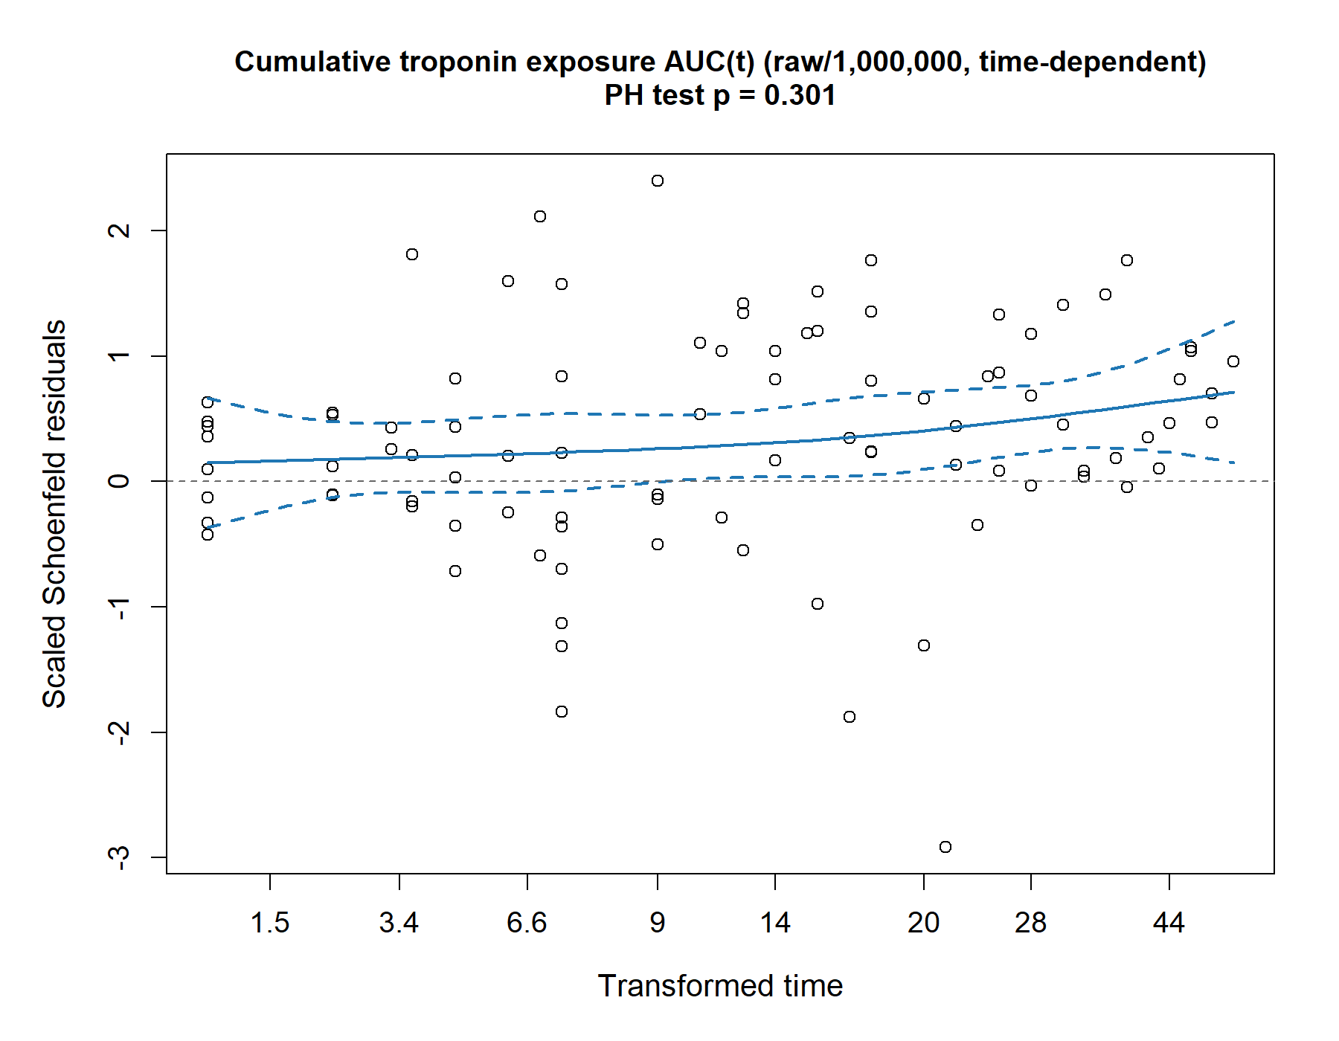
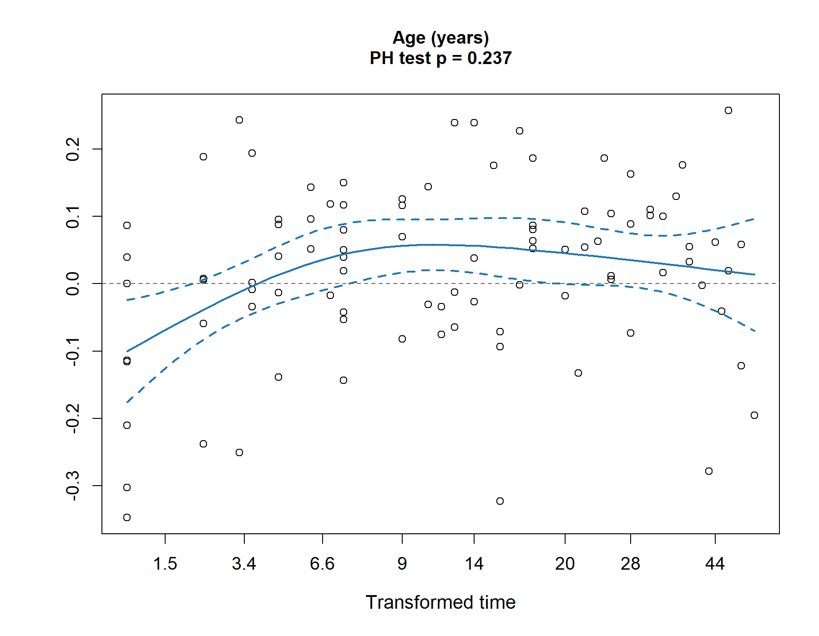
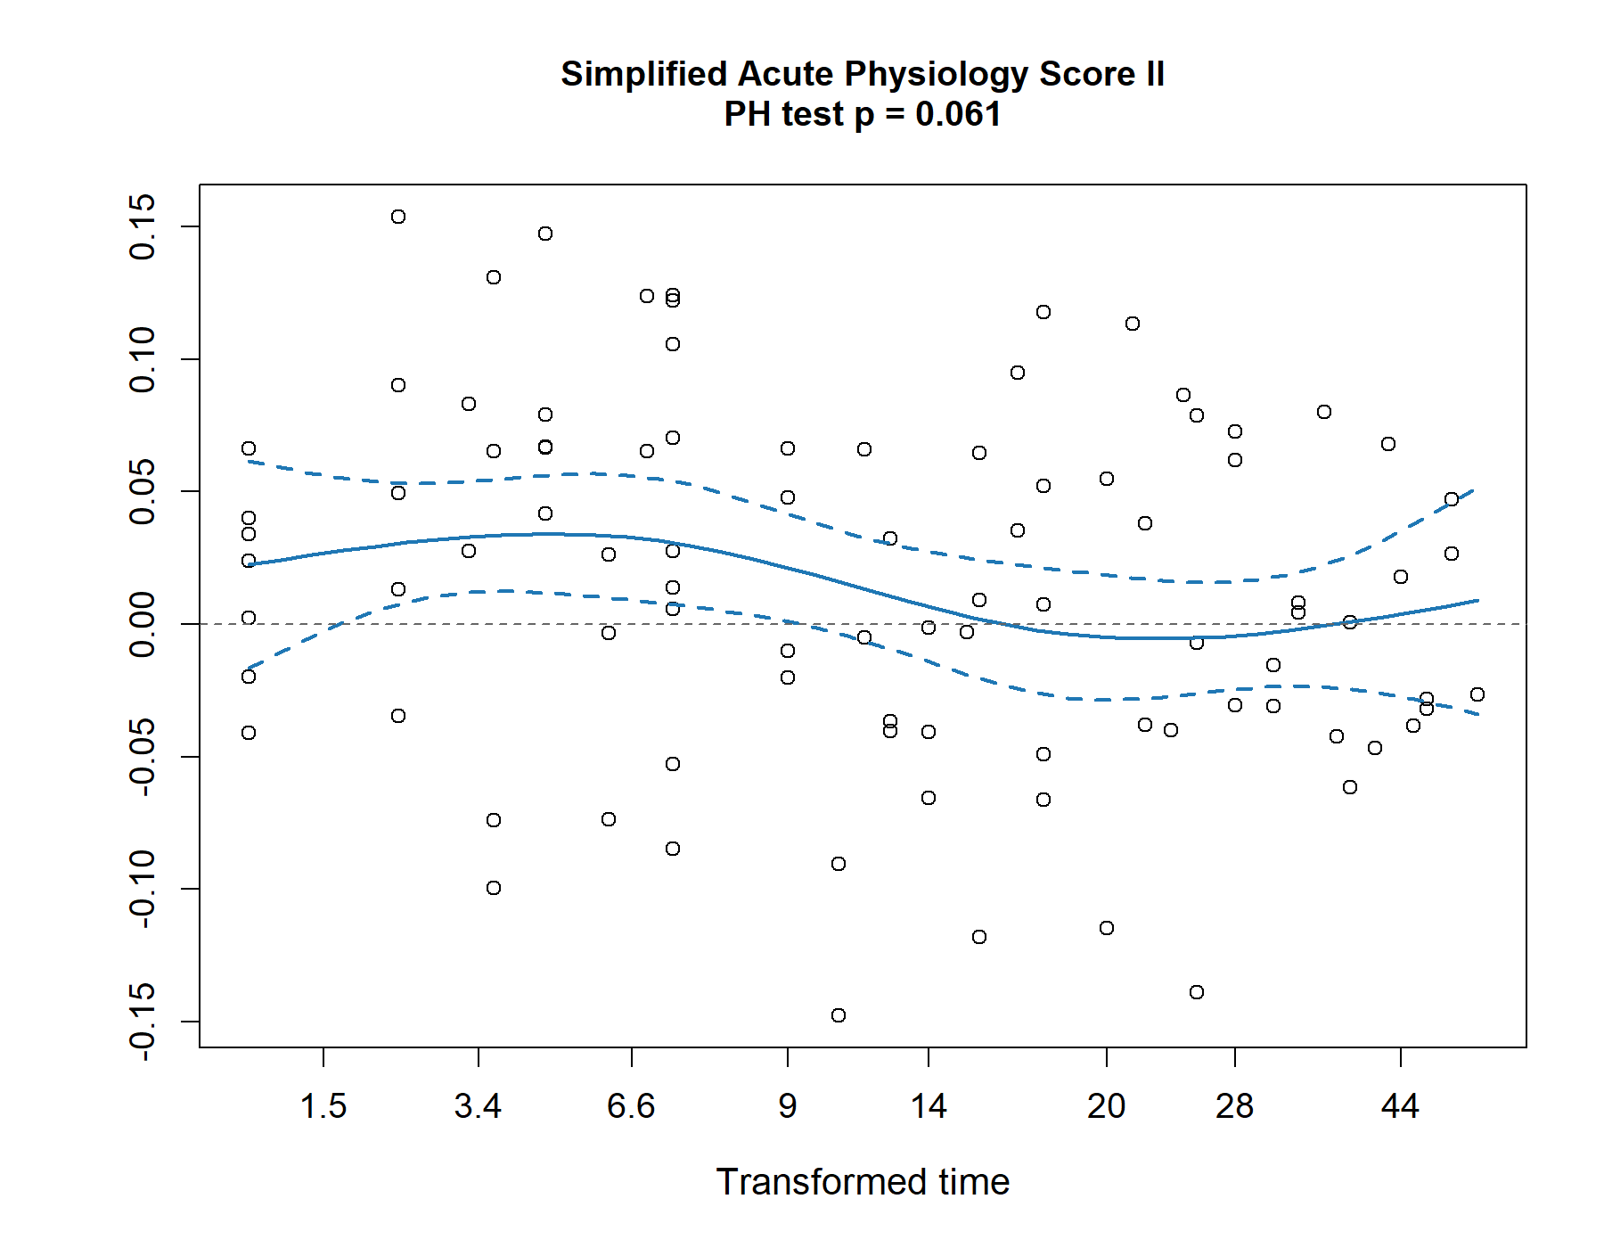
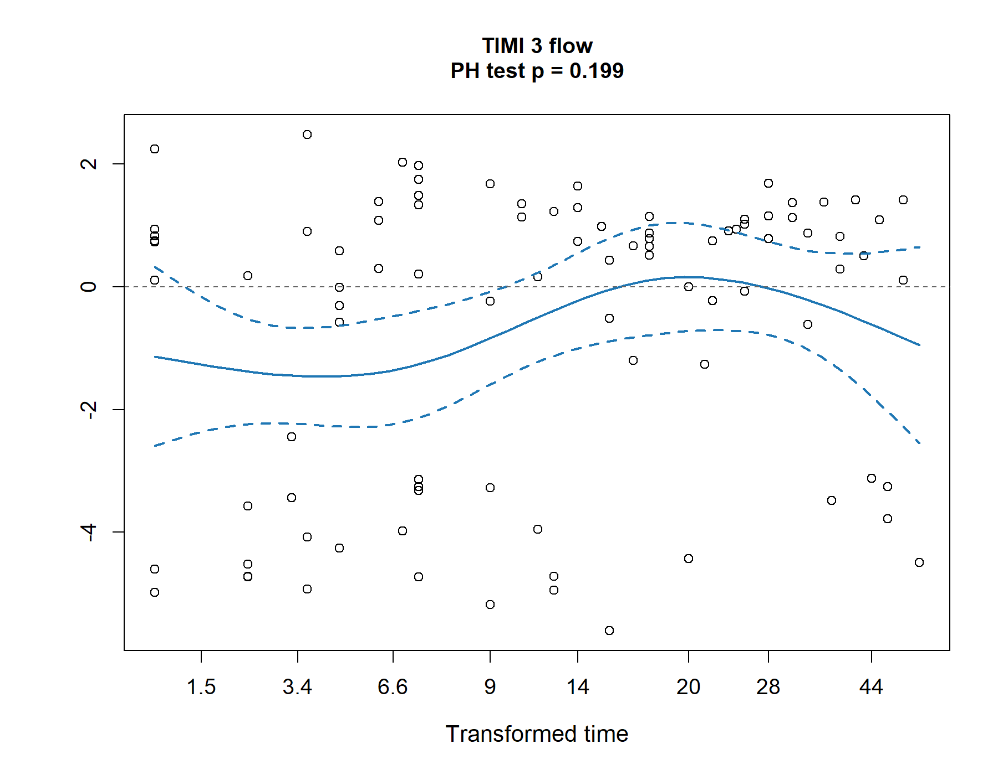
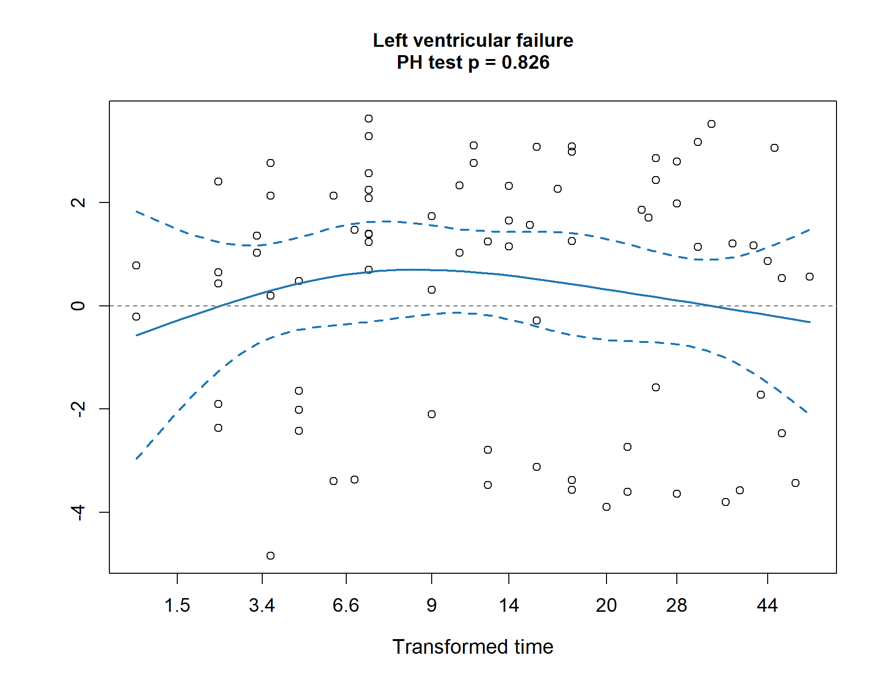
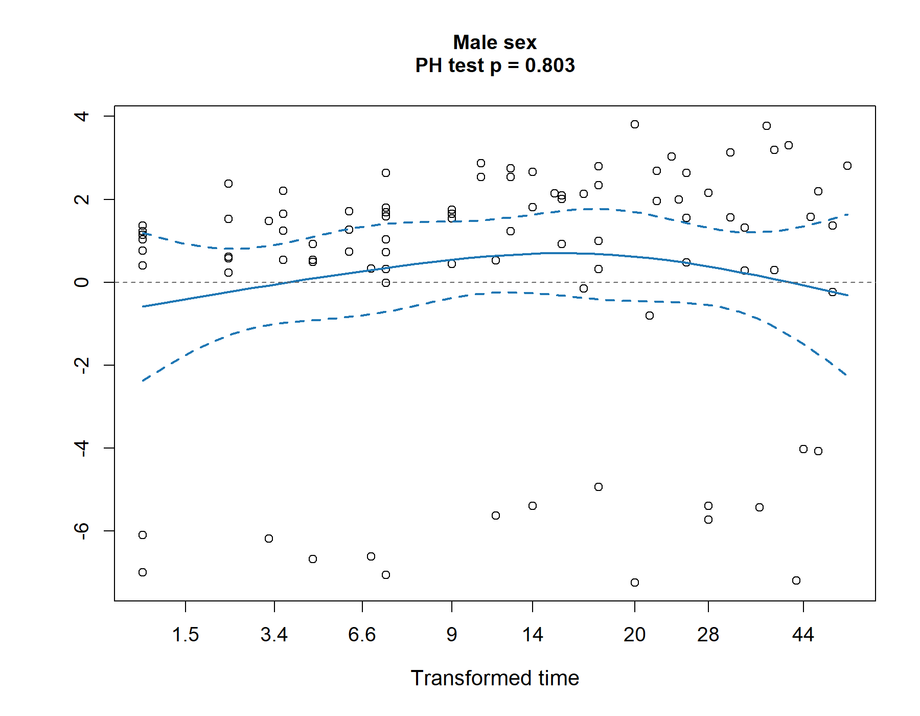
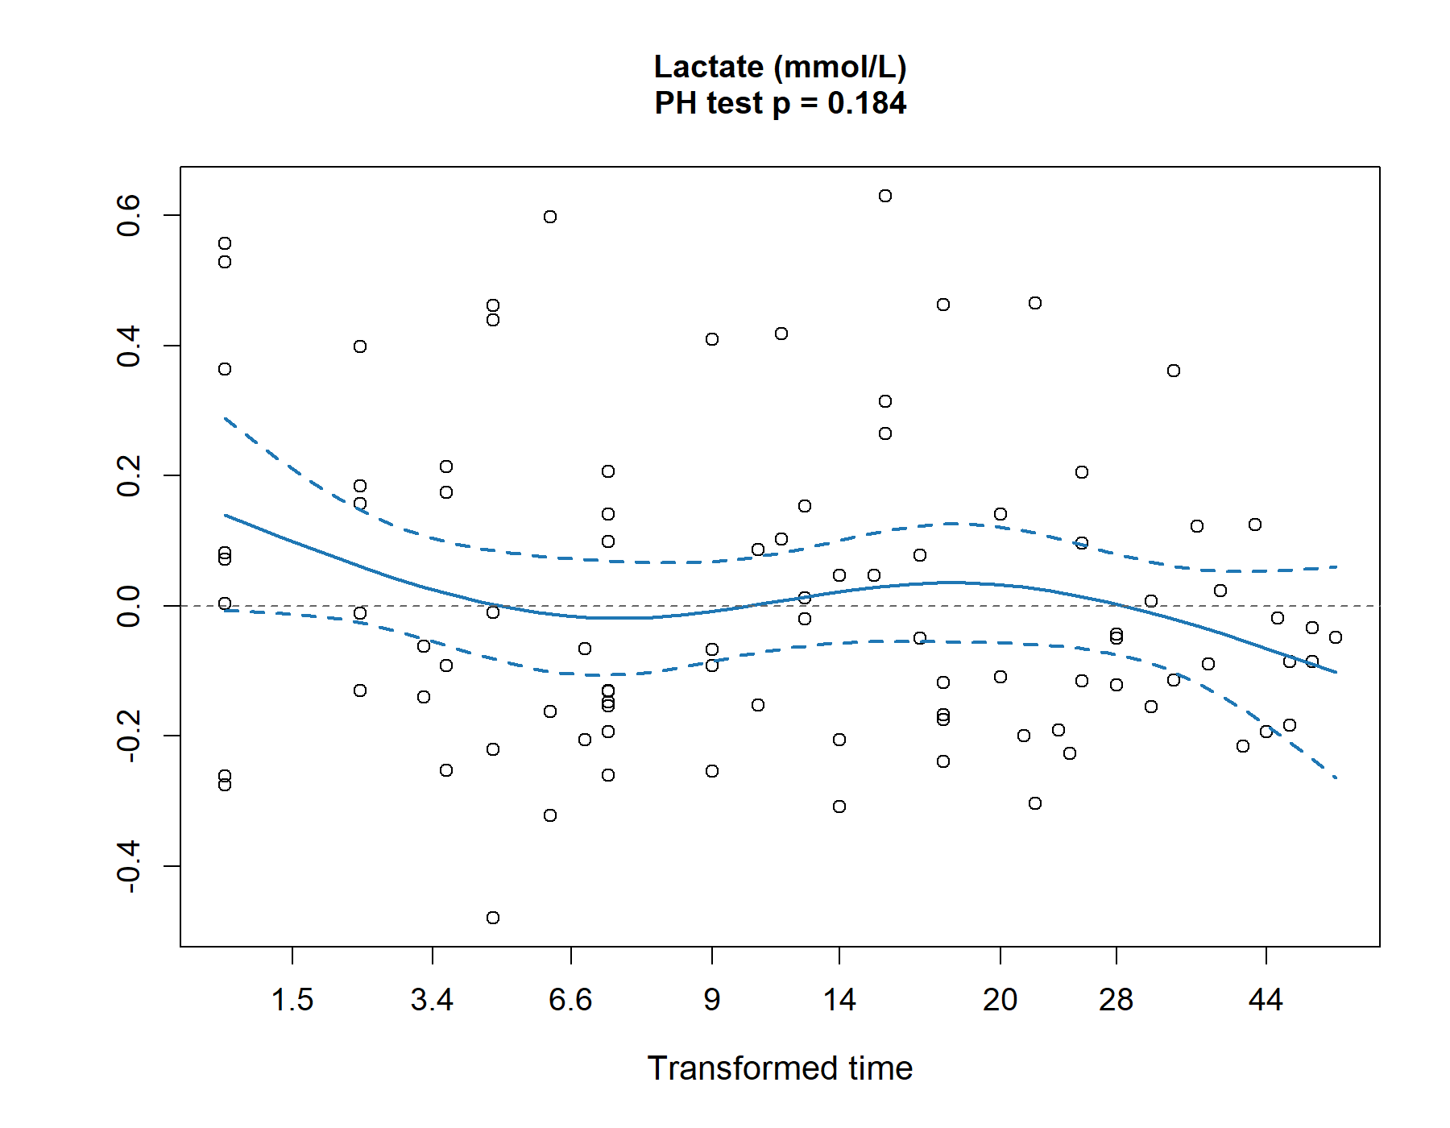
Supplementary Figure S2. Scaled Schoenfeld residuals for the final multivariable time-dependent Cox model

Scaled Schoenfeld residuals are shown for the covariates included in the final stratified multivariable time-dependent Cox model. Visual inspection did not reveal any clear systematic time-dependent pattern, and the proportional hazards tests were not statistically significant for any of the displayed covariates, supporting the absence of any major violation of the proportional hazards assumption. Extracorporeal cardiopulmonary resuscitation and left ventricular unloading are not shown because they were incorporated as stratification variables.
Abbreviations: AUC(t), time-updated cumulative troponin area under the concentration–time curve

Supplementary Figure S3. Discriminative performance of individual biomarkers for predicting tMCS weaning failure
A
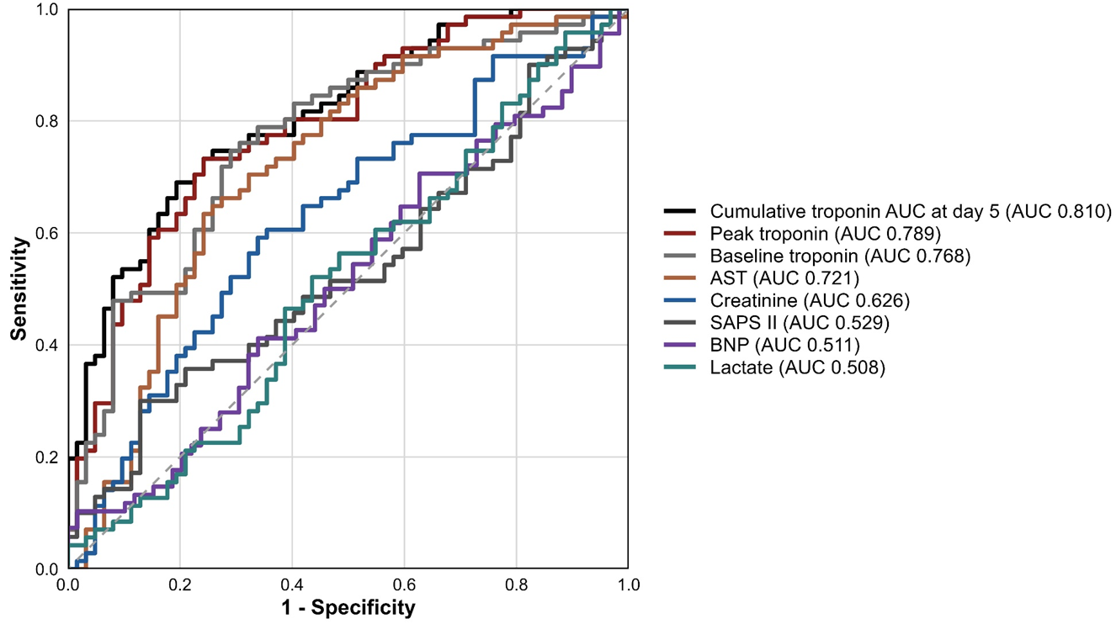
B
Biomarker | N | Events | AUC | 95% CI | Se | Sp | PPV | NPV | Youden | Threshold
T- AUC at day 5 | 133 | 71 | 0.81 | 0.74–0.88 | 0.69 | 0.81 | 0.80 | 0.69 | 0.50 | 869710
Peak troponin | 133 | 71 | 0.79 | 0.71–0.87 | 0.73 | 0.76 | 0.78 | 0.71 | 0.49 | 244938
Baseline troponin | 133 | 71 | 0.78 | 0.69–0.85 | 0.75 | 0.71 | 0.75 | 0.71 | 0.46 | 56305
AST | 133 | 71 | 0.72 | 0.63–0.81 | 0.63 | 0.76 | 0.75 | 0.64 | 0.39 | 733
Creatinine | 133 | 71 | 0.63 | 0.53–0.72 | 0.59 | 0.66 | 0.67 | 0.59 | 0.25 | 141
SAPS II | 132 | 70 | 0.53 | 0.43–0.63 | 0.29 | 0.87 | 0.71 | 0.52 | 0.16 | 81
BNP | 127 | 68 | 0.51 | 0.41–0.61 | 0.10 | 0.98 | 0.88 | 0.49 | 0.09 | 2480
Lactate | 133 | 71 | 0.51 | 0.41–0.61 | 0.52 | 0.57 | 0.58 | 0.51 | 0.09 | 6.25
ROC analysis evaluating the discriminative performance of individual biomarkers for predicting the primary endpoint between days 5 and 100. The analysis was performed in the day-5 landmark population, including patients alive and free from the primary endpoint at that time.
Panel A shows the ROC curves for each biomarker evaluated individually. Discrimination was quantified using the AUC.
Panel B reports the corresponding diagnostic performance metrics, including AUC with 95% CIs, Se, Sp, PPV, NPV, and the Youden index. The optimal classification threshold for each biomarker was determined using the Youden index.
Abbreviations: AUC, area under the receiver operating characteristic curve; AST, aspartate aminotransferase; BNP, B-type natriuretic peptide; CI, confidence interval; NPV, negative predictive value; PPV, positive predictive value; ROC, receiver operating characteristic; SAPS II, Simplified Acute Physiology Score II; Se, sensitivity; Sp, specificity; T-AUC, troponin area under the concentration–time curve

Supplementary Methods. Detailed methodology for ROC and logistic regression analyses
In total, 159 patients were included in the initial cohort. After application of the day-5 landmark definition, 133 patients remained eligible for analysis. Among them, 71 experienced the primary endpoint between days 5 and 100, whereas 62 did not. Biomarker availability was high in the landmark population, with complete data available for all patients for day-5 T-AUC, baseline troponin, peak troponin, creatinine, AST, and lactate, whereas SAPS II and BNP were missing in a small number of patients (n = 1 and n = 6, respectively).
To quantify the discriminative performance of the biomarkers, univariable receiver operating characteristic (ROC) analyses were first performed for each biomarker individually. Discrimination was assessed using the area under the ROC curve (AUC) with corresponding 95% confidence intervals (CIs). To evaluate whether biomarkers improved prediction beyond clinical variables, a landmark multivariable logistic regression framework was applied. The binary outcome corresponded to the occurrence of the primary endpoint between days 5 and 100. Under this formulation, logistic regression models the log-odds of the event probability according to the following equation:
logit(P(Y = 1)) = β₀ + β₁X₁ + β₂X₂ + … + βₖXₖ
where P(Y = 1) represents the probability of experiencing the primary endpoint during the day-5 to day-100 interval, β₀ is the intercept, βᵢ are the regression coefficients, and Xᵢ represent the predictor variables included in the model.
A reference clinical model was specified a priori and included sex, age, TIMI 3 flow after revascularisation, SAPS II, arterial lactate concentration, left ventricular failure, extracorporeal cardiopulmonary resuscitation (ECPR), and left ventricular unloading. All predictors were entered simultaneously into the model without variable-selection procedures. Biomarker-augmented models were then constructed by adding one biomarker at a time to the reference clinical model. The biomarkers evaluated were day-5 T-AUC, baseline troponin, peak troponin, creatinine, AST, and BNP. Regression coefficients were estimated using maximum likelihood estimation. For each fitted model, predicted probabilities of the primary endpoint were calculated using the inverse logit transformation:
P(Y = 1) = exp(β₀ + ΣβᵢXᵢ) / (1 + exp(β₀ + ΣβᵢXᵢ))
These predicted probabilities were then used as continuous predictors to construct ROC curves. For each model, the AUC was calculated with 95% CIs using the pROC package. The optimal classification threshold was determined using the Youden index (sensitivity + specificity − 1), allowing calculation of sensitivity, specificity, positive predictive value (PPV), negative predictive value (NPV), and the corresponding Youden index.
To ensure comparability across the multivariable models, ROC analyses were performed using a common complete-case dataset including only patients with complete information for all variables included in the compared models. Finally, the discriminative performance of the biomarker-augmented models was formally compared with that of the reference clinical model using DeLong’s test for paired ROC curves.
Pairwise comparisons of the ROC curves were performed using DeLong’s test to assess whether the addition of individual biomarkers improved the discriminative performance of the clinical model. The addition of day-5 T-AUC significantly improved model discrimination compared with the clinical model alone (AUC 0.862 vs 0.750; p = 0.001). The addition of peak troponin also significantly improved discrimination (AUC 0.848 vs 0.750; p = 0.004). By contrast, the addition of baseline troponin did not significantly improve model discrimination (AUC 0.800 vs 0.750; p = 0.052).

Table S2. Sensitivity analyses
A
Variable | HR | 95% CI | p-value
AUC(t) (per 1,000,000 ng/L·day) | 1.500 | 1.249–1.802 | < 0.001
Male sex | 1.446 | 0.745–2.805 | 0.275
Age (years) | 1.045 | 1.012–1.078 | 0.006
TIMI 3 flow | 0.729 | 0.404–1.315 | 0.294
SAPS II | 1.005 | 0.990–1.020 | 0.551
Lactate (mmol/L) | 0.985 | 0.930–1.044 | 0.614
Left ventricular failure | 1.619 | 0.901–2.909 | 0.107
B
Variable | HR | 95% CI | p-value
Peak troponin (per 100,000 ng/L) | 1.127 | 1.056–1.201 | < 0.001
Male sex | 1.606 | 0.819–3.152 | 0.168
Age (years) | 1.035 | 1.003–1.067 | 0.030
TIMI 3 flow | 0.605 | 0.339–1.081 | 0.090
SAPS II | 1.007 | 0.992–1.022 | 0.369
Lactate (mmol/L) | 0.989 | 0.933–1.047 | 0.695
Left ventricular failure | 1.730 | 0.968–3.092 | 0.064
Panel A shows the time-dependent Cox proportional hazards model restricted to the day-5 landmark population. The model included cumulative troponin exposure modelled as the time-dependent variable AUC(t) from day 5 onwards and was adjusted for sex, age, TIMI 3 flow after revascularisation, SAPS II, arterial lactate concentration, and left ventricular failure, with stratification by extracorporeal cardiopulmonary resuscitation and left ventricular unloading. The model included 130 patients, comprising 69 events and 61 non-events, corresponding to 6,910 observation rows. Model fit and discrimination were summarised by the Akaike information criterion (AIC = 448.680) and Harrell’s concordance index (C-index = 0.721; SE = 0.035). The proportional hazards assumption was not violated (global Schoenfeld test: χ² = 7.508, df = 7, p = 0.378).
Panel B shows an alternative multivariable landmark Cox proportional hazards model in which cumulative troponin exposure was replaced by peak troponin concentration entered as a fixed baseline covariate at day 5. The model included 130 patients, comprising 69 events and 61 non-events, with 130 observation rows. Model fit and discrimination were summarised by the AIC (AIC = 456.192) and Harrell’s concordance index (C-index = 0.700; SE = 0.033). The model was stratified by extracorporeal cardiopulmonary resuscitation and left ventricular unloading. The proportional hazards assumption was not violated (global Schoenfeld test: χ² = 8.216, df = 7, p = 0.314).
Abbreviations: AIC, Akaike information criterion; AUC(t), time-updated cumulative troponin area under the concentration–time curve; CI, confidence interval; C-index, concordance index; df, degrees of freedom; HR, hazard ratio; ROC, receiver operating characteristic; SAPS II, Simplified Acute Physiology Score II; SE, standard error; TIMI, Thrombolysis in Myocardial Infarction

