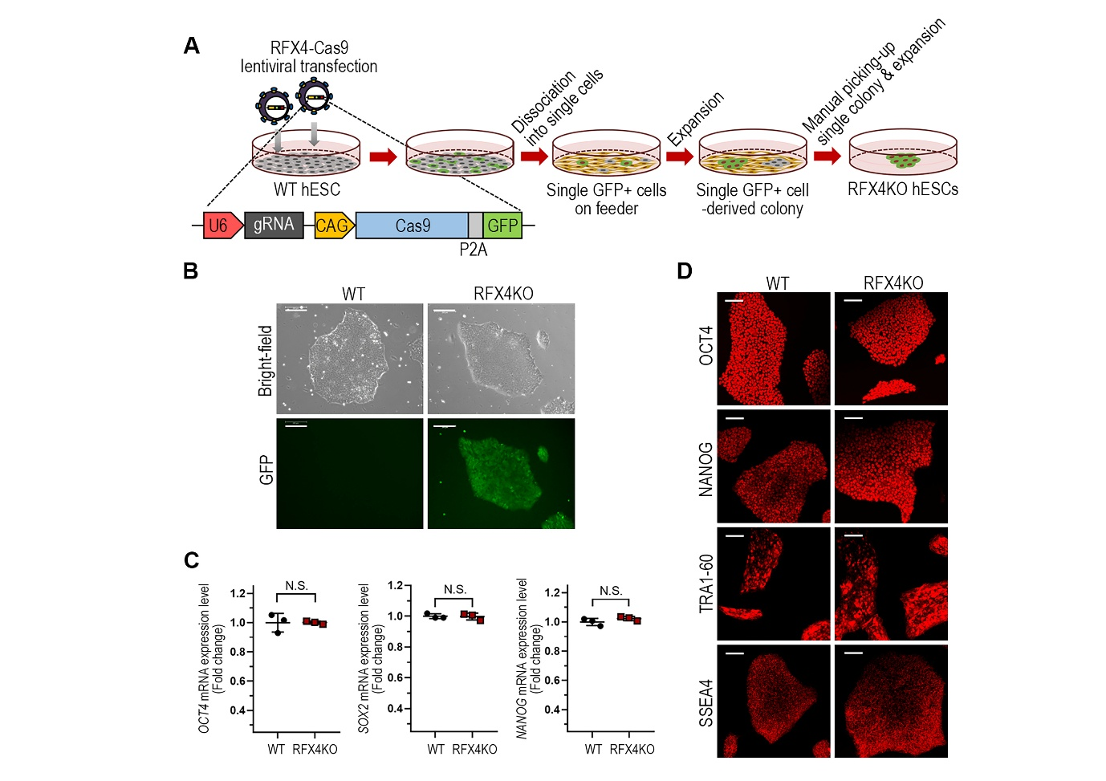
Supplementary Fig. 1. Establishment of RFX4KO hESC line. (A) Schematic illustration of the procedures for establishment of RFX4KO hESC line. hESCs were transduced with lentiviral particles encoding U6-driven RFX4 gRNA and CAG-driven Cas9-P2A-GFP (RFX4-Cas9). Single-cell suspensions were plated onto feeder layer. After expansion, individual GFP⁺ colonies were manually selected, and further expanded to establish the RFX4KO hESC line. U6, human U6 small nuclear RNA promoter; CAG, CMV early enhancer/chicken β-actin. (B) Representative bright-field and fluorescence images of WT and RFX4KO hESCs. Scale bar, 200 μm. (C) RT-qPCR analysis of pluripotency markers OCT4, SOX2, and NANOG in WT and RFX4KO hESCs. Data are presented as mean ± S.D. (n=6). N.S., not significant. (D) Representative immunofluorescence images showing the expression of pluripotency markers OCT4, NANOG, TRA1-60, and SSEA4 in WT and RFX4KO hESCs. Scale bar, 200 μm.

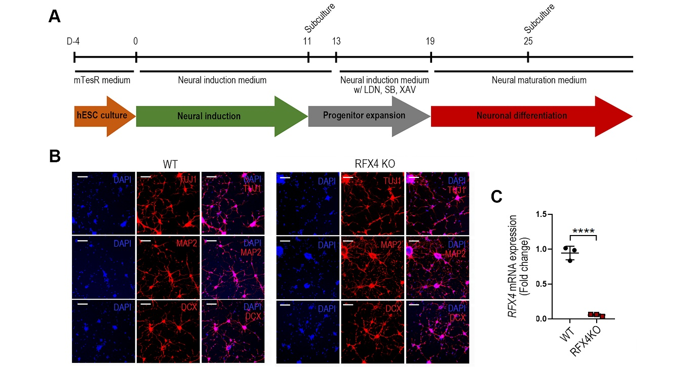
Supplementary Fig. 2. Differentiation of WT and RFX4KO hESCs into cortical neurons. (A) Schematic illustration of the procedures for differentiation of WT and RFX4KO hESCs into cortical neurons. (B) Representative immunofluorescence images showing the expression of the neuronal markers TUJ1, MAP2, and DCX in WT and RFX4KO hESC-derived neurons. Scale bar, 200 μm. (C) RT-qPCR analysis of RFX4 expression in WT and RFX4KO hESC-derived neurons. (n=3). ****p< 0.0001.

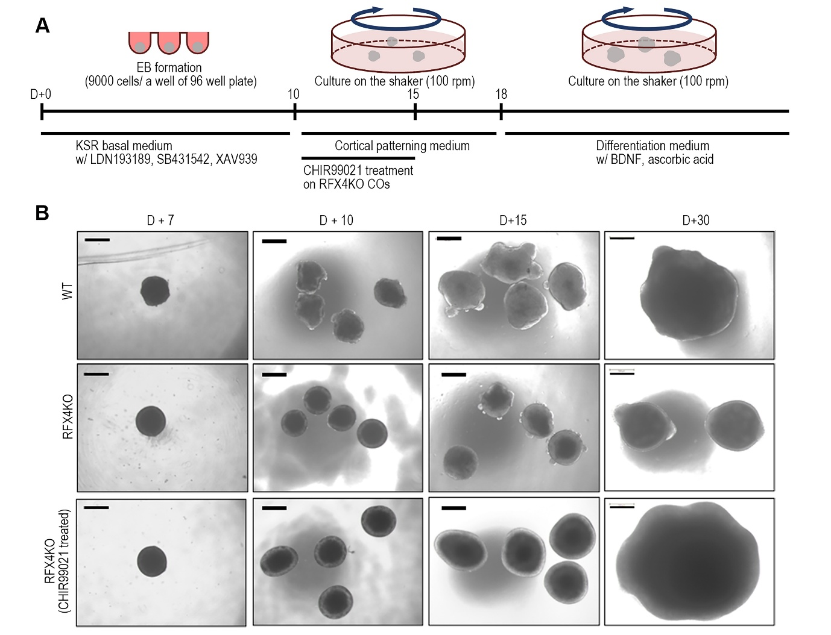
Supplementary Fig. 3. Generation of hESC-derived cortical organoids (COs). (A) Schematic illustration of the procedures for COs generation and the timing of CHIR99021 treatment. (B) Representative bright-field images showing the temporal changes in the morphology and size of WT COs (top), RFX4KO COs (middle), and CHIR99021-treated RFX4KO COs (bottom) at days 7, 10, 15, and 30. Scale bar, 500 μm.

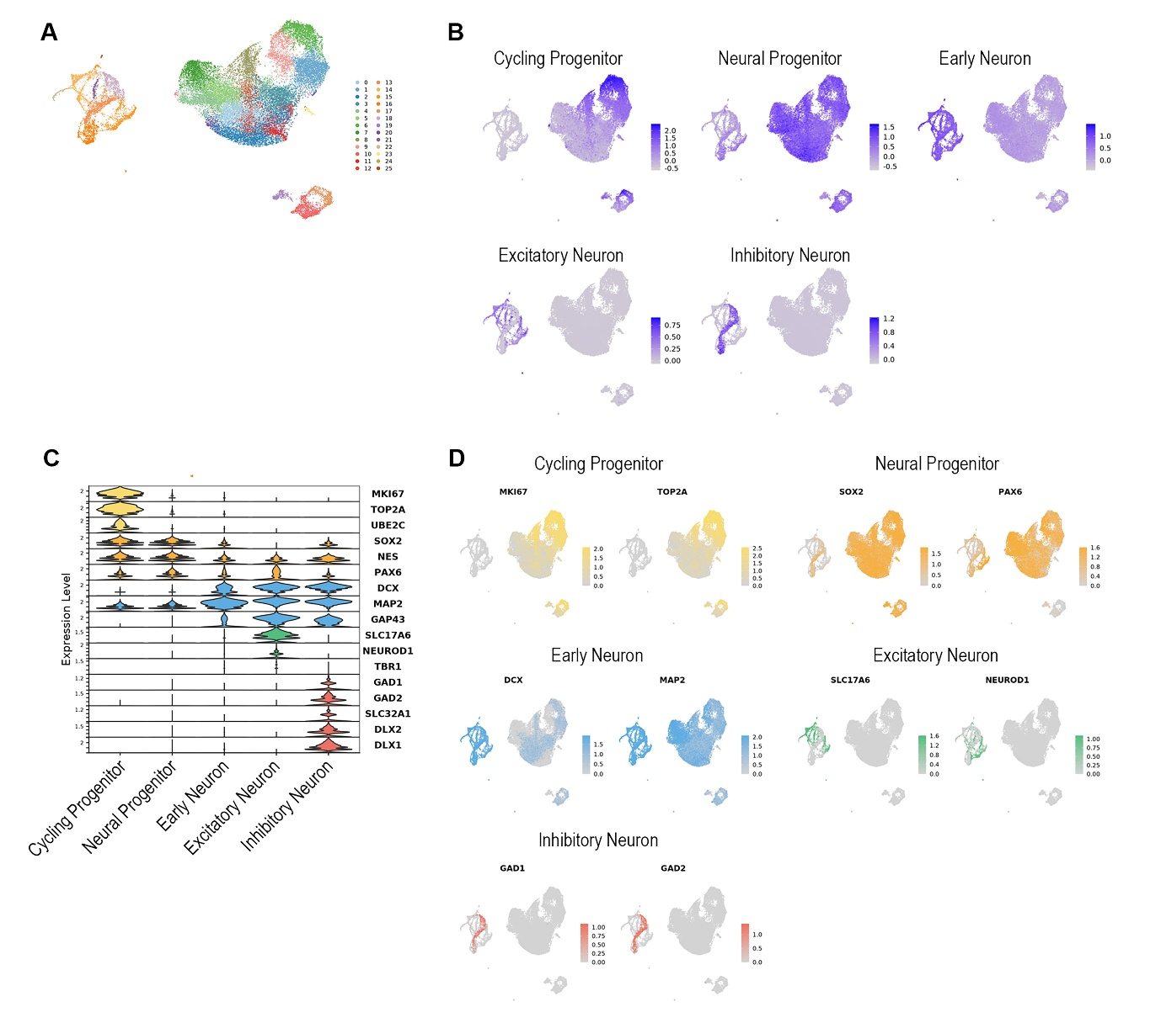
Supplementary Fig. 4. Single-cell RNA sequencing annotation of hESC-derived COs. (A) UMAP visualization of integrated scRNA-seq data from WT and RFX4KO COs at day 15, colored by unsupervised clustering. (B) Feature plots showing module scores for the annotated cell type signatures. (C) Stacked violin plot showing the expression of canonical marker genes across the five annotated cell populations. (D) Feature plots showing the expression of representative marker genes for each cell population. MKI67 and TOP2A (Cycling Progenitor); SOX2 and PAX6 (Neural Progenitor); DCX and MAP2 (Early Neuron); SLC17A6 and NEUROD1 (Excitatory Neuron); GAD1 and GAD2 (Inhibitory Neuron).
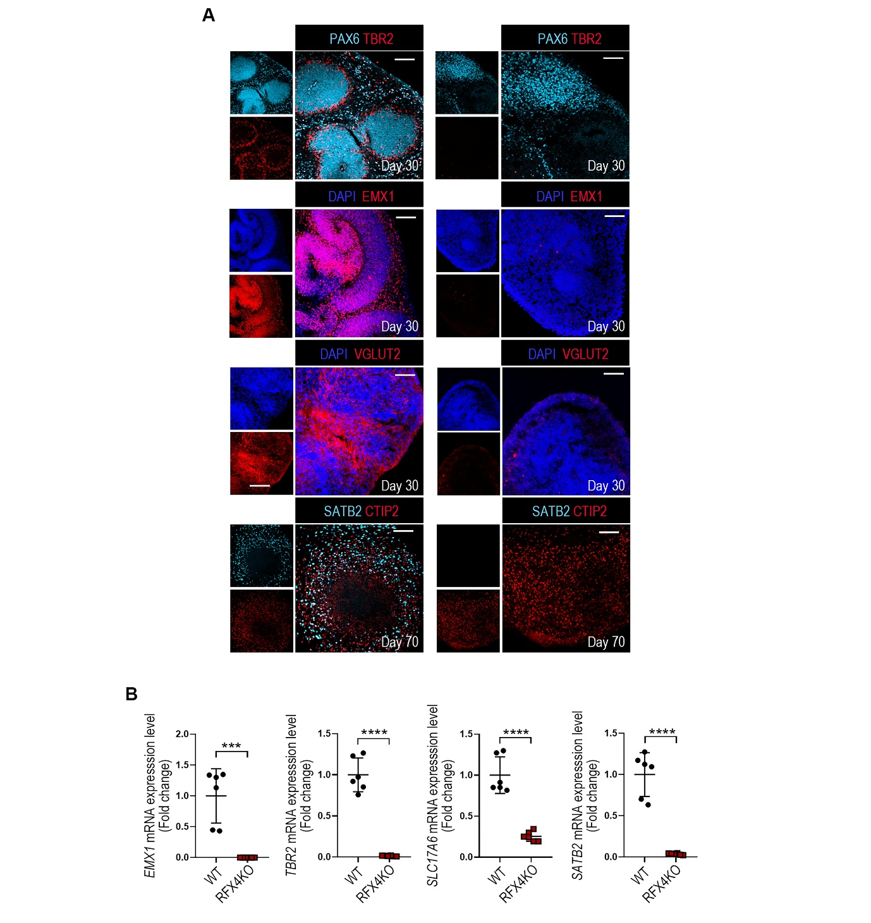
Supplementary Fig. 5. Expression of dorsal telencephalic markers in WT and RFX4KO COs. Immunohistochemistry for PAX6, EMX1, TBR2, VGLUT2, CTIP2, and SATB2 in WT and RFX4KO COs at different time points (day 30 and 70). Scale bar, 100 μm. (K) RT-qPCR analysis of dorsal telencephalic markers EMX1, TBR2, SLC17S6, and SATB2 in WT and RFX4KO COs. Data are represented as mean ± S.D. (n=6). ****p< 0.0001.

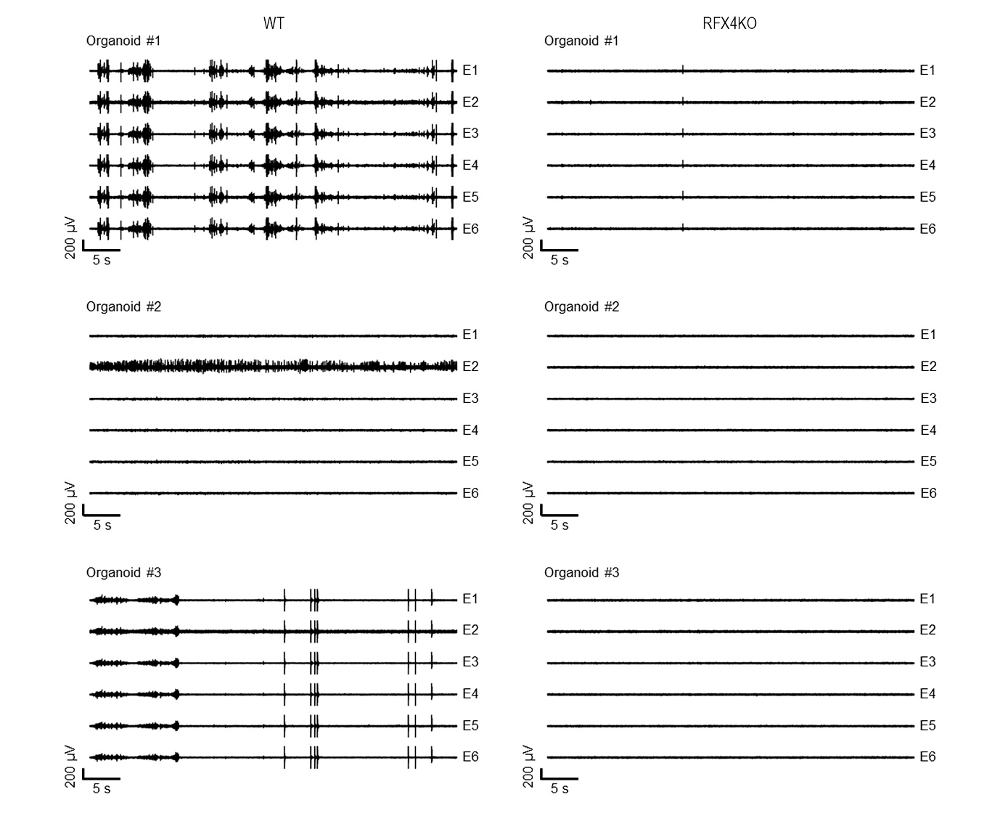
Supplementary Fig. 6. Representative extracellular recordings from WT and RFX4KO COs. Representative neural recordings obtained from three independent WT COs and three independent RFX4KO COs across six recording channels (E1–E6).

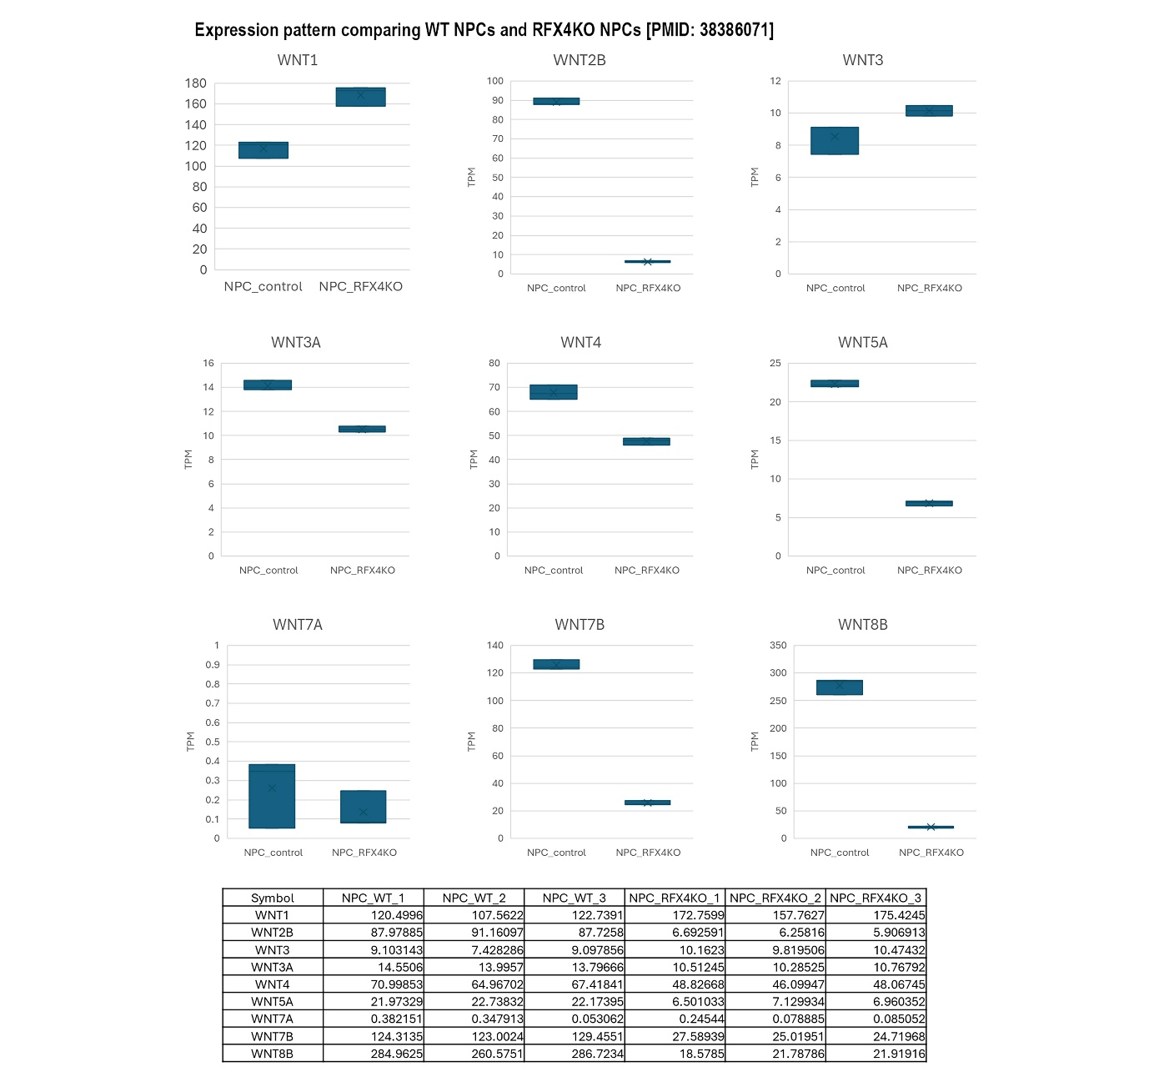
Supplementary Fig. 7. Expression of WNT family genes in WT and RFX4 KO neural progenitor cells (NPCs). TPM expression values of WNT1, WNT2B, WNT3, WNT3A, WNT4, WNT5A, WNT7A, WNT7B, and WNT8B in WT (NPC_control) and RFX4KO (NPC_RFX4KO) NPCs. n = 3 biological replicates per group. The table below shows the TPM values for each biological replicate.
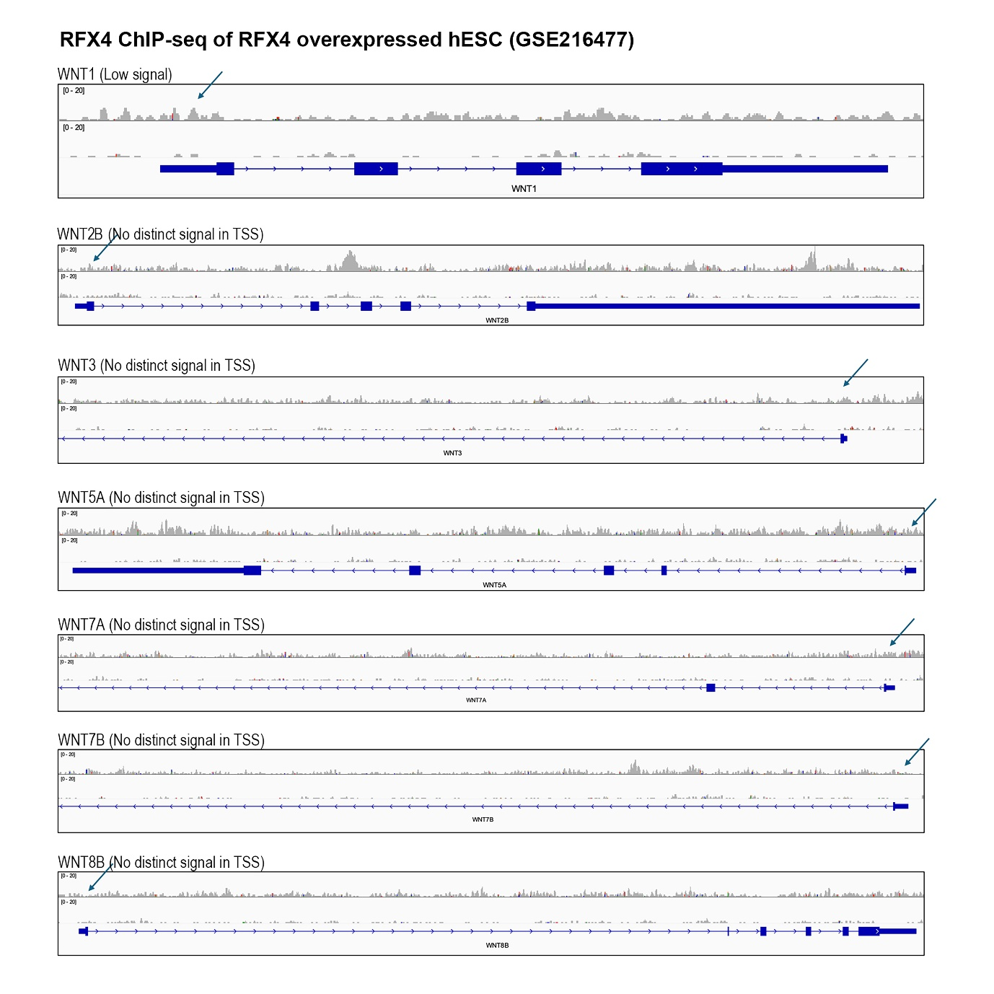
Supplementary Fig. 8. RFX4 ChIP-seq signal at WNT family gene loci. Genome browser tracks showing RFX4 ChIP-seq signal at the WNT1, WNT2B, WNT3, WNT5A, WNT7A, WNT7B, and WNT8B loci in RFX4-overexpressing hESCs. Arrows indicate the transcription start site (TSSs).
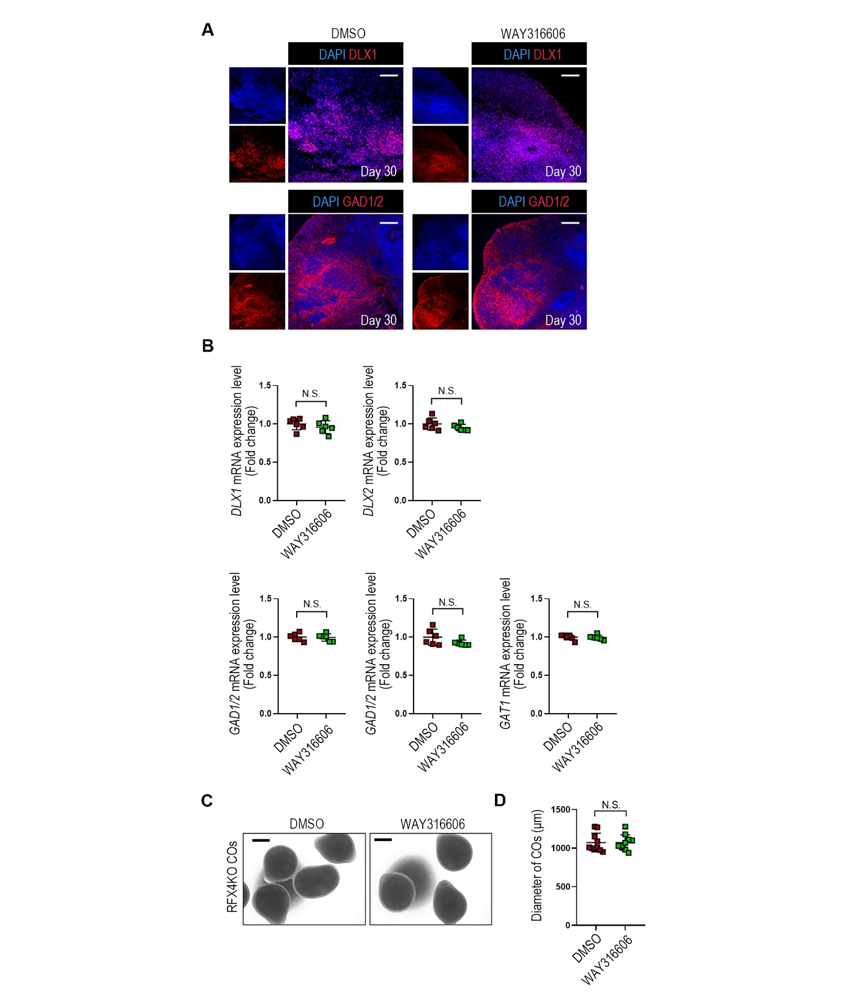
Supplementary Fig. 9. Effect of WAY316606, a SFRP1 inhibitor, on RFX4KO COs. (A) Immunohistochemistry for DLX1 and GAD1/2 in RFX4KO COs treated with DMSO (left) or WAY316606 (right) at day 30. Scale bar, 100 μm. (B) RT-qPCR analysis of ventral telencephlic markers (DLX1, DLX2, GAD1, GAD2, and GAT1) in RFX4KO COs treated with DMSO or WAY316606. Data are presented as mean ± S.D. (n=6). ****p< 0.0001. (C) Representative bright-field images showing the morphology and size of RFX4KO COs treated with DMSO or WAY316606. Scale bar, 500 μm. (D) Quantification of CO diameter at day 30 Diameters of RFX4KO COs treated with DMSO or WAY316606 were measured. Data are presented as mean ± S.D. (n=10).
Supplementary Table 1: List of Primary Antibodies
Antibody | Dilution | Source | Vendor, Cat. Number
Anti-SOX2 | 1:400 | Rabbit | Cell Signaling Technology, #3579S
Anti-SOX2 | 1:1000 | Mouse | Proteintech, #66411-1-Ig
Anti-RFX4 | 1:100 | Rabbit | NOVUS, #NBP2-48967
Anti-TUJ1 | 1:200 | Rabbit | Cell Signaling Technology, #5666S
Anti-TUJ1 | 1:200 | Mouse | R&D systems, #MAB1195
Anti-DCX | 1:200 | Rabbit | Cell Signaling Technology, #4604S
Anti-MAP2 | 1:400 | Rabbit | Biolegend, #840601
Anti-Nestin | 1:200 | Mouse | Biolegend, #656802
Anti-NKX2-1 | 1:200 | Rabbit | ABclonal, #A22248
Anti-DLX1 | 1:200 | Rabbit | Cell Signaling Technology, #96585T
Anti-GAD1/2 | 1:100 | Mouse | Santa Cruz, #sc-365180
Anti-GABA | 1:500 | Rabbit | GeneTex, #GTX125988
Anti-TBR2 | 1:200 | Rabbit | Abcam, #ab23345
Anti-EMX1 | 1:200 | Rabbit | NOVUS, #NBP1-86500
Anti-PAX6 | 1:500 | Rabbit | Biolegend, #901301
Anti-VGluT2 | 1:200 | Rabbit | Cell Signaling Technology, #16066T
Anti-SATB2 | 1:100 | Mouse | Santa Cruz, #sc-81376
Anti-CTIP2 | 1:400 | Rabbit | MedChemExpress, #HY-P80095
Anti-FOXG1 | 1:200 | Rabbit | Cell Signaling Technology, #29642T
Anti-Ki67 | 1:200 | Rabbit | ABclonal, #A20018
Anti-OCT4 | 1:200 | Mouse | Santa Cruz, #sc-5279
Anti-NANOG | 1:200 | Rabbit | Cell Signaling Technology, #3580S
Anti-TRA1-60 | 1:200 | Mouse | Santa Cruz, #sc-21705
Anti-SSEA4 | 1:200 | Mouse | Santa Cruz, #sc-21704

Supplementary Table 2: List of Secondary Antibodies
Antibody | Dilution | Vendor, Cat. Number
Goat anti-mouse IgG, FSD™ 488 | 1:500 | BioActs, # RSA1145
Goat anti-rabbit IgG, FSD™ 488 | 1:500 | BioActs, # RSA1245
Goat anti-mouse IgG, FSD™ 594 | 1:500 | BioActs, # RSA1195
Goat anti-rabbit IgG, FSD™ 594 | 1:500 | BioActs, # RSA1295

Supplementary Table 3: List of RT-qPCR Primers
Target | Sequence
RFX4 Fw | CGAGTCCTACATTGAGTGGCTG
RFX4 Rv | GTGCCGAAACAGGACCACATCA
OCT4 Fw | CCTGAAGCAGAAGAGGATCACC
OCT4 Rv | AAAGCGGCAGATGGTCGTTTGG
NANOG Fw | CTCCAACATCCTGAACCTCAGC
NANOG Rv | CGTCACACCATTGCTATTCTTCG
SOX2 Fw | GCTACAGCATGATGCAGGACCA
SOX2 Rv | TCTGCGAGCTGGTCATGGAGTT
TUJ1 Fw | TCAGCGTCTACTACAACGAGGC
TUJ1 Rv | GCCTGAAGAGATGTCCAAAGGC
MAP2 Fw | AGGCTGTAGCAGTCCTGAAAGG
MAP2 Rv | CTTCCTCCACTGTGACAGTCTG
DCX Fw | TATGCGCCGAAGCAAGTCTCCA
DCX Rv | CATCCAAGGACAGAGGCAGGTA
DLX1 Fw | CATCAGTTCGGTGCAGTCCTAC
DLX1 Rv | CCTTGCCATTGAAGCGCACTTC
DLX2 Fw | TACTCCGCCAAGAGCAGCTATG
DLX2 Rv | CGAATTTCAGGCTCAAGGTCCTC
GAD1 Fw | GCGGACCCCAATACCACTAAC
GAD1 Rv | CACAAGGCGACTCTTCTCTTC
GAD2 Fw | CTACGCGTTTCTCCATGCAA
GAD2 Rv | GCCAAAGTGGGCCTTTCTC
GAT1 Fw | TGCCGTGGAAACAGTGCGACAACCC
GAT1 Rv | TGCATGTTGCGCTCCCAGAACTCCACC
WNT2B Fw | TGGATGCCAAGGAGAAGAGGCT
WNT2B Rv | GTACAGGAACCACTCACGCCAT
WNT3A Fw | ATGAACCGCCACAACAACGAGG
WNT3A Rv | GTCCTTGAGGAAGTCACCGATG
WNT4 Fw | GCTGGAGAAGTGCGGCTGTGA
WNT4 Rv | CCACAAACGACTGTGAGAAGGC
WNT7B Fw | AGAAGACCGTCTTCGGGCAAGA
WNT7B Rv | AGTTGCTCAGGTTCCCTTGGCT
FOXG1 Fw | AGAAGAACGGCAAGTACGAGA
FOXG1 Rv | TGTTGAGGGACAGATTGTGGC
TBR2 Fw | AAATGGGTGACCTGTGGCAAAGC
TBR2 Rv | CTCCTGTCTCATCCAGTGGGAA
VGluT2 Fw | GAGAGGAGTAGACTGGCAACCA
VGluT2 Rv | CTGAAGACCAGCCAGTGTACTG
EMX1 Fw | GCCTTCGAGAAGAACCACTACG
EMX1 Rv | CGGTTCTGGAACCACACCTTCA
SATB2 Fw | GCAGTTGGACGGCTCTCTT
SATB2 Rv | CACCTTCCCAGCTTGATTATTCC
GAPDH Fw | CTCCACGACGTACTCAGCG
GAPDH Rv | TGTTGCCATCAATGACCCCTT

