Supplemental information

PET imaging using [¹⁸F]olaparib in mouse models of malignant glioma: considerations for molecular imaging and radionuclide therapy targeting PARP

Chung Ying Chan¹*, Samantha L. Hopkins¹*, Florian Guibbal^{2,}, Anna Pacelli¹, Julia Baguña Torres¹, Michael Mosley¹, Doreen Lau¹, Patrick Isenegger², Zijun Chen², Thomas C. Wilson², Gemma Dias¹, Rebekka Hueting¹, Véronique Gouverneur^{2,†}, and Bart Cornelissen^{1,3,†}

¹ MRC Oxford Institute for Radiation Oncology, Department of Oncology, University of Oxford, Oxford, OX3 7LJ, UK.
² Department of Chemistry, Chemistry Research Laboratory, University of Oxford, 12 Mansfield Road, Oxford, OX1 3TA, UK.
³ Department of Nuclear Medicine and Molecular Imaging, University Medical Centre Groningen, University of Groningen, Groningen, The Netherlands.

* These authors contributed equally on this work.

Supplemental Methods:
Unless otherwise noted, all reagents were purchased from Sigma-Aldrich and used without further purification.

Western blot of glioblastoma cell lysates
Western blots of cell lysates were performed to determine relative expression of PARP isoforms. Total protein preparations were produced at 4°C using RIPA buffer (50 mM Tris – pH 8.0, 1% NP40, 0.5% sodium deoxycholate, 0.1% sodium dodecyl sulphate, 150 mM sodium chloride, cOmpleteTM protease inhibitor cocktail [Sigma-Aldrich]). Cell lysates were isolated by centrifugation after lysis through a 21G hypodermic syringe. Bicinchoninic acid (BCA) colorimetric assay (Thermo Fisher) was used to normalise for total protein content. Thirty micrograms of cell lysate samples were run on a 4-12% NuPAGE Bis-Tris SDS gel (Novex) in MES running buffer (Novex), before semi-dry protein transfer (iBlot2) to a PVDF membrane. Membranes were washed with PBS-Tween20 (0.1%) for 10 min and blocked using 5% skim milk in PBS-Tween20 (0.1%) for 120 min. Anti-human PARP rabbit polyclonal antibodies at 1:500 dilution: anti-PARP1 antibody (HPA045168), anti-PARP2 antibody (HPA052003), and anti-PARP3 antibody (HPA067657) were incubated with membrane in 2.5% skim milk in PBS-Tween20 (0.1%) at 4°C overnight. The membranes were then washed for 3 x 10 min in PBS-Tween20 (0.1%) and incubated with the secondary goat anti-rabbit-HRP antibody (1:3000 dilution) (R&D Systems HAF008) at RT for 1 h, washed three time for 10 min with PBS-Tween20 (0.1%), and incubated with SuperSignalTM West Pico PLUS Chemiluminescent substrate (Thermo-Fisher) for 5 min. Images were acquired using a Licor C-Digit.

Autoradiography and Immunohistochemical staining
U251MG and U87MG xenograft tissues were flash-frozen using isopentane on dry ice and sectioned (10 µm) using a Leica CM1950 cryostat. Tissue sections were thaw-mounted onto Superfrost PLUS glass microscope slides (Menzel-Glaser, Thermo Scientific) and allowed to dry at room temperature (RT). The slides were then fixed in 10% NBF for 10 min at RT, dried, and exposed to a storage phosphor screen (PerkinElmer, Super Resolution, 12.5 x 25.2 cm) in a standard X-ray cassette for 15 h at 4°C. The phosphor screen was then imaged using a Cyclone® Plus Storage Phosphor System (PerkinElmer).
For tissues that were not used in autoradiography, after imaging and automated gamma counting, selected tissues from mice were fixed in 10% neutral buffered formalin overnight. Tissue was then flash frozen and stored at -80°C overnight. Frozen tissue was sectioned (10 µm) using a Leica CM1950 cryostat. Tissue sections were thaw-mounted onto Superfrost PLUS glass microscope slides (Menzel-Glaser, Thermo Scientific) and allowed to dry at RT. The slides were then stored at 4°C until used.

Immunohistochemical staining
For immunohistochemical staining, slides were placed at RT for 5-10 mins to thaw. Slide incubation procedures were performed in glass Coplin type jars. The sections were dehydrated and rehydrated by sequential immersion in ethanol at 100% (twice), 70% and 50%, for 3 min at each concentration, with a final 1 min wash in water. The slides were then immersed in citrate buffer (10 mM sodium citrate pH 6.0) with 0.05% tween-20, and antigen retrieval was performed in an antigen-decloaking chamber (Biocare Medical) at 125°C for 2.5 min, then 95°C for 1 min. The slides were allowed to cool, then placed on ice.
The sections were processed using the EnVision FLEX DAB+ Substrate Chromogen System (Dako Omnis; Agilent Stockport UK). Tissue sections were blocked in Peroxidase and Alkaline Phosphatase Blocking Reagent (S2003) for 15 min at RT, then incubated overnight at 4°C in tris-buffered saline buffer (TBS) with 1% bovine serum albumen (BSA) containing the following Atlas Antibodies (Sigma Aldrich, UK): anti-human PARP rabbit polyclonal antibodies at 1:150 dilution: anti-PARP1 antibody (HPA045168), anti-PARP2 antibody (HPA052003), and anti-PARP3 antibody (HPA067657). Following this incubation, the tissues were washed five times (5 min each) in phosphate-buffered saline (PBS), incubated for 30 min with Envision rabbit/mouse HRP polymer (K4065), and developed for 2.5 min using 1:50 dilution of DAB+ 2-component substrate (K3467). The sections were then washed in water twice (5 min each), and the nuclei counter-stained for 1 min in aqueous haematoxylin. This was followed by a 3 min wash in water, and four separate incubations in 100% ethanol (30 sec each), and two incubations in xylene (30 sec each). Coverslips were then mounted on DPX mounting media, and the slides left to set, and stored at 4°C.
Positive PARP staining in the tissue sections appeared brown, and the nuclei were counter-stained pink by the haematoxylin. Section images were acquired by a brightfield Aperio (Leica biosystem ScanScope CS2, Milton Keynes UK), and image analysis performed using the Leica Aperio ImageScope software.

Supplemental table:

Supplemental Table S1: Ex vivo biodistribution of [¹⁸F]olaparib (%ID/g) in U87MG and U251MG xenograft bearing-mice with or without the co-injection of unlabelled olaparib (20 µg) as blocking agent.

Tumour Xenograft %ID/g | U87MG-blocked |  |  | U87MG-non block |  |  | U251MG-blocked |  |  | U251MG-non block
Blood | 0.33 | 0.16 | 0.16 | 0.44 | 0.34 | 0.37 | 0.22 | 0.15 | 0.10 | 0.47 | 0.36 | 1.47
Tumour | 1.14 | 1.03 | 1.49 | 7.14 | 6.55 | 8.37 | 1.54 | 0.89 | 1.14 | 5.97 | 6.73 | 5.64
Heart | 0.44 | 0.26 | 0.31 | 1.01 | 0.70 | 1.02 | 0.21 | 0.23 | 0.40 | 0.83 | 0.68 | 0.63
Lung | 0.75 | 0.44 | 0.55 | 1.88 | 1.39 | 1.73 | 0.39 | 0.45 | 0.50 | 1.44 | 1.56 | 0.91
Liver | 16.35 | 15.93 | 12.82 | 19.56 | 13.67 | 15.61 | 12.39 | 9.13 | 10.74 | 14.92 | 14.05 | 8.95
Spleen | 4.42 | 3.40 | 3.60 | 18.29 | 12.51 | 22.55 | 2.51 | 1.87 | 2.08 | 14.65 | 13.32 | 14.29
Stomach | 2.28 | 1.24 | 3.51 | 3.99 | 2.68 | 5.83 | 0.80 | 2.10 | 2.23 | 4.23 | 3.43 | 3.28
Large intestine | 19.59 | 19.71 | 15.62 | 38.43 | 27.12 | 26.34 | 31.34 | 90.56 | 88.47 | 45.69 | 58.84 | 45.24
Small intestine | 72.15 | 57.42 | 52.18 | 29.03 | 24.09 | 29.89 | 40.38 | 15.62 | 18.95 | 24.14 | 16.82 | 17.60
Pancreas | 1.39 | 0.90 | 1.25 | 7.25 | 5.24 | 6.55 | 0.83 | 0.76 | 0.65 | 5.56 | 5.70 | 3.42
Kidney | 2.29 | 0.90 | 1.13 | 4.71 | 3.26 | 4.00 | 0.84 | 0.62 | 0.78 | 3.41 | 2.91 | 1.78
Muscle | 0.37 | 0.28 | 0.19 | 1.19 | 0.77 | 1.07 | 0.20 | 0.20 | 0.22 | 0.80 | 0.91 | 1.22
Skin | 0.41 | 0.26 | 0.37 | 1.40 | 0.80 | 1.12 | 0.29 | 0.35 | 0.17 | 0.97 | 0.93 | 0.87
Fat | 0.22 | 0.24 | 0.33 | 5.59 | 1.56 | 0.68 | 0.23 | 0.19 | 0.31 | 0.80 | 1.00 | --
Bone | 0.46 | 0.48 | 0.44 | 2.62 | 2.03 | 3.10 | 0.35 | 0.28 | 0.40 | 2.11 | 1.59 | 1.48
Caecum | 22.09 | 27.96 | 99.56 | 61.44 | 61.39 | -- | 81.85 | 184.08 | 175.74 | 95.13 | 96.66 | 131.24
Gallbladder | 78.87 | 180.66 | 147.48 | -- | 60.93 | 75.94 | 123.51 | 73.06 | 36.54 | 73.52 | 99.15 | 45.74
Brain | 0.05 | 0.03 | 0.04 | 0.08 | 0.04 | 0.11 | 0.03 | 0.04 | 0.11 | 0.12 | 0.09 | 0.07

Supplemental Table S2: Ex vivo biodistribution [¹⁸F]olaparib (%ID/g) in the U215MG xenograft bearing-mice.
U215MG  Xenograft %ID/g | Injected mass ([^{Total}F]olaparib)
U215MG  Xenograft %ID/g | 0.04 µg |  |  | 0.5 µg |  |  | 1.0 µg |  |  | 4.0 µg |  |  | 8.0 µg
Blood | 0.18 | 0.15 | 0.18 | 0.47 | 0.35 | 0.38 | 0.42 | 0.41 | 0.44 | 0.20 | 0.12 | 0.09 | -- | 0.27 | 0.21
Tumour | 3.56 | 2.79 | 4.98 | 5.70 | 4.49 | 3.92 | 8.82 | 6.52 | 5.99 | 3.68 | 2.76 | 2.26 | 2.82 | 3.33 | 3.61
Heart | 0.78 | 0.68 | 0.80 | 3.36 | 2.49 | 1.68 | 2.55 | 2.30 | 1.95 | 0.57 | 0.42 | 0.26 | 1.91 | 0.79 | 0.57
Lung | 1.68 | 1.21 | 1.37 | 6.97 | 4.95 | 3.12 | 4.72 | 3.86 | 3.56 | 1.39 | 0.86 | 0.72 | 3.59 | 1.49 | 1.20
Liver | 11.16 | 9.92 | 11.41 | 35.27 | 24.47 | 19.22 | 27.16 | 13.45 | 18.05 | 7.96 | 6.99 | 6.18 | 28.73 | 13.84 | 10.18
Spleen | 10.06 | 12.75 | 13.41 | 21.12 | 17.38 | 19.23 | 19.79 | 26.68 | 26.89 | 9.74 | 6.50 | 5.75 | 13.27 | 8.63 | 9.05
Stomach | 1.09 | 0.76 | 1.56 | 4.70 | 2.23 | 1.93 | 2.90 | 25.75 | 2.20 | 3.71 | 0.57 | 1.22 | 8.11 | 2.13 | 0.50
Large intestine | 13.32 | 49.46 | 57.79 | 8.78 | 10.88 | 27.82 | 10.44 | 4.27 | 20.61 | 18.72 | 8.59 | 42.58 | 11.87 | 9.01 | 38.73
Small intestine | 19.33 | 11.75 | 14.22 | 39.85 | 41.78 | 23.56 | 35.99 | 36.80 | 33.69 | 21.55 | 12.18 | 12.23 | 21.00 | 61.98 | 44.69
Pancreas | 5.38 | 5.23 | 6.01 | 10.48 | 13.03 | 9.50 | 14.16 | 11.09 | 11.78 | 3.93 | 2.50 | 1.88 | 6.06 | 2.97 | 3.14
Kidney | 2.92 | 2.73 | 2.70 | 12.67 | 9.70 | 6.04 | 8.17 | 7.36 | 6.88 | 2.26 | 1.37 | 1.08 | 9.80 | 2.55 | 2.06
Muscle | 0.82 | 0.70 | 0.87 | 1.99 | 1.77 | 1.42 | 1.89 | 1.54 | 1.59 | 0.57 | 0.29 | 0.26 | 1.17 | 0.60 | 0.42
Skin | 0.97 | 0.56 | 0.86 | 2.00 | 2.28 | 1.27 | 2.42 | 1.82 | 2.79 | 0.77 | 0.32 | 0.33 | 1.99 | 0.98 | 0.55
Fat | 0.31 | 1.63 | 0.74 | 0.87 | 3.09 | 1.96 | 1.05 | 1.49 | 2.09 | 0.95 | 0.30 | 0.24 | 7.82 | 0.44 | 0.63
Bone | 1.55 | 1.68 | 1.85 | 4.22 | 3.99 | 1.58 | 3.10 | 3.45 | 4.51 | 1.22 | 0.49 | 0.79 | 2.38 | 1.68 | 0.88
Caecum | 17.76 | 49.66 | 57.73 | 8.06 | 17.97 | 49.40 | 8.90 | 41.10 | 32.75 | 15.47 | 12.35 | 45.39 | 6.45 | 14.38 | 97.51
Gallbladder | 25.47 | 24.40 | 16.25 | 58.89 | 55.32 | 82.25 | 41.83 | 84.21 | 86.78 | 12.89 | 17.72 | 20.49 | -- | 51.95 | 40.69
Brain | 0.02 | 0.02 | 0.02 | 0.05 | 0.04 | 0.06 | 0.05 | 0.04 | 0.04 | 0.03 | 0.02 | 0.01 | 0.09 | 0.03 | 0.02

Supplemental Table S3: Ex vivo biodistribution [¹⁸F]olaparib (%ID/g) in the U87MG xenograft bearing-mice.
U87MG  Xenograft %ID/g | Injected mass ([^{Total}F]olaparib)
U87MG  Xenograft %ID/g | 0.04 µg |  |  | 0.5 µg |  |  | 1.0 µg |  |  | 4.0 µg |  |  | 8.0 µg
Blood | 0.76 | 0.23 | 0.21 | 0.47 | -- | 0.29 | 0.41 | 0.45 | 0.38 | 0.38 | 0.23 | 0.21 | -- | 0.11 | 0.13
Tumour | 5.01 | 3.05 | 2.81 | 7.62 | 6.02 | 4.59 | 7.35 | 5.62 | 6.49 | 3.47 | 1.27 | 2.46 | 1.56 | 1.62 | 1.95
Heart | 1.88 | 1.15 | 1.02 | 1.18 | 1.57 | 1.51 | 1.97 | 1.81 | 1.87 | 0.85 | 0.40 | 1.08 | 1.44 | 0.33 | 0.36
Lung | 2.71 | 4.09 | 1.92 | 2.86 | 2.53 | 2.85 | 3.79 | 3.22 | 3.03 | 1.74 | 0.77 | 1.92 | 2.49 | 0.73 | 0.76
Liver | 9.73 | 13.67 | 12.24 | 17.95 | 15.89 | 14.36 | 24.74 | 18.98 | 16.03 | 9.52 | 10.69 | 9.15 | 10.61 | 11.42 | 10.48
Spleen | 8.86 | 11.35 | 10.65 | 18.15 | 16.48 | 11.98 | 19.13 | 12.42 | 21.50 | 7.32 | 6.97 | 9.90 | 6.74 | 6.88 | 5.77
Stomach | 1.19 | 1.45 | 1.63 | 1.01 | 1.38 | 3.75 | 2.13 | 1.31 | 3.77 | 2.02 | 3.31 | 0.70 | 2.32 | 2.93 | 0.43
Large intestine | 15.39 | 13.60 | 18.81 | 16.86 | 8.32 | 10.76 | 16.42 | 13.52 | 10.91 | 14.48 | -- | 8.93 | 26.81 | -- | --
Small intestine | 17.70 | 18.95 | 17.65 | 42.79 | 25.29 | 33.04 | 40.72 | 33.72 | 38.64 | 31.36 | 9.74 | 23.81 | 28.57 | 17.76 | 9.37
Pancreas | 9.61 | 7.63 | 7.21 | 9.78 | 9.78 | 9.22 | 11.63 | 11.01 | 9.38 | 4.71 | 2.39 | 8.22 | 5.36 | 1.81 | 2.09
Kidney | 5.39 | 4.26 | 4.24 | 5.17 | 5.76 | 6.35 | 7.58 | 6.23 | 6.15 | 2.78 | 1.37 | 2.23 | 3.68 | 1.18 | 1.12
Muscle | 1.19 | 1.07 | 0.95 | 1.49 | 1.06 | 1.39 | 1.37 | 1.96 | 1.15 | 0.61 | 0.36 | 0.41 | 0.86 | 0.28 | 0.30
Skin | 1.87 | 1.40 | 1.36 | 2.54 | 1.33 | 1.87 | 1.94 | 1.72 | 1.55 | 1.12 | 0.41 | 0.33 | 1.74 | 0.38 | 0.44
Fat | 10.68 | 1.78 | 1.38 | 1.90 | 1.00 | 1.60 | 1.64 | 2.72 | 1.32 | 0.87 | 0.24 | 0.27 | 3.39 | 0.14 | 0.21
Bone | 2.22 | 1.85 | 1.37 | 3.03 | 2.22 | 2.35 | 2.03 | 2.19 | 2.72 | 0.90 | 0.71 | 1.57 | 2.20 | 0.61 | 0.60
Caecum | 13.32 | 19.64 | 40.32 | 33.53 | 14.75 | 11.90 | 8.08 | 19.42 | 18.01 | 15.07 | -- | 15.66 | 10.28 | -- | 91.52
Gallbladder | 24.23 | 18.60 | 31.81 | 78.39 | 31.04 | 42.10 | -- | 35.81 | -- | 22.84 | 25.78 | -- | 10.93 | 28.20 | 32.95
Brain | 0.07 | 0.03 | 0.03 | 0.03 | 0.04 | 0.04 | 0.05 | 0.05 | 0.03 | 0.05 | 0.02 | 0.02 | 0.07 | 0.01 | 0.02

Supplemental Table S4: Tumour uptake of [¹⁸F]olaparib at various injected masses. Error bars are mean ± SD.

Tumour Xenograft %ID/g | Injected mass of [^{Total}F]olaparib
 | 0.04 μg | 0.5 μg | 1.0 μg | 4.0 μg | 8.0 μg | 21.0 μg
U87MG | 3.6 ± 1.2 | 6.1 ± 1.5 | 6.9 ± 1.3 | 2.4 ± 1.1 | 1.7 ± 0.2 | 1.2 ± 0.2
U251MG | 3.8 ± 1.1 | 4.7 ± 0.9 | 6.7 ± 1.2 | 2.9 ± 0.7 | 3.3 ± 0.4 | 1.2 ± 0.3

Supplemental Table S5: Summary of PARP1-3 expression in different organs. www.ebi.ac.uk

 | Bone | Spleen | Pancreas | Lung | Skin | Intestine | Caecum
PARP1 | high | high | mid | mid | mid | mid | mid
PARP2 | mid | high | mid | high | mid | mid | mid
PARP3 | low | low | low | low | mid | low | low

Supplemental data:

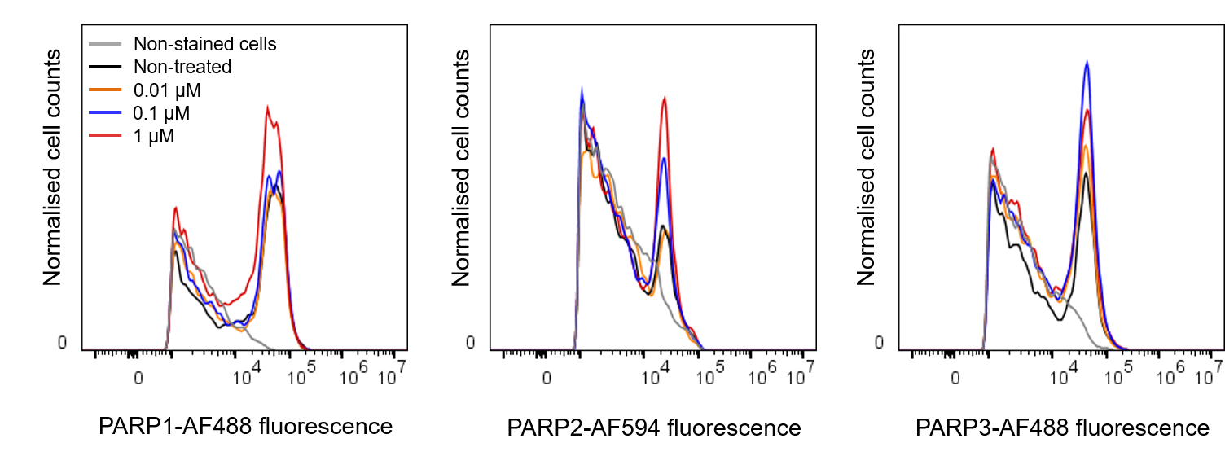

Supplemental Fig. S1: Representative histogram frequency probing for PARP1-3 expressions in U87MG cells after exposed to unlabelled olaparib (0-1 μM) for 3 h.
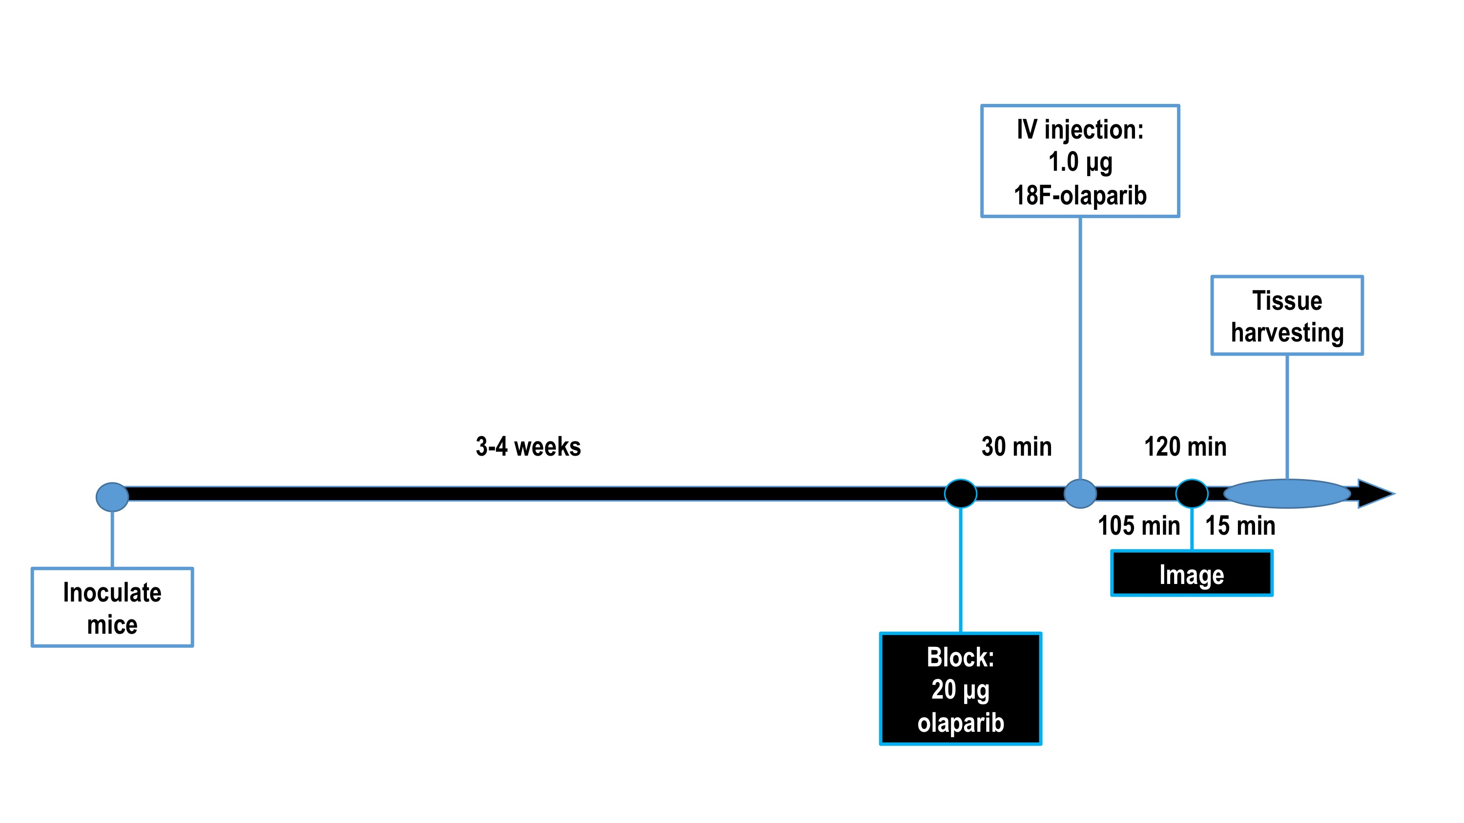
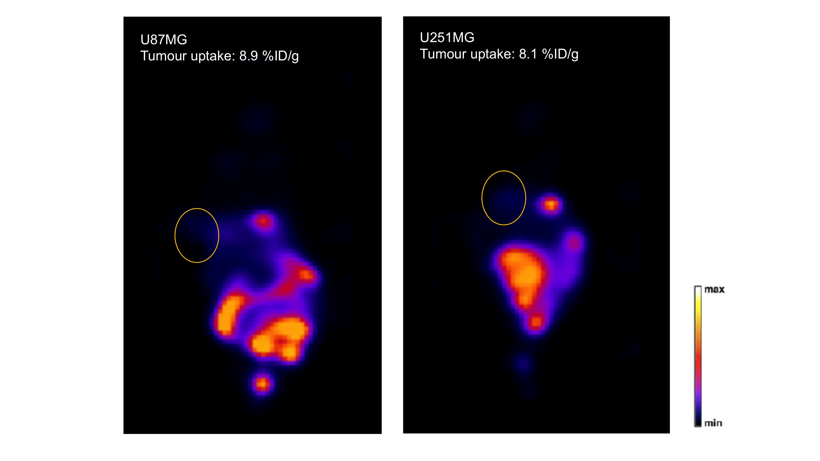

Supplemental Fig. S2: Schematic of experimental design of imaging experiments and representative PET images of U87MG and U251MG xenograft-bearing mice 105 min after injection of [¹⁸F]olaparib.

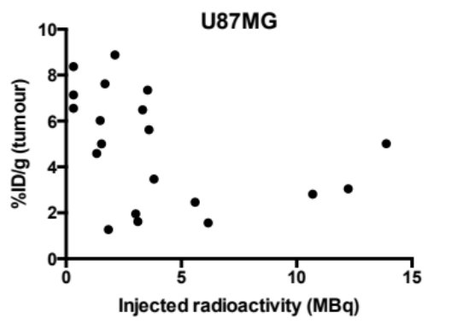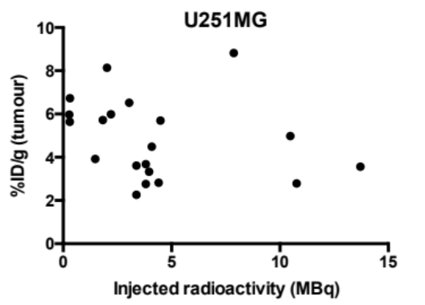

Supplemental Fig. S3: A lack of correlation between injected radioactivity (0.28-13.89 MBq) and tumour uptake of [¹⁸F]olaparib in the U87MG and U251MG xenograft tumours.

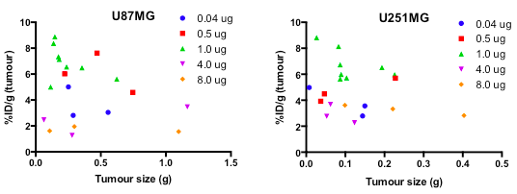

Supplemental Fig. S4: A lack of effect of tumour size (0.03-1.26 g) on tumour uptake of [¹⁸F]olaparib in the U87MG and U251MG xenograft tumours.

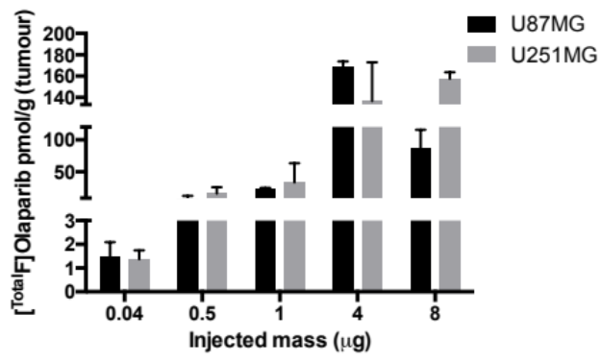

Supplemental Fig. S5: The effect of injected mass (μg, [¹⁸F]olaparib + [¹⁹F]olaparib) on overall olaparib accumulation (pmol/g) in the U87MG (P>0.05) and U251MG (P<0.01) xenograft tumours.

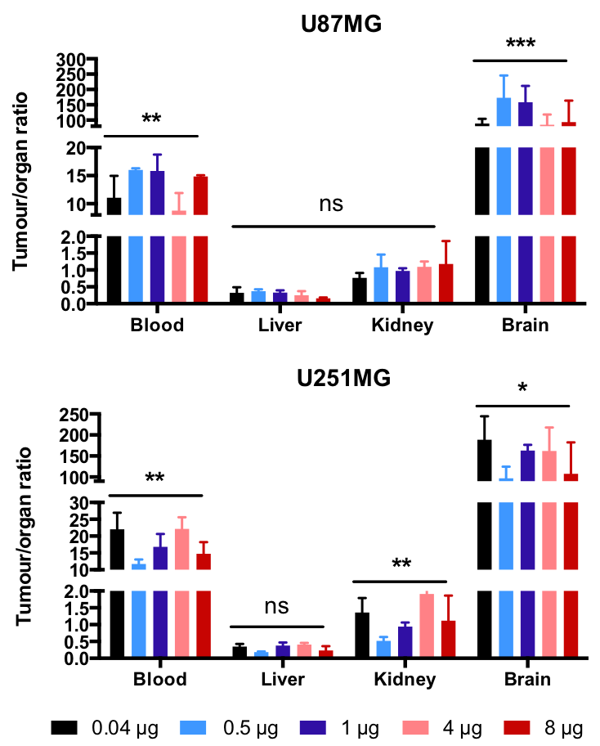

Supplemental Fig. S6: Tumour-to-organ ratio ([¹⁸F]olaparib, %ID/g) in the U251MG an U87MG xenograft bearing-mice. ^{ns}P>0.05; *P<0.05; **P<0.01; ***P<0.001.

