Supplementary Material
Figure S1. Comparison of continuous variable outliers before and after processing. Page 1
Figure S2. Variable missing value overview. Page 2-3
Figure S3. Sensitivity analysis of six missing data imputation methods. Page 4-5
Figure S4. Feature importance consistency across machine learning models. Page 6-7
Figure S5. Confusion matrices and accuracy (ACC) of ten machine learning models on the independent testing set. Page 8-9
Figure S6. Decision Curve Analysis of Ten Machine Learning Models Based on 200 Bootstrap Resampling Corrections. Page 10
Figure S7. Feature importance heatmap across multiple machine learning models. Page 11
Table S1. Sensitivity analysis of six missing data imputation methods. Page 12
Table S2. Relationship between baseline characteristics and the occurrence of MACE events. Page 13-18

Table S3. Comparison of characteristics before and after multiple imputation in the training set. Page 19-21
Table S4. Comparison of characteristics before and after multiple imputation in the testing set. Page 22-24
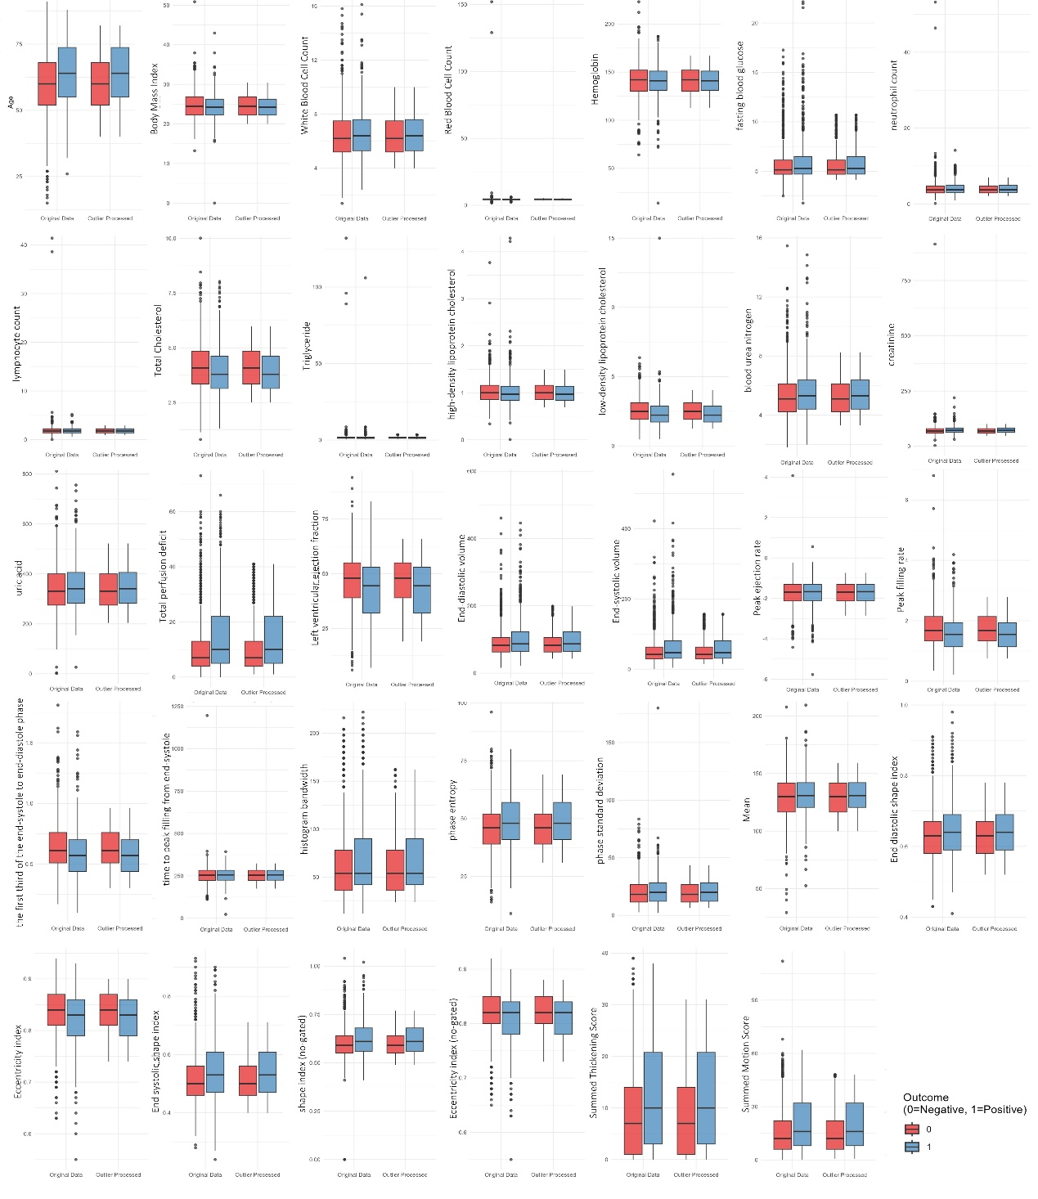
Figure S1. Comparison of continuous variable outliers before and after processing.
This figure illustrates the comparison of continuous variable outliers before and after processing. Outliers are defined as values exceeding the upper quartile (Q3) plus 1.5 times the interquartile range (IQR), or below the lower quartile (Q1) minus 1.5 times the interquartile range, and are replaced with these limits to bring them closer to the main data distribution. The box plots depict the distribution of each variable before and after processing, including the median, interquartile range, and extreme values. This visualization allows for a straightforward assessment of the distributional changes for each variable before and after outlier processing.
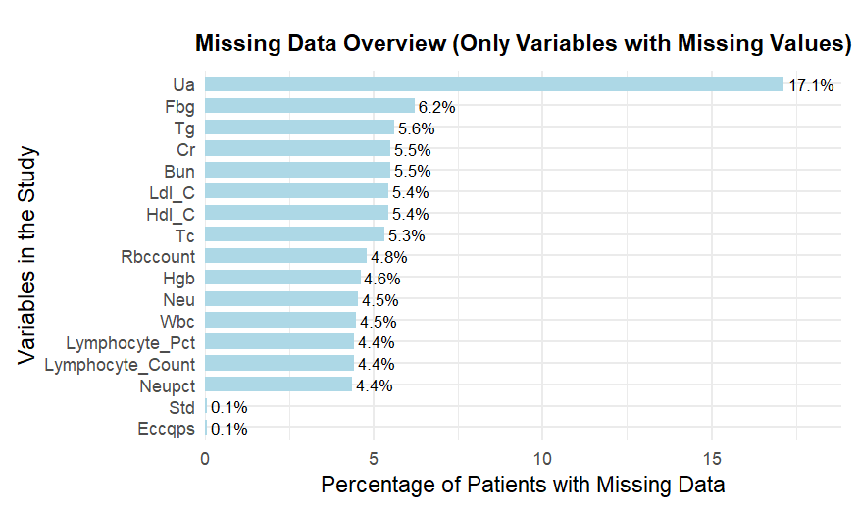
Figure S2. Missing data overview for study variables.
Variables are displayed on the y-axis. The x-axis represents the percentage of missing values (ranging from 0% to 100%). Variables are sorted from highest to lowest missingness, revealing data completeness patterns across the study cohort.
The details of the six missing data imputation methods are as follows:
1.multiple imputation method: pmm_logreg_polyreg (Predictive Mean Matching, Logistic Regression, Multinomial Logistic Regression):
Predictive Mean Matching: Used for imputing continuous variables by selecting observed values most similar to the missing data, ensuring the plausibility of the imputed values.
Logistic Regression: Applied for imputing binary variables by fitting a logistic regression model to predict missing values.
Multinomial Logistic Regression: Used for imputing categorical variables with multiple categories, preserving the distributional characteristics of the categorical data.
2.random_forest (Random Forest Imputation, rf):
Random Forest: A non-parametric imputation method that uses the Random Forest algorithm to model missing values based on the relationships between variables. This method can handle both continuous and categorical variables.
3.bayes_logreg_polyreg (Bayesian Regression, Logistic Regression, Multinomial Logistic Regression):
Bayesian Regression: Used for imputing continuous variables, this method incorporates prior distributions into the regression model for better estimation.
Logistic Regression: Used for imputing binary variables as in the pmm_logreg_polyreg method.
Multinomial Logistic Regression: Applied for imputing categorical variables with multiple categories, as in the pmm_logreg_polyreg method.
4.CART (Classification and Regression Trees):
CART Imputation: A decision-tree-based method used to impute both continuous and categorical variables. It builds a tree based on the non-missing data to predict the missing values.
5.kNN Imputation:
k-Nearest Neighbors (kNN) Imputation: This method imputes missing values by finding the k-nearest neighbors (based on a distance metric like Euclidean distance) and using their values to impute the missing data. It works for both continuous and categorical variables.
6.Mean and Mode Imputation:
Mean Imputation: For continuous variables, missing values are replaced by the mean of the observed data.
Mode Imputation: For categorical variables, missing values are replaced by the most frequent category (mode).

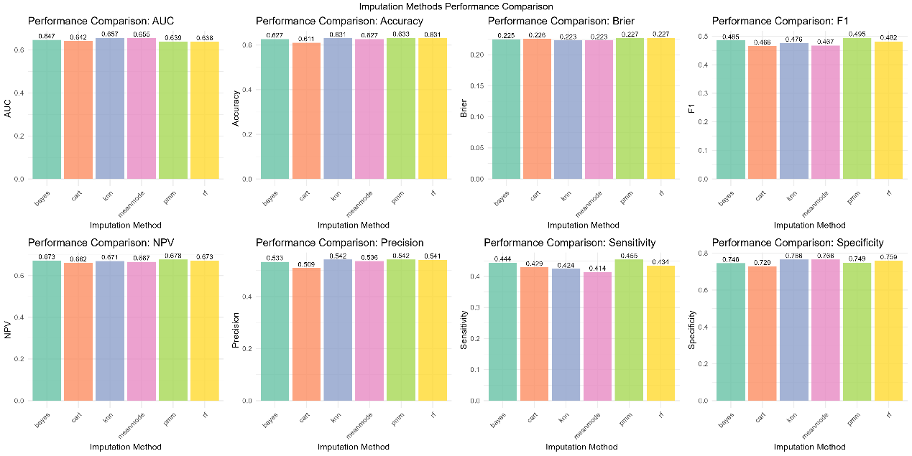
Figure S3. Sensitivity analysis of six missing data imputation methods.
The bar plots compare model performance across eight evaluation metrics (AUC, accuracy, Brier score, F1 score, NPV, precision, sensitivity, and specificity) after applying six different missing data imputation techniques: Bayesian regression (Bayes), classification and regression trees (CART), k-nearest neighbors (kNN), mean/mode imputation (Mean/Mode), predictive mean matching (PMM), and random forest imputation (RF).
Results of sensitivity analysis of imputation methods:
In this study, we evaluated the impact of six different imputation methods on the performance of various machine learning models. Based on the results from the "Figure S3" we draw the following conclusions:
1. Overall Impact of Different Imputation Methods on Model Performance
The pmm_logreg_polyreg (original method used) and random_forest imputation methods: On both the training and test sets, these two imputation methods demonstrated stable performance across most machine learning models, such as Logistic Regression (LR), Random Forest (RF), Neural Network (NNET), and XGBoost (XGB), with minimal performance differences. This indicates high robustness and consistency.
Other imputation methods (bayes_logreg_polyreg, CART, kNN, mean_mode) had a larger impact on certain models (e.g., Naive Bayes (NB) and KNN), showing more significant fluctuations. This suggests that these models are more sensitive to the choice of imputation method, requiring more careful selection.
2. Specific Impact of Imputation Methods on Different Models
Training set analysis: On the training set, pmm_logreg_polyreg and random_forest imputation methods performed the best overall. In particular, for Random Forest (RF) and XGBoost (XGB) models, these two imputation methods outperformed others in terms of accuracy, AUC, sensitivity, and specificity.
Test set analysis: On the test set, pmm_logreg_polyreg demonstrated good stability in models such as Logistic Regression (LR), Random Forest (RF), Neural Network (NNET), and XGBoost (XGB). The random_forest method also performed
comparably well, indicating that both methods can maintain good predictive performance after data imputation.
3. Recommended Imputation Methods
Based on the sensitivity analysis results, it is recommended to continue using pmm_logreg_polyreg as the default imputation method in most cases, as it consistently exhibited stable performance across both the training and test sets.
For Random Forest (RF) and XGBoost (XGB) models, the random_forest imputation method is also a strong alternative, especially in terms of preserving the structure of the data features.
4. Impact of Imputation Method Selection on Model Evaluation
The choice of imputation method had a significant impact on the evaluation results of certain models (e.g., Naive Bayes and KNN). Therefore, when using these models, it is important to carefully select the imputation method and conduct sensitivity analysis to ensure the reliability of the model and the robustness of the results.

Figure S4. Feature importance consistency across machine learning models.
Feature importance rankings of the selected variables across different machine learning models using a recursive feature elimination (RFE) framework. Higher scores indicate greater contribution to model predictions. Although the relative importance varied across algorithms, the majority of selected features consistently ranked among the most influential variables, supporting the robustness of the feature selection process.
Figure S5. Confusion matrices and accuracy (ACC) of ten machine learning models on the independent testing set
The panels show the performance of logistic regression (Logistic), k-nearest neighbors (KNN), support vector machine (SVM), naïve Bayes (NB), decision tree (DT), random forest (RF), XGBoost, LightGBM, CatBoost, and multilayer perceptron (MLP) on the testing cohort. In each matrix, the top-left, top-right, bottom-left, and bottom-right cells represent true positives (TP), false positives (FP), false negatives (FN), and true negatives (TN), with corresponding counts and percentages. The accuracy (ACC) for each model is indicated in the subplot title.

Figure S6. Decision Curve Analysis of Ten Machine Learning Models Based on 200 Bootstrap Resampling Corrections.
This figure illustrates the clinical net benefit corresponding to each predictive model at different threshold probabilities. The curves undergo bias correction and stability assessment through 200 Bootstrap resamples, with the shaded areas surrounding them representing the 95% confidence intervals for net benefit calculated via resampling. Models maintaining higher net benefit across a broader threshold range are considered to possess superior clinical utility.

Figure S7. Feature importance heatmap across multiple machine learning models
The heatmap displays the normalized feature importance scores of ten machine learning models (CatBoost, Decision Tree, KNN, LightGBM, Logistic Regression, MLP, Naïve Bayes, Random Forest, SVM, and XGBoost) on the independent testing set. Colors indicate the relative contribution of each feature to the model prediction, with red representing higher importance and yellow lower importance. Each row corresponds to a feature and each column to a model, allowing a direct comparison of the relative importance of the same feature across models. Features include Age, Coronary stenosis ≥50%, Eccentricity index (no-gated), Entropy, Low-density lipoprotein cholesterol (LDL-C), NYHA Functional Class, Previous history of cardio-cerebrovascular disease, Peak filling rate, and Total perfusion deficit.
Table S1. Sensitivity analysis of six missing data imputation methods.
Imputation | AUC | Accuracy | Brier | F1 | NPV | Precision | Sensitivity | Specificity
PMM | 0.639 | 0.633 | 0.227 | 0.495 | 0.678 | 0.542 | 0.455 | 0.749
RF | 0.638 | 0.631 | 0.227 | 0.482 | 0.673 | 0.541 | 0.434 | 0.759
Bayes | 0.647 | 0.627 | 0.225 | 0.485 | 0.673 | 0.533 | 0.444 | 0.746
CART | 0.642 | 0.611 | 0.226 | 0.466 | 0.662 | 0.509 | 0.429 | 0.729
KNN | 0.657 | 0.631 | 0.223 | 0.476 | 0.671 | 0.542 | 0.424 | 0.766
Mean mode | 0.655 | 0.627 | 0.223 | 0.467 | 0.667 | 0.536 | 0.414 | 0.766

pmm (Predictive Mean Matching), rf (Random Forest Imputation), Bayes (Bayesian Regression), cart (Classification and Regression Trees), kNN (k-Nearest Neighbors), and Mean/Mode (Mean Imputation).

Table S2. Relationship between baseline characteristics and the occurrence of MACE events
Characteristic, Median (Q1, Q3) | Cohort (Training Cohort), N = 1173 |  |  | Cohort (Internal Test Cohort), N = 502
Characteristic, Median (Q1, Q3) | Patients Without MACE Events  N = 712 | Patients With MACE Events  N = 461 | p-value¹ | Patients Without MACE Events  N = 301 | Patients With MACE Events  N = 201 | p-value¹
Sex (man) | 456 (64.0%) | 325 (70.5%) | 0.022 | 195 (64.8%) | 133 (66.2%) | 0.749
Age | 60 (52, 69) | 64 (56, 73) | <0.001 | 59 (51, 68) | 64 (54, 74) | <0.001
BMI | 24.3 (22.2, 27.0) | 24.2 (22.2, 26.2) | 0.087 | 24.6 (22.5, 26.8) | 24.5 (22.4, 26.8) | 0.959
Coronary stenosis≥50% | 163 (22.9%) | 191 (41.4%) | <0.001 | 65 (21.6%) | 84 (41.8%) | <0.001
Previous history of cardio-cerebrovascular disease | 307 (43.1%) | 302 (65.5%) | <0.001 | 120 (39.9%) | 127 (63.2%) | <0.001
NYHA Functional Class |  |  | <0.001 |  |  | <0.001
I | 50 (7.0) | 15 (3.2) |  | 27 (8.9) | 22 (10.9)
II | 301 (42.3) | 156 (33.9) |  | 82 (27.4) | 68 (33.8)
III | 265 (37.2) | 193 (41.8) |  | 165 (54.8) | 68 (33.8)
IV | 96 (13.5) | 97 (21.1) |  | 27 (8.9) | 43 (21.4)
Hyperlipidemia | 189 (26.5%) | 104 (22.6%) | 0.124 | 89 (29.6%) | 46 (22.9%) | 0.098
Hyperhomocysteinemia | 81 (11.4%) | 54 (11.7%) | 0.860 | 36 (12.0%) | 17 (8.5%) | 0.211
Hyperuricemia | 47 (6.6%) | 27 (5.9%) | 0.609 | 18 (6.0%) | 10 (5.0%) | 0.631
hypertension | 373 (52.4%) | 290 (62.9%) | <0.001 | 160 (53.2%) | 134 (66.7%) | 0.003
Smoking | 166 (23.3%) | 144 (31.2%) | 0.003 | 59 (19.6%) | 68 (33.8%) | <0.001
Diabetes | 300 (42.1%) | 217 (47.1%) | 0.096 | 124 (41.2%) | 88 (43.8%) | 0.566
White Blood Cell Count | 6.20 (5.20, 7.40) | 6.40 (5.20, 7.50) | 0.578 | 6.20 (5.00, 7.70) | 6.50 (5.40, 7.90) | 0.107
neutrophil count | 3.73 (2.90, 4.71) | 3.70 (3.00, 4.90) | 0.606 | 3.60 (2.80, 4.70) | 3.70 (3.10, 4.80) | 0.227
lymphocyte count | 1.80 (1.40, 2.20) | 1.71 (1.40, 2.14) | 0.433 | 1.80 (1.40, 2.20) | 1.80 (1.50, 2.20) | 0.277
Red Blood Cell Count | 4.52 (4.16, 4.87) | 4.43 (4.11, 4.77) | 0.007 | 4.53 (4.18, 4.86) | 4.54 (4.17, 4.83) | 0.485
Hemoglobin | 142 (130, 153) | 140 (130, 151) | 0.141 | 142 (131, 152) | 142 (133, 152) | 0.967
creatinine | 70 (60, 80) | 72 (62, 84) | 0.006 | 69 (59, 81) | 71 (63, 81) | 0.092
blood urea nitrogen | 5.16 (4.25, 6.16) | 5.37 (4.39, 6.37) | 0.066 | 4.97 (4.10, 6.02) | 5.24 (4.40, 6.29) | 0.118
uric acid | 330 (277, 402) | 340 (281, 404) | 0.373 | 323 (270, 389) | 333 (277, 403) | 0.118
fasting blood glucose | 5.19 (4.72, 6.30) | 5.29 (4.73, 6.48) | 0.271 | 5.10 (4.66, 5.92) | 5.29 (4.71, 6.58) | 0.058
Triglyceride | 1.47 (1.07, 2.04) | 1.40 (1.03, 1.93) | 0.059 | 1.48 (1.10, 1.93) | 1.46 (1.11, 1.89) | 0.844
Total Cholesterol | 4.08 (3.35, 4.85) | 3.76 (3.16, 4.59) | <0.001 | 4.06 (3.30, 4.84) | 3.87 (3.09, 4.78) | 0.120
high-density lipoprotein cholesterol | 1.01 (0.86, 1.16) | 0.96 (0.82, 1.15) | 0.016 | 1.01 (0.85, 1.14) | 0.99 (0.87, 1.15) | 0.977
low-density lipoprotein cholesterol | 2.50 (1.90, 3.12) | 2.20 (1.76, 2.79) | <0.001 | 2.48 (1.91, 3.01) | 2.29 (1.70, 3.00) | 0.107
Total perfusion deficit | 7 (4, 14) | 10 (5, 23) | <0.001 | 7 (4, 11) | 9 (5, 18) | <0.001
Peak filling rate | 1.67 (1.34, 2.14) | 1.48 (1.10, 1.89) | <0.001 | 1.72 (1.31, 2.15) | 1.67 (1.21, 1.96) | 0.024
the first third of the end-systole to end-diastole phase | 0.61 (0.50, 0.76) | 0.55 (0.43, 0.70) | <0.001 | 0.62 (0.52, 0.76) | 0.59 (0.48, 0.71) | 0.016
time to peak filling from end-systole | 256 (222, 284) | 256 (225, 285) | 0.803 | 253 (228, 282) | 255 (226, 280) | 0.495
Summed Motion Score | 12 (6, 22) | 18 (9, 33) | <0.001 | 12 (6, 22) | 15 (6, 31) | 0.026
Summed Thickening Score | 7 (1, 14) | 10 (3, 20) | <0.001 | 7 (1, 14) | 8 (1, 21) | 0.064
Left ventricular ejection fraction | 48 (39, 55) | 44 (31, 52) | <0.001 | 48 (40, 56) | 47 (33, 54) | 0.037
End-diastolic volume | 82 (63, 106) | 88 (65, 124) | 0.002 | 83 (64, 105) | 84 (65, 116) | 0.344
End-systolic volume | 42 (29, 64) | 48 (32, 84) | <0.001 | 43 (28, 63) | 47 (29, 73) | 0.155
shape index (no-gated) | 0.59 (0.55, 0.64) | 0.61 (0.56, 0.68) | <0.001 | 0.59 (0.55, 0.64) | 0.60 (0.55, 0.67) | 0.014
Eccentricity index (no-gated) | 0.82 (0.80, 0.85) | 0.82 (0.78, 0.84) | <0.001 | 0.83 (0.80, 0.85) | 0.81 (0.78, 0.84) | <0.001
End diastolic shape index | 0.63 (0.58, 0.67) | 0.65 (0.59, 0.69) | <0.001 | 0.63 (0.59, 0.68) | 0.64 (0.59, 0.70) | 0.128
End systolic shape index | 0.50 (0.46, 0.56) | 0.54 (0.47, 0.61) | <0.001 | 0.51 (0.47, 0.56) | 0.52 (0.46, 0.60) | 0.118
Eccentricity index | 0.84 (0.81, 0.87) | 0.83 (0.79, 0.86) | <0.001 | 0.84 (0.81, 0.87) | 0.83 (0.80, 0.86) | 0.007
histogram bandwidth | 54 (36, 81) | 60 (42, 90) | 0.003 | 48 (36, 78) | 54 (36, 90) | 0.136
Mean | 130 (117, 142) | 131 (120, 142) | 0.182 | 130 (116, 142) | 132 (122, 142) | 0.097
phase standard deviation | 18 (12, 27) | 20 (12, 28) | 0.061 | 19 (12, 27) | 19 (12, 28) | 0.587
Entropy | 46 (40, 52) | 48 (41, 58) | <0.001 | 45 (38, 52) | 48 (41, 56) | 0.004
¹Continuous variables are presented as median (interquartile range) and were compared using the Wilcoxon rank-sum test. Categorical variables are presented as counts (percentages) and were compared using Pearson’s chi-squared test or Fisher’s exact test, as appropriate.

Table S3. Comparison of characteristics before and after multiple imputation in the training set.
Characteristic, mean (SD) | Before multiple imputation | After multiple imputation | p-value¹
Age | 61.38 (12.80) | 61.61 (11.72) | 0.756
Body Mass Index | 24.71 (3.24) | 24.70 (2.83) | 0.839
White Blood Cell Count | 6.58 (1.92) | 6.52 (1.63) | 0.138
Neutrophil count | 4.14 (2.53) | 3.99 (1.32) | 0.239
Lymphocyte count | 1.92 (1.74) | 1.83 (0.55) | 0.104
Red Blood Cell Count | 4.75 (5.80) | 4.50 (0.47) | 0.314
Hemoglobin | 141.17 (17.54) | 141.39 (14.68) | 0.532
Creatinine | 72.08 (16.53) | 71.74 (14.35) | 0.248
Blood urea nitrogen | 5.38 (1.64) | 5.33 (1.37) | 0.485
Uric acid | 344.71 (97.90) | 343.75 (85.69) | 0.926
Fasting blood glucose | 5.91 (2.17) | 5.81 (1.67) | 0.662
Triglyceride | 1.89 (5.09) | 1.62 (0.73) | 0.602
Total Cholesterol | 4.06 (1.14) | 4.04 (1.00) | 0.454
High-density lipoprotein cholesterol | 1.03 (0.29) | 1.02 (0.22) | 0.398
Low-density lipoprotein cholesterol | 2.48 (0.95) | 2.45 (0.79) | 0.636
Total perfusion deficit | 12.72 (12.53) | 12.37 (11.46) | 0.420
Peak filling rate | 1.70 (0.64) | 1.68 (0.56) | 0.957
The first third of the end-systole to end-diastole phase | 0.62 (0.21) | 0.61 (0.18) | 0.414
Time to peak filling from end-systole | 252.12 (53.25) | 251.83 (40.98) | 0.054
Summed Motion Score | 18.07 (14.79) | 17.80 (14.04) | 0.199
Summed Thickening Score | 10.52 (9.92) | 10.39 (9.62) | 0.256
Left ventricular ejection fraction | 44.72 (13.94) | 44.71 (13.03) | 0.226
End-diastolic volume | 96.81 (51.83) | 94.03 (40.76) | 0.788
End-systolic volume | 59.07 (48.24) | 56.21 (37.04) | 0.929
Shape index (no-gated) | 0.61 (0.09) | 0.61 (0.08) | 0.930
Eccentricity index (no-gated) | 0.82 (0.05) | 0.82 (0.04) | 0.294
End diastolic shape index | 0.64 (0.08) | 0.64 (0.07) | 0.681
End systolic shape index | 0.53 (0.10) | 0.53 (0.09) | 0.815
Eccentricity index | 0.83 (0.05) | 0.83 (0.04) | 0.317
Histogram bandwidth | 68.64 (43.36) | 67.63 (40.22) | 0.129
Mean ( | 130.07 (19.10) | 130.31 (16.47) | 0.957
Phase standard deviation | 21.11 (12.89) | 20.60 (10.70) | 0.632
Entropy | 47.83 (11.29) | 47.82 (10.36) | 0.087

¹ P values were calculated using Student’s t test for continuous variables.
Table S4. Comparison of characteristics before and after multiple imputation in the testing set.
Characteristic | Before multiple imputation | After multiple imputation | p-value¹
Age | 61.59 (12.58) | 61.79 (11.63) | 0.769
Body Mass Index | 24.67 (3.62) | 24.63 (2.98) | 0.649
White Blood Cell Count | 6.42 (1.80) | 6.40 (1.62) | 0.200
Neutrophil count | 3.99 (1.62) | 3.94 (1.38) | 0.440
Lymphocyte count | 1.78 (0.60) | 1.78 (0.54) | 0.109
Red Blood Cell Count | 4.48 (0.57) | 4.48 (0.50) | 0.393
Hemoglobin | 140.57 (17.53) | 140.72 (15.15) | 0.405
Creatinine | 73.82 (43.19) | 71.41 (15.03) | 0.682
Blood urea nitrogen | 5.45 (1.67) | 5.37 (1.36) | 0.617
Uric acid | 345.24 (99.81) | 343.22 (88.21) | 0.918
Fasting blood glucose | 5.97 (2.31) | 5.83 (1.71) | 0.856
Triglyceride | 2.05 (6.01) | 1.62 (0.75) | 0.888
Total Cholesterol | 4.11 (1.06) | 4.09 (0.97) | 0.340
High-density lipoprotein cholesterol | 1.02 (0.28) | 1.01 (0.21) | 0.492
Low-density lipoprotein cholesterol | 2.50 (0.85) | 2.49 (0.78) | 0.420
Total perfusion deficit | 12.18 (12.74) | 11.65 (11.00) | 0.230
Peak filling rate | 1.70 (0.67) | 1.67 (0.57) | 0.767
The first third of the end-systole to end-diastole phase | 0.61 (0.20) | 0.61 (0.17) | 0.471
Time to peak filling from end-systole | 257.33 (44.23) | 256.81 (40.47) | 0.022
Summed Motion Score | 17.05 (14.88) | 16.76 (13.78) | 0.160
Summed Thickening Score | 9.92 (9.68) | 9.81 (9.40) | 0.251
Left ventricular ejection fraction | 45.62 (14.09) | 45.37 (12.94) | 0.337
End-diastolic volume | 97.58 (58.51) | 94.00 (41.67) | 0.986
End-systolic volume | 59.30 (53.91) | 55.85 (37.98) | 0.858
Shape index (no-gated) | 0.61 (0.09) | 0.61 (0.07) | 0.739
Eccentricity index (no-gated) | 0.81 (0.04) | 0.81 (0.04) | 0.305
End diastolic shape index | 0.64 (0.07) | 0.64 (0.07) | 0.601
End systolic shape index | 0.53 (0.09) | 0.53 (0.08) | 0.714
Eccentricity index | 0.83 (0.05) | 0.83 (0.04) | 0.363
Histogram bandwidth | 65.19 (40.55) | 64.53 (37.82) | 0.141
Mean | 130.02 (17.56) | 130.02 (15.83) | 0.739
Phase standard deviation | 20.80 (11.15) | 20.51 (10.00) | 0.867
Entropy | 46.80 (11.01) | 46.89 (10.04) | 0.088
¹ P values were calculated using Student’s t test for continuous variables.

