Supplementary Information for
A fundamental viewpoint on the hydrogen spillover phenomenon of electrocatalytic hydrogen evolution
Jiayuan Li¹, Jun Hu^{2,}* Mingkai Zhang³, Wangyan Gou¹, Sai Zhang¹, Zhong Chen⁴, Yongquan Qu^{1,3,}* and Yuanyuan Ma^{1,}*
¹ School of Chemistry and Chemical Engineering, Northwestern Polytechnical University, Xi’an 710072, China
2 School of Chemical Engineering, Northwest University, Xi’an, P. R. China 710069
³ Frontier Institute of Science and Technology, Xi’an Jiaotong University, Xi’an, 710049, China.
4 School of Materials Science and Engineering, Nanyang Technological University, 50 Nanyang Avenue, Singapore 639798

Table of content:
Experimental Section Page 1-4
Supplementary Figures (Fig. S1-Fig. S14) Page 5-12
Supplementary Tables (Table S1-S6) Page 13-15
References Page 16-17

Experimental Section
Electrochemical measurements. Electrochemical measurements of various catalysts were conducted on a CHI 660D electrochemical analyzer (CH Instruments, Inc., Shanghai). The catalyst ink was prepared by dispersing 4 mg of various catalysts into 1 mL of the mixed solvent containing water, ethanol and 5% Nafion with a volumetric ratio of 768 : 200 : 32. For the preparation of the catalytic electrodes, 5 μL of the catalyst ink was loaded onto a carbon fiber paper (CFP) electrode to reach a sample loading of ~0.06 mg/cm². The CFP electrodes were dried at room temperature naturally.
HER activity of the as-prepared electrodes was investigated in a three-electrode system, using the as-fabricated electrodes as working electrode, saturated calomel electrode (SCE)as reference electrodeand graphite rod (GC) as counter electrode, respectively. Linear sweep voltammetry (LSV) profiles were employed to investigate the HER activities of variouselectrodes with a scan rate of 5 mV/s in 0.5 M H₂SO₄. The onset potentials were determined by the initially linear regime of the Tafel plots.The catalytic stability of the electrodes was recorded as a function of reaction time. Electrochemical impedance spectroscopy (EIS) investigations wereconducted on the GAMRY Reference 600 electrochemistry workstation in the frequency range of 100 kHz-0.1 Hz at various HER overpotentials. The potentials reported herein are relative to the reversible hydrogen electrode (RHE). The calibration was performed in the high purity hydrogen saturated electrolyte with a Pt foil as the working electrode.¹ Cyclic voltammetry (CV) was performed at a scan rate of 1 mV/s, and the average of the two potentials at which the current crossed zero was taken to be the thermodynamic potential for the hydrogen electrode reaction. The results were shown below, E(RHE) = E(SCE) + 0.281 V.
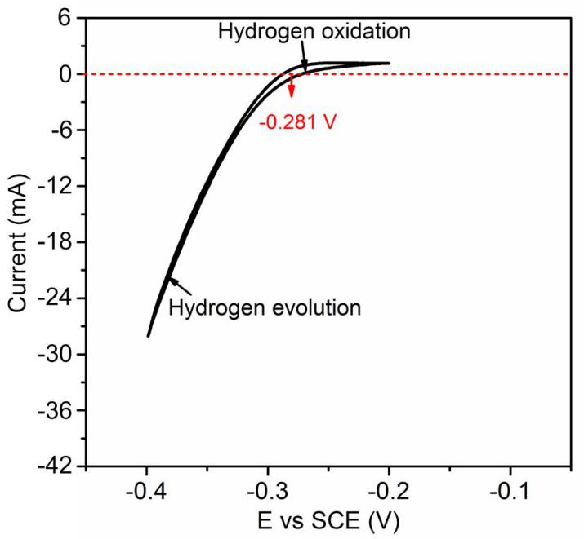

Density functional theory (DFT) calculations. In the calculations, work functions were calculated use clean and M (M = Ir, Rh, Pd, Ag, Au) doped Pt(111) surfaces. The Pt and PtM clusters were built on the CoP(011) surface with a vacuum region of 15 Å to reduce dispersive error.² The optimized Pt/CoP and Pt₂Ir₁/CoP geometries are shown below:
The CASTEP module of the Materials Studio software (Accelrys Inc.) was employed for the quantum chemistry calculations. Perdew-Burke-Ernzerhof Generalized-Gradient-Approximation method was used with Density Functional Dispersion correction to calculate the exchange-correlation energy.³ Ultrasoft pseudopotential was selected to describe the characters of ionic cores. During the interface optimization, bottom CoP layers were fixed in order to reduce the calculation time.The energy cutoff is 300 eV and k-point is Gamma point for adsorption thermodynamics.The choicehas beenverified to produce reasonably small difference when using higher cutoff energy and larger k-point, as shown below:
The 4×4×1 Monkhorst–Pack grids was adopted for electron density difference calculations. LST (Linear Synchronous Transit)/QST (Quadratic Synchronous Transit) transition state search algorithm wasused to search for the transition state based on nudged elastic band (NEB) method. And then the transition state confirmation calculation was performedto validate the transition state.⁴
The optimization is completed when the energy, maximum force, maximum stress and maximum displacement are smaller than 5.0 × 10^{–6} eV/atom, 0.01 eV/Å, 0.02 GPa and 5.0 × 10^{–4} Å, respectively. Gibbs free energy of adsorption hydrogen atom are calculated by eqs. (1).⁵
ΔG = E[surface+H*] − E[surface] − 1/2E[H₂] + ΔE_{ZPE} − TΔS_{H} (1)
where E[surface+H*] is the total energy of the system, including the adsorbed molecules and facet; E[surface] is the energy of the facet; E(H₂) represents the total energy of a gas phase H₂ molecule; ΔE_{ZPE} denotes the zero-point energy of the system simplified as 0.05 eV; The −TΔS_{H} is the contribution from entropy at temperature K, taken as 0.20 eV at 298 K.

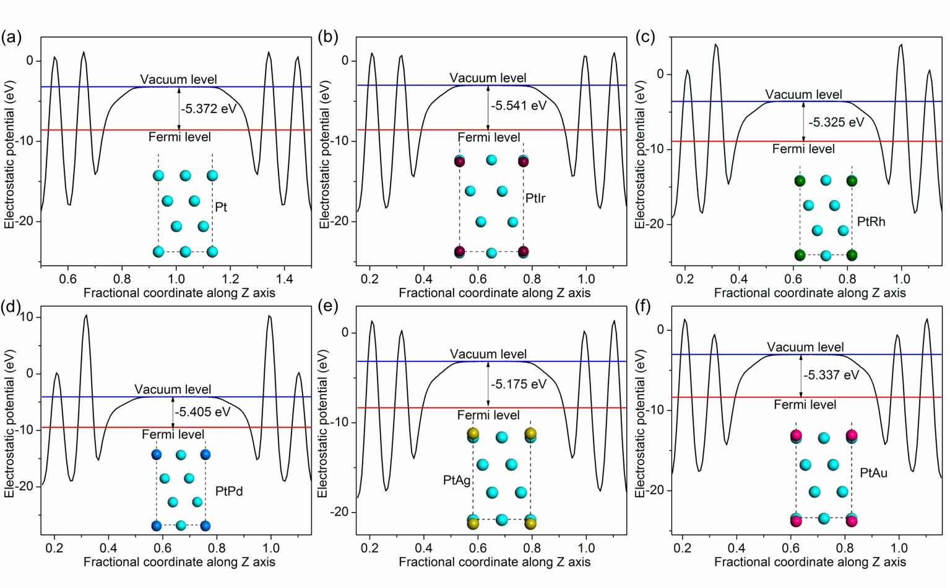
Figure S1. Work function estimation for various PtM alloys by DFT calculations, where M = Pt (a), Ir (b), Rh (c), Pd (d), Ag (e) and Au (f).

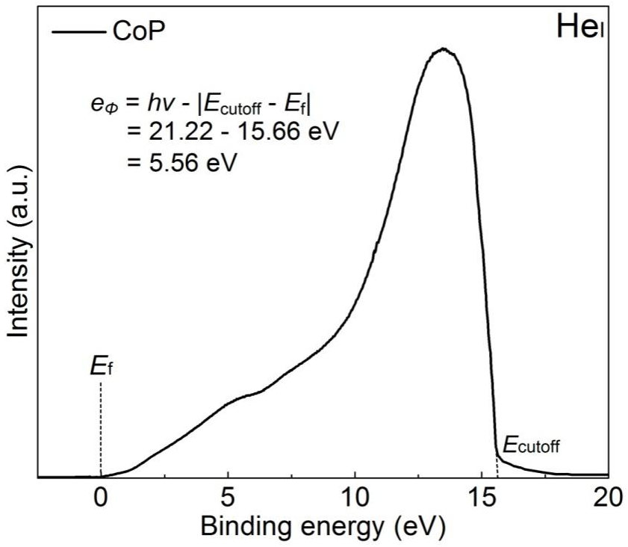
Figure S2. Work function estimation for CoP by ultraviolet photoelectron spectroscopy analysis.

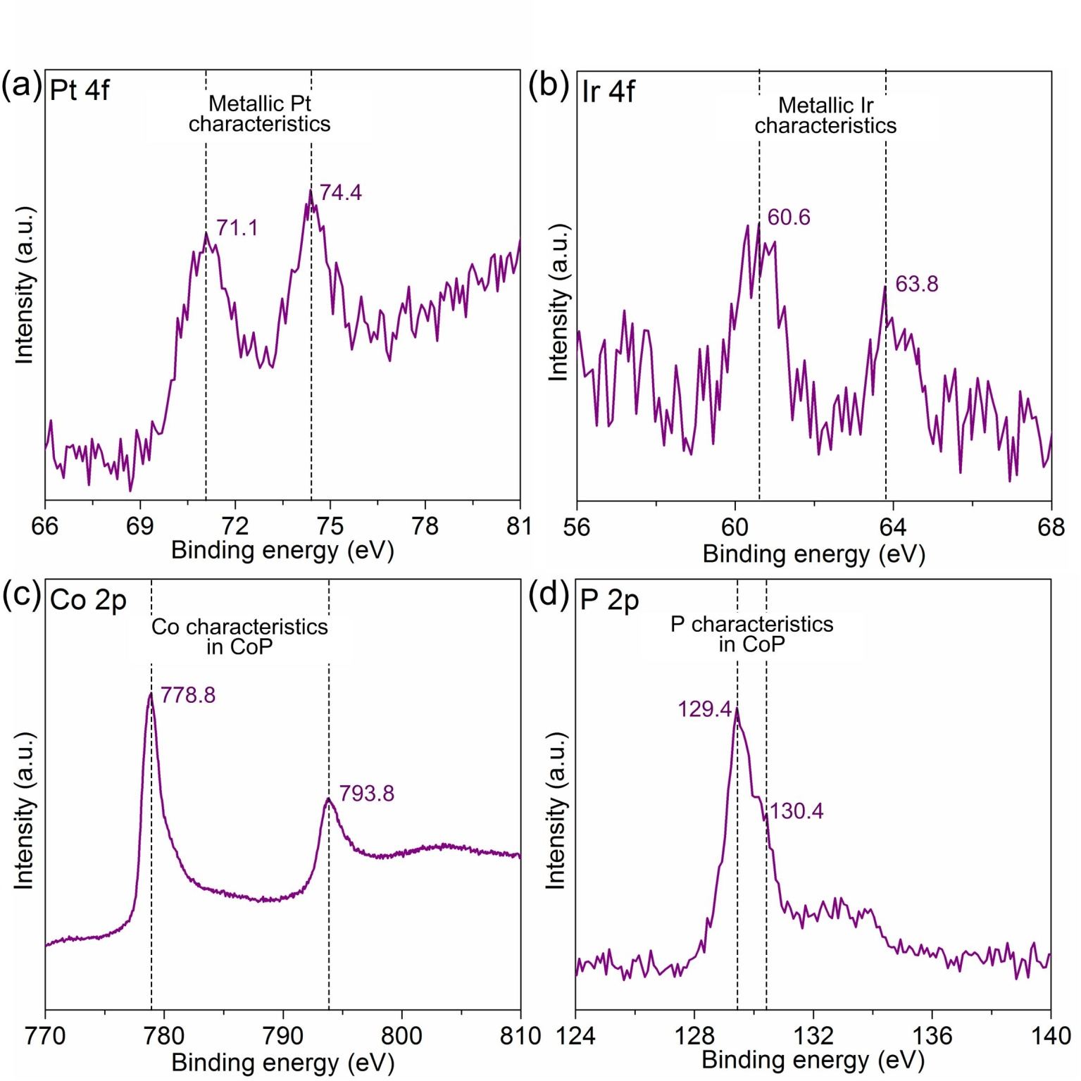
Figure S3. High-resolution XPS spectra in (a) Pt 4f, (b) Ir 4f, (c) Co 2p and (d) P 2p region for Pt₂Ir₁/CoP catalysts.

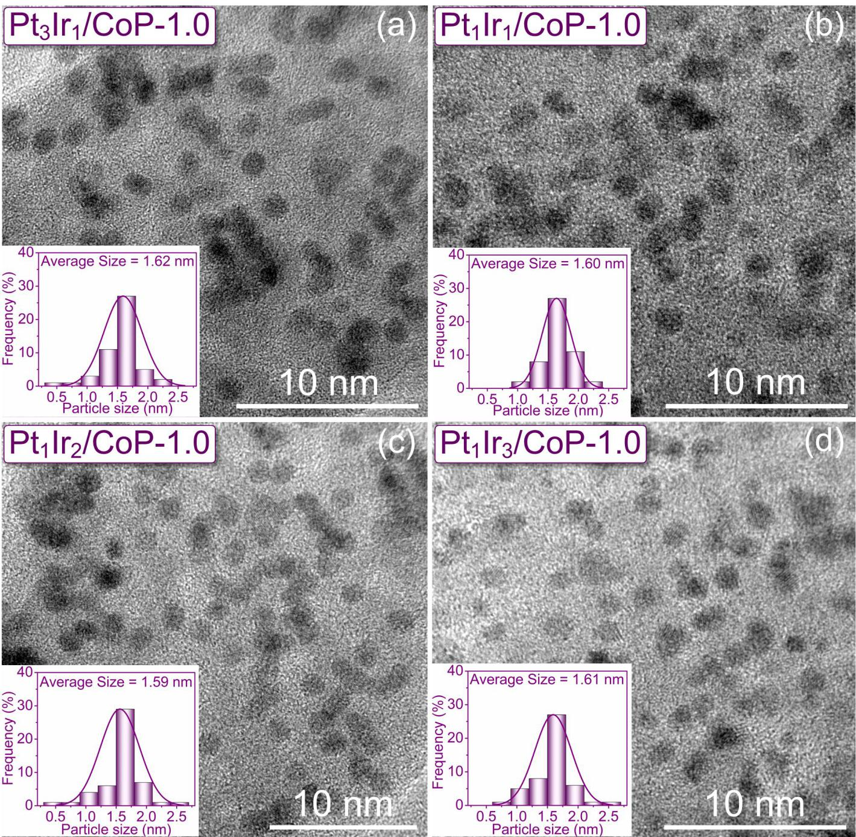
Figure S4. TEM images for (a) Pt₃Ir₁/CoP, (b) Pt₁Ir₁/CoP, (c) Pt₁Ir₂/CoP and (d) Pt₁Ir₃/CoP at metal loading of 1.0 wt%. The insets show the size distributions of the loaded metal nanoparticles.

Figure S5. HER performance for the PtIr/CoP model catalysts with different molar ratio of Pt and Ir.

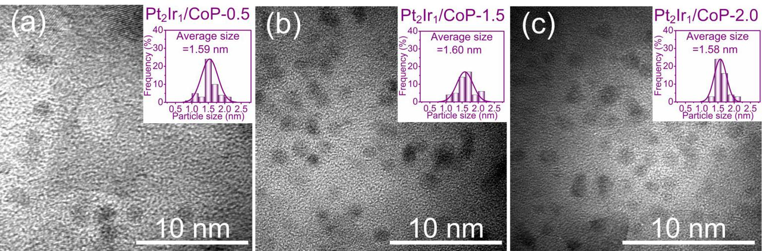
Figure S6. TEM images for the Pt₂Ir₁/CoP catalysts at metal loading of (a) ~ 0.5 wt%, (b) ~ 1.5 wt% and (c) ~ 2.0 wt%. The insets show the size distributions of the loaded metal nanoparticles.

Figure S7. HER performance for the Pt₂Ir₁/CoP catalysts at different metal loading.
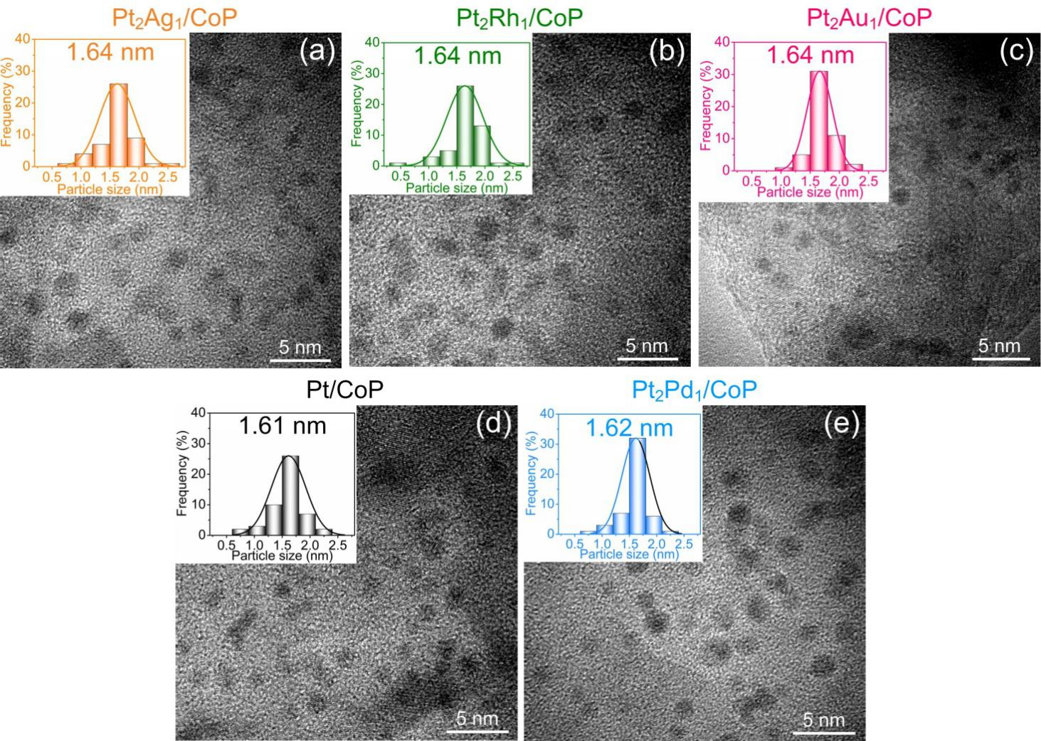
Figure S8. TEM images for the (a) Pt₂Ag₁/CoP, (b) Pt₂Rh₁/CoP, (c) Pt₂Au₁/CoP, (d) Pt/CoP and (e) Pt₂Pd₁/CoP catalysts at the metal loading of 1.0 wt%. The insets show the size distributions of the loaded metal nanoparticles.
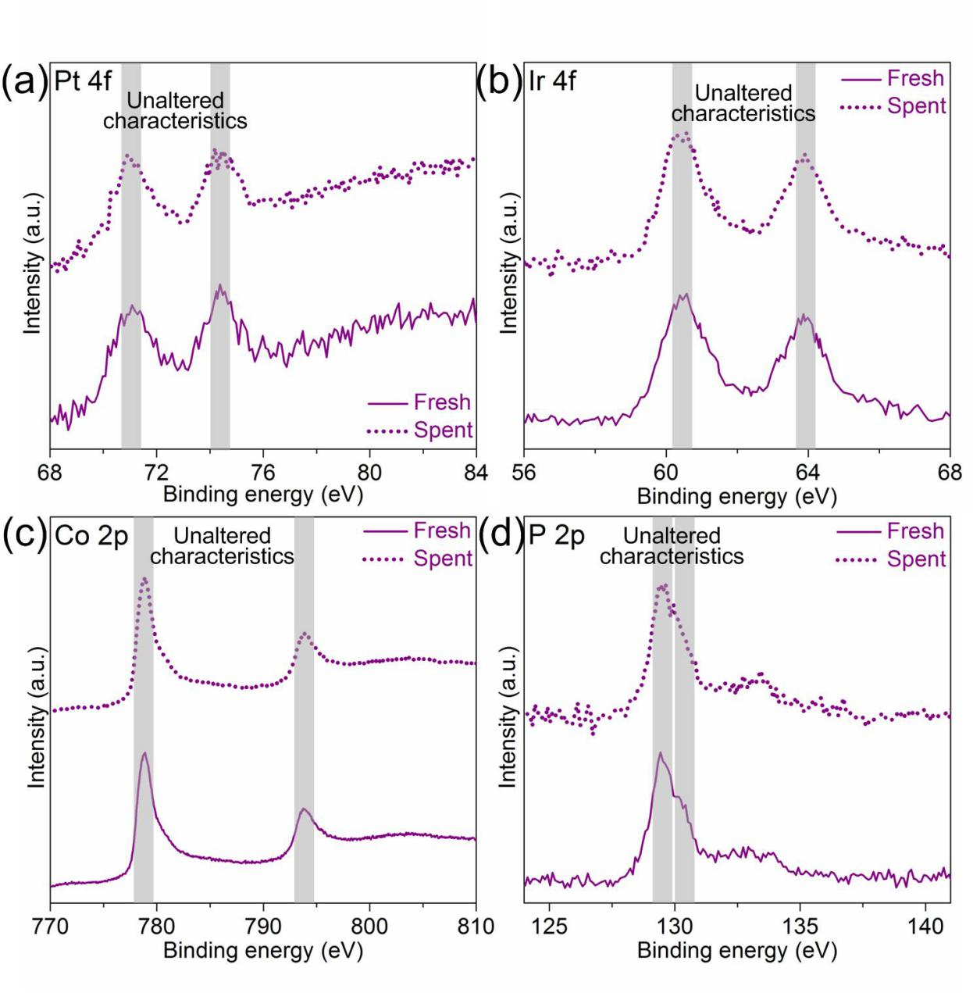
Figure S9. High-resolution XPS spectra in (a) Pt 4f, (b) Ir 4f, (c) Co 2p and (d) P 2p region for the fresh and spent Pt₂Ir₁/CoP catalysts.

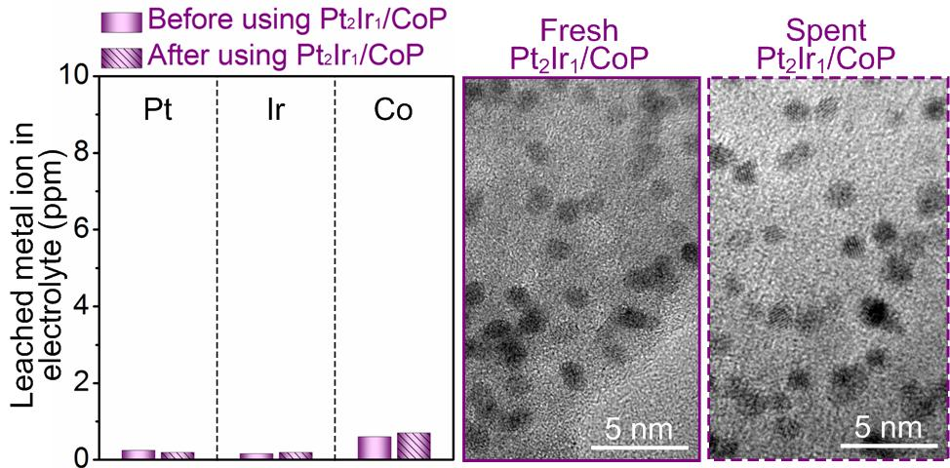
Figure 10. Durability analysis for the Pt₂Ir₁/CoP catalysts. The ICP (left) and TEM (right) results show the negligible leaching of catalyst composition and morphology change during HER operation.
Figure 11. HER performance of the bare CoP, Pt/CoP and Pt₂Ir₁/CoP catalysts in 0.5 M H₂SO₄ with or without the thiocyanate ions (SCN–) probe, which are known to block and deactivate the Pt sites under acidic conditions. Clearly, the introduction of SCN– probe brings the negligible HER deactivation and unaltered kinetics for Pt/CoP but significant deactivation and CoP-like kinetics for Pt₂Ir₁/CoP.This finding suggestedthe limited contributions of loaded metal on the solo HER process for CoP supports. Probably, the components of loaded metal were the major participants in the overall HER process rather than the modulator for CoP, which was likely responsible for capturing and transferring hydrogen.

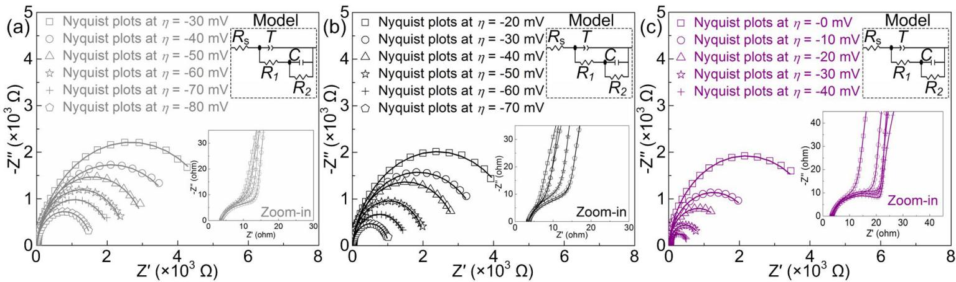
Figure S12. Nyquist plots for (a) bare CoP, (b) Pt/CoP and (c) Pt₂Ir₁/CoP catalysts in 0.5 M H₂SO₄ at various HER overpotentials. Zoom-in parts were correspondingly presented asinset. The scattered symbols represent the experimental results, and the solid lines are simulation fitted results. The inset at the top right shows the equivalent circuit for the simulation. The fitted parameters are summarized in Table S4.
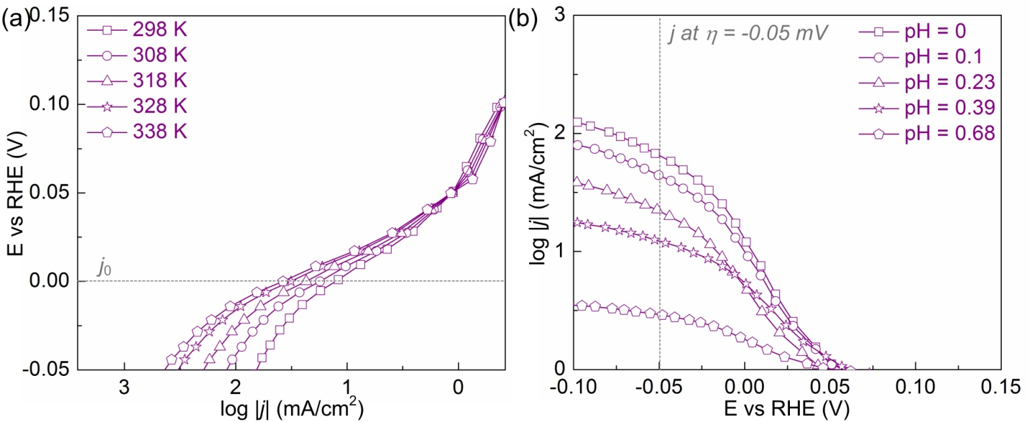
Figure S13. (a) Tafel curves of Pt₂Ir₁/CoP catalysts in Ar saturated 0.5 M H₂SO₄ at different temperatures ranging from 298 to 338 K. (b) Tafel curves of Pt₂Ir₁/CoP catalysts in Ar saturated H₂SO₄ electrolyte with pH ranging from 0 to 0.68.

Figure S14. High-resolution XPS spectra in (a) Pt 4f and (b) Co 2p region for the Pt/CoP and Pt₂Ir₁/CoP catalysts. Compared with Pt/CoP, the XPS peaks of Pt 4f_{7/2} and Co 2p_{3/2} for Pt₂Ir₁/CoP shift to the low and high binding energy, which is closer to the characters of the Pt⁰ and Ir⁰ benchmarks and thus suggested the limited charge-transfer from Pt to CoP in Pt₂Ir₁/CoP.

Table S1. ICP analysis for series of PtIr/CoP catalysts.
Catalyst | Alloy loading [wt.%] | Pt loading [wt.%] | Ir loading [wt.%] | Molar ratio of Pt : Ir
Pt₃Ir₁/CoP | 1.03 | 0.77 | 0.26 | 2.97
Pt₂Ir₁/CoP | 0.99 | 0.67 | 0.32 | 2.04
Pt₁Ir₁/CoP | 1.01 | 0.51 | 0.50 | 0.99
Pt₁Ir₂/CoP | 1.05 | 0.34 | 0.71 | 0.48
Pt₁Ir₃/CoP | 1.03 | 0.25 | 0.78 | 0.31

Table S2. ICP analysis for the Pt₂Ir₁/CoP catalysts with different metal loading.
Catalyst | Alloy loading [wt.%] | Pt loading [wt.%] | Ir loading [wt.%] | Molar ratio of Pt : Ir
Pt₂Ir₁/CoP-0.5 | 0.47 | 0.32 | 0.15 | 2.09
Pt₂Ir₁/CoP-1.0 | 1.04 | 0.81 | 0.23 | 2.01
Pt₂Ir₁/CoP-1.5 | 1.51 | 1.0 | 0.51 | 1.97
Pt₂Ir₁/CoP-2.0 | 1.97 | 1.32 | 0.65 | 2.02

Table S3. ICP analysis for series of PtM/CoP catalysts.
Catalyst | Alloy loading [wt.%] | Pt loading [wt.%] | Foreign metal loading [wt.%] | Molar ratio of Pt :foreign metal
Pt₂Rh₁/CoP | 1.05 | 0.83 | 0.22 (Rh) | 1.98 (Pt : Rh)
Pt₂Pd₁/CoP | 1.04 | 0.81 | 0.23 (Pd) | 2.01 (Pt : Pd)
Pt₂Ag₁/CoP | 1.0 | 0.78 | 0.22 (Ag) | 2.0 (Pt : Ag)
Pt₂Au₁/CoP | 0.98 | 0.64 | 0.34 (Au) | 2.06 (Pt : Au)

Table S4. Comparison of HER performance in acidic media for Pt₂Ir₁/CoP with the earth-abundant and noblemetal-based HER catalysts, especially the single-atom Pt catalysts.
Catalyst |  | Noble metalcontent[μg/cm²] | η₂₀[mV] | Tafel slope [mV/dec] | Durability | Ref.
 | Pt₂Ir₁/CoP | 0.6 | 7 | 25.2 | 500 h | This work
 | Ni₂P NPs | 0 | 130 | 46 | − | Ref. 6
 | CoP NWs | 0 | 100 | 51 | 22 h | Ref. 7
 | Co-Fe-P  3D electrode | 0 | 80 | 45 | − | Ref. 8
 | Mo-W-P | 0 | 101 | 52 | 8 h | Ref. 9
 | Ni_{0.33}Co_{0.67}S₂ NWs | 0 | 88 | 44.1 | < 3 h | Ref. 10
 | CoSP/CNTs | 0 | 65 | 55 | 24 h | Ref. 11
 | CoPS NPs | 0 | 65 | 56 | 35 h | Ref. 12
 | NiCoP/rGO | 0 | 55 | 45.2 | 18 h | Ref. 13
 | PANI/CoP | 0 | 70 | 34.5 | 30 h | Ref.14
 | CoP/Co-MoF | 0 | 33 | 43 | 17 h | Ref.15
 | CoP₂ | 0 | 53 | 32 | 36 h | Ref.16
 | Pt_{tripods}@PAA | 79 | 0 | 26 | 1.67 h | Ref. 17
 | Pt/MoS₂ | 18 | >150 | 96 | 5000 cycles | Ref. 18
 | PtSA-NT-NF | 140 | 46 | 30 | 24 h | Ref.19
 | ALD50Pt/NGNs | 1.1 | 54 | 29 | 1000 cycles | Ref. 20
 | Pt-GDY2 | 4.65 | 92 | 46.6 | 2.78 h | Ref.21
 | Pt-MoS₂ | 7.0 | 47 | 25.0 | 35 h | Ref.22
 | Pt SASs/AG | 31 | 19 | 29.3 | 24 h | Ref.23
 | Mo₂TiC₂T_{x}–Pt_{SA} | 12 | 43 | 30 | 100 h | Ref.24
 | Pt₁/OLC | 1.37 | 55 | 36 | 100 h | Ref.25
 | Pt/Co_{0.85}Se | 204 | 60 | 26 | 40 h | Ref.26
 | Rh-MoS₂ | 24 | 90 | 54 | 20 h | Ref.27
 | Pt-SA/MoO_{x} | 1.68 | 18 | 123 | 20 h | Ref.28
 | Pt-PVP/TNR | 21.9 | 27 | 27 | 44 h | Ref.29
 | Pt/PCM | 113 | 142 | 65.3 | 5 h | Ref.30
 | RuCoP | 60 | 25 | 31 | 150 h | Ref.31
Table S5. Comparison of HER performance in acidic media for Pt₂Ir₁/CoP with previously reported HSBB electrocatalysts.
Catalyst |  | Noble metalcontent[μg/cm²] | η₂₀[mV] | Tafel slope [mV/dec] | Durability | Ref.
 | Pt₂Ir₁/CoP | 0.6 | 7 | 25.2 | 500 h | This work
 | Pt/RuCeO₂ | 1.9 | 72 | 31 | 8 h | Ref. 32
 | Rh/SiNW | 56 | 81 | 24 | 138 h | Ref. 33
 | Ir/SiNW | 60 | 22 | 20 | 14 h | Ref. 34
 | Rh/MoS₂ | 16 | 47 | 24 | 22.2 | Ref. 35
 | Pt/WO₃ | 16 | 42 | 73 | 19.4 h | Ref. 36
 | WO₂/WS₂ | 0 | 100 | 54 | 3.1 h | Ref. 37
 | EG-Pt/CoP-1.5 | 1.5 | 21 | 42.5 | 100 h | Ref. 2

Table S6. The fitted parameters of the EIS data of bare CoP, Pt/CoP and Pr₂Ir₁/CoP for HER.
Catalysts | η[mV] | R_{s}[Ω] | T[F s^{n-1}] | R₁[Ω] | n₁ | R₂[Ω] | C_{φ} [F]
CoP | -30 | 3.61 | 0.0042 | 20.8 | 0.83 | 5370.3 | 0.0032
CoP | -40 | 3.64 | 0.0045 | 20.4 | 0.81 | 4265.8 | 0.004
CoP | -50 | 3.59 | 0.0044 | 19.8 | 0.90 | 3162.3 | 0.07
CoP | -60 | 3.65 | 0.0042 | 17.7 | 0.91 | 2511.9 | 0.010
CoP | -70 | 3.61 | 0.0044 | 16.7 | 0.85 | 2137.9 | 0.0132
CoP | -80 | 3.66 | 0.0042 | 15.8 | 0.86 | 1548.8 | 0.0145
Pt/CoP | -20 | 3.57 | 0.0061 | 23.7 | 0.87 | 4786.3 | 0.0006
Pt/CoP | -30 | 3.56 | 0.0058 | 24.0 | 0.86 | 3715.4 | 0.0026
Pt/CoP | -40 | 3.55 | 0.006 | 23.1 | 0.9 | 3020 | 0.0025
Pt/CoP | -50 | 3.51 | 0.0054 | 22.8 | 0.91 | 2041.7 | 0.0020
Pt/CoP | -60 | 3.56 | 0.0059 | 21.0 | 0.83 | 1513.6 | 0.0018
Pt/CoP | -70 | 3.50 | 0.0064 | 20.7 | 0.88 | 1000 | 0.0020
Pt₂Ir₁/CoP | 0 | 3.41 | 0.0054 | 25.1 | 0.86 | 4365.2 | 0.0066
Pt₂Ir₁/CoP | -10 | 3.31 | 0.0051 | 24.7 | 0.82 | 2512 | 0.0192
Pt₂Ir₁/CoP | -20 | 3.37 | 0.0061 | 23.9 | 0.91 | 1621.8 | 0.051
Pt₂Ir₁/CoP | -30 | 3.40 | 0.006 | 22.2 | 0.90 | 891.3 | 0.066
Pt₂Ir₁/CoP | -40 | 3.39 | 0.0055 | 21.7 | 0.85 | 512.9 | 0.081
References
(1) Xu, Y. F.; Gao, M. R.; Zheng, Y. R.; Jiang, J.; Yu, S. H. Angew. Chem. Int. Edit. 2013, 52, 8546.
(2) Li, J.; Liu, H.-X.; Gou, W.; Zhang, M.; Xia, Z.; Zhang, S.; Chang, C.-R.; Ma, Y.; Qu, Y. Energy Environ. Sci. 2019, 12, 2298.
(3) Perdew, J. P.; Burke, K.; Wang, Y. Phy. Rev. B 1996, 54, 16533.
(4) Henkelman, G.; Jónsson, H. J.Chem.Phys. 2000, 113, 9978.
(5) Tang, Q.; Jiang, D.-e. ACS Catal. 2016, 6, 4953.
(6) Popczun, E. J.; McKone, J. R.; Read, C. G.; Biacchi, A. J.; Wiltrout, A. M.; Lewis, N. S.; Schaak, R. E. J. Am. Chem. Soc2013, 135, 9267.
(7) Tian, J.; Liu, Q.; Asiri, A. M.; Sun, X. J. Am. Chem. Soc. 2014, 136, 7587.
(8) Tan, Y.; Wang, H.; Liu, P.; Shen, Y.; Cheng, C.; Hirata, A.; Fujita, T.; Tang, Z.; Chen, M. Energy Environ. Sci. 2016, 9, 2257.
(9) Wang, X.-D.; Xu, Y.-F.; Rao, H.-S.; Xu, W.-J.; Chen, H.-Y.; Zhang, W.-X.; Kuang, D.-B.; Su, C.-Y. Energy Environ. Sci. 2016, 9, 1468.
(10) Peng, Z.; Jia, D.; Al‐Enizi, A. M.; Elzatahry, A. A.; Zheng, G. Adva. Energy Mater. 2015, 5, 1402031.
(11) Liu, W.; Hu, E.; Jiang, H.; Xiang, Y.; Weng, Z.; Li, M.; Fan, Q.; Yu, X.; Altman, E. I.; Wang, H. Nat. Commun. 2016, 7, 10771.
(12) Cabán-Acevedo, M.; Stone, M. L.; Schmidt, J.; Thomas, J. G.; Ding, Q.; Chang, H.-C.; Tsai, M.-L.; He, J.-H.; Jin, S. Nat. Mater. 2015, 14, 1245.
(13) Li, J.; Yan, M.; Zhou, X.; Huang, Z. Q.; Xia, Z.; Chang, C. R.; Ma, Y.; Qu, Y. Adv. Funct. Mater. 2016, 26, 6785.
(14) Feng, J.-X.; Tong, S.-Y.; Tong, Y.-X.; Li, G.-R. J. Am. Chem. Soc. 2018, 140, 5118.
(15) Liu, T.; Li, P.; Yao, N.; Cheng, G.; Chen, S.; Luo, W.; Yin, Y. Angew. Chem. Int. Edit. 2019, 58, 4679.
(16) Li, H.; Wen, P.; Itanze, D. S.; Kim, M. W.; Adhikari, S.; Lu, C.; Jiang, L.; Qiu, Y.; Geyer, S. M. Adv. Mater. 2019, 31, 1900813.
(17) Xu, G.-R.; Bai, J.; Yao, L.; Xue, Q.; Jiang, J.-X.; Zeng, J.-H.; Chen, Y.; Lee, J.-M. ACS Catal. 2016, 7, 452.
(18) Deng, J.; Li, H.; Xiao, J.; Tu, Y.; Deng, D.; Yang, H.; Tian, H.; Li, J.; Ren, P.; Bao, X. Energy Environ. Sci. 2015, 8, 1594.
(19) Luo, J.; Zhang, L.; Han, L.; Liu, H.; Liu, X. Angew. Chem. Int. Edit. 2017, 56, 13694.
(20) Cheng, N.; Stambula, S.; Wang, D.; Banis, M. N.; Liu, J.; Riese, A.; Xiao, B.; Li, R.; Sham, T.-K.; Liu, L.-M. Nat.Commun. 2016, 7, 13638.
(21) Yin, X.-P.; Wang, H.-J.; Tang, S.-F.; Lu, X.-L.; Shu, M.; Si, R.; Lu, T.-B. Angew. Chem. Int. Edit. 2018, 57, 9382.
(22) Chen, Z.; Leng, K.; Zhao, X.; Malkhandi, S.; Tang, W.; Tian, B.; Dong, L.; Zheng, L.; Lin, M.; Yeo, B. S.; Loh, K. P. Nat. Commun. 2017, 8, 14548.
(23) Ye, S.; Luo, F.; Zhang, Q.; Zhang, P.; Xu, T.; Wang, Q.; He, D.; Guo, L.; Zhang, Y.; He, C.; Ouyang, X.; Gu, M.; Liu, J.; Sun, X. Energy Environ. Sci. 2019, 12, 1000.
(24) Zhang, J.; Zhao, Y.; Guo, X.; Chen, C.; Dong, C.-L.; Liu, R.-S.; Han, C.-P.; Li, Y.; Gogotsi, Y.; Wang, G. Nat. Catal. 2018, 1, 985.
(25) Liu, D.; Li, X.; Chen, S.; Yan, H.; Wang, C.; Wu, C.; Haleem, Y. A.; Duan, S.; Lu, J.; Ge, B.; Ajayan, P. M.; Luo, Y.; Jiang, J.; Song, L. Nat. Energy 2019, 4, 512.
(26) Jiang, K.; Liu, B.; Luo, M.; Ning, S.; Peng, M.; Zhao, Y.; Lu, Y.-R.; Chan, T.-S.; de Groot, F. M. F.; Tan, Y. Nat. Commun. 2019, 10, 1743.
(27) Meng, X.; Ma, C.; Jiang, L.; Si, R.; Meng, X.; Tu, Y.; Yu, L.; Bao, X.; Deng, D. Angew. Chem. 2020, 132, 10588.
(28) Xu, J.; Zhang, C.; Liu, H.; Sun, J.; Xie, R.; Qiu, Y.; Lü, F.; Liu, Y.; Zhuo, L.; Liu, X.; Luo, J. Nano Energy 2020, 70, 104529.
(29) Li, C.; Chen, Z.; Yi, H.; Cao, Y.; Du, L.; Hu, Y.; Kong, F.; Campen, R. K.; Gao, Y.; Du, C. Angew. Chem. 2020, 132, 16036.
(30) Zhang, H.; An, P.; Zhou, W.; Guan, B. Y.; Zhang, P.; Dong, J.; Lou, X. W. D. Sci. Adv. 2018, 4, eaao6657.
(31) Xu, J.; Liu, T.; Li, J.; Li, B.; Liu, Y.; Zhang, B.; Xiong, D.; Amorim, I.; Li, W.; Liu, L. Energy Environ. Sci. 2018, 11, 1819.
(32) Liu, T.; Gao, W.; Wang, Q.; Dou, M.; Zhang, Z.; Wang, F. Angew. Chem. Int. Edit. 2020, 59, 1.
(33) Zhu, L.; Lin, H.; Li, Y.; Liao, F.; Lifshitz, Y.; Sheng, M.; Lee, S.-T.; Shao, M. Nat. Commun. 2016, 7, 12272.
(34) Sheng, M.; Jiang, B.; Wu, B.; Liao, F.; Fan, X.; Lin, H.; Li, Y.; Lifshitz, Y.; Lee, S.-T.; Shao, M. ACS Nano 2019, 13, 2786.
(35) Cheng, Y.; Lu, S.; Liao, F.; Liu, L.; Li, Y.; Shao, M. Adv. Funct. Mater. 2017, 27, 1700359.
(36) Tian, H.; Cui, X.; Zeng, L.; Su, L.; Song, Y.; Shi, J. J. Mater. Chem. A 2019, 7, 6285.
(37) Yang, L.; Zhu, X.; Xiong, S.; Wu, X.; Shan, Y.; Chu, P. K. ACS Appl. Mater. Inter. 2016, 8, 13966.

