Table S1. Primers used for shRNA, qRT-PCR, gene cloning and CHIP analysis.
Name | Primer sequences | remarks
shTCN1-1 | GATCCGGAGCATTCAGCAATCCAAACTTTCAAGAGAAGTTTGGATTGCTGAATGCTCCTTTTTTG | shRNA
shTCN1-2 | GATCCGCCAACAATAATGACAGAACCTTTCAAGAGAAGGTTCTGTCATTATTGTTGGCTTTTTTG | shRNA
TCN1-qPCR-F1 | CATCCGCCTAAAACCTCTGTT | qRT-PCR
TCN1--qPCR-R1 | CCGAGCTTACATCTGACAATCTG | qRT-PCR
TCN1-qPCR-F1 | TCCTGGAGCTGCAAGAAGTTGA | qRT-PCR
TCN1--qPCR-R1 | ATGACAACATCTGACTCGTGAAGC | qRT-PCR
GAPDH-F | ACG GAT TTG GTC GTA TTG GG | qRT-PCR
GAPDH-R | CGC TCC TGG AAG ATG GTG AT | qRT-PCR
TCN1-F | CATAGAAGATTCTAGAGCCACCATGAGACAGTCACACCAGCT | Gene cloning
TCN1-R | TCGCGGCCGCGGATCCTTAGTATTTGCTCCAGCGAACCTCCA | Gene cloning
TCN1-F | CCCCTAGTGGGGCTCTTACT | CHIP
TCN1-R | CAGAGGTTTTAGGCGGATGTAG | CHIP
ITGB4-F | GCAGCTTCCAAATCACAGAGG | CHIP
ITGB4-R | CCAGATCATCGGACATGGAGTT | CHIP
ITGB4-ChIP-F | GGACCGGAGGGAGAGGGAGAG | CHIP
ITGB4-ChIP-R | GTGCCGCCGCCGGAGCCGGGTC | CHIP

Figure S1. Generation of stable cell lines using lentivirus infection. a-d Plasmid mapping for cell lines construction. e Representative pictures of mCherry (lower panel) and differential interference contrast (DIC, upper panel) were shown. The mCherry expression in TCN1-silenced and TCN1-overexpressed HCT116 CRC cells was examined under fluorescence microscopy. Scale bars = 100 um.
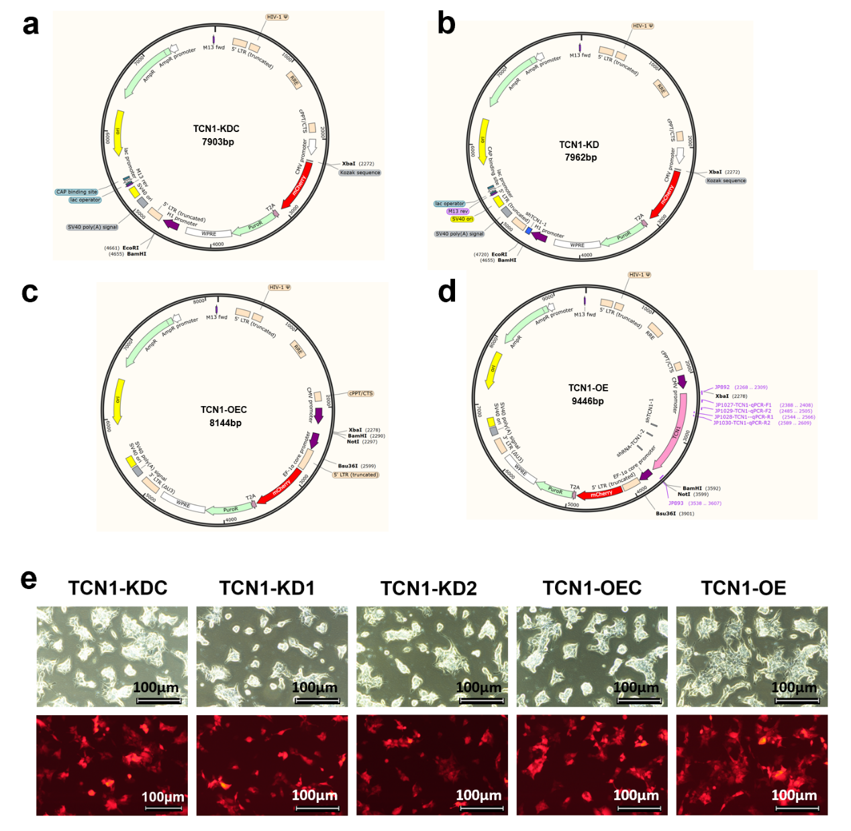

Figure S2. Identification of transcriptional targets of TCN1. a-c Gene set enrichment analysis (GSEA) plots for cell proliferation-related and EGFR signaling pathway-related genes in HCT116 cells followingTCN1 knockdown.

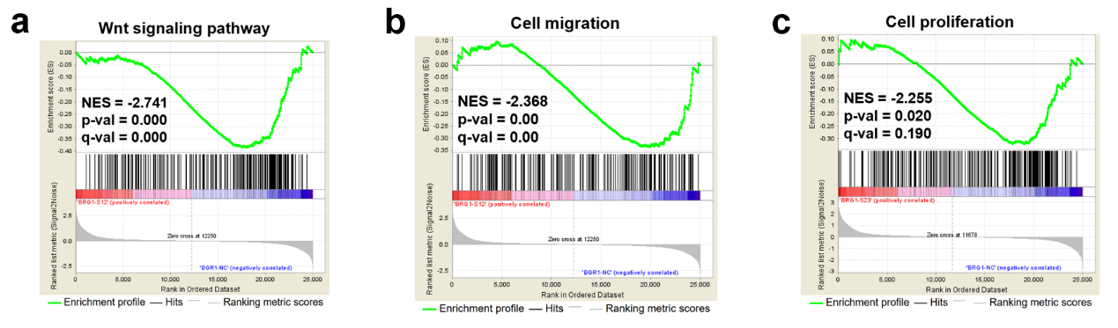

Figure S3. TCN1 deficiency causes cytoskeletal network damage. a-b Representative images obtained from confocal microscopy are shown. Immunofluorescence assay performed with the FLNA and PLEC antibodies. Scale bars=100 μm.

