Instrumentation data
Characterizations:
The crystallinity and phase composition of the synthesized nanoparticles were analyzed using an X-ray diffractometer Ringaku (Miniflex 600) equipped with Cu Ka radiation (1.54178 A) operating over a Bragg angle (2θ) range of 10°–80°. Functional groups present on the nanoparticle surface were identified by Fourier-transform infrared (FTIR) spectroscopy using Shimadzu spectrophotometer (Serial No. A224160) in the wavenumber range of 4000 to 500 cm⁻¹. Surface and morphological and elemental composition were study, by field-emission scanning electron microscopy (FE-SEM; JSM-7610F) energy coupled with energy- dispersive X-ray spectroscopy (EDS). Internal morphology and particle size distribution were further investigated using transmission electron microscopy (TEM), on Thermo Scientific Themis 300 G3 using an accelerating voltage of 300 kV.
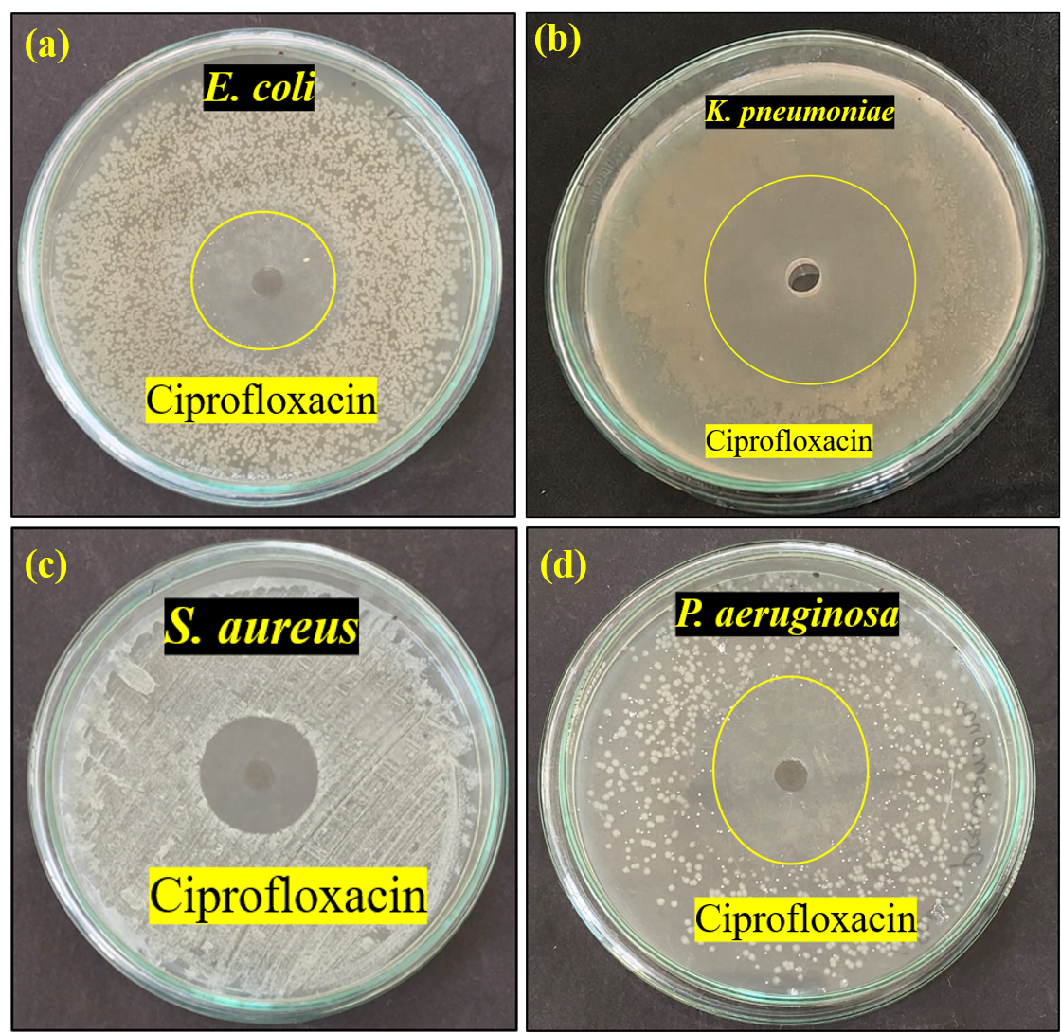
Fig. 6. (a-d) Antimicrobial activity Ciprofloxacin against Gram-positive and Gram-Negative bacteria

