Appendix:

A. Tables
Table 1. Baseline demographic and socioeconomic characteristics of participants.
 |  | Damascus  (N 102 , %) | Homs  (N 171 , %) | Total Cohort  (N 273, %) | P- value  (95% CI)
Sex (Male/Female) |  | 22 (21.6%) / 80 (78.4%) | 75 (43.9%) / 96 (56.1%) | 97 (35.5%) / 176 (64.5%) | < 0.001
Age (Mean ± SD) |  | 49.15 ± 13.0 | 58.69 ± 8.586 | 55.13 ± 11.23 | < 0.001
Pediatric / Adults (% of PED) |  | 7/95 (6.8%) | 4/167 (2.3%) | 11/261 ( 4.2%) | 0.088
Place of Residency (City/Rural) (% of city) |  | 20 / 82 (19.6%) | 52 / 119 (31.2%) | 72 /201 (26.4%) | 0.034
Socioeconomic history
Education Level | No formal education | 64 (63%) | 75 (46%) | 139 (51.9%) | 0.012
Education Level | 9th grade - High school | 27 (27%) | 63 (37%) | 90 (33.6%) | 0.012
Education Level | Higher education | 10 (10%) | 29 (17%) | 39 (14.6%) | 0.012
Education Level | Missing | 1 | 4 | 5 | 0.012
Employment status | Employed/Self employed | 44 (44.9%) | 33 (19.2%) | 77 (28.6%) | < 0.001
Employment status | Unemployed | 54 (55.1%) | 137 (80.8%) | 192 (71.4%) | < 0.001
Employment status | Missing | 3 | 1 | 4 | < 0.001
Number of people In the household (Mean ± SD ) |  | 5.78 ± 3.67 | 6.5 ± 3.39 | 6.23 ± 3.51 | 0.162
Marital status | Single | 17 (16.8%) | 13 (7.7%) | 30 (11.2%) | 0.003
Marital status | Married | 45 (44.6%) | 124 (73.8%) | 169 (62.8%) | 0.003
Marital status | Widowed | 28 (27.7%) | 29 (17.3%) | 57 (21.2%) | 0.003
Marital status | Not reported | 1 | 3 | 4 | 0.003
Access to clean water and food (Yes) |  | 44 (43%) | 126 (73.7%) | 170 (62.3%) | < 0.001
Social habits
Smoking |  | 27 (26.5%) | 56 (32.7%) | 83 (30.4%) | 0.382
Physical activity | Active | 15 (14.9%) | 26 (15.4%) | 41 (15.2%) | 0.013
Physical activity | Moderately active | 49 (48.5%) | 64 (37.9%) | 113 (41.9%) | 0.013
Physical activity | Sedentary | 38 (37.6%) | 79 (46.7%) | 117 (43.3%) | 0.013
Physical activity | Not reported | 1 | 2 | 3 | 0.013
Healthcare visits Frequency | Once a month | 40 (40.4%) | 41 (24.8%) | 81 (30.7%) | 0.013
Healthcare visits Frequency | Once every 3 months | 17 (17.2%) | 21 (12.7%) | 38 (14.4%) | 0.013
Healthcare visits Frequency | Once every 6 months | 5 (5.1%) | 25 (15.2%) | 30 (11.4%) | 0.013
Healthcare visits Frequency | Once annually | 7 (7.1%) | 14 (8.5%) | 21 (8.0%) | 0.013
Healthcare visits Frequency | Not regularly | 31 (31.3%) | 64 (38.8%) | 95 (36.0%) | 0.013
Healthcare visits Frequency | Not reported | 3 | 6 | 9 | 0.013

Table 2. Healthcare access, medication availability, and affordability among participants
Access to care |  | Damascus  (N 102 %) | Homs  (N 171 %) | Total Cohort  (N 273 %) | P value
Source of Care | Private clinics | 59 (57.8%) | 98 (57.3%) | 157 (57.5%) | 0.6138
Source of Care | Public hospitals | 13 (12.7%) | 28 (16.4%) | 41 (15.0%) | 0.6138
Source of Care | NGOs missions | 2 (2.0%) | 6 (3.5%) | 8 (2.9%) | 0.6138
Source of Care | None | 28 (27.5%) | 37 (21.6%) | 65 (23.8%) | 0.6138
Source of Care | Missing | 0 | 2 | 2 | 0.6138
Time to nearest care facility | 5-10 minutes | 12 (11.8%) | 61 (35.7%) | 73 (26.7%) | < 0.001
Time to nearest care facility | 15-30minutes | 25 (24.5%) | 45 (26.3%) | 70 (25.6%) | < 0.001
Time to nearest care facility | 30-1h + | 65 (63.7%) | 54 (31.6%) | 119 (43.6%) | < 0.001
Time to nearest care facility | Missing | 0 | 11 | 11 | < 0.001
Access Glucometer and Strips |  | 34 (33.3%) | 46 (26.9%) | 80 (29.3%) | 0.639
Access to oral medication |  | 56 (54.9%) | 132 ( 76.3%) | 188 (68.9%) | < 0.001
Access to insulin |  | 34 (33.3%) | 52, (30%) | 86 (31.5%) | 0.639
Affordability of medication and care |  | 16 (15.7%) | 20 (11.6%) | 38 (13.9%) | 0.485

Table 3. Clinical characteristics and diabetes-related complications by geographic location
 |  | Damascus  (N 102 %) | Homs  (N 171 %) | Total Cohort  (N 273 %) | P- value  (95% CI)
Type 1 diabetes  Type 2 diabetes  Unclassified/uncertain diabetes |  | 18 (17.6%)  74 (72.5%)  10 (9.8%) | 21 (12.3%)  148 (86.5%)  2 (1.2%) | 39 (14.3%)  222 (81.3%)  12 (4.4%) | 0.008
Year of diagnosis | 0-5 | 40 (39.2%) | 34 (19.9%) | 74 (27.1%) | 0.0063
Year of diagnosis | 5-10 | 19 (18.6%) | 34 (19.9%) | 53 (19.4%) | 0.0063
Year of diagnosis | More than 10 years | 42 (41.2%) | 95 (55.6%) | 137 (50.2%) | 0.0063
Year of diagnosis | Unknown | 1 (1.0%) | 9 (5.3%) | 10 (3.7%) | 0.0063
Last HbA1c value | Less than 7.5 | 17 (16.7%) | 27 (15.8%) | 44 (16.1%) | 0.174
Last HbA1c value | 7.5 or higher | 37 (36.2%) | 34 (19.9%) | 73 (26.7%) | 0.174
Last HbA1c value | Unknown | 46 (45.1%) | 110 (64.3%) | 156 (57.1%) | 0.174
Last HbA1c value | HbA1c  (Mean ± SD ) | 8.30 ±1.85 | 8.00 ± 1.22 | 8.12 ± 1.50 | 0.359
Complications
Previous hospitalizations of diabetes |  | 48 (47.1%) | 58 (33.9%) | 106 (38.8%) | 0.036
Microvascular complications | Retinopathy | 30 (29.4%) | 43 (25.1%) | 73 (26.7%) | 0.493
Microvascular complications | Nephropathy | 2 (2.0%) | 4 (2.3%) | 6 (2.2%) | 0.975
Microvascular complications | Neuropathy | 21 (20.6%) | 34 (19.9%) | 55 (20.1%) | 1.0000
Macrovascular complications | Cardiovascular diseases | 3 (2.9%) | 14 (8.2%) | 17 (6.2%) | 0.120
Macrovascular complications | diabetic foot ulcer | 7 (6.9%) | 11 (6.4%) | 18 (6.6%) | 1.0000
Associated comorbidity factors
Hypertension |  | 24 (23.5%) | 26 (15.2%) | 50 (18.3%) | 0.109
Dyslipidemia |  | 1 (1.0%) | 3 (1.8%) | 4 (1.5%) | 1.0000

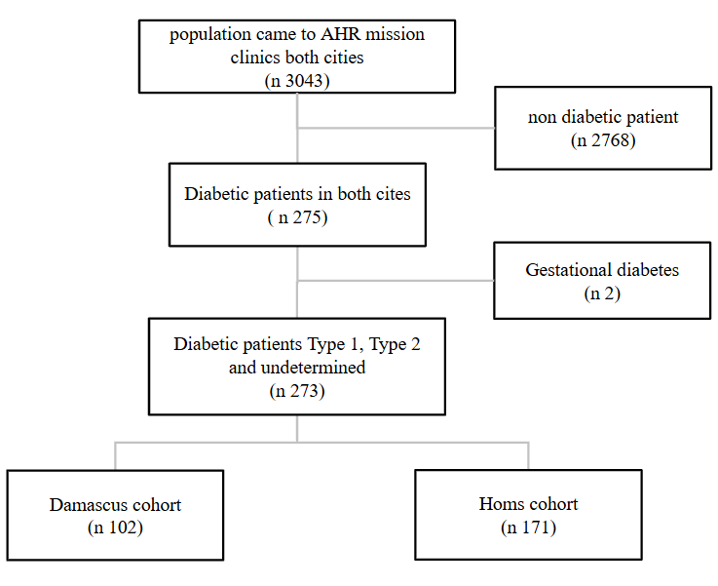
B. Figures

Figure 1. Flow diagram of participant recruitment and inclusion as 3043 participants who attended the AHR humanitarian temporary clinics were screened for inclusion, 2768 was not diabetics and only 275 were diabetics, 2 cases was excluded as they had gestational diabetes including 273 in the final analysis, 102 and 171 diabetic participants were included in Damascus and Homs respectively.

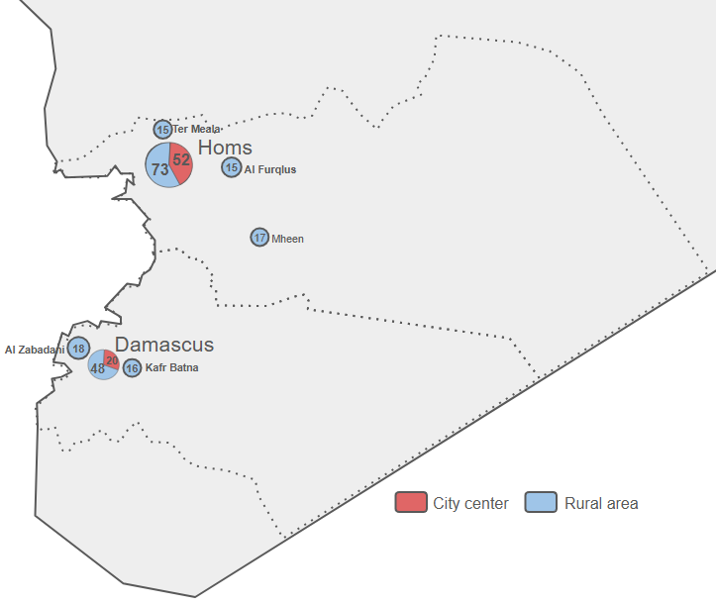

Figure 2. Geographic distribution of study sites and participant recruitment across Damascus and Homs*This map was originally designed for the study.
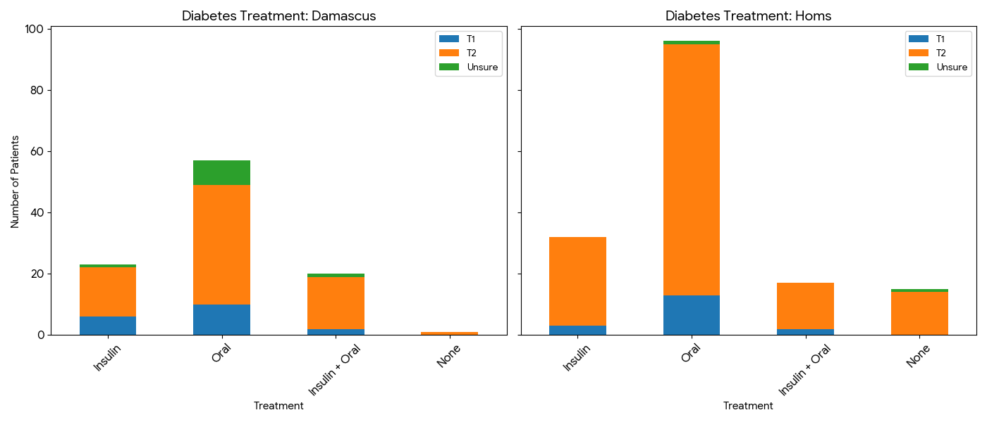
Figure 3. Distribution of current diabetes treatment modalities among participants in Damascus
Figure 4. Distribution of current diabetes treatment modalities among participants in Homs

