Supplemental Information

Uncovering Collective Modes Underlying the Giant Dielectric Response of Ferroelectric Nematic Liquid Crystals

Kazuma Nakajima^{1*}, Hirokazu Kamifuji¹, Hirotsugu Kikuchi², Kenjiro Fukuda^{1*}, and Masanori Ozaki¹

¹Division of Electrical, Electronic and Infocommunications Engineering, Graduate School of Engineering, The University of Osaka, 2-1 Yamadaoka, Suita, Osaka 565-0871, Japan
²Institute for Materials Chemistry and Engineering, Kyushu University, Kasuga, Fukuoka 816-8580, Japan
*nakajima.kazuma@eei.eng.osaka-u.ac.jp, fukuda@eei.eng.osaka-u.ac.jp

Contents
Supplementary Figures
- Figure S1. Cole–Cole plots and fitting results
- Figure S2. Temperature evolution of dielectric spectra
- Figure S3. Convergence of dielectric parameters during repeated DC-voltage cycling
- Figure S4. Voltage dependence of dielectric spectra
- Figure S5. Temperature dependence under applied DC voltages
- Figure S6. Thickness dependence of dielectric strengths and relaxation frequencies
- Figure S7. Chemical structures of FNLC components
- Figure S8. Schematic illustration of dielectric spectroscopy measurement setup
Supplementary Notes
- Supplementary Note I. Derivation of the low-frequency mode
- Supplementary Note II. Derivation of the high-frequency mode

This PDF file includes Supplementary Figures S1–S8 and Supplementary Notes 1–2.

Supplementary Figures

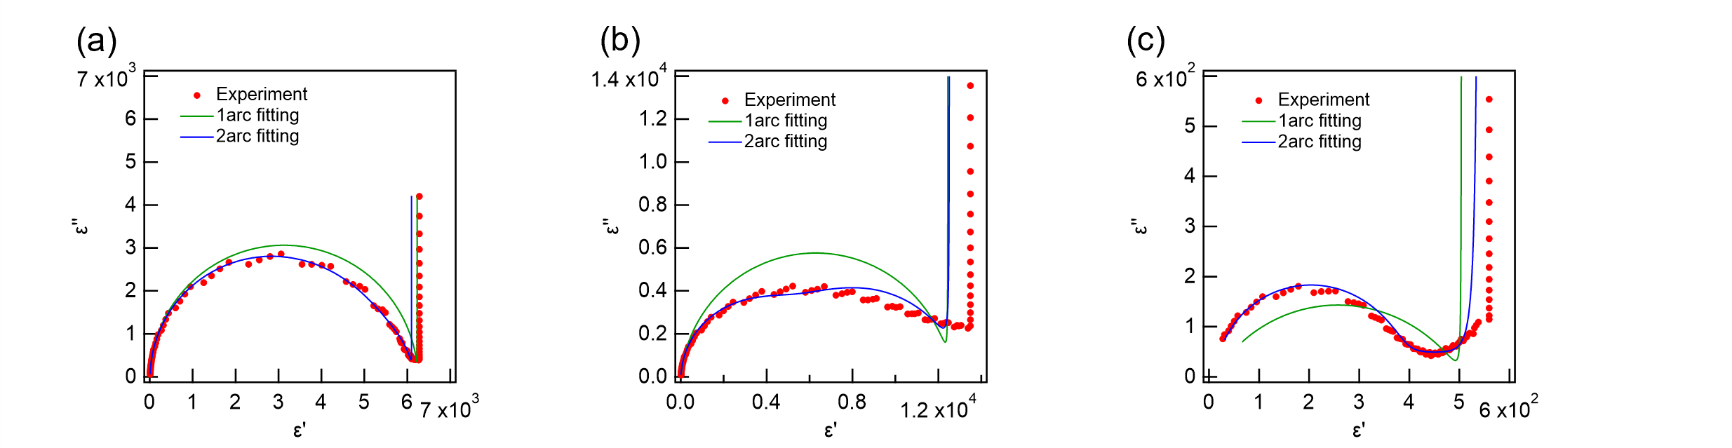
Figure S1 Cole–Cole plots and fitting results for the ferroelectric nematic liquid crystal. (a–c) Cole–Cole plots measured at 75°C for (a) a 9.05-μm-thick cell without an alignment layer, (b) a 9.51-μm-LIA-03-coated cell, and (c) an 8.90-μm-AL1254 coated cell. Red symbols represent the experimental data. Green and blue curves correspond to the fitting results obtained using the one-relaxation (1 arc) and two-relaxation (2 arc) models, respectively. The 2 arc model reproduces the experimental Cole–Cole plots more accurately than the conventional 1 arc model, supporting the existence of two independent dielectric relaxation modes in the FNLC.

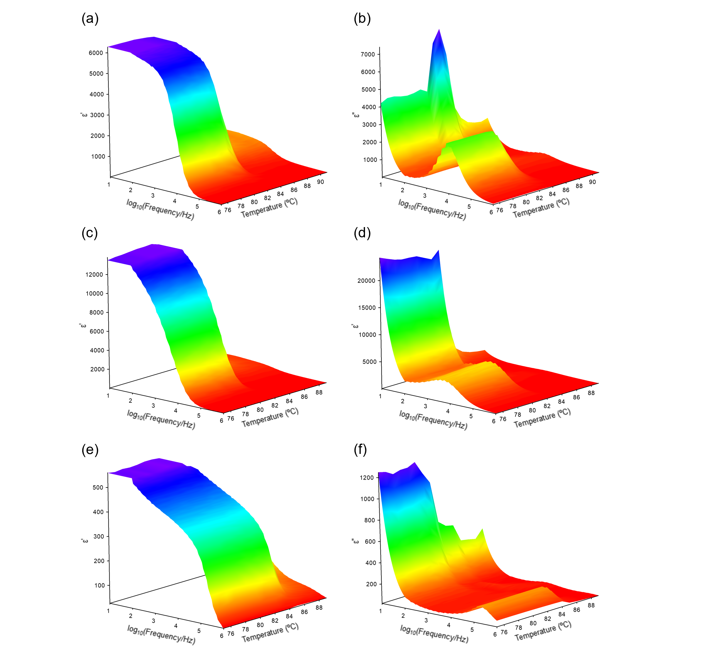
Figure S2 Temperature evolution of the dielectric spectra used for the relaxation analysis. Three-dimensional plots of the real part and the imaginary part of the complex dielectric permittivity ($ε', ε''$) as a function of frequency and temperature during cooling. (a,b) a 9.05-μm-thick cell without an alignment layer, (c,d) a 9.51-μm-LIA-03-coated cell, and (e,f) an 8.90-μm-AL1254 coated cell. Panels (a,c,e) show $ε'$, while panels (b,d,f) show $ε''$. The measurements were performed during cooling at a rate of $0.2 ^{∘}C min^{-1}$. These data were used to extract the dielectric strengths and relaxation frequencies presented in Fig. 2.

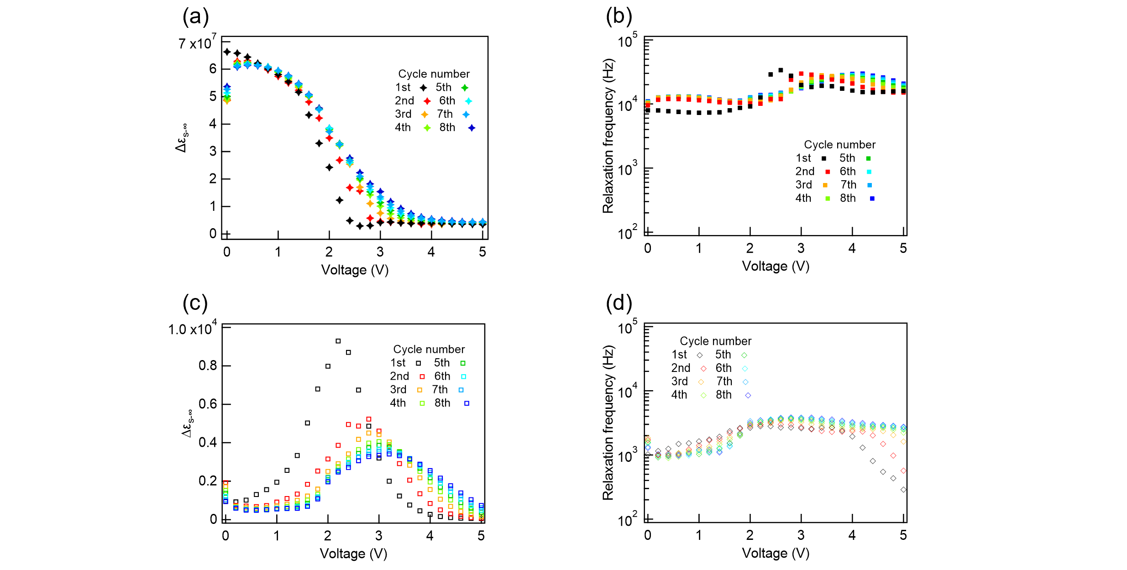
Figure S3 Convergence of dielectric relaxation parameters during repeated dc-voltage cycling. Voltage dependence of the dielectric strength and relaxation frequency obtained from the 2 arc analysis at 80°C for a 14.25 μm cell without an alignment layer. (a) Dielectric strength $Δε_{s-∞,H}$ and (b) relaxation frequency $f_{r,H}$ of the high-frequency mode. (c) Dielectric strength $Δε_{s-∞,L}$ and (d) relaxation frequency $f_{r,L}$ of the low-frequency mode. The DC voltage was swept repeatedly from 0 to 5 V for 8 cycles. Significant changes are observed during the first few cycles, whereas the dielectric parameters converge after repeated voltage cycling. The measurements presented in Fig. 3(a–e) were performed after confirming the convergence of the dielectric response.

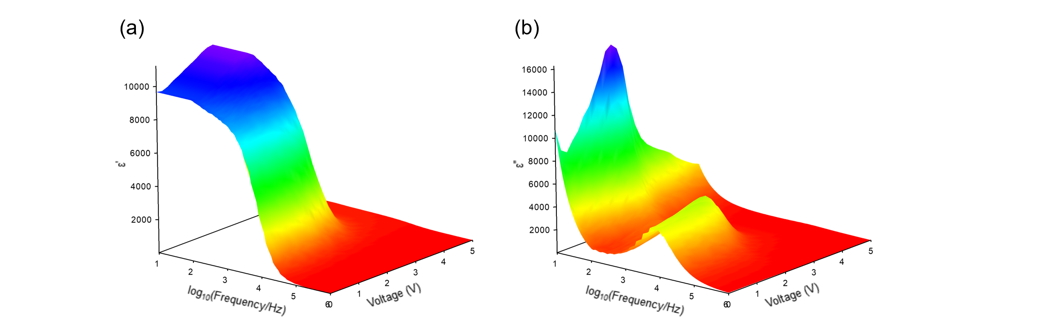
Figure S4 Voltage dependence of the dielectric spectra in the ferroelectric nematic phase. Three-dimensional plots of (a) the real part and (b) the imaginary part of the complex dielectric permittivity as a function of frequency and applied DC voltage measured at 80°C in a 14.25 μm cell without an alignment layer. With increasing DC voltage, the dielectric-loss peak shifts toward lower frequencies and the contribution of the low-frequency relaxation mode becomes increasingly pronounced. These spectra were used to obtain the voltage dependences of the dielectric strengths and relaxation frequencies shown in Fig. 3(d,e).
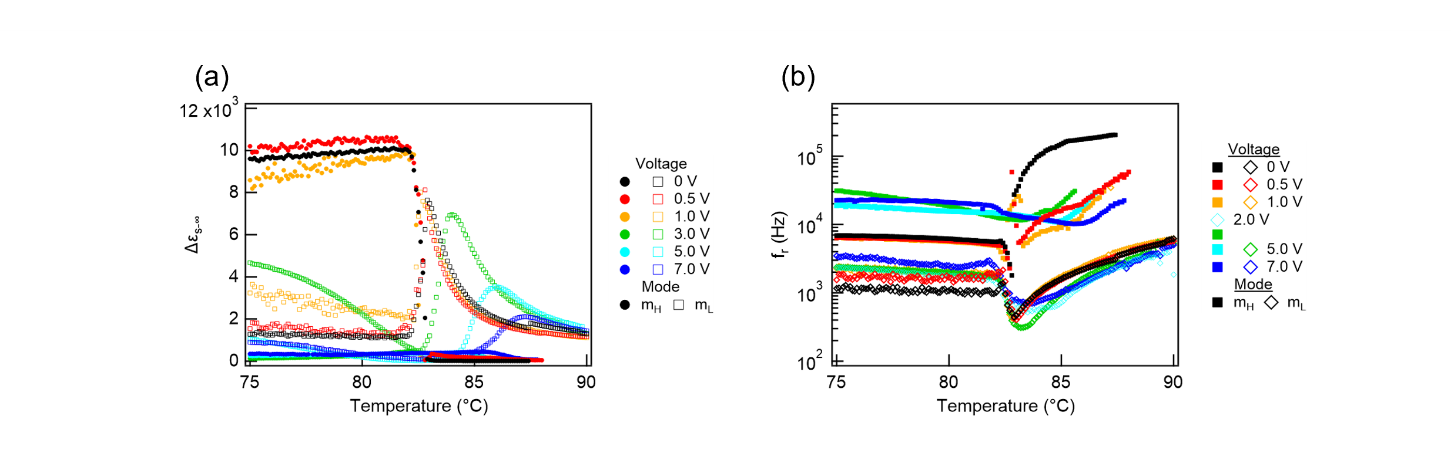
Figure S5 Temperature dependence of the dielectric strengths and relaxation frequencies under applied dc voltages. (a) Temperature dependence of the dielectric strength $Δε_{s-∞}$ and (b) relaxation frequency $f_{r}$ obtained from the 2 arc analysis for different DC voltages in a 14.31 μm cell without an alignment layer. Filled symbols correspond to the high-frequency mode ($m_{H}$) and open symbols to the low-frequency mode ($m_{L}$). Increasing DC voltage suppresses the dielectric strength of the high-frequency mode, while the low-frequency mode remains pronounced and develops a peak that shifts toward higher temperature. Also, the minimum value of the relaxation frequency in the low-frequency mode was observed to shift toward higher temperatures when a voltage was applied.

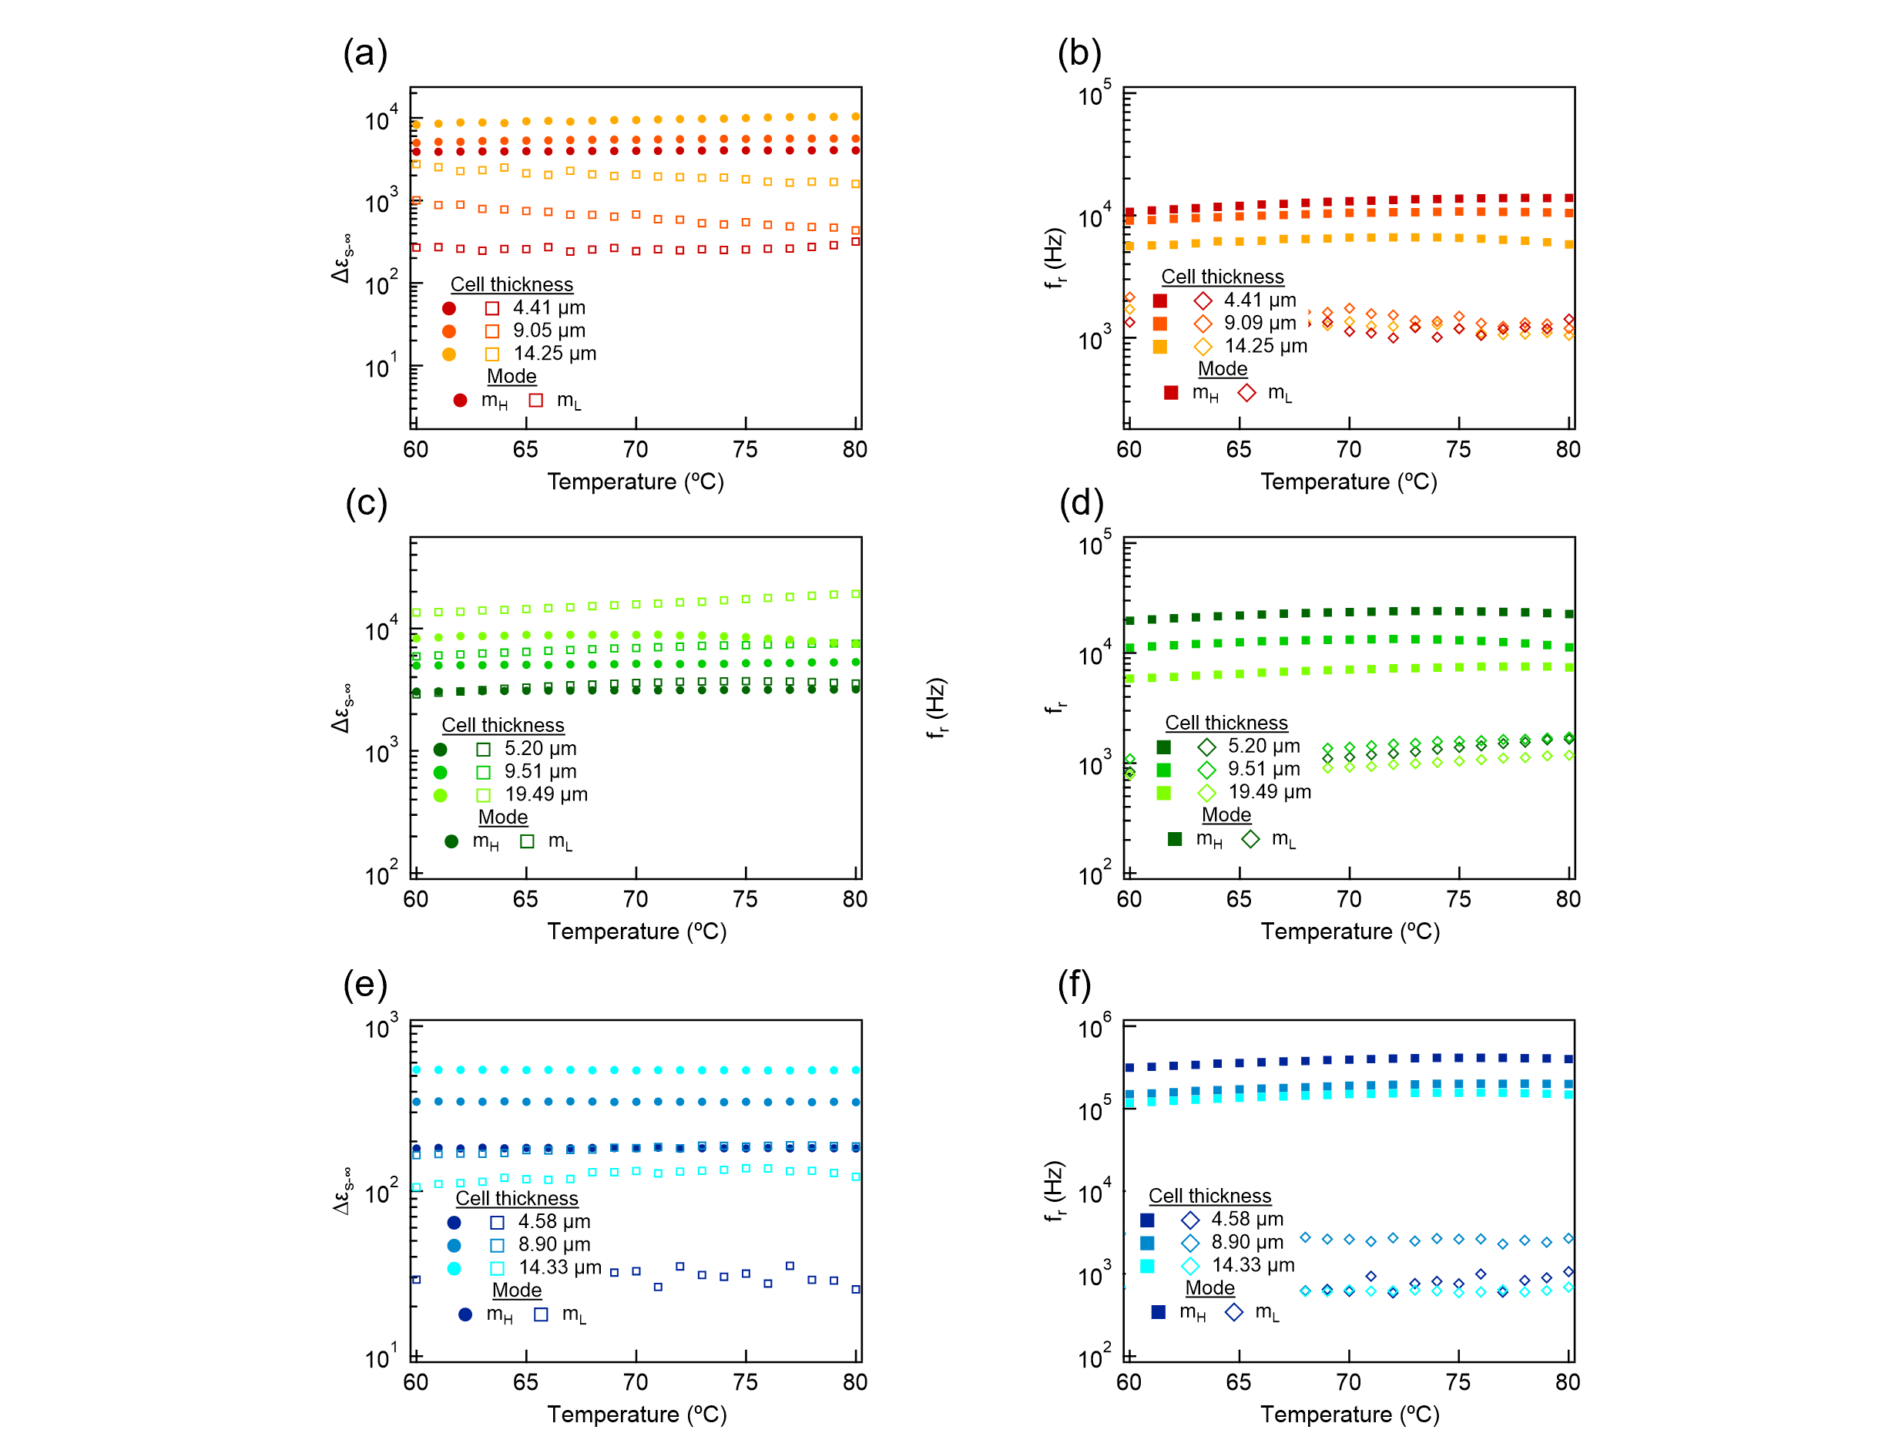
Figure S6 Temperature dependences of the dielectric strengths and relaxation frequencies for different cell thicknesses. (a,b) Cells without an alignment layer (($d=4.41$, 9.05, and 14.25 μm), (c,d) LIA-03-coated cells ($d=5.20$, 9.51, and 19.49 μm), and (e,f) AL1254-coated cells ($d=4.58$, 8.90, and 14.33 μm). Panels (a,c,e) show the dielectric strength $Δε_{s-∞}$, and panels (b,d,f) show the relaxation frequency $f_{r}$. Filled symbols correspond to the high-frequency mode ($m_{H}$), and open symbols correspond to the low-frequency mode ($m_{L}$). These data were used for the thickness-scaling analysis presented in Fig. 4.

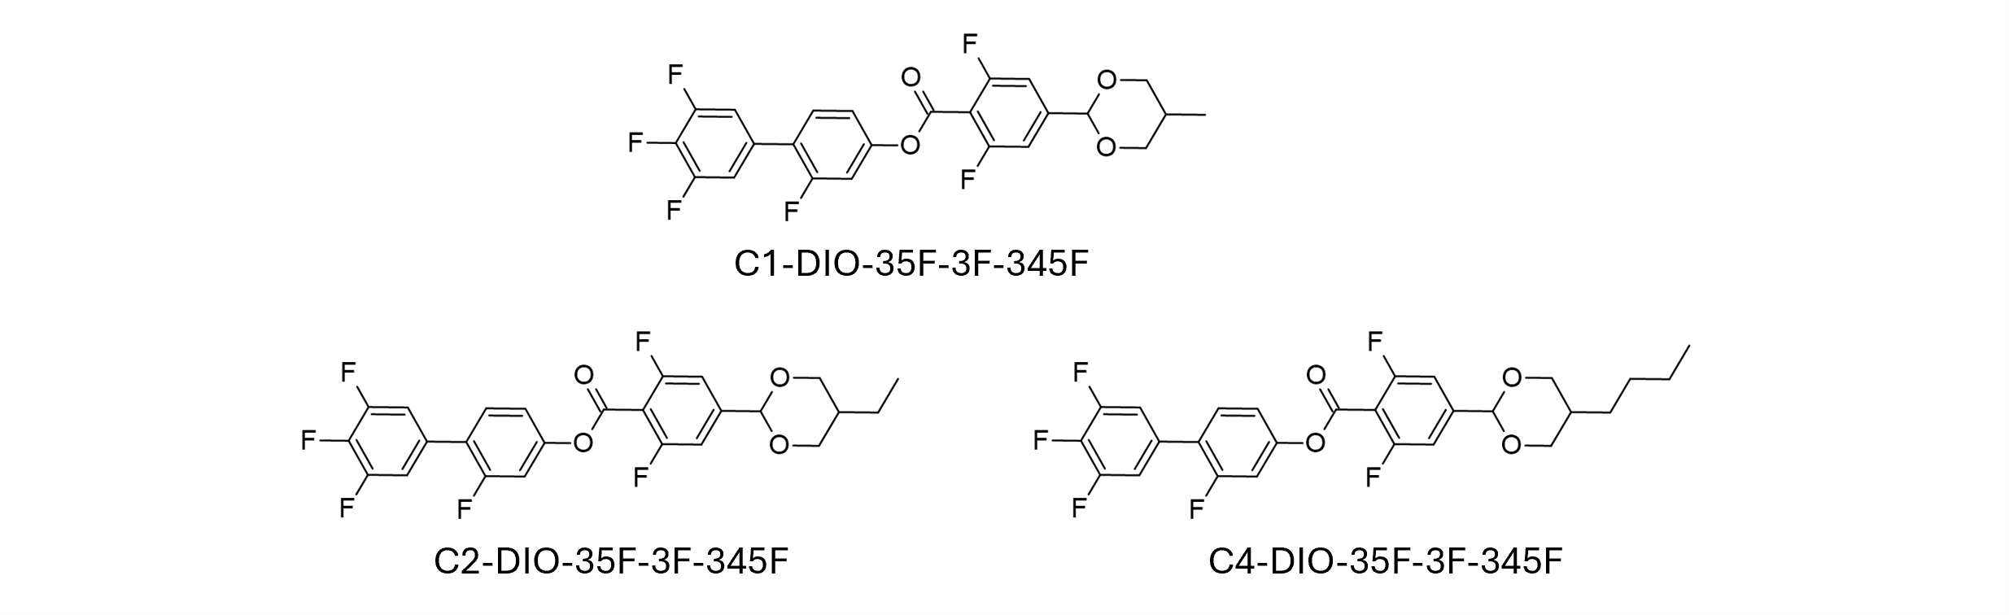
Figure S7 Chemical structures of the FNLC components used in this study. Molecular structures of C1-DIO-35F-3F-345F, C2-DIO-35F-3F-345F, and C4-DIO-35F-3F-345F. The FNLC investigated in this work was prepared from a mixture of these compounds with different terminal alkyl-chain lengths.

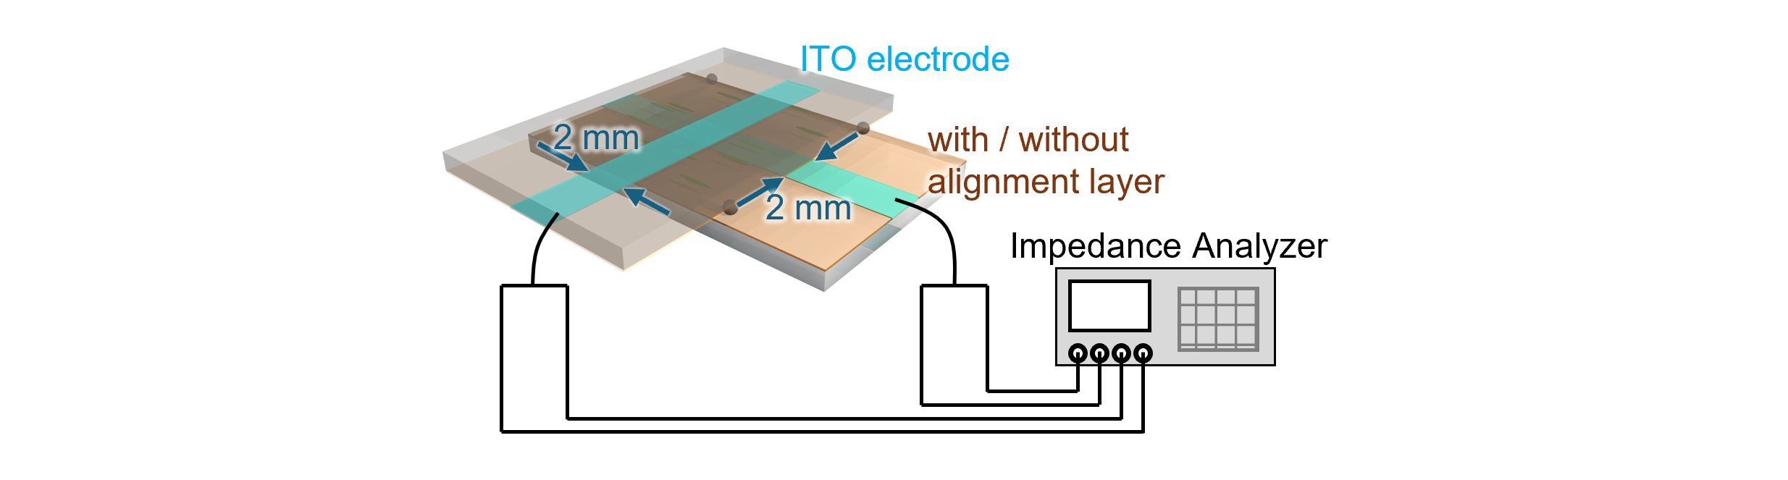
Figure S8 Schematic illustration of the dielectric spectroscopy measurement setup. Two ITO-coated glass substrates were crossed orthogonally to form a measurement area of $2×2 {mm}^{2}$. Cells were prepared with or without an alignment layer, and the complex dielectric permittivity was measured using an impedance analyzer. The cell thickness was controlled by spacer particles dispersed between the substrates.

Supplementary Notes
Supplementary Note I. Derivation of the low-frequency mode
We describe the low-frequency mode as a soft-mode-like fluctuation associated with molecular rotation around the short molecular axis. In a planar cell, this motion is accompanied by a spatially distributed director displacement that is constrained by the interfaces. In contrast, when the director is reoriented toward the electric-field direction, the response is dominated by a more local change in the orientational order. We formulate these two limiting cases separately.
I-1 Planar director configuration
We first consider the case in which the polar director lies parallel to the substrates and the electric field is applied along the cell normal. In this configuration, molecular rotation around the short molecular axis induces a displacement of the director and of the orientational distribution toward the electric-field direction. Because the interfaces suppress this displacement, whereas the bulk region can deform more freely, the displacement is expected to be largest near the center of the cell. We approximate the spatial profile as
$$\begin{aligned}ϕ_{A}\left(z\right)=A_{L}\sin\left(\frac{πz}{d}\right),\#\left(S1\right)\end{aligned}$$
where $A_{L}$ is the maximum displacement amplitude at $z=d/2$, and $d$ is the cell thickness.
The intrinsic restoring force of this mode is assumed to originate from changes in the orientational distribution around the director. We introduce the orientational order parameter
$$\begin{aligned}η=\left\langle \cos^{2}{θ}\right\rangle ,\#\left(S2\right)\end{aligned}$$
where $θ$ is the angle between the molecular long axis and the local director. The equilibrium value is denoted by $η_{0}$. A short-axis rotational displacement is accompanied by a small change in the orientational distribution, which we write phenomenologically as
$$\begin{aligned}η\left(z\right)-η_{0}=aϕ_{A}\left(z\right),\#\left(S3\right)\end{aligned}$$
where $a$ is a coupling coefficient. The free-energy cost associated with this order-parameter distortion is
$$\begin{aligned}F_{order}=\int_{0}^{d}{\frac{1}{2}}K_{η}{(η\left(z\right)-η_{0})}^{2}dz,\#\left(S4\right)\end{aligned}$$
where $K_{η}$ is the stiffness of the orientational distribution. Substituting Eq. (S3) gives
$$\begin{aligned}F_{order}=\int_{0}^{d}{\frac{1}{2}}K_{η}a^{2}ϕ_{A}{\left(z\right)}^{2}dz.\#\left(S5\right)\end{aligned}$$
Using Eq. (S1),
$$\begin{aligned}F_{order}=\frac{1}{2}K_{η}a^{2}{A_{L}}^{2}\int_{0}^{d}{\sin^{2}\left(\frac{πz}{d}\right)}dz.\#\left(S6\right)\end{aligned}$$
Since
$$\begin{aligned}\int_{0}^{d}{\sin^{2}\left(\frac{πz}{d}\right)}dz=\frac{d}{2},\#\left(S7\right)\end{aligned}$$
we obtain
$$\begin{aligned}F_{order}=\frac{1}{4}K_{0}{A_{L}}^{2}d,\#\left(S8\right)\end{aligned}$$
where
$$\begin{aligned}K_{0}=K_{η}a^{2}.\#\left(S9\right)\end{aligned}$$
Thus, the coefficient $K_{0}$ represents the effective bulk restoring coefficient associated with the orientational-order distortion induced by the short-axis rotational mode.
Next, we include the interfacial displacement $ϕ_{s}$, which represents the director displacement near the substrates. The interfacial displacement is coupled to the bulk amplitude $A_{L}$, and the corresponding free energy is written as
$$\begin{aligned}F_{int}=w_{∥}ϕ_{s}^{2}+\int_{0}^{d}{\frac{1}{2}g{\left(ϕ_{s}-λA_{L}\right)}^{2}dz}=w_{∥}ϕ_{s}^{2}+\frac{1}{2}dg{\left(ϕ_{s}-λA_{L}\right)}^{2},\#\left(S10\right)\end{aligned}$$
where $w_{∥}$ is the anchoring coefficient for the director deformation associated with the low-frequency mode, $g$ is the coupling coefficient between the bulk and interfacial displacements, and $λ$ describes how efficiently the bulk distortion induces the interfacial displacement.
The electric field couples to both the spatially distributed bulk displacement and the interfacial displacement.
$$\begin{aligned}F_{E}=-\int_{0}^{d}{P_{∥}}E\left(ϕ_{s}+ϕ_{A}\left(z\right)\right)dz,\#\left(S11\right)\end{aligned}$$
where $P_{∥}$ is the polarization component associated with the short-axis rotational response. Using Eq. (S1),
$$\begin{aligned}F_{E}=-\left(P_{∥}Eϕ_{s}d+P_{∥}EA_{L}\int_{0}^{d}{\sin\left(\frac{πz}{d}\right)}dz\right)=-P_{∥}Ed\left(\frac{2}{π}A_{L}+ϕ_{s}\right).\#\left(S12\right)\end{aligned}$$
Thus, the total free energy in the planar configuration is therefore
$$\begin{aligned}F_{pl}\left(A_{L},ϕ_{s}\right)=\frac{1}{4}K_{0}{A_{L}}^{2}d+w_{∥}ϕ_{s}^{2}+\frac{1}{2}dg{\left(ϕ_{s}-λA_{L}\right)}^{2}-P_{∥}Ed\left(\frac{2}{π}A_{L}+ϕ_{s}\right).\#\left(S13\right)\end{aligned}$$
The equilibrium interfacial displacement is obtained from
$$\begin{aligned}\frac{∂F_{pl}}{∂ϕ_{s}}=0.\#\left(S14\right)\end{aligned}$$
This gives
$$\begin{aligned}2w_{∥}ϕ_{s}+dg\left(ϕ_{s}-λA_{L}\right)-P_{∥}Ed=0,\#\left(S15\right)\end{aligned}$$
and hence
$$\begin{aligned}ϕ_{s}=\frac{dgλ}{2w_{∥}+dg}A_{L}+\frac{dP_{∥}}{2w_{∥}+dg}E.\#\left(S16\right)\end{aligned}$$
Substituting Eq. (S16) into Eq. (S13), the effective free energy for $A_{L}$ becomes
$$\begin{aligned}F_{pl}\left(A_{L}\right)=\frac{1}{2}K_{eff,L}{A_{L}}^{2}d-P_{∥}Ed\left(\frac{2}{π}+\frac{dgλ}{2w_{∥}+dg}\right)A_{L}-\frac{d^{2}P_{∥}^{2}}{2\left(2w_{∥}+dg\right)}E^{2},\#\left(S17\right)\end{aligned}$$
where
$$\begin{aligned}K_{eff,L}=\frac{1}{2}K_{0}+\frac{2gw_{∥}λ^{2}}{2w_{∥}+dg}.\#\left(S18\right)\end{aligned}$$
The first term in Eq. (S17) is the intrinsic bulk restoring force originating from orientational-order distortion, whereas the second term arises from the coupling between the bulk director displacement and the interfacial anchoring.
The equilibrium bulk amplitude is obtained from
$$\begin{aligned}\frac{∂F_{pl}}{∂A_{L}}=K_{eff,L}A_{L}d-P_{∥}Ed\left(\frac{2}{π}+\frac{dgλ}{2w_{∥}+dg}\right)=0.\#\left(S19\right)\end{aligned}$$
This gives
$$\begin{aligned}A_{L}=\frac{P_{∥}E\left(\frac{2}{π}+\frac{dgλ}{2w_{∥}+dg}\right)}{K_{eff,L}}.\#\left(S20\right)\end{aligned}$$
The polarization response should be evaluated from the spatial average of the induced polarization displacement. Within the present effective model,
$$\begin{aligned}\left\langle δP_{L}\right\rangle =\frac{1}{d}\int_{0}^{d}{P_{∥}}\left(ϕ_{A}\left(z\right)+ϕ_{s}\right)dz.\#\left(S21\right)\end{aligned}$$
Using Eq. (S1), this becomes
$$\begin{aligned}\left\langle δP_{L}\right\rangle =P_{∥}\left(\frac{2}{π}A_{L}+ϕ_{s}\right).\#\left(S22\right)\end{aligned}$$
Substituting Eqs. (S16) and (S20), we obtain
$$\begin{aligned}\left\langle δP_{L}\right\rangle =P_{∥}^{2}E\left[\frac{{\left(\frac{2}{π}+\frac{dgλ}{2w_{∥}+dg}\right)}^{2}}{K_{eff,L}}+\frac{d}{2w_{∥}+dg}\right].\#\left(S23\right)\end{aligned}$$
Therefore, the polarization susceptibility is
$$\begin{aligned}χ_{L}=\frac{∂\left\langle δP_{L}\right\rangle }{∂E}=P_{∥}^{2}\left[\frac{{\left(\frac{2}{π}+\frac{dgλ}{2w_{∥}+dg}\right)}^{2}}{K_{eff,L}}+\frac{d}{2w_{∥}+dg}\right].\#\left(S24\right)\end{aligned}$$
Thus, the dielectric strength is given by
$$\begin{aligned}Δε_{L}\sim \frac{χ_{L}}{ε_{0}}=\frac{P_{∥}^{2}}{ε_{0}}\left[\frac{{\left(\frac{2}{π}+\frac{dgλ}{2w_{∥}+dg}\right)}^{2}}{K_{eff,L}}+\frac{d}{2w_{∥}+dg}\right].\#\left(S25\right)\end{aligned}$$
The relaxation dynamics of the low-frequency mode are described by the overdamped equation of motion for $A_{L}$,
$$\begin{aligned}γ_{L}\frac{dA_{L}}{dt}=-K_{eff,L}A_{L}+P_{∥}E\left(t\right)\left(\frac{2}{π}+\frac{dgλ}{2w_{∥}+dg}\right),\#\left(S26\right)\end{aligned}$$
where $γ_{L}$ is the effective rotational viscosity. Therefore,
$$\begin{aligned}τ_{L}=\frac{γ_{L}}{K_{eff,L}},\#\left(S27\right)\end{aligned}$$
and
$$\begin{aligned}f_{L}=\frac{1}{2πτ_{L}}=\frac{K_{eff,L}}{2πγ_{L}}.\#\left(S28\right)\end{aligned}$$
Equations (S25) and (S28) show how the planar low-frequency response depends on the balance between the intrinsic bulk restoring force and the interfacial contribution.
A particularly important limiting case is obtained when the intrinsic bulk restoring force dominates over the interfacial contribution,
$$\begin{aligned}\frac{1}{2}K_{0}≫\frac{2gw_{∥}λ^{2}}{2w_{∥}+dg}.\#\left(S29\right)\end{aligned}$$
In this limit,
$$\begin{aligned}K_{eff,L}≃\frac{1}{2}K_{0},\#\left(S30\right)\end{aligned}$$
and hence
$$\begin{aligned}f_{L}≃\frac{K_{0}}{4πγ_{L}},\#\left(S31\right)\end{aligned}$$
which is nearly independent of the cell thickness. If, in addition, the interfacial polarization contribution dominates the dielectric amplitude and $2w_{∥}≫dg$, Eq. (S25) reduces approximately to
$$\begin{aligned}Δε_{L}\sim \frac{P_{∥}^{2}}{2ε_{0}w_{∥}}d.\#\left(S32\right)\end{aligned}$$
Thus, the model explains the experimental trend in which the dielectric strength increases with cell thickness, whereas the relaxation frequency remains nearly thickness-independent. Physically, the relaxation frequency is governed mainly by the intrinsic bulk restoring force associated with orientational-order distortion, while the dielectric amplitude is enhanced by the polarization displacement accumulated across the cell and by the interfacial director response.

I-2: Homeotropic director configuration under dc electric field
We next consider the case in which a sufficiently strong dc electric field reorients the director toward the field direction. In this configuration, the low-frequency mode no longer requires a spatially distributed director deformation constrained by the substrates. Instead, the response is dominated by a local change in the orientational order parameter itself.
The order parameter is again defined as
$$\begin{aligned}η=\left\langle \cos^{2}{θ}\right\rangle .\#\left(S33\right)\end{aligned}$$
In the homeotropic state, the director is approximately parallel to the electric field, and the field-induced change in $η$ directly changes the polarization component along the field direction. We define
$$\begin{aligned}δη=η-η_{0}.\#\left(S34\right)\end{aligned}$$
The free energy for this order-parameter fluctuation is written as
$$\begin{aligned}F_{homeo}\left(δη\right)=\frac{1}{2}K_{η}{δη}^{2}d-P_{η}Edδη,\#\left(S35\right)\end{aligned}$$
where $P_{η}$ is the effective coupling coefficient between the orientational-order change and the electric-field-induced polarization response.
The equilibrium value of $δη$ is obtained from
$$\begin{aligned}\frac{∂F_{homeo}}{∂δη}=0,\#\left(S36\right)\end{aligned}$$
which gives
$$\begin{aligned}δη=\frac{P_{η}}{K_{η}}E.\#\left(S37\right)\end{aligned}$$
The dielectric susceptibility in the homeotropic state is therefore
$$\begin{aligned}χ_{L}=\frac{∂}{∂E}\left(P_{η}δη\right)=\frac{P_{η}^{2}}{K_{η}},\#\left(S38\right)\end{aligned}$$
and
$$\begin{aligned}Δε_{L}\sim \frac{P_{η}^{2}}{ε_{0}K_{η}}.\#\left(S39\right)\end{aligned}$$
The relaxation dynamics are described by
$$\begin{aligned}γ_{L}\frac{dδη}{dt}=-K_{η}δη+P_{η}E\left(t\right),\#\left(S40\right)\end{aligned}$$
where $γ_{L}$ is the effective viscosity for the orientational-order fluctuation. Thus,
$$\begin{aligned}τ_{L}=\frac{γ_{L}}{K_{η}},\#\left(S41\right)\end{aligned}$$
and
$$\begin{aligned}f_{L}=\frac{K_{η}}{2πγ_{L}}.\#\left(S42\right)\end{aligned}$$
Equations (S39) and (S42) show that, in the homeotropic configuration, the dielectric response directly reflects the intrinsic order-parameter fluctuation. Since the director deformation constrained by the substrates is largely removed, the response is no longer governed primarily by the interfacial anchoring term¹. This explains why the dielectric anomaly associated with the low-frequency mode becomes more pronounced when the director is reoriented toward the electric-field direction. It should be noted, however, that the dc electric field plays two distinct roles. The first is to reorient the director and thereby remove the interfacially constrained director-deformation component. The second is to modify the fluctuation of the orientational distribution once the director is already aligned along the field. In this field-aligned state, increasing the dc bias can reduce the differential order-parameter response to the ac probing field (Fig. 3d). This reduction naturally leads to a decrease in the dielectric strength. After the low-frequency mode becomes pronounced, the subsequent decrease in relaxation frequency indicates that the field also lowers the effective dynamic response rate of the collective fluctuation, namely the ratio between the effective restoring coefficient and the effective kinetic coefficient (Fig. 3e). We therefore do not attribute the voltage dependence to a simple increase in restoring stiffness alone. Instead, the observed decrease in both dielectric strength and relaxation frequency suggests that the dc field suppresses the oscillator strength of the order-parameter fluctuation and slows the collective response in the field-aligned state.
Therefore, although the planar and homeotropic configurations differ in the extent to which the director-deformation component and interfacial anchoring contribute to the response, both cases originate from perturbations of the orientational order associated with molecular rotation around the short molecular axis. Thus, the low-frequency mode is expected to be sensitive to the softening of the orientational-order stiffness near the SmZ_{A}–N_{F} phase transition. This provides a natural explanation for the pronounced dielectric anomaly and the soft-mode-like behavior observed for the low-frequency mode near the phase transition.

Reference
1. Nakase, M. et al. Field-induced phase transition behaviour of ferroelectric nematic liquid crystals under DC electric fields. Soft Matter 22, 2538–2544 (2026).

Supplementary Note II. Derivation of the high-frequency mode
To understand the physical origin of the high-frequency dielectric relaxation mode, we consider a collective phase displacement of the transverse polarization component around the director. The molecular dipole is tilted with respect to the molecular long axis and therefore has a component perpendicular to the long axis. This transverse dipolar component can rotate around the long axis with a certain degree of freedom. Owing to dipole–dipole correlations, however, the azimuthal distribution of this transverse component is not completely isotropic, and a biased transverse polarization component remains at the macroscopic level. We denote this effective transverse polarization component as $P_{⊥}$. The high-frequency mode is then described as a collective displacement of this transverse polarization phase around the director. Importantly, this motion does not require an appreciable deformation of the director field itself.
We introduce a collective rotational displacement $ϕ_{A}\left(z\right)$, which describes the phase displacement of the transverse polarization component $P_{⊥}$ along the cell normal direction $z$. Since the displacement is constrained by the interfaces and becomes largest in the bulk, we approximate the spatial profile by
$$\begin{aligned}ϕ_{A}\left(z\right)=A_{H}\sin\left(\frac{πz}{d}\right),\#\left(S43\right)\end{aligned}$$
where $A_{H}$ is the maximum displacement amplitude at the cell center $z=d/2$, and $d$ is the cell thickness. The magnitude of the transverse polarization component is written phenomenologically as
$$\begin{aligned}P_{⊥}=P_{s}\sin{θ},\#\left(S44\right)\end{aligned}$$
where $P_{s}$ is the magnitude of the local polar order and $θ$ represents the tilt angle of the molecular dipole from the director. Here, $P_{⊥}$ should be understood as the effective transverse polarization component that remains after azimuthal averaging under dipole–dipole correlations.
Although the director field remains essentially unchanged during this motion, the collective displacement of $P_{⊥}$ can have a weak bulk restoring energy. We write this polarization-displacement energy per unit area as
$$\begin{aligned}F_{pol}=\int_{0}^{d}{\frac{1}{2}}K_{P}ϕ_{A}{\left(z\right)}^{2}dz,\#\left(S45\right)\end{aligned}$$
where $K_{P}$ is the bulk stiffness associated with the collective displacement of the transverse polarization phase. Substituting Eq. (S43), we obtain
$$\begin{aligned}F_{pol}=\frac{1}{2}K_{P}A_{H}^{2}\int_{0}^{d}{\sin^{2}\left(\frac{πz}{d}\right)}dz.\#\left(S46\right)\end{aligned}$$
Using
$$\begin{aligned}\int_{0}^{d}{\sin^{2}\left(\frac{πz}{d}\right)}dz=\frac{d}{2},\#\left(S47\right)\end{aligned}$$
the free energy is
$$\begin{aligned}F_{pol}=\frac{1}{4}K_{P}A_{H}^{2}d.\#\left(S48\right)\end{aligned}$$
We next introduce an interfacial displacement $ϕ_{s}$, representing the phase displacement of the transverse polarization near the substrate surface. The interfacial contribution is written as
$$\begin{aligned}F_{int}=w_{⊥}ϕ_{s}^{2}+\frac{1}{2}dg{\left(ϕ_{s}-λA_{H}\right)}^{2},\#\left(S49\right)\end{aligned}$$
where $w_{⊥}$ is the anchoring coefficient for the transverse polarization phase, $g$ is the coupling strength between the bulk and interfacial displacements, and $λ$ describes how efficiently the bulk displacement induces an interfacial displacement.
The electric field couples to the transverse polarization component through the collective displacement $ϕ_{A}\left(z\right)$. The electric field energy is
$$\begin{aligned}F_{E}=-\int_{0}^{d}{P_{⊥}}E(ϕ_{A}\left(z\right)+ϕ_{s})dz.\#\left(S50\right)\end{aligned}$$
Substituting Eq. (S43),
$$\begin{aligned}F_{E}=-P_{⊥}E\left(A_{H}\int_{0}^{d}{\sin\left(\frac{πz}{d}\right)}dz+ϕ_{s}d\right).\#\left(S51\right)\end{aligned}$$
Using
$$\begin{aligned}\int_{0}^{d}{\sin\left(\frac{πz}{d}\right)}dz=\frac{2d}{π},\#\left(S52\right)\end{aligned}$$
we obtain
$$\begin{aligned}F_{E}=-P_{⊥}Ed\left(\frac{2}{π}A_{H}+ϕ_{s}\right).\#\left(S53\right)\end{aligned}$$
Accordingly, the total free energy becomes
$$\begin{aligned}F_{H}\left(A_{H},ϕ_{s}\right)=\frac{1}{4}K_{P}A_{H}^{2}d+w_{⊥}ϕ_{s}^{2}+\frac{1}{2}dg{\left(ϕ_{s}-λA_{H}\right)}^{2}-P_{⊥}Ed\left(\frac{2}{π}A_{H}+ϕ_{s}\right).\#\left(S54\right)\end{aligned}$$
The equilibrium interfacial displacement is obtained from
$$\begin{aligned}\frac{∂F_{H}}{∂ϕ_{s}}=0.\#\left(S55\right)\end{aligned}$$
This gives
$$\begin{aligned}2w_{⊥}ϕ_{s}+dg\left(ϕ_{s}-λA_{H}\right)-P_{⊥}Ed=0.\#\left(S56\right)\end{aligned}$$
Therefore,
$$\begin{aligned}ϕ_{s}=\frac{dgλ}{2w_{⊥}+dg}A_{H}+\frac{dP_{⊥}}{2w_{⊥}+dg}E.\#\left(S57\right)\end{aligned}$$
Substituting Eq. (S57) into Eq. (S54), we obtain an effective free energy for the collective amplitude,
$$\begin{aligned}F_{H}\left(A_{H}\right)=\frac{1}{2}K_{eff,H}A_{H}^{2}d-P_{⊥}EdA_{H}\left(\frac{2}{π}+\frac{dgλ}{2w_{⊥}+dg}\right)-\frac{d^{2}P_{⊥}^{2}}{2\left(2w_{⊥}+dg\right)}E^{2},\#\left(S58\right)\end{aligned}$$
with
$$\begin{aligned}K_{eff,H}=\frac{1}{2}K_{P}+\frac{2gw_{⊥}λ^{2}}{2w_{⊥}+dg}.\#\left(S59\right)\end{aligned}$$
The first term represents the weak bulk stiffness of the collective transverse-polarization displacement, whereas the second term represents the interfacial restoring contribution. The equilibrium amplitude is obtained from
$$\begin{aligned}\frac{∂F_{H}}{∂A_{H}}=K_{eff,H}A_{H}d-P_{⊥}Ed\left(\frac{2}{π}+\frac{dgλ}{2w_{⊥}+dg}\right)=0,\#\left(S60\right)\end{aligned}$$
giving
$$\begin{aligned}A_{H}=\frac{P_{⊥}E}{K_{eff,H}}\left(\frac{2}{π}+\frac{dgλ}{2w_{⊥}+dg}\right).\#\left(S61\right)\end{aligned}$$
The average polarization response is evaluated from the spatial average of the induced displacement of the transverse polarization component. In the present effective description, both the bulk phase displacement $ϕ_{A}\left(z\right)$ and the interfacial phase displacement $ϕ_{s}$ contribute to the cell-averaged polarization response. Therefore,
$$\begin{aligned}\left\langle δP_{H}\right\rangle =\frac{1}{d}\int_{0}^{d}{P_{⊥}}\left(ϕ_{H}\left(z\right)+ϕ_{s}\right)dz.\#\left(S62\right)\end{aligned}$$
Using Eq. (S43), this becomes
$$\begin{aligned}\left\langle δP_{H}\right\rangle =P_{⊥}\left(\frac{2}{π}A_{H}+ϕ_{s}\right).\#\left(S63\right)\end{aligned}$$
Substituting Eq. (S57),
$$\begin{aligned}\left\langle δP_{H}\right\rangle =P_{⊥}\left[\left(\frac{2}{π}+\frac{dgλ}{2w_{⊥}+dg}\right)A_{H}+\frac{dP_{⊥}}{2w_{⊥}+dg}E\right].\#\left(S64\right)\end{aligned}$$
Using Eq. (S61), we obtain
$$\begin{aligned}\left\langle δP_{H}\right\rangle =P_{⊥}^{2}E\left[\frac{{\left(\frac{2}{π}+\frac{dgλ}{2w_{⊥}+dg}\right)}^{2}}{K_{eff,H}}+\frac{d}{2w_{⊥}+dg}\right].\#\left(S65\right)\end{aligned}$$
Therefore, the polarization susceptibility is
$$\begin{aligned}χ_{H}=\frac{∂\left\langle δP_{H}\right\rangle }{∂E}=P_{⊥}^{2}\left[\frac{{\left(\frac{2}{π}+\frac{dgλ}{2w_{⊥}+dg}\right)}^{2}}{K_{eff,H}}+\frac{d}{2w_{⊥}+dg}\right].\#\left(S66\right)\end{aligned}$$
Thus, the dielectric strength is given by
$$\begin{aligned}Δε_{H}\sim \frac{χ_{H}}{ε_{0}}=\frac{P_{⊥}^{2}}{ε_{0}}\left[\frac{{\left(\frac{2}{π}+\frac{dgλ}{2w_{⊥}+dg}\right)}^{2}}{K_{eff,H}}+\frac{d}{2w_{⊥}+dg}\right].\#\left(S67\right)\end{aligned}$$
In the experimentally relevant regime, the bulk polarization-phase stiffness is assumed to be much smaller than the interfacial restoring contribution,
$$\begin{aligned}\frac{1}{2}K_{P}≪\frac{2gw_{⊥}λ^{2}}{2w_{⊥}+dg},\#\left(S68\right)\end{aligned}$$
and, for sufficiently thick cells,
$$\begin{aligned}dg≫2w_{⊥}.\#\left(S69\right)\end{aligned}$$
Under this condition, the effective restoring coefficient becomes
$$\begin{aligned}K_{eff,H}≃\frac{2w_{⊥}λ^{2}}{d}.\#\left(S70\right)\end{aligned}$$
If the amplitude-mediated contribution dominates the dielectric response, i.e.,
$$\begin{aligned}\frac{{\left(\frac{2}{π}+\frac{dgλ}{2w_{⊥}+dg}\right)}^{2}}{K_{eff,H}}≫\frac{d}{2w_{⊥}+dg}\#\left(S71\right)\end{aligned}$$
we obtain
$$\begin{aligned}Δε_{H}\sim \frac{P_{⊥}^{2}d}{2ε_{0}w_{⊥}λ^{2}}{\left(\frac{2}{π}+λ\right)}^{2}.\#\left(S72\right)\end{aligned}$$
The dynamics of the collective amplitude are described by the overdamped equation
$$\begin{aligned}γ_{H}\frac{dA_{H}}{dt}=-K_{eff,H}A_{H}+P_{⊥}E\left(t\right)\left(\frac{2}{π}+\frac{dgλ}{2w_{⊥}+dg}\right),\#\left(S73\right)\end{aligned}$$
where $γ_{H}$ is the effective viscosity for the collective transverse-polarization phase displacement. The relaxation time is
$$\begin{aligned}τ_{H}=\frac{γ_{H}}{K_{eff,H}},\#\left(S74\right)\end{aligned}$$
and the relaxation frequency is
$$\begin{aligned}f_{H}=\frac{1}{2πτ_{H}}=\frac{K_{eff,H}}{2πγ_{H}}.\#\left(S75\right)\end{aligned}$$
Using Eq. (S70),
$$\begin{aligned}f_{H}≃\frac{w_{⊥}λ^{2}}{πγ_{H}}\frac{1}{d}.\#\left(S76\right)\end{aligned}$$
Combining Eqs. (S72) and (S76), we obtain
$$\begin{aligned}Δε_{H}f_{H}≃\frac{P_{⊥}^{2}}{2πε_{0}γ_{H}}{\left(\frac{2}{π}+λ\right)}^{2},\#\left(S77\right)\end{aligned}$$
which is independent of cell thickness and anchoring strength. Therefore, the present model naturally explains the experimentally observed relations, $Δε_{H}∝d$, $f_{H}∝d^{-1}$, and $Δε_{H}f_{H}≈const$.
The high-frequency mode is thus assigned to a collective phase displacement of the transverse polarization component around the director. This motion does not involve appreciable director deformation, and therefore the Frank elastic contribution is negligible. Although a weak bulk stiffness associated with the collective polarization displacement can exist, the observed thickness scaling is reproduced when this bulk stiffness is much smaller than the boundary-induced restoring contribution. In this sense, the mode is Goldstone-like: the bulk transverse-polarization phase is nearly degenerate, and a finite relaxation frequency appears mainly through boundary-induced symmetry breaking.

