Shared Genetic Architecture of Premenstrual Disorder and Postpartum Depression: Registry-Based and Genetic Evidence

Legends of Supplementary Figures

Figure S1. Quantile–Quantile (Q–Q) plot of the PMD–PPD meta-analysis.
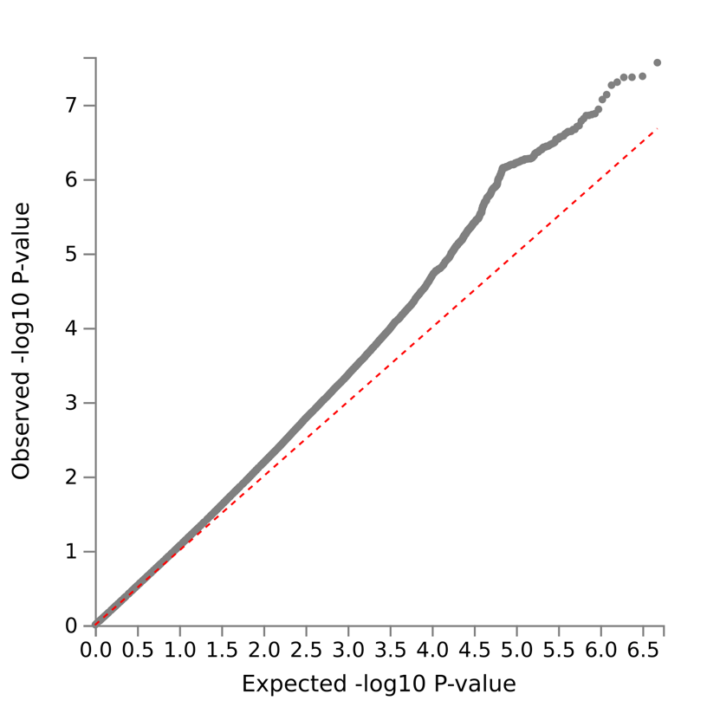

Figure S2. Regional association plot of GWAS summary statistics from PMD and PPD for the two lead SNPs separately.
Regional association plots were generated using LocusZoom with the hg19/1000 Genomes Nov 2014 European LD reference and a ±500 kb window around each index SNP to compare association patterns with PMD and PPD. A–B: rs358651 (chr5) demonstrated a stronger association in PMD than in PPD, although the direction of effect was consistent across datasets. Both plots showed a single LD peak without evidence of secondary signals. C–D: rs7338841 (chr13) showed comparable association patterns across PMD and PPD, with consistent effect directions and similar LD structures, indicating a shared signal. SNPs are colored by LD (r²) with the index SNP, and the blue line represents recombination rate.

Figure S3. Integrated functional characterization of shared loci.
A. Summary of genomic risk loci defined at P < 1 $×$ 10⁻⁵ from METAL and genes mapped using FUMA SNP2GENE based on positional, eQTL, and chromatin interaction mapping. B. Distribution of functional annotations of candidate SNPs across genomic categories. C. Developmental expression patterns of mapped genes across 29 BrainSpan brain developmental stages. Nominally enriched differentially expressed gene (DEG) sets are highlighted in red (P_{bon} < 0.05). D. Pathway and biological process enrichment analysis of 213 mapped genes, highlighting enrichment for cell–cell adhesion–related pathways and additional processes related to intracellular transport and immune function.

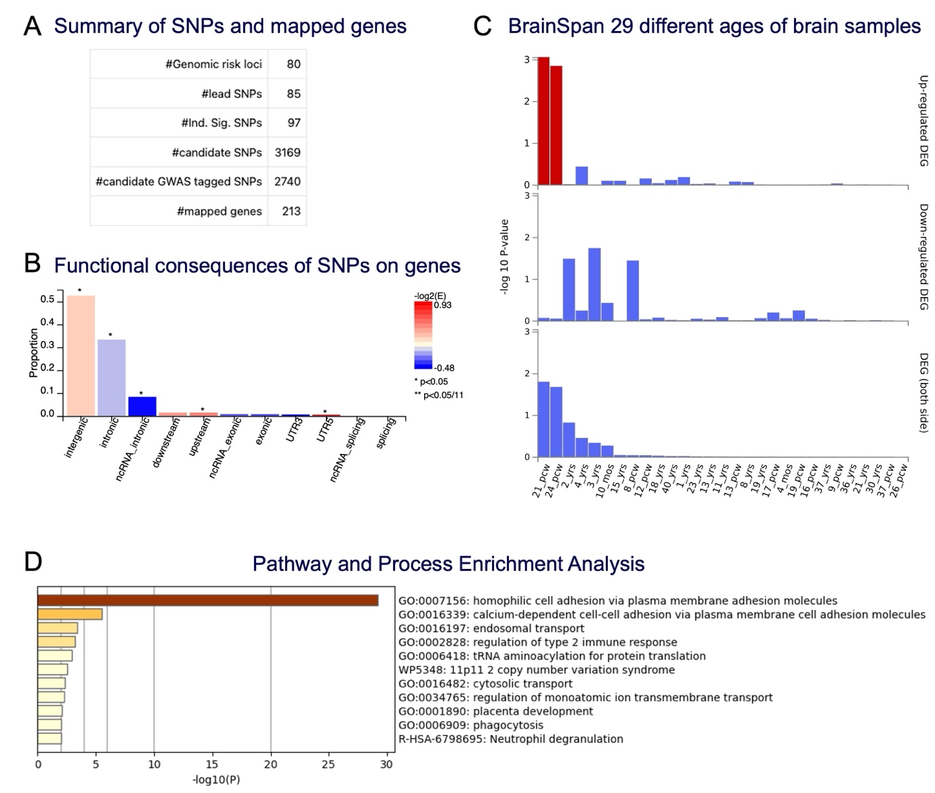

Legends of Supplementary Tables

Table S1. Characteristics of all women, and women with PMD and PPD in the nationwide register-based analysis.

Table S2. Conditional FDR and conjunctional FDR results of PMDall and PPDrmmoba.

Table S3. SNPs reached suggestive significance (P < 1×10⁻⁵) after Meta-analysis.

Table S4. Significant Lead SNPs in GWAS catalog.

Table S5. The original full results across different panel and tissues of FUSION were merged.

Table S6. Lead GWAS/TWAS-prioritized genes available in both PMDD and PPD baseline LCL datasets (n=286).

