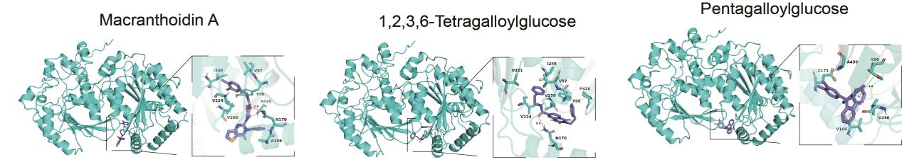

Figure S1.Molecular docking analysis reveals the binding modes of the three candidate compounds to the predicted PFKFB2 protein structure.
The three-dimensional structure of human PFKFB2 predicted by ProteinX is shown in green cartoon representation. The three top-ranked compounds from virtual screening—Macranthoidin A (left), 1,2,3,6-Tetragalloylglucose (middle), and pentagalloylglucose (PGG, right)—are depicted as blue sticks. The magnified insets show the detailed atomic interactions between each compound and the key amino acid residues lining the ATP-binding pocket of PFKFB2. Hydrogen bonds are indicated by red dashed lines with labeled bond lengths in angstroms (Å).
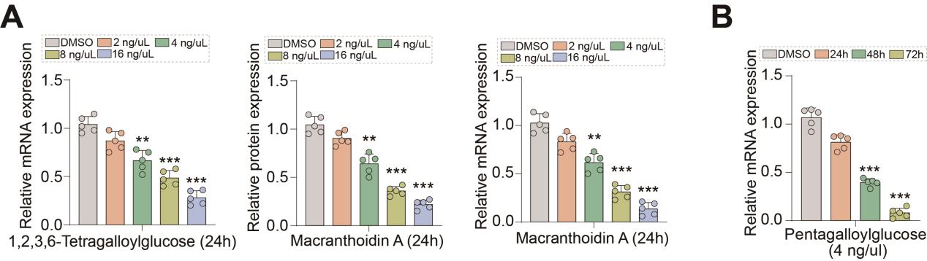

Figure S2. PGG inhibits PFKFB2 mRNA expression in a dose- and time-dependent manner.
(A) qRT-PCR analysis of PFKFB2 mRNA expression in neutrophils treated with different concentrations of the three candidate compounds from virtual screening (Macranthoidin A, 1,2,3,6-Tetragalloylglucose, and PGG) for 24 hours. (B) qRT-PCR analysis of PFKFB2 mRNA expression in neutrophils treated with 4 μg/mL PGG at the indicated time points. Data are presented as mean ± SD. *P < 0.05, **P < 0.01, ***P < 0.001.

