HUNT Women’s Health & Pelvic Pain Questionnaire 2024-2025
Introduction/consent form
You and 30 000 other women who participated in the HUNT4 survey are invited to take part in a follow-up study (the HUNT Women’s Health – Pelvic Pain study). The aim of this study is to investigate the prevalence of pelvic pain and other bodily pain among women in Norway. Every participant is equally important, and we encourage you to participate even if you do not experience pain. The questionnaire takes approximately 5-20 minutes to complete. For women who experience pain, it may take longer because additional questions will be presented. Please note some questions may appear more than once.
Some of the questions may be perceived as personal or sensitive. However, participation is entirely voluntary. You may choose to skip most questions (with the exception of a few mandatory questions). Please note that on some pages of the questionnaire, it will not be possible to return to the previous page.
This questionnaire is part of a long-planned, larger research project on persistent pelvic pain in women. By identifying possible causes of such pain, this research may contribute to improved prevention and treatment.
Before participating, please read the participant information sheet, which is available on the study’s website or via the link sent to you by text message.

Obligatory fields are marked with an asterisk (*)

HUNT Women’s Health – Pelvic Pain Part 1
The following initial questions concern pain in different parts of the body.
Do you currently have, or have you previously had, pain in your muscles and / or joints that have lasted at least 6 months?
- Yes
- No
- I don’t know / don’t remember

In the last year, have you had pain or stiffness in muscles and / or joints that has lasted at least 3 consecutive months?
- Yes
- No
- I don’t know / don’t remember

Do you currently have, or have you previously had, stomach pain or discomfort that has lasted at least 6 months?
- Yes
- No
- I don’t know / don’t remember

Have you had stomach pain or discomfort in the last 12 months?
- Yes, much
- Yes, a little
- No, never
- I don’t know / don’t remember

Do you currently have, or have you previously had, pelvic pain which has lasted at least 6 months?*
- Yes
- No
- I don’t know / don’t remember

Have you experienced such pelvic pain in the last 12 months?*
This question is displayed only if “Yes” is selected for the question “Do you currently have, or have you previously had, pelvic pain which has lasted at least 6 months?”.
- Yes
- No
- I don’t know / don’t remember

Do you currently have, or have you previously had, long-lasting or recurrent headaches for a period of at least 6 months?
- Yes
- No
- Don’t know / don’t remember

Have you suffered from headaches during the last year?
- Yes
- No
- Don’t know / don’t remember

HUNT Women’s Health – Pelvic Pain Part 2
The following questions concern menstrual pain, pregnancy, and pain during sexual activity.
Do you still have menstruation?
- Yes
- No
- Don’t know / don’t remember
- Not applicable

Have you had regular menstruation in the last 12 months?
This question is displayed only is “Yes” is selected for the question “Do you still have menstruation”.
- Yes
- No
- Don’t know / don’t remember
- Not applicable

If your menstrual periods have not been regular during the past 12 months, what do you think is the reason?
This question is displayed only if “No” or “Don’t know / don’t remember” is selected for the question “Have you had regular menstruation the last 12 months?”.
Select from:
- Hormonal contraception
- Stopped by itself
- Unsure if menstruation has stopped
- Stopped after operation, radiation treatment or other medication
- Have not menstruated again after pregnancy
- Can be irregular
- Other

Do you know how many days it is from the first day of your menstruation until the first day of the next?
This question is displayed only if “Yes” is selected for the question “Have you had regular menstruation the last 12 months?”.
- Yes
- No

How many days is it from the first day of your menstruation until the first day of the next?
This question is displayed only if “Yes” is selected for the question “Do you know how many days it is from the first day of your menstruation until the first day in the next?”.
*Answer box*

Do you remember the date for last menstruation?
This question is displayed only if “Yes” is selected for the question “Have you had regular menstruation the last 12 months?”.
- Yes
- No

Approximately which date did your last menstruation start?
This question is displayed only if “Yes” is selected for the question “Do you remember the date for last menstruation?”
*Answer box (date)*

How old were you when you stopped menstruating (years)?
This question is displayed only if “No” is selected for the question “Do you still have menstruation?”.
*Answer box*

Do you currently have, or have you previously had, pain related to menstruation or other vaginal bleeding which has lasted at least 6 months?
- Yes
- No
- Don’t know / don’t remember
- Not applicable

To what extent has pain related to menstruation or other vaginal bleeding interfered with your ability to perform daily activities?
This question is displayed only if “Yes” is selected for the question “Do you currently have, or have you previously had, pain related to menstruation or other vaginal bleeding which has lasted at least 6 months?”.
0-10 Numeric Rating Scale (horizontal slider)
- 0 = Did not interfere
- 10 = Unable to do anything

Have you ever been absent from school or work because of pain associated with menstruation or other vaginal bleeding?
This question is displayed only if “Yes” is selected for the question “Do you currently have, or have you previously had, pain related to menstruation or other vaginal bleeding which has lasted at least 6 months?”.
- Never
- Rarely
- Quite often
- Very often

Have you ever been pregnant?*
- Yes
- No
- Don’t know / don’t remember

Are you currently pregnant, or have you been pregnant during the past 12 months?*
This question is displayed only if “Yes” is selected for the question “Have you ever been pregnant?”.
- Yes
- No
- Don’t know / don’t remember
- Not appliable

During the past 4 weeks, to what extent have you been sexually active (with or without intercourse)?
- Not at all
- A little
- Quite a bit
- Very much

When was the last time you attempted to be sexually active (with or without intercourse)?
- Less than 1 week ago
- Less than 4 weeks ago
- Between 4 weeks and 6 months ago
- More than 6 months ago
- I have never attempted any sexual activity

During the past 4 weeks, to what extent have you enjoyed your sexual activity (with or without intercourse)?
This question is displayed only if “Less than 1 week ago” or “Less than 4 weeks ago” is selected for the question “When was the last time you attempted to be sexually active (with or without intercourse)?”.
- Not at all
- A little
- Quite a bit
- Very much

During the past 4 weeks, to what extent have you experienced pain during sexual activity (with or without intercourse)?
This question is displayed only if “Less than 1 week ago” or “Less than 4 weeks ago” is selected for the question “When was the last time you attempted to be sexually active (with or without intercourse)?”.
- Not at all
- A little
- Quite a bit
- Very much

Do you currently have, or have you previously had, pain associated with sexual activity (with or without intercourse, during or afterwards) which has lasted for at least 6 months?
- Yes
- No
- Don’t know / don’t remember
- I have never engaged in sexual activity

To what extent has pain associated with sexual activity affected your sex life?
This question is displayed only if “Yes” is selected for the question “Do you currently have, or have you previously had, pain associated with sexual activity (with or without intercourse, during or afterwards) which has lasted for at least 6 months?”
0-10 Numeric Rating Scale (horizontal slider)
- 0 = Did not affect
- 10 = Unable to have sex

Do you currently have a sexual partner (or partners)?
- Yes
- No

To what extent has pain associated with sexual activity affected your relationship with your current and/or previous partner(s)?
This question is only displayed if “Yes” is selected for the question “Do you currently have, or have you previously had, pain associated with sexual activity (with or without intercourse, during or afterwards) which has lasted for at least 6 months?”.
0-10 Numeric Rating Scale (horizontal slider)
- 0 = Did not affect
- 10 = Affected to a great extent

To what extent has pain associated with sexual activity interfered with your ability to perform daily activities?
This question is only displayed if “Yes” is selected for the question “Do you currently have, or have you previously had, pain associated with sexual activity (with or without intercourse, during or afterwards) which has lasted for at least 6 months?”.
0-10 Numeric Rating Scale (horizontal slider)
- 0 = Did not interfere
- 10 = Unable to do anything

Have you ever been absent from school or work because of pain associated with sexual activity?
This question is only displayed if “Yes” is selected for the question “Do you currently have, or have you previously had, pain associated with sexual activity (with or without intercourse, during or afterwards) which has lasted for at least 6 months?”.
- Never
- Rarely
- Quite often
- Very often

Have you ever experienced unwanted sexual acts?
- No
- Yes, before the age of 18 years
- Yes, after the age of 18 years
- Yes, during the past 12 months

HUNT Women’s Health – Pelvic Pain Part 3
Do you currently have, or have you previously had, pain lasting at least 6 months in one or more of the areas marked below?*
- Yes
- No
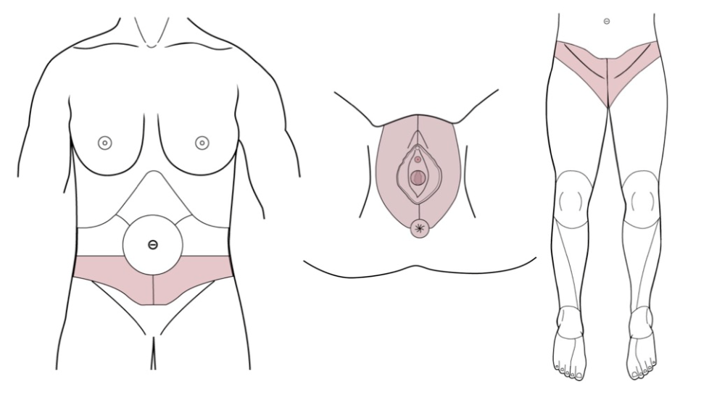
To what extent has pain in this area (or these areas) interfered with your ability to perform daily activities?
This question is displayed only if “Yes” is selected for the question “Do you currently have, or have you previously had, pain lasting at least 6 months in one or more of the areas marked below?”.
0-10 Numeric Rating Scale (horizontal slider)
- 0 = Did not interfere
- 10 = Unable to do anything

Have you ever been absent from school for work because of pain in this area (or these areas)?
This question is displayed only if “Yes” is selected for the question “Do you currently have, or have you previously had, pain lasting at least 6 months in one or more of the areas marked below?”.
- Never
- Rarely
- Quite often
- Very often

Has the pain in this area (or these areas) occurred only during pregnancy or the postpartum period?”
This question is displayed only if “Yes” is selected for the question “Do you currently have, or have you previously had, pain lasting at least 6 months in one or more of the areas marked below?”.
- Yes
- No

Graphical Index of Pain (GRIP)
This section of the questionnaire uses the Graphical Index of Pain (GRIP), an interactive digital body diagram, developed by Steingrímsdóttir et. al. (1), to assess pain distribution.

HUNT Women’s Health – Pelvic Pain Part 4
This section of the questionnaire is adapted from the Amsterdam Complex Pelvic Pain Symptom Scale (ACPPS) (2, 3).
Finally, the following questions concern pain related to sexual activity and specific physical signs and symptoms.
Some people may find the following three questions about sexual activity to have a rather intimate character. Nevertheless, we hope that you will answer them.

Questions related to sexual activity
Please indicate how often you experience the following symptoms:
Pain with vaginal penetration and/or a burning sensation after sexual intercourse
- Never
- Sometimes (less than half the time)
- Regularly (about half the time)
- Often (more than half the time)
- Very often
- No sexual activity

Pain in the genitals during or after orgasm
- Never
- Sometimes (less than half the time)
- Regularly (about half the time)
- Often (more than half the time)
- Very often
- No sexual activity

Pain upon deep thrusting of the penis during sexual intercourse
- Never
- Sometimes (less than half the time)
- Regularly (about half the time)
- Often (more than half the time)
- Very often
- No sexual activity

Questions related to specific physical symptoms
Please indicate how often you experience the following symptoms:
Menstrual pain
- Never
- Sometimes (less than half the time)
- Regularly (about half the time)
- Often (more than half the time)
- Very often
- I do not menstruate

Abdominal pain not related to menstruation
- Never
- Sometimes (less than half the time)
- Regularly (about half the time)
- Often (more than half the time)
- Very often

Abdominal cramps
- Never
- Sometimes (less than half the time)
- Regularly (about half the time)
- Often (more than half the time)
- Very often

Alternating periods of diarrhea and constipation
- Never
- Sometimes (less than half the time)
- Regularly (about half the time)
- Often (more than half the time)
- Very often

Frequent urination (more than 10 times per 24 hours)
- Never
- Sometimes (less than half the time)
- Regularly (about half the time)
- Often (more than half the time)
- Very often

Having to push or strain in order to be able to urinate
- Never
- Sometimes (less than half the time)
- Regularly (about half the time)
- Often (more than half the time)
- Very often

Sudden, compelling urge to urinate (urinary urgency)
- Never
- Sometimes (less than half the time)
- Regularly (about half the time)
- Often (more than half the time)
- Very often

Poor stream, hesitancy, terminal dribbling or incomplete voiding at micturition
- Never
- Sometimes (less than half the time)
- Regularly (about half the time)
- Often (more than half the time)
- Very often

Anal pain
- Never
- Sometimes (less than half the time)
- Regularly (about half the time)
- Often (more than half the time)
- Very often

Hemorrhoids
- Never
- Sometimes (less than half the time)
- Regularly (about half the time)
- Often (more than half the time)
- Very often

Anal fissures or tears
- Never
- Sometimes (less than half the time)
- Regularly (about half the time)
- Often (more than half the time)
- Very often

Feelings of tightness in jaw muscles
- Never
- Sometimes (less than half the time)
- Regularly (about half the time)
- Often (more than half the time)
- Very often

Headache
- Never
- Sometimes (less than half the time)
- Regularly (about half the time)
- Often (more than half the time)
- Very often

Neck / shoulder pain
- Never
- Sometimes (less than half the time)
- Regularly (about half the time)
- Often (more than half the time)
- Very often

REFERENCES
1. Steingrímsdóttir Ó A, Engdahl B, Hansson P, Stubhaug A, Nielsen CS. The Graphical Index of Pain: a new web-based method for high-throughput screening of pain. Pain. 2020;161(10):2255-62.
2. Postma R, Bicanic I, van der Vaart H, Laan E. Pelvic floor muscle problems mediate sexual problems in young adult rape victims. J Sex Med. 2013;10(8):1978-87.
3. Saga S, Stafne SN, Dons V, Bratlie I, Spetalen S, Hagemann CT. Amsterdam complex pelvic pain symptom scale with subscales: Based on a Norwegian translation, psychometric assessment and modification of the Amsterdam hyperactive pelvic floor scale. Acta Obstet Gynecol Scand. 2023;102(10):1409-23.

