Supplement table 1. Demographics and outcomes of patients with acute kidney injury divided into the CRRT and Non-CRRT groups
 | Overall | CRRT group | Non-CRRT group
 | (n=5682) | (n=770) | (n=4912) | P-Value
Gender, male, n (%) | 3105 (54.6) | 477 (61.9) | 2628 (53.5) | <0.001
Age, median [Q1, Q3], years | 70.3 [58.8,80.5] | 64.5 [53.7,74.4] | 71.3 [60.0,81.3] | <0.001
Height, mean (±SD), cm | 170.0 [160.0,178.0] | 170.0 [163.0,178.0] | 170.0 [160.0,178.0] | 0.034
Weight, median [Q1, Q3], Kg | 83.0 [69.4,100.3] | 85.0 [71.9,100.3] | 82.9 [69.0,100.3] | 0.028
Ethnicity, n (%) |  |  |  | 0.002
African American | 633 (11.1) | 77 (10.0) | 556 (11.3)
White | 3821 (67.2) | 489 (63.5) | 3332 (67.8)
Other | 1228 (21.6) | 204 (26.5) | 1024 (20.8)
Admission type, n (%) |  |  |  | 0.005
Elective | 148 (2.6) | 28 (3.6) | 120 (2.4)
Observation admission | 807 (14.2) | 132 (17.1) | 675 (13.7)
Surgical same day admission | 320 (5.6) | 50 (6.5) | 270 (5.5)
Urgent | 4407 (77.6) | 560 (72.7) | 3847 (78.3)
Time from stage 1 to stage 3 (days) | 1.1 [0.6,3.3] | 1.5 [0.6,4.5] | 1.1 [0.7,3.1] | <0.001
Charlson comorbidity index, mean (SD) | 7.0 [5.0,9.0] | 7.0 [5.0,9.0] | 7.0 [5.0,9.0] | 0.791
Myocardial infarct, n (%) | 1285 (22.6) | 203 (26.4) | 1082 (22.0) | 0.009
Congestive heart failure, n (%) | 2441 (43.0) | 355 (46.1) | 2086 (42.5) | 0.063
Peripheral vascular disease, n (%) | 846 (14.9) | 155 (20.1) | 691 (14.1) | <0.001
Cerebrovascular disease, n (%) | 839 (14.8) | 97 (12.6) | 742 (15.1) | 0.077
Dementia, n (%) | 242 (4.3) | 9 (1.2) | 233 (4.7) | <0.001
Chronic pulmonary disease, n (%) | 1689 (29.7) | 207 (26.9) | 1482 (30.2) | 0.07
Rheumatic disease, n (%) | 234 (4.1) | 27 (3.5) | 207 (4.2) | 0.411
Peptic ulcer disease, n (%) | 221 (3.9) | 30 (3.9) | 191 (3.9) | 0.928
Mild liver disease, n (%) | 1156 (20.3) | 271 (35.2) | 885 (18.0) | <0.001
Severe liver disease, n (%) | 693 (12.2) | 180 (23.4) | 513 (10.4) | <0.001
Diabetes without complex complications, n (%) | 1570 (27.6) | 199 (25.8) | 1371 (27.9) | 0.25
Diabetes with complex complications, n (%) | 893 (15.7) | 165 (21.4) | 728 (14.8) | <0.001
Paraplegia, n (%) | 283 (5.0) | 25 (3.2) | 258 (5.3) | 0.022
Malignant cancer, n (%) | 922 (16.2) | 97 (12.6) | 825 (16.8) | 0.004
Metastatic solid tumor, n (%) | 438 (7.7) | 20 (2.6) | 418 (8.5) | <0.001
AIDS, n (%) | 35 (0.6) | 4 (0.5) | 31 (0.6) | 1
Sepsis, n (%) | 4390 (77.3) | 707 (91.8) | 3683 (75.0) | <0.001
Mechanical ventilation, n (%) | 3990 (70.2) | 691 (89.7) | 3299 (67.2) | <0.001
vasopressor, n (%) | 3675 (64.7) | 685 (89.0) | 2990 (60.9) | <0.001
Fluid balance,median [Q1,Q3], ml | 5556.7 [1332.2,12850.5] | 34164.2 [17448.5,64877.0] | 4519.5 [882.4,9661.9] | <0.001
Fluid balance positive, n (%) | 4729 (83.2) | 753 (97.8) | 3976 (80.9) | <0.001
Disease severity scores
SAPSII, median [Q1, Q3] | 47.0 [37.0,57.0] | 52.0 [41.2,63.8] | 46.0 [37.0,56.0] | <0.001
SIRS, median [Q1, Q3] | 3.0 [2.0,4.0] | 3.0 [3.0,4.0] | 3.0 [2.0,3.0] | <0.001
SOFA, median [Q1, Q3] | 9.0 [6.0,12.0] | 14.0 [11.0,17.0] | 9.0 [6.0,11.0] | <0.001
OASIS, median [Q1, Q3] | 40.0 [33.0,47.0] | 43.0 [36.0,50.0] | 39.0 [33.0,46.0] | <0.001
LODS, median [Q1, Q3] | 8.0 [5.0,10.8] | 11.0 [8.0,13.0] | 7.0 [5.0,10.0] | <0.001
SBP, mean (SD), mmHg | 119.0 [103.0,137.0] | 115.0 [99.0,132.0] | 119.0 [103.0,138.0] | <0.001
HR, median [Q1, Q3], bpm | 90.0 [77.0,106.0] | 91.0 [78.0,108.0] | 90.0 [77.0,105.0] | 0.056
RR, median [Q1, Q3] | 19.0 [16.0,24.0] | 20.0 [16.0,24.0] | 19.0 [16.0,24.0] | 0.043
Temperature, ℃ | 36.3 [35.0,37.4] | 35.8 [34.6,37.0] | 36.4 [35.2,37.5] | <0.001
Lab results
ALB, mean (±SD), mmol/l | 3.0 [2.5,3.4] | 2.9 [2.4,3.4] | 3.0 [2.5,3.4] | 0.008
ALT, median [Q1, Q3], mmol/l | 26.0 [16.0,59.0] | 31.0 [17.0,87.0] | 26.0 [15.0,56.0] | <0.001
AST, median [Q1, Q3], mmol/l | 41.0 [24.0,98.0] | 57.0 [29.0,154.0] | 39.0 [23.0,88.0] | <0.001
Bicarbonate, median [Q1, Q3], mmol/l | 23.0 [20.0,26.0] | 22.0 [18.2,25.0] | 23.0 [20.0,26.0] | <0.001
Bilirubin, median [Q1, Q3], mmol/l | 0.7 [0.4,1.5] | 0.9 [0.5,2.6] | 0.7 [0.4,1.4] | <0.001
BUN, median [Q1, Q3], mmol/l | 26.0 [17.0,43.0] | 34.0 [20.0,54.8] | 25.0 [17.0,41.0] | <0.001
Calcium, median [Q1, Q3], mmol/l | 8.4 [7.8,8.9] | 8.3 [7.8,8.9] | 8.4 [7.8,8.9] | 0.049
Creatinine, median [Q1, Q3], mmol/l | 1.3 [0.9,2.1] | 1.8 [1.2,3.3] | 1.2 [0.9,2.0] | <0.001
eGFR, median [Q1, Q3], mmol/l | 48.6 [28.3,75.1] | 33.4 [17.6,56.0] | 51.9 [30.3,78.7] | <0.001
Glucose, median [Q1, Q3], mmol/l | 128.0 [103.0,173.0] | 130.5 [102.0,178.8] | 128.0 [103.0,172.0] | 0.891
Hemoglobin, median [Q1, Q3], mmol/l | 10.6 [9.0,12.2] | 10.2 [8.5,11.7] | 10.6 [9.1,12.2] | <0.001
INR, median [Q1, Q3] | 1.3 [1.1,1.8] | 1.5 [1.2,2.0] | 1.3 [1.1,1.7] | <0.001
Lactate, median [Q1, Q3], mmol/l | 1.8 [1.3,2.9] | 2.0 [1.3,3.4] | 1.8 [1.3,2.8] | <0.001
Leukocyte, median [Q1, Q3] | 10.6 [7.3,15.3] | 10.6 [6.7,15.0] | 10.6 [7.4,15.4] | 0.085
Magnesium, median [Q1, Q3], mmol/l | 2.0 [1.7,2.2] | 2.0 [1.8,2.3] | 1.9 [1.7,2.2] | <0.001
Platelet, median [Q1, Q3] | 193.5 [131.0,263.0] | 159.0 [94.0,234.5] | 198.0 [137.2,266.0] | <0.001
Potassium, median [Q1, Q3], mmol/l | 4.2 [3.8,4.7] | 4.3 [3.8,4.9] | 4.2 [3.8,4.7] | <0.001
Sodium, median [Q1, Q3], mmol/l | 138.0 [134.0,141.0] | 137.0 [133.0,140.0] | 138.0 [135.0,141.0] | <0.001
Primary outcome
90-day mortality rate | 2017 (35.5) | 382 (49.6) | 1635 (33.3) | <0.001
Secondary outcomes
28-day mortality rate | 1748 (30.8) | 302 (39.2) | 1446 (29.4) | <0.001
In-hospital mortality | 1909 (33.6) | 367 (47.7) | 1542 (31.4) | <0.001
Length of hospital stay median [Q1, Q3], days | 12.7 [6.9,21.6] | 20.9 [10.6,34.1] | 11.8 [6.7,19.7] | <0.001
Length of ICU stay median [Q1, Q3], days | 5.6 [2.9,11.2] | 11.8 [5.7,20.7] | 5.0 [2.8,9.8] | <0.001
SAPSII, Simplified Acute Physiology Score; SIRS, Systemic Inflammatory Response Syndrome; SOFA, Sequential Organ Failure Assessment; OASIS, Oxford acute severity of illness score; LODS, Logistic Organ Dysfunction System; SBP, systolic blood pressure; HR, heart rate; RR, respiratory rate; ALB, albumin; ALT, alanine aminotransferase; AST, aspartate aminotransferase; BUN, blood urea nitrogen; eGFR, estimated glomerular filtration rate; INR, international normalized ratio
*P <0.05
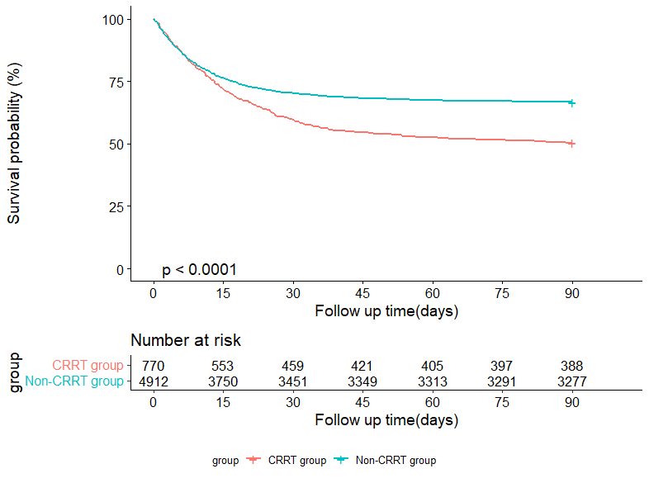Supplement figure 1. Kaplan–Meier estimates of 90-day survival

