Supplementary Material
A Single Arm Pilot Study to Evaluate the Safety, Feasibility, and Dose Ranging of Splenic Nerve Stimulation in Patients with Rheumatoid Arthritis Using a Novel Implantable Device
Figure S1.

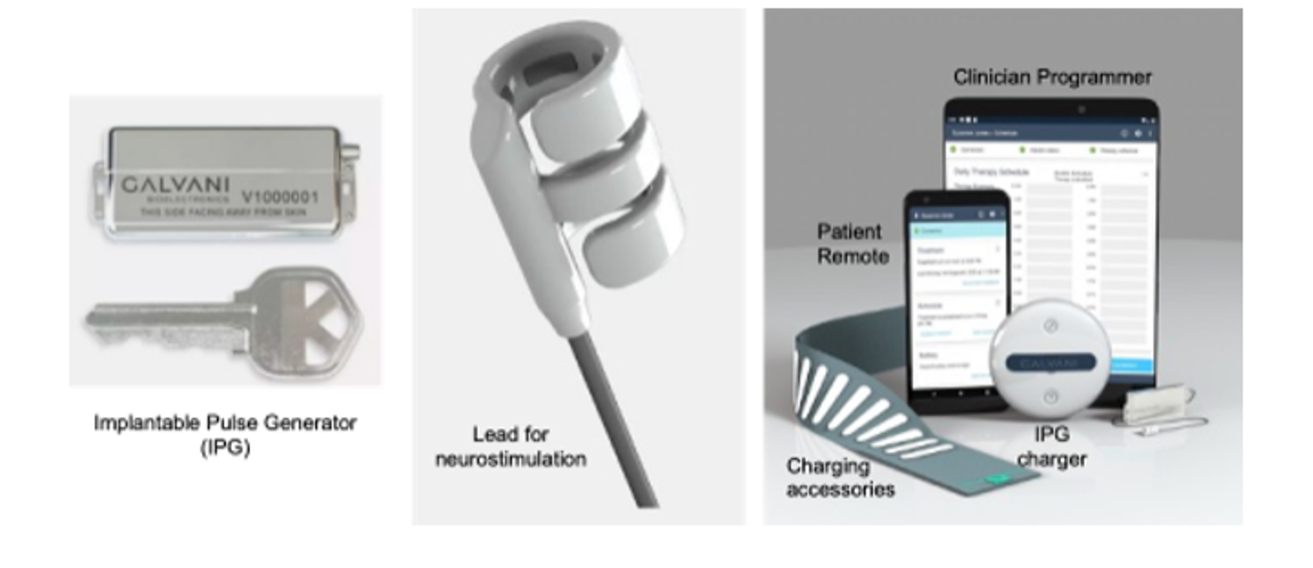
Figure S1. The Galvani Neuromodulation System. The system consists of implantable and external components. Implantable elements include the rechargeable Implantable Pulse Generator (A), the lead body (B), and the distal cuff electrode (C), which is designed to interface with nerves around the splenic neurovascular bundle and incorporates two active electrode arms and one inert central arm for secure placement. External components include the Clinician Programmer, the Patient Remote, the IPG Charger, and charging accessories (belt and patch). The Clinician Programmer is used to configure implant settings, adjust therapy parameters, and verify device integrity, while the Patient Remote provides limited user functions for therapy management. Communication between the implantable and external components occurs via Bluetooth Low Energy.

Figure S2.
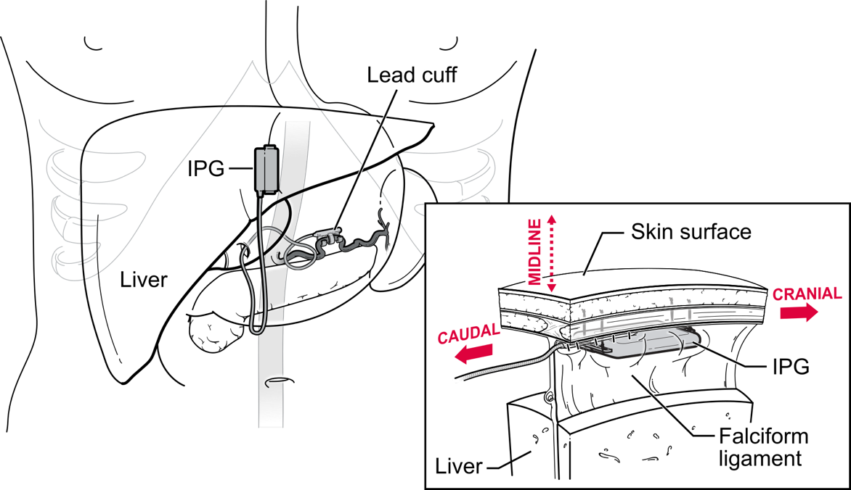
Figure S2. Schematic presentation of the implantation location of the Galvani System. The system was designed to allow for laparoscopic implantation entirely within the abdominal cavity. The system was introduced into the abdominal cavity via laparoscopic trocars. The Implantable Pulse Generator (IPG) was secured to the anterior abdominal wall within the pre-peritoneal fat pad of the falciform ligament and connected with a lead to the neural interface containing the active electrodes was placed around the splenic arterial loop to encompass the splenic NVB. The lead was anchored to the right crus of the diaphragm and the anterior abdominal wall and fixation of the IPG in the fat pad associated with the falciform ligament.

Table S1. Period 1 clinical endpoints overtime. Disease Activity Score 28-CRP (DAS28-CRP), Clinical Disease Activity Index (CDAI) and Simplified Disease Activity Index (SDAI). Δ = absolute change from Day 1 baseline (BL) value. % = percentage change from Day 1 baseline value
Visit | DAS28-CRP |  | CDAI |  | SDAI
Visit | Visit Value | Δ / % from BL value | Visit Value | Δ / % from BL value | Visit Value | Δ / % from BL value
Participant 1
D1 / BL | 3.93 | - | 15.7 | - | 15.9 | -
D14 | 3 | -0.93 / -24 | 9.1 | -6.6 / -42 | 9.4 | -6.5 / -41
D28 | 3.3 | -0.63 / -16 | 10.3 | -5.4 / -34 | 10.8 | -5.1 / -32
D42 | 3.26 | -0.67 / -17 | 10.4 | -5.3 / -34 | 10.6 | -5.3 / -33
D56 | 3.43 | -0.5 / -13 | 13.7 | -2 / -13 | 13.8 | -2.1 / -13
D70 | N/A | N/A | N/A | N/A | N/A | N/A
D84 | N/A | N/A | N/A | N/A | N/A | N/A
Participant 2
D1 / BL | 4.92 | - | 30.5 | - | 31.1 | -
D14 | 5.91 | 1 / 20 | 44.4 | 13.9 / 46 | 44.9 | 13.8 / 44
D28 | 5.63 | 0.71 / 14 | 36.6 | 6.1 / 20 | 37.4 | 6.3 / 20
D42 | 5.34 | 0.42 / 9 | 30.9 | 0.4 / 1 | 32.5 | 1.4 / 5
D56 | 5.45 | 0.53 / 11 | 29.9 | -0.6 / -2 | 31.8 | 0.7 / 2
D70 | 5.13 | 0.21 / 4 | 27.3 | -3.2 / -10 | 29.3 | -1.8 / -6
D84 | 5.63 | 0.72 / 14 | 30.5 | 0 / 0 | 33.5 | 2.4 / 8
Participant 3
D1 / BL | 6.13 | - | 46.6 | - | 47.8 | -
D14 | 3.79 | -2.34 / -38 | 17.9 | -28.7 / -67 | 18 | -29.8 / -62
D28 | 4.56 | -1.56 / -26 | 28.8 | -17.8 / -38 | 28.9 | -18.9 / -40
D42 | 4.24 | -1.89 / -31 | 25.1 | -21.5 / -46 | 25.2 | -22.6 / -47
D56 | 4.56 | -1.57 / -26 | 18.7 | -27.9 / -60 | 19.7 | -28.1 / -59
D70 | 2.83 | -3.3 / -54 | 9.5 | -37.1 / -80 | 9.6 | -38.2 / -80
D84 | 3.79 | -2.34 / -38 | 18.5 | -28.1 / -60 | 18.6 | -29.2 / -62
Participant 4
D1 / BL | 3.81 | - | 14.2 | - | 14.5 | -
D14 | 3.98 | 0.17 / 4 | 16.9 | 2.7 / 19 | 17.1 | 2.6 / 18
D28 | 3.34 | -0.47 / -12 | 13.3 | -0.9 / -6 | 13.5 | -1 / -7
D42 | 4.59 | 0.78 / 20 | 26.2 | 12 / 85 | 26.4 | 11.9 / 82
D56 | 4.15 | 0.34 / 9 | 19.4 | 5.2 / 37 | 19.6 | 5.1 / 35
D70 | 4.41 | 0.6 / 16 | 20.3 | 6.1 / 43 | 20.6 | 6.1 / 42
D84 | 3.09 | -0.72 / -19 | 8.9 | -5.3 / -37 | 9.2 | -5.3 / -37
Participant 5
D1 / BL | 4.01 | - | 19.8 | - | 19.9 | -
D14 | 3.87 | -0.13 / -4 | 16.7 | -3.1 / -20 | 16.8 | -3.1 / -19
D28 | 2.38 | -1.63 / -41 | 5.3 | -14.5 / -92 | 6.1 | -13.8 / -87
D42 | 2.61 | -1.4 / -36 | 4.2 | -15.6 / -100 | 6.5 | -13.4 / -84
D56 | 3.02 | -0.98 / -25 | 7.8 | -12 / -76 | 8.2 | -11.7 / -74
D70 | 4.46 | 0.45 / 11 | 24.4 | 4.6 / 29 | 24.6 | 4.7 / 30
D84 | 5.92 | 1.91 / 48.6 | 44.9 | 25.1 / 159.87 | 45.3 | 25.4 / 159.75

Table S2 Overview of Participant 3 CRPS-1 medication and date of modification relative to study day.
Study Day | Change In Treatment therapy for CRPS-1
Day 1 | Stimulation Start
Day 4 | Patient reported improvement of symptoms.
Day 7 | Patient reported resolution of symptoms  Cessation of opioid treatment.
Day 28 | Cessation of paracetamol treatment.
P2M1 | Reduction in schedule for pregabaline & amitryptaline
P2M6 | Cessation of pregabaline & amitryptaline

Table S3 Concomitant RA Medication in Period 2.

Medication | Class of Drug | Dose | Frequency | Route | Study Week | Treatment Duration / Week
Participant 2
Triamcinolone acetonide | Corticosteroid | 40 mg | Once | i.a. | 14 | n/a
Lidocaine | Other | 5 I.U. / ml | Once | i.a. | 14 | n/a
Adalimumab | b/tsDMARD | 40 mg | Every 2 weeks | s.c. | 18 | On-going
Participant 3
Triamcinolone acetonide | Triamcinolone acetonide | 40 mg | Once | i.a. | 6 | n/a
Participant 4
oral prednisone | Corticosteroid | 7.5 mg | Daily | p.o. | 16 | 21
Fligotinib | b/tsDMARD | 200 mg | Daily | p.o. | 27 | On-going
oral prednisone | Corticosteroid | 5 mg | Daily | p.o. | 37 | On-going
Participant 5
Prednisone | Corticosteroid | 30 mg | Daily | p.o. | 3 | 0
Prednisone | Corticosteroid | 20 mg | Daily | p.o. | 12 | 3
Prednisone | Corticosteroid | 15 mg | Daily | p.o. | 15 | 7
Prednisone | Corticosteroid | 10 mg | Daily | p.o. | 22 | On-going
Abatacept | b/tsDMARD | 500 mg | Every Month | i.v. | 20 | On-going

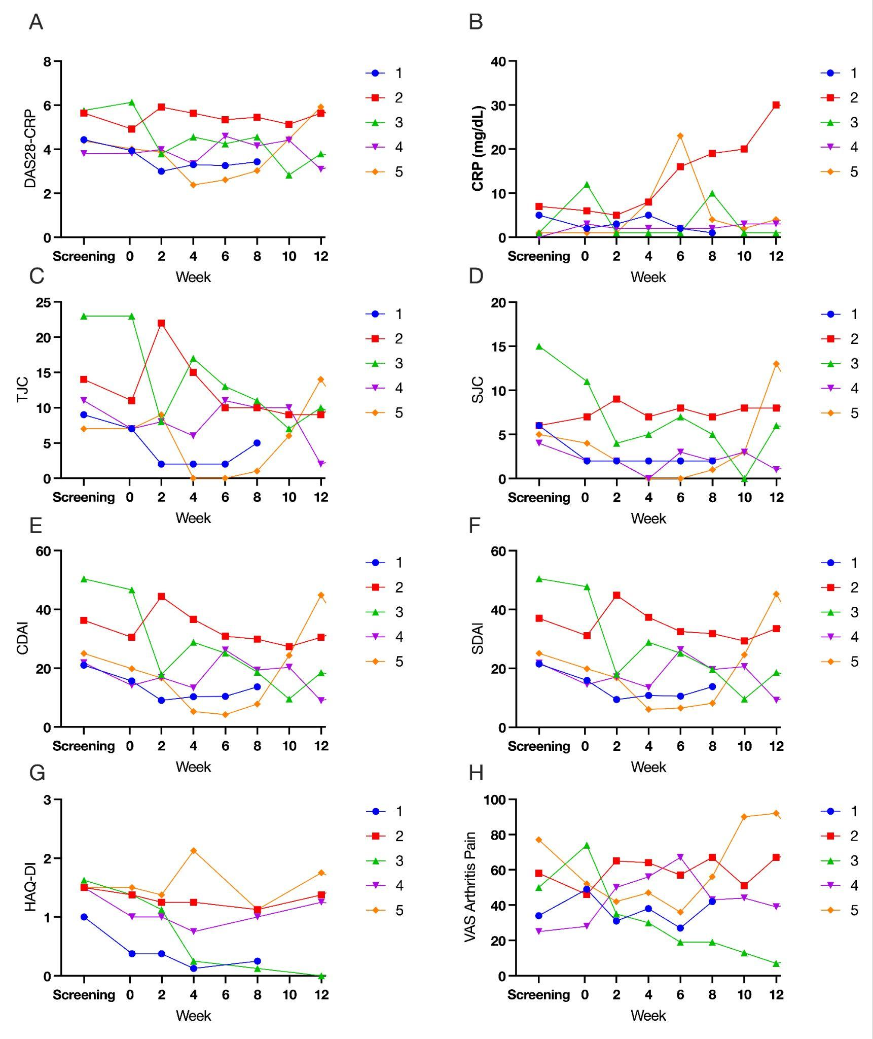
Figure S3. Individual Disease Activity Scores Period 1 overtime. All numbers are raw values. Screening values were obtained at screening (~42 days prior to surgery, Week 0 Day 1 (immediately prior to initiation of chronic neuromodulation) and at subsequent visits. (A) DAS28 - Disease Activity Score in 28 Joints; (B) CRP - C-Reactive Protein; (C) TJC – Tender Joint Count; (D) SJC – Swollen Joint Count; (E) CDAI – Clinical Disease Activity Score; (F) SDAI – Simple Disease Activity Score, (G) HAQ-DI - Health Assessment Questionnaire-Disability Index; and (H) VAS Arthritis Pain – Patient’s Assessment of Arthritis Pain Visual Analogue Scale (0-100).

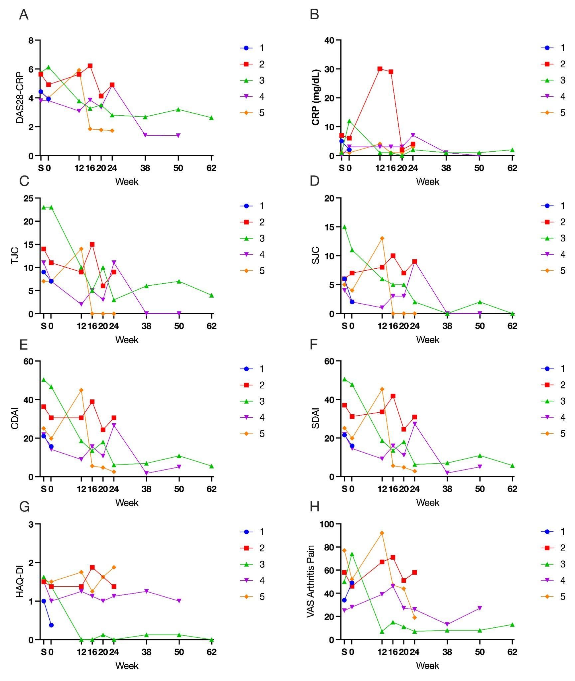
Figure S4. Individual Disease Activity Scores Period 1 and 2 overtime. All numbers are raw values. Screening values were obtained at screening (~42 days prior to surgery, Week 0 Day 1 (immediately prior to initiation of chronic neuromodulation) and at subsequent visits. (A) DAS28 - Disease Activity Score in 28 Joints; (B) CRP - C-Reactive Protein; (C) TJC – Tender Joint Count; (D) SJC – Swollen Joint Count; (E) CDAI – Clinical Disease Activity Score; (F) SDAI – Simple Disease Activity Score, (G) HAQ-DI - Health Assessment Questionnaire-Disability Index; and (H) VAS Arthritis Pain – Patient’s Assessment of Arthritis Pain Visual Analogue Scale (0-100).
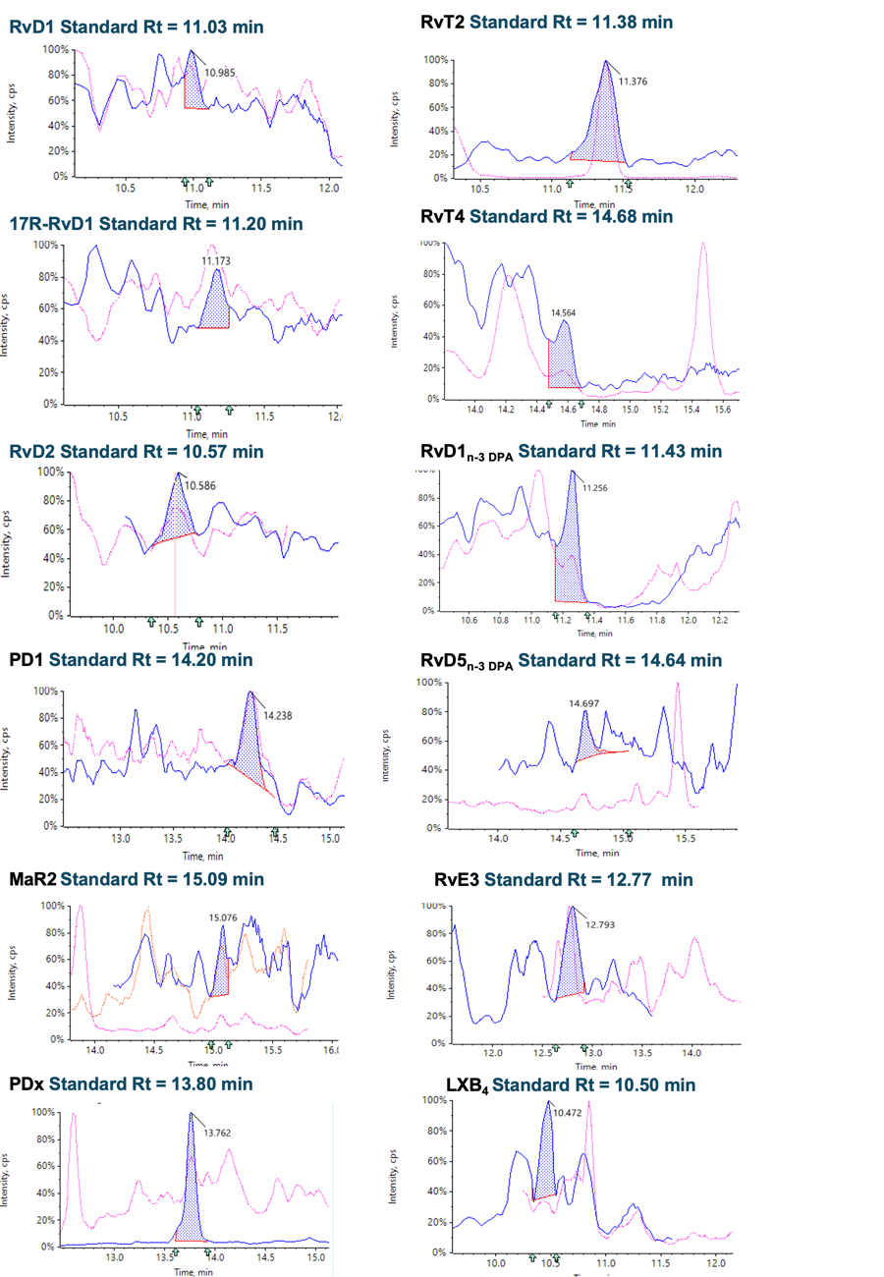
Figure S5. Example chromatograms for each Lipid mediator identified in samples derived in the clinical trial. Lipid mediators were identified using liquid chromatography tandem mass spectrometry with chromatograms presenting primary (blue) and secondary (red) transitions employed for lipid mediator identification. Retention times for respective reference standards are provided for each lipid mediator.

