Table 2. Substrate Scopes
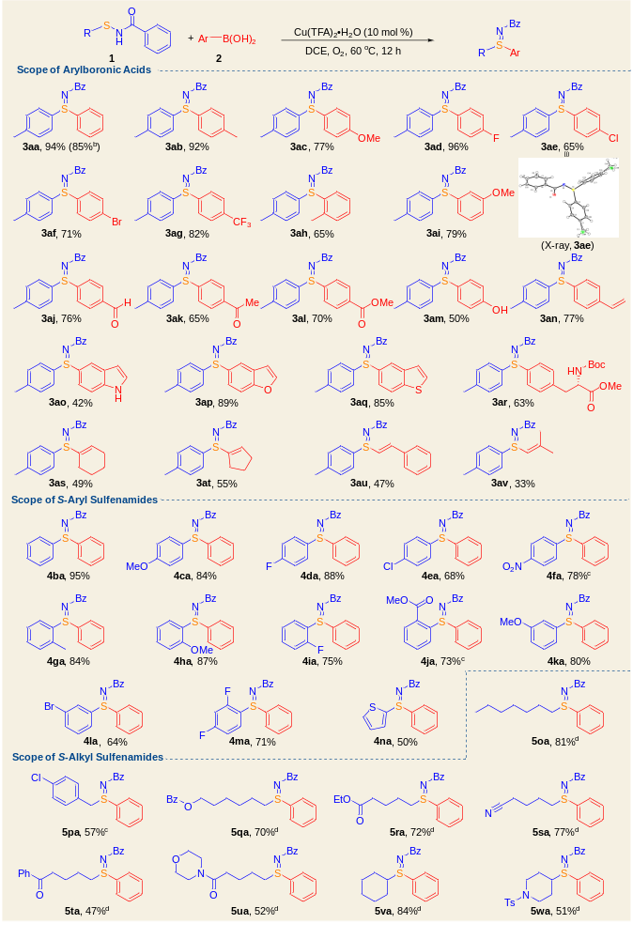
ªReaction conditions: 1a (0.1 mmol), 2 (1.2 equiv), Cu(TFA)₂H₂O (10 mol %) and DCE (0.5 mL), stirred at 60 ºC for 12 h under an O₂ atmosphere (1 atm).
^{b}1a (4.1 mmol, 1.0 g), 2a (4.9 mmol, 0.6 g), Cu(TFA)₂H₂O (10 mol %), DCE (10.0 mL).
^{c}DTBP (2.0 equiv) instead of O₂, under an argon atmosphere.
^{d}DTBP (2.0 equiv) instead of O₂, 80 ºC, under an argon atmosphere.
Bz = benzoyl. DTBP = di-tert-butyl peroxide.

