Supplementary materials
Habitat adaptation determines dark septate endophyte mediated stabilization of the soil-root-plant continuum under sulfate salinity
Yinli Bi a, b, c, 1, *, Shishuang Zhang a, b, 1, Jianying Zhang d, Yuguang Zhang d, Hai Tan a, b, Jiapeng Kang a, b
a Institute of Ecological and Environmental Restoration in Mine Areas of West China, Xi’an University of Science and Technology, Xi’an 710054, China
b College of Geology and Environment, Xi’an University of Science and Technology, Xi’an 710054, China
c State Key Laboratory of Fine Exploration and Intelligent Development of Coal Resources, China University of Mining and Technology (Beijing), Beijing 100083, China
d SDIC Hami Energy Development Co., Ltd, Hami 839099, China
* Corresponding author. Institute of Ecological and Environmental Restoration in Mine Areas of West China, Xi’an University of Science and Technology, Xi’an 710054, China
E-mail: ylbi88@126.com (Y. Bi).
Fig. S1 Effects of DSE fungi on shoot nutrient accumulation under salt stress. (A–E) Shoot contents of C, N, P, and S and C/N ratio in plants inoculated with CK (control), DSE, or SC11 under 0–0.4 M Na₂SO₄. Data represent means ± SE (n = 4). Different uppercase letters indicate statistically significant differences among inoculation treatments under the same salt concentration (p < 0.05), while different lowercase letters represent significant variations across salt concentrations within the same inoculation treatment (p < 0.05).

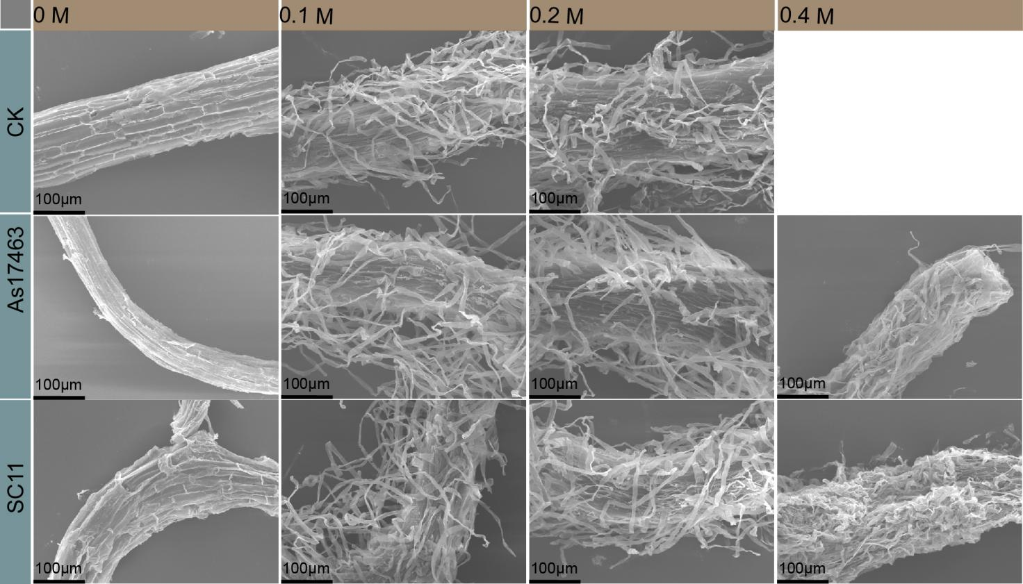
Fig. S2 SEM images of root surfaces showing fungal colonization under different Na₂SO₄ concentrations (0–0.4 M). CK, non-inoculated control; As17463 and SC11, endophytic fungal inoculations. SC11 formed denser, more stable hyphal networks on root surfaces across increasing salinity, whereas As17463 hyphae exhibited deformation and detachment under high-salt conditions. Scale bar = 100 μm.

Fig. S3 Effects of salt stress and fungal inoculation on soil physicochemical and microbial properties. (A) SOC, (B) DOC, (C) DON, (D) Olsen-P, (E) Conductivity, (F) pH, (G) MBC, (H) MBN, (I) MBP. Data are means ± SE. Different letters indicate significant differences (p < 0.05). SC11 inoculation maintained higher soil organic matter and microbial biomass under salt stress.Data represent means ± SE (n = 4). Different uppercase letters indicate statistically significant differences among inoculation treatments under the same salt concentration (p < 0.05), while different lowercase letters represent significant variations across salt concentrations within the same inoculation treatment (p < 0.05).

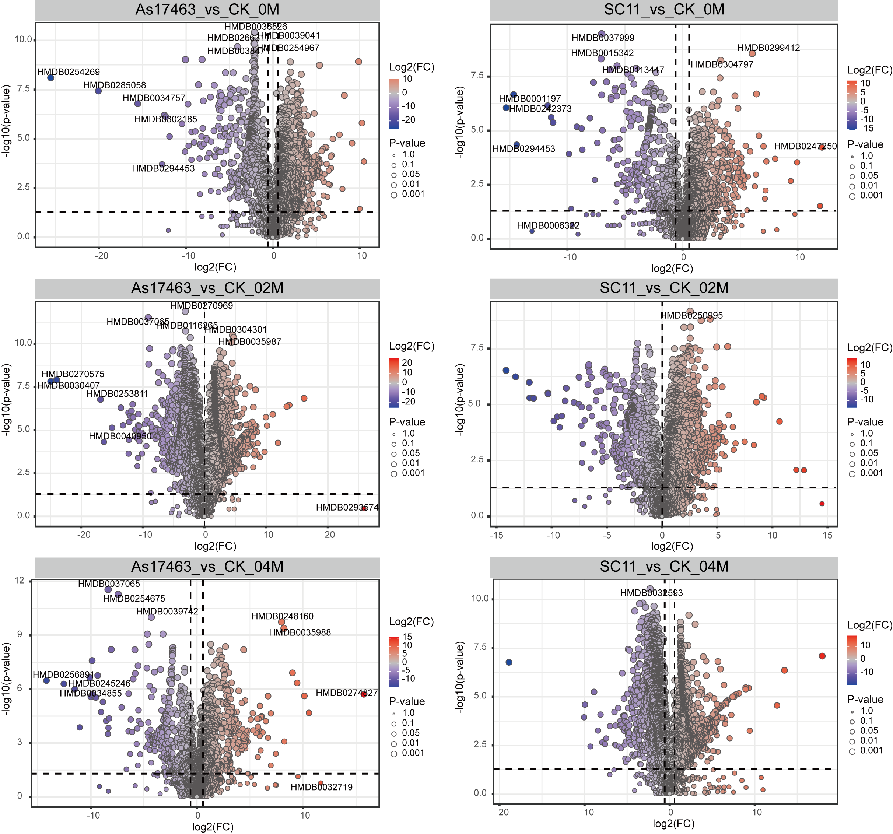
Fig. S4 Volcano plot of differential metabolites between AS17463 and SC11 treated groups and control group (CK). Each dot represents one metabolite. The abscissa represents Log2(Fold Change) and the ordinate represents-log10 (P-value). The vertical and horizontal dashed lines indicate the fold difference and the significance threshold of the p-value, respectively. Red and blue dots indicate metabolites that were significantly upregulated and downregulated relative to the control group, respectively. Six panels present the results of the analysis of AS17463(left column) and SC11(right column) in the periods 0m, 02M, and 04M, respectively.

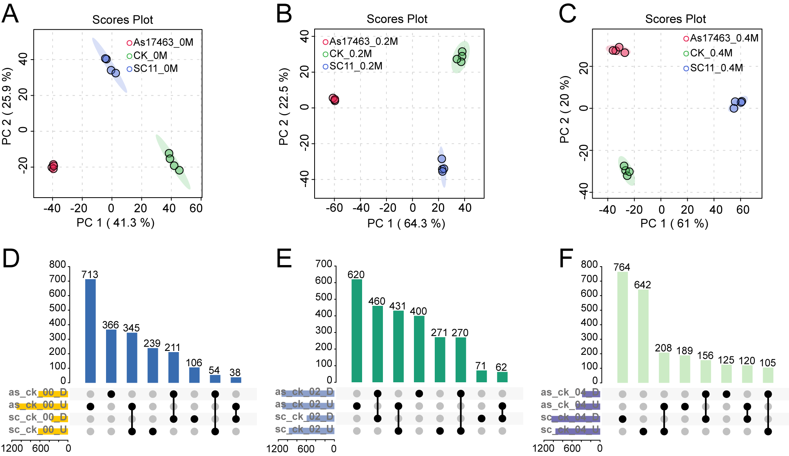
Fig. S5 PCA clustering and UpSet analysis of differential metabolites of Suaeda salsa inoculated with different DSE bacteria at different salt concentrations. A–C: Principal component analysis (PCA) score plots showing metabolic profiles of strains As17463, CK, and SC11 under three Na₂SO₄concentrations: 0 M (A), 0.2 M (B), and 0.4 M (C). Each point represents one biological replicate, and shaded ellipses indicate 95% confidence regions for each group. PC1 and PC2 percentages indicate explained variance. D–F: UpSet plots summarizing shared and unique differentially expressed metabolites (DEMs) among pairwise comparisons between As17463 and CK, and between SC11 and CK, under 0 M (D), 0.2 M (E), and 0.4 M (F) NaCl. Bars show the number of DEMs in each intersection set. Black dots indicate set membership, and horizontal labels denote up- or down-regulated DEMs in each comparison.
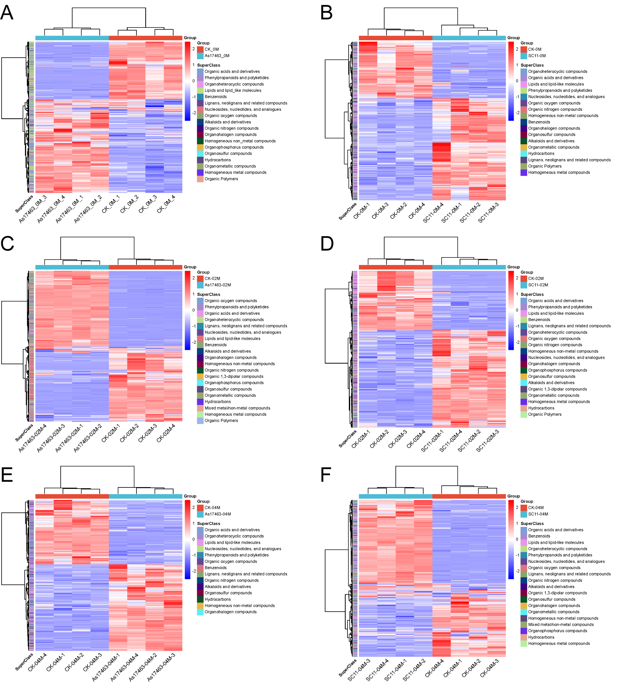
Fig. S6 Heat map of differential metabolite clustering in As17463-and SC11-treated groups relative to the control group (CK) . Each column represents a sample and each row represents a differential metabolite. The color scale indicates the relative abundance levels of metabolites (high abundance in red and low abundance in blue) . (A-F) corresponding to the following comparison groups, respectively: (a) AS17463 vs CK (0m) ; (B) SC11 vs CK (0m) ; (C) AS17463 vs CK (02M) ; (D) SC11 vs CK (02M) ; (E) AS17463 vs CK (04M) ; (F) SC11 vs CK (04M) .

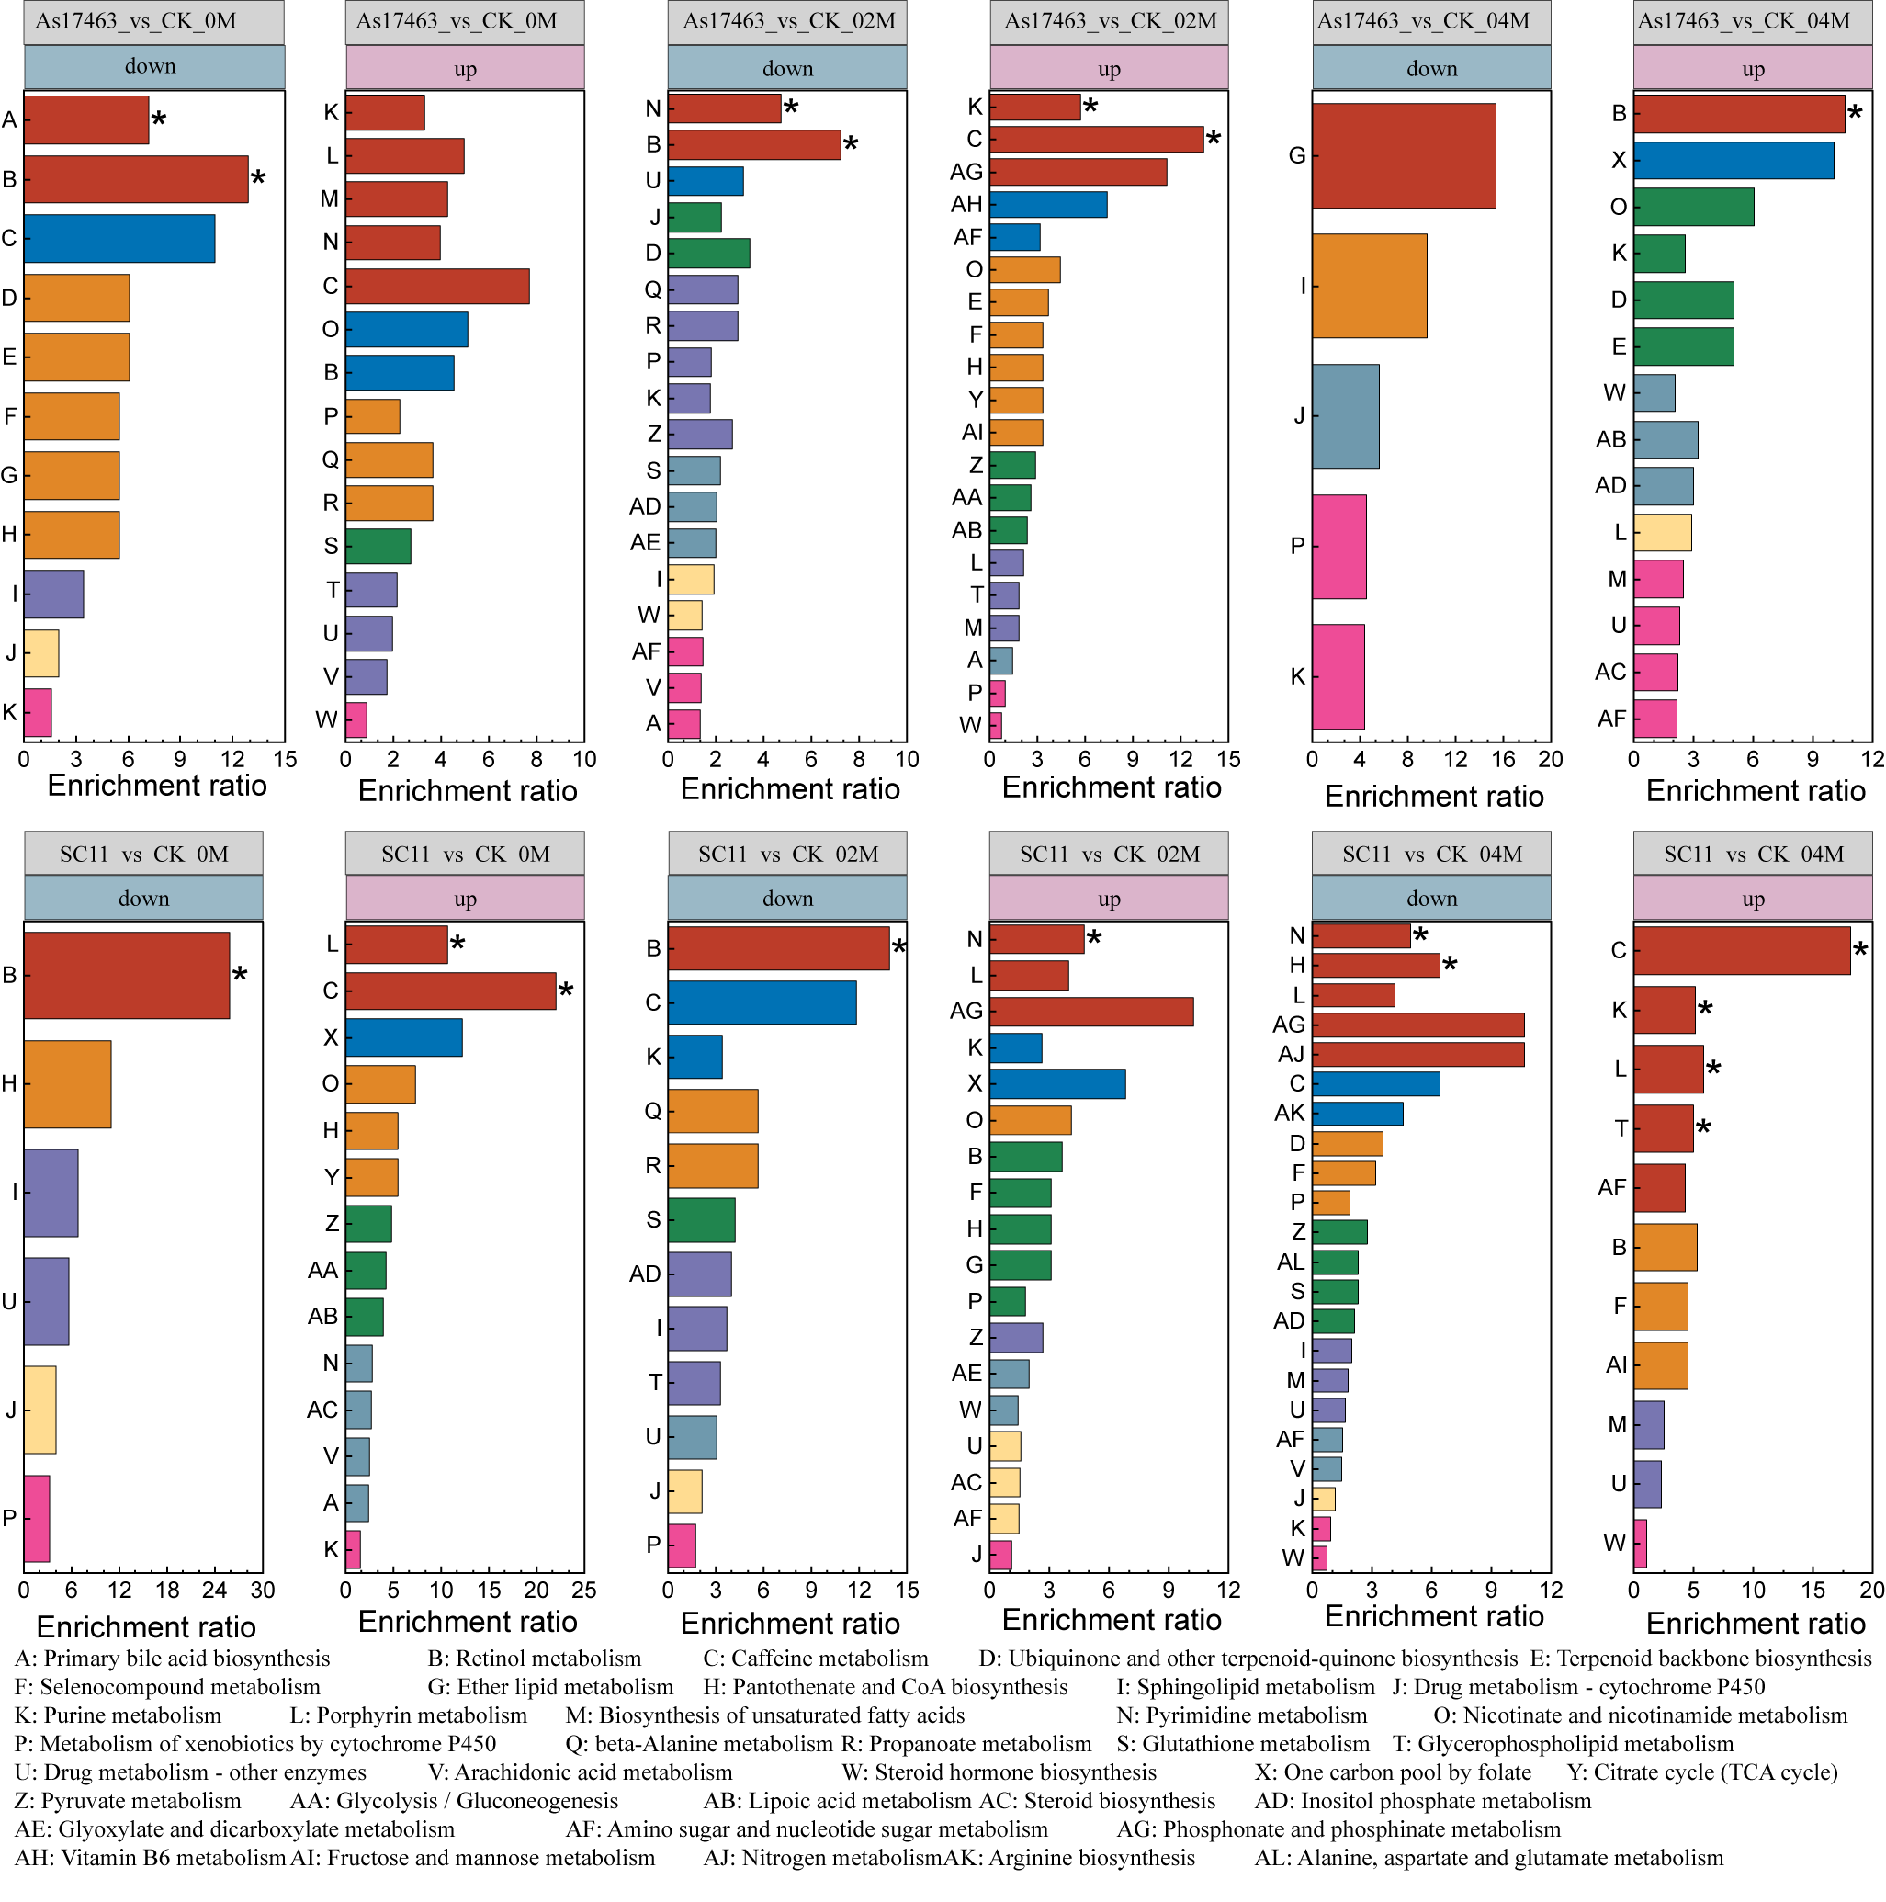
Fig. S7 KEGG enrichment analysis of differentially accumulated metabolites (DAMs) under different salt concentrations. Bar plots show KEGG pathway enrichment ratios for up‑regulated and down‑regulated DAMs in As17463 vs CK and SC11 vs CK under 0 M, 0.2 M, and 0.4 M Na₂SO₄. Pathways with significant enrichment are marked with an asterisk. Pathway labels (A–AK) correspond to KEGG metabolic categories listed below the figure. * indicates P value < 0.05.

