Supporting Information for

A Relationship Between Baroclinic Tidal and Wave Horizontal Spectral Energy and Stratification on the Australian Continental Shelf
R. Robertson^{1*}
¹Xiamen University Malaysia.
Corresponding author: Robin Robertson (robin.robertson@xmu.edu.my; r.robertson_nomad@yahoo.com)

Introduction
Ten figures and six tables are supplied as supporting information for those who need more specific coefficients and/or evidence of relationships. The first two figures give an example of the depth and time distribution of the data used. Supplemental figures S3-S10 give the dependence of the data for the sites and their regression lines for the diurnal, semidiurnal, harmonic, and high frequency bands. Table S1 gives mooring information for all 66 of the IMOS moorings Tables S2-S4 give the unnormalized site specific coefficients for the power regression, with the barotropic spectral levels used for normalization given in Table S5. Table S6 presents the reasons that the data from a site was not used or did not have a relationship.

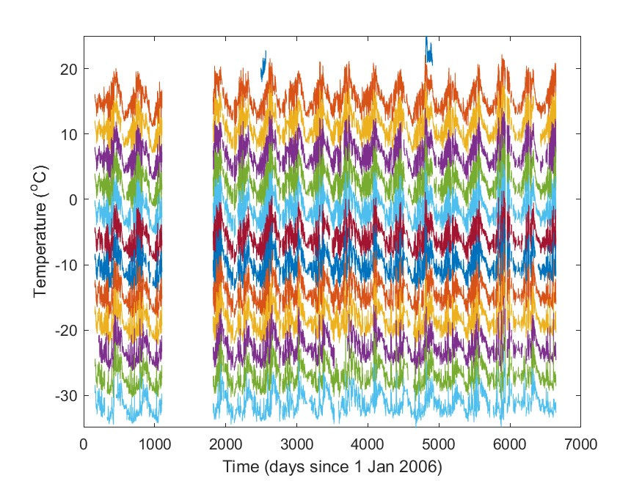
Figure S1. Time series of the temperature from instruments at different depths, each offset by -4ºC from the depth above.

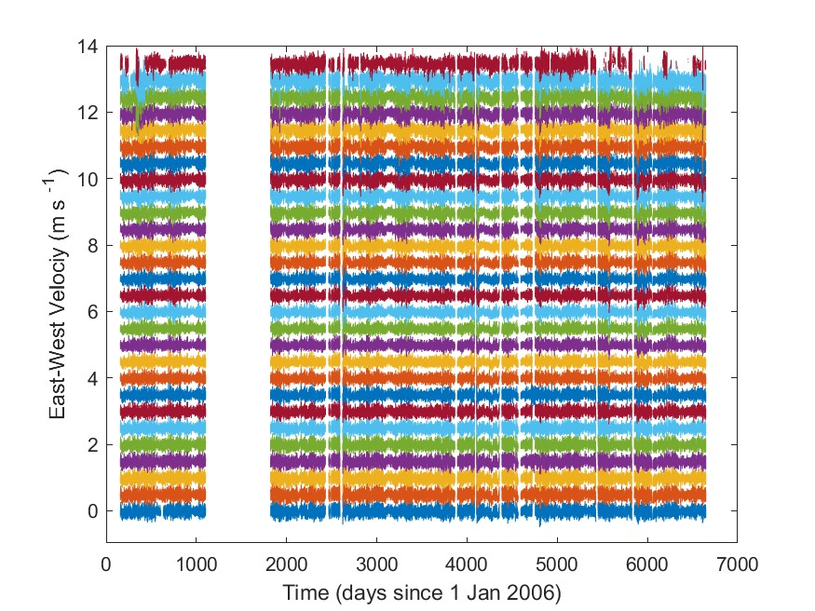
Figure S2. Time series of the East-West velocities from the ADCP at different depths, each offset by 0.5 ms⁻¹ from the depth below.

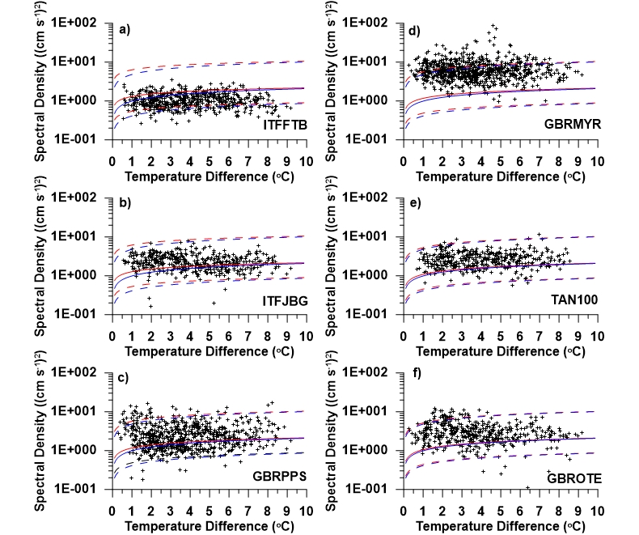

Figure S3. The baroclinic spectral density versus the upper ocean to bottom temperature difference for combined East-West and North-South velocities integrated over the diurnal frequency band for sites equatorward of the diurnal tidal critical latitude range: a) ITFFTB, b) ITFJBG, c) GBRPPS, d) GBRMYR, e) TAN100, and f) GBTOTE. The power regression lines are shown in blue for the averaged coefficients and in red for the latitude dependent coefficients. The dashed lines indicate the 95% confidence limits. The regression lines in this figure used the generalized relations.

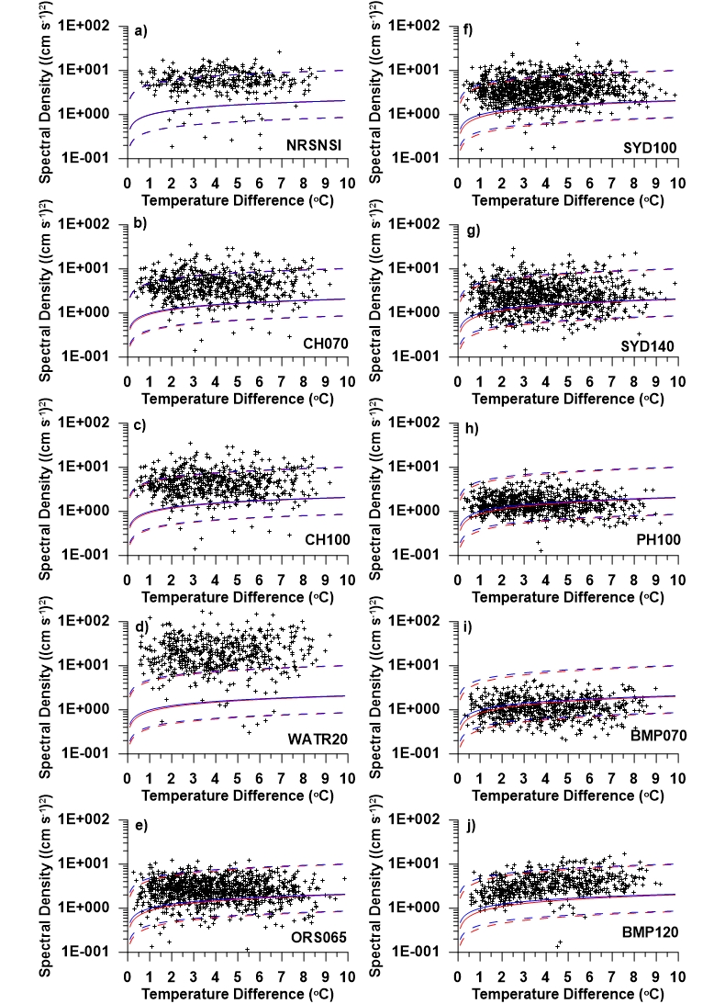
Figure S4. The baroclinic spectral density versus the upper ocean to bottom temperature difference for combined East-West and North-South velocities integrated over the diurnal frequency band for sites in or poleward of the diurnal tidal critical latitude range: a) NRSNSI, b) CH070, c) CH100, d) WATR020, e) ORS065, f) SYD100, g) SYD140, h) PH100, i) BMP070, and j) BMP120a). The power regression lines are shown in blue for the averaged coefficients and in red for the latitude dependent coefficients. The dashed lines indicate the 95% confidence limits. The regression lines in this figure used the generalized relations. Sites NRSNSI, CH070, and CH100 are in the diurnal tidal critical latitude range and the other sites here are poleward of it

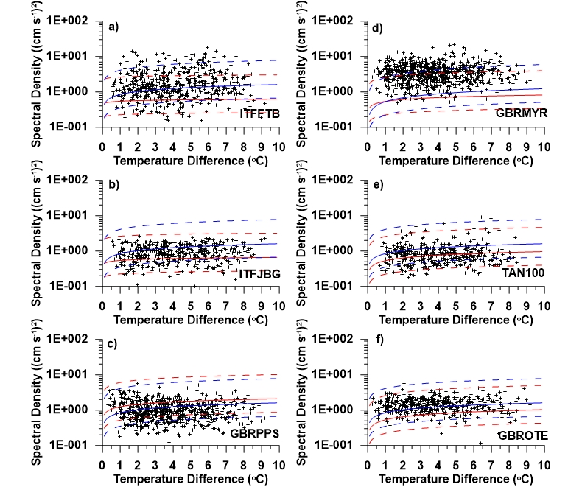
Figure S5. The baroclinic spectral density versus the upper ocean to bottom temperature difference for combined East-West and North-South velocities integrated over the semidiurnal frequency band for sites equatorward of the diurnal tidal critical latitude range: a) ITFFTB, b) ITFJBG, c) GBRPPS, d) GBRMYR, e) TAN100, and f) GBTOTE. The power regression lines are shown in blue for the averaged coefficients and in red for the latitude dependent coefficients. The dashed lines indicate the 95% confidence limits. The regression lines in this figure used the generalized relations.

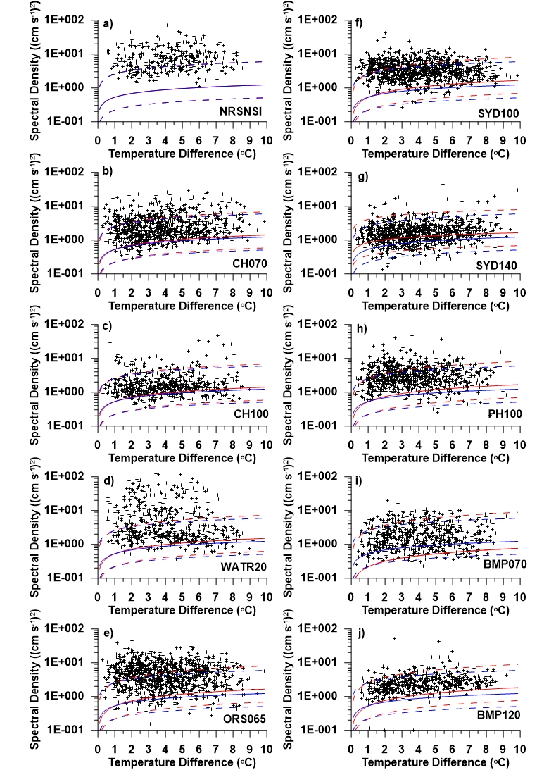
Figure S6. The baroclinic spectral density versus the upper ocean to bottom temperature difference for combined East-West and North-South velocities integrated over the semidiurnal frequency band for sites in or poleward of the diurnal tidal critical latitude range: a) NRSNSI, b) CH070, c) CH100, d) WATR020, e) ORS065, f) SYD100, g) SYD140, h) PH100, i) BMP070, and j) BMP120. The power regression lines are shown in blue for the averaged coefficients and in red for the latitude dependent coefficients. The dashed lines indicate the 95% confidence limits. The regression lines in this figure used the generalized relations. Sites NRSNSI, CH070, and CH100 are in the diurnal tidal critical latitude range and the other sites here are poleward of it

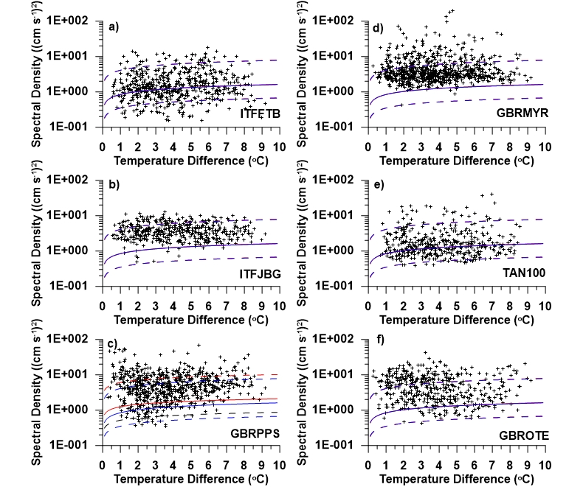

Figure S7. The baroclinic spectral density versus the upper ocean to bottom temperature difference for combined East-West and North-South velocities integrated over the harmonic frequency band for sites equatorward of the diurnal tidal critical latitude range a) ITFFTB, b) ITFJBG, c) GBRPPS, d) GBRMYR, e) TAN100, and f) GBTOTE. The power regression lines are shown in blue for the averaged coefficients and in red for the latitude dependent coefficients. The dashed lines indicate the 95% confidence limits. The regression lines in this figure used the generalized relations.

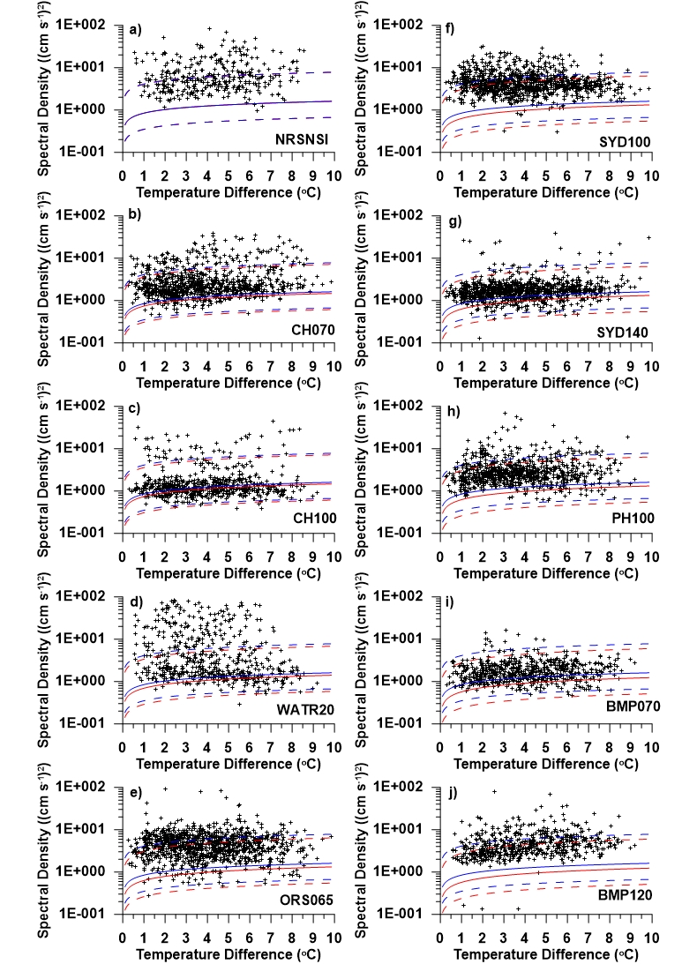
Figure S8. The baroclinic spectral density versus the upper ocean to bottom temperature difference for combined East-West and North-South velocities integrated over the harmonic frequency band for sites in or poleward of the diurnal tidal critical latitude range: a) NRSNSI, b) CH070, c) CH100, d) WATR020, e) ORS065, f) SYD100, g) SYD140, h) PH100, i) BMP070, and j) BMP120. The power regression lines are shown in blue for the averaged coefficients and in red for the latitude dependent coefficients. The dashed lines indicate the 95% confidence limits. The regression lines in this figure used the generalized relations. Sites NRSNSI, CH070, and CH100 are in the diurnal tidal critical latitude range and the other sites here are poleward of it
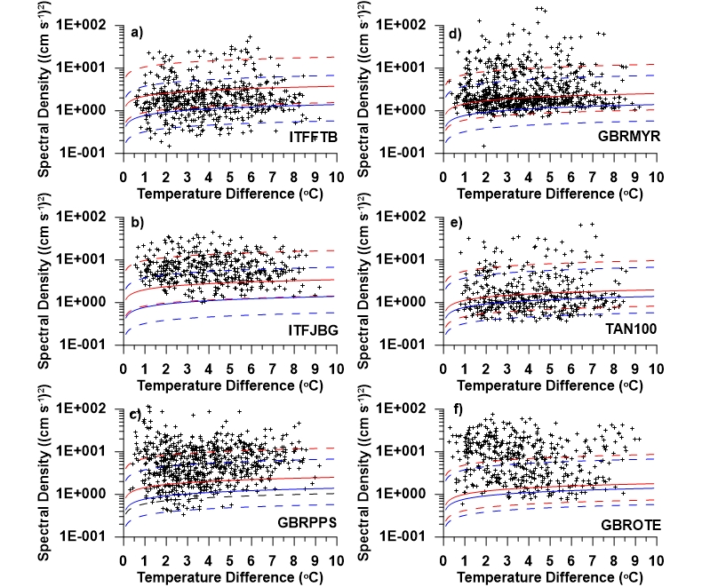

Figure S9. The baroclinic spectral density versus the upper ocean to bottom temperature difference for combined East-West and North-South velocities integrated over the high frequency band for sites equatorward of the diurnal tidal critical latitude range a) ITFFTB, b) ITFJBG, c) GBRPPS, d) GBRMYR, e) TAN100, and f) GBTOTE. The power regression lines are shown in blue for the averaged coefficients and in red for the latitude dependent coefficients. The dashed lines indicate the 95% confidence limits. The regression lines in this figure used the generalized relations.

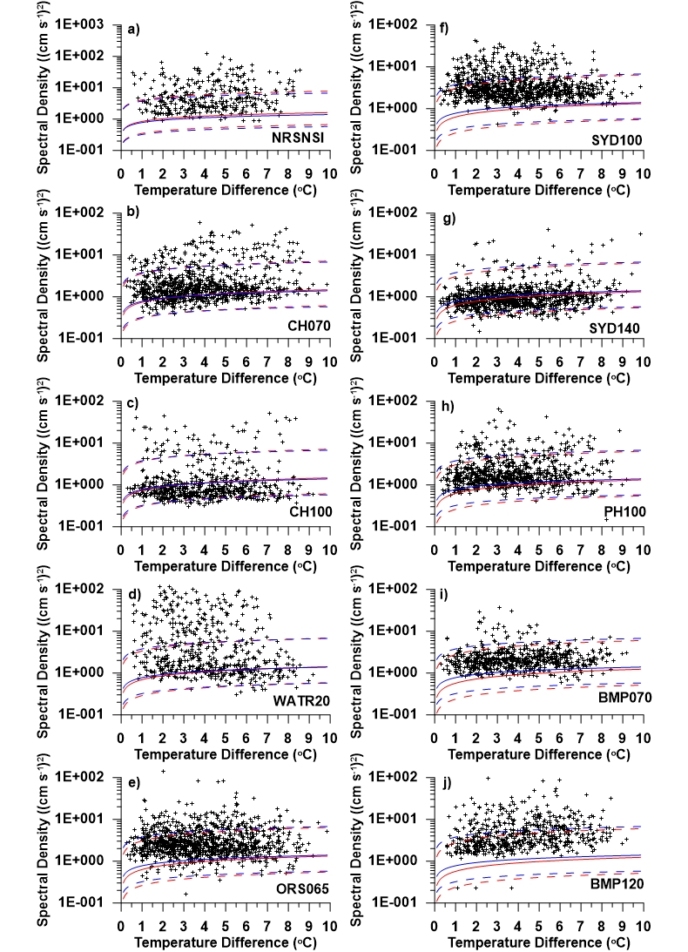
Figure S10. The baroclinic spectral density versus the upper ocean to bottom temperature difference for combined East-West and North-South velocities integrated over the high frequency band for sites in or poleward of the diurnal tidal critical latitude range: a) NRSNSI, b) CH070, c) CH100, d) WATR020, e) ORS065, f) SYD100, g) SYD140, h) PH100, i) BMP070, and j) BMP120. The power regression lines are shown in blue for the averaged coefficients and in red for the latitude dependent coefficients. The dashed lines indicate the 95% confidence limits. The regression lines in this figure used the generalized relations. Sites NRSNSI, CH070, and CH100 are in the diurnal tidal critical latitude range and the other sites here are poleward of it

Code | Site Name | Latitude | Longitude | Water Depth (m) | No. of T Files | No. of V Files | Start Date | End Date | No. of Years | Comments
BMP070 | Bateman’s Bay 70m | 36º 11.430’ S | 150º 11.358’ E | 70 | 236 | 28 | 18 Nov 2014 | On-going | 9+ | Used
BMP090 | Bateman’s Bay 90m | 36º 11.401’ S | 150º 13.998’ E | 95 | 154 | 1 | 25 Mar 2011 | 7 Dec 2015 | 4+ | Used
BMP120 | Bateman’s Bay 120m | 36º 12.361’ S | 150º 18.872’ E | 119 | 597 | 29 | 25 Mar 2011 | On-going | 13+ | Too Deep
CAM050 | Camden Sound 50 m | 14º 51.024’ S | 123º 48.163’E | 50 | 5 | 2 | 28 Aug 2014 | 29 Jul 2015 | <1 | Too Short
CAM100 | Camden Sound 100m | 14º 18.893’ S | 123º 35.739’E | 100 | 15 | 2 | 29 Aug 2014 | 29 Jul 2015 | <1 | Too Short
CH050 | Coffs Harbour 50m | 30º 18.628’ S | 153º 13.720’E | 50 | 124 | 0 | 6 Nov 2016 | On-going | 7+ | No Velocities
CH070 | Coffs Harbour 70m | 30º 16.434’ S | 153º 17.937’E | 70 | 567 | 62 | 12 Aug 2009 | On-going | 14+ | Used
CH100 | Coffs Harbour 100m | 30º 16.029’ S | 153º 23.678’E | 100 | 887 | 58 | 12 Aug 2009 | On-going | 14+ | Used
DARBGF | Darwin Beagle Gulf | 12º  6.466’ S | 130º 35.210’E | 30 | 0 | 6 | 7 Jan 2014 | 8 Feb 2017 | 3 | No Temperatures
GBRCCH | Great Barrier Reef (GBR): Capricorn Channel | 22º 24.233’ S | 151º 59.340’E | 87 | 170 | 31 | 9 Sep 2007 | On-going | 16+ | Stratification too weak
GBRELR | GBR: Elusive Reef | 21º  1.315’ S | 152º 48.650’E | 300 | 45 | 12 | 15 Sep 2007 | 14 Oct 2014 | 7+ | Stratification too weak and too shallow
GBRHIN | GBR: Heron Island North | 23º 22.896’ S | 151º 59.227’E | 46 | 38 | 11 | 10 Sep 2007 | 17 Mar 2013 | 5+ | Stratification too weak and too shallow
GBRHIS | GBR: Heron Island South | 23º 30.799’ S | 151º 57.322’E | 48 | 129 | 39 | 12 Sep 2007 | On-going | 16+ | Stratification too weak and too shallow
GBRLSH | GBR: Lizard Island Shelf | 14º 42.248’ S | 145º 37.611’E | 24 | 3 | 10 | 29 May 2013 | 21 May 2014 | 1 | Too Short
GBRLSL | GBR: Lizard Island Slope | 14º 20.390’ S | 145º 19.336’E | 360 | 192 | 21 | 24 Oct 2011 | On-going | 12+ | Shallowest T is too deep, 60m
GBRMYR | GBR: Myrmidon Reef | 18º 18.523’ S | 147º 20.739’E | 200 | 285 | 31 | 30 Oct 2007 | On-going | 16+ | Used
GBROTE | GBR: One Tree East | 23º 28.992’ S | 152º 10.367’E | 60 | 126 | 40 | 14 Sep 2007 | On-going | 16+ | Too shallow
GBRPPS | GBR: Palm Passage | 18º 13.170’ S | 147º 9.933’E | 60 | 184 | 33 | 28 Oct 2007 | On-going | 16+ | Stratification too weak and too shallow
ITFFTB | Indonesian Throughflow (ITF): Flat Tops Bank | 12º 17.397’ S | 128º 28.628’E | 103 | 85 | 17 | 26 Jun 2010 | 31 Jul 2019 | 9+ | Used
ITFJBG | ITF: Joseph Bonaparte Gulf | 13º 36.511’ S | 128º 57.998’E | 59 | 59 | 18 | 25 Jun 2010 | 31 Jul 2019 | 9+ | Used
ITFMHB | ITF: Margaret Harries Banks | 11º  0.003’ S | 128º  0.010’E | 145 | 162 | 17 | 28 Jun 2010 | 31 Jul 2019 | 9+ | Too Deep
ITFTIS | ITF: Timor South | 9º  49.071’ S | 127º 33.255’E | 465 | 289 | 17 | 29 Jun 2010 | 20 Feb 2019 | 9+ | Too Deep
JB070 | Jervis Bay | 35º 4.600’ S | 150º 50.868’E | 70 | 8 | 0 | 28 Jul 2009 | 4 Nov 2009 | <1 | No Velocities
KIM050 | Kimberley 50m | 16º 23.271’ S | 121º 35.310’E | 50 | 12 | 5 | 1 Feb 2012 | 19 Aug 2014 | 2+ | Too Short
KIM100 | Kimberley 100m | 15º 40.375’ S | 121º 18.116’E | 100 | 39 | 5 | 31 Jan 2012 | 24 Aug 2014 | 2+ | Too Short
KIM200 | Kimberley 200m | 15º 32.078’ S | 121º 14.586’E | 200 | 70 | 5 | 1 Feb 2012 | 27 Aug 2014 | 2+ | Too Short
KIM400 | Kimberley 400m | 15º 13.275’ S | 121º 6.913’E | 400 | 105 | 5 | 2 Feb 2012 | 25 Aug 2014 | 2+ | Too Short
NRSDAR | Darwin | 12º 20.571’ S | 130º 42.772’E | 20 | 16 | 29 | 13 Jan 2012 | On-going | 12+ | Only 1 T depth
NRSESP | Esperance | 33º 55.938’ S | 121º 50.990’E | 50 | 35 | 5 | 27 Nov 2008 | 12 Dec 2013 | 5+ | T’s too close, < 10m
NRSKAI | Kangaroo Island | 35º 50.212’ S | 136º 28.802’E | 110 | 472 | 47 | 4 Nov 2000 | On-going | 23+ | Stratification too weak
NRSMAI | Maria Island | 42º 35.793’ S | 148º 14.011’E | 90 | 26 | 27 | 4 Jun 2018 | On-going | 6+ | Stratification too weak
NRSNIN | Ningaloo | 21º 52.036’ S | 113º 56.848’E | 55 | 34 | 9 | 2 Aug 2010 | 17 Aug 2014 | 4 | Stratification too weak and too shallow
NRSNSI | North Stradbroke Island | 27º 20.591’ S | 153º 33.715’E | 60 | 28 | 35 | 4 Jun 2018 | On-going | 5+ | Used
NRSROT | Rottnest Island | 31º 59.521’ S | 115º 23.437’E | 50 | 147 | 36 | 20 Nov 2008 | On-going | 16+ | Stratification too weak and too shallow
NRSYON | Yongala Wreck | 19º 18.155’ S | 147º 37.257’E | 28 | 23 | 32 | 17 Sep 2008 | On-going | 15+ | Stratification too weak and too shallow
NWSBAR | Northwest Shelf (NWS): Barrow Island | 20º 45.645’ S | 114º 45.423’E | 215 | 149 | 20 | 27 Jul 2019 | On-going | 5+ | Too Deep
NWSBRW | NWS: Browse Island | 14º 14.125’ S | 123º 9.975’E | 220 | 136 | 20 | 27 Jul 2019 | On-going | 4+ | Too short
NWSLYN | NWS: Lynedoch Shoal | 9º  56.284’ S | 130º 20.966’E | 205 | 122 | 16 | 27 Jul 2019 | On-going | 4+ | Too short
NWSROW | NWS: Rowley Shoals | 17º 45.513’ S | 119º 54.354’E | 150 | 148 | 20 | 27 Jul 2019 | On-going | 4+ | Too short
ORS065 | Ocean Reference Station | 33º 53.666’ S | 151º 18.884’E | 65 | 2,910 | 185 | 7 Jun 2006 | On-going | 17+ | Used
PH100 | Port Hacking 100m | 34º  6.253’ S | 151º 11.202’E | 100 | 929 | 55 | 28 Oct 2009 | On-going | 14+ | Used
PIL050 | Pilbara 50m | 20º  3.278’ S | 151º 24.961’E | 50 | 10 | 4 | 20 Feb 2012 | 17 Aug 2014 | 2+ | Too Short
PIL100 | Pilbara 100m | 19º 41.659’ S | 115º 6.698’E | 100 | 29 | 5 | 20 Feb 2012 | 18 Aug 2014 | 2+ | Too Short
PIL200 | Pilbara 200m | 19º 26.130’ S | 116º 54.919’E | 200 | 84 | 5 | 19 Feb 2012 | 18 Aug 2014 | 2+ | Too Short
SAM1DS | South Australia (SA): Deep Slope | 36º 30.970’ S | 136º 14.572’E | 525 | 0 | 2 | 3 Dec 2008 | 5 Jun 2009 | <1 | No Temperatures
SAM2CP | SA: Cabbage Patch | 35º 16.305’ S | 135º 40.863’E | 99 | 0 | 3 | 20 Oct 2008 | 19 Mar 2010 | + | No Temperatures
SAM3MS | SA: Mid-Slope | 36º  8.745’ S | 135º 54.170’E | 175 | 0 | 3 | 19 Feb 2009 | 10 Jul 2013 | 2+ | No Temperatures
SAM4CY | SA: Canyon | 36º 31.354’ S | 136º 51.658’E | 119 | 0 | 4 | 4 Feb 2009 | 19 Mar 2010 | 1 | No Temperatures
SAM5CB | SA: Coffin Bay | 34º 55.644’ S | 135º  0.569’E | 99 | 13 | 30 | 4 Dec 2018 | On-going | 5+ | T’s too close, < 10m
SAM6IS | SA: Investigator Strait | 35º 29.951’ S | 136º 36.069’E | 82 | 0 | 1 | 4 Feb 2009 | 5 Jun 2009 | <1 | No Temperatures
SAM7DS | SA: Deep Slope | 36º  11.083’ S | 135º 50.583’E | 500 | 0 | 4 | 14 Dec 2009 | 20 Mar 2014 | 4 | No Temperatures
SAM8SG | SA: Spencer Gulf | 35º 14.951’ S | 136º 41.449’E | 47 | 15 | 36 | 4 Dec 2018 | On-going | 5+ | T’s too close, < 10m
SAMUSG | SA: Upper Spencer Gulf | 33º  6.678’ S | 137º 42.498’E | 18 | 8 | 17 | 11 Nov 2020 | On-going | 3+ | Too shallow
SEQ200 | South East Queensland 200m | 27º 20.399’ S | 153º 46.487’E | 200 | 6 | 3 | 1 Apr 2012 | 9 Jun 2013 | 1+ | Too Short
SEQ400 | South East Queensland 400m | 27º 19.911’ S | 153º 52.592’E | 404 | 10 | 3 | 1 Apr 2012 | 9 Jun 2013 | 1+ | Too Short
SR030 | Seal Rocks 30m | 32º 27.452’ S | 152º 32.944’E | 28 | 3 | 0 | 10 Aug 2021 | 26 Oct 2023 | 3+ | No Velocities
SR050 | Seal Rock 50m | 32º 28.808’ S | 152º 34.111’E | 43 | 3 | 0 | 10 Aug 2021 | 26 Oct 2023 | 3+ | No Velocities
SYD100 | Sydney 100m | 33º 56.559’ S | 151º 22.932’E | 100 | 881 | 72 | 24 Jun 2008 | On-going | 16+ | Used
SYD140 | Sydney 140m | 33º 59.776’ S | 151º 26.212’E | 140 | 1,117 | 71 | 24 Jun 2008 | On-going | 16+ | Used
TAN100 | Ningaloo | 21º 50.997’ S | 113º 54.413’E | 112 | 263 | 35 | 2 Aug 2010 | On-going | 14+ | Used
VBM100 | Victoria Bonney Coast | 38º 24.516’ S | 141º 16.255’E | 89 | 120 | 9 | 18 Jun 2019 | On-going | 5+
WACA20 | Western Australia (WA): Perth Canyon | 31º 59.007’ S | 115º 13.713’E | 200 | 116 | 35 | 11 Jan 2010 | On-going | 14+ | Shallow T’s stop after 2015
WACANO | WA: Perth Canyon North | 31º 55.969’ S | 115º 0.667’E | 500 | 11 | 9 | 22 Jan 2010 | 22 Jul 2010 | <1 | Too Short
WACASO | WA: Perth Canyon South | 32º  5.183’ S | 115º 4.242’E | 500 | 44 | 24 | 22 Jan 2010 | 11 Mar 2014 | 4+ | Too Deep
WATR05/ WATR04 | WA: Two Rocks 50m | 31º 37.596’ S | 115º 14.730’E | 44/50 | 40 | 12 | 10 Jul 2009 | 29 May 2013 | 3+ | Too Short
WATR10 | WA: Two Rocks 100m | 31º 38.739’ S | 115º 11.987’E | 100 | 220 | 24 | 10 Jul 2009 | On-going | 15 | V depths change often
WATR15 | WA: Two Rocks 150m | 31º 41.246’ S | 115º 7.617’E | 150 | 57 | 2 | 10 Jul 2009 | 7 Oct 2013 | 4+ | V depths change often
WATR20 | WA: Two Rocks 200m | 31º 43.651’ S | 115º 2.372’E | 200 | 216 | 23 | 15 Jul 2009 | On-going | 14+ | V depths change often
WATR50 | WA: Two Rocks 500m | 31º 46.231’ S | 114º 57.429’E | 500 | 54 | 23 | 15 Jul 2009 | On-going | 14+ | Shallow T stops in 2010

Table S1. Information on the 66 IMOS sites, including, the location, the location code, the latitude and longitude, the water depth, the number of temperature and velocity files, the start date, the number of years, and comments on the data.

SITE CODE | Coefficient | Average |  |  |  |  | Lower 95% Confidence Limit |  |  |  |  | Upper 95% Confidence Limit
SITE CODE | Coefficient | Diurnal | Semidiurnal | Harmonic | High  Frequency | All  Frequencies | Diurnal | Semidiurnal | Harmonic | High  Frequency | All  Frequencies | Diurnal | Semidiurnal | Harmonic | High  Frequency | All  Frequencies
ITFITB | A | 0.22 | 0.06 | 0.19 | 0.23 | 0.22 | 0.22 | 0.06 | 0.19 | 0.23 | 0.22 | 0.22 | 0.06 | 0.19 | 0.23 | 0.22
ITFITB | B | 1.31 | 0.54 | 1.63 | 2.21 | 0.11 | 0.54 | 0.23 | 0.68 | 0.92 | 0.05 | 6.34 | 2.64 | 7.09 | 10.7 | 0.55
ITFJBG | A | 0.23 | 0.09 | 0.20 | 0.23 | 0.23 | 0.23 | 0.09 | 0.20 | 0.23 | 0.23 | 0.23 | 0.09 | 0.20 | 0.23 | 0.23
ITFJBG | B | 1.28 | 0.54 | 1.54 | 2.01 | 0.10 | 0.53 | 0.23 | 0.64 | 0.84 | 0.04 | 6.19 | 2.63 | 7.46 | 9.76 | 0.48
GBRPPS | A | 0.26 | 0.18 | 0.23 | 0.24 | 0.26 | 0.26 | 0.18 | 0.23 | 0.24 | 0.26 | 0.26 | 0.18 | 0.23 | 0.24 | 0.26
GBRPPS | B | 1.17 | 0.54 | 1.25 | 1.45 | 0.06 | 0.49 | 0.22 | 0.52 | 0.60 | 0.03 | 5.67 | 2.61 | 6.07 | 7.03 | 0.29
GBRMYR | A | 0.26 | 0.18 | 0.22 | 0.24 | 0.26 | 0.26 | 0.18 | 0.22 | 0.24 | 0.26 | 0.26 | 0.18 | 0.22 | 0.24 | 0.26
GBRMYR | B | 1.17 | 0.54 | 1.26 | 1.46 | 0.06 | 0.49 | 0.22 | 0.52 | 0.61 | 0.03 | 5.68 | 2.61 | 6.10 | 7.07 | 0.29
TAN100 | A | 0.29 | 0.26 | 0.25 | 0.25 | 0.29 | 0.29 | 0.26 | 0.25 | 0.25 | 0.29 | 0.29 | 0.26 | 0.25 | 0.25 | 0.29
TAN100 | B | 1.10 | 0.54 | 1.07 | 1.13 | 0.04 | 0.46 | 0.22 | 0.45 | 0.47 | 0.02 | 5.31 | 2.60 | 5.20 | 5.49 | 0.19
GBROTE | A | 0.30 | 0.29 | 0.26 | 0.25 | 0.30 | 0.30 | 0.29 | 0.26 | 0.25 | 0.30 | 0.30 | 0.29 | 0.26 | 0.25 | 0.30
GBROTE | B | 1.06 | 0.53 | 1.00 | 1.01 | 0.03 | 0.44 | 0.22 | 0.42 | 0.42 | 0.01 | 5.15 | 2.60 | 4.84 | 4.90 | 0.16
NRSNSI | A | 0.32 | 0.37 | 0.28 | 0.25 | 0.33 | 0.32 | 0.37 | 0.28 | 0.25 | 0.33 | 0.32 | 0.37 | 0.28 | 0.25 | 0.33
NRSNSI | B | 0.99 | 0.53 | 0.84 | 0.77 | 0.02 | 0.41 | 0.22 | 0.35 | 0.32 | 0.009 | 4.80 | 2.57 | 4.09 | 3.75 | 0.11
CH070 | A | 0.34 | 0.43 | 0.30 | 0.26 | 0.35 | 0.34 | 0.43 | 0.30 | 0.26 | 0.35 | 0.34 | 0.43 | 0.30 | 0.26 | 0.35
CH070 | B | 0.94 | 0.53 | 0.74 | 0.63 | 0.02 | 0.39 | 0.22 | 0.31 | 0.26 | 0.007 | 4.55 | 2.56 | 3.60 | 3.05 | 0.08
CH100 | A | 0.34 | 0.43 | 0.30 | 0.26 | 0.35 | 0.34 | 0.43 | 0.30 | 0.26 | 0.35 | 0.34 | 0.43 | 0.30 | 0.26 | 0.35
CH100 | B | 0.94 | 0.53 | 0.74 | 0.63 | 0.02 | 0.39 | 0.22 | 0.31 | 0.26 | 0.007 | 4.55 | 2.56 | 3.60 | 3.06 | 0.08
WATR20 | A | 0.35 | 0.46 | 0.31 | 0.26 | 0.36 | 0.35 | 0.46 | 0.31 | 0.26 | 0.36 | 0.35 | 0.46 | 0.31 | 0.26 | 0.36
WATR20 | B | 0.91 | 0.53 | 0.70 | 0.57 | 0.01 | 0.38 | 0.22 | 0.29 | 0.24 | 0.006 | 4.43 | 2.56 | 3.37 | 2.76 | 0.07
ORS065 | A | 0.37 | 0.50 | 0.32 | 0.27 | 0.37 | 0.37 | 0.50 | 0.32 | 0.27 | 0.37 | 0.37 | 0.50 | 0.32 | 0.27 | 0.37
ORS065 | B | 0.88 | 0.53 | 0.63 | 0.49 | 0.01 | 0.36 | 0.22 | 0.26 | 0.20 | 0.004 | 4.25 | 2.55 | 3.07 | 2.37 | 0.05
SYD100 | A | 0.37 | 0.50 | 0.32 | 0.27 | 0.37 | 0.37 | 0.50 | 0.32 | 0.27 | 0.37 | 0.37 | 0.50 | 0.32 | 0.27 | 0.37
SYD100 | B | 0.88 | 0.53 | 0.63 | 0.49 | 0.01 | 0.36 | 0.22 | 0.26 | 0.20 | 0.004 | 4.25 | 2.55 | 3.06 | 2.37 | 0.05
SYD140 | A | 0.37 | 0.50 | 0.32 | 0.27 | 0.37 | 0.37 | 0.50 | 0.32 | 0.27 | 0.37 | 0.37 | 0.50 | 0.32 | 0.27 | 0.37
SYD140 | B | 0.88 | 0.53 | 0.63 | 0.49 | 0.01 | 0.36 | 0.22 | 0.26 | 0.20 | 0.004 | 4.24 | 2.55 | 3.06 | 2.36 | 0.05
PH100 | A | 0.37 | 0.50 | 0.32 | 0.27 | 0.37 | 0.37 | 0.51 | 0.32 | 0.27 | 0.37 | 0.37 | 0.50 | 0.32 | 0.27 | 0.37
PH100 | B | 0.87 | 0.53 | 0.63 | 0.48 | 0.01 | 0.36 | 0.22 | 0.26 | 0.20 | 0.004 | 4.24 | 2.55 | 3.04 | 2.34 | 0.05
BMP070 | A | 0.38 | 0.55 | 0.34 | 0.27 | 0.39 | 0.38 | 0.55 | 0.34 | 0.27 | 0.39 | 0.38 | 0.55 | 0.34 | 0.27 | 0.39
BMP070 | B | 0.84 | 0.52 | 0.57 | 0.42 | 0.008 | 0.35 | 0.22 | 0.24 | 0.17 | 0.003 | 4.07 | 2.54 | 2.78 | 2.02 | 0.04
BMP120 | A | 0.38 | 0.55 | 0.34 | 0.27 | 0.39 | 0.38 | 0.55 | 0.34 | 0.27 | 0.39 | 0.38 | 0.55 | 0.34 | 0.27 | 0.39
BMP120 | B | 0.84 | 0.52 | 0.57 | 0.42 | 0.008 | 0.35 | 0.22 | 0.24 | 0.17 | 0.003 | 4.07 | 2.54 | 2.78 | 2.02 | 0.04
Overall  Average | A | 0.32 | 0.37 | 0.28 | 0.25 | 0.33 | 0.32 | 0.37 | 0.28 | 0.25 | 0.32 | 0.32 | 0.37 | 0.28 | 0.25 | 0.33
Overall  Average | B | 0.99 | 0.53 | 0.85 | 0.78 | 0.22 | 0.41 | 0.22 | 0.35 | 0.32 | 0.01 | 4.81 | 2.57 | 4.11 | 3.77 | 0.11

Table S2. Site specific A and B coefficients for the five frequency bands for the combined East-West and North-South velocities.

SITE CODE | Coefficient | Average |  |  |  |  | Lower 95% Confidence Limit |  |  |  |  | Upper 95% Confidence Limit
SITE CODE | Coefficient | Diurnal | Semidiurnal | Harmonic | High  Frequency | All  Frequencies | Diurnal | Semidiurnal | Harmonic | High  Frequency | All  Frequencies | Diurnal | Semidiurnal | Harmonic | High  Frequency | All  Frequencies
ITFITB | A | 0.16 | -0.04 | 0.10 | 0.14 | 0.14 | 0.16 | -0.04 | 0.10 | 0.14 | 0.14 | 0.16 | -0.04 | 0.10 | 0.14 | 0.14
ITFITB | B | 1.35 | 0.45 | 1.28 | 1.64 | 0.09 | 0.56 | 0.19 | 0.53 | 0.68 | 0.04 | 6.53 | 2.16 | 6.21 | 7.95 | 0.44
ITFJBG | A | 0.18 | 0.00 | 0.11 | 0.15 | 0.15 | 0.18 | 0.00 | 0.11 | 0.15 | 0.15 | 0.18 | 0.00 | 0.11 | 0.15 | 0.15
ITFJBG | B | 1.35 | 0.47 | 1.30 | 1.62 | 0.09 | 0.56 | 0.20 | 0.54 | 0.67 | 0.04 | 6.57 | 2.29 | 6.29 | 7.86 | 0.41
GBRPPS | A | 0.23 | 0.13 | 0.16 | 0.17 | 0.20 | 0.23 | 0.13 | 0.16 | 0.17 | 0.20 | 0.23 | 0.13 | 0.16 | 0.17 | 0.20
GBRPPS | B | 1.39 | 0.58 | 1.36 | 1.56 | 0.07 | 0.58 | 0.24 | 0.56 | 0.65 | 0.03 | 6.72 | 2.79 | 6.57 | 7.56 | 0.32
GBRMYR | A | 0.23 | 0.13 | 0.16 | 0.17 | 0.20 | 0.23 | 0.13 | 0.16 | 0.17 | 0.20 | 0.23 | 0.13 | 0.16 | 0.17 | 0.20
GBRMYR | B | 1.39 | 0.57 | 1.36 | 1.56 | 0.07 | 0.58 | 0.24 | 0.56 | 0.65 | 0.03 | 6.72 | 2.78 | 6.57 | 7.56 | 0.32
TAN100 | A | 0.27 | 0.23 | 0.20 | 0.19 | 0.23 | 0.27 | 0.23 | 0.20 | 0.19 | 0.23 | 0.27 | 0.23 | 0.20 | 0.19 | 0.23
TAN100 | B | 1.41 | 0.67 | 1.40 | 1.51 | 0.06 | 0.59 | 0.28 | 0.58 | 0.63 | 0.02 | 6.84 | 3.24 | 6.81 | 7.34 | 0.27
GBROTE | A | 0.29 | 0.27 | 0.22 | 0.19 | 0.25 | 0.29 | 0.27 | 0.22 | 0.19 | 0.25 | 0.29 | 0.27 | 0.22 | 0.19 | 0.25
GBROTE | B | 1.42 | 0.72 | 1.43 | 1.49 | 0.05 | 0.59 | 0.30 | 0.59 | 0.62 | 0.02 | 6.90 | 3.47 | 6.92 | 7.24 | 0.25
NRSNSI | A | 0.33 | 0.38 | 0.26 | 0.21 | 0.29 | 0.33 | 0.38 | 0.26 | 0.21 | 0.29 | 0.33 | 0.38 | 0.26 | 0.21 | 0.29
NRSNSI | B | 1.45 | 0.84 | 1.48 | 1.45 | 0.04 | 0.60 | 0.35 | 0.62 | 0.60 | 0.02 | 7.03 | 4.09 | 7.18 | 7.01 | 0.20
CH070 | A | 0.36 | 0.46 | 0.29 | 0.23 | 0.32 | 0.36 | 0.46 | 0.29 | 0.23 | 0.32 | 0.36 | 0.46 | 0.29 | 0.23 | 0.32
CH070 | B | 1.47 | 0.10 | 1.52 | 1.41 | 0.04 | 0.61 | 0.40 | 0.63 | 0.59 | 0.02 | 7.13 | 4.63 | 7.38 | 6.85 | 0.17
CH100 | A | 0.36 | 0.46 | 0.29 | 0.23 | 0.32 | 0.36 | 0.46 | 0.29 | 0.23 | 0.32 | 0.36 | 0.46 | 0.29 | 0.23 | 0.32
CH100 | B | 1.47 | 0.10 | 1.52 | 1.41 | 0.04 | 0.61 | 0.40 | 0.63 | 0.59 | 0.02 | 7.13 | 4.63 | 7.38 | 6.85 | 0.17
WATR20 | A | 0.38 | 0.50 | 0.30 | 0.23 | 0.33 | 0.38 | 0.50 | 0.30 | 0.23 | 0.33 | 0.38 | 0.50 | 0.30 | 0.23 | 0.33
WATR20 | B | 1.48 | 1.02 | 1.54 | 1.40 | 0.03 | 0.62 | 0.42 | 0.64 | 0.58 | 0.01 | 7.19 | 4.93 | 7.49 | 6.76 | 0.16
ORS065 | A | 0.40 | 0.56 | 0.33 | 0.24 | 0.35 | 0.40 | 0.56 | 0.33 | 0.24 | 0.35 | 0.40 | 0.56 | 0.33 | 0.24 | 0.35
ORS065 | B | 1.50 | 1.11 | 1.58 | 1.37 | 0.03 | 0.62 | 0.46 | 0.66 | 0.57 | 0.01 | 7.26 | 5.40 | 7.65 | 6.64 | 0.14
SYD100 | A | 0.40 | 0.56 | 0.33 | 0.24 | 0.35 | 0.40 | 0.56 | 0.33 | 0.24 | 0.35 | 0.40 | 0.56 | 0.33 | 0.24 | 0.35
SYD100 | B | 1.50 | 1.12 | 1.58 | 1.37 | 0.03 | 0.62 | 0.46 | 0.66 | 0.57 | 0.01 | 7.27 | 5.41 | 7.65 | 6.64 | 0.14
SYD140 | A | 0.40 | 0.56 | 0.33 | 0.24 | 0.35 | 0.40 | 0.56 | 0.33 | 0.24 | 0.35 | 0.40 | 0.56 | 0.33 | 0.24 | 0.35
SYD140 | B | 1.50 | 1.12 | 1.58 | 1.37 | 0.03 | 0.62 | 0.46 | 0.66 | 0.57 | 0.01 | 7.27 | 5.42 | 7.65 | 6.64 | 0.14
PH100 | A | 0.40 | 0.56 | 0.33 | 0.24 | 0.35 | 0.40 | 0.56 | 0.33 | 0.24 | 0.35 | 0.40 | 0.56 | 0.33 | 0.24 | 0.35
PH100 | B | 1.50 | 1.12 | 1.58 | 1.37 | 0.03 | 0.62 | 0.47 | 0.66 | 0.57 | 0.01 | 7.27 | 5.45 | 7.66 | 6.63 | 0.14
BMP070 | A | 0.43 | 0.62 | 0.35 | 0.25 | 0.37 | 0.43 | 0.62 | 0.35 | 0.25 | 0.37 | 0.43 | 0.62 | 0.35 | 0.25 | 0.37
BMP070 | B | 1.52 | 1.23 | 1.61 | 1.34 | 0.03 | 0.63 | 0.51 | 0.67 | 0.56 | 0.01 | 7.35 | 5.95 | 7.82 | 6.52 | 0.13
BMP120 | A | 0.43 | 0.62 | 0.35 | 0.25 | 0.37 | 0.43 | 0.62 | 0.35 | 0.25 | 0.37 | 0.43 | 0.62 | 0.35 | 0.25 | 0.37
BMP120 | B | 1.52 | 1.23 | 1.61 | 1.34 | 0.03 | 0.63 | 0.51 | 0.67 | 0.56 | 0.01 | 7.35 | 5.95 | 7.82 | 6.52 | 0.13
Overall  Average | A | 0.32 | 0.37 | 0.25 | 0.21 | 0.29 | 0.33 | 0.37 | 0.26 | 0.21 | 0.29 | 0.33 | 0.37 | 0.26 | 0.21 | 0.29
Overall  Average | B | 1.44 | 0.84 | 1.48 | 1.45 | 0.04 | 0.60 | 0.35 | 0.61 | 0.60 | 0.02 | 7.02 | 4.07 | 7.17 | 7.02 | 0.20

Table S3. Site specific A and B coefficients for the five frequency bands for the East-West velocities.

SITE CODE | Coefficient | Average |  |  |  |  | Lower 95% Confidence Limit |  |  |  |  | Upper 95% Confidence Limit
SITE CODE | Coefficient | Diurnal | Semidiurnal | Harmonic | High  Frequency | All  Frequencies | Diurnal | Semidiurnal | Harmonic | High  Frequency | All  Frequencies | Diurnal | Semidiurnal | Harmonic | High  Frequency | All  Frequencies
ITFITB | A | 0.23 | 0.09 | 0.22 | 0.26 | 0.24 | 0.23 | 0.09 | 0.22 | 0.26 | 0.24 | 0.23 | 0.09 | 0.22 | 0.26 | 0.24
ITFITB | B | 1.30 | 0.61 | 1.95 | 2.65 | 0.13 | 0.54 | 0.25 | 0.81 | 1.01 | 0.05 | 6.33 | 2.96 | 9.45 | 12.9 | 0.61
ITFJBG | A | 0.23 | 0.12 | 0.23 | 0.26 | 0.25 | 0.23 | 0.12 | 0.23 | 0.26 | 0.25 | 0.23 | 0.12 | 0.23 | 0.26 | 0.25
ITFJBG | B | 1.25 | 0.59 | 1.78 | 2.34 | 0.11 | 0.52 | 0.25 | 0.74 | 0.97 | 0.04 | 6.07 | 2.88 | 8.62 | 11.3 | 0.52
GBRPPS | A | 0.26 | 0.19 | 0.25 | 0.26 | 0.28 | 0.26 | 0.19 | 0.25 | 0.26 | 0.28 | 0.26 | 0.19 | 0.25 | 0.26 | 0.28
GBRPPS | B | 1.08 | 0.54 | 1.28 | 1.49 | 0.06 | 0.45 | 0.22 | 0.53 | 0.62 | 0.02 | 5.25 | 2.60 | 6.21 | 7.21 | 0.28
GBRMYR | A | 0.26 | 0.19 | 0.25 | 0.26 | 0.28 | 0.26 | 0.19 | 0.25 | 0.26 | 0.28 | 0.26 | 0.19 | 0.25 | 0.26 | 0.28
GBRMYR | B | 1.09 | 0.54 | 1.29 | 1.50 | 0.06 | 0.45 | 0.22 | 0.54 | 0.62 | 0.03 | 5.27 | 2.60 | 6.24 | 7.27 | 0.29
TAN100 | A | 0.28 | 0.26 | 0.26 | 0.26 | 0.30 | 0.28 | 0.26 | 0.26 | 0.26 | 0.30 | 0.28 | 0.26 | 0.26 | 0.26 | 0.30
TAN100 | B | 0.97 | 0.50 | 1.00 | 1.06 | 0.04 | 0.40 | 0.21 | 0.42 | 0.44 | 0.02 | 4.71 | 2.40 | 4.85 | 5.12 | 0.18
GBROTE | A | 0.29 | 0.28 | 0.27 | 0.26 | 0.31 | 0.29 | 0.28 | 0.27 | 0.26 | 0.31 | 0.29 | 0.28 | 0.27 | 0.26 | 0.31
GBROTE | B | 0.92 | 0.48 | 0.89 | 0.90 | 0.03 | 0.38 | 0.20 | 0.37 | 0.38 | 0.01 | 4.48 | 2.32 | 4.32 | 4.38 | 0.15
NRSNSI | A | 0.31 | 0.35 | 0.28 | 0.26 | 0.34 | 0.31 | 0.35 | 0.28 | 0.26 | 0.34 | 0.31 | 0.35 | 0.28 | 0.26 | 0.34
NRSNSI | B | 0.82 | 0.44 | 0.68 | 0.62 | 0.02 | 0.34 | 0.18 | 0.28 | 0.26 | 0.008 | 3.98 | 2.13 | 3.30 | 3.02 | 0.09
CH070 | A | 0.33 | 0.40 | 0.29 | 0.26 | 0.36 | 0.33 | 0.40 | 0.29 | 0.26 | 0.36 | 0.33 | 0.40 | 0.29 | 0.26 | 0.36
CH070 | B | 0.75 | 0.41 | 0.55 | 0.47 | 0.01 | 0.31 | 0.17 | 0.23 | 0.20 | 0.005 | 3.63 | 2.00 | 2.69 | 2.28 | 0.06
CH100 | A | 0.33 | 0.40 | 0.29 | 0.26 | 0.36 | 0.33 | 0.40 | 0.29 | 0.26 | 0.36 | 0.33 | 0.40 | 0.29 | 0.26 | 0.36
CH100 | B | 0.75 | 0.41 | 0.56 | 0.47 | 0.01 | 0.31 | 0.17 | 0.23 | 0.20 | 0.005 | 3.63 | 2.00 | 2.69 | 2.28 | 0.06
WATR20 | A | 0.34 | 0.42 | 0.30 | 0.27 | 0.37 | 0.34 | 0.42 | 0.30 | 0.27 | 0.37 | 0.34 | 0.42 | 0.30 | 0.27 | 0.37
WATR20 | B | 0.72 | 0.40 | 0.50 | 0.41 | 0.01 | 0.30 | 0.17 | 0.21 | 0.17 | 0.004 | 3.47 | 1.94 | 2.43 | 1.98 | 0.05
ORS065 | A | 0.35 | 0.46 | 0.30 | 0.27 | 0.38 | 0.35 | 0.46 | 0.30 | 0.27 | 0.38 | 0.35 | 0.46 | 0.30 | 0.27 | 0.38
ORS065 | B | 0.67 | 0.38 | 0.43 | 0.33 | 0.008 | 0.28 | 0.16 | 0.18 | 0.14 | 0.003 | 3.25 | 1.84 | 2.09 | 1.61 | 0.04
SYD100 | A | 0.35 | 0.46 | 0.30 | 0.27 | 0.38 | 0.35 | 0.46 | 0.30 | 0.27 | 0.38 | 0.35 | 0.46 | 0.30 | 0.27 | 0.38
SYD100 | B | 0.67 | 0.38 | 0.43 | 0.33 | 0.008 | 0.28 | 0.16 | 0.18 | 0.14 | 0.003 | 3.24 | 1.84 | 2.08 | 1.60 | 0.04
SYD140 | A | 0.35 | 0.46 | 0.30 | 0.27 | 0.38 | 0.35 | 0.46 | 0.30 | 0.27 | 0.38 | 0.35 | 0.46 | 0.30 | 0.27 | 0.38
SYD140 | B | 0.67 | 0.38 | 0.43 | 0.33 | 0.008 | 0.28 | 0.16 | 0.18 | 0.14 | 0.003 | 3.24 | 1.84 | 2.07 | 1.59 | 0.04
PH100 | A | 0.35 | 0.46 | 0.30 | 0.27 | 0.38 | 0.35 | 0.46 | 0.30 | 0.27 | 0.38 | 0.35 | 0.46 | 0.30 | 0.27 | 0.38
PH100 | B | 0.67 | 0.38 | 0.42 | 0.33 | 0.008 | 0.28 | 0.15 | 0.18 | 0.14 | 0.003 | 3.23 | 1.84 | 2.06 | 1.58 | 0.04
BMP070 | A | 0.36 | 0.50 | 0.31 | 0.27 | 0.39 | 0.36 | 0.50 | 0.31 | 0.27 | 0.39 | 0.36 | 0.50 | 0.31 | 0.27 | 0.39
BMP070 | B | 0.62 | 0.36 | 0.37 | 0.27 | 0.006 | 0.26 | 0.15 | 0.15 | 0.11 | 0.003 | 3.02 | 1.76 | 1.78 | 1.29 | 0.03
BMP120 | A | 0.36 | 0.50 | 0.31 | 0.27 | 0.40 | 0.36 | 0.50 | 0.31 | 0.27 | 0.40 | 0.36 | 0.50 | 0.31 | 0.27 | 0.40
BMP120 | B | 0.62 | 0.36 | 0.37 | 0.27 | 0.006 | 0.26 | 0.15 | 0.15 | 0.11 | 0.003 | 3.02 | 1.75 | 1.78 | 1.29 | 0.03
Overall  Average | A | 0.31 | 0.35 | 0.28 | 0.26 | 0.34 | 0.31 | 0.35 | 0.28 | 0.26 | 0.34 | 0.31 | 0.34 | 0.28 | 0.26 | 0.34
Overall  Average | B | 0.82 | 0.44 | 0.69 | 0.63 | 0.02 | 0.34 | 0.18 | 0.28 | 0.26 | 0.008 | 3.98 | 2.13 | 3.33 | 3.05 | 0.09

Table S4. Site specific A and B coefficients for the five frequency bands for the North-South velocities.

Site | Combined East-West and North-South Velocities |  |  |  |  | East-West Velocity |  |  |  |  | North-South Velocity
 | Diurnal | Semidiurnal | Harmonic | High  Frequency | All  Frequencies | Diurnal | Semidiurnal | Harmonic | High  Frequency | All  Frequencies | Diurnal | Semidiurnal | Harmonic | High  Frequency | All  Frequencies
ITFITB | 239 | 224 | 63 | 8 | 5,070 | 89 | 140 | 40 | 5 | 2,720 | 150 | 83 | 23 | 3 | 2,340
ITFJBG | 161 | 203 | 122 | 9 | 3,350 | 34 | 59 | 33 | 3 | 1,150 | 127 | 144 | 89 | 7 | 2,200
GBRPPS | 67 | 41 | 27 | 5 | 13,250 | 30 | 18 | 14 | 2 | 6,480 | 36 | 23 | 13 | 2 | 6,770
GBRMYR | 34 | 17 | 37 | 8 | 24,370 | 19 | 8 | 21 | 5 | 16,830 | 15 | 9 | 15 | 3 | 7,540
TAN100 | 74 | 20 | 60 | 14 | 33,430 | 29 | 8 | 24 | 5 | 10,160 | 45 | 12 | 35 |  | 23,270
GBROTE | 13 | 89 | 35 | 4 | 7,780 | 63 | 70 | 22 | 2 | 2,100 | 74 | 20 | 13 | 2 | 5,690
NRSNSI | 9 | 1.6 | 12 | 3 | 17,940 | 18 | 0.5 | 2 | 0.5 | 2,490 | 61 | 1 | 10 | 3 | 15,450
CH070 | 69 | 6 | 45 | 11 | 58,570 | 16 | 1 | 7 | 2 | 7,740 | 54 | 5 | 38 | 10 | 50,840
CH100 | 102 | 11 | 105 | 27 | 108,600 | 30 | 2 | 15 | 3 | 14,420 | 72 | 9 | 90 | 23 | 93,630
WATR20 | 17 | 5 | 48 | 12 | 10,630 | 5 | 0.5 | 6 | 1 | 1,680 | 13 | 4 | 42 | 11 | 8,950
ORS065 | 161 | 6 | 42 | 11 | 47,680 | 16 | 0.5 | 5 | 1 | 3,760 | 146 | 5 | 37 | 10 | 43,240
SYD100 | 102 | 3 | 26 | 6 | 5,180 | 30 | 0.6 | 5 | 1 | 7,190 | 78 | 3 | 21 | 5 | 46,990
SYD140 | 165 | 7 | 49 | 13 | 99,250 | 60 | 2 | 13 | 3 | 20,770 | 105 | 35 | 37 | 10 | 78,480
PH100 | 135 | 3 | 28 | 7 | 40,440 | 47 | 1 | 10 | 3 | 14,880 | 88 | 2 | 17 | 4 | 25,570
BM)100 | 199 | 6 | 42 | 9 | 40,250 | 33 | 1 | 8 | 1 | 1,780 | 167 | 5 | 34 | 7 | 38,470
BMP120 | 173 | 10 | 79 | 20 | 96,250 | 33 | 1 | 6 | 1 | 4,210 | 141 | 9 | 73 | 19 | 91,940

Table S5 The barotropic spectral densities used for normalization of the baroclinic spectral densities for the East-West, North-South, and Combined East-West and North-South velocities for the 16 sites for each frequency band.

Site  Code | Site Name | Latitude | Longitude | Water Depth (m) | No. of T Files | No. of V Files | Start Date | No. of Years | Temperature Depths (m) | Comments
ITFTIS | ITF: Timor South | 9º  49.07’ S | 127º 33.26’E | 465 | 289 | 17 | 29 Jun 2010 | 9+ | 40  300 | Too deep
ITFMHB | ITF: Margaret Harries Banks | 11º  0.00’ S | 128º  0.01’E | 145 | 162 | 17 | 28 Jun 2010 | 9+ | 20  100 | Too few points
GBRLSL | GBR: Lizard Island Slope | 14º 20.39’ S | 145º 19.34’E | 360 | 192 | 21 | 24 Oct 2011 | 12+ | 60  170 | Shallowest T is too deep, 60m
NRSROW | NRS: Rowley Shoals | 17º 45.51’ S | 119º 54.35’E | 150 | 148 | 20 | 27 Jul 2019 | 4+ | 20  100 | Record is short
GBRCCH | Great Barrier Reef (GBR): Capricorn Channel | 22º 24.23’ S | 151º 59.34’E | 87 | 170 | 31 | 9 Sep 2007 | 16+ | 34  87 | Thermocline is too deep
GBRHIN | GBR: Heron Island North | 23º 22.90’ S | 151º 59.23’E | 46 | 38 | 11 | 10 Sep 2007 | 5+ | 12  30 | Too few points
GBRHIS | GBR: Heron Island South | 23º 30.80’ S | 151º 57.32’E | 48 | 129 | 39 | 12 Sep 2007 | 16+ | 13  28 | Stratification too weak and too shallow
WATR10 | WA: Two Rocks 100m | 31º 38.74’ S | 115º 11.99’E | 100 | 220 | 24 | 10 Jul 2009 | 15 | 40  74 | Stratification too weak and shallow T is too deep
WACA20 | Western Australia (WA): Perth Canyon | 31º 59.01’ S | 115º 13.71’E | 200 | 116 | 35 | 11 Jan 2010 | 14+ | 25  155 | Shallow temperatures stop after 2015
NRSROT | Rottnest Island | 31º 59.52’ S | 115º 23.44 | 50 | 147 | 36 | 20 Nov 2008 | 16+ | 35  45 | Stratification too weak and too shallow
NRSKAI | Kangaroo Island | 35º 50.21’ S | 136º 28.80’E | 110 | 472 | 47 | 4 Nov 2000 | 23+ | 41  56 | Stratification too weak
NRSMAI | Maria Island | 42º 35.79’ S | 148º 14.01’E | 90 | 26 | 27 | 4 Jun 2018 | 6 | 20  85 | Too little data

Table S6. Reasons that no relationship was found for the 12 sites with sufficient temperature and velocity data for a relationship

