Novel 1,4-Dihydropyridine–1,3,4-Oxadiazole Hybrids as Potential Anticonvulsant Agents: Microwave-Assisted Synthesis, In Silico Studies, And Biological Evaluation

Supplementary Data

Where:
- This File Contains FTIR, ¹H-NMR and LCMS Spectrum of Synthesis Compound
- It also contains Novelty Result of compound

IR Spectrum- DP01

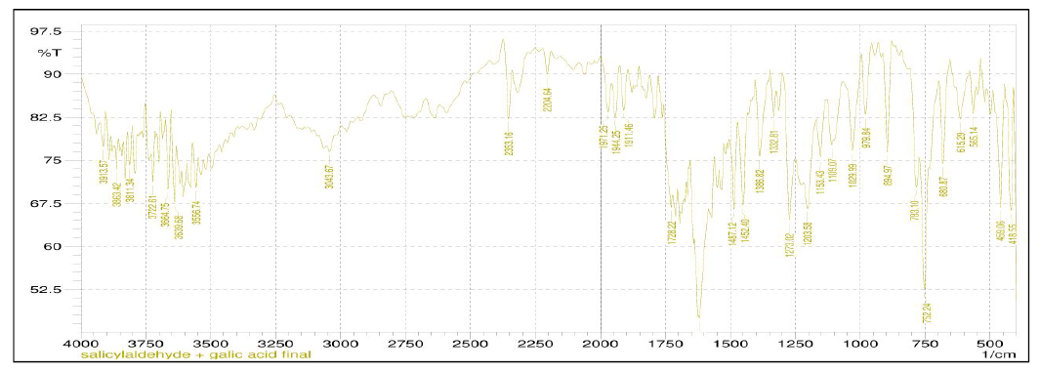

IR Spectrum- DP02

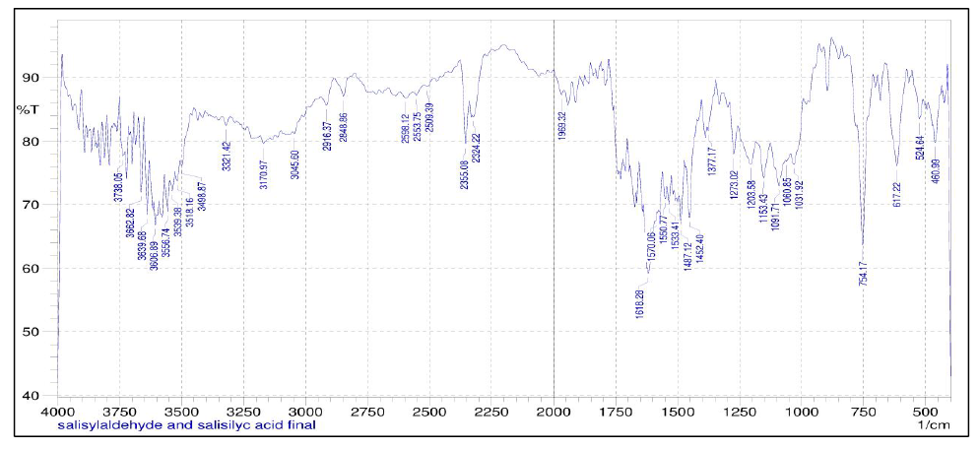

IR Spectrum- DP03

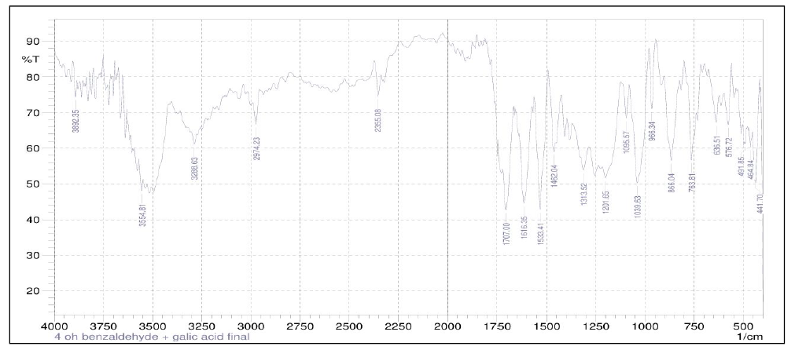

¹H-NMR Spectrum- DP01

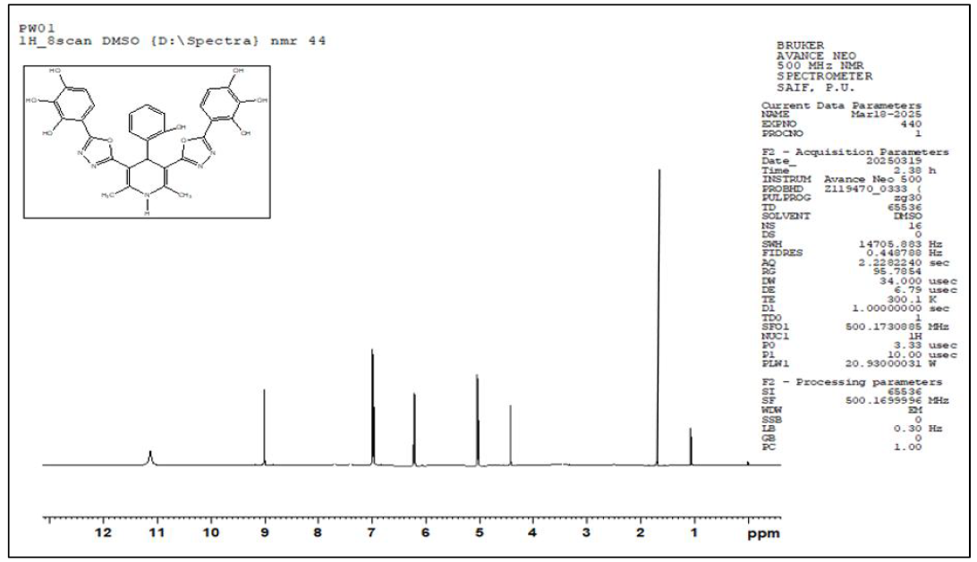

¹H-NMR Spectrum- DP02

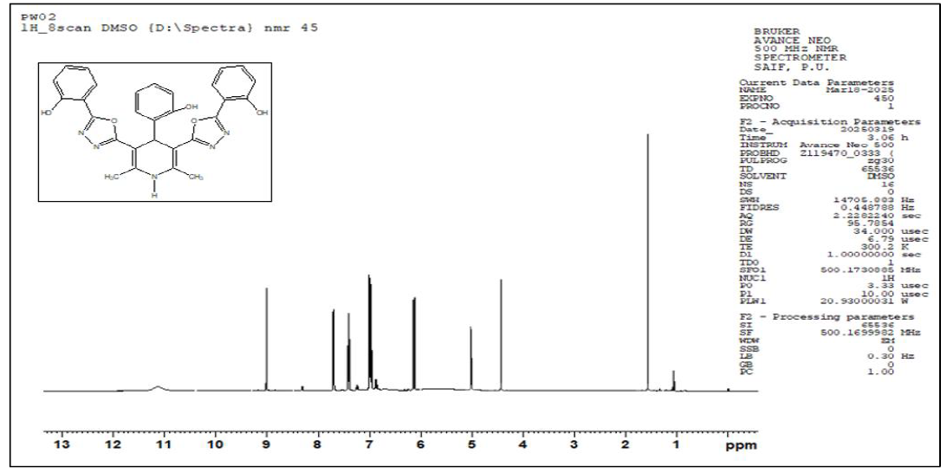

¹H-NMR Spectrum- DP03

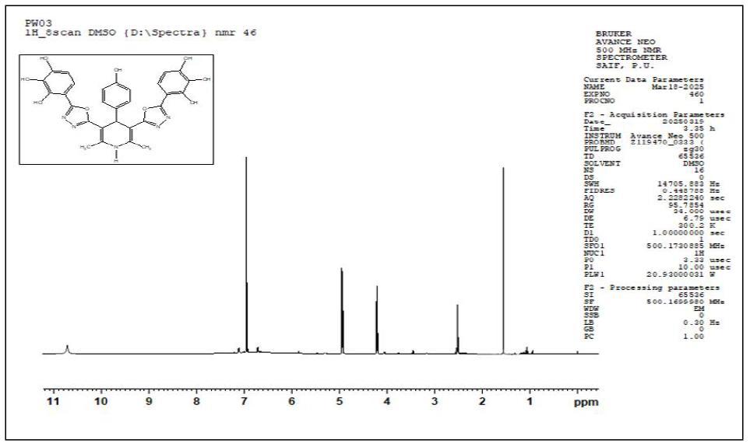

LC-MS- DP01

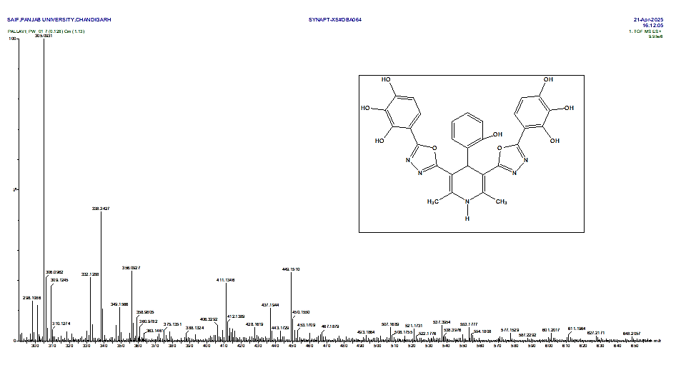

Mass Fragment Observed of DP01

Molecular formula | Mass fragmentation | m/z
C29H23N₅O₉ |  | 587
C₂₂H₁₈N5O₆••• |  | 448.126
C₁₆H₁₃N₅O₅•••• |  | 355.092
C₂₂H₁₈N₄O₆•••• |  | 434.123
C₁₆H₁₃N₅O₂•••• |  | 307.107

LC-MS- DP03

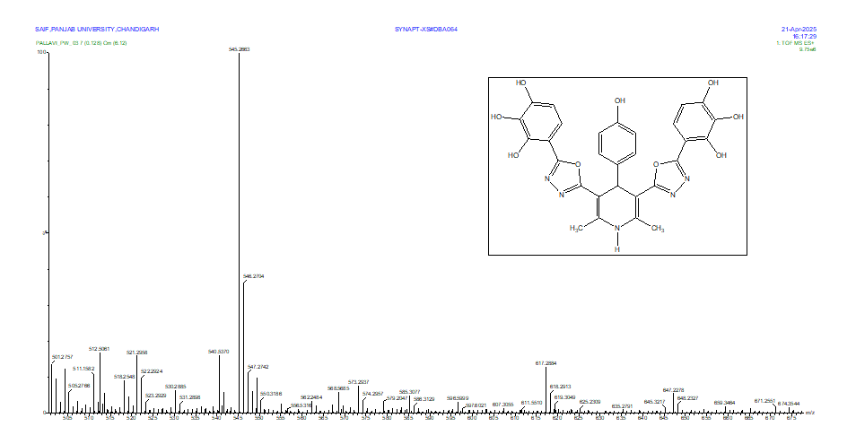

Mass Fragment Observed for DP03
Molecular formula | Mass fragmentation | m/z
C29H23N₅O9 |  | 585
C₂₇H₁₉N₄O₉• |  | 543.115
C₁₃H₁₄NO• |  | 200.108

Novelty of synthesized compounds

DP01:- 4-(5-(4-(2-hydroxyphenyl)-2,6-dimethyl-5-(5-(2,3,4-trihydroxyphenyl)-1,3,4-oxadiazol-2-yl)-1,4-dihydropyridin-3-yl)-1,3,4-oxadiazol-2-yl) benzene-1,2,3-triol

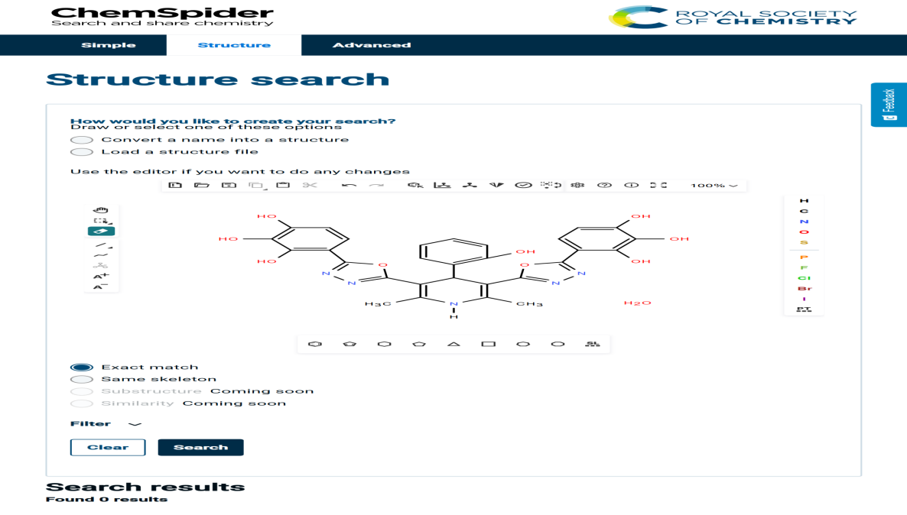
DP02:-2-(5-(4-(2-hydroxyphenyl)-5-(5-(2-hydroxyphenyl)-1,3,4-oxadiazol-2-yl)-2,6-dimethyl-1,4-dihydropyridin-3-yl)-1,3,4-oxadiazol-2-yl)phenol
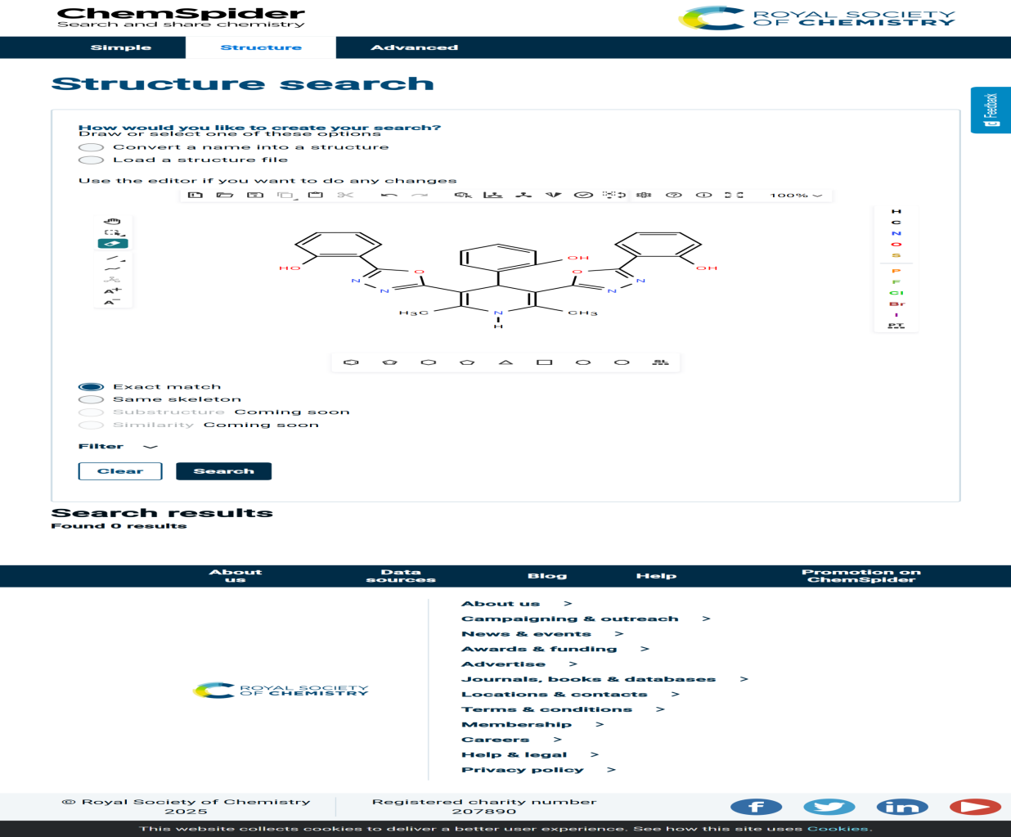
DP03:- 4-(5-(4-(4-hydroxyphenyl)-2,6-dimethyl-5-(5-(2,3,4-trihydroxyphenyl)-1,3,4 oxadiazol-2-yl)-1,4-dihydropyridin-3-yl)-1,3,4-oxadiazol-2-yl)benzene-1,2,3-triol

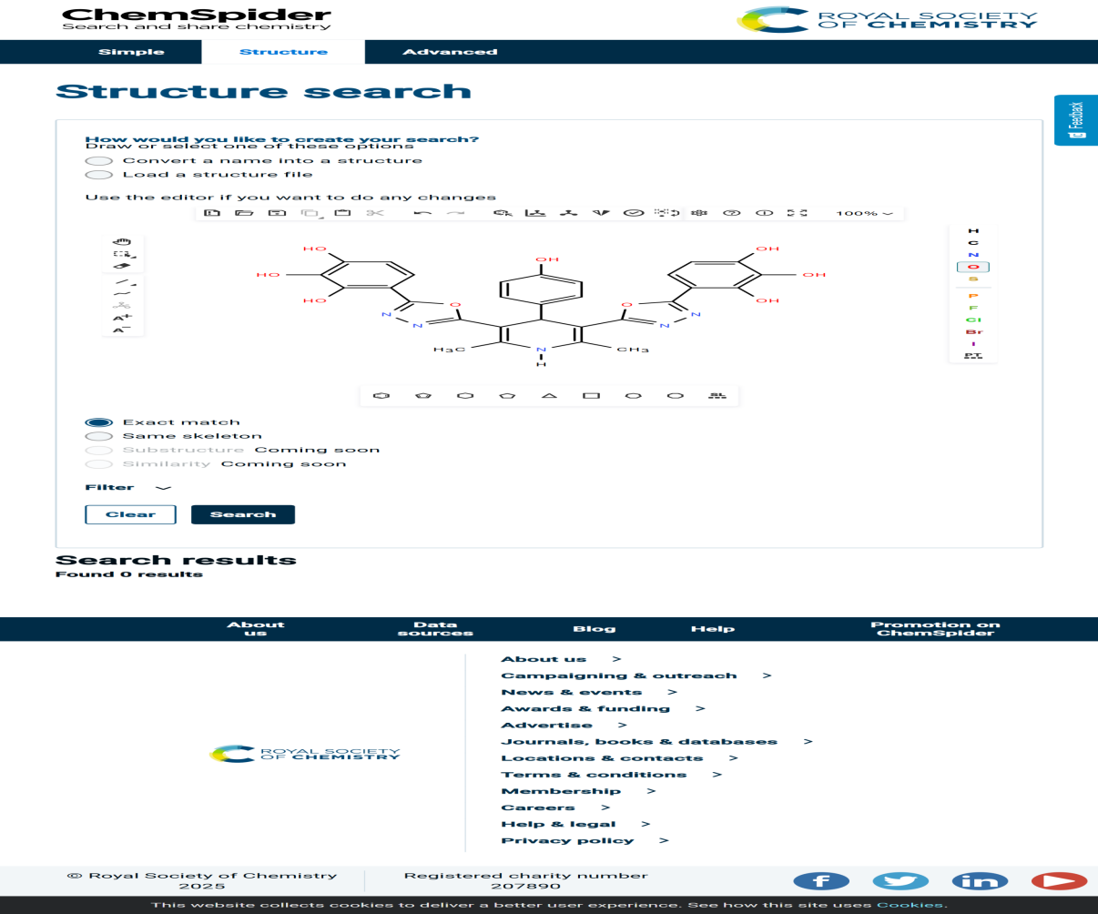

DP04:- 2-(5-(4-(4-hydroxyphenyl)-5-(5-(2-hydroxyphenyl)-1,3,4-oxadiazol-2-yl)-2,6 dimethyl-1,4-dihydropyridin-3-yl)-1,3,4-oxadiazol-2-yl)phenol
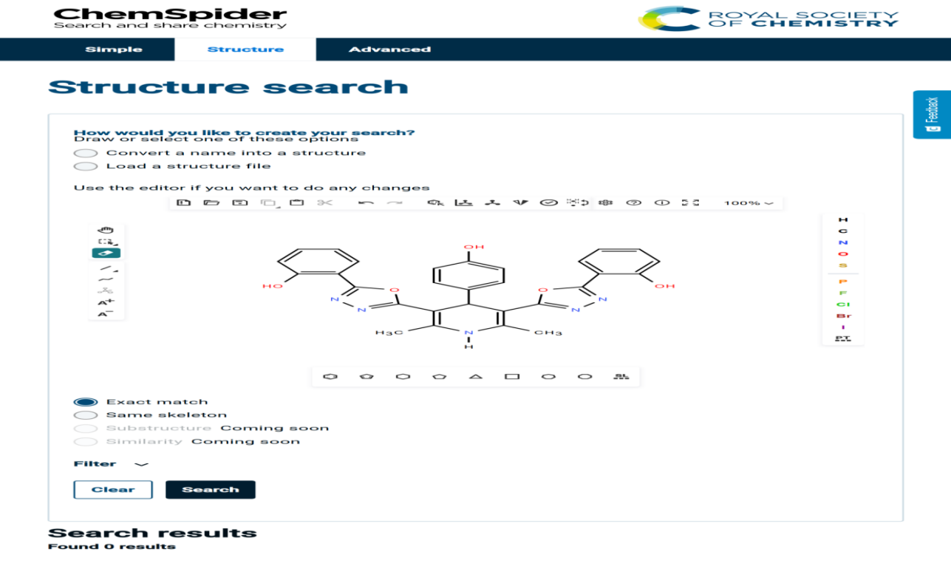

DP05:- 4-(3,5-bis(5-(2-chlorophenyl)-1,3,4-oxadiazol-2-yl)-2,6-dimethyl-1,4 dihydropyridin-4-yl)phenol

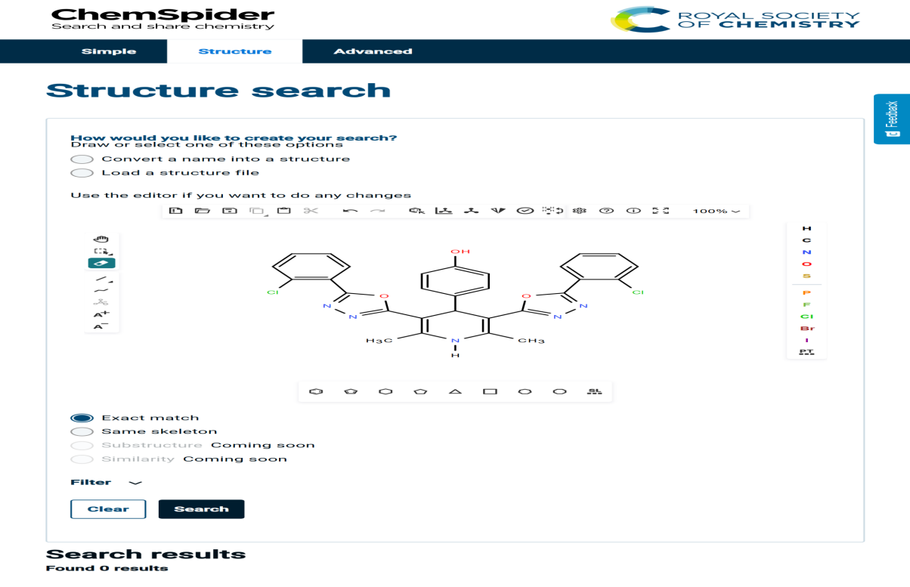
DP06:-3,5-bis(5-(2-chlorophenyl)-1,3,4-oxadiazol-2-yl)-2,6-dimethyl-4-phenyl-1,4-dihydropyridine

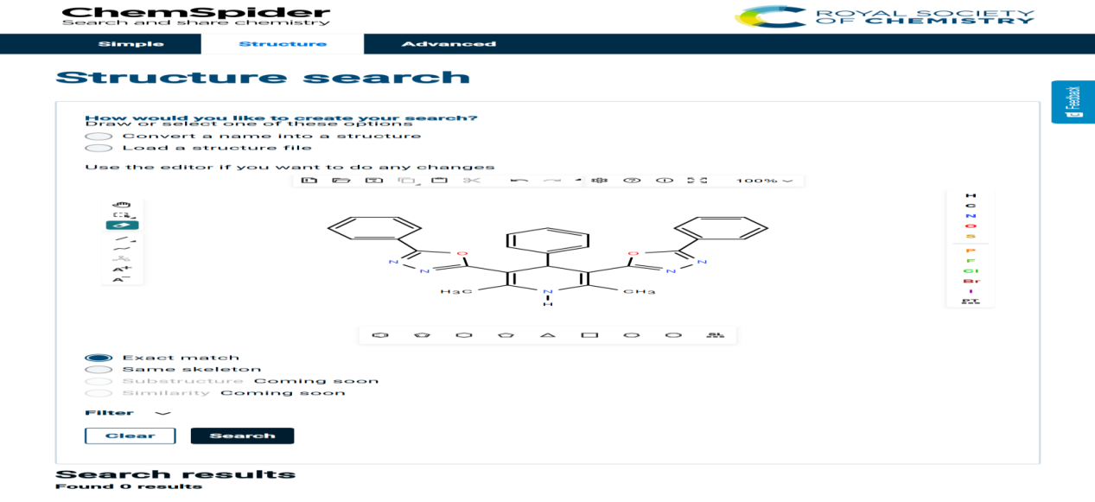

DP07:- 2,6-dimethyl-4-phenyl-3,5-bis(5-(E)-styryl-1,3,4-oxadiazol-2-yl)-1,4-dihydropyridine
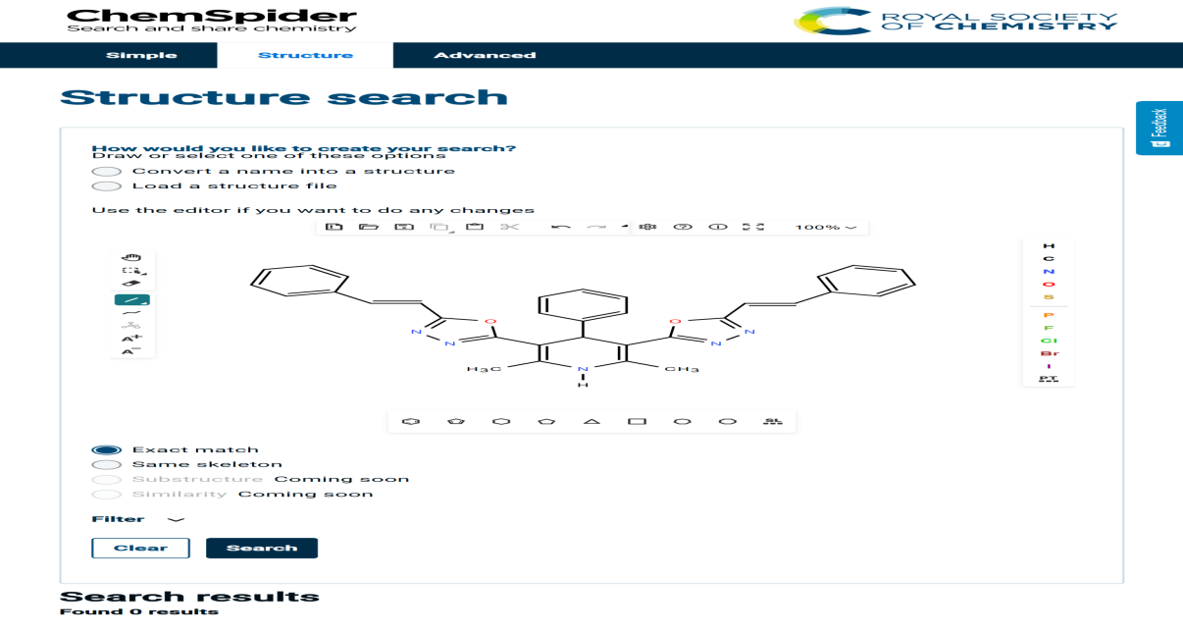

DP08:- 2-(5-(5-(5-(2-hydroxyphenyl)-1,3,4-oxadiazol-2-yl)-2,6-dimethyl-4-phenyl-1,4-dihydropyridin-3-yl)-1,3,4-oxadiazol-2-yl)phenol

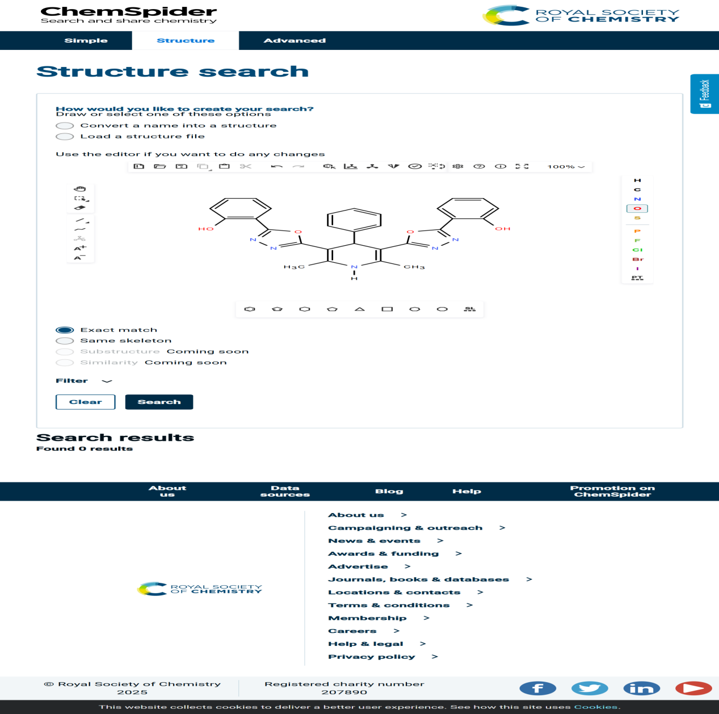

DP09:- 4-(5-(4-(4-methoxyphenyl)-2,6-dimethyl-5-(5-(2,3,4-trihydroxyphenyl)-1,3,4-oxadiazol-2-yl)-1,4-dihydropyridin-3-yl)-1,3,4-oxadiazol-2-yl)benzene-1,2,3-triol

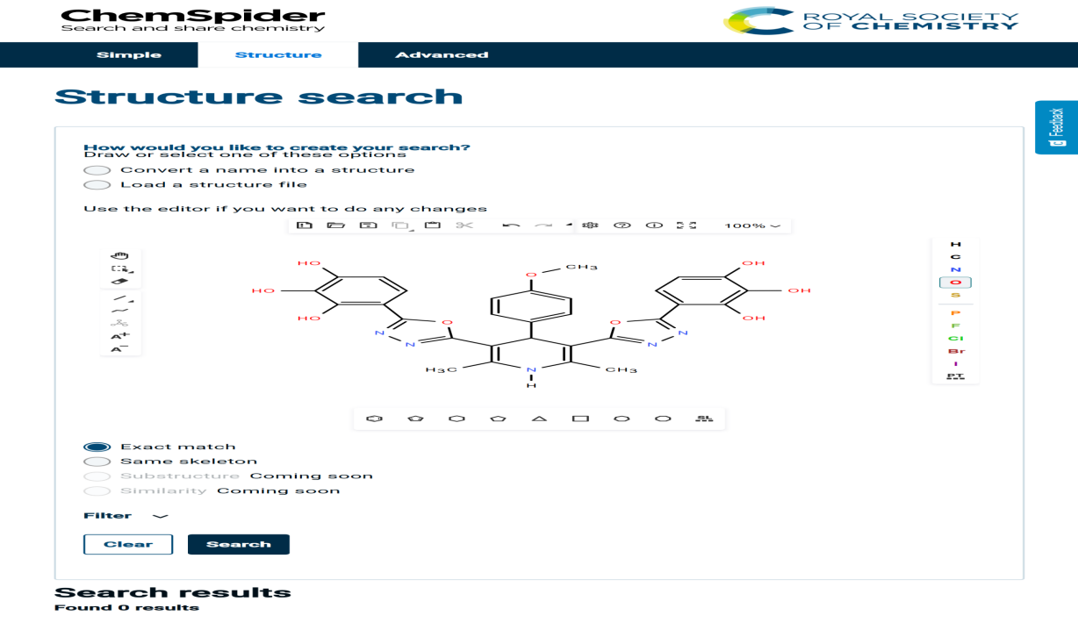
DP10:-2-(5-(5-(5-(2-hydroxyphenyl)-1,3,4-oxadiazol-2-yl)-4-(4-methoxyphenyl)-2,6-dimethyl-1,4-dihydropyridin-3-yl)-1,3,4-oxadiazol-2-yl)phenol

