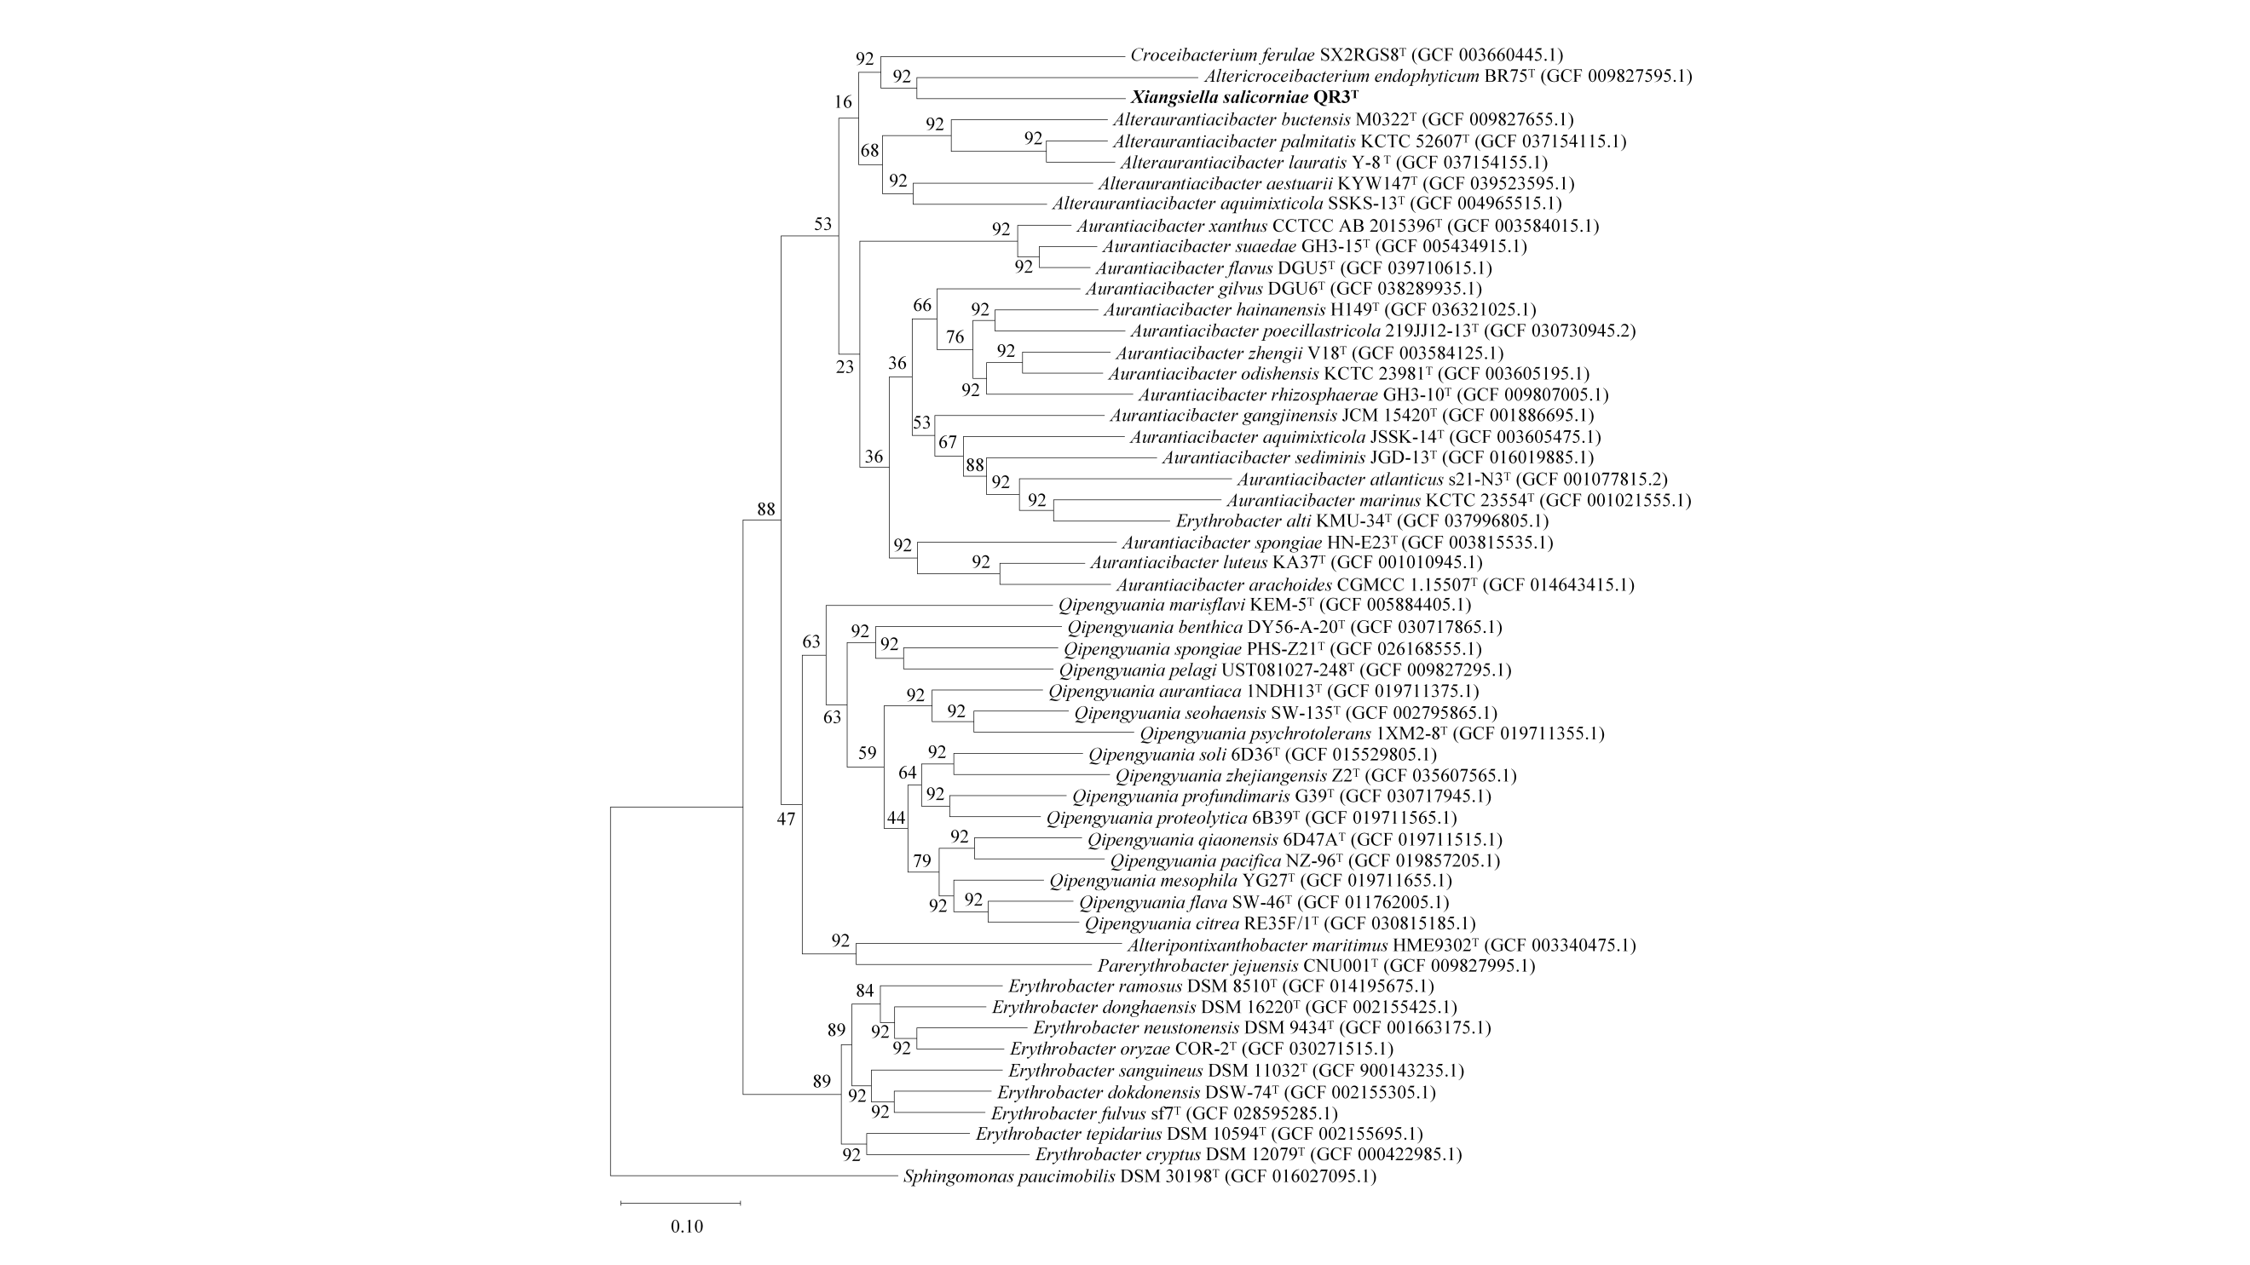
Fig. S1 Phylogenomic tree reconstructed using the UBCG pipeline based on 92 bacterial core genes, showing the phylogenetic position of strain QR3^{T} within the family Erythrobacteraceae. Gene support indices are shown at branch nodes. Genome accession numbers are given in parentheses. Sphingomonas paucimobilis DSM 30198^{T} was used as an outgroup. Bar, 0.10 substitutions per position
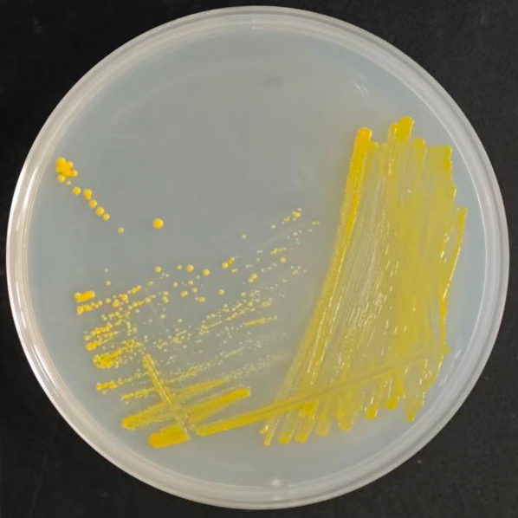
Fig. S2 Colony morphology of strain QR3^{T} grown on 2216E agar at 30℃ for 72 h. Colonies were bright yellow, circular, convex, smooth and glistening

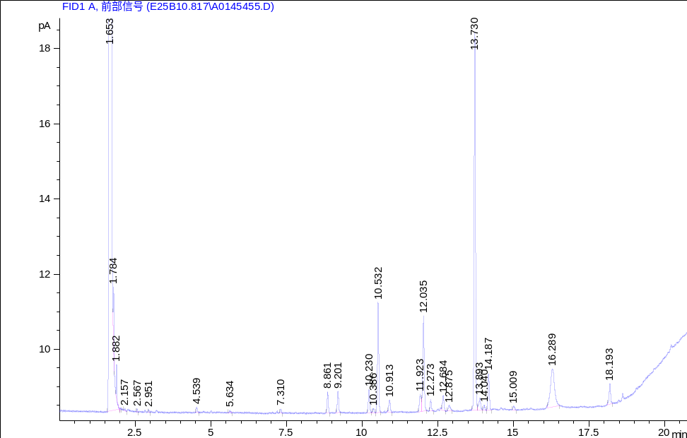
Fig. S3 Gas chromatogram of cellular fatty acid methyl esters of strain QR3^{T}. Whole-cell fatty acids were extracted from cells grown on 2216E agar at 30 ℃ for 72 h and analysed by gas chromatography with flame ionization detection. The x-axis represents retention time in minutes, and the y-axis represents detector response in picoamperes. Peak labels indicate retention times
Fig. S4 Two-dimensional thin-layer chromatogram of polar lipids extracted from strain QR3^{T}. The major polar lipids detected were SGL, sphingoglycolipid; DPG, diphosphatidylglycerol; PE, phosphatidylethanolamine; and PC, phosphatidylcholine
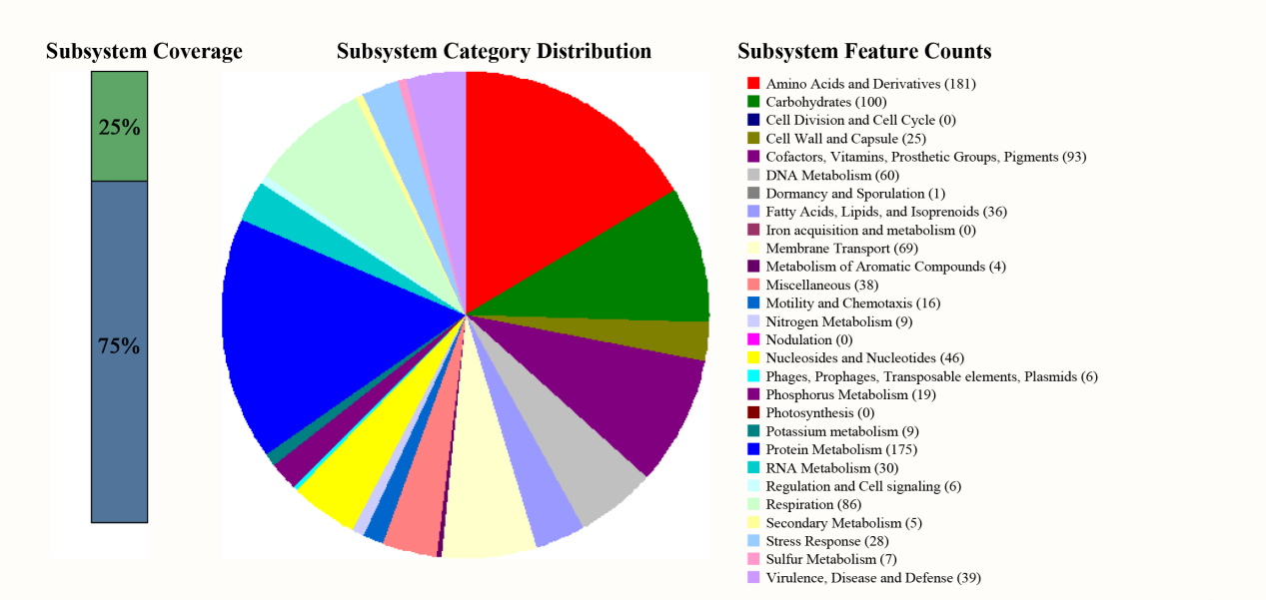
Fig. S5 RAST subsystem annotation of the genome of strain QR3^{T}. The figure shows subsystem coverage, subsystem category distribution and subsystem feature counts. A total of 262 subsystems were annotated, with major categories including amino acids and derivatives, protein metabolism, carbohydrates, cofactors, vitamins, prosthetic groups and pigments, respiration, membrane transport, DNA metabolism and stress response

Table S1 Genus-level comparison of AAI, POCP and evolutionary distance values between strain QR3^{T} and representative genera in the family Erythrobacteraceae
Genus | No. of strains | QR3^{T} vs genus |  |  | Intra-genus
Genus | No. of strains | AAI range (%) | POCP range (%) | Evolutionary distance range | AAI range  (%) | POCP range  (%) | Evolutionary distance range
Alteraurantiacibacter | 5 | 69.64-72.38 | 61.19-66.52 | 0.35-0.42 | 73.05-91.78 | 66.47-88.91 | 0.05-0.33
Aurantiacibacter | 17 | 69.81-71.46 | 59.10-69.46 | 0.37-0.41 | 70.74-91.60 | 50.81-82.90 | 0.05-0.37
Erythrobacter | 10 | 65.66-70.46 | 52.35-60.27 | 0.39-0.55 | 66.24-86.77 | 57.46-84.04 | 0.10-0.54
Qipengyuania | 16 | 66.92-67.73 | 53.44-60.54 | 0.49-0.51 | 73.33-86.24 | 64.78-83.66 | 0.10-0.34

