Directly Measured Hemodynamic Variability Reveals Network Target Engagement During Prefrontal iTBS
Running title: TMS-fMRI-fNIRS measures variability of BOLD during iTBS

Supplementary information

Authors: Adam Weili Xia¹, Nancy M.X.Y. Shi¹, Ivan K.Y. Chak¹, Alvin H.P. Tang¹, Tim T.Z. Lin¹, Sharie Xiao Wang¹, Penny Ping Qin¹, Minxia Jin^{1,2}, Bella Bingbing Zhang¹, Rebecca L.D. Kan¹, Rongxia Dai², Robin F.H. Cash^{3,4}, Andrew Zalesky^{3,4}, Frank Padberg^{5,6}, Martin Tik^{7*}, Georg S. Kranz^{1,8,9*}

Affiliations:
¹Department of Rehabilitation Sciences, The Hong Kong Polytechnic University, Hong Kong SAR, China
²Shanghai YangZhi Rehabilitation Hospital (Shanghai Sunshine Rehabilitation Center), School of Medicine, Tongji University, Shanghai, China
³Department of Psychiatry, University of Melbourne, Parkville, Victoria, Australia
⁴Department of Biomedical Engineering, University of Melbourne, Parkville, Victoria, Australia
⁵Department of Psychiatry and Psychotherapy, LMU University Hospital, LMU Munich, Germany
⁶DZPG (German Center for Mental Health), partner site Munich-Augsburg, Germany
⁷High Field MR Center, Center for Medical Physics and Biomedical Engineering, Medical University of Vienna, Vienna, Austria
⁸Mental Health Research Center (MHRC), The Hong Kong Polytechnic University, Hong Kong, China
⁹University Research Facility in Behavioral and Systems Neuroscience (UBSN), The Hong Kong Polytechnic University, Hong Kong, China

* Correspondence to:
Dr. Georg S. Kranz
Department of Rehabilitation Sciences, The Hong Kong Polytechnic University
Hong Kong SAR, China.
Tel: 852-2766-4838
Fax: 852-2330-8656
Email: Georg.kranz@polyu.edu.hk
&
Dr. Martin Tik
Center for Medical Physics and Biomedical Engineering, Medical University of Vienna
Vienna, Austria.
Email: martin.tik@meduniwien.ac.at

Supplementary methods
Procedure
During the baseline session, structural MRI scans were acquired for neuronavigation and fNIRS channel registration. Resting motor threshold (rMT) was subsequently determined outside the scanner using the same MR-compatible figure-of-eight coil (MagPro MRI-B91) employed for the subsequent iTBS session, and with the fNIRS cap on. The left primary motor cortex hand area was initially approximated using the C3 position of the international 10-20 EEG system¹. The stimulation hotspot was then manually identified following established procedures^{2, 3}. The rMT was defined as the minimum stimulator intensity (dI/dT) required to elicit visible muscle twitches in at least 5 out of 10 consecutive trails in the relaxed right index finger. During the rMT determination, a 7-channel surface radio frequency (RF) coil (4.5 mm)⁴ was mounted underneath the TMS coil, and participants wore the fully configured fNIRS cap (10 mm). This configuration increased the coil-to-cortex distance (~ 15 mm), resulting in higher measured rMT compared to standard setups. After rMT determination, a test stimulation at 90% rMT^{5, 6} roughly over the left DLPFC was delivered to assess tolerability. Subsequently, the 3D coordinates of all optodes and fiducial landmarks (nasion, NAS; left ear, LPA; and right ear, RPA) were digitized using a 3D digitizer (PATRIOT, Polhemus) for co-registration with anatomical MRI using NIRSTORM (https://github.com/Nirstorm/nirstorm) (Fig. 1b).
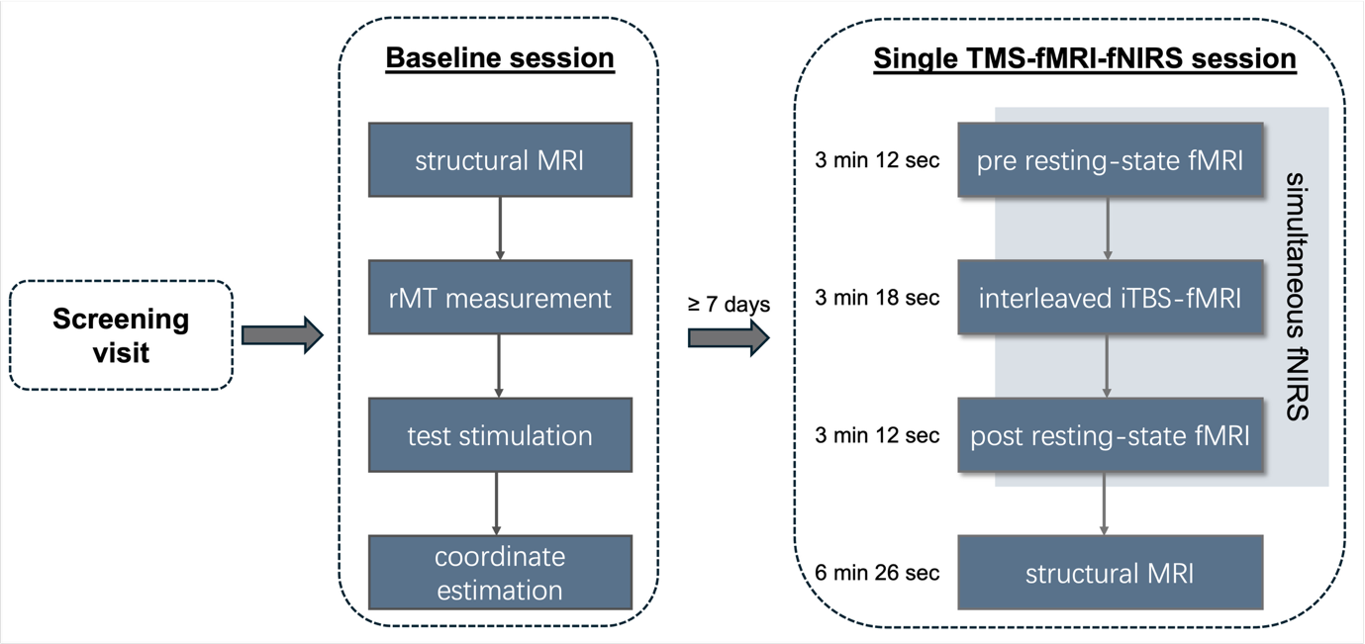
To ensure participant safety during concurrent iTBS-fMRI-fNIRS sessions, physiological parameters, including blood pressure and peripheral oxygen saturation (SpO₂), were monitored before and immediately after the concurrent iTBS-fMRI-fNIRS session. In addition, subjective ratings of pain and fatigue using a verbal analog scale (VAS, from 0 to 10) were collected immediately following the experiment. During the scanning and stimulation, participants were instructed to remain relaxed, awake, and still, while wearing earplugs to protect their hearing and reduce auditory stimulation from TMS pulses and scanner noise.
Supplementary Fig S1: Experimental procedure. The experiment protocol on the bassline and concurrent iTBS-fMRI-fNIRS sessions.

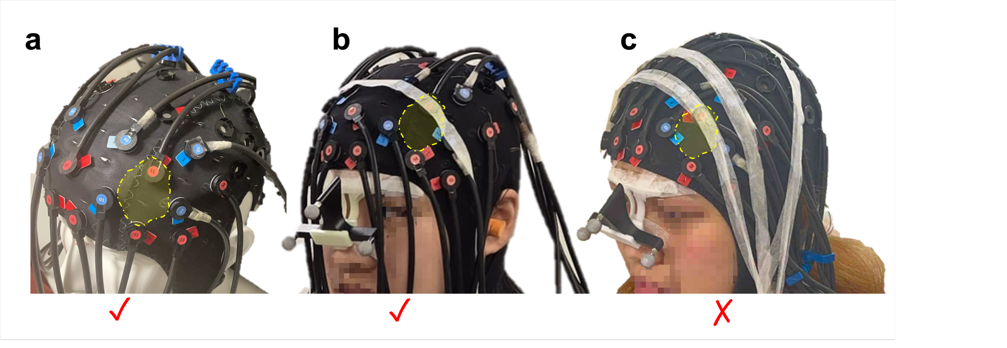
Supplementary Fig S2: Recommended fNIRS cable management for concurrent MR acquisition. (a), (b) Optimal configuration (Recommended). Optode cables are sparsely distributed and systematically routed in parallel (i.e., without crossing) along the cap. Cables are deliberately routed away from the estimated direct contact areas (indicated by yellow shading) of the surface RF coil. Furthermore, cables retain natural slack to maintain a physical distance from the scalp. While adhesive tape is recommended to keep the optodes flush against the scalp to ensure robust fNIRS signal quality throughout the session, the cables themselves should not be taped to the scalp. This arrangement effectively prevents localized signal dropout and preserves the image quality of the functional and structural MR images acquiring during concurrent iTBS-fMRI-fNIRS session. (c) Discouraged configuration. An example of poor cable management where cables are densely clustered and excessively secured (e.g., using adhesive tape) tightly against the scalp. Such configurations, particularly when positioned directly under the RF coil, can result in severe localized signal dropout (i.e., visually missing MR signal in the adjacent cortical regions).
Note: These practical recommendations are specifically based on the hardware and equipment configurations utilized in the current study.

Supplementary results

Safety
No adverse events were observed during or after the concurrent iTBS-fMRI-fNIRS sessions. Physiological measures (blood pressure and SpO₂) remained within normal ranges, and participants reported acceptable levels of pain and fatigue (mean ± SD: VAS = 4.89 ± 2.85 and 4.22 ± 1.99, respectively).

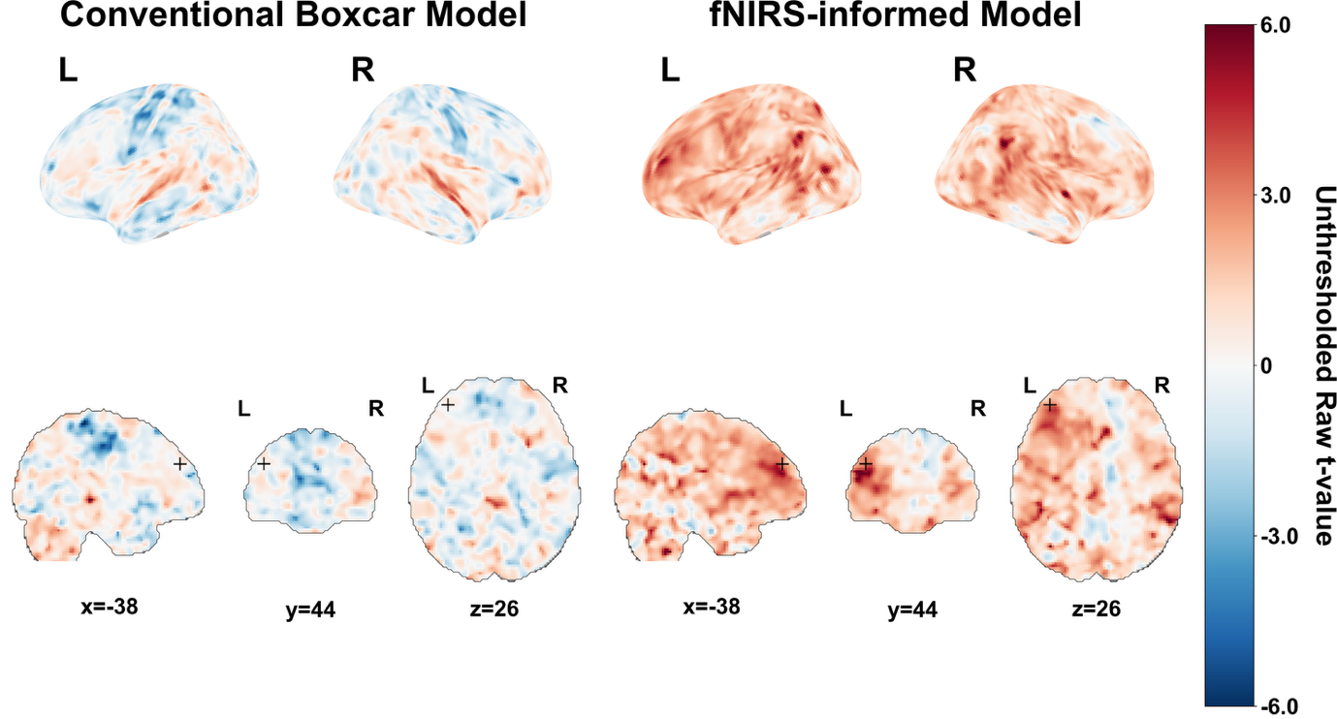
Supplementary Fig S3: Group-level unthresholded raw t-maps of the conventional model and the fNIRS-informed model. Corresponding brain maps (Upper panel: 3D surface renderings; and bottom panel: orthogonal slices centered at the target site, i.e., left DLPFC: x=-38, y=44, z=26) showing no similar sub-threshold target engagement between two models in the target site.

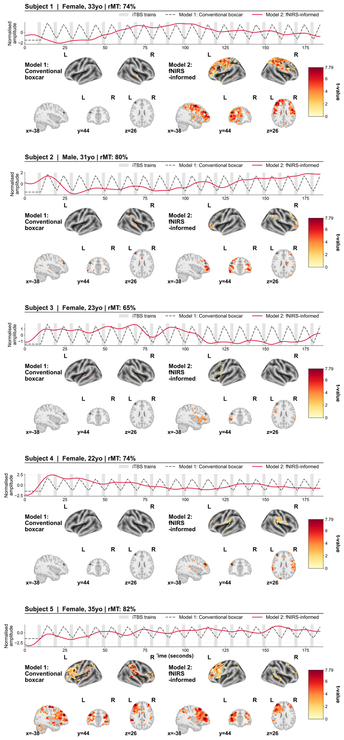

Supplementary Fig S4: Individual-level results of the conventional model (Model 1, left panel) and the fNIRS-informed model (Model 2, right panel) across the entire cohort (Subjects 1–5 shown, remaining subjects shown in Supplementary Fig S4). Upper graphs: The canonical theoretical boxcar model (grey dashed line) assumes a uniform temporal response. In contrast, individualized fNIRS-HbO trajectories (red solid lines) reveal highly subject-specific time courses, profoundly deviating from canonical expectations. Bottom panels: Corresponding brain maps (3D surface renderings and orthogonal slices) showing voxel-wise t-statistics (cluster-level P_{FWE} < 0.05.), centered at the target site (Left DLPFC: x=-38, y=44, z=26).

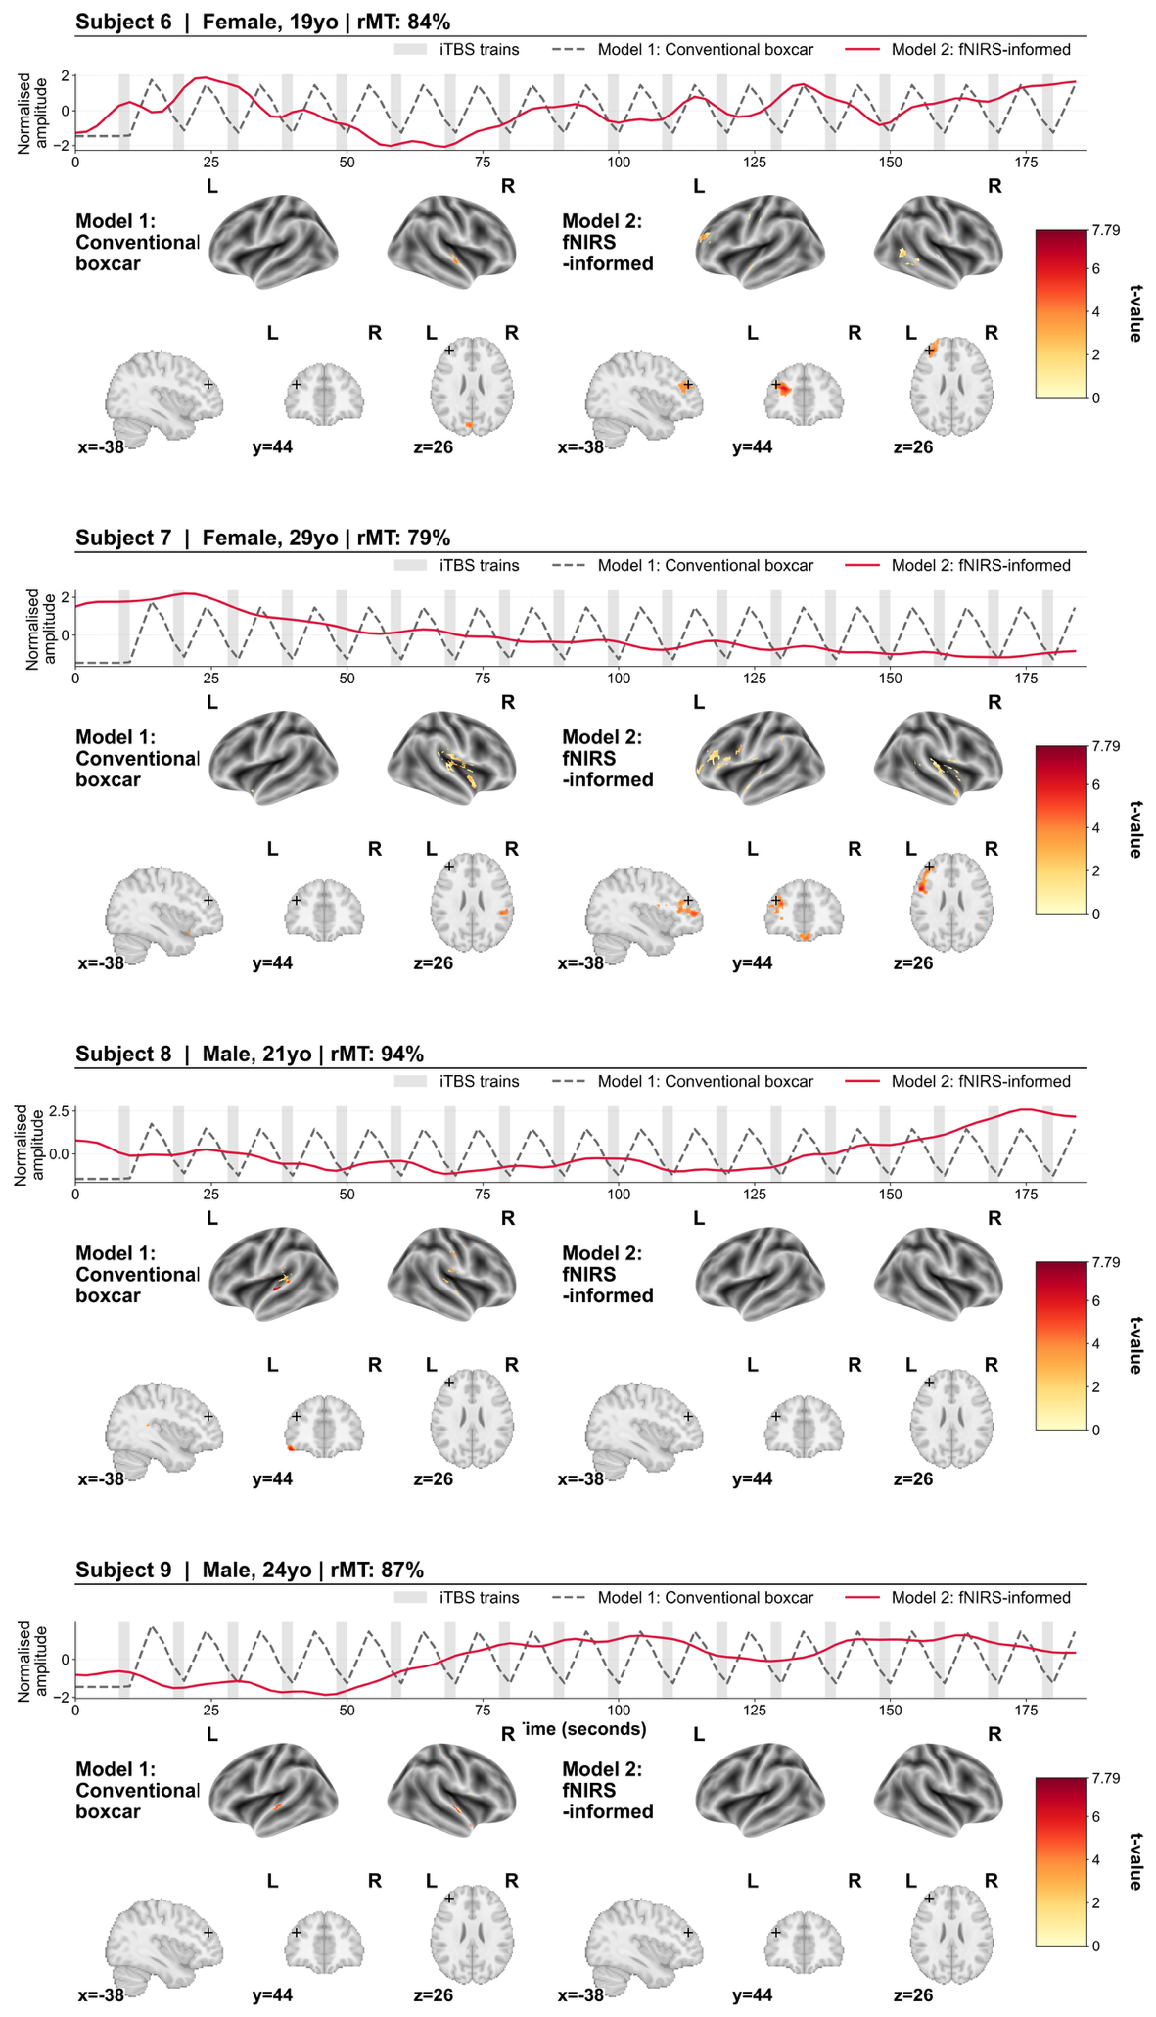
Supplementary Fig S5: Individual-level results of the conventional model (Model 1, left panel) and the fNIRS-informed model (Model 2, right panel) across the entire cohort (Subjects 6–9 shown). Upper graphs: The canonical theoretical boxcar model (grey dashed line) assumes a uniform temporal response. In contrast, individualized fNIRS-HbO trajectories (red solid lines) reveal highly subject-specific time courses, profoundly deviating from canonical expectations. Bottom panels: Corresponding brain maps (3D surface renderings and orthogonal slices) showing voxel-wise t-statistics (cluster-level P_{FWE} < 0.05.), centered at the target site (Left DLPFC: x=-38, y=44, z=26).

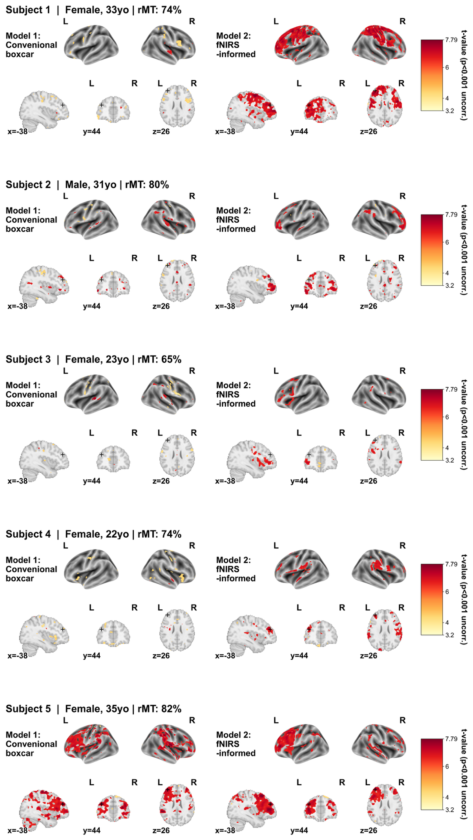
Supplementary Fig S6: Individual-level results (uncorrected P < 0.001) of the conventional model (Model 1, left panel) and the fNIRS-informed model (Model 2, right panel) across the entire cohort (Subjects 1–5 shown, remaining subjects shown in Supplementary Fig S2). Corresponding brain maps (3D surface renderings and orthogonal slices) showing voxel-wise t-statistics (uncorrected P < 0.001.), centered at the target site (Left DLPFC: x=-38, y=44, z=26). The results remained consistent with corrected voxel-wise t-statistics (cluster-level P_{FWE} < 0.05, see Supplementary Fig. S3), confirming the absence of sub-threshold target activation in the conventional model.

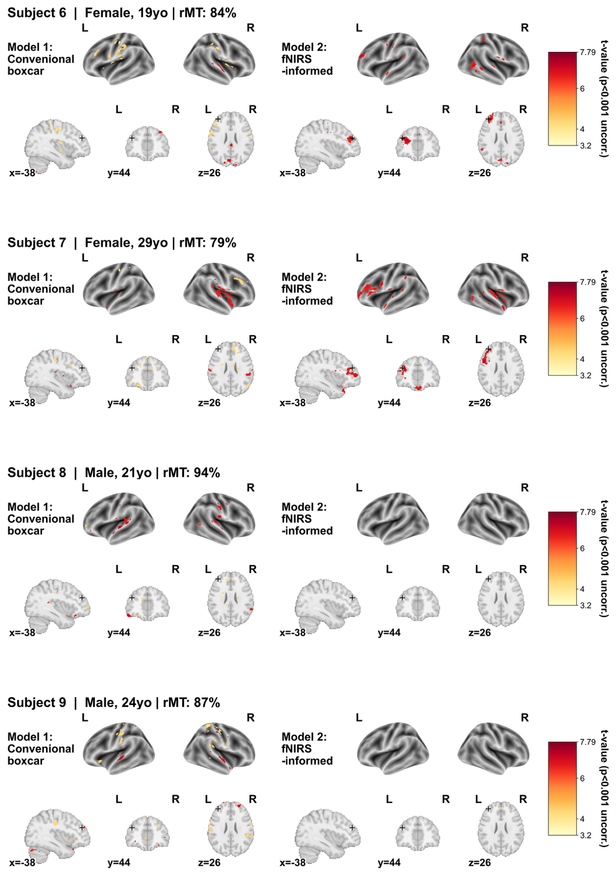

Supplementary Fig S7: Individual-level results (uncorrected P < 0.001) of the conventional model (Model 1, left panel) and the fNIRS-informed model (Model 2, right panel) across the entire cohort (Subjects 6–9 shown). Corresponding brain maps (3D surface renderings and orthogonal slices) showing voxel-wise t-statistics (uncorrected P < 0.001), centered at the target site (Left DLPFC: x=-38, y=44, z=26). The results remained consistent with corrected voxel-wise t-statistics (cluster-level P_{FWE} < 0.05, see Supplementary Fig. S4), confirming the absence of sub-threshold target activation in the conventional model.

Supplementary Table S1 Individual and group level local target engagement.
Subject | Conventional iTBS Model (Boxcar) |  |  |  | fNIRS-informed Model
Subject | Local target engagement (Y/N) | Peak MNI* [mm] | t-value | Minimum Euclidean distance between the DLPFC cluster edge and the target site (mm) | Analyzed channel# | Local target engagement (Y/N) | Peak MNI* [mm] | t-value | Minimum Euclidean distance between the DLPFC cluster edge and the target site (mm)
Sub-01 | N | -- | -- | -- | CH 7 | Y | -32, 48, 18 | 6.90 | 0.00
Sub-02 | Y | -40, 44, 36 | 6.35 | 6.00 | CH 7 | Y | -38, 40, 38 | 6.84 | 8.25
Sub-03 | N | -- | -- | -- | CH 2 | Y | -46, 36, 30 | 4.14 | 6.32
Sub-04 | N | -- | -- | -- | CH 7 | Y | -36, 42, 22 | 4.69 | 0.00
Sub-05 | Y | -38, 46, 26 | 7.56 | 0.00 | CH 7 | Y | -38, 50, 26 | 7.29 | 0.00
Sub-06 | N | -- | -- | -- | CH 2 | Y | -42, 52, 20 | 3.47 | 0.00
Sub-07 | N | -- | -- | -- | CH 7 | Y | -34, 44, 30 | 3.98 | 2.00
Sub-08 | N | -- | -- | -- | CH 7 | N | -- | -- | --
Sub-09 | N | -- | -- | -- | CH 7 | N | -- | -- | --
Group-level | N | -- | -- | -- | -- | Y | -36, 44, 18 | 6.00 | 3.46
Peak MNI *: the MNI coordinates of the nearest local maximum to the target site (-38, 44, 26).
Chosen channel#: the channel nearest to the stimulation target, from which the HbO signal was derived for analysis.
Y/N = Yes/No; CH = channel.

References:

1. Sparing R, Buelte D, Meister IG, Paus T, Fink GR. Transcranial magnetic stimulation and the challenge of coil placement: a comparison of conventional and stereotaxic neuronavigational strategies. Hum Brain Mapp 2008; 29(1): 82–96.

2. Rossini PM, Burke D, Chen R, Cohen LG, Daskalakis Z, Di Iorio R et al. Non-invasive electrical and magnetic stimulation of the brain, spinal cord, roots and peripheral nerves: Basic principles and procedures for routine clinical and research application. An updated report from an I.F.C.N. Committee. Clin Neurophysiol 2015; 126(6): 1071–1107.

3. Ortega-Robles E, Cantillo-Negrete J, Carino-Escobar RI, Arias-Carrión O. Methodological approach for assessing motor cortical excitability changes with single-pulse transcranial magnetic stimulation. MethodsX 2023; 11: 102451.

4. Navarro de Lara LI, Windischberger C, Kuehne A, Woletz M, Sieg J, Bestmann S et al. A novel coil array for combined TMS/fMRI experiments at 3 T. Magn Reson Med 2015; 74(5): 1492–1501.

5. Blumberger DM, Vila-Rodriguez F, Thorpe KE, Feffer K, Noda Y, Giacobbe P et al. Effectiveness of theta burst versus high-frequency repetitive transcranial magnetic stimulation in patients with depression (THREE-D): a randomised non-inferiority trial. Lancet 2018; 391(10131): 1683–1692.

6. Cole EJ, Stimpson KH, Bentzley BS, Gulser M, Cherian K, Tischler C et al. Stanford Accelerated Intelligent Neuromodulation Therapy for Treatment-Resistant Depression. Am J Psychiatry 2020; 177(8): 716–726.

