Additional file 1
Robustness figures for the symptom network of domain-specific cognitive function in stable COPD
This additional file contains the two robustness figures recommended for routine submission: edge-weight bootstrap confidence intervals and the overall case-dropping stability plot. The duration-specific case-dropping plot was generated during exploratory subgroup analysis but is not included in this supplementary file because the disease-duration comparison was exploratory and was not statistically significant.
Figure S1. Edge-weight bootstrap confidence intervals.
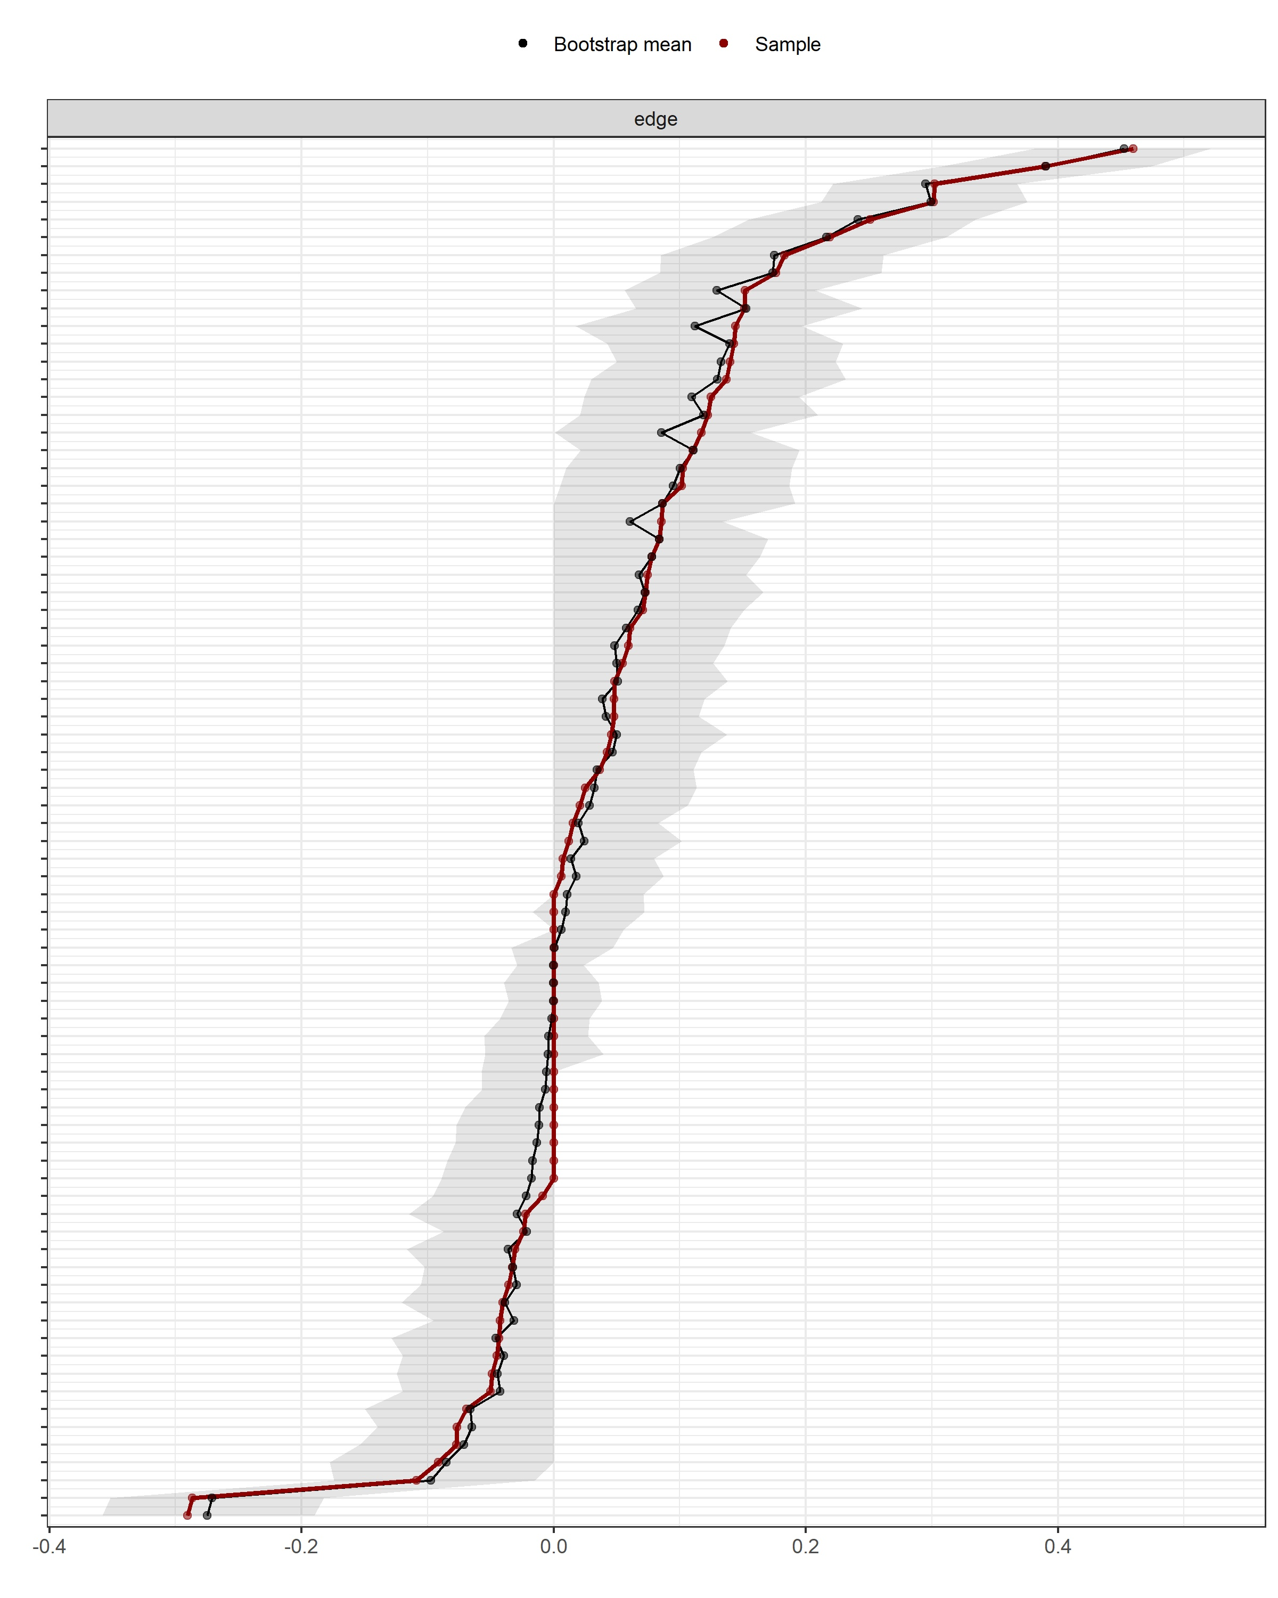
The red points and line show the sample edge estimates. The black points and line show the mean bootstrap estimates. The gray areas indicate the bootstrap confidence intervals. Stronger edges show narrower intervals than weaker edges.
Figure S2. Overall case-dropping stability plot.
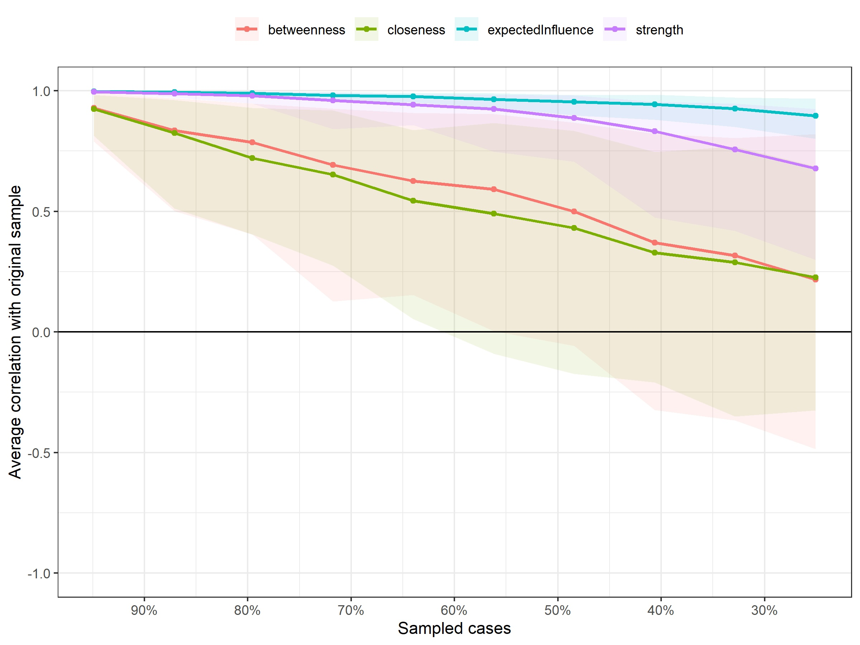
Strength and expected influence showed acceptable to very good stability. Closeness and betweenness were not stable and were therefore not interpreted in the main manuscript.

