Supplementary Material
Table S1. Publication output and academic impact ranking of countries/regions (Top 10)
Table S2 Top 10 journals by publication output
Figure S1. Top 20 most productive authors vs. Top 20 most cited authors
Figure S2. Top 15 keyword citation burst analysis

Table S1. Publication output and academic impact ranking of countries/regions (Top 10)
Rank | Country | Publication | Citations | Total Link Strength | Average TC per article
1 | USA | 310 | 11790 | 215 | 38.03
2 | CHINA | 204 | 5126 | 80 | 25.13
3 | GERMANY | 72 | 2802 | 102 | 38.92
4 | SOUTH KOREA | 70 | 1772 | 39 | 25.31
5 | JAPAN | 69 | 2010 | 35 | 29.13
6 | ITALY | 41 | 1175 | 41 | 28.66
7 | UK | 36 | 1101 | 62 | 30.58
8 | AUSTRALIA | 26 | 1125 | 22 | 43.27
9 | SWITZERLAND | 25 | 962 | 46 | 38.48
10 | CANADA | 24 | 787 | 31 | 32.79
Abbreviation: TC, total citations.

Table S2 Top 10 journals by publication output
Rank | Journal | Count | IF
1 | INTERNATIONAL JOURNAL OF MOLECULAR SCIENCES | 28 | 5.60
2 | BIOMATERIALS | 22 | 13.60
3 | SCIENTIFIC REPORTS | 21 | 4.90
4 | FRONTIERS IN CELL AND DEVELOPMENTAL BIOLOGY | 18 | 5.30
5 | CELLS | 17 | 6.00
6 | NATURE COMMUNICATIONS | 16 | 18.10
7 | STEM CELL RESEARCH & THERAPY | 15 | 7.80
8 | FRONTIERS IN BIOENGINEERING AND BIOTECHNOLOGY | 11 | 5.80
9 | STEM CELLS INTERNATIONAL | 8 | 3.60
10 | ACTA BIOMATERIALIA | 7 | 10.40
Abbreviation: IF, impact factor.

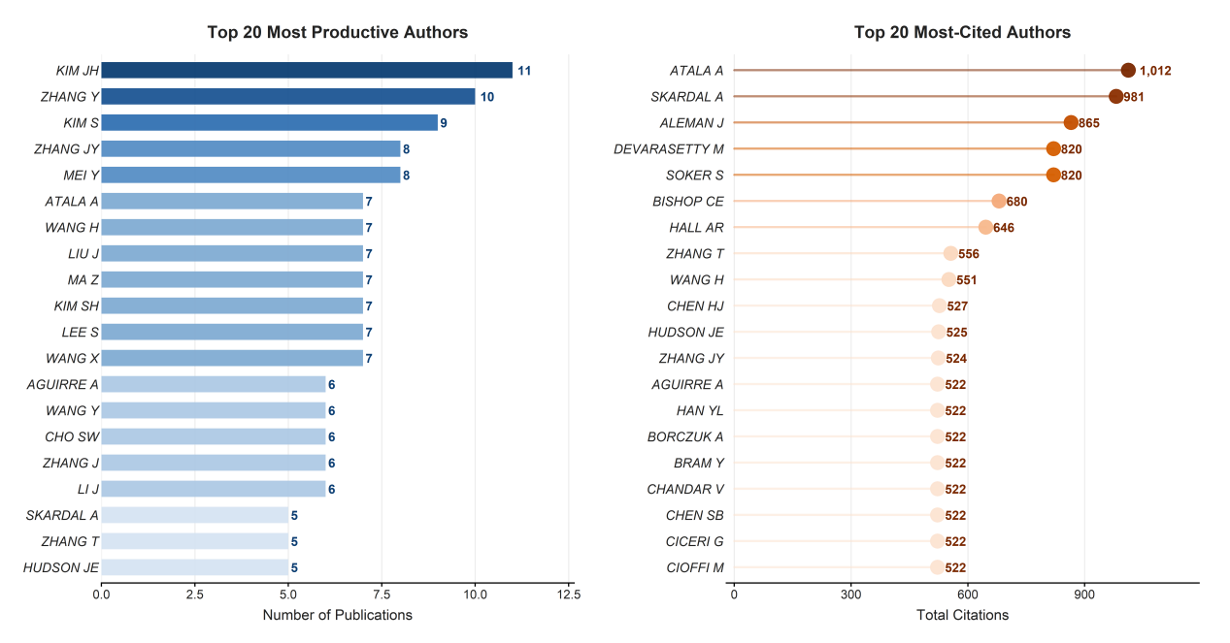
Figure S1. Top 20 most productive authors vs. Top 20 most cited authors.
A, The 20 authors with the highest number of publications in this field, where the accompanying numbers denote publication counts. B, The 20 authors with the highest total citations, where the accompanying numbers denote citation counts.

Figure S2. Top 15 keyword citation burst analysis.

