Proteomic analysis reveals WNT3a, TGFβ, and cAMP-dependent cell type differentiation in gastric antral mucosoids
Marzieh Ehsani ^{1,2}, Alvaro Quevedo-Olmos ¹, Ayham Moustafa ^{3,4,5}, Manuela Moritz ⁴, Bente Siebels ⁴, Annika Brauer ^{6,7,8}, Shihan Wang ¹, Xiaochen Zhang ¹, Lucas Riedel ¹, Marion Tina van Mackelenbergh ^{6,7}, Jürgen Ordemann ⁹, Susanne Wiegand ¹⁰, Jan Hahn ^{4,5}, Nina Hedemann ^{6,7}, David Holthaus ^{1,6,7,10 #*}, and Thomas F. Meyer ^{1,11 #*}
¹ Laboratory of Infection Oncology, Institute of Clinical Molecular Biology, Christian-Albrechts-Universität zu Kiel and University Hospital Schleswig-Holstein, Kiel, Germany
² Department of Neurology, Christian-Albrechts-University Kiel & University Hospital Schleswig-Holstein, Kiel, Germany
³ Department of Radiotherapy and Radiooncology, University Medical Center Hamburg-Eppendorf, Hamburg, Germany
⁴ Section Mass Spectrometry and Proteomics, University Medical Center Hamburg Eppendorf, Hamburg, Germany
⁵ Mildred Scheel Cancer Career Center HaTriCS4, University Medical Center Hamburg-Eppendorf, Hamburg, Germany.
⁶ Department of Gynaecology and Obstetrics, Christian-Albrechts-University Kiel & University Hospital Schleswig-Holstein, Kiel, Germany
⁷ Unit for 3D-Patient Avatars and Personalized Medicine, Department of Gynaecology and Obstetrics, Christian-Albrechts-University Kiel & University Hospital Schleswig-Holstein, Kiel, Germany
⁸ Group of Inflammatory Carcinogenesis, Institute for Experimental Cancer Research, University Hospital Schleswig-Holstein, Kiel, Germany
⁹ Department of Bariatric and Metabolic Surgery, Helios Klinikum, Berlin, Germany
¹⁰ Department of Otorhinolaryngology, Head and Neck Surgery, Christian-Albrechts-University Kiel & University Hospital Schleswig-Holstein, Kiel, Germany
¹¹ Department of Molecular Biology, Max Planck Institute for Infection Biology, Berlin, Germany
# Shared authorship

* Correspondence:
Dr. David Holthaus
david.holthaus@uksh.de

Prof. Dr. Thomas F. Meyer
t.meyer@ikmb.uni-kiel.de
Supplementary Figures:
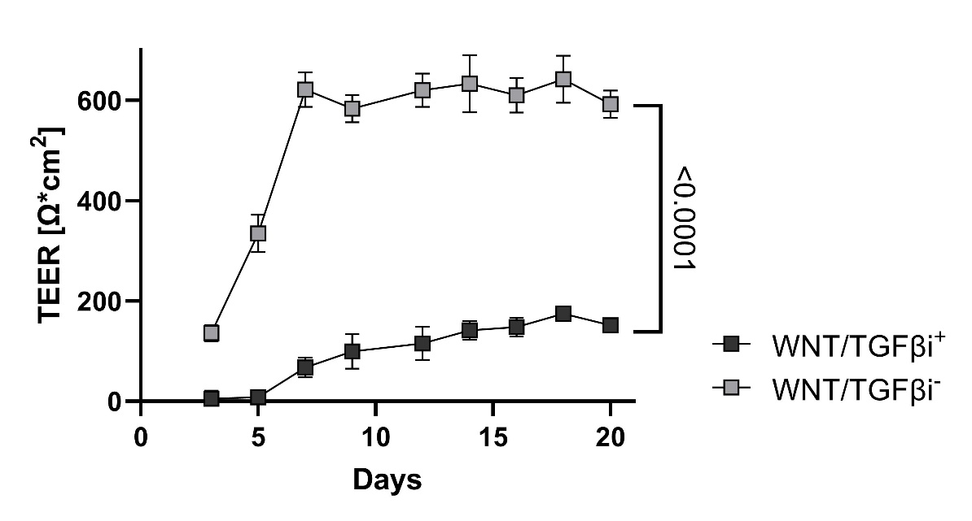
Supplementary Figure 1: Transepithelial electrical resistance (TEER) over time of a representative experiment. TEER values stabilize in both conditions after ~7 days of culture. Mean and individual values per well/filter are shown.
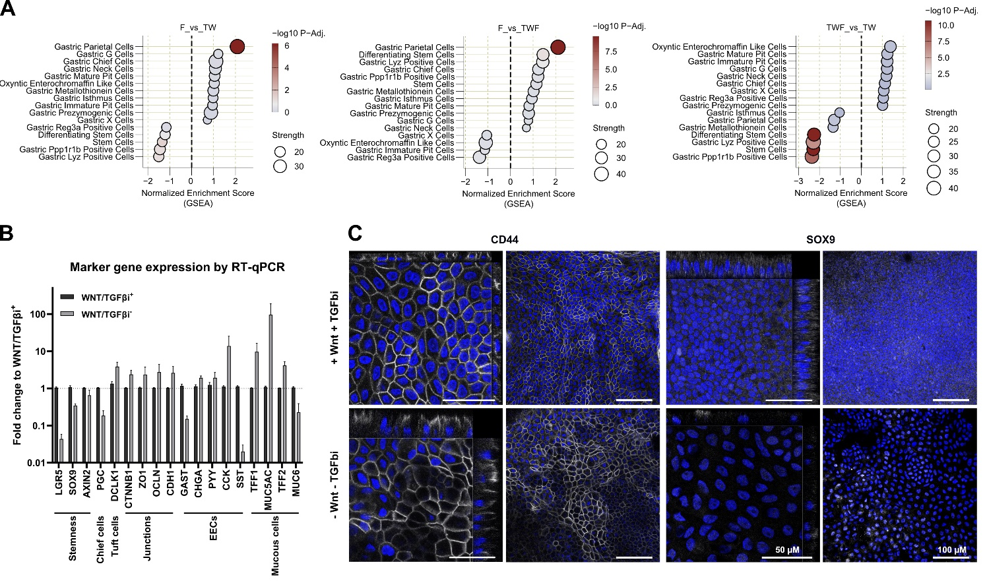
Supplementary Figure 2: A Dot plots indicating differences in the differentiation of gastric cells types indicated by Busslinger gene sets [1] of the comparisons F vs TW, and F vs TWF, and TWF vs TW. B RT-qPCR analysis of transcripts of the WNT/TGFβ⁺ and WNT/TGFβ⁻ conditions. WNT/TGFβ⁻ show a reduction in stemness marker while upregulating expression profiles of the antral tip such as MUC5AC, TFF1, and junctional markers. Primer sequences are provided in Supplementary table 3. C Representative immunofluorescence images and orthogonal projections of Z-stacks of mucosoid cultures stained for CD44 and SOX9. Nuclei are stained with Hoechst 33342 (blue) and primary antibodies in white. Scale bars indicate 50 µm for orthogonal projections of Z-stacks and 100 µm for overview images.

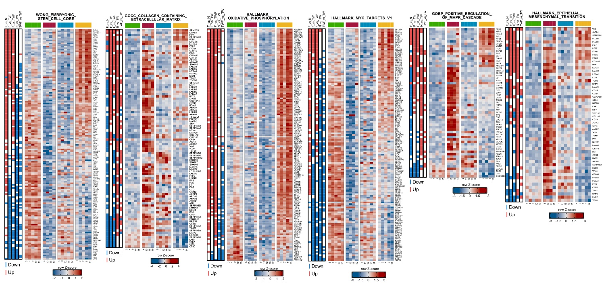
Supplementary Figure 3: Scaled heatmaps of the gene sets WONG_EMBRYONIC_STEM_CELL_CORE [2], GOCC_COLLAGEN_CONTAINING_EXTRACELLULAR_MATRIX, HALLMARK_OXIDATIVE_PHOSPHORYLATION, HALLMARK_MYC_TARGETS_V1, GOBP_POSITIVE_REGULATION_OF_MAPK_CASCADE, and HALLMARK_EPITHELIAL_MESENCHYMAL_TRANSITION with indications for significantly up (red), down (blue), or unchanged proteins.

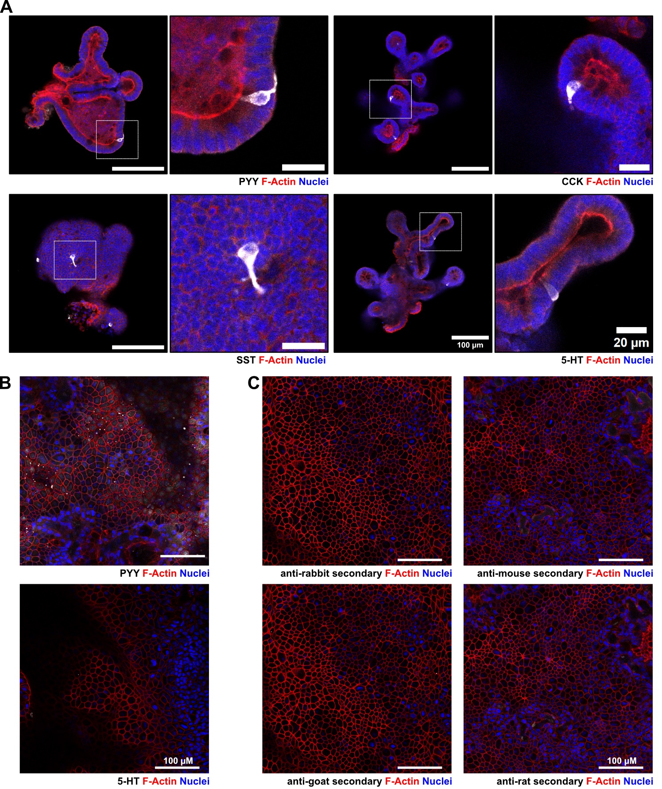
Supplementary Figure 4: Validation of antibodies against proteins expressed in enteroendocrine cells. A Mouse small intestinal organoids were used as positive control as they spontaneously differentiate in enteroendocrine cells. Nuclei are stained by Hoechst33342 (blue) and F-Actin using Phalloidin-iFluor 633 Reagent (red). Enteroendocrine markers are shown in white. B Staining of PYY and 5-HT in WNT/TGFβ⁻ mucosoids showing inconclusive stainings. C Secondary antibody controls. Secondary antibody staining is shown in white. Scale bars indicate 100 and 20 µm.

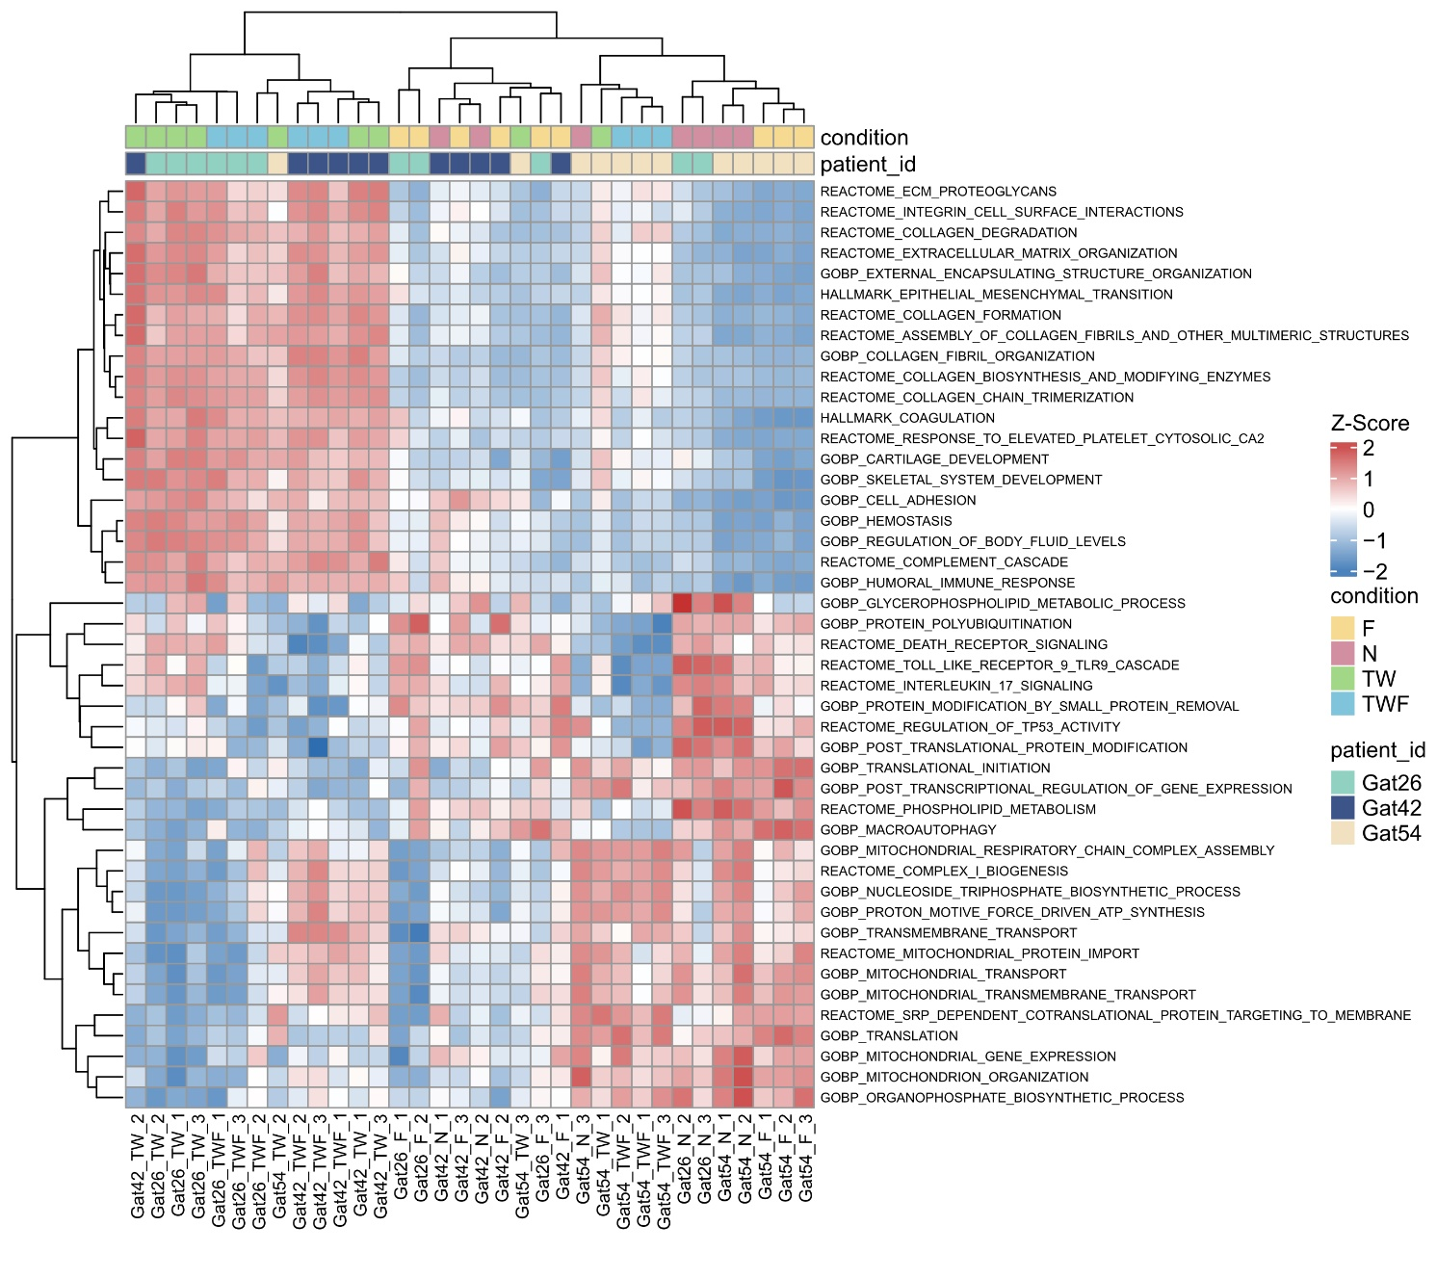
Supplementary Figure 5: Gene set variation analysis (GSVA) of mucus samples. The analysis validates findings of upregulated and downregulated pathways across conditions irrespective of patient.

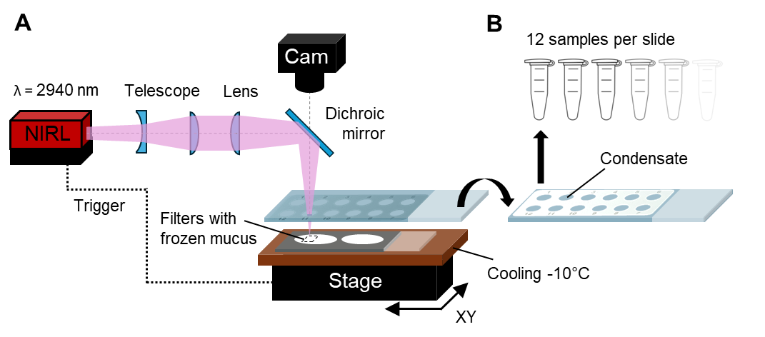
Supplementary Figure 6: Layer-wise laser sampling system of mucus for proteomics. A Laser sampling system. B PTFE-coated glass slides, where the generated aerosol containing intact proteins was condensed and collected.
Supplementary Tables:
Supplementary table 1: Medium compositions
Ingredients | Human gastric organoids |  | Mouse small intestinal organoids | Vendor
Ingredients | WNT +  TGFbi + | WNT -  TGFbi - | ENR
WRN | 50% | - | - | Made in-house,  L-WRN - CRL-3276 [3]
R-Spondin | 25% | 25% | 20% | Made in-house,  Cultrex HA-R-Spondin1-Fc 293T Cells, 3710-001-01
NCS21 Neuronal Supplement | 1x | 1x | 1x | Capricorn, C21-H
Nicotinamide | 10 mM | 10 mM | 10 mM | Sigma, N0636
N2 | 1x | 1x | 1x | Capricorn, N2-K
N-acetyl cysteine | 1.25 mM | 1.25 mM | 1.25 mM | Sigma, A9165
Human EGF | 50 ng/ml | 50 ng/ml | - | Peprotech, AF-100-15
Mouse EGF | - | - | 50 ng/ml | Peprotech, AF-315-09
A83-01 | 1 µM | - | - | Cayman Chemicals, Cay9001799
Human FGF | 100 ng/ml | 100 ng/ml | - | Peprotech, 100-26-25
Human Noggin | 100 ng/ml | 100 ng/ml | 100 ng/ml | Peprotech, 120-10C
Gastrin | 10 nM | 10 nM | - | Sigma, G9145
Y-27632 | 10 µM | 10 µM | - | Cayman Chemicals, Cay10005583
GlutaMax | 1% | 1% | 1% | Gibco, 35050061
HEPES | 10 mM | 10 mM | 10 mM | Capricorn, HEP-B
Advanced DMEM/F12 | Rest |  |  | Gibco, 12634
Supplementary table 2: Antibodies and dyes
Target | Host | Vendor | Application | Dilution
Primary antibodies
MUC5ac | Mouse | Abcam, ab3649, RRID: AB_2146844 | IF | 1:250
CD44 | Rat | BioLegend, 103001, RRID: AB_312952 | IF | 1:250
SOX9 | Rabbit | Millipore, AB5535, RRID: AB_2239761 | IF | 1:250
CHGA | Goat | Santa-Cruz, sc-1488, RRID: AB_2276319 | WB | 1:100
5HT | Goat | Abcam, ab66047, RRID: AB_1142794 | IF | 1:100
STT | Rat | R&D Systems, MAB2358, RRID: AB_2722572 | IF | 1:100
CCK | Rabbit | Abcam, ab27441, RRID: AB_470973 | IF | 1:100
PYY | Rabbit | Abcam, ab22663, RRID: AB_2175186 | IF | 1:100
ACTB | Mouse | Sigma, A2228, RRID: AB_476697 | WB | 1:1000
Secondary antibodies
Anti-Goat HRP | Donkey | Abcam, ab97110, RRID: AB_10679463 | WB | 1:3000
Anti-Mouse HRP | Donkey | Thermo, SA1-100, RRID: AB_325993 | WB | 1:3000
Anti-Goat A647 | Donkey | Jackson Immuno Research, RRID: AB_2340436 | IF | 1:200
Anti-Rabbit A647 | Donkey | Jackson Immuno Research, RRID: AB_2492288 | IF | 1:200
Anti-Rat A594 | Donkey | Jackson Immuno Research, RRID: AB_2340691 | IF | 1:200
Anti-Mouse A647 | Donkey | Jackson Immuno Research, RRID: AB_2340863 | IF | 1:200
Dyes
Hoechst33342 | - | Thermo Fisher, H1399 | IF | 5 µg/ml
Phalloidin-iFluor 555 Reagent | - | Abcam, ab176756 | IF | 1:1000
Phalloidin-iFluor 633 Reagent | - | Abcam, ab176758 | IF | 1:1000
Griffonia simplicifolia-II (GS-II) -A488 conjugate | - | Invitrogen, L21415 | IF | 250 µg/ml
Ulex Europaeus Agglutinin I (UEA1) -FITC conjugate | - | Invitrogen, L32476 | IF | 500 µg/ml

Supplementary table 3: Cell lysate sample annotations for mass spectrometry
Run_ID | sample_ID
E:\Data\Ayham\Ayham_David mucus\260223_Fus_DIA_AM_1.raw | Outlier (excluded from the analysis)
E:\Data\Ayham\Ayham_David mucus\260223_Fus_DIA_AM_2.raw | Gat26_F_1
E:\Data\Ayham\Ayham_David mucus\260223_Fus_DIA_AM_7.raw | Gat26_F_2
E:\Data\Ayham\Ayham_David mucus\260223_Fus_DIA_AM_12.raw | Gat26_F_3
E:\Data\Ayham\Ayham_David mucus\260223_Fus_DIA_AM_6.raw | Gat26_N_2
E:\Data\Ayham\Ayham_David mucus\260223_Fus_DIA_AM_11.raw | Gat26_N_3
E:\Data\Ayham\Ayham_David mucus\260223_Fus_DIA_AM_16.raw | Gat26_TW_1
E:\Data\Ayham\Ayham_David mucus\260223_Fus_DIA_AM_20.raw | Gat26_TW_2
E:\Data\Ayham\Ayham_David mucus\260223_Fus_DIA_AM_24.raw | Gat26_TW_3
E:\Data\Ayham\Ayham_David mucus\260223_Fus_DIA_AM_28.raw | Gat26_TWF_1
E:\Data\Ayham\Ayham_David mucus\260223_Fus_DIA_AM_32.raw | Gat26_TWF_2
E:\Data\Ayham\Ayham_David mucus\260223_Fus_DIA_AM_3.raw | Gat26_TWF_3
E:\Data\Ayham\Ayham_David mucus\260223_Fus_DIA_AM_17.raw | Gat42_F_1
E:\Data\Ayham\Ayham_David mucus\260223_Fus_DIA_AM_21.raw | Gat42_F_2
E:\Data\Ayham\Ayham_David mucus\260223_Fus_DIA_AM_25.raw | Gat42_F_3
E:\Data\Ayham\Ayham_David mucus\260223_Fus_DIA_AM_8.raw | Gat42_N_1
E:\Data\Ayham\Ayham_David mucus\260223_Fus_DIA_AM_13.raw | Gat42_N_2
E:\Data\Ayham\Ayham_David mucus\260223_Fus_DIA_AM_29.raw | Gat42_TW_1
E:\Data\Ayham\Ayham_David mucus\260223_Fus_DIA_AM_33.raw | Gat42_TW_2
E:\Data\Ayham\Ayham_David mucus\260223_Fus_DIA_AM_4.raw | Gat42_TW_3
E:\Data\Ayham\Ayham_David mucus\260223_Fus_DIA_AM_9.raw | Gat42_TWF_1
E:\Data\Ayham\Ayham_David mucus\260223_Fus_DIA_AM_14.raw | Gat42_TWF_2
E:\Data\Ayham\Ayham_David mucus\260223_Fus_DIA_AM_18.raw | Gat42_TWF_3
E:\Data\Ayham\Ayham_David mucus\260223_Fus_DIA_AM_5.raw | Gat54_F_1
E:\Data\Ayham\Ayham_David mucus\260223_Fus_DIA_AM_10.raw | Gat54_F_2
E:\Data\Ayham\Ayham_David mucus\260223_Fus_DIA_AM_15.raw | Gat54_F_3
E:\Data\Ayham\Ayham_David mucus\260223_Fus_DIA_AM_22.raw | Gat54_N_1
E:\Data\Ayham\Ayham_David mucus\260223_Fus_DIA_AM_26.raw | Gat54_N_2
E:\Data\Ayham\Ayham_David mucus\260223_Fus_DIA_AM_34.raw | Gat54_N_3
E:\Data\Ayham\Ayham_David mucus\260223_Fus_DIA_AM_23.raw | Gat54_TW_1
E:\Data\Ayham\Ayham_David mucus\260223_Fus_DIA_AM_27.raw | Gat54_TW_2
E:\Data\Ayham\Ayham_David mucus\260223_Fus_DIA_AM_30.raw | Gat54_TW_3
E:\Data\Ayham\Ayham_David mucus\260223_Fus_DIA_AM_31.raw | Gat54_TWF_1
E:\Data\Ayham\Ayham_David mucus\260223_Fus_DIA_AM_35.raw | Gat54_TWF_2
E:\Data\Ayham\Ayham_David mucus\260223_Fus_DIA_AM_19.raw | Gat54_TWF_3

Supplementary table 4: Mucus sample annotations for mass spectrometry
Run_ID | sample_ID
DIA_AM_1.raw | WNT/TGFβ⁻ FSK+ (F)
DIA_AM_2.raw | WNT/TGFβ+ FSK- (TW)
DIA_AM_3.raw | WNT/TGFβ+ FSK+ (TWF)
DIA_AM_4.raw | WNT/TGFβ⁻ FSK- (N)
DIA_AM_5.raw | WNT/TGFβ⁻ FSK+ (F)
DIA_AM_6.raw | WNT/TGFβ⁻ FSK+ (F)
DIA_AM_7.raw | WNT/TGFβ+ FSK- (TW)
DIA_AM_8.raw | WNT/TGFβ+ FSK- (TW)
DIA_AM_9.raw | WNT/TGFβ+ FSK+ (TWF)
DIA_AM_10.raw | WNT/TGFβ+ FSK+ (TWF)
DIA_AM_11.raw | WNT/TGFβ⁻ FSK- (N)
DIA_AM_12.raw | WNT/TGFβ⁻ FSK- (N)
DIA_AM_13.raw | WNT/TGFβ⁻ FSK+ (F)
DIA_AM_14.raw | WNT/TGFβ⁻ FSK+ (F)
DIA_AM_15.raw | WNT/TGFβ⁻ FSK+ (F)
DIA_AM_16.raw | WNT/TGFβ+ FSK- (TW)
DIA_AM_17.raw | WNT/TGFβ+ FSK- (TW)
DIA_AM_18.raw | WNT/TGFβ+ FSK- (TW)
DIA_AM_19.raw | WNT/TGFβ+ FSK+ (TWF)
DIA_AM_20.raw | WNT/TGFβ+ FSK+ (TWF)
DIA_AM_21.raw | WNT/TGFβ+ FSK+ (TWF)
DIA_AM_22.raw | WNT/TGFβ⁻ FSK- (N)
DIA_AM_23.raw | WNT/TGFβ⁻ FSK- (N)
DIA_AM_24.raw | WNT/TGFβ⁻ FSK- (N)
DIA_AM_25.raw | WNT/TGFβ⁻ FSK+ (F)
DIA_AM_26.raw | WNT/TGFβ⁻ FSK+ (F)
DIA_AM_27.raw | WNT/TGFβ⁻ FSK+ (F)
DIA_AM_28.raw | WNT/TGFβ+ FSK- (TW)
DIA_AM_29.raw | WNT/TGFβ+ FSK- (TW)
DIA_AM_30.raw | WNT/TGFβ+ FSK- (TW)
DIA_AM_31.raw | WNT/TGFβ+ FSK+ (TWF)
DIA_AM_32.raw | WNT/TGFβ+ FSK+ (TWF)
DIA_AM_33.raw | WNT/TGFβ+ FSK+ (TWF)
DIA_AM_34.raw | WNT/TGFβ⁻ FSK- (N)
DIA_AM_35.raw | WNT/TGFβ⁻ FSK- (N)
DIA_AM_36.raw | WNT/TGFβ⁻ FSK- (N)

Supplementary table 5: RT-qPCR primers
Target | Sequence (5' -> 3') | Reference/  Primerbank IDs
Leucine Rich Repeat Containing G Protein-Coupled Receptor 5 (LGR5) | Forward: GAGTTACGTCTTGCGGGAAAC  Reverse: TGGGTACGTGTCTTAGCTGATTA | 24475886c3 [4]
SRY-Box Transcription Factor 9 (SOX9) | Forward: AGCGAACGCACATCAAGAC  Reverse: CTGTAGGCGATCTGTTGGGG | 182765453c1 [4]
Axin 2 (AXIN2) | Forward: TACACTCCTTATTGGGCGATCA  Reverse: TTGGCTACTCGTAAAGTTTTGGT | 195927058c2 [4]
Progastricsin (PGC) | Forward: GGGTGCCCTCTGTCTACTG  Reverse: TTCTCACTCAAGCCGAACTCC | 262206231c3 [4]
Doublecortin Like Kinase 1 (DCLK1) | Forward: GCTGATTTGACCCGAACTCTG  Reverse: AGCCACATACATAACTCTCTCCT | 4758128a2 [4]
Catenin Beta 1 (CTNNB1) | Forward: AGCTTCCAGACACGCTATCAT  Reverse: CGGTACAACGAGCTGTTTCTAC | 148233337c3 [4]
Zona Occludens 1 (ZO1) | Forward: CAACATACAGTGACGCTTCACA  Reverse: CACTATTGACGTTTCCCCACTC | 116875766c1 [4]
Occludin (OCLN) | Forward: ACAAGCGGTTTTATCCAGAGTC  Reverse: GTCATCCACAGGCGAAGTTAAT | 327478413c1 [4]
E-Cadherin (CDH1) | Forward: ATTTTTCCCTCGACACCCGAT  Reverse: TCCCAGGCGTAGACCAAGA | 169790842c2 [4]
Gastrin (GAST) | Forward: ATGCAGCGACTATGTGTGTATG  Reverse: GCCCCTGTACCTAAGGGTG | 351721765c1 [4]
Chromogranin A (CHGA) | Forward: TAAAGGGGATACCGAGGTGATG  Reverse: TCGGAGTGTCTCAAAACATTCC | 134244286c1 [4]
Peptide YY (PYY) | Forward: GACGCCTACCCCATCAAACC  Reverse: CCGTCTCTTTTCCCATACCGC | 300068955c1 [4]
Cholecystokinin (CCK) | Forward: AGCTCCTTCTGGACGAATGTC  Reverse: TGTAGTCCCGGTCACTTATCC | 292494893c1 [4]
Somatostatin (SST) | Forward: ACCCAACCAGACGGAGAATGA  Reverse: GCCGGGTTTGAGTTAGCAGA | 71979669c1 [4]
Trefoil Factor 1 (TFF1) | Forward: CCCCGTGAAAGACAGAATTGT  Reverse: GGTGTCGTCGAAACAGCAG | 4507451a1 [4]
Mucin 5AC (MUC5ac) | Forward: CAGCACAACCCCTGTTTCAAA  Reverse: GCGCACAGAGGATGACAGT | 3334747a1 [4]
Trefoil Factor 2 (TFF2) | Forward: CGGGGAGTGAGAAACCCTC  Reverse: CACTGGAGTCGAAACAGCATC | 195234777c1 [4]
Mucin 6 (MUC6) | Forward: CTGCCCTATACCAGCAATGGA  Reverse: CTGACCCATGTACTTCCGCTC | 151301153c2 [4]
Glyceraldehyde-3-Phosphate Dehydrogenase (GAPDH) | Forward: CTCCTGTTCGACAGTCAGCC  Reverse: CCCAATACGACCAAATCCGTTG | Holthaus, et al. [5]
Primerbank IDs can be retrieved at https://pga.mgh.harvard.edu/primerbank/ [4].

Supplementary references:
1. Busslinger, G. A., Weusten, B. L. A., Bogte, A., Begthel, H., Brosens, L. A. A. and Clevers, H. (2021). Human gastrointestinal epithelia of the esophagus, stomach, and duodenum resolved at single-cell resolution. Cell reports 34(10): 108819. https://doi.org/10.1016/j.celrep.2021.108819.
2. Wong, D. J., Liu, H., Ridky, T. W., Cassarino, D., Segal, E. and Chang, H. Y. (2008). Module map of stem cell genes guides creation of epithelial cancer stem cells. Cell Stem Cell 2(4): 333-344. https://doi.org/10.1016/j.stem.2008.02.009.
3. VanDussen, K. L., Sonnek, N. M. and Stappenbeck, T. S. (2019). L-WRN conditioned medium for gastrointestinal epithelial stem cell culture shows replicable batch-to-batch activity levels across multiple research teams. Stem Cell Res 37: 101430. https://doi.org/10.1016/j.scr.2019.101430.
4. Wang, X., Spandidos, A., Wang, H. and Seed, B. (2012). PrimerBank: a PCR primer database for quantitative gene expression analysis, 2012 update. Nucleic acids research 40(Database issue): D1144-1149. https://doi.org/10.1093/nar/gkr1013.
5. Holthaus, D., Kraft, M. R., Krug, S. M., Wolf, S., Muller, A., Delgado Betancourt, E., Schorr, M., Holland, G., Knauf, F., Schulzke, J. D., et al. (2022). Dissection of Barrier Dysfunction in Organoid-Derived Human Intestinal Epithelia Induced by Giardia duodenalis. Gastroenterology 162(3): 844-858. https://doi.org/10.1053/j.gastro.2021.11.022.

