Supplementary Tables & Figure
Table S1. Mean ±SE heavy metal (mg∙kg⁻¹) concentrations with correlations ≥ 0.7 for environmental groupings (i.e., based on Fig. 2.8) for sampling sites (i.e., Head, Central, West-1, West-2, East-1, and East-2) in Placentia Bay, Newfoundland, Canada (2020).
Heavy metal | Head | Central | West-1 | West-2 | East-1 | East-2
Aluminum | 48666.7±667.7 | 51666.7±333.3 | 48666.7±333.3 | 52333.3±333.3 | 52500±500 | 53333.3±333.3
Arsenic | 19.7±0.7 | 15.3±0.9 | 32.0±2.1 | 16.3±1.7 | 21.0±1.9 | 16.0±1.5
Barium | 346.7±3.3 | 393.3±6.7 | 383.3±8.8 | 393.3±8.8 | 415.0±5.0 | 406.7±3.3
Cadmium | 0.5±0.01 | 0.19±0.009 | 0.0±0.0 | 0.2±0.02 | 0.0±0.0 | 0.1±0.06
Chromium | 58.0±0.6 | 46.3±1.5 | 51.3±0.9 | 43.7±1.5 | 50.0±1.0 | 48.3±1.5
Cobalt | 7.3±0.03 | 7.6±0.0 | 7.9±0.06 | 8.2±0.2 | 8.3±0.3 | 8.2±0.1
Copper | 33.0±0.0 | 27.7±0.9 | 37.7±0.3 | 26.0±1.0 | 31.0±1.0 | 27.3±0.3
Iron | 26000±577.4 | 26000±577.4 | 31333.3±666.7 | 26666.7±333.3 | 31000±1000 | 28666.7±333.3
Lead | 28.3±0.3 | 23.3±0.3 | 41.0±0.6 | 17.3±0.7 | 25.0±1.0 | 22.0±0.0
Manganese | 400.0±0.0 | 473.3±3.3 | 453.3±6.7 | 490.0±5.8 | 490.0±10.0 | 513.3±3.3
Molybdenum | 3.03±0.19 | 0±0 | 0±0 | 0.83±0.83 | 1.1±1.1 | 0±0
Nickel | 30.7±0.3 | 31.0±0.6 | 33.0±0.0 | 29.3±0.9 | 32.0±1.0 | 30.3±0.3
Selenium | 3.0±0.06 | 2.3±0.06 | 2.9±0.03 | 1.4±0.7 | 2.3±0.0 | 0.7±0.7
Strontium | 163.3±6.7 | 253.3±6.7 | 210.0±5.8 | 243.3±6.7 | 195.0±15.0 | 226.7±3.3
Thallium | 0.5±0.01 | 0.4±0.02 | 0.3±0.02 | 0.4±0.02 | 0.3±0.02 | 0.4±0.003
Uranium | 2.7±0.03 | 1.7±0.06 | 1.6±0.07 | 1.8±0.19 | 1.5±0.1 | 1.6±0.03
Vanadium | 100.0±0.0 | 79.3±0.9 | 100.0±0.0 | 78.3±0.9 | 91.5±0.8 | 83.3±0.7
Zinc | 66.0±0.0 | 66.3±1.5 | 73.0±0.6 | 65.3±0.9 | 72.5±2.5 | 70.7±1.2

Table S2. Mean ±SE polycyclic aromatic hydrocarbons (mg∙kg⁻¹) concentrations in sediments at sampling sites (i.e., Head, Central, West-1, West-2, East-1, and East-2) in Placentia Bay, Newfoundland, Canada (2020).
PAHs | Head | Central | West-1 | West-2 | East-1 | East-2
Benzo(a)anthracene | 0.016±0.0078 | 0±0 | 0.022±0 | 0±0 | 0.022±0.0005 | 0.021±0.0017
Benzo(a)pyrene | 0.016±0.0078 | 0.021±0.00058 | 0.022±0 | 0±0 | 0.022±0.0005 | 0.021±0.0017
Benzo(b)fluoranthene | 0.033±0.0012 | 0.024±0.00088 | 0.034±0.00033 | 0.013±0.0068 | 0.030±0.0005 | 0.028±0.0018
Benzo(b/j)fluoranthene | 0.033±0.0012 | 0.024±0.00088 | 0.034±0.00033 | 0.013±0.0068 | 0.030±0.0005 | 0.034±0.0071
Benzo(g,h,i)perylene | 0.030±0.00058 | 0.025±0.00088 | 0.034±0.00033 | 0.014±0.0069 | 0.026±0 | 0.026±0.0015
Chrysene | 0.030±0.001 | 0.023±0.0012 | 0.032±0.00033 | 0.011±0.0058 | 0.030±0.0020 | 0.027±0.0022
Fluoranthene | 0.061±0.0022 | 0.043±0.0020 | 0.064±0.0045 | 0.028±0.0032 | 0.070±0.010 | 0.057±0.0029
Indeno(1,2,3-cd)pyrene | 0.024±0.00058 | 0.019±0.00067 | 0.027±0.00033 | 0.011±0.0056 | 0.021±0 | 0.021±0.0012
Perylene | 0.12±0.0058 | 0.051±0 | 0.11±0.010 | 0.043±0.0075 | 0.050±0.0010 | 0.058±0.0044
Phenanthrene | 0.036±0.0015 | 0.029±0.0031 | 0.048±0.012 | 0.020±0.0020 | 0.067±0.030 | 0.044±0.0023
Pyrene | 0.050±0.0015 | 0.036±0.0015 | 0.052±0.0048 | 0.023±0.0024 | 0.055±0.013 | 0.044±0.0020

Table S3. Number of grab samples (n) collected at each site in Placentia Bay Newfoundland (2020), with depth and mean ±SE for sediment grain size (sand, silt, clay; percent), total organic matter (TOM; precent), chlorophyll-a (chl-a)/phaeopigment (Phaeo) (μg∙g⁻1) ratio, total heavy metals (mg∙kg⁻¹) and polycyclic aromatic hydrocarbons (PAHs; mg∙kg⁻¹).
Site | n | Depth (m) | Sand (%) | Silt (%) | Clay (%) | TOM (%) | Chl-a  μg∙g⁻¹ | Phaeo  μg∙g⁻¹ | Chl-a /Phaeo | Heavy metals (mg∙kg⁻¹) | PAHs (mg∙kg⁻¹)
Head | 3 | 58 | 34.2 ±3.5 | 30.3 ±0.2 | 35.3 ±3.4 | 20.3 ±0.7 | 0.6  ±0.06 | 1.6  ±0.1 | 0.4  ±0.01 | 142.9  ±1.2 | 285.9  ±2.3
Central | 3 | 204 | 36.9 ±4.0 | 31.4 ±1.3 | 31.7 ±3.7 | 11.4  ±1.4 | 0.6  ±0.07 | 1.6 ±0.09 | 0.4  ±0.04 | 283.3  ±1.7 | 566.6  ±3.5
East-1 | 3 | 237 | 22.7 ±2.9 | 35.0 ±1.3 | 42.7 ±2.4 | 13.6 ±0.19 | 0.5  ±0.03 | 1.3  ±0.2 | 0.5  ±0.07 | 300.2  ±1.0 | 600.6  ±2.0
East-2 | 3 | 219 | 15.4 ±1.2 | 40.6±1.1 | 44.3 ±4.4 | 18.2 ±7.2 | 0.6  ±0.04 | 1.9 ±0.2 | 0.3 ±0.02 | 296.0  ±10.2 | 592.0 ±20.5
West-1 | 3 | 217 | 35.9 ±3.6 | 28.7±2.6 | 35.4 ±1.0 | 15.6 ±1.8 | 0.5  ± 0.04 | 1.4 ±0.03 | 0.3 ±0.02 | 295.5 ±2.1 | 591.0 ±4.3
West-2 | 3 | 257 | 34.1 ±2.6 | 32.7 ±2.2 | 33.5 ±0.8 | 10.3 ±1.0 | 0.5  ± 0.03 | 1.9 ±0.3 | 0.3 ±0.04 | 334.0 ±1.2 | 668.1 ±2.4

Supplementary Figure Caption
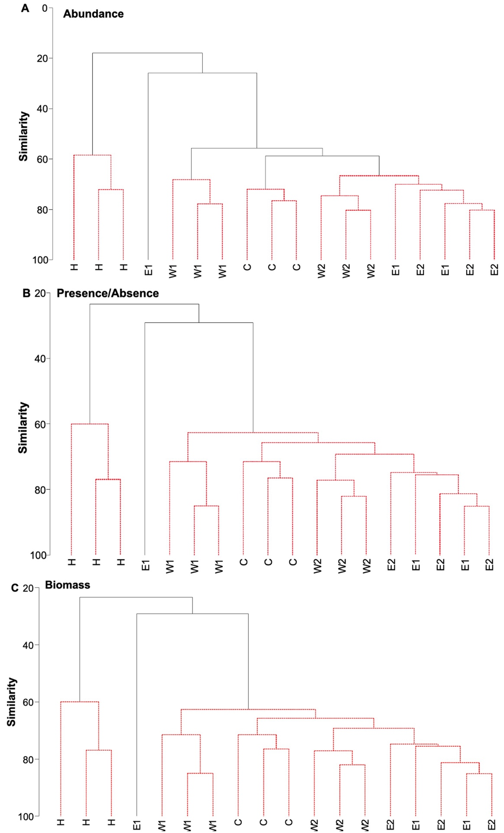

Figure S1. Hierarchical clustering with SIMPROF analysis of macrofaunal composition and abundance data using A) abundance matrix based on Bray-Curtis resemblance (n=18), B) presence/absence matrix based on Sorensen resemblance (n=18), and biomass based on Bray-Curtis resemblance (n=18) for sites in Placentia Bay, Newfoundland, Canada (2020). Significant groups identified by SIMPROF at the 1% significance level (P=0.01) shown in red.

