Supplementary information
Table SI1. Comparison of the physicochemical properties of the biochar derived of digestate (BDD) with the parameters requested by the EBC and IBI standards
Parameter | Units | BDD | EBC/IBI requirement
pH | - | 10.83 ± 0.01 | Required declaration/Required declaration
Electrical conductivity | µS cm⁻¹ | 1330 ± 3 | Required declaration/Required declaration
Total nitrogen | % w/w | 1.87 ± 0.04 | Required declaration/Required declaration
Total carbon | % w/w | 22.8 ± 0.3 | EBC requires organic C (Corg) and H/Corg/IBI requires organic C
Phosphorus (P) | mg kg⁻¹ | 134 ± 13 | Declared as nutrient element/Optional (Category C)
Potassium (K) | mg kg⁻¹ | 153 ± 15 | Declared as nutrient element/Optional (Category C)
Sodium (Na) | mg kg⁻¹ | 48 ± 5 | Not specifically required; indirectly relevant to salt content/Not specifically required
Surface area | m² g⁻¹ | 3.2± 0.2 | Optional (Category C)
Pore volume | cm³ g⁻¹ | 0.018± 0.002 | Not specifically required
Pyrolysis yield | % | 53.1± 0.4 | Feedstock-dependent
EBC: European Biochar Certificate; IBI: International Biochar Initiative.
European Biochar Foundation (EBC). (2022). European Biochar Certificate. Guidelines for a sustainable production of biochar. European Biochar Foundation (EBC), Arbaz, Switzerland. https://www.european-biochar.org
International Biochar Initiative (IBI). (2015). Standardized Product Definition and Product Testing Guidelines for Biochar That Is Used in Soil. International Biochar Initiative. https://biochar-international.org

Table SI2. Replicate dispersion and robust metrics for batch assays (n=3)
 | M2% | M1.5% | M1% | M0.5% | M0.25% | M0%
Average CV% | 1.63 | 1.94 | 2.17 | 1.35 | 1.72 | 1.76
Median CV% | 0.92 | 0.89 | 0.65 | 0.77 | 0.87 | 1.05
CV% ≤ 5 (%) | 88.9 | 88.9 | 88.9 | 88.9 | 88.9 | 100.0

Table SI3. Standardized effect sizes vs. control for key indicators (n=3)
Variable | Dose | Mean treat | SD treat | Mean control | SD control | Change vs. control (%)
OMT (%) | 2% | 61.05 | 0.43 | 39.66 | 0.37 | 53.94
OMT (%) | 1.5% | 60.30 | 0.50 | 39.66 | 0.37 | 52.04
OMT (%) | 1% | 61.60 | 0.40 | 39.66 | 0.37 | 55.32
OMT (%) | 0.5% | 52.43 | 0.50 | 39.66 | 0.37 | 32.20
OMT (%) | 0.25% | 48.26 | 0.42 | 39.66 | 0.37 | 21.68
Biogas (mL CNPyT) | 2% | 1050.00 | 6.30 | 619.28 | 12.00 | 69.56
Biogas (mL CNPyT) | 1.5% | 1005.00 | 7.00 | 619.28 | 12.00 | 62.30
Biogas (mL CNPyT) | 1% | 992.43 | 5.00 | 619.28 | 12.00 | 60.25
Biogas (mL CNPyT) | 0.5% | 719.96 | 4.00 | 619.28 | 12.00 | 16.26
Biogas (mL CNPyT) | 0.25% | 688.64 | 6.00 | 619.28 | 12.00 | 11.20
Methane (mL CH₄ CNPyT) | 2% | 585.90 | 4.20 | 322.03 | 14.00 | 81.94
Methane (mL CH₄ CNPyT) | 1.5% | 562.80 | 5.00 | 322.03 | 14.00 | 74.77
Methane (mL CH₄ CNPyT) | 1% | 565.69 | 5.00 | 322.03 | 14.00 | 75.67
Methane (mL CH₄ CNPyT) | 0.5% | 388.78 | 3.00 | 322.03 | 14.00 | 20.73
Methane (mL CH₄ CNPyT) | 0.25% | 358.09 | 4.00 | 322.03 | 14.00 | 11.20
BPP (mL·gVS⁻¹) | 2% | 435.83 | 4.00 | 257.04 | 1.20 | 69.56
BPP (mL·gVS⁻¹) | 1.5% | 417.15 | 3.50 | 257.04 | 1.20 | 62.29
BPP (mL·gVS⁻¹) | 1% | 411.93 | 0.50 | 257.04 | 1.20 | 60.26
BPP (mL·gVS⁻¹) | 0.5% | 298.84 | 0.40 | 257.04 | 1.20 | 16.26
BPP (mL·gVS⁻¹) | 0.25% | 285.84 | 0.60 | 257.04 | 11.20 | 0
MPP (mL·gVS⁻¹) | 2% | 243.19 | 3.40 | 133.66 | 1.40 | 81.95
MPP (mL·gVS⁻¹) | 1.5% | 233.60 | 4.00 | 133.66 | 1.40 | 74.77
MPP (mL·gVS⁻¹) | 1% | 234.80 | 0.50 | 133.66 | 1.40 | 75.67
MPP (mL·gVS⁻¹) | 0.5% | 161.37 | 0.30 | 133.66 | 1.40 | 20.73
MPP (mL·gVS⁻¹) | 0.25% | 148.64 | 0.40 | 133.66 | 1.40 | 11.20
CH₄ (%) | 2% | 55.80 | 0.45 | 52.00 | 0.34 | 7.31
CH₄ (%) | 1.5% | 56.00 | 0.50 | 52.00 | 0.34 | 7.69
CH₄ (%) | 1% | 57.00 | 0.40 | 52.00 | 0.34 | 9.62
CH₄ (%) | 0.5% | 54.00 | 0.30 | 52.00 | 0.34 | 3.85
CH₄ (%) | 0.25% | 52.00 | 0.24 | 52.00 | 0.34 | 0.00
VFA (g L⁻¹) | 2% | 3.43 | 0.07 | 8.89 | 0.10 | -61.42
VFA (g L⁻¹) | 1.5% | 3.54 | 0.09 | 8.89 | 0.10 | -60.18
VFA (g L⁻¹) | 1% | 3.38 | 0.10 | 8.89 | 0.10 | -61.98
VFA (g L⁻¹) | 0.5% | 5.32 | 0.05 | 8.89 | 0.10 | -40.16
VFA (g L⁻¹) | 0.25% | 6.12 | 0.20 | 8.89 | 0.10 | -31.16
TAN (g L⁻¹) | 2% | 3.86 | 0.24 | 6.54 | 0.30 | -40.98
TAN (g L⁻¹) | 1.5% | 3.98 | 0.32 | 6.54 | 0.30 | -39.14
TAN (g L⁻¹) | 1% | 3.95 | 0.51 | 6.54 | 0.30 | -39.60
TAN (g L⁻¹) | 0.5% | 5.49 | 0.40 | 6.54 | 0.30 | -16.06
TAN (g L⁻¹) | 0.25% | 6.20 | 0.50 | 6.54 | 0.30 | -5.20
H₂S (ppm) | 2% | 49.00 | 0.60 | 118.00 | 0.90 | -58.47
H₂S (ppm) | 1.5% | 50.00 | 0.50 | 118.00 | 0.90 | -57.63
H₂S (ppm) | 1% | 48.0 | 0.3 | 118.0 | 0.9 | -59.32
H₂S (ppm) | 0.5% | 75.0 | 0.6 | 118.0 | 0.9 | -36.44
H₂S (ppm) | 0.25% | 98.0 | 0.3 | 118.0 | 0.9 | -16.95

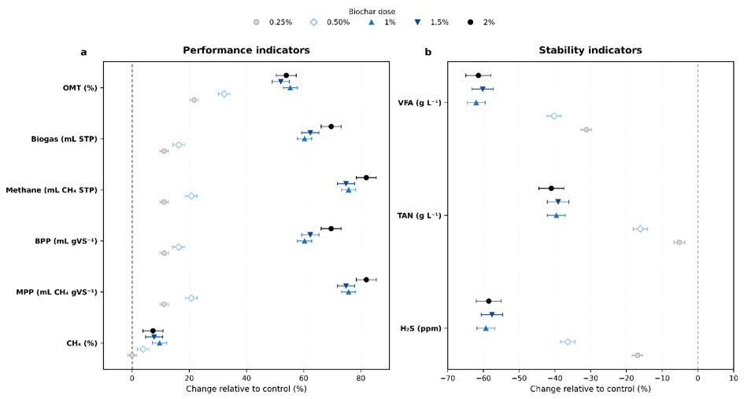
SI1
Figure SI1. Dose-dependent effect sizes of biochar addition relative to the control. Grouped forest plots show the percentage change of each variable at increasing biochar doses (0.25%, 0.5%, 1%, 1.5%, and 2%). The left panel (b) presents performance indicators (biogas, methane, and OMT), while the right panel (a) shows stability indicators (VFA, TAN, and H₂S). Points represent mean effect sizes and horizontal lines indicate approximate 95% confidence intervals. Colors correspond to biochar dose. The vertical dashed line at zero indicates no change relative to the control.

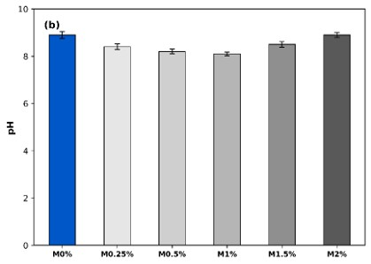
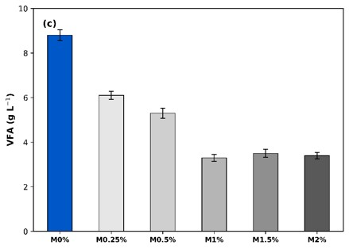
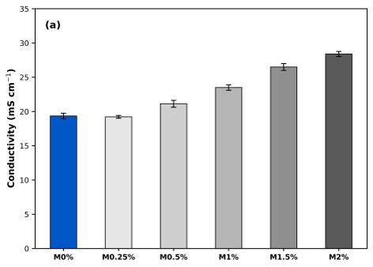
SI2

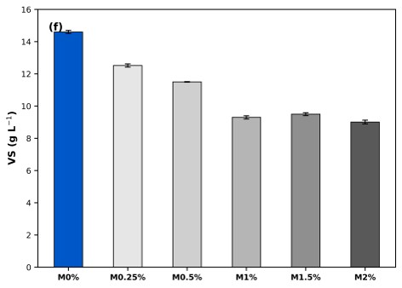
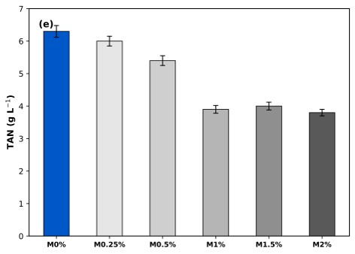
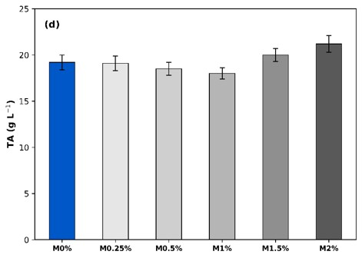

Figure SI2. Physicochemical parameters measured at the start of the batch assays (Initial) and after 45 days for each treatment (M2%, M1.5%, M1%, M0.5%, M0.25%, and Control): (a) conductivity, (b) pH, (c) volatile fatty acids (VFA), (d) total alkalinity (TA), (e) total ammoniacal nitrogen (TAN), (f) volatile solids (VS). Bars represent means ± SE (n=3).

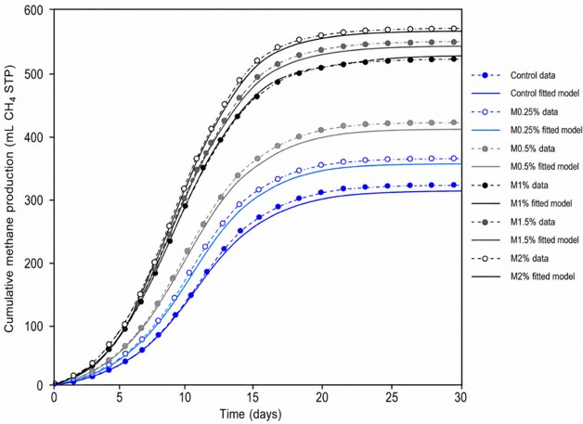
SI3

Figure SI3. Cumulative methane production (mL STP) with experimental data and fitted curves using the modified Gompertz model for control, M0.25%, M0.5%, M1% M1.5% and M2% treatments. All fits showed high accuracy (R² > 0.98).

Table SI4. Parameters of the model fitted to cumulative methane production
 | Treatment | P_{max} (mL STP) | R_{max} (mL d⁻¹) | λ (days) | R²
Methane | Control | 320 | 30.0 | 2.1 | 0.987
Methane | M0.25% | 360 | 32.0 | 1.8 | 0.991
Methane | M0.5% | 390 | 34.0 | 1.5 | 0.994
Methane | M1% | 580 | 40.0 | 1.2 | 0.996
Methane | M1.5% | 590 | 39.5 | 1.3 | 0.998
Methane | M2% | 600 | 39.5 | 1.3 | 0.996

