Supplemental tables
Supplemental table 1: Elemental composition of tap water used in the greenhouse fertility trial. Concentrations are reported in micrograms per milliliter (µg/ml).
AL | B | Ca | Cu | Fe | K | Mg | Mn | Mo | Na | P | S | Zn
0.018 | 0.046 | 27.29 | 0.004 | 0.008 | 1.42 | 10.36 | 0.001 | 0.001 | 26.56 | <0.003 | 17.18 | 0.013

Supplemental table 2: Electrical conductivity (EC; mS cm⁻¹), pH, and solution temperature (°C) of irrigation solution and leachate runoff across sampling dates and fertility regimes.
Trial | Date | NPK program | EC (mS cm⁻¹) | pH | Temp (°C) | Run-off EC (mS cm⁻¹) | Run-off pH
1 | 3-17-2025 | High | 3.08 | 6.2525 | 16.845 | 2.065 | 6.27
1 | 3-17-2025 | Sufficiency | 2.0275 | 6.6925 | 16.5625 | 1.26 | 6.55
1 | 3-17-2025 | Unfertilized | 0.51 | 7.71 | 17.1075 | 0.45 | 7.38
1 | 4-21-2026 | High | 2.8875 | 6.4375 | 18.375 | 1.95 | 6.35
1 | 4-21-2026 | Sufficiency | 1.755 | 6.56 | 17.95 | 1.015 | 6.42
1 | 4-21-2026 | Unfertilized | 0.4825 | 7.4575 | 18.2325 | 0.4 | 7.86
1 | 5-16-2026 | High | 3.125 | 6.155 | 16.875 | 1.83 | 6.17
1 | 5-16-2026 | Sufficiency | 1.775 | 6.625 | 15.975 | 0.9075 | 6.58
1 | 5-16-2026 | Unfertilized | 0.49 | 7.905 | 15.875 | 0.44 | 7.68
1 | 6-12-2026 | High | 2.925 | 6.5325 | 19.025 | 1.6125 | 6.31
1 | 6-12-2026 | Sufficiency | 1.7075 | 6.6425 | 18 | 0.8475 | 6.2
1 | 6-12-2026 | Unfertilized | 0.55 | 7.4125 | 18.3825 | 0.44 | 7.22
2 | 8-16-2026 | High | 2.6425 | 6.47 | 22.35 | 1.44 | 6.31
2 | 8-16-2026 | Sufficiency | 1.74 | 6.6875 | 22.85 | 0.82 | 6.65
2 | 8-16-2026 | Unfertilized | 0.465 | 8.1275 | 23.675 | 0.4425 | 7.21
2 | 9-22-2026 | High | 3.015 | 6.3875 | 23 | 1.57 | 6.33
2 | 9-22-2026 | Sufficiency | 2.135 | 6.6 | 22.375 | 1.175 | 6.69
2 | 9-22-2026 | Unfertilized | 0.485 | 8.0925 | 21.25 | 0.4475 | 7.81
2 | 10-17-2026 | High | 2.79 | 6.335 | 20.95 | 1.6775 | 6.2
2 | 10-17-2026 | Sufficiency | 1.7425 | 6.5925 | 20.9 | 0.87 | 6.6
2 | 10-17-2026 | Unfertilized | 0.6025 | 7.055 | 22.625 | 0.5225 | 7.86
2 | 11-12-2026 | High | 2.8775 | 6.52 | 18.675 | 1.6675 | 6.25
2 | 11-12-2026 | Sufficiency | 1.85 | 6.74 | 19.175 | 0.925 | 6.51
2 | 11-12-2026 | Unfertilized | 0.465 | 7.995 | 21.075 | 0.465 | 7.43

Supplemental table 3: Leaf tissue nutrient concentrations (nitrogen, phosphorus, and potassium) of pepper plants under high, sufficient, and unfertilized fertility regimes across trials.
Trial # | NPK program | Nitrogen (%) | Phosphorus (%) | Potassium (%)
1 | High | 4.59 | 0.36 | 10.69
1 | High | 3.83 | 0.31 | 7.09
1 | High | 3.69 | 0.27 | 7.44
1 | High | 2.9 | 0.23 | 5.69
1 | High | 4.47 | 0.32 | 10.18
1 | High | 4.97 | 0.31 | 10.2
1 | High | 4.23 | 0.29 | 10.12
1 | High | 3.94 | 0.25 | 7.52
1 | High | 4.69 | 0.3 | 9.55
1 | High | 4.45 | 0.26 | 9.08
1 | High | 3.93 | 0.27 | 7.42
1 | High | 4.74 | 0.33 | 10.83
1 | Sufficiency | 4.84 | 0.39 | 8.79
1 | Sufficiency | 4.36 | 0.3 | 6.58
1 | Sufficiency | 3.92 | 0.34 | 7.21
1 | Sufficiency | 3.68 | 0.32 | 6.89
1 | Sufficiency | 2.64 | 0.27 | 5.47
1 | Sufficiency | 3 | 0.23 | 4.8
1 | Sufficiency | 3.25 | 0.25 | 5.49
1 | Sufficiency | 3.4 | 0.26 | 7.12
1 | Sufficiency | 3.48 | 0.31 | 7.3
1 | Sufficiency | 4.56 | 0.32 | 8.2
1 | Sufficiency | 3.61 | 0.3 | 7.22
1 | Sufficiency | 3.96 | 0.33 | 6.68
1 | Unfertilized | 1.42 | 0.78 | 5.63
1 | Unfertilized | 1.55 | 0.78 | 6.28
1 | Unfertilized | 1.72 | 0.73 | 6.17
1 | Unfertilized | 1.65 | 0.75 | 5.91
1 | Unfertilized | 1.26 | 0.61 | 4.27
1 | Unfertilized | 1.26 | 0.63 | 5.57
1 | Unfertilized | 1.37 | 0.67 | 5.66
1 | Unfertilized | 1.45 | 0.68 | 4.85
1 | Unfertilized | 1.46 | 0.83 | 6.22
1 | Unfertilized | 1.44 | 0.74 | 6.37
1 | Unfertilized | 1.61 | 0.75 | 6.62
1 | Unfertilized | 1.39 | 0.59 | 5.83
2 | High | 4.95 | 0.45 | 7.86
2 | High | 5.48 | 0.51 | 7.22
2 | High | 5.46 | 0.42 | 7.74
2 | High | 4.7 | 0.37 | 7.03
2 | High | 5.29 | 0.39 | 7.87
2 | High | 4.72 | 0.36 | 7.52
2 | High | 5.28 | 0.37 | 7.17
2 | High | 4.82 | 0.37 | 7.08
2 | High | 4.75 | 0.35 | 6.8
2 | High | 4.61 | 0.34 | 6.34
2 | High | 4.74 | 0.39 | 7.11
2 | High | 5.09 | 0.35 | 6.93
2 | High | 4.46 | 0.43 | 6.18
2 | Sufficiency | 4.71 | 0.41 | 5.86
2 | Sufficiency | 4.64 | 0.48 | 6.09
2 | Sufficiency | 4.55 | 0.47 | 5.57
2 | Sufficiency | 4.54 | 0.52 | 5.95
2 | Sufficiency | 4.16 | 0.48 | 5.81
2 | Sufficiency | 4.25 | 0.46 | 5.54
2 | Sufficiency | 4.52 | 0.4 | 5.54
2 | Sufficiency | 4.04 | 0.35 | 3.61
2 | Sufficiency | 4.16 | 0.47 | 5.53
2 | Sufficiency | 4.37 | 0.41 | 4.74
2 | Sufficiency | 4.35 | 0.48 | 5.6
2 | Sufficiency | 1.47 | 0.41 | 2.88
2 | Unfertilized | 1.41 | 0.48 | 3.3
2 | Unfertilized | 1.25 | 0.4 | 2.45
2 | Unfertilized | 1.17 | 0.38 | 2.6
2 | Unfertilized | 1.16 | 0.33 | 2.44
2 | Unfertilized | 1.13 | 0.32 | 2.3
2 | Unfertilized | 1.19 | 0.31 | 2.59
2 | Unfertilized | 1.13 | 0.36 | 2.4
2 | Unfertilized | 1.36 | 0.41 | 2.84
2 | Unfertilized | 1.26 | 0.37 | 2.26
2 | Unfertilized | 1.07 | 0.3 | 2.3
2 | Unfertilized | 1.19 | 0.39 | 2.64

Supplemental figures:
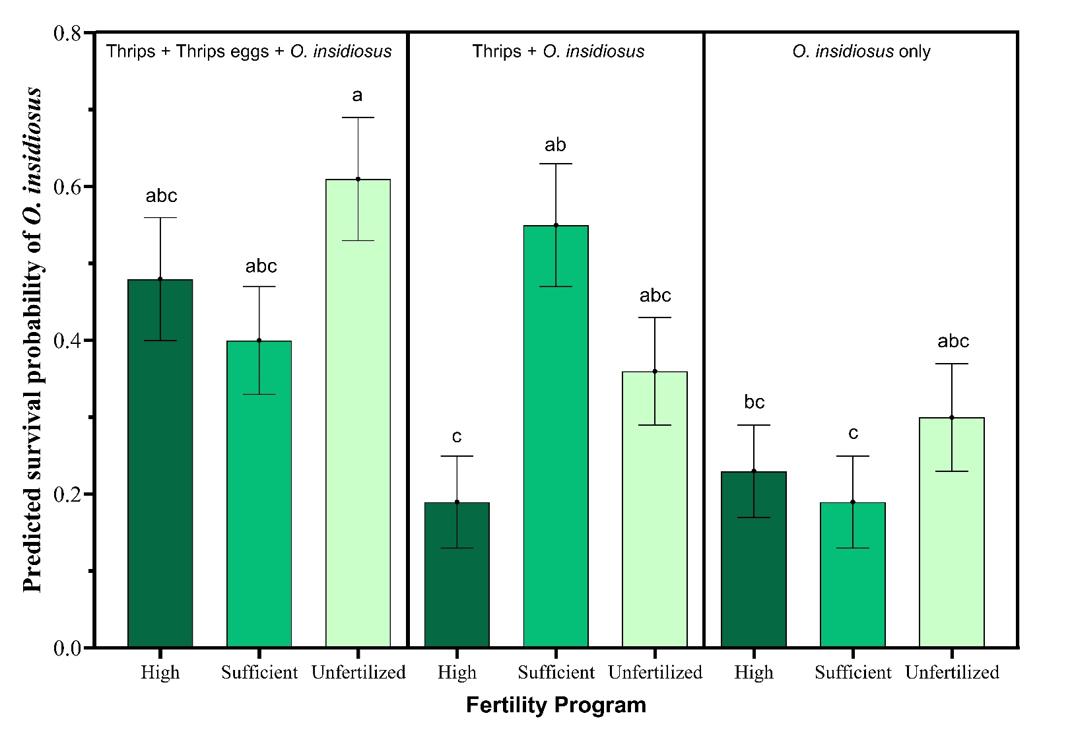
Supplemental figure 1: Effects of the interaction of fertility regime and prey availability (χ² = 12.57 (13.02), df=4, p = 0.013 (0.011)) on survival of O. insidiosus in laboratory bioassays. Points represent predicted survival probability (mean ± SE) of O. insidiosus and back transformed from the logit scale. Survival was modeled as the number of live individuals out of three predators initially introduced per arena. Values are averaged across sampling times. Means are averaged across sampling weeks. Means that share the same letter are not significantly different (P > 0.05; Lsmeans).

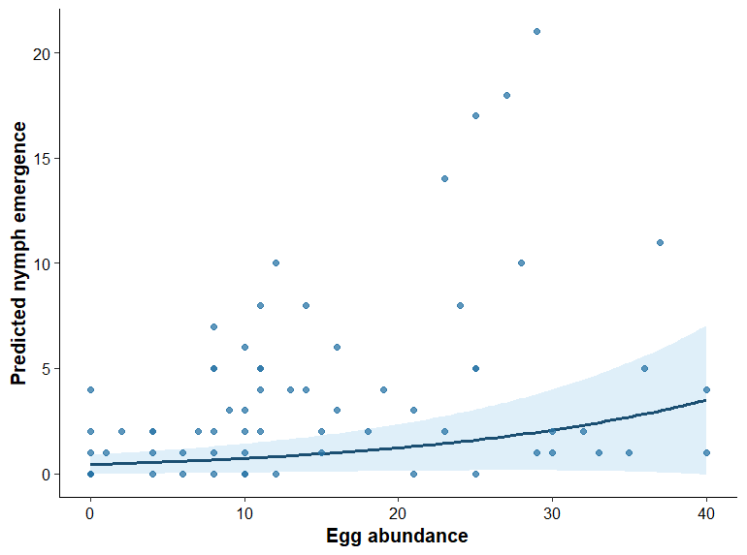
Supplemental figure 2: Relationship between early oviposition and subsequent nymph emergence of O. insidiosus in laboratory bioassays. Points represent observed values of late nymph abundance plotted against early egg abundance. The solid line indicates model-predicted nymph abundance from a negative binomial generalized linear mixed model, and the shaded area represents the 95% confidence interval. Predictions are averaged across fertility regimes and prey treatments. Nymph emergence increased significantly with early egg abundance (χ² = 17.33, df = 1, P < 0.001).

