Supporting Information
A CDs-doped europium-MOF for ratiometric fluorescence and colorimetric dual-mode sensing of flumequine
Jintao Yi^{a,} *, Anqi Liª, Xianqin Hanª, Nani Fuª, Ziluo Chenª, Tingting Yangª, Zihan Zhouª, Min Wangª, Yashan Chenª, Jun Xueª, Xiaoming Ma^{a, b}* and Yiping Qian^{a,} *

^{a.}Key Laboratory of Synthetic Pharmaceutical Chemistry of Jiangxi Province, Gannan Normal University, Ganzhou 341000, P. R. China
^{b.}Key Laboratory of Quality and Safety for Agricultural Products, Jiangxi Academy of Agricultural Sciences, Nanchang 330200, P. R. China

Corresponding Author
E-mail: yistarthappy@163.com; Tel.: +86-797-8393536; Fax: (+86)797-8393536.

The supporting materials include:
Figures S1 Page S3
Figures S2 Page S4
Figures S3 Page S5
Figures S4 Page S6
Figures S5 Page S7
Figures S6 Page S8
Figures S7 Page S9
Figures S8 Page S10
Figures S9 Page S11
Figures S10 Page S12
Figures S11 Page S13
Figures S12 Page S14
Table S1 Page S15

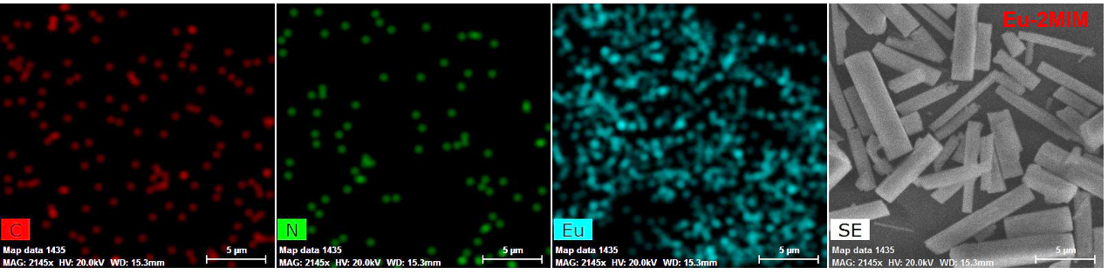
Fig. S1 The elemental mapping images of Eu-2MIM. Scale bar, 5 μm.

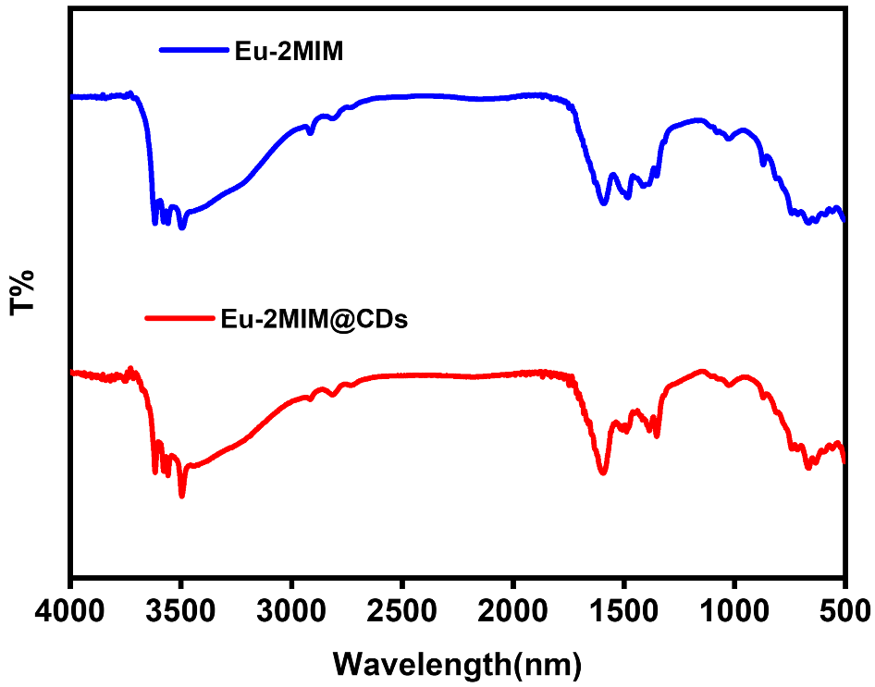
Fig. S2 The Fourier transform infrared spectra of Eu-2MIM and Eu-2MIM@CDs.

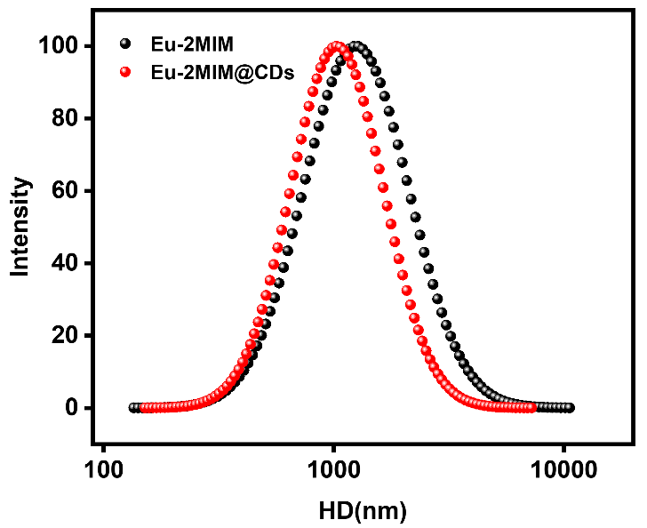
Fig. S3 The dynamic light scattering analysis of Eu-2MIM and Eu-2MIM@CDs.

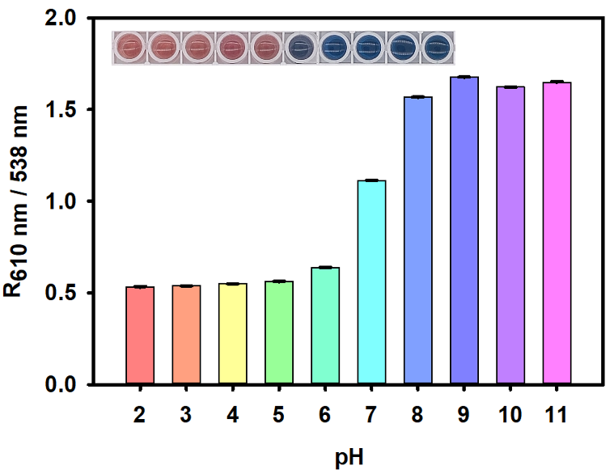
Fig. S4 Effect of pH on the absorbance ratio (R_{610 nm/538 nm}) in the EBT colorimetric system. Inset: visual color changes at different pH values. Error bars indicated standard deviations of three replicate measurements.

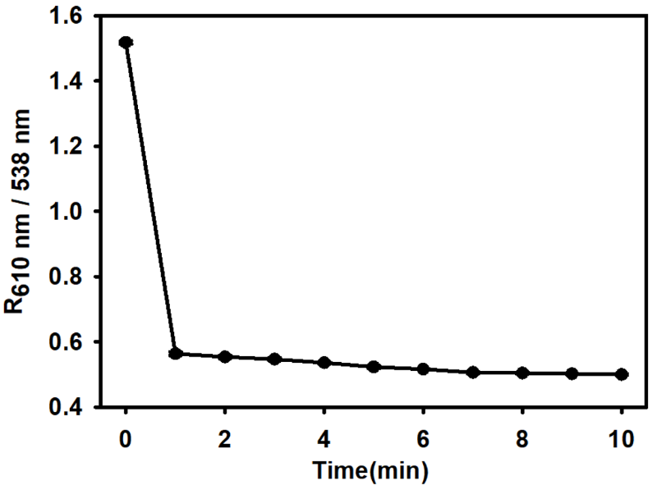
Fig. S5 Time-dependent absorbance ratio (R_{610 nm/538 nm}) of the Eu-2MIM@CDs and EBT colorimetric system. Error bars indicated standard deviations of three replicate measurements.

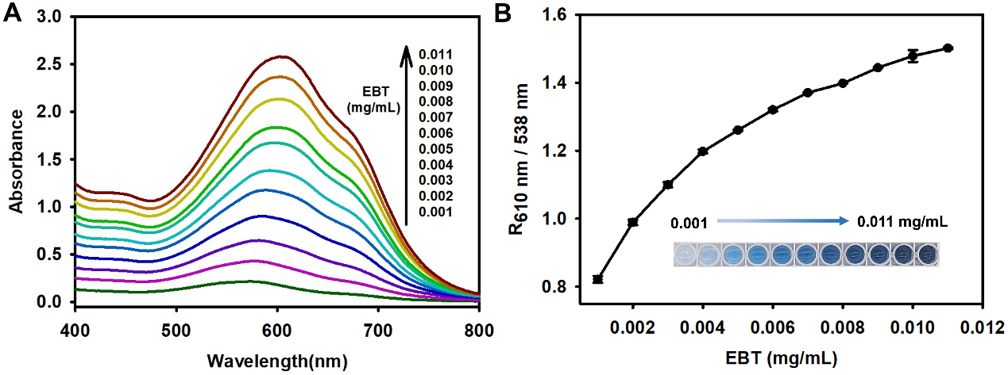
Fig. S6 Optimization of EBT concentration for the colorimetric detection of FLU. (A) The UV-vis absorption spectra with different EBT concentrations. (B) Relationship between the absorbance ratio R_{610 nm/538 nm} and EBT concentrations, where R_{610 nm/538 nm} represented the absorbance value at 610 nm versus that at 538 nm. Inset: the colorimetric color images. Error bars indicated standard deviations of three replicate measurements.

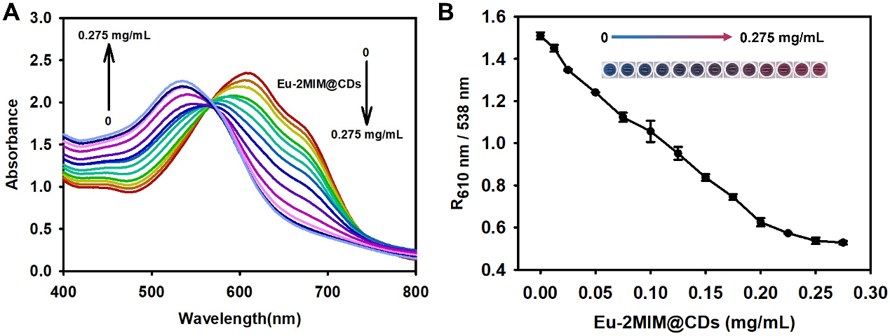
Fig. S7 Optimization of Eu-2MIM@CDs concentration for the colorimetric detection of FLU. (A) The UV-vis absorption spectra with different Eu-2MIM@CDs concentrations. (B) Relationship between the absorbance ratio R_{610 nm/538 nm} and Eu-2MIM@CDs concentrations, where R_{610 nm/538 nm} represented the absorbance value at 610 nm versus that at 538 nm. Inset: the colorimetric color images. Error bars indicated standard deviations of three replicate measurements.

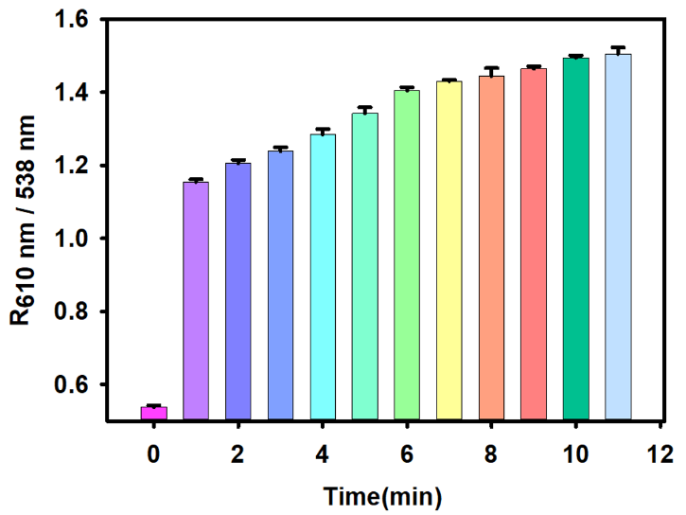
Fig. S8 Time-dependent absorbance ratio (R_{610 nm/538 nm}) for the colorimetric detection of FLU. Error bars indicated standard deviations of three replicate measurements.

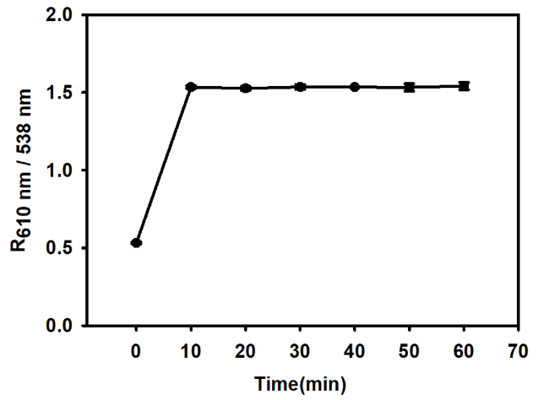
Fig. S9 The stability of Eu-2MIM@CDs for FLU colorimetric detection. Error bars indicated standard deviations of three replicate measurements.

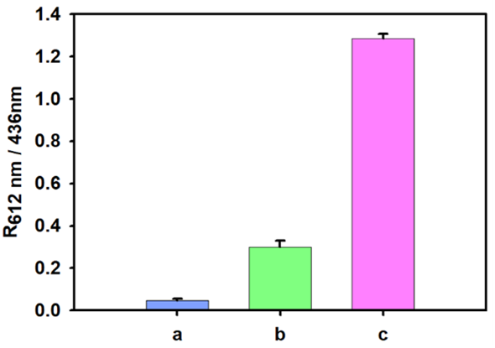
Fig. S10 The fluorescence intensity ratio R_{612 nm/436 nm} of (a) Eu-2MIM@CDs, (b) FLU, (c) Eu-2MIM@CDs in the presence of FLU. Error bars indicated standard deviations of three replicate measurements.

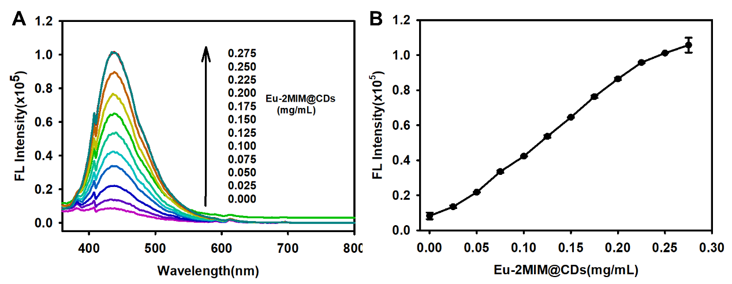
Fig. S11 Optimization of Eu-2MIM@CDs concentration for the fluorescence detection of FLU. (A) The fluorescence spectra with different Eu-2MIM@CDs concentrations. (B) Relationship between the fluorescence peak at 436 nm and Eu-2MIM@CDs concentrations. Error bars represented standard deviations from three replicate measurements.

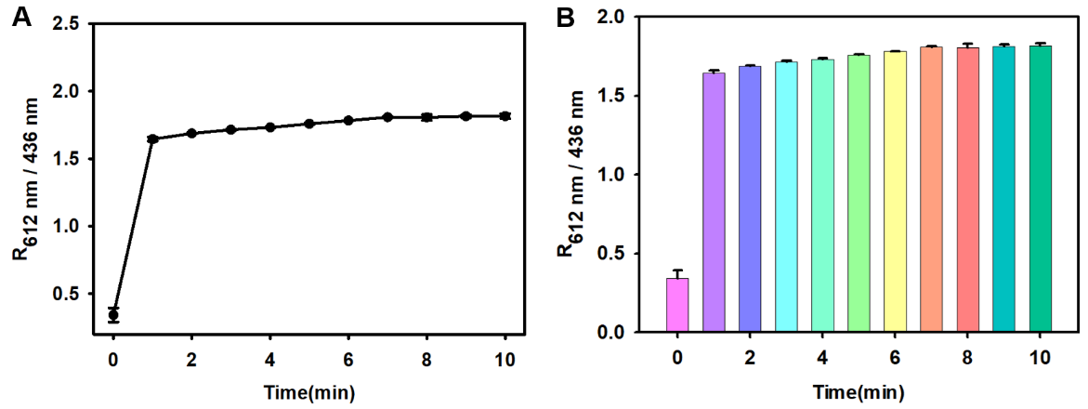
Fig. S12 Time-dependent ratio (R_{612 nm/436 nm}) for the fluorescence detection of FLU. Error bars indicated standard deviations of three replicate measurements.

Table S1 A comparison of this proposed dual-mode Eu-2MIM@CDs sensors with different methods for FLU detection.
Detection mode | Materials | Linear range for FLU (μM) | Detection limit for FLU (μM) | Reference
Colorimetric | AuNP | 0.007-0.957 | 0.015 | 23
 | AuNF-LFIS | 0.001-0.383 | 0.006 | 23
 | Eu@COF | 0.1-100 | 0.1 | 24
 | Polypyrrole | 0-500 | 1 | 25
 | Eu-2MIM@CDs | 0.01-2.5 | 0.0033 | This work
Fluorometric | COFs | 0-30 | 0.041 | 26
 | Cu-atda | 5-50 | 0.048 | 27
 | Trp@ZIF-8/Tb³⁺ | 0.03-1.53 | 0.018 | 28
 | MIP | 0.02-2.0 | 0.0025 | 29
 | Eu-2MIM@CDs | 0.005-2.0 | 0.0017 | This work

