Supplementary Table 1 The prevalence of serological HBV markers in general population and DLBCL patients in our cohort.
 | General population (%) | DLBCL patients (%) | P value
HBsAg | 7.2 | 9.5 | 0.226
HBsAb | 50.1 | 52.1 | 0.581
HBcAb | 34.1 | 51.6 | <0.001
Numbers in bold are statistically significant.

Note: The sample size (81775 cases) and source of the serology data for the healthy population were clearly stated in the epidemiological report. (Liang X et al. (2009) Epidemiological serosurvey of hepatitis B in China--declining HBV prevalence due to hepatitis B vaccination Vaccine 27:6550-6557 doi:10.1016/j.vaccine.2009.08.048)

Supplementary Table 2 The correlation between molecular expression in immunohistochemistry (IHC) and HBV antibody among DLBCL patients.

- The expression of CD21 and CD30 in HBsAb negative and positive group
IHC | HBsAb negative  n (%) | HBsAb positive  n (%) | P value
CD21
Positive | 12(32.4%) | 21(53.8%) | 0.06
Negative | 25(67.6%) | 18(46.2%)
CD30
Positive | 3(10.0%) | 8(30.8%) | 0.051
Negative | 27(90.0%) | 18(69.2%)

(b) The expression of BCL2 in HBeAb negative and positive group
IHC | HBeAb negative  n (%) | HBeAb positive  n (%) | P value
BCL2
Positive | 47(67.1%) | 15(93.7%) | 0.067
Negative | 23(32.9%) | 1(6.3%)

(c) The expression of MYC in HBcAb negative and positive group
IHC | HBcAb negative  n (%) | HBcAb positive  n (%) | P value
MYC
Positive | 21(84.0%) | 11(55.0%) | 0.033
Negative | 4(16.0%) | 9(45.0%)
Numbers in bold are statistically significant.

(d) The expression of BCL2 and MYC based on HBsAb and HBcAb status
IHC | HBsAb- or HBcAb-  n (%) | HBsAb+ and HBcAb+ n (%) | P value
BCL2
Positive | 34(64.2%) | 28(45.2%) | 0.037
Negative | 19(35.8%) | 34(54.8%)
MYC
Positive | 22(84.6%) | 10(52.6%) | 0.019
Negative | 4(15.4%) | 9(47.4%)
Numbers in bold are statistically significant.

Supplementary Table 3 Positive effect of Rituximab on clinical outcome in DLBCL patients
Factor | Therapeutic Efficacy |  |  |  | P value
Factor | CR | PR | SD | PD | P value
With Rituximab
Yes | 49 | 15 | 4 | 28 | 0.05
No | 3 | 2 | 0 | 7
Numbers in bold are statistically significant.
Abbreviations: CR, complete remission; PR, partial remission; SD, stable disease; PD, progressive disease.

Supplementary Table 4. Univariate and multivariate analysis of potential risk factors for Progression Free Survival
Factor | Univariable analysis |  |  |  | Multivariable analysis
Factor | HR | 95% CI of HR | P value |  | HR | 95% CI of HR | P value
Stage (Ⅲ/Ⅳ) | 3.86 | 1.38-10.81 | 0.01 |  | 3.35 | 1.16-9.67 | 0.025
Elevated WBC | 2.28 | 1.15-4.54 | 0.019
Reduced Lymphocyte | 1.83 | 1.0-3.35 | 0.05
Elevated β2-MG | 2.67 | 1.42-5.04 | 0.002
Reduced Albumin | 2.35 | 1.2-4.6 | 0.013
Elevated Globulin | 3.73 | 1.14-12.23 | 0.03
Prolonged PT | 3.96 | 1.83-8.57 | <0.001 |  | 3.14 | 1.43-6.89 | 0.004
HBsAb+ and HBcAb+ | 2.18 | 1.2-4.0 | 0.011
HBeAb positive | 2.39 | 1.29-4.44 | 0.006
HBcAb positive | 1.87 | 1.01-3.45 | 0.045
Bone marrow involvement | 2.38 | 1.18-4.81 | 0.015 |  | 2.1 | 1.01-4.34 | 0.046
Spleen involvement | 2.15 | 1.12-4.13 | 0.021
Bulky mass | 3.36 | 1.03-10.92 | 0.044
With Rituximab | 0.42 | 0.2-0.88 | 0.021 |  | 0.45 | 0.2-0.99 | 0.046
Numbers in bold are statistically significant.
Abbreviations: HR, hazard ratio; CI, confidence interval.

Supplementary Table 5. Univariate and multivariate analysis of potential risk factors for Overall Survival
Factor | Univariable analysis |  |  |  | Multivariable analysis
Factor | HR | 95% CI of HR | P value |  | HR | 95% CI of HR | P value
Stage (Ⅲ/Ⅳ) | 10.23 | 1.39-75.49 | 0.023
Elevated WBC | 2.95 | 1.29-6.79 | 0.011 |  | 6.29 | 1.85-21.34 | 0.003
Reduced Lymphocyte | 2.65 | 1.24-5.66 | 0.012
Elevated LDH | 2.42 | 1.11-5.28 | 0.027
Elevated CRP | 3.01 | 1.16-7.83 | 0.024
Elevated β2-MG | 3.69 | 1.65-8.22 | 0.001
Reduced Albumin | 2.86 | 1.2-6.79 | 0.017
Elevated BUN | 2.79 | 0.96-8.07 | 0.059
Prolonged PT | 5.90 | 2.31-15.04 | <0.001 |  | 3.85 | 1.13-13.08 | 0.031
NLR>2 | 3.27 | 1.13-9.51 | 0.029
HBsAb+ and HBcAb+ | 2.23 | 1.03-4.81 | 0.041
HBeAb positive | 2.71 | 1.26-5.79 | 0.01
With Rituximab | 0.31 | 0.13-0.78 | 0.013
Numbers in bold are statistically significant.
Abbreviations: HR, hazard ratio; CI, confidence interval.

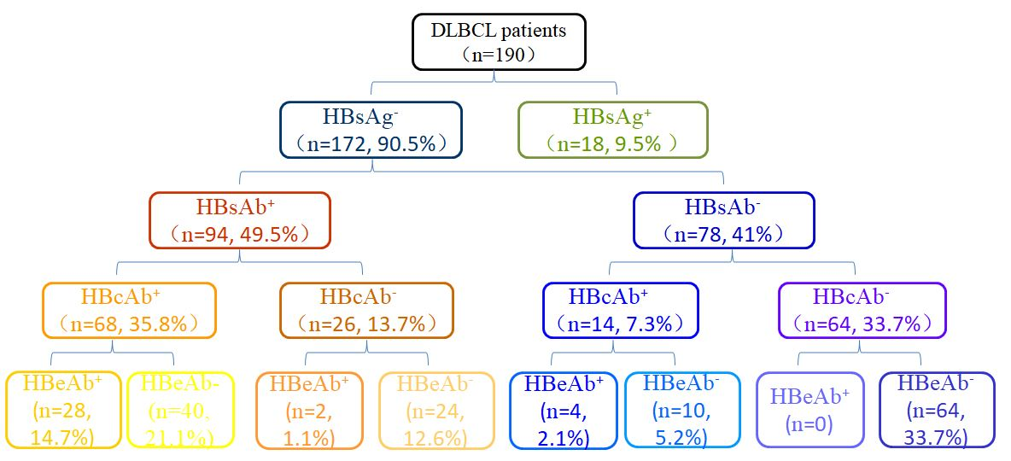
Supplementary Fig 1. Results of the HBV serum marker assays for 190 diffuse large B-cell lymphoma patients
Abbreviations: HBV, hepatitis B virus; HBsAg, hepatitis B surface antigen; HBsAb, hepatitis B surface antibody; HBcAb, hepatitis B core antibody; HBeAb, hepatitis B e antibody.

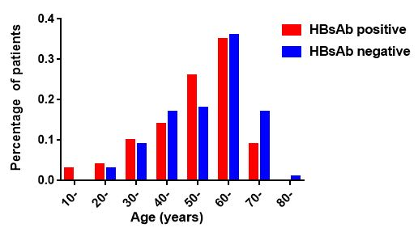
Supplementary Fig 2. Age distribution of diffuse large B-cell lymphoma patients in HBsAb-positive group and HBsAb-negative group

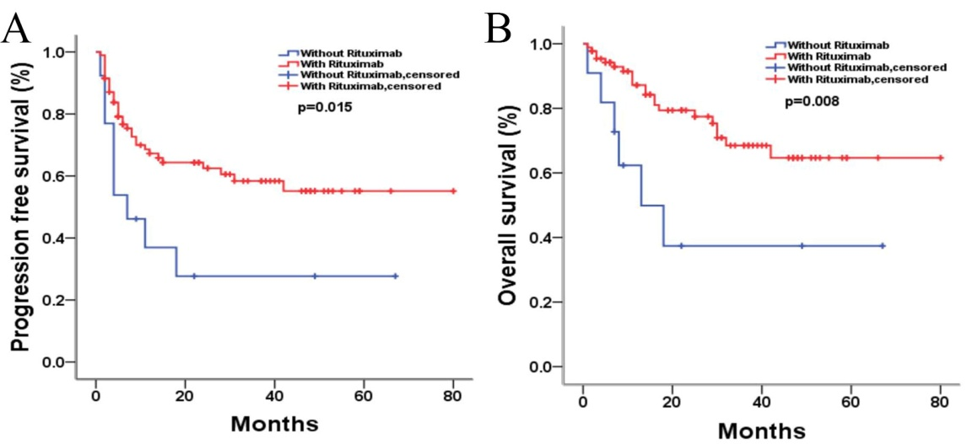
Supplementary Fig 3. Survival analysis according to therapy regimen in DLBCL patients: (A) Progression-free survival between Rituximab-containing group and Rituximab-free group. (B) Overall survival between Rituximab-containing group and Rituximab-free group.

