Additional file 1:
Figure 1. Organisational structure of Center for Medical Biochemistry University Clinical Center of Serbia
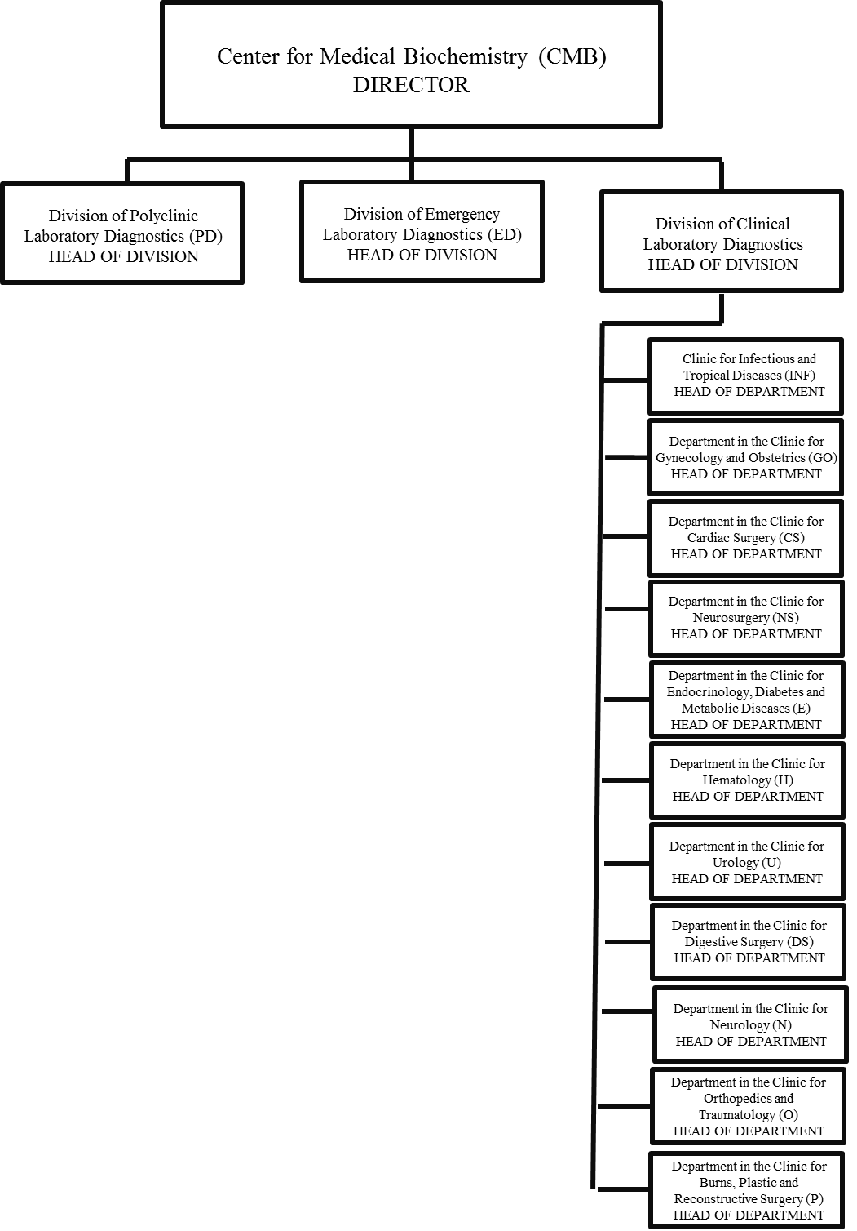
Division of Polyclinic Laboratory Diagnostics (1PD), Division of Emergency Laboratory Diagnostics (2ED), and Division of Clinical Laboratory Diagnostics in Department in the Clinic for Infectious and Tropical Diseases (3INF), Department in the Clinic for Gynaecology and Obstetrics (4GO), Department in the Clinic for Cardiac Surgery (5CS), Department in the Clinic for Neurosurgery (6NS), Department in the Clinic for Endocrinology, Diabetes and Metabolic Diseases (7E), Department in the Clinic for Haematology (8H), Department in the Clinic for Urology (9U), Department in the Clinic for Digestive Surgery (10DS) , Department in the Clinic for Neurology (11N), Department in the Clinic for Orthopaedics and Traumatology (12O) and Department in the Clinic for Burns, Plastic and Reconstructive Surgery (13P).

Additional file 2: WISN Steps

The first WISN step determines priority cadre for which staffing assessment is required.

The second WISN step calculates the available working time (AWT) that represents the total number of working hours available for each laboratory staff category in one year, considering authorised and unauthorised absences. using the formula: AWT=[A−(B+C+D+E)] * F where A is the number of possible working days in one year, B is the number of public holidays, C is the number of annual leaves (earned, casual leaves, relocation, death in the family, continuing medical education, entitled layoffs etc.), D is the number of days off due to sick leaves in one year, E is the number of days off due to other leaves in one year (training, personal leave, union activity), and F is the number of working hours in 1 one day. Half an hour of rest was considered for each staff category per shift. The number of annual working and nonworking days were obtained from the official government calendar for public sector institutions, and the information about the other absences from work from the laboratory staff’s record of personnel information.

The third WISN step define all the current workload components of laboratory cadre: core laboratory service activities (performed by all employees of a specific profile and regular statistics are collected on them), additional categorical activities (performed by all members of the cadre, but regular statistics are not collected on them), and additional individual activities (performed only by certain (not all) members of the cadre and regular statistics are not collected on them). The direct observation of the laboratory working processes and examination of standard operating procedures and documentation of laboratories were also used for that purposes.

The fourth WISN step sets activity standards. An activity standard is the time necessary for a well-trained, skilled, motivated worker to perform an activity to professional standards in the local circumstances. Two types of activity standards are defined: service standards as standards for core laboratory service activities and allowance standards as activity standards determined for support activities (category allowance standards (CAS)) and additional activities (individual allowance standards (IAS)). CAS (expressed in %) is calculated as the percentage of AWT spent on each support activity. IAS (expressed in time units) is calculated multiplying the number of laboratory staff members by the time that each additional activity requires in one year. Activity standards were established based on daily records and interview with laboratory staff.

The fifth WISN step establishes standard workloads that represents the amount of work that laboratory professional can do in one year within all core laboratory activities according to professional standards. Standard workload is calculated by dividing the AWT in one year by the unit time for the activity.
The sixth WISN step is calculating allowance factors. The category allowance factor (CAF) is a multiplier that is used to calculate the total number of full-time equivalent (FTE) medical biochemists/laboratory technicians, required for categorical additional activities CAF = 1 / [1 – (Total CAS / 100)]. The individual allowance factor (IAF) shows how many FTE laboratory staff (or what proportion of such a staff member’s time) are needed to cover additional activities of certain cadre members. IAF is calculated by dividing the total IAS by total AWT.
The seventh WISN step determines staff requirements based on WISN. The required number of FTE laboratory workers to accomplish core laboratory service, and additional activities of certain cadre members is calculated by equation WISN = (N * CAF) +IAF, where N is number of laboratory workers need to perform the core laboratory activities.

The eighth WISN step is analysing and interpreting WISN results. The WISN results could be analysed considering the difference between current and required staff number (difference shows surplus or shortage of laboratory workers) or the WISN ratio of the current and the required number of laboratory workers (WISN ratio of 1.0 is an indication that staffing and workload are in balance; WISN ratio greater than 1 is evidence of overstaffing in relation to the workload (low workload pressure); WISN ratio less than 1 indicates that the current staffing level is insufficient to overcome a certain workload (moderate or high pressure).

Additional File 3:
Figure 2. Flowcharts of laboratory activities
Figure 2A. Process of laboratory activities in laboratories without laboratory information system, Center for Medical Biochemistry University Clinical Center of Serbia, 2019
Figure 2B. Process of laboratory activities in laboratories with laboratory information system, Center for Medical Biochemistry University Clinical Center of Serbia, 2019
Figure 2C. Process of laboratory activities in laboratories with laboratory information system and preanalytics, Center for Medical Biochemistry University Clinical Center of Serbia, 2019
Figure 2D. Process of laboratory activities in laboratories with laboratory information system and total laboratory automation with storage, Center for Medical Biochemistry University Clinical Center of Serbia, 2019

Start
Finish

Sample reception and assignement of laboratory number

Laboratory technician at the reception counter

Entering data from the laboratory instruction into the laboratory protocol
Laboratory technician in the administrative part of the laboratory

Pre-analytical
phase

Samples triage
Laboratory technician in the sample triage section

Preanalytical sample preparation (putting samples on centrifuge, removing from centrifuge de-capping, aliquoting, assessment of interferences preparation, transfer to other analyzers or to other laboratories)
Laboratory technician in the sample triage section

Laboratory .technician in the analysing section

Loading tubes on analyzer

Analytical
phase
Non-standard fluids analysis

Laboratory technician in the analyzing section

Analyzing samples
Laboratory technician in the analyzing section

Removing samples from analyzer on analyzers
Sample tube capping and
putting tubes in the refrigerator

Laboratory technician in the analyzing section

Laboratory technician in the administrative part of the laboratory

Entering test results into the laboratory protocol and laboratory report

Post-analytical
phase

Verification and issuing of laboratory report
Responsible medical biochemist

Laboratory technician
Distribution of laboratory reports in the registers of CCS services

Laboratory technician

Disposal of expired samples

Figure 2A. Process of laboratory activities in laboratories without laboratory information system, Center for Medical Biochemistry University Clinical Center of Serbia, 2019
Start

Sample reception

Laboratory technician at the reception counter

Entering data from the laboratory instruction to laboratory information system, barcode print, sample labeling
barcode print
system

Laboratory technician in the administrative part of the laboratory

Pre-analytical
phase

Laboratory technician in the sample triage section
Samples triage

Preanalytical sample preparation
(putting samples on centrifuge, removing from centrifuge de-capping, aliquoting, assessment of interferences preparation, transfer to other analyzers or to other laboratories)
Laboratory technician in the sample triage section

Non-standard fluids analysis
Laboratory technician in the analyzing section

Loading tubes on analyzer

Laboratory technician in the analyzing section

Analytical
phase
Analyzing samples
on analyzers
Laboratory technician in the analyzing section

Removing samples from analyzer on analyzers
Sample tube recapping and
putting tubesin the refrigerator
Laboratory technician in the analyzing section

Responsible medical biochemist

Verification of results in laboratory
information system

Post-analytical
phase

Issuing of laboratory report

Responsible medical biochemist

Laboratory technician
Distribution of laboratory reports in the registers of CCS services

Laboratory technician

Disposal of expired samples
Finish

Figure 2B. Process of laboratory activities in laboratories with laboratory information system, Center for Medical Biochemistry University Clinical Center of Serbia, 2019
Start

Laboratory technician at the reception counter

Sample reception

Entering data from the laboratory instruction to laboratory information system, barcode print, sample labeling
barcode print
system

Laboratory technician in the administrative part of the laboratory
laboratory

Receiving samples from outpatients clinics, clinics that do not have a laboratory and other CMB laboratories

Pre-analytical
phase
Laboratory technician in the triage section “small” triage
“amall

Laboratory technician in the sample triage section
Samples triage

Samples decapping

Laboratory technician in the analysing section

Putting samples on pre-analytical system

Non-standard fluids analysis
Laboratory technician in the analysing section

Analytical
phase
Automatic centrifugation and analysis

Laboratory technician in the analysing section

Removing samples from analyzer
Laboratory technician in the analyzing section

Sample tube recapping and
putting tubes
in the refrigerator

Responsible medical biochemist

Verification of results in laboratory
information system

Post-analytical
phase
Responsible medical biochemist

Issuing of
laboratory report

Distribution of laboratory reports in the registers of CCS services

Laboratory technician
Laboratory technician

Disposal of expired samples

Finish

Figure 2C. Process of laboratory activities in laboratories with laboratory information system and preanalytics, Center for Medical Biochemistry University Clinical Center of Serbia, 2019

Start
Admission and registration of patients, barcode print

(unos podataka u LIS)
Sample reception (morning urine, 24h urine,feces, etc.)

Laboratory technician at the reception counter

Patient admission
and
bood sampling
samples labeling

Laboratory technician in the sampling booth
Pre-analytical
phase
Laboratory technician in the triage section “small” triage

Laboratory technician in the biological material reception section

Entering data from the laboratory instruction to laboratory information system, barcode print, sample labeling
barcode print
system

Receiving samples from outpatients clinics, clinics that do not have a laboratory and other CMB laboratories

Laboratory technician in the sample triage section

Samples
triage

Laboratory technician in the analysing section

Putting samples on pre-analytical system

Laboratory technician in the analyzing section

Non-standard fluids analysis Electrophoresis
Automatic centrifugation, de-capping, analysis, recapping, automatic archiving storage racks, automatic samples disposal.
Analytical
phase

Responsible medical biochemist

Verification of results in laboratory
information system

Post-analytical
phase
Responsible medical biochemist

Issuing of
laboratory report

Distribution of laboratory reports in the registers of CCS services

Laboratory technician

Laboratory technician

Disposal of expired samples
Finish

Figure 2D. Process of laboratory activities in laboratories with laboratory information system and total laboratory automation with storage, Center for Medical Biochemistry University Clinical Center of Serbia, 2019
Additional File 4: Category and individual allowance standards for medical biochemists/medical laboratory technicians, Center for Medical Biochemistry University Clinical Center of Serbia, 2019
Table 1A. Category allowance standards for medical biochemists, Center for Medical Biochemistry University Clinical Center of Serbia, 2019
Table 1B. Category allowance standards for medical laboratory technicians, Center for Medical Biochemistry University Clinical Center of Serbia, 2019
Table 2A Individual allowance standards for medical biochemists, Center for Medical Biochemistry University Clinical Center of Serbia, 2019

Table 2B. Individual allowance standards for medical laboratory technicians, Center for Medical Biochemistry University Clinical Center of Serbia, 2019

Table 1A. Category allowance standards (CAS) for medical biochemists, Center for Medical Biochemistry University Clinical Center of Serbia, 2019

Staff category: Medical biochemists
Workload  group | Workload  components | Category allowance standards (CAS)  (actual working time)
Support  activities | Workplace preparation (preparing analyzer for operation, reviewing calibration/QC analysis results) | 5 minutes per day
Support  activities | Internal communication/consultation (with physicians, nurses by phone and in person) | 30 minutes per day
Support  activities | Staff supervision meetings | 8 days per year
Support  activities | Continuing medical education | 9 days per year

Table 1B. Category allowance standards (CAS) for medical laboratory technicians, Center for Medical Biochemistry University Clinical Center of Serbia, 2019

Staff category: Medical laboratory technicians
Workload  group | Workload  components | Category allowance standards (CAS)  (actual working time)
Support  activities | Workplace preparation and maintenance (Analyzer maintenance, and preparing analyzer for operation - calibration/internal QC; environmental/refrigeration temperature monitoring, controlling and recording, maintaining a safe, tidy environment) | 50 minutes per day
Support  activities | Internal communication/consultation (with physicians, nurses by phone and in person) | 30 minutes per day
Support  activities | Staff supervision meetings | 8 days per year
Support  activities | Continuing medical education | 6 days per year

Table 2A Individual allowance standards (IAS) for medical biochemists, Center for Medical Biochemistry University Clinical Center of Serbia, 2019

Staff category: Medical biochemists
Workload  group | Workload  components | Individual additional standards (IAS)  per type of laboratory and number of FTE
Workload  group | Workload  components | n | PD lab | n | ED lab | n | Other labs
Additional  activities | Quality management system - commission (peer evaluations or assessments; drafting, revising and reading standard operating procedures; laboratory accreditation, participation in inter-laboratory comparisons (i.e., ILC) and/or external proficiency testing (i.e., PT) schemes) | 9  1 | 3 days per month  5 days per month | 9  2 | 3 days per month  4 days per month | 1  1 | 8 days per year  2 days per month
Additional  activities | Documentation preparation (analyzer operating instructions, methods validation, measurement uncertainty determination, writing notices) | 5 | 3 days per year | 5 | 3 days per year | 1 | 3 days per year
Additional  activities | Planning (education, UCCS integrated work plan, laboratory improvement  plan, and monitoring the implementation) | 4  2 | 2 days per year  6 days per year | 4 | 2 days per year | 1 | 2 days per year
Additional  activities | Procurement planning & Reporting (laboratory level supply & stock checking reagent and consumables) | 4  4 | 30 minutes per month  2 day per month | 4  4 | 30 minutes per month  2 day per month | 1  1 | 30 minutes per month  2 day per month
Additional  activities | Teaching/In-Service (students, professionals, on-the job education) | 9  1 | 30 minutes per day  4 days/year | 9  1 | 30 minutes per day  4 days/year | 1 (2) | 30 minutes per day
Additional  activities | External meetings (Board/Committee Functions, public relations, participation in professional association committees, etc.) | 3  5  1 | 1 day per month  1.5 hours per month  2 days per month | 3  5 | 1 day per month  1.5 hours per month | 1  1 | 1 day per month  1.5 hours per month
Additional  activities | Commercial/non-commercial clinical research | 1  3 | 3 day per year  30 minutes per month | 13 | 3 days per year  30 minutes per month | 1 | 30 minutes per month
Additional  activities | Surveys for internal purposes | 2 | 3 days per year | 2 | 3 days per year | 1 | 3 days per year
n-number of FTE medical laboratory technicians
PD - Division of Polyclinic Laboratory Diagnostics
ED - Division of Emergency Laboratory Diagnostics
Other labs - Division of Clinical Laboratory Diagnostics in Department in the Clinic for Infectious and Tropical Diseases, Department in the Clinic for Gynecology and Obstetrics, Department in the Clinic for Cardiac Surgery, Department in the Clinic for Neurosurgery, Department in the Clinic for Endocrinology, Diabetes and Metabolic Diseases, Department in the Clinic for Hematology, Department in the Clinic for Urology, Department in the Clinic for Digestive Surgery, Department in the Clinic for Neurology, Department in the Clinic for Orthopedics and Traumatology, Department in the Clinic for Burns, Plastic and Reconstructive Surgery.

Table 2B. Individual allowance standards for medical laboratory technicians, Center for Medical Biochemistry University Clinical Center of Serbia, 2019

Staff category: Medical laboratory technicians
Workload  group | Workload  components | Individual additional standards (IAS)  per type of laboratory and number of FTE
Workload  group | Workload  components | n | PD lab | n | ED lab | n | Other labs
Additional  activities | Quality management (quality management meetings; reading standard operating procedures; laboratory accreditation, participation in inter-laboratory comparisons (ie., ILC) and/or external proficiency testing (ie., PT) schemes) | 2  3 | 2 hours per month  4 hours per year | 23 | 2 hours per month  4 hours per year | 1  1.5* | 2 hours per month  1 hour per year
Additional  activities | Creating work schedules | 1 | 1 day per month | 1 | 1 day per month | 1 | 1 day per month
Additional  activities | Reagents and consumable reception/storage/inventory records | 2  3 | 6,7 hours per day  2 days per month | 3 | 2 days per month | 1 | 2 days per month
Additional  activities | Reporting  (recording and calculating workload and other statistical data, preparing consumption reports, recording of worthless registry material etc.) | 2 | 4 days per month | 2 | 4 days per month | 1 | 4 days per month
Additional  activities | Teaching/In-Service  (technicians on practice, in-service education) | 5 | 30 minutes per day | 5 | 30 minutes per day | 1.5* | 30 minutes per day
Additional  activities | Employee Meetings | 5 | 45 minutes per month | 5 | 30 minutes per month | 1 | 30 minutes per month
Additional  activities | Surveying (patients and/or clinicians, employees) for internal purposes | 1  1 | 1 day per year  30 minutes per year | 1 | 1 hour per year | 1 | 30 minutes per year
n-number of FTE medical laboratory technicians
PD - Division of Polyclinic Laboratory Diagnostics
ED - Division of Emergency Laboratory Diagnostics
Other labs - Division of Clinical Laboratory Diagnostics in Department in the Clinic for Infectious and Tropical Diseases, Department in the Clinic for Gynecology and Obstetrics, Department in the Clinic for Cardiac Surgery, Department in the Clinic for Neurosurgery, Department in the Clinic for Endocrinology, Diabetes and Metabolic Diseases, Department in the Clinic for Hematology, Department in the Clinic for Urology, Department in the Clinic for Digestive Surgery, Department in the Clinic for Neurology, Department in the Clinic for Orthopedics and Traumatology, Department in the Clinic for Burns, Plastic and Reconstructive Surgery.
*1.5 refers to the situation that this is a duty of one person in some laboratories while in others, large, laboratories, 2 persons perform this activity.

