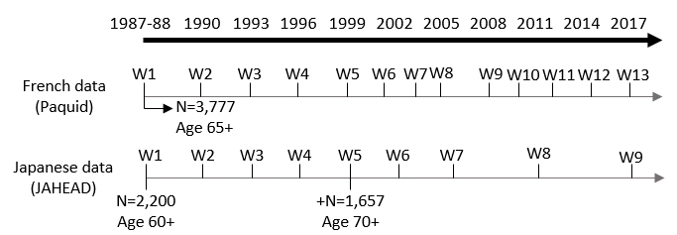
Supplementary Figure S1. Study design of the Paquid (France) and the JAHEAD (Japan) longitudinal studies.

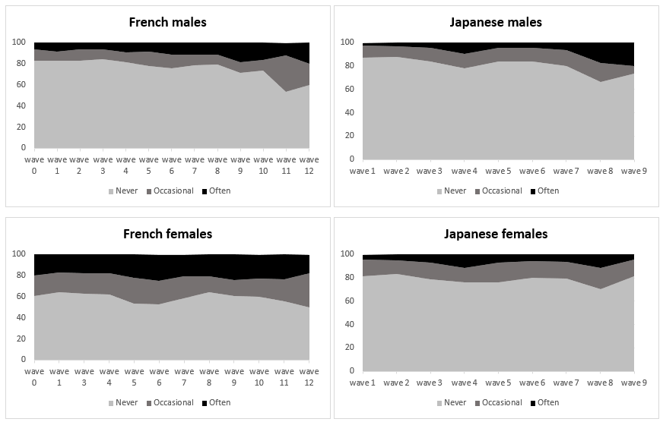
Supplementary Figure S2. Prevalence of loneliness by three categories of loneliness for France and Japan, 1988-2017, stratified by gender.

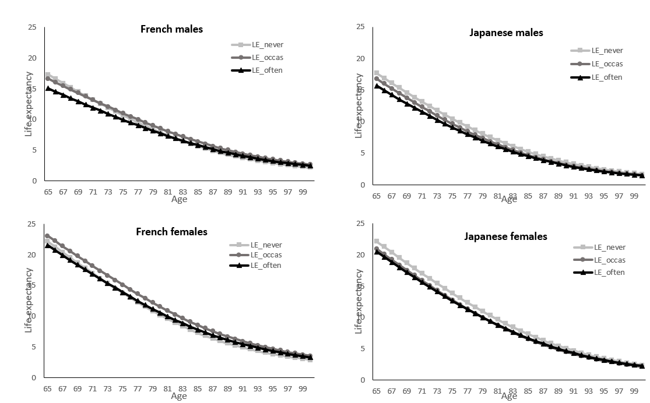
Supplementary Figure S3. Life expectancy (LE) by levels of loneliness for France and Japan, by gender.

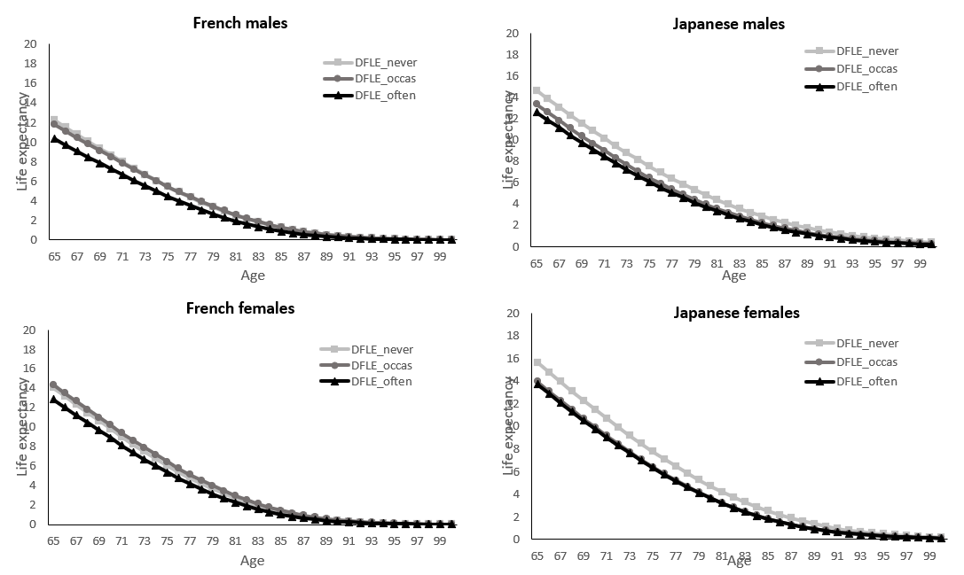
Supplementary Figure S4. Disability-free life expectancy (DFLE) by levels of loneliness for France and Japan, by gender.

