Supplementary Materials
Supplementary Table S1. Comparison of Predictive Performance of Preliminary Multivariable Cox Models
Candidate Model | Immune-Inflammatory Indicator | C-index | AIC | Evaluation
Model 1 | ΔPLR (> 74.55) | 0.810 | 584.96 | Best
Model 2 | ΔSII (≥ 7.40) | 0.800 | 588.69 | Intermediate
Model 3 | ΔNLR (≥ −0.10) | 0.800 | 591.27 | Worst

Supplementary Table S2. Annual distribution, neoadjuvant treatment regimens, and follow-up time (N=328)
Enrollment Year | Total Enrolled (N) | Conventional NAT n (%) | Immuno-Combination n (%) | Median Follow-up (Months)
2020 | 20 | 18 (90.0%) | 2 (10.0%) | 45
2021 | 35 | 25 (71.4%) | 10 (28.6%) | 36
2022 | 50 | 15 (30.0%) | 35 (70.0%) | 28
2023 | 65 | 8 (12.3%) | 57 (87.7%) | 20
2024 | 78 | 4 (5.1%) | 74 (94.9%) | 14
2025 | 80 | 2 (2.5%) | 78 (97.5%) | 8

Supplementary Table S3. Baseline characteristics of low-risk subgroup patients before and after PSM
Variable | Observation (N=87) | Adjuvant Therapy (N=87) | SMD
Age (mean, SD) | 62.23 (6.88) | 62.16 (8.02) | 0.009
Sex (mean, SD) | 1.21 (0.41) | 1.20 (0.40) | 0.029
LVI = Positive (%) | 0 (0.0) | 0 (0.0) | < 0.001
NAE (mean, SD) | 9.95 (10.74) | 10.79 (8.65) | 0.086

Supplementary Table S4. Spearman correlation matrix among dynamic changes (Δ) of systemic immune-inflammatory indicators
Variable | ΔPLR | ΔNLR | ΔSII
ΔPLR | 1 | 0.625 (P < 0.001) | 0.695 (P < 0.001)
ΔNLR | 0.625 (P < 0.001) | 1 | 0.852 (P < 0.001)
ΔSII | 0.695 (P < 0.001) | 0.852 (P < 0.001) | 1

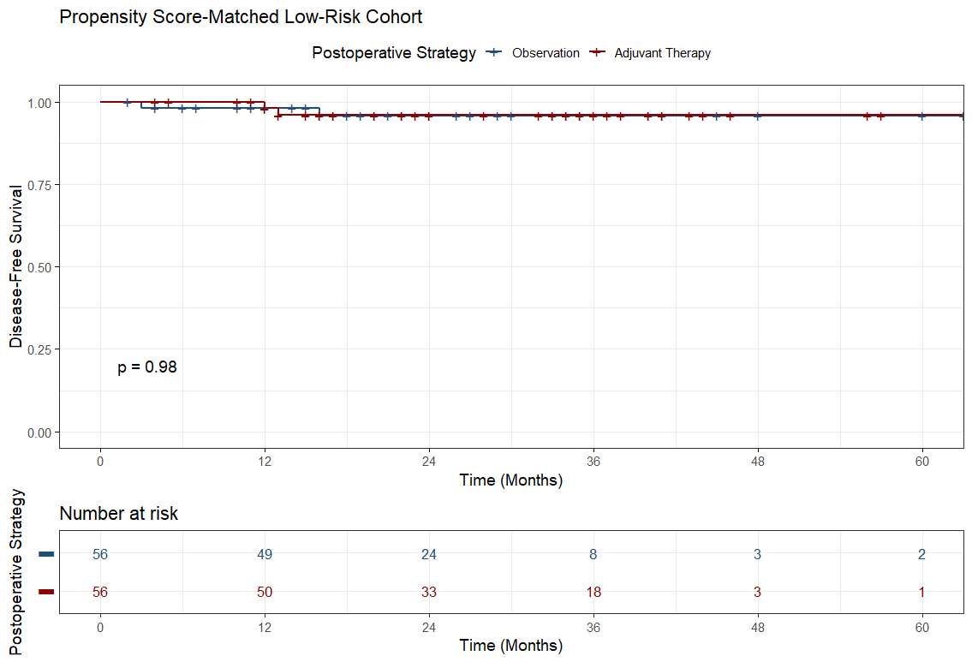
Supplementary Figure S1. Kaplan-Meier curves comparing observation versus adjuvant therapy in the propensity score-matched (PSM) low-risk cohort (Observation group: N=56; Adjuvant Therapy group: N=56). No significant difference in survival was observed (P = 0.98).

