Appendix S1
The full search strategy:
((((((((((((("Ranibizumab"[Mesh]) OR "Vascular Endothelial Growth Factor A"[Mesh]) OR "Bevacizumab"[Mesh]) OR "Receptors, Vascular Endothelial Growth Factor"[Mesh]) OR "aflibercept" [Supplementary Concept]) OR "KH902 fusion protein" [Supplementary Concept]) OR (anti-VEGF)) OR (VEGF)) OR (Vascular Endothelial Growth Factor)) OR (VEGF-A)) OR (conbercept)) OR (subretinal neovascularization)) AND ((((("Child"[Mesh])) OR "Adolescent"[Mesh]) OR (child*)) OR (pediatric*))) AND (((((((("Choroidal Neovascularization"[Mesh]) OR (Choroid Neovascularizations)) OR (Neovascularization, Choroid)) OR (Neovascularization, Choroidal)) OR (Choroidal Neovascularizations)) OR (CNV)) OR (MNV)) OR (macular neovascularization)) OR (subretinal neovascularization))
Appendix S2 and Appendix S3
Appendix S2: JBI critical appraisal checklist of the case series
Study ID | Q1 | Q2 | Q3 | Q4 | Q5 | Q6 | Q7 | Q8 | Q9 | Q10 | Total (/10) | Quality rating
Zhang T 2021 | ✓ | ✓ | ✓ | ✓ | ✓ | ✗ | ✓ | ✓ | ✓ | ✓ | 9/10 | High
Zhangly 2024 | ✓ | ✓ | ✓ | ✗ | ✗ | ✓ | ✓ | ✓ | ✓ | ✓ | 8/10 | High
Yan S 2025 | ✓ | ✓ | ✓ | ✗ | ✗ | ✓ | ✓ | ✓ | ✓ | ✓ | 8/10 | High
Sisk RA 2010 | ✓ | ✓ | ✓ | ✓ | ✗ | ✓ | ✓ | ✓ | ✓ | ✓ | 9/10 | High
Pavlíková K 2025 | ✓ | ✓ | ✓ | ✗ | ✓ | ✓ | ✓ | ✓ | ✓ | ✓ | 9/10 | High
Ranjan S 2022 | ✓ | ✓ | ✓ | ✓ | ✗ | ✓ | ✓ | ✓ | ✓ | ✓ | 9/10 | High
Kozak I 2014 | ✓ | ✓ | ✓ | ✗ | ✓ | ✓ | ✓ | ✓ | ✓ | ✓ | 9/10 | High
Kohly RP 2010 | ✓ | ✓ | ✓ | ✓ | ✓ | ✓ | ✓ | ✓ | ✓ | ✗ | 9/10 | High
Katargina LA 2024 | ✓ | ✓ | ✓ | ✗ | ✓ | ✓ | ✓ | ✓ | ✓ | ✓ | 9/10 | High
Hykin PG 2021 | ✓ | ✓ | ✓ | ✓ | ✓ | ✓ | ✓ | ✓ | ✓ | ✓ | 10/10 | High
Henry CR 2015 | ✓ | ✓ | ✓ | ✓ | ✓ | ✓ | ✓ | ✓ | ✓ | ✓ | 10/10 | High
Choi SI 2023 | ✓ | ✓ | ✓ | ✗ | ✓ | ✓ | ✓ | ✓ | ✓ | ✓ | 9/10 | High
Barth T 2016 | ✓ | ✓ | ✓ | ✓ | ✓ | ✓ | ✓ | ✓ | ✓ | ✓ | 10/10 | High
Hang C 2025 | ✓ | ✓ | ✓ | ✗ | ✓ | ✓ | ✓ | ✓ | ✓ | ✓ | 9/10 | High
Moosajee M 2018 | ✓ | ✓ | ✓ | ✓ | ✓ | ✓ | ✓ | ✓ | ✓ | ✓ | 10/10 | High
Hoyek S 2024 | ✓ | ✓ | ✓ | ✓ | ✓ | ✓ | ✓ | ✓ | ✓ | ✓ | 10/10 | High
Avni P. Finn 2022 | ✓ | ✓ | ✓ | ✓ | ✓ | ✗ | ✓ | ✓ | ✓ | ✓ | 9/10 | High
Rego-Lorca D 2024 | ✓ | ✓ | ✓ | ✗ | ✓ | ✓ | ✓ | ✓ | ✓ | ✓ | 9/10 | High
JBI checklist items (10 items):
Q1: Were clear criteria for inclusion in the case series clearly defined?
Q2: Was the condition measured in a standard, reliable way?
Q3: Were consecutive patients included?
Q4: Were all participants included?
Q5: Was the outcome measured objectively?
Q6: Was the follow‑up period clearly reported?
Q7: Were demographic and clinical characteristics clearly described?
Q8: Were relevant outcomes clearly reported?
Q9: Was the analysis appropriate?
Q10: Were loss to follow‑up and reasons described?
Quality rating: high (≥8/10), moderate (5–7/10), low (≤4/10).
✓ = yes (low risk); ✗ = no (high risk); ? = unclear or not reported.

Appendix S3: Newcastle-Ottawa Scale (NOS) for cohort studies
Study ID | Selection  (max 4★) |  |  |  | Comparability  (max 2★) |  | Outcome  (max 3★) |  |  | Total (/9★) | Quality rating
 | S1 | S2 | S3 | S4 | C1 | C2 | O1 | O2 | O3
Rishi, P.2022 | ★ | ★ | ★ | ★ | ✗ | ✗ | ★ | ★ | ✗ | 6/9 | Moderate
Padhi, T. R 2018 | ★ | ★ | ★ | ★ | ✗ | ✗ | ★ | ★ | ★ | 7/9 | High
NOS items:
Selection (maximum 4 stars):
S1: Representativeness of the exposed cohort
S2: Selection of the non‑exposed cohort
S3: Ascertainment of exposure
S4: Demonstration that the outcome of interest was not present at the start of the study
Comparability (maximum 2 stars):
C1: Comparability of cohorts on the basis of the design or analysis (e.g., age, sex)
C2: Additional comparability factors (e.g., baseline visual acuity, follow‑up duration)
Outcomes (maximum 3 stars):
O1: Assessment of outcomes (independent blind assessment or record linkage)
O2: Was follow‑up long enough for outcomes to occur? (≥6 months)
O3: Adequacy of follow‑up of cohorts (≥80% completeness)
Quality rating: high (≥7 stars), moderate (5–6 stars), low (≤4 stars).
★ = criterion met; ✗ = criterion not met or not reported.

Supplementary Table S1: Sensitivity analysis of BCVA change in meta-analysis
studlab | n | mean | sd | TE | seTE | lower | upper | w.common | w.random | zval | w.fixed
Zhang T2021 | 25 | −0.11 | 0.45 | −0.11 | 0.09 | −0.29 | 0.07 | 123.46 | 56.41 | NA | 123.46
Yan S2025 | 26 | −0.12 | 0.46 | −0.12 | 0.09 | −0.30 | 0.06 | 122.87 | 56.29 | NA | 122.87
Sisk RA2010 | 14 | −0.6 | 0.4 | −0.6 | 0.11 | −0.81 | −0.39 | 87.50 | 47.49 | NA | 87.50
Pavlíková K2025 | 12 | −0.37 | 0.36 | −0.37 | 0.10 | −0.57 | −0.17 | 92.59 | 48.95 | NA | 92.59
Ranjan S2022 | 26 | −0.4 | 0.36 | −0.4 | 0.08 | −0.54 | −0.26 | 200.62 | 68.44 | NA | 200.62
Moosajee M2018 | 26 | −0.17 | 0.53 | −0.17 | 0.10 | −0.37 | 0.03 | 92.56 | 48.94 | NA | 92.56
Kohly RP2010 | 4 | −0.4 | 0.33 | −0.4 | 0.17 | −0.72 | −0.08 | 36.73 | 27.14 | NA | 36.73
Hoyek S2024 | 23 | −0.3 | 0.57 | −0.3 | 0.12 | −0.53 | −0.07 | 70.79 | 42.10 | NA | 70.79
Henry CR2015 | 35 | −0.24 | 0.38 | −0.24 | 0.06 | −0.37 | −0.11 | 242.38 | 85.37 | NA | 242.38
Choi SI2023 | 13 | −0.23 | 0.35 | −0.23 | 0.10 | −0.42 | −0.04 | 106.12 | 58.79 | NA | 106.12
Hang C2025 | 14 | −0.4 | 0.56 | −0.4 | 0.15 | −0.69 | −0.11 | 44.64 | 33.35 | NA | 44.64
Rego-Lorca D2024 | 33 | −0.31 | 0.41 | −0.31 | 0.07 | −0.45 | −0.17 | 196.31 | 78.86 | NA | 196.31

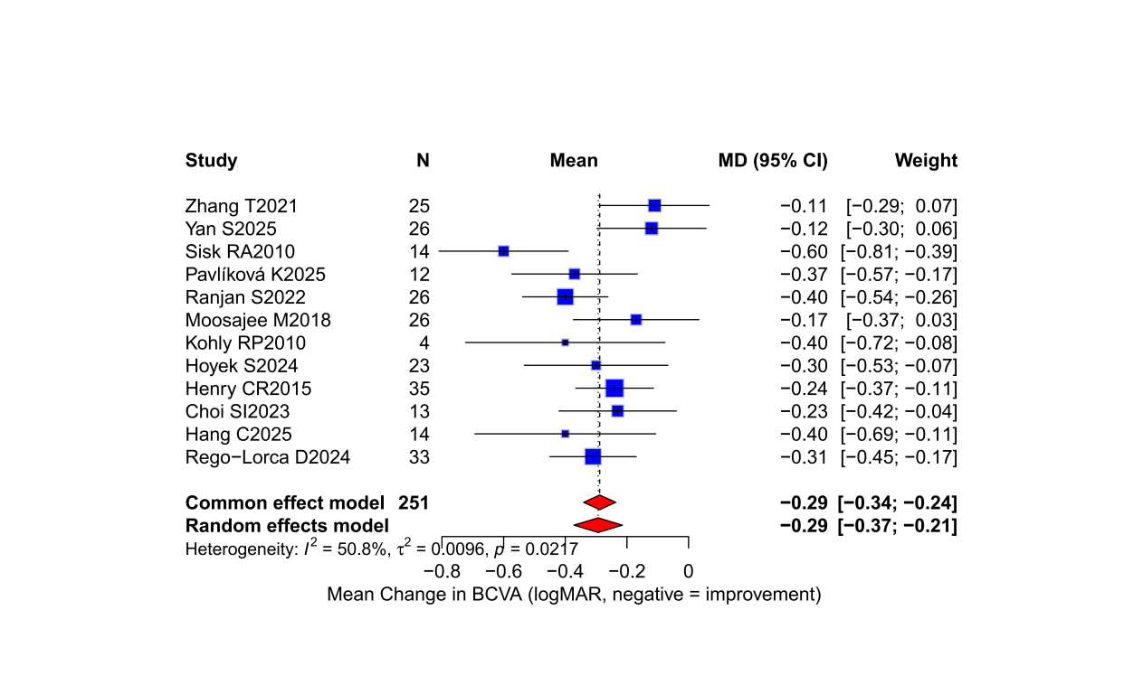
Supplementary Figure S1. Forest plot of sensitivity analysis (BCVA change excluding Finn. AP 2022) from baseline to last follow-up (logMAR). Negative values indicate improvement. Pooled mean difference: −0.29 (95% CI: −0.37 to −0.21); I² = 50.8%, P=0.0217.

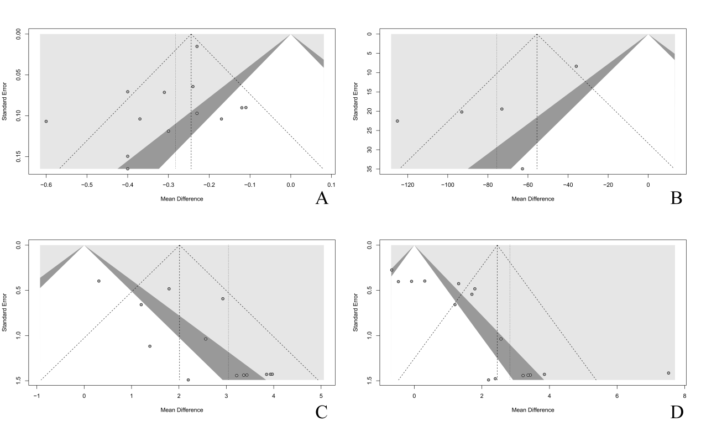
Supplementary Figure S2. Funnel plot of secondary outcomes. Panels A through D correspond to the number of injections, central macular thickness (CMT) change, CMT improvement, and visual acuity (VA) improvement, respectively. The x-axis represents the mean difference, and the y-axis represents the standard error (a measure of study precision). The vertical dashed line indicates the pooled effect estimate. The diagonal dotted lines and gray shaded areas represent the pseudo-95% confidence intervals.
MD, mean difference; SE, standard error.

