SUPPORTING INFORMATION
1- Supplementary Figure Legends
2- Materials, methods and equipments.
3- Synthesis of 5-aminopentyl LacNac.
4- Synthesis of 5-aminopentyl Le^{X}.
5- NMR and MS spectra.

1- Supplementary Figure Legends
Supplementary Figure 1: Identification of the glycosylation reaction conditions to obtain the desired glycosylation degree of the corresponding mutant. The figure shows the incorporation of increasing equivalents (eq) of the Lex glycan in the click chemistry reaction to the M471 mutant to obtain different percentage of glycosylated VPs eventually reaching 100% glycosylation of the monomers. To calculate the percentage of glycosylated VPs, only the glycosylation of VP3 was quantified.
Supplementary Figure 2: Analysis of mutant M471 glycosylation with different glycans. Glycosylation reactions of M471 mutant with S2G2, G2, G0, 6SLN LacNAc, and Man were analyzed by SDS-PAGE and SYPRO staining obtaining a modification of 20% of the VP proteins. There is a direct correlation between the glycan size and the glycosylated VP size.
Supplementary Figure 3: Hepatic GFP expression following AAV9A591 mannosylation. Representative IHC images of liver sections taken two weeks post-injection show GFP expression for vectors without or with 20% and 50% glycosylation levels.
Supplementary Figure 4: Assessing in culture transduction capacity of the M471 mutant following M6P glycosylation. Viral genome quantity (A) and GFP transgene expression (B) of AAV9M471 mutant virus glycosylated with M6P compared to the unmodified virus in HEK293T and PKD2 cells. Data of the modified viruses were normalized relative to the value of the unmodified mutant, which was assigned a value of 1. Statistical analysis of the groups in each case was performed using ANOVA test. * symbol indicates the following p values comparing every group with A591 non-modified (NM) group: * = p < 0.05, ** = p < 0.01, *** = p < 0.001, and **** = p < 0.0001. Mean + SD was represented
Supplementary Figure 5: Hepatic GFP expression following AAV9M471 mannosylation. Representative IF images of liver sections taken two weeks post-injection show GFP expression for vectors without or with 50% glycosylation levels.
2- Materials, methods and equipments
Chemicals, solvents and dry solvents were purchased from Sigma‐Aldrich or Fisher and were used without further purification. Dibenzylcyclooctyne-PEG₄₋NHS ester was purchase by Jena Biosciences. 6SLN and N-acetyl-2-O-(2-aminoethyl)-α-neuraminic acid were purchased from Asparia glycomics. β-N-acetylglucosaminidase S from Streptococcus pneumoniae was purchased from SigmaAldrich. Uridine 5′‐diphosphogalactose disodium salt (UDP‐Gal), uridine 5’‐diphospho‐Nacetylgalactosaminedisodium salt (UDP‐GalNAc) and guanosine 5’‐diphospho‐β‐L‐fucosesodium salt (GDP‐Fuc) were purchased from Carbosynth. All aqueous solutions were prepared from MiliQ water produced with a MiliQ Q-POD dispenser. O-Glycans and N-glycans were synthetized using protocols previously published,,,,. Microwave irradiation was performed on Biotage Initiator monomode oven, (Biotage AB). Purifications of compounds were performed on: SampliQ high performance graphitized carbon cartridges (1 mL) from Agilent Technologies, C18 Sep-Pak Cartridges (1 mL) from Waters (Milford), flash chromatography using Merck 62 Å 230−400 mesh silica gel or on a Biotage SP4 automated flash chromatography system, (Biotage AB) employing prepacked silica cartridges and HPLC. Reactions were analyzed by Maldi TOF and HPLC. Analitical and preparative HPLC were carried out in a Waters autopurification system including Waters 2767 Sample Manager collector, Waters 2996 Photodiode Array Detector, Waters SFO System Fluidics Organizer, Waters 2545 Binary Gradient Module and Waters SQ detector 2 equipped with a standard ESI source (capillary voltage of 2.10 kV and a cone voltage of 50 V. Cone and desolvation gas flow were set to 50 and 900 L/h, respectively; source temperature and desolvation temperatures were 120 °C and 500°C, respectively). The samples were purified on a Gemini® C18 250 x 21.2 mm with a particle size of 5 µm from Phenomenex at a flowrate of 16 mL/min with 1/1000 of the flowrate was diverted to the PDA and ESI-MS detector using a splitter and a Waters 515 as make up pump. The mobile phases were 0.1% TFA in H₂O (A) and acetonitrile (B) and the gradient for the separation : 0–3 at min 80% A, 3–33 min to 45% A, 33–33.50 min to 20% A, 33.50-36.50 min at 20% A, 36.50-37 min to 80% A and 37–40 min at 80% A. Fractions containing the product were pooled together, concentrated by rotary evaporation and freeze dryed on an ALPHA-2-4 LSC freeze-dryer from Christ. MALDI-TOF mass analyses were performed on an Ultraflextreme III time-of-flight mass spectrometer equipped with a pulsed N2 laser (337 nm) and controlled by FlexControl 3.3 software (Bruker Daltonics).

3- Synthesis 5-aminopentyl LacNac.
Figure 1: Synthetic route and conditions for compound 7. i) NIS, TMSOTf, DCM, -40 ºC to r. t., 1h, under Ar, 80 %. ii) 1. TBAF, AcOH, THF, 0 ºC, 1 h. 2. Cl₃CCN, DBU, DCM, 1 h, 77 %. iii) Benzyl N-(5-hydroxypentyl)carbamate, TMSOTf, DCM, -20 ºC to r. t., 1 h, 79 %. iv) 1. Ethylendiamine, n-BuOH, 120 ºC (MW), 1.5 h. 2. Ac₂O, DMAP, pyridine, r. t., 2 h, 91 %. v) 1. MeONa/MeOH (1:2), r. t., 3 h. 2. H₂, Pd(OH)₂, MeOH/TFA, r. t., 72 h, 99 %.

2-deoxy-2-phthalimido-3,6-di-O-benzyl-4-O-(2,3,4,6-tetra-O-acetyl-β-D-galactopyranosyl)-1-(tert-butyldimethylsilyil)-β-D-Glucopyranoside (3).
A solution of 1 (300 mg, 0.491 mmol, 1.2 equiv), 2 (186 mg, 0.409 mmol) and NIS (138 mg, 0.614 mmol) in dry CH₂Cl₂ with 3Å molecular sieves is stirring for 1h at room temperature. This mixture is cooled to -40ºC and trimethylsilyl trifluoromethanesulfonate (0.012 mL, 0.061 mmol, 0.15 equiv.) was added and the reaction was stirred until TLC showed complete conversion of the starting material (1h). The reaction mixture was quenched with NaHCO₃ and Na₂S₂O₃, and then filtered. The organic mixture was washed with NaHCO₃ and brine. Finally, the crude of reaction was purified on a silica gel column using Hexane/EtOAc (4:1), and the pure compound 3 was obtained as a white solid (307 mg, 80%).
¹H NMR (CDCl₃): δ 7.77 – 7.59 (m, 4Ar-H), 7.40 – 7.33 (m, 5Ar-H), 7.04 – 7.02 (m, 2Ar-H), 6.95 – 6.80 (m, 3Ar-H), 5.33 – 5.25 (m, 2H), 5.16 (dd, J = 10.4, 8.0 Hz, 1H), 4.89 ( dd, J = 10.4, 3.5 Hz, 1H), 4.78 (dd, J = 12.3, 3.1 Hz, 2H), 4.65 (d, J = 8.0 Hz, 1H), 4.54 (d, J = 12.2 Hz, 1H), 4.47 – 4.44 (d, J = 12.3 Hz, 1H), 4.28 (dd, J = 10.9, 8.6 Hz, 1H), 4.12 – 4.04 (m, 2H), 3.97 (m, 2H), 3.79 – 3.77 (m, 1H), 3.72 – 3.68 (m, 2H), 3.54 – 3.51 (m, 1H), 2.06 – 1.97 (12H, m, 4 Ac), 0.66 (s, 9H, 3CH₃), 0.03 (s, 3H, SiCH₃), -0.13 (s, 3H, SiCH₃).
2-deoxy-2-phthalimido-3,6-di-O-benzyl-4-O-(2,3,4,6-tetra-O-acetyl-β-D-galactopyranosyl)-1-(2,2,2-trichloroethanimidate)-β-D-glucopyranoside (4).
To a solution of 3 (2100 mg, 2.4 mmol) in dry CH₂Cl₂ at 0 °C, TBAF (3.56 mL, 3.84 mmol, 1.6 equiv.) and AcOH (0.172 mL, 3.84 mmol, 1.6 equiv.) were added and stirred for one hour. The reaction was quenched with NaHCO₃, extracted with EtOAc (x3), and dried with MgSO₄. The crude mixture was concentrated under vacuum. The crude was dissolved in dry CH₂Cl₂, and then Cl₃CN (3.2 mL, 36.02 mmol, 15 equiv.) and DBU (0.032 mL, 0.24 mmol, 0.1 equiv.) were added under argon. After 1 hour, the reaction mixture was concentrated and purified on a silica gel column using Hexane/EtOAc/TEA (2:1:0.03), obtaining the pure compound 47 (1778 mg, 77 %).
- ¹H NMR (CDCl₃): δ 7.68 – 7.65 (m, 4Ar-H), 7.41 – 7.40 (m, 5Ar-H), 7.04 – 7.02 (m, 2Ar-H), 6.88 – 6.85 (m, 3Ar-H), 5.28 – 5.27 (m, 2H), 5.14 (dd, J = 10.4, 8.0 Hz, 1H), 4.83 ( dd, J = 10.4, 3.5 Hz, 1H), 4.58 (s, 2H), 4.51 (m, 1H), 4.45 (m, 1H), 4.38 – 4.34 (m, 1H), 4.20 – 4.16 (m, J, 1H), 4.01 (m, 2H), 3.97 (m, 2H), 3.82 (m, 1H), 3.73 – 3.71 (m, 2H), 3.66 – 3.63 (m, 1H), 2.06 – 1.97 (m, 12H, 4 Ac).

Phenylmethyl N-[5-[[O-4,6-di-O-acetyl-β-D-galactopyranosyl-(1→4)-3,6-di-O-benzyl-2-deoxy-2-phthalamido-β-D-glucopyranosyl]oxy]pentyl]carbamate (5).
A solution of 4 (2 g, 2.08 mmol), phenylmethyl N-(5-hydroxy pentyl)carbamate (740 mg, 3.12 mmol, 1.5 equiv.) and 3Å molecular sieves in dry CH₂Cl₂ was stirred for 1h at -20 ºC. Trimethylsilyl trifluoromethanesulfonate (0.075 mL, 0.416 mmol, 0.20 equiv.) was added and stirred for 1 hour. The reaction mixture was quenched with TEA and evaporated under vacuum. The crude of reaction was purified on a silica gel column using Hexane/EtOAc (1:1), and 5 was obtained as a white solid (1.424 g, 79 %).
¹H NMR (CDCl₃): δ 7.76 – 7.63 (m, 4Ar-H), 7.42 – 7.29 (m, 10Ar-H), 7.02 (m, 2Ar-H), 6.87 (m, 3Ar-H), 5.26 (dd, J = 3.5, 1.2 Hz, 1H), 5.14 (dd, J = 10.4, 8.0 Hz, 1H), 5.06 (s, 2H, OCH₂-Bz), 4.78 (m, 3H), 4.57 (d, J = 8.0 Hz, 1H), 4.49 (d, J = 12.1 Hz, 1H), 4.43 (d, J = 12.3 Hz, 1H), 4.23 (dd, J = 10.8, 8.5 Hz, 1H), 4.09 (m, 2H), 3.96 (m, 2H), 3.80 – 3.74 (m, 3H, CH₂), 3.64 – 3.61 (m, 1H), 3.53 – 3.50 (m, 1H), 3.37 – 3.32 (m, 1H, CH₂), 2.88 – 2.84 (m, 2H, CH₂), 2.06 – 1.97 (m, 12H, 4Ac), 1.43 – 1.35 (m, 2H, CH₂), 1.27 – 1.24 (m, 2H, CH₂), 1.09 – 1.05 (m, 2H, CH₂).
HRMS (Q-TOF): m/z calculated for C₅₅H₆₂N₂O₁₈NH₄: 1056.4341 [M+NH₄]⁺; found 1056.4347.

Phenylmethyl N-[5-[[O-4,6-di-O-acetyl-β-D-galactopyranosyl-(1→4)-3,6-di-O-benzyl-2-(acetylamino)-2-deoxy-β-D-glucopyranosyl]oxy]pentyl]carbamate (6).
A solution of compound 5 (1.40 g, 1.35 mmol) in n-BuOH was prepared in a microwave flask with ethylenediamine (2 mL). The reaction mixture was heated in the microwave for 90 minutes at 120 ºC and was concentrated under vacuum with co-evaporation with toluene. The crude was dissolved in pyridine and acetic anhydride (6 mL) and DMAP were added. The reaction was stirred for two hours at room temperature and the crude was concentrate under vacuum and was purified using a silica gel column with EtOAc as an eluent to get the pure compound 6. (1.17 g, 91%).
¹H NMR (CDCl₃): δ 7.37 – 7.29 (m, 15Ar-H), 5.31 – 5.26 (m, 1H), 5.14 – 5.06 (m, 3H), 4.94 – 4.87 (m, 1H), 4.80 – 4.73 (m, 2H), 4.67 – 4.61 (dd, J = 17.9 Hz, 11.7 Hz, 1H), 4.49 (d, J = 8.0 Hz, 1H), 4.43 (d, J = 12.0 Hz, 1H), 4.07 – 3.93 (m, 4H), 3.82 (m, 2H, CH₂) 3.73 (dd, J = 10.2 Hz, 4.2 Hz, 1H, CH₂), 3.65 (t, J = 6.7 Hz, 1H), 3.59 – 3.56 (m, 1H), 3.42 – 3.38 (m, 1H, CH₂), 3.16 – 3.12 (m, 2H, CH₂), 2.10 – 1.90 (m, 15H, 5Ac), 1.56 – 1.46 (m, 4H, CH₂), 1.34 – 1.31 (m, 2H, CH₂).
HRMS (Q-TOF): m/z calculated for C₄₉H₆₂N₂O₁₇Na: 973.3946 [M+Na]⁺; found 973.3920.

5-Aminopentyl 2-(acetylamino)-2-deoxy-4-O-β-D-galactopyranosyl-β-D-glucopyranoside (5-aminopentyl β-N-acetyllactosamine) (7)
A solution of compound 6 (1.15 g, 1.21 mmol) in MeOH/MeONa 0.5M in MeOH (2:1) was stirred at room temperature for 3 hours. The solvent was evaporated under vacuum. The crude was purified using a C18 cartridge (10 g) with an ACN/H₂O gradient as eluent. Fractions containing the product were concentrated in vacuum and the resulting crude was dissolved in MeOH/TFA (1:0.001) under argon conditions. Then, Pd(OH)₂ (180 mg) was added. The hydrogenation was carried out at room temperature for 72 hours using an H₂-filled balloon. Finally, the crude was filtered through celite and concentrated under vacuum, obtaining the pure compound 7 as a white solid (562 mg, 99%).
¹H NMR (D₂O): δ 4.54 (d, J = 7.3 Hz, 1H), 4.49 (d, J = 7.8 Hz, 1H, H-1_{Gal}), 4.02 – 3.99 (d, J = 12.3 Hz, 1H, H-1_{GlcNAc}), 3.94 – 3.54 (m, 13H), 3.02 – 2.99 (t, J = 7.8 Hz, 2H, CH₂), 2.05 (s, 3H, Ac), 1.72 – 1.57 (m, 4H, CH₂), 1.45 – 1.40 (m, 2H, CH₂).
HRMS (Q-TOF): m/z calculated for C₁₉H₃₆N₂O₁₁H: 469.2397 [M+H]⁺; found 469.2319.

4- Synthesis 5-aminopentyl Le^{X}.
A solution of compound 7 (15 mg, 0.032 mmol), GDP-Fuc (23 mg, 0.038 mmol), MnCl₂ (20 mM) and MgCl₂ (20 mM) in Tris-buff. (25 mM, pH 7.5) was incubated with α-1,3-FUT H. Pylori (0.2 U) at 37 ºC for 2 days. The reaction progress was monitored via MALDI-TOF. Then, the reaction mixture was centrifuged at 12500 rpm for 5 min. The supernatant was purified by HPLC with an ACN/H₂O gradient as eluent. Product 8 was obtained after lyophilizing as a white solid (15.56 mg, 79 %).
¹H NMR (D₂O): δ 5.10 (d, J = 4.0 Hz, 1H, H-1_{Fuc}), 4.52 (d, J = 7.9 Hz, 1H, H-1_{Gal}), 4.45 (d, J = 7.8 Hz, 1H, H-1_{GlcNAc}), 4.01 – 3.98 (m, 1H), 3.93 – 3.55 (m, 16H), 3.49 (dd, J = 9.9 Hz, 7,8 Hz, 1H), 2.98 (t, J = 7.8 Hz, 2H, CH₂), 2.02 (s, 3H, Ac), 1.70 – 1.56 (m, 4H, CH₂), 1.42 – 1.37 (m, 2H, CH₂) 1.17 (d, J = 6.6 Hz, 3H, CH_{3Fuc}).
HRMS (Q-TOF): m/z calculated for C₂₅H₄₆N₂O₁₅H: 615.2977 [M+H]⁺; found 615.3000.

5- NMR and MS spectra
Figure 1: ¹H NMR spectrum of compound 3 in CDCl₃
Figure 2: HSQC spectrum of compound 3 in CDCl₃
Figure 3: ¹H NMR of compound 4 in CDCl₃
Figure 4: HSQC spectrum of compound 4 in CDCl₃
Figure 5: ¹H NMR spectrum of compound 5 in CDCl₃

Figure 6: HSQC spectrum of compound 5 in CDCl₃
Figure 7: HRMS spectrum of compound 5

Figure 8: ¹H NMR spectrum of compound 6 in CDCl₃
Figure 9: HSQC spectrum of compound 6 in CDCl₃
Figure 10: HRMS spectrum of compound 6
Figure 11: ¹H spectrum of compound 7 in D₂O
Figure 12: HSQC spectrum of compound 7 in D₂O
Figure 13: HRMS spectrum of compound 7
Figure 14: ¹H spectrum of compound 8 in D2O
Figure 15: HRMS spectrum of compound 8

Figure 16: ¹H NMR spectrum of compound A in D2O
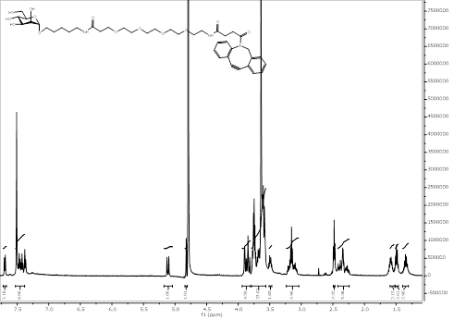
Figure 17: HRMS spectra of Man
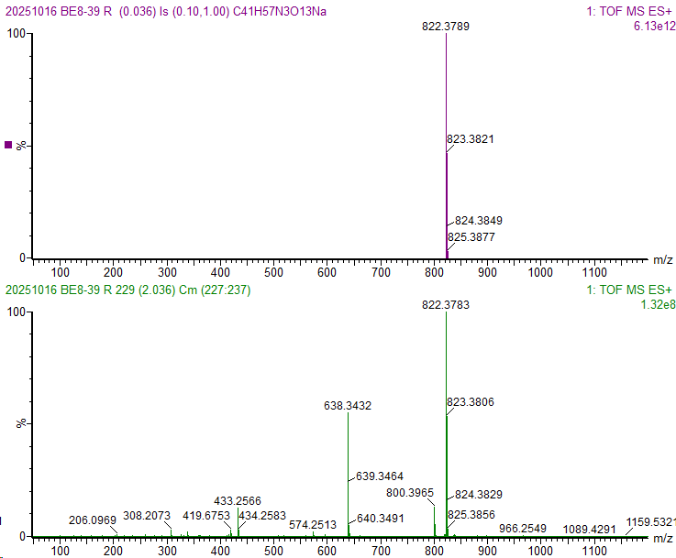
Figure 18: ¹H NMR spectrum of Man6P-PEG4DBCO
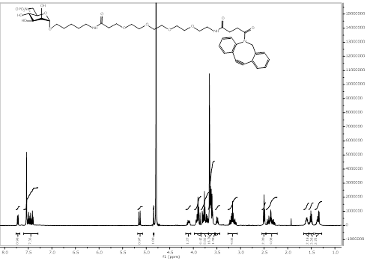
Figure 19: HRMS spectra of Man6P
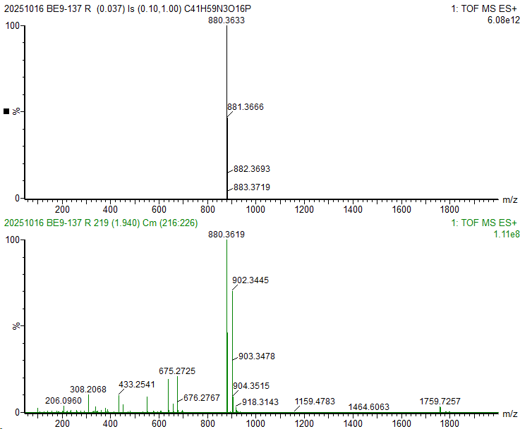

Figure 20: ¹H NMR spectrum of NeuNAc in D2O
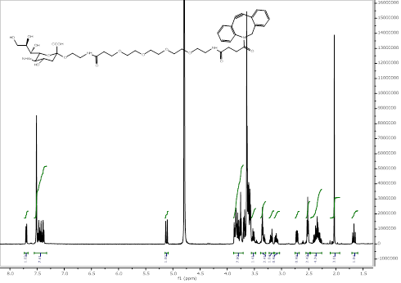
Figure 21: MS spectrum of NeuNAc
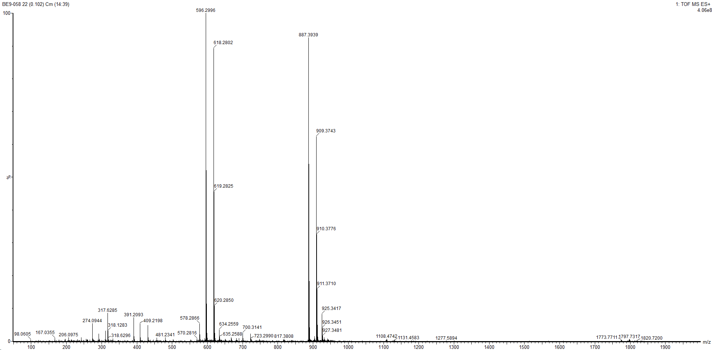
Figure 22: ¹H NMR spectrum of GalNAc-PEG₄DBCO in D2O
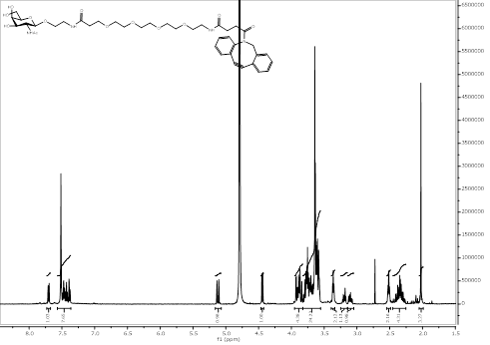

Figure 23: MS spectrum of compound of GalNAc
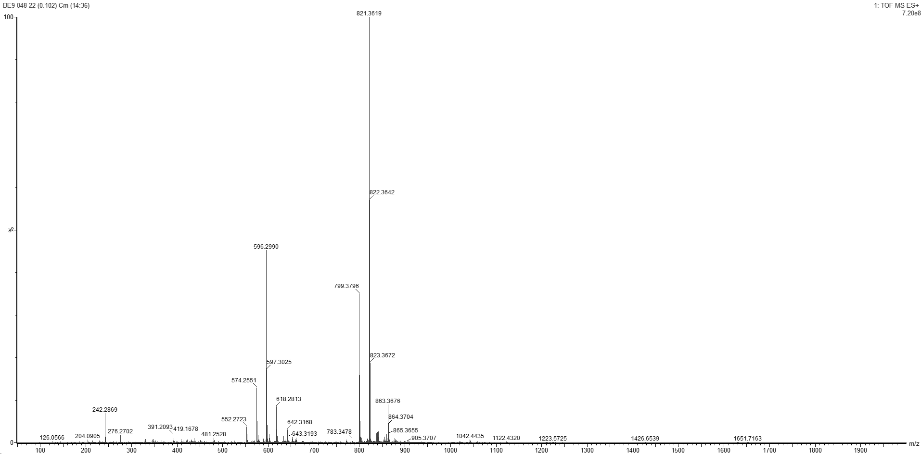

Figure 24: ¹H spectrum of LacNAc in D₂O
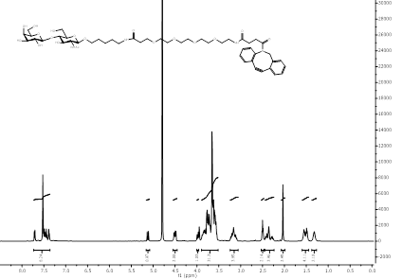
Figure 25: HSQC spectrum of LacNAc
Figure 26: HRMS spectrum of LacNAc
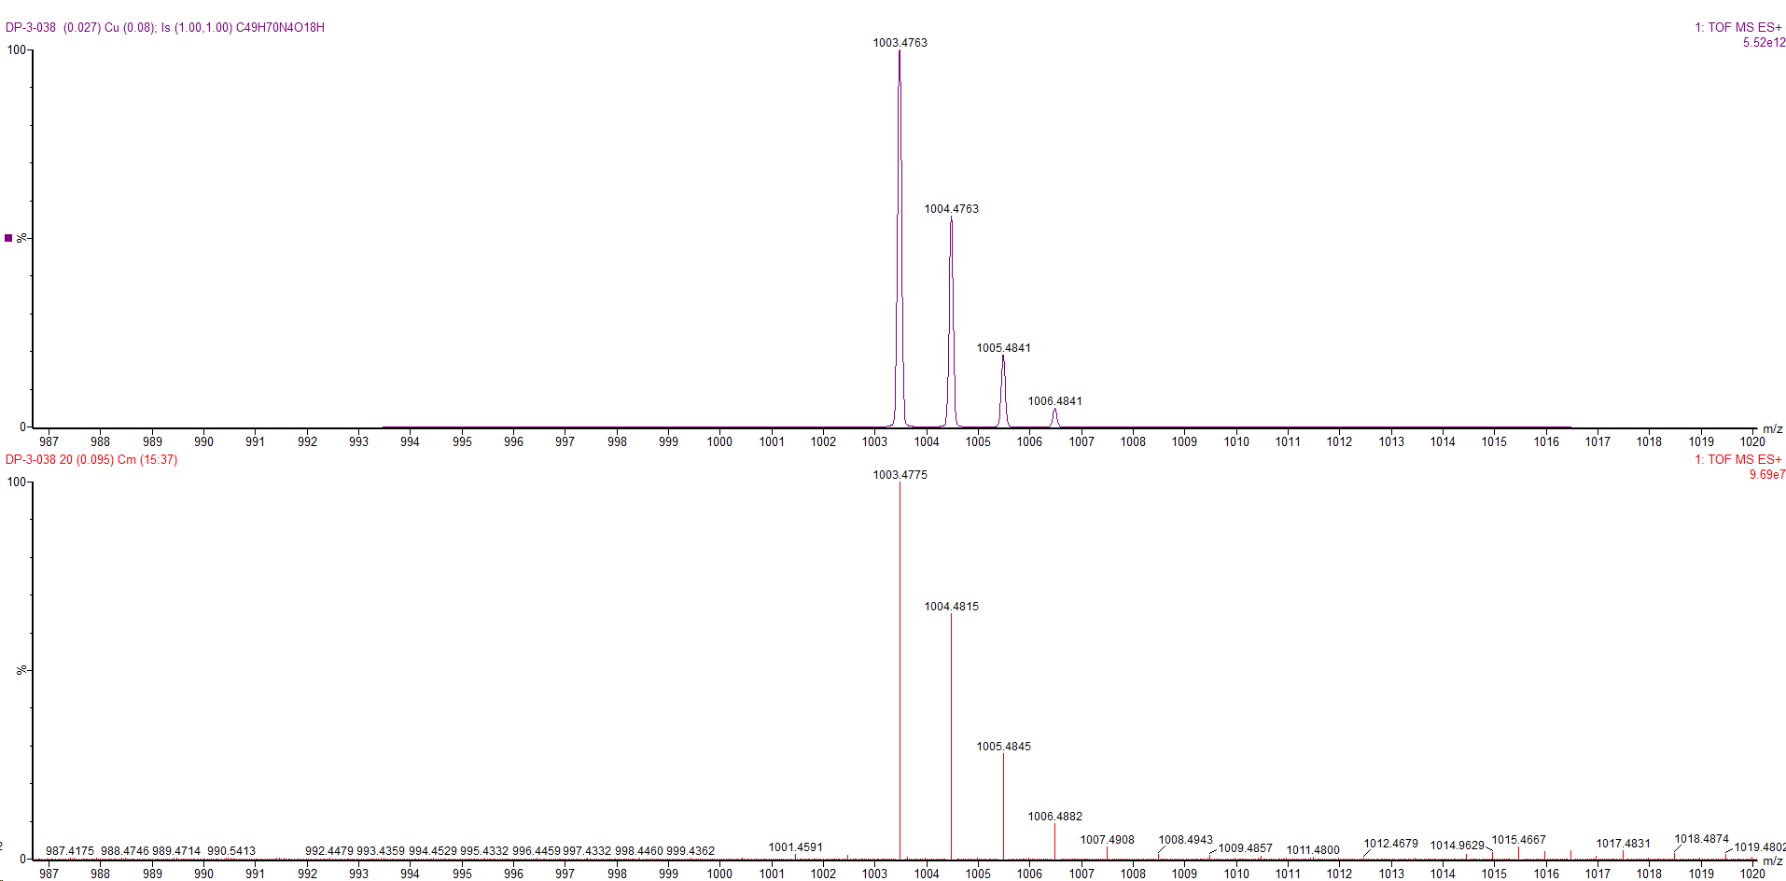
Figure 27: 1H NMR spectrum of LeX
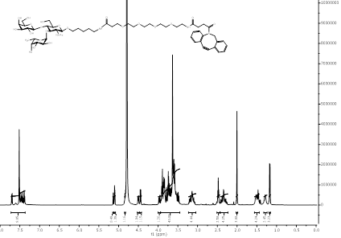
Figure 28: HSQC spectrum of LeX
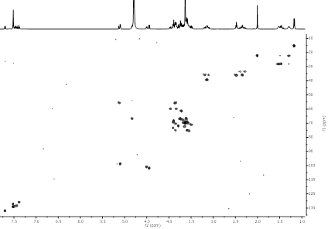
Figure 29: HRMS of LeX
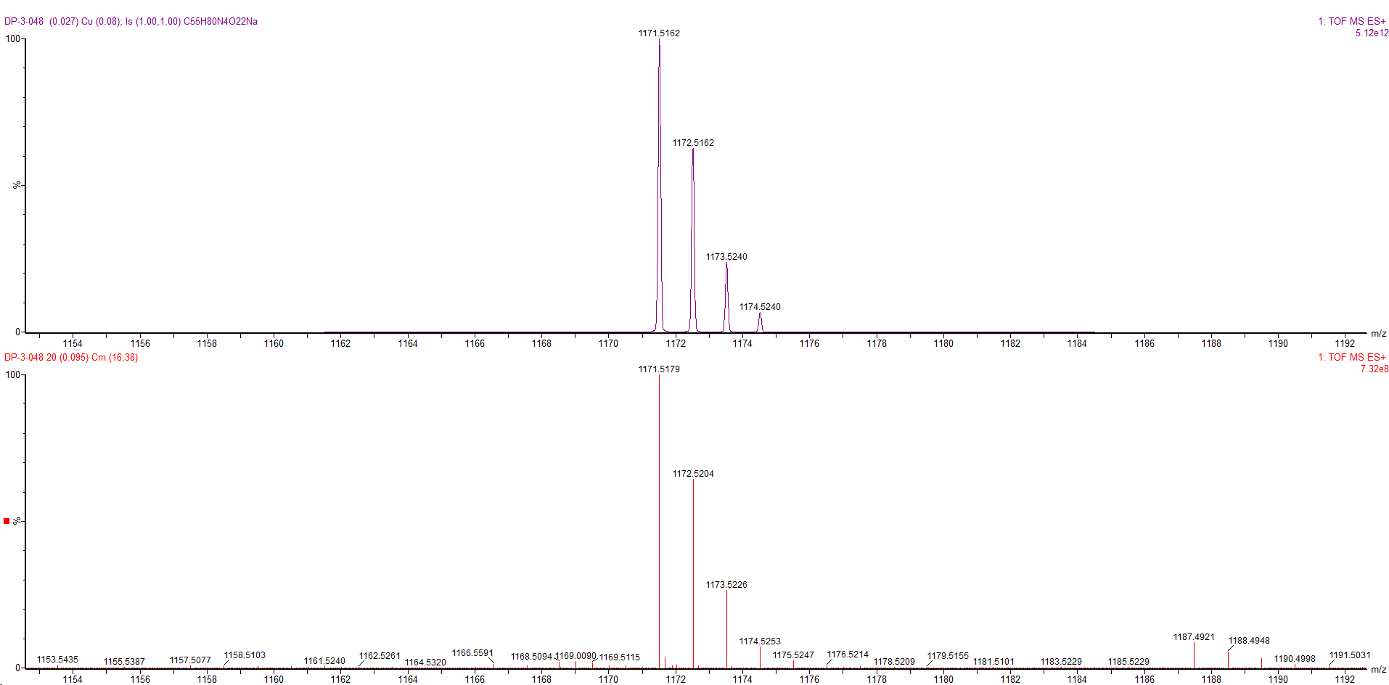
Figure 30: ¹H NMR spectrum of 6SLN
Figure 31: HRMS spectra of 6SLN
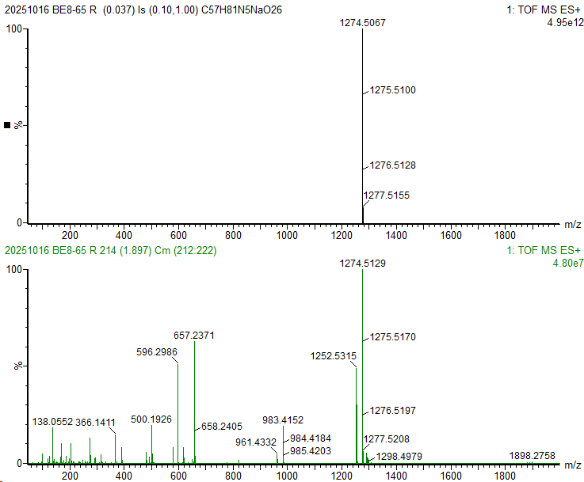

Figure 321H NMR spectrum of Man3
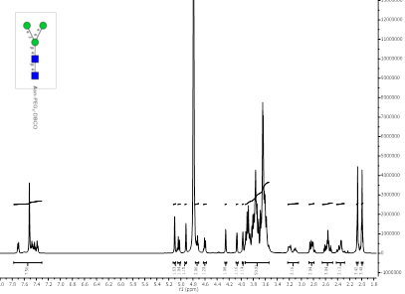

Figure 33: HSQC spectrum of Man3
Figure 34: HRMS spectrum of Man3
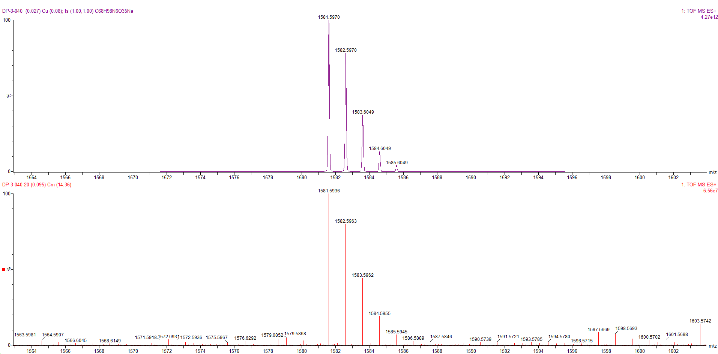
Figure 35: 1H NMR spectrum of G0
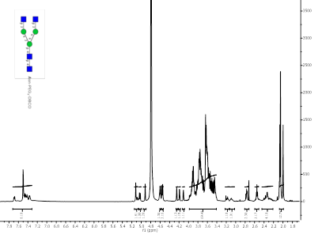
Figure 36: HRMS spectrum of G0
Figure 37: 1H NMR spectrum of G2
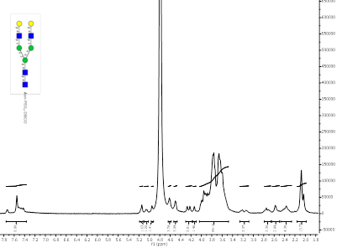
Figure 38: HSQC spectrum of G2
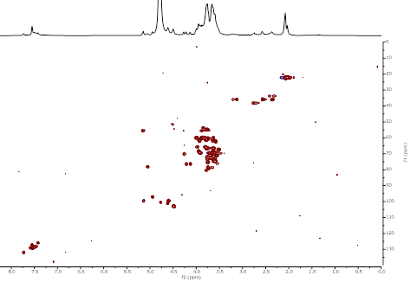
Figure 39: HRMS spectrum of G2
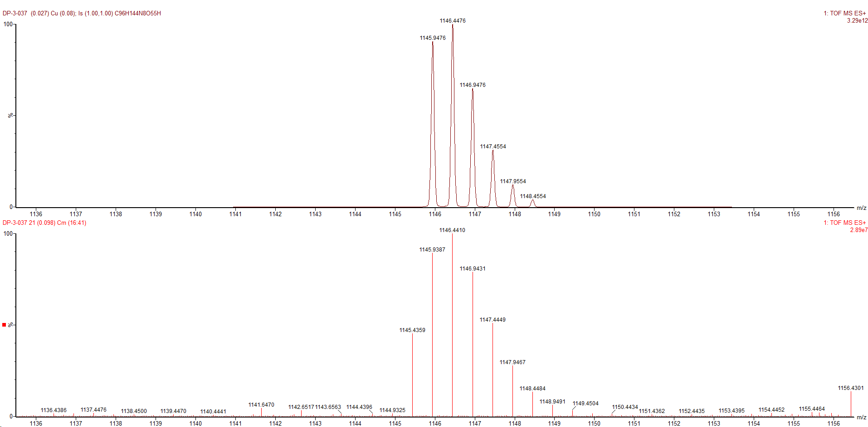

Figure 40: ¹H NMR spectrum of S2G2 in D₂O
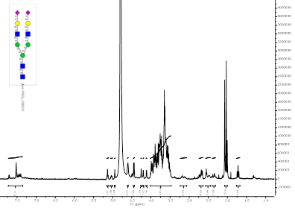

Figure 41: HRMS spectrum of S2G2
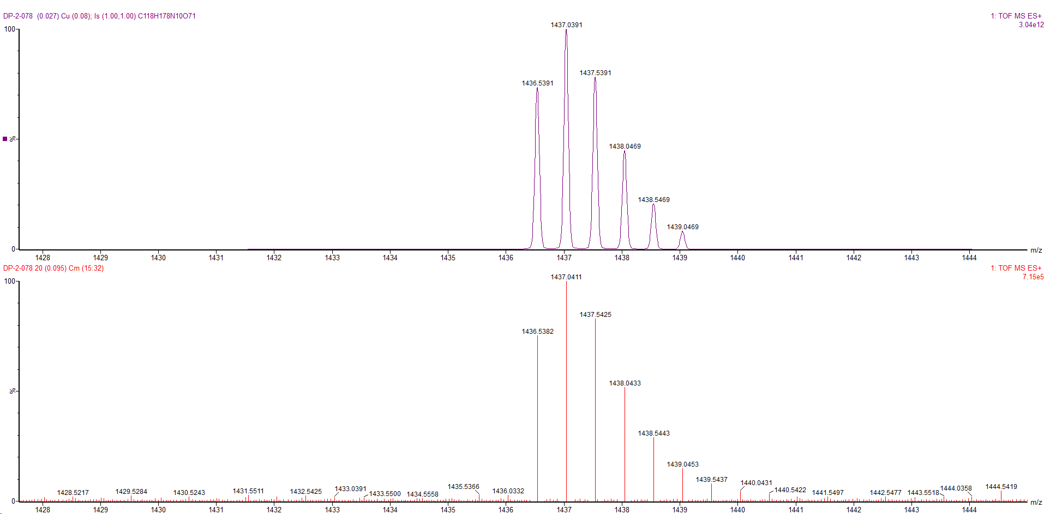

Anatoly Ya. Chernyak, Carbohydrate Research,Volume 223,1992,Pages 303-309
Sardzik, Robert Beilstein Journal of Organic Chemistry, 2010, vol. 6, p. 699 – 703.
Gao, Chao et al. Cell Chemical Biology, Volume 26, Issue 4, 535 - 547.e4.
Srinivas, Oruganti, Org. Biomol. Chem., 2005,3, 4252-4257
Sletten, Eric T., Carbohydrate Research 511 (2022) 108489

