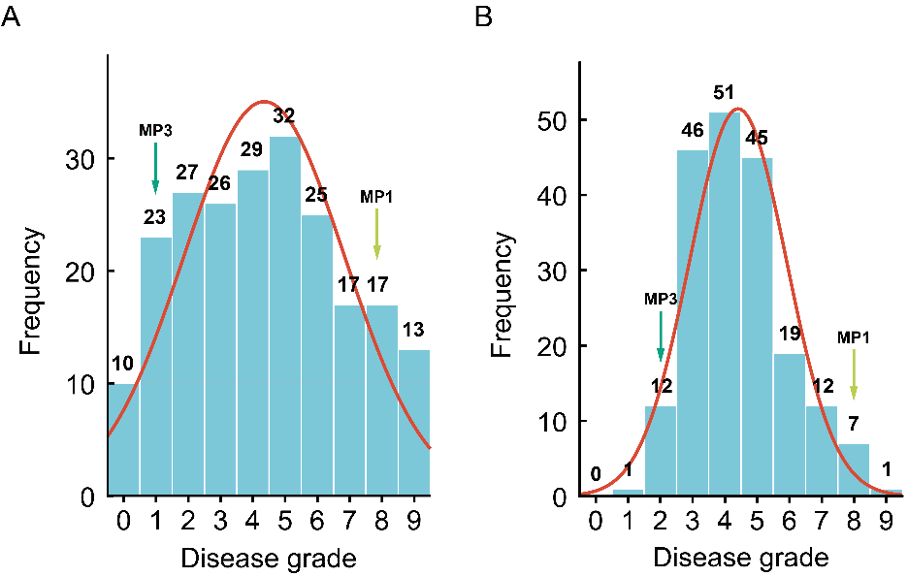

Fig. S1. Frequency distribution of disease severity distribution and normality assessment in the F₂ and RIL populations inoculated with B. sorokiniana. (A) Distribution of disease severity ratings in the F₂ population (n=219) and normality test (kurtosis=-0.708, skewness=0.138). (B) Distribution of disease severity ratings in the RIL population (n=194) and normality test (kurtosis=0.084, skewness=0.582).

