Supplementary Notes

Table of Contents

Supplementary Note 1: Genetic overlap results in SECA 5
1. Summarised SECA results: genetic overlap between AD and GIT disorders 6
Supplementary Note Table 1: Simplified SECA results summarising genetic overlap between AD and GIT disorders 6
1. SECA Results: AD vs PGM 7
Supplementary Note Table 2: genetic overlap between AD (P1) and PGM (P2) 7
Supplementary Note Figure 1: Heatmap: genetic overlap between AD (P1) and PGM (P2) 7
Supplementary Note Table 3: Genetic overlap between PGM (P1) and AD (P2) 7
Supplementary Note Figure 2: Heatmap: genetic overlap between PGM (P1) and AD (P2) 8
2. SECA Results: AD vs PUD 8
Supplementary Note Table 4: Genetic overlap between AD (P1) and PUD (P2) 8
Supplementary Note Figure 3: Heatmap: genetic overlap between AD (P1) and PUD (P2) 9
Supplementary Note Table 5: Genetic overlap between PUD (P1) and AD (P2) 9
Supplementary Note Figure 4: Heatmap: genetic overlap between PUD (P1) and AD (P2) 10
3. SECA Results: AD vs IBS 10
Supplementary Note Table 6: Genetic overlap between AD (P1) and IBS (P2) 10
Supplementary Note Figure 5: Heatmap: genetic overlap between AD (P1) and IBS (P2) 11
Supplementary Note Table 7: Genetic overlap between IBS (P1) and AD (P2) 11
Supplementary Note Figure 6: Heatmap: genetic overlap between IBS (P1) and AD (P2) 12
4. SECA Results: AD vs IBD-wuª 12
Supplementary Note Table 8: Genetic overlap between AD (P1) and IBD-wuª (P2) 12
Supplementary Note Figure 7: Heatmap: genetic overlap between AD (P1) and IBD (P2) 13
Supplementary Note Table 9: Genetic overlap between IBD-wu (P1) and AD (P2) 13
Supplementary Note Figure 8: Heatmap: genetic overlap between IBD (P1) and AD (P2) 14
5. SECA Results: AD vs Gastritis-duodenitis 14
Supplementary Note Table 10: Genetic overlap between AD (P1) and Gastritis-duodenitis (P2) 14
Supplementary Note Figure 9: Heatmap: genetic overlap between AD (P1) and Gastritis-duodenitis (P2) 15
Supplementary Note Table 11: Genetic overlap between Gastritis-duodenitis (P1) and AD (P2) 15
Supplementary Note Figure 10: Heatmap: genetic overlap between Gastritis-duodenitis (P1) and AD (P2) 16
6. SECA Results: AD vs GERD 16
Supplementary Note Table 12: Genetic overlap between AD (P1) and GERD (P2) 16
Supplementary Note Figure 11: Heatmap: genetic overlap between AD (P1) and GERD (P2) 17
Supplementary Note Table 13: Genetic overlap between GERD (P1) and AD (P2) 17
Supplementary Note Figure 12: Heatmap: genetic overlap between GERD (P1) and AD (P2) 18
7. SECA Results: AD vs Diverticular disease 18
Supplementary Note Table 14: Genetic overlap between AD (P1) and Diverticular (P2) 18
Supplementary Note Figure 13: Heatmap: genetic overlap between AD (P1) and Diverticular disease (P2) 19
Supplementary Note Table 15: Genetic overlap between Diverticular (P) and AD (P1) 19
Supplementary Note Figure 14: Heatmap: genetic overlap between Diverticular disease (P1) and AD (P2) 20
8. SECA Results: AD vs Inflammatory Bowel Disease 20
Supplementary Note Table 16: Genetic overlap between AD (P1) and Inflammatory Bowel Disease^{b} (P2) 20
Supplementary Note Figure 15: Heatmap: genetic overlap between AD (P1) and Inflammatory Bowel Disease (P2). 21
Supplementary Note Table 17: Genetic overlap between Inflammatory Bowel Diseaseª (P1) and AD (P1) 21
Supplementary Note Figure 16: Heatmap: genetic overlap between Inflammatory Bowel Disease (P1) and AD (P2). 22
9. Remark 22
Supplementary Note II: Causality assessment results (AD and GIT disorders) 23
A. Mendelian randomisation analysis: AD GWAS (exposure) vs PGM GWAS (outcome) 23
1. Scatter plot for AD and PGM MR analysis 24
2. Forest plot for AD and PGM MR analysis 25
3. Leave one out plot for AD and PGM MR analysis 25
4. Funnel plot for AD and PGM MR analysis 25
B. Mendelian randomisation analysis: PGM GWAS (exposure) vs AD (outcome) 26
1. Scatter plot for PGM and AD MR analysis 26
2. Forest plot for PGM and AD MR analysis 27
3. Leave one out plot for PGM and AD MR analysis 27
4. Funnel plot for PGM and AD MR analysis 28
C. Mendelian randomisation analysis of AD (exposure) vs GERD (outcome) 28
1. Scatter plot for AD and GERD MR analysis 28
2. Forest plot for AD and GERD MR analysis 29
3. Leave one out plot for AD and GERD MR analysis 29
4. Funnel plot for AD and GERD MR analysis 30
D. Mendelian randomisation analysis of GERD (exposure) vs AD (outcome) 30
1. Scatter plot for GERD and AD MR analysis 30
2. Forest plot for GERD and AD MR analysis 31
3. Leave one out plot for GERD and AD MR analysis 31
4. Funnel plot for GERD and AD MR analysis 32
E. Mendelian randomisation analysis of AD (exposure) vs PUD (outcome) 32
1. Scatter plot for AD and PUD MR analysis 32
2. Forest plot for AD and PUD MR analysis 33
3. Leave one out plot for AD and PUD MR analysis 33
4. Funnel plot for AD and PUD MR analysis 34
F. Mendelian randomisation analysis of PUD (exposure) vs AD (outcome) 34
1. Scatter plot for PUD and AD MR analysis 34
2. Forest plot for PUD and AD MR analysis 35
3. Leave one out plot for PUD and AD MR analysis 35
4. Funnel plot for PUD and AD MR analysis 36
G. Mendelian randomisation analysis of AD (exposure) vs IBS (outcome) 36
1. Scatter plot for AD and IBS MR analysis 36
2. Forest plot for AD and IBS MR analysis 37
3. Leave one out plot for AD and IBS MR analysis 37
4. Funnel plot for AD and IBS MR analysis 38
H. Mendelian randomisation analysis of AD (exposure) vs IBD (outcome) 38
1. Scatter plot for AD and IBD MR analysis 38
2. Forest plot for AD and IBD MR analysis 39
3. Leave one out plot for AD and IBD MR analysis 39
4. Funnel plot for AD and IBD MR analysis 40
I. Mendelian randomisation analysis of IBD (exposure) vs AD (outcome) 40
1. Scatter plot for IBD and AD MR analysis 40
2. Forest plot for IBD and AD MR analysis 41
3. Leave one out plot for IBD and AD MR analysis 41
4. Funnel plot for IBD and AD MR analysis 42
J. Mendelian randomisation analysis of AD (exposure) vs Diverticular disease (outcome) 42
1. Scatter plot for AD and Diverticular disease MR analysis 42
2. Forest plot for AD and Diverticular disease MR analysis 43
3. Leave one out plot for AD and Diverticular disease MR analysis 43
4. Funnel plot for AD and Diverticular disease MR analysis 44
K. Mendelian randomisation analysis of Diverticular disease (exposure) vs AD (outcome) 44
1. Scatter plot for Diverticular disease and AD MR analysis 44
2. Forest plot for Diverticular disease and AD MR analysis 45
3. Leave one out plot for Diverticular disease and AD MR analysis 45
4. Funnel plot for Diverticular disease and AD MR analysis 46
Supplementary Note III: Pathway-based analysis of AD and PGM GWAS 47
References 50

Supplementary Note 1: Genetic overlap results in SECA

This Supplementary Note summarises the results of analyses assessing the single nucleotide polymorphism (SNP)-level genetic overlap relationship between Alzheimer’s disease (AD) [1] and several gastrointestinal tract (GIT) disorders [2] using SNP effect concordance analysis (SECA) method [3]. The GIT disorders assessed in this study include peptic ulcer disease (PUD) [2], gastroesophageal reflux disease (GERD) [4], gastritis-duodenitis [5], diverticular disease [5], irritable bowel syndrome (IBS) [5], inflammatory bowel disease (IBD) [2, 5] and medication commonly used for PUD and GERD (PGM) [2].
The first section of this note provides a simplified summary of SECA results across AD GWAS and each of the GIT-disorder GWAS (Supplementary Note Table 1). The second section provides more detailed results (Tables and heatmap plots) for the assessment of AD GWAS against each of the GIT-disorder GWAS. The GWAS data utilised in the present study have been well described in the associated publications (referenced) and are summarised in Supplementary Table 1.

Summarised SECA results: genetic overlap between AD and GIT disorders

Supplementary Note Table 1: Simplified SECA results summarising genetic overlap between AD and GIT disorders

Test in SECA | SNP subsets ratio  (144 total) (OR > 1, P < 0.05) | P_{permuted} | Interpretation
AD (P1) vs GERD (P2) | 144 | 0.000999 | Significant
GERD (P1) vs AD (P2) | 144 | 0.000999 | Significant
AD (P1) vs Gastritis-D (P2) | 144 | 0.000999 | Significant
Gastritis-D (P1) vs AD (P2) | 135 | 0.000999 | Significant
AD (P1) vs PGM (P2) | 144 | 0.000999 | Significant
PGM (P1) vs AD (P2) | 141 | 0.000999 | Significant
AD (P1) vs PUD (P2) | 137 | 0.000999 | Significant
PUD (P1) vs AD | 133 | 0.000999 | Significant
AD (P1) vs IBS (P2) | 134 | 0.000999 | Significant
IBS (P1) vs AD (P2) | 118 | 0.000999 | Significant
AD (P1) vs Diverticular Disease | 111 | 0.000999 | Significant
Diverticular Disease (P1) vs AD (P2) | 97 | 0.002 | Significant
AD (P1) vs IBDª (P2) | 42 | 0.025 | Significant
IBDª (P2) vs AD (P2) | 9 | 0.122 | Not significant
AD (P1) vs Inflammatory Bowel Disease^{b} (P2) | 34 | 0.041 | Significant
Inflammatory Bowel Disease^{b} (P1) vs AD (P2) | 22 | 0.0599 | Not significant
AD: Alzheimer’s disease, GIT: gastro-intestinal tract, GERD: gastroesophageal reflux disease, PUD: peptic ulcer disease, PGM: medications for GERD and PUD, IBS: irritable bowel syndrome, IBD: Inflammatory bowel disease. P1: P-value for the dataset, P2: P-value for dataset 2, SNP: Single Nucleotide Polymorphism, OR: Odds ratio for the effect direction concordance association test for P1 and P2. Note: we used two different IBD GWAS having different samples (cases) to assess the relationship between AD and IBD. The first IBDª GWAS was sourced from WU et al., 2021 [2] while the second IBD^{b} GWAS was sourced from the GWAS atlas (ftp://ftp.sanger.ac.uk/pub/consortia/ibdgenetics/iibdgc-trans-ancestry-filtered-summary-stats.tgz) [6]. The results suggest greater sample size for cases of IBD produced improved overlap with AD, thus indicating that using more powerful GWAS for IBD will likely produce greater genetic overlap with AD.

SECA Results: AD vs PGM

Supplementary Note Table 2: genetic overlap between AD (P1) and PGM (P2)
P1 | P2 | P1P2snp | Concord | Prop | FtestOR | FtestPval
1 | 1 | 45669 | 23453 | 0.51 | 1.11 | 7.71E-09
0.9 | 0.9 | 41204 | 21227 | 0.52 | 1.13 | 7.34E-10
0.8 | 0.8 | 36454 | 18831 | 0.52 | 1.14 | 2.67E-10
0.7 | 0.7 | 31671 | 16432 | 0.52 | 1.16 | 2.27E-11
0.6 | 0.6 | 26965 | 14039 | 0.52 | 1.18 | 1.26E-11
0.5 | 0.5 | 22334 | 11675 | 0.52 | 1.2 | 1.15E-11
0.4 | 0.4 | 17609 | 9260 | 0.53 | 1.23 | 6.92E-12
0.3 | 0.3 | 12999 | 6956 | 0.54 | 1.32 | 1.41E-15
0.2 | 0.2 | 8305 | 4517 | 0.54 | 1.42 | 1.56E-15
0.1 | 0.1 | 3831 | 2142 | 0.56 | 1.61 | 2.63E-13
0.05 | 0.05 | 1673 | 955 | 0.57 | 1.77 | 7.58E-09
0.01 | 0.01 | 234 | 141 | 0.60 | 2.31 | 2.45E-03
AD: Alzheimer’s disease, PGM: medications for GERD and PUD, GERD: gastroesophageal reflux disease, PUD: peptic ulcer disease, P1: P-value for the dataset, P2: P-value for dataset 2, P1P2snp: Independent SNPs overlapping AD (P1) and PGM (P2) at each of the SNP subsets, Concord: number of concordant SNPs, SNP: Single Nucleotide Polymorphism, Ftest: Fisher’s Exact test, OR: Odds ratio for the effect direction concordance association test for P1 and P2. Pval: Fisher’s exact P-value for the effect direction concordance association test between AD (P1) and PGM (P2).

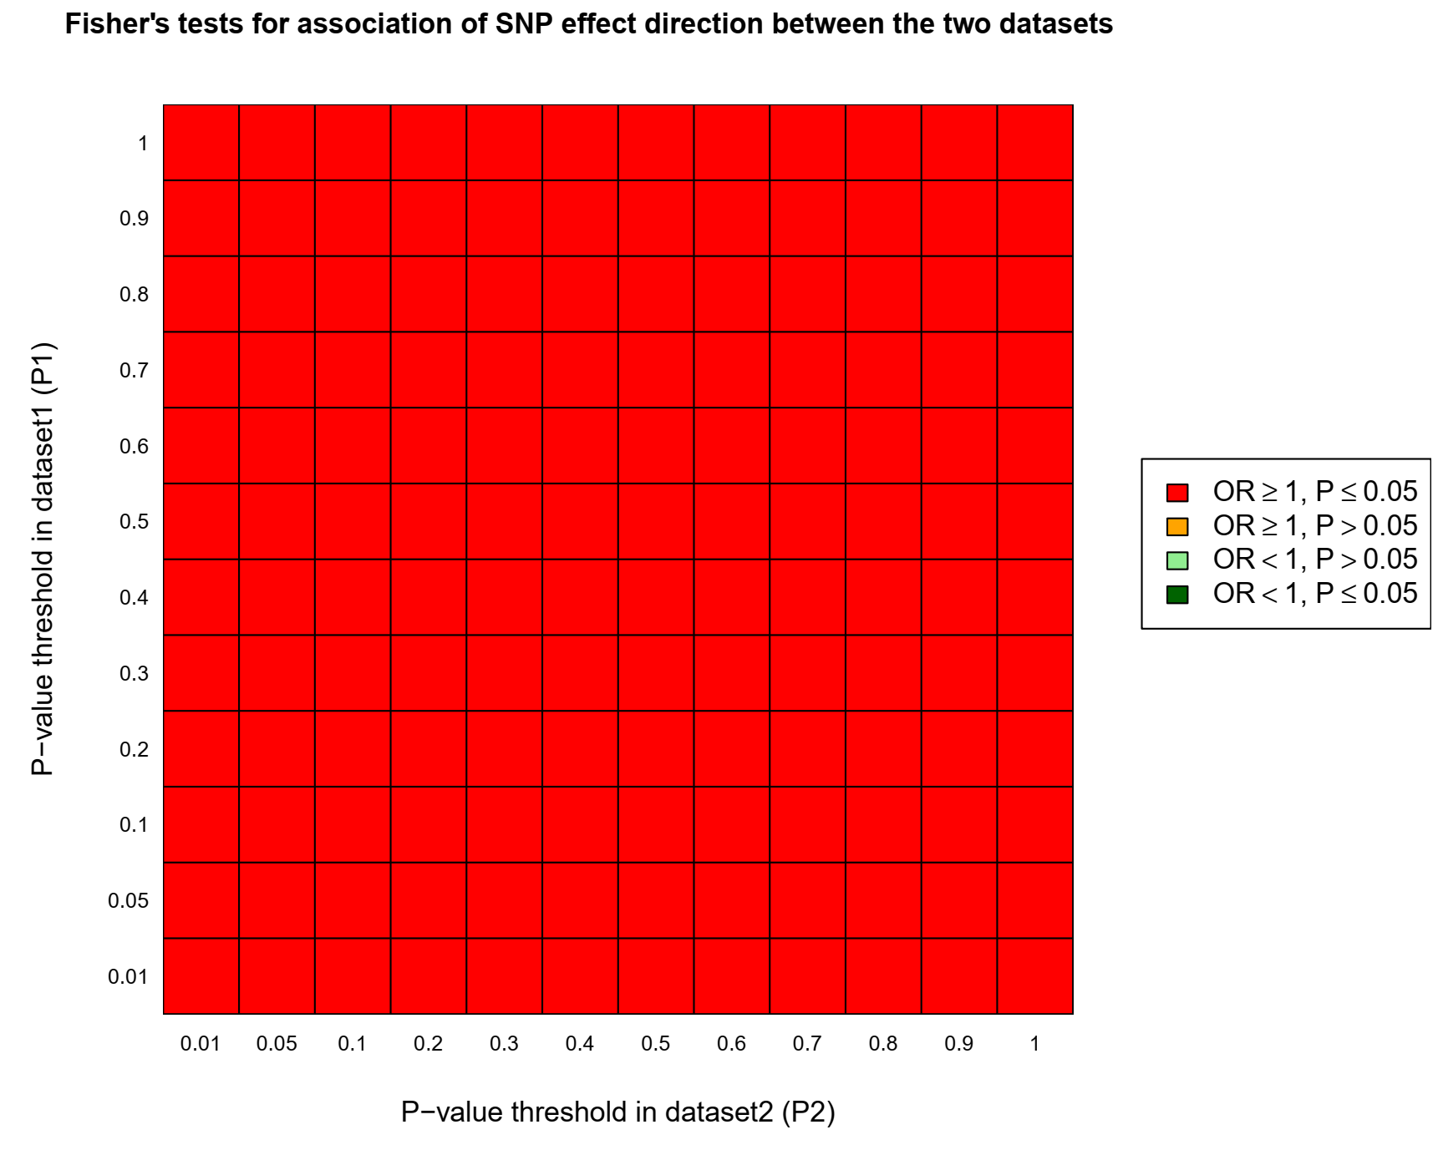

Supplementary Note Figure 1: Heatmap: genetic overlap between AD (P1) and PGM (P2)

Supplementary Note Table 3: Genetic overlap between PGM (P1) and AD (P2)
P1 | P2 | P1P2snp | Concord | Prop | FtestOR | FtestPval
1 | 1 | 56835 | 29282 | 0.52 | 1.13 | 4.20E-13
0.9 | 0.9 | 50574 | 26162 | 0.52 | 1.15 | 7.63E-15
0.8 | 0.8 | 44363 | 23104 | 0.52 | 1.18 | 2.20E-18
0.7 | 0.7 | 38007 | 19810 | 0.52 | 1.19 | 1.34E-16
0.6 | 0.6 | 31772 | 16577 | 0.52 | 1.19 | 1.06E-14
0.5 | 0.5 | 25776 | 13515 | 0.52 | 1.22 | 5.62E-15
0.4 | 0.4 | 19745 | 10443 | 0.53 | 1.26 | 4.86E-16
0.3 | 0.3 | 13895 | 7379 | 0.53 | 1.28 | 2.58E-13
0.2 | 0.2 | 8379 | 4473 | 0.53 | 1.31 | 7.09E-10
0.1 | 0.1 | 3533 | 1912 | 0.54 | 1.39 | 1.05E-06
0.05 | 0.05 | 1374 | 765 | 0.56 | 1.58 | 3.16E-05
0.01 | 0.01 | 173 | 97 | 0.56 | 1.59 | 1.70E-01
AD: Alzheimer’s disease, PGM: medications for GERD and PUD, GERD: gastroesophageal reflux disease, PUD: peptic ulcer disease, P1: P-value for the dataset, P2: P-value for dataset 2, P1P2snp: Independent SNPs overlapping PGM (P1) and AD (P2) at each of the SNP subsets, Concord: number of concordant SNPs, SNP: Single Nucleotide Polymorphism, Ftest: Fisher’s Exact test, OR: Odds ratio for the effect direction concordance association test for P1 and P2. Pval: Fisher’s exact P-value for the effect direction concordance association test between PGM (P1) and AD (P2).

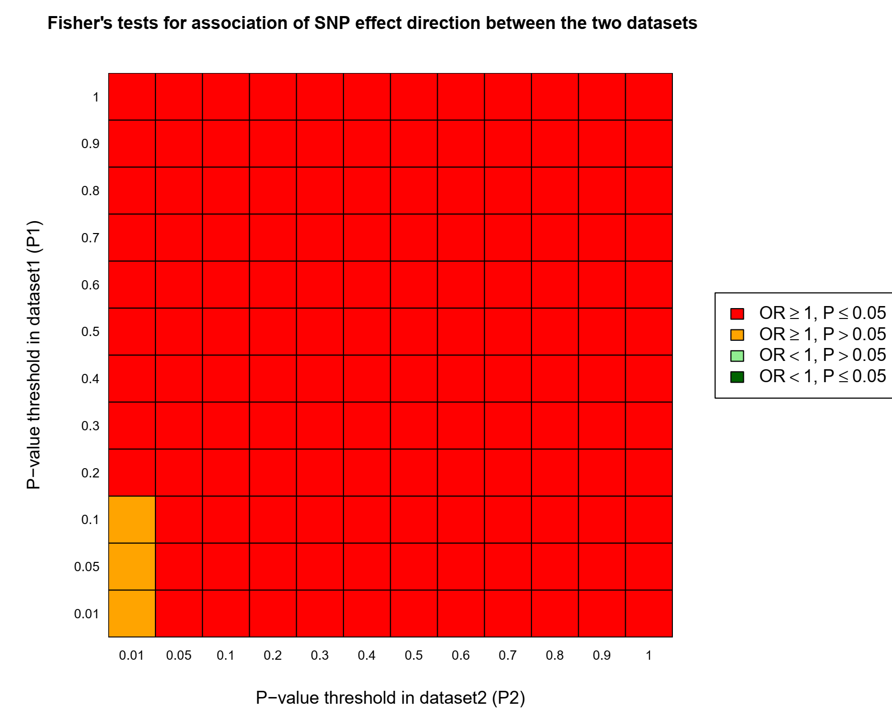

Supplementary Note Figure 2: Heatmap: genetic overlap between PGM (P1) and AD (P2)

SECA Results: AD vs PUD

Supplementary Note Table 4: Genetic overlap between AD (P1) and PUD (P2)
P1 | P2 | P1P2snp | Concord | Prop | FtestOR | FtestPval
1 | 1 | 45669 | 23227 | 0.51 | 1.07 | 2.44E-04
0.9 | 0.9 | 40908 | 20836 | 0.51 | 1.08 | 1.65E-04
0.8 | 0.8 | 35946 | 18303 | 0.51 | 1.08 | 5.19E-04
0.7 | 0.7 | 31043 | 15796 | 0.51 | 1.07 | 1.94E-03
0.6 | 0.6 | 26151 | 13357 | 0.51 | 1.09 | 5.34E-04
0.5 | 0.5 | 21278 | 10895 | 0.51 | 1.1 | 4.72E-04
0.4 | 0.4 | 16435 | 8509 | 0.52 | 1.15 | 6.04E-06
0.3 | 0.3 | 11653 | 6078 | 0.52 | 1.19 | 3.62E-06
0.2 | 0.2 | 7115 | 3710 | 0.52 | 1.19 | 3.12E-04
0.1 | 0.1 | 3015 | 1583 | 0.53 | 1.22 | 6.30E-03
0.05 | 0.05 | 1155 | 624 | 0.54 | 1.38 | 8.09E-03
0.01 | 0.01 | 111 | 67 | 0.60 | 2.37 | 3.72E-02
AD: Alzheimer’s disease, PUD: peptic ulcer disease, P1: P-value for the dataset, P2: P-value for dataset 2, P1P2snp: Independent SNPs overlapping AD (P1) and PUD (P2) at each of the SNP subsets, Concord: number of concordant SNPs, SNP: Single Nucleotide Polymorphism, Ftest: Fisher’s Exact test, OR: Odds ratio for the effect direction concordance association test for P1 and P2. Pval: Fisher’s exact P-value for the effect direction concordance association test between AD (P1) and PUD (P2).

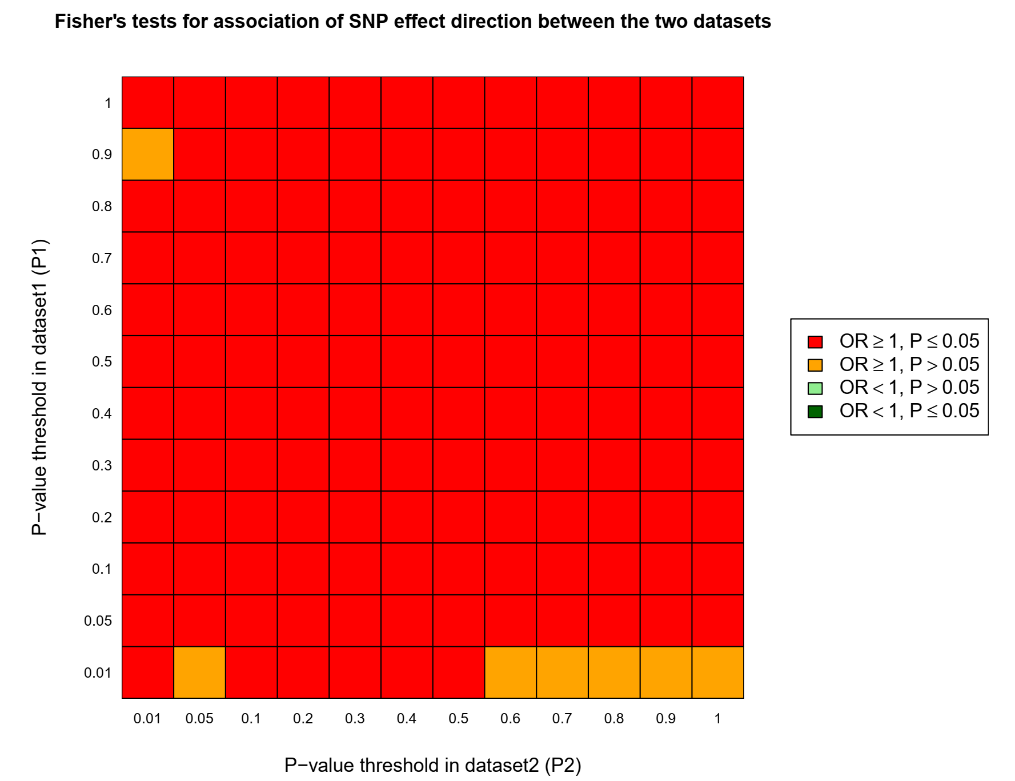

Supplementary Note Figure 3: Heatmap: genetic overlap between AD (P1) and PUD (P2)

Supplementary Note Table 5: Genetic overlap between PUD (P1) and AD (P2)
P1 | P2 | P1P2snp | Concord | Prop | FtestOR | FtestPval
1 | 1 | 56690 | 28731 | 0.51 | 1.06 | 1.22E-03
0.9 | 0.9 | 50348 | 25546 | 0.51 | 1.06 | 9.43E-04
0.8 | 0.8 | 44008 | 22346 | 0.51 | 1.06 | 1.15E-03
0.7 | 0.7 | 37723 | 19175 | 0.51 | 1.07 | 1.27E-03
0.6 | 0.6 | 31357 | 15996 | 0.51 | 1.08 | 3.43E-04
0.5 | 0.5 | 25167 | 12862 | 0.51 | 1.09 | 4.57E-04
0.4 | 0.4 | 19336 | 9930 | 0.51 | 1.11 | 1.74E-04
0.3 | 0.3 | 13452 | 6971 | 0.52 | 1.16 | 2.39E-05
0.2 | 0.2 | 7958 | 4121 | 0.52 | 1.15 | 1.57E-03
0.1 | 0.1 | 3177 | 1691 | 0.53 | 1.3 | 2.95E-04
0.05 | 0.05 | 1184 | 652 | 0.55 | 1.5 | 5.99E-04
0.01 | 0.01 | 120 | 71 | 0.59 | 2.23 | 4.42E-02
AD: Alzheimer’s disease, PUD: peptic ulcer disease, P1: P-value for the dataset, P2: P-value for dataset 2, P1P2snp: Independent SNPs overlapping PUD (P1) and AD (P2) at each of the SNP subsets, Concord: number of concordant SNPs, SNP: Single Nucleotide Polymorphism, Ftest: Fisher’s Exact test, OR: Odds ratio for the effect direction concordance association test for P1 and P2. Pval: Fisher’s exact P-value for the effect direction concordance association test between PUD (P1) and AD (P2).

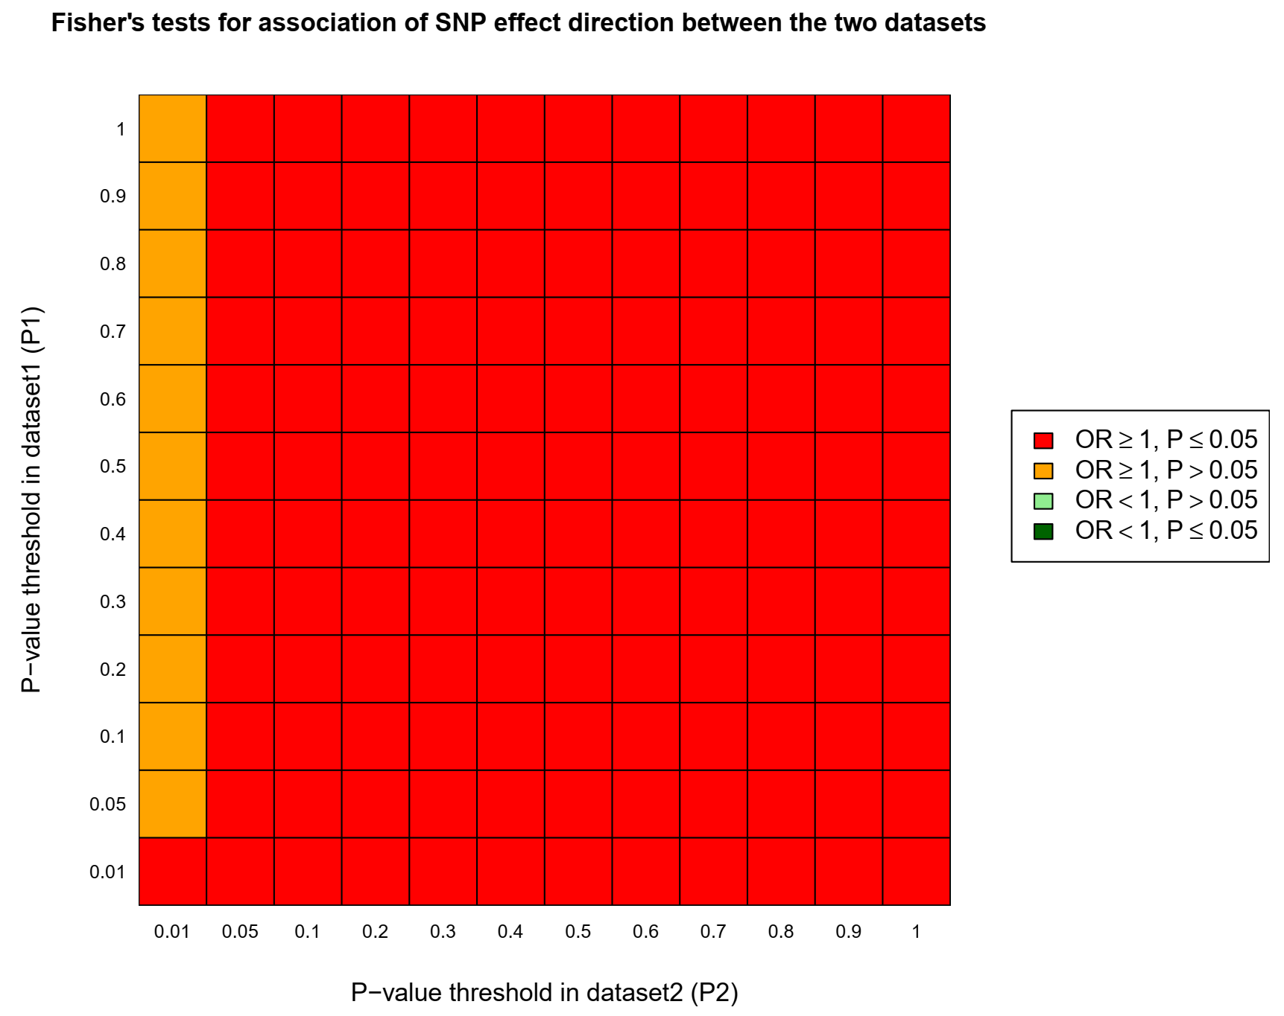

Supplementary Note Figure 4: Heatmap: genetic overlap between PUD (P1) and AD (P2)

SECA Results: AD vs IBS

Supplementary Note Table 6: Genetic overlap between AD (P1) and IBS (P2)
P1 | P2 | P1P2snp | Concord | Prop | FtestOR | FtestPval
1 | 1 | 45669 | 23268 | 0.51 | 1.08 | 5.07E-05
0.9 | 0.9 | 41049 | 20879 | 0.51 | 1.07 | 4.75E-04
0.8 | 0.8 | 35988 | 18380 | 0.51 | 1.09 | 4.93E-05
0.7 | 0.7 | 31012 | 15867 | 0.51 | 1.1 | 4.13E-05
0.6 | 0.6 | 26159 | 13372 | 0.51 | 1.09 | 3.20E-04
0.5 | 0.5 | 21226 | 10938 | 0.52 | 1.13 | 8.66E-06
0.4 | 0.4 | 16310 | 8409 | 0.52 | 1.13 | 7.41E-05
0.3 | 0.3 | 11764 | 6131 | 0.52 | 1.19 | 4.39E-06
0.2 | 0.2 | 7195 | 3782 | 0.53 | 1.23 | 1.43E-05
0.1 | 0.1 | 3049 | 1639 | 0.54 | 1.35 | 3.62E-05
0.05 | 0.05 | 1199 | 659 | 0.55 | 1.49 | 6.52E-04
0.01 | 0.01 | 133 | 81 | 0.61 | 2.35 | 2.33E-02
AD: Alzheimer’s disease, IBS: Irritable Bowel Disease, P1: P-value for the dataset, P2: P-value for dataset 2, P1P2snp: Independent SNPs overlapping AD (P1) and IBS (P2) at each of the SNP subsets, Concord: number of concordant SNPs, SNP: Single Nucleotide Polymorphism, Ftest: Fisher’s Exact test, OR: Odds ratio for the effect direction concordance association test for P1 and P2. Pval: Fisher’s exact P-value for the effect direction concordance association test between AD (P1) and IBS (P2).

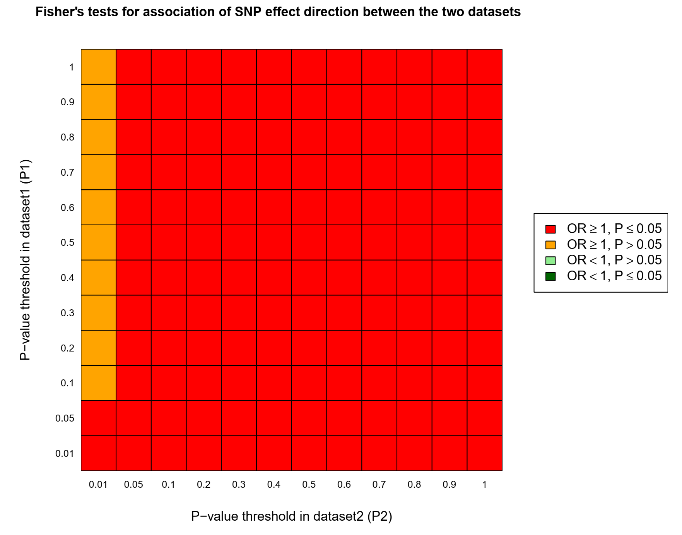

Supplementary Note Figure 5: Heatmap: genetic overlap between AD (P1) and IBS (P2)

Supplementary Note Table 7: Genetic overlap between IBS (P1) and AD (P2)
P1 | P2 | P1P2snp | Concord | Prop | FtestOR | FtestPval
1 | 1 | 56684 | 28803 | 0.51 | 1.07 | 1.08E-04
0.9 | 0.9 | 50516 | 25683 | 0.51 | 1.07 | 1.56E-04
0.8 | 0.8 | 44171 | 22480 | 0.51 | 1.07 | 1.84E-04
0.7 | 0.7 | 37676 | 19202 | 0.51 | 1.08 | 1.84E-04
0.6 | 0.6 | 31388 | 16038 | 0.51 | 1.09 | 1.08E-04
0.5 | 0.5 | 25181 | 12897 | 0.51 | 1.1 | 1.21E-04
0.4 | 0.4 | 19133 | 9807 | 0.51 | 1.11 | 5.20E-04
0.3 | 0.3 | 13305 | 6915 | 0.52 | 1.17 | 5.54E-06
0.2 | 0.2 | 7977 | 4127 | 0.52 | 1.15 | 2.00E-03
0.1 | 0.1 | 3269 | 1712 | 0.52 | 1.21 | 7.05E-03
0.05 | 0.05 | 1246 | 638 | 0.51 | 1.1 | 4.28E-01
0.01 | 0.01 | 101 | 55 | 0.54 | 1.48 | 4.28E-01
AD: Alzheimer’s disease, IBS: Irritable Bowel Disease, P1: P-value for the dataset, P2: P-value for dataset 2, P1P2snp: Independent SNPs overlapping IBS (P1) and AD (P2) at each of the SNP subsets, Concord: number of concordant SNPs, SNP: Single Nucleotide Polymorphism, Ftest: Fisher’s Exact test, OR: Odds ratio for the effect direction concordance association test for P1 and P2. Pval: Fisher’s exact P-value for the effect direction concordance association test between IBS (P1) and AD (P2).

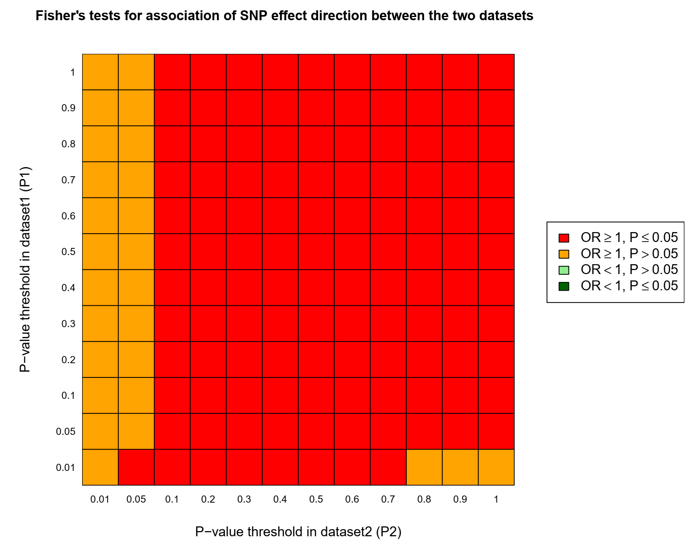

Supplementary Note Figure 6: Heatmap: genetic overlap between IBS (P1) and AD (P2)

SECA Results: AD vs IBD-wuª

Supplementary Note Table 8: Genetic overlap between AD (P1) and IBD-wuª (P2)
P1 | P2 | P1P2snp | Concord | Prop | FtestOR | FtestPval
1 | 1 | 45669 | 22993 | 0.50 | 1.03 | 1.42E-01
0.9 | 0.9 | 40940 | 20618 | 0.50 | 1.03 | 1.46E-01
0.8 | 0.8 | 35839 | 18057 | 0.50 | 1.03 | 1.51E-01
0.7 | 0.7 | 30987 | 15670 | 0.51 | 1.05 | 4.55E-02
0.6 | 0.6 | 26038 | 13216 | 0.51 | 1.06 | 1.51E-02
0.5 | 0.5 | 21164 | 10793 | 0.51 | 1.08 | 4.06E-03
0.4 | 0.4 | 16356 | 8350 | 0.51 | 1.09 | 7.49E-03
0.3 | 0.3 | 11640 | 5935 | 0.51 | 1.08 | 3.30E-02
0.2 | 0.2 | 7179 | 3591 | 0.50 | 1.00 | 9.81E-01
0.1 | 0.1 | 3033 | 1495 | 0.49 | 0.95 | 4.68E-01
0.05 | 0.05 | 1187 | 582 | 0.49 | 0.93 | 5.61E-01
0.01 | 0.01 | 152 | 75 | 0.49 | 1.00 | 1.00E+00
AD: Alzheimer’s disease, IBD: Inflammatory Bowel Disease, P1: P-value for the dataset, P2: P-value for dataset 2, P1P2snp: Independent SNPs overlapping AD (P1) and IBD (P2) at each of the SNP subsets, Concord: number of concordant SNPs, SNP: Single Nucleotide Polymorphism, Ftest: Fisher’s Exact test, OR: Odds ratio for the effect direction concordance association test for P1 and P2. Pval: Fisher’s exact P-value for the effect direction concordance association test between AD (P1) and IBD (P2). The GWAS for IBD-wuª was sourced from WU et al., 2021 [2].

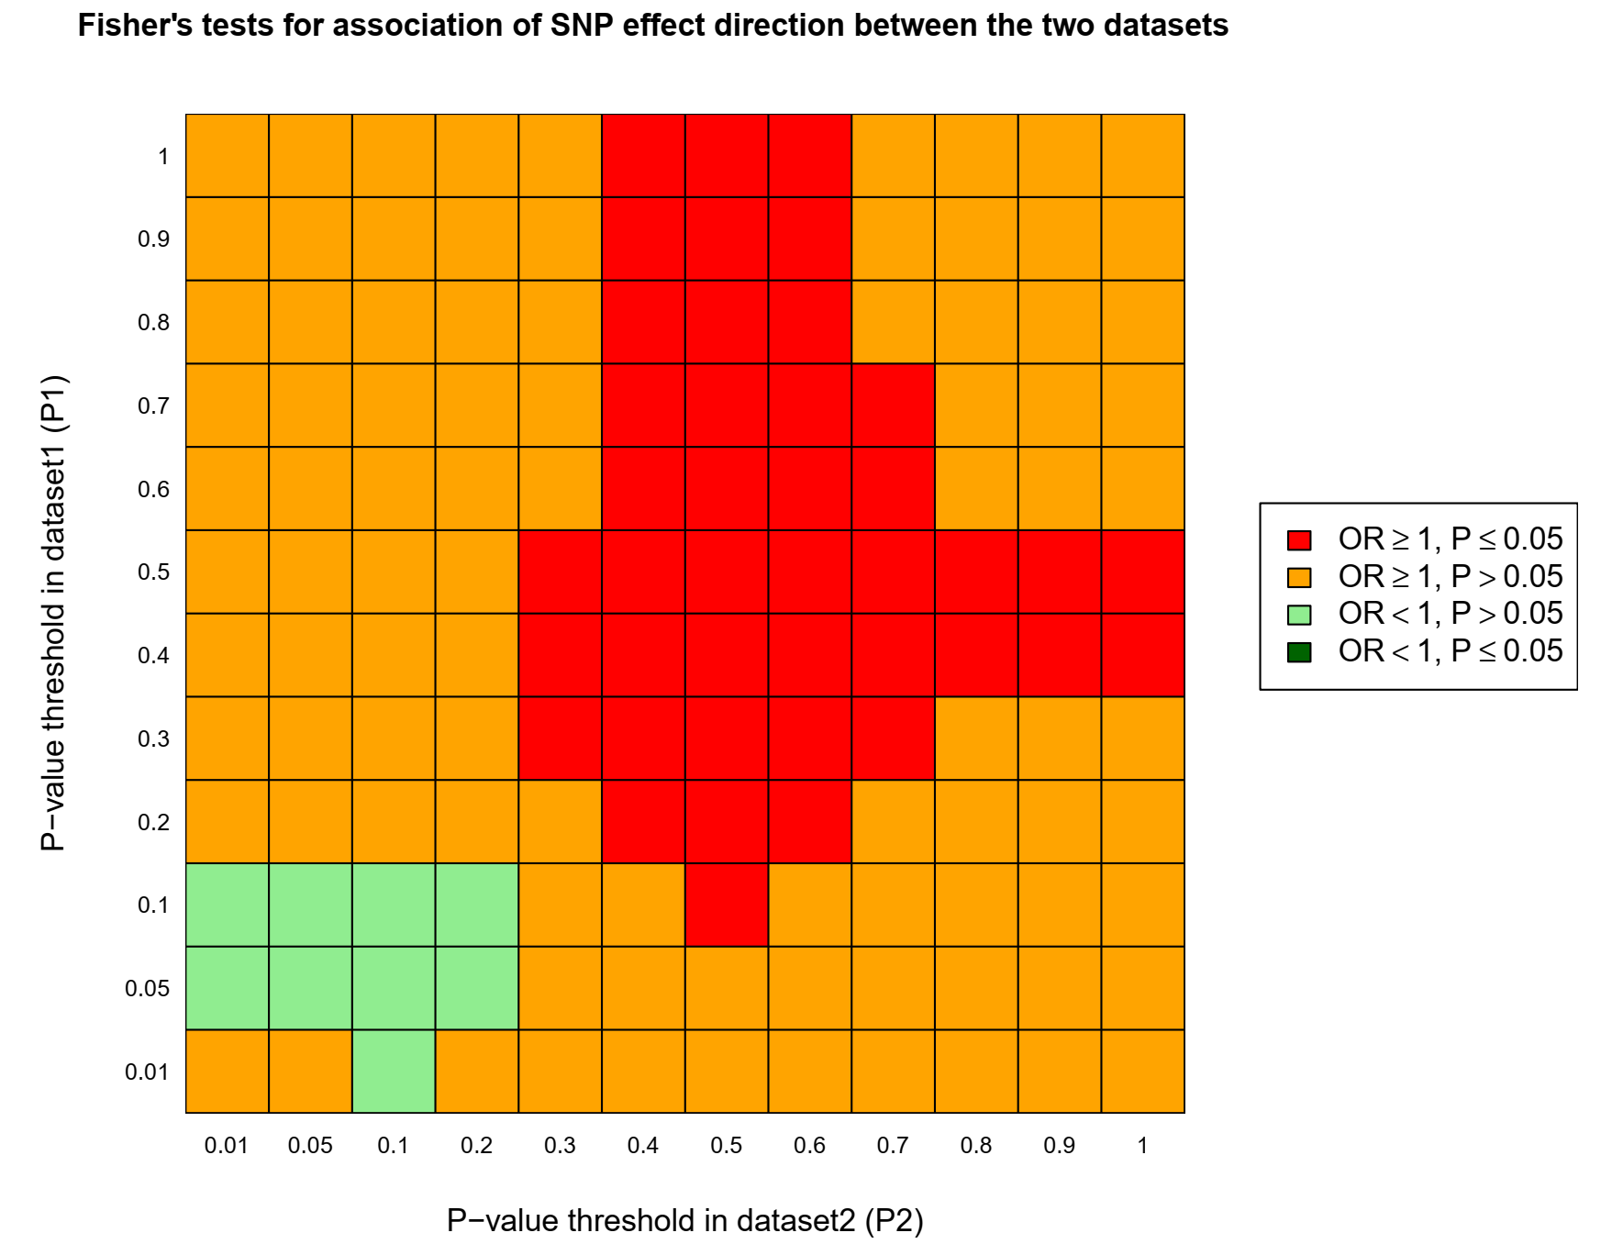

Supplementary Note Figure 7: Heatmap: genetic overlap between AD (P1) and IBD (P2)

Supplementary Note Table 9: Genetic overlap between IBD-wu (P1) and AD (P2)
P1 | P2 | P1P2snp | Concord | Prop | FtestOR | FtestPval
1 | 1 | 56858 | 28480 | 0.50 | 1.01 | 6.75E-01
0.9 | 0.9 | 50533 | 25368 | 0.50 | 1.02 | 3.69E-01
0.8 | 0.8 | 44165 | 22251 | 0.50 | 1.03 | 1.10E-01
0.7 | 0.7 | 37822 | 19055 | 0.50 | 1.03 | 1.41E-01
0.6 | 0.6 | 31521 | 15865 | 0.50 | 1.03 | 2.46E-01
0.5 | 0.5 | 25412 | 12781 | 0.50 | 1.02 | 3.60E-01
0.4 | 0.4 | 19397 | 9806 | 0.51 | 1.04 | 1.28E-01
0.3 | 0.3 | 13561 | 6873 | 0.51 | 1.06 | 1.18E-01
0.2 | 0.2 | 8045 | 4064 | 0.51 | 1.04 | 3.61E-01
0.1 | 0.1 | 3284 | 1662 | 0.51 | 1.05 | 5.07E-01
0.05 | 0.05 | 1264 | 654 | 0.52 | 1.15 | 2.37E-01
0.01 | 0.01 | 130 | 71 | 0.55 | 1.44 | 3.84E-01
AD: Alzheimer’s disease, IBD: Inflammatory Bowel Disease, P1: P-value for the dataset, P2: P-value for dataset 2, P1P2snp: Independent SNPs overlapping IBD (P1) and AD (P2) at each of the SNP subsets, Concord: number of concordant SNPs, SNP: Single Nucleotide Polymorphism, Ftest: Fisher’s Exact test, OR: Odds ratio for the effect direction concordance association test for P1 and P2. Pval: Fisher’s exact P-value for the effect direction concordance association test between IBD (P1) and AD (P2).

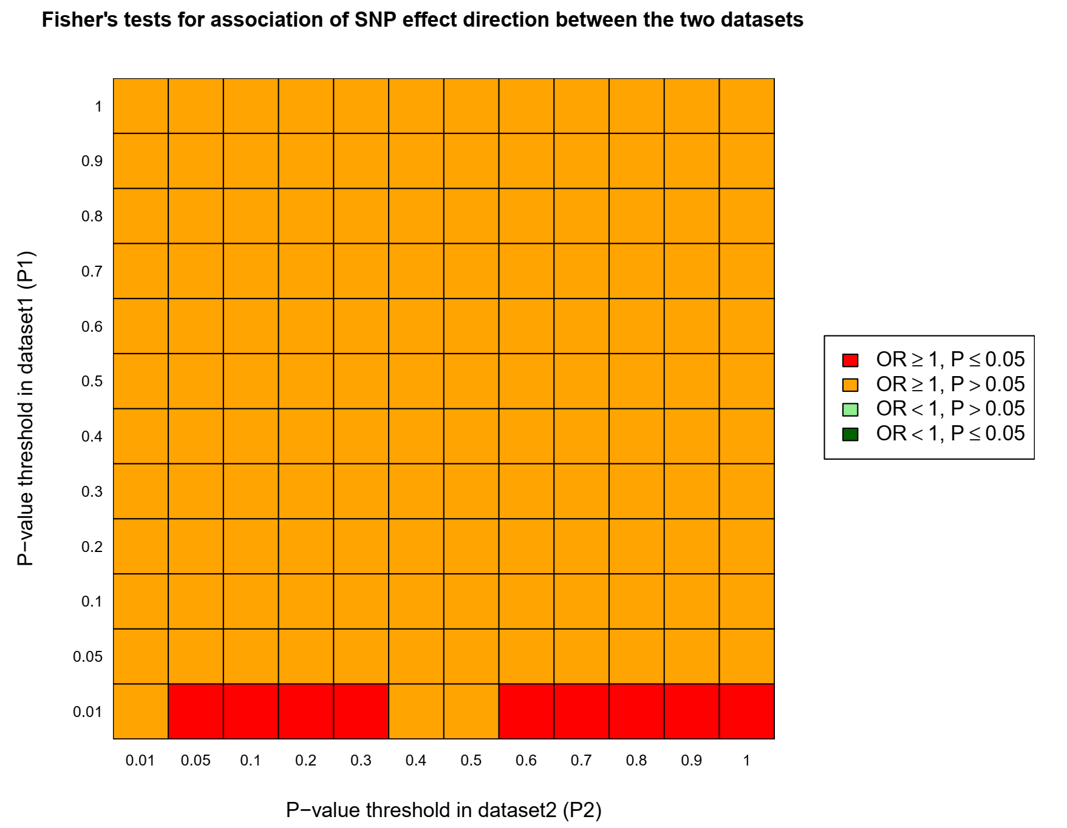

Supplementary Note Figure 8: Heatmap: genetic overlap between IBD (P1) and AD (P2)

SECA Results: AD vs Gastritis-duodenitis

Supplementary Note Table 10: Genetic overlap between AD (P1) and Gastritis-duodenitis (P2)
P1 | P2 | P1P2snp | Concord | Prop | FtestOR | FtestPval
1 | 1 | 51469 | 26274 | 0.51 | 1.09 | 2.11E-06
0.9 | 0.9 | 45767 | 23391 | 0.51 | 1.09 | 2.14E-06
0.8 | 0.8 | 40083 | 20465 | 0.51 | 1.09 | 2.49E-05
0.7 | 0.7 | 34540 | 17704 | 0.51 | 1.11 | 3.16E-06
0.6 | 0.6 | 28920 | 14887 | 0.51 | 1.13 | 5.11E-07
0.5 | 0.5 | 23310 | 12083 | 0.52 | 1.16 | 2.22E-08
0.4 | 0.4 | 17991 | 9402 | 0.52 | 1.2 | 1.4E-09
0.3 | 0.3 | 12831 | 6768 | 0.53 | 1.25 | 5.7E-10
0.2 | 0.2 | 7846 | 4170 | 0.53 | 1.29 | 2.76E-08
0.1 | 0.1 | 3355 | 1824 | 0.54 | 1.42 | 5.47E-07
0.05 | 0.05 | 1331 | 751 | 0.56 | 1.68 | 3.1E-06
0.01 | 0.01 | 152 | 92 | 0.61 | 2.34 | 0.0147
AD: Alzheimer’s disease, P1: P-value for the dataset, P2: P-value for dataset 2, P1P2snp: Independent SNPs overlapping AD (P1) and Gastritis-duodenitis (P2) at each of the SNP subsets, Concord: number of concordant SNPs, SNP: Single Nucleotide Polymorphism, Ftest: Fisher’s Exact test, OR: Odds ratio for the effect direction concordance association test for P1 and P2. Pval: Fisher’s exact P-value for the effect direction concordance association test between AD (P1) and Gastritis-duodenitis (P2).

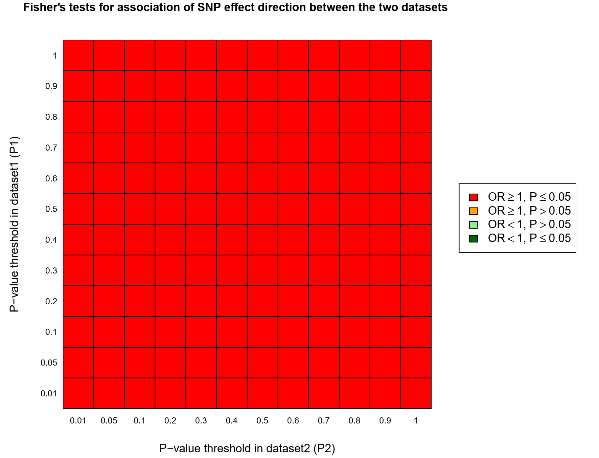

Supplementary Note Figure 9: Heatmap: genetic overlap between AD (P1) and Gastritis-duodenitis (P2)

Supplementary Note Table 11: Genetic overlap between Gastritis-duodenitis (P1) and AD (P2)
P1 | P2 | P1P2snp | Concord | Prop | FtestOR | FtestPval
1 | 1 | 59414 | 30235 | 0.51 | 1.07 | 1.53E-05
0.9 | 0.9 | 52724 | 26872 | 0.51 | 1.08 | 9.27E-06
0.8 | 0.8 | 46012 | 23564 | 0.51 | 1.1 | 2.06E-07
0.7 | 0.7 | 39289 | 20198 | 0.51 | 1.12 | 2.55E-08
0.6 | 0.6 | 32723 | 16865 | 0.52 | 1.13 | 2.84E-08
0.5 | 0.5 | 26311 | 13622 | 0.52 | 1.15 | 9.11E-09
0.4 | 0.4 | 20004 | 10439 | 0.52 | 1.19 | 6.39E-10
0.3 | 0.3 | 13947 | 7302 | 0.52 | 1.21 | 2.76E-08
0.2 | 0.2 | 8280 | 4378 | 0.53 | 1.26 | 1.88E-07
0.1 | 0.1 | 3329 | 1793 | 0.54 | 1.36 | 1.06E-05
0.05 | 0.05 | 1257 | 677 | 0.54 | 1.36 | 0.00797
0.01 | 0.01 | 153 | 85 | 0.56 | 1.52 | 0.256
AD: Alzheimer’s disease, P1: P-value for the dataset, P2: P-value for dataset 2, P1P2snp: Independent SNPs overlapping Gastritis-duodenitis (P1) and AD (P2) at each of the SNP subsets, Concord: number of concordant SNPs, SNP: Single Nucleotide Polymorphism, Ftest: Fisher’s Exact test, OR: Odds ratio for the effect direction concordance association test for P1 and P2. Pval: Fisher’s exact P-value for the effect direction concordance association test between Gastritis-duodenitis (P1) and AD (P2).
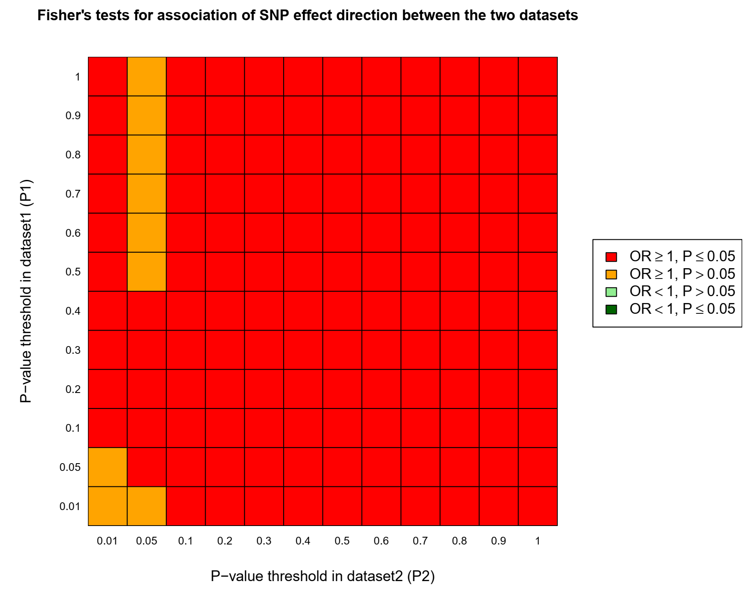

Supplementary Note Figure 10: Heatmap: genetic overlap between Gastritis-duodenitis (P1) and AD (P2)

SECA Results: AD vs GERD

Supplementary Note Table 12: Genetic overlap between AD (P1) and GERD (P2)
P1 | P2 | P1P2snp | Concordant | Prop | FtestOR | FtestPval
1 | 1 | 26963 | 13955 | 0.52 | 1.18 | 4.65E-11
0.9 | 0.9 | 24237 | 12653 | 0.52 | 1.19 | 7.46E-12
0.8 | 0.8 | 21551 | 11289 | 0.52 | 1.21 | 3.02E-12
0.7 | 0.7 | 18759 | 9860 | 0.53 | 1.23 | 2.64E-12
0.6 | 0.6 | 16001 | 8483 | 0.53 | 1.27 | 2.48E-14
0.5 | 0.5 | 13297 | 7081 | 0.53 | 1.3 | 7.54E-14
0.4 | 0.4 | 10432 | 5603 | 0.54 | 1.35 | 3.42E-14
0.3 | 0.3 | 7638 | 4173 | 0.55 | 1.45 | 6.22E-16
0.2 | 0.2 | 4936 | 2755 | 0.56 | 1.6 | 2.86E-16
0.1 | 0.1 | 2283 | 1315 | 0.58 | 1.85 | 4.06E-13
0.05 | 0.05 | 1015 | 585 | 0.58 | 1.84 | 1.74E-06
0.01 | 0.01 | 152 | 93 | 0.61 | 2.34 | 1.47E-02
AD: Alzheimer’s disease, GERD: gastroesophageal reflux disease, P1: P-value for the dataset, P2: P-value for dataset 2, P1P2snp: Independent SNPs overlapping AD (P1) and GERD (P2) at each of the SNP subsets, Concord: number of concordant SNPs, SNP: Single Nucleotide Polymorphism, Ftest: Fisher’s Exact test, OR: Odds ratio for the effect direction concordance association test for P1 and P2. Pval: Fisher’s exact P-value for the effect direction concordance association test between AD (P1) and GERD (P2)
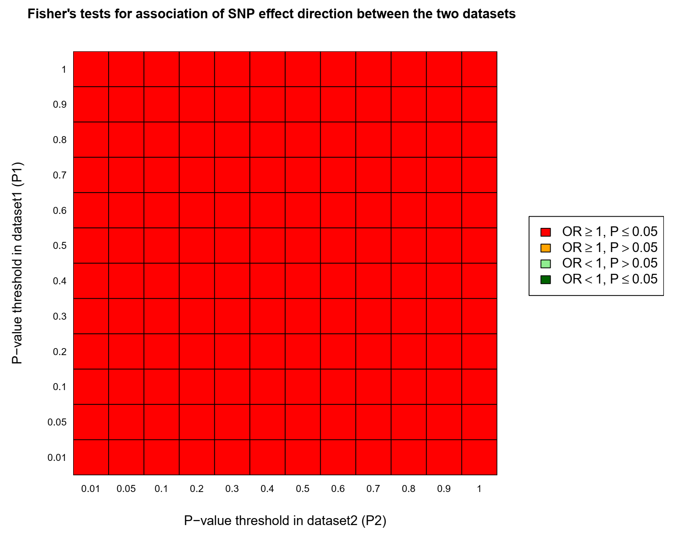

Supplementary Note Figure 11: Heatmap: genetic overlap between AD (P1) and GERD (P2)

Supplementary Note Table 13: Genetic overlap between GERD (P1) and AD (P2)
P1 | P2 | P1P2snp | Concord | Prop-overlap | FtestOR | FtestPval
1 | 1 | 63623 | 32704 | 0.51 | 1.12 | 4.97E-13
0.9 | 0.9 | 56459 | 29098 | 0.52 | 1.13 | 2.74E-13
0.8 | 0.8 | 49228 | 25446 | 0.52 | 1.15 | 6.81E-14
0.7 | 0.7 | 42065 | 21865 | 0.52 | 1.17 | 5.29E-16
0.6 | 0.6 | 35174 | 18368 | 0.52 | 1.2 | 8.85E-17
0.5 | 0.5 | 28332 | 14872 | 0.52 | 1.22 | 5.36E-17
0.4 | 0.4 | 21613 | 11458 | 0.53 | 1.27 | 9.14E-19
0.3 | 0.3 | 15317 | 8165 | 0.53 | 1.3 | 3.24E-16
0.2 | 0.2 | 9305 | 5047 | 0.54 | 1.41 | 3.00E-16
0.1 | 0.1 | 3822 | 2123 | 0.56 | 1.56 | 8.43E-12
0.05 | 0.05 | 1498 | 857 | 0.57 | 1.79 | 2.99E-08
0.01 | 0.01 | 173 | 109 | 0.63 | 2.83 | 1.29E-03
AD: Alzheimer’s disease, GERD: gastroesophageal reflux disease, P1: P-value for the dataset, P2: P-value for dataset 2, P1P2snp: Independent SNPs overlapping GERD (P1) and AD (P2) at each of the SNP subsets, Concord: number of concordant SNPs, SNP: Single Nucleotide Polymorphism, Ftest: Fisher’s Exact test, OR: Odds ratio for the effect direction concordance association test for P1 and P2. Pval: Fisher’s exact P-value for the effect direction concordance association test between GERD (P1) and AD (P2).

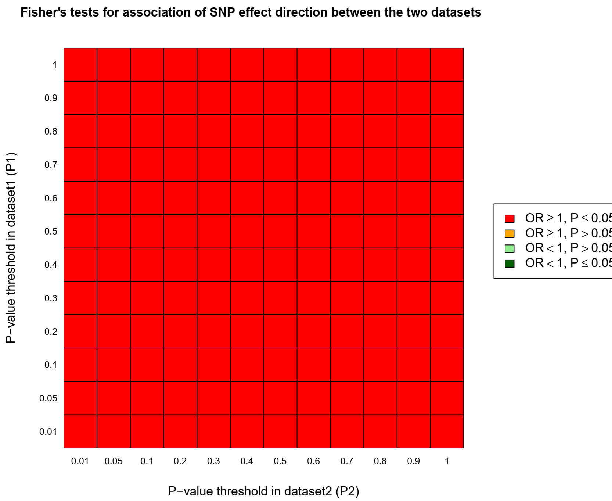

Supplementary Note Figure 12: Heatmap: genetic overlap between GERD (P1) and AD (P2)

SECA Results: AD vs Diverticular disease

Supplementary Note Table 14: Genetic overlap between AD (P1) and Diverticular (P2)
P1 | P2 | P1P2snp | Concord | Prop | FtestOR | FtestPval
1 | 1 | 39511 | 19843 | 0.50 | 1.06 | 3.04E-03
0.9 | 0.9 | 35268 | 17891 | 0.51 | 1.06 | 6.20E-03
0.8 | 0.8 | 30853 | 15682 | 0.51 | 1.07 | 3.83E-03
0.7 | 0.7 | 26643 | 13598 | 0.51 | 1.09 | 7.20E-04
0.6 | 0.6 | 22397 | 11498 | 0.51 | 1.11 | 6.82E-05
0.5 | 0.5 | 18201 | 9357 | 0.51 | 1.12 | 1.56E-04
0.4 | 0.4 | 13988 | 7153 | 0.51 | 1.09 | 7.93E-03
0.3 | 0.3 | 9968 | 5127 | 0.51 | 1.12 | 4.17E-03
0.2 | 0.2 | 6121 | 3168 | 0.52 | 1.15 | 6.22E-03
0.1 | 0.1 | 2591 | 1319 | 0.51 | 1.08 | 3.66E-01
0.05 | 0.05 | 1094 | 575 | 0.53 | 1.23 | 1.03E-01
0.01 | 0.01 | 139 | 74 | 0.53 | 1.33 | 4.96E-01
AD: Alzheimer’s disease, P1: P-value for the dataset, P2: P-value for dataset 2, P1P2snp: Independent SNPs overlapping AD (P1) and Diverticular disease (P2) at each of the SNP subsets, Concord: number of concordant SNPs, SNP: Single Nucleotide Polymorphism, Ftest: Fisher’s Exact test, OR: Odds ratio for the effect direction concordance association test for P1 and P2. Pval: Fisher’s exact P-value for the effect direction concordance association test between AD (P1) and Diverticular disease (P2).

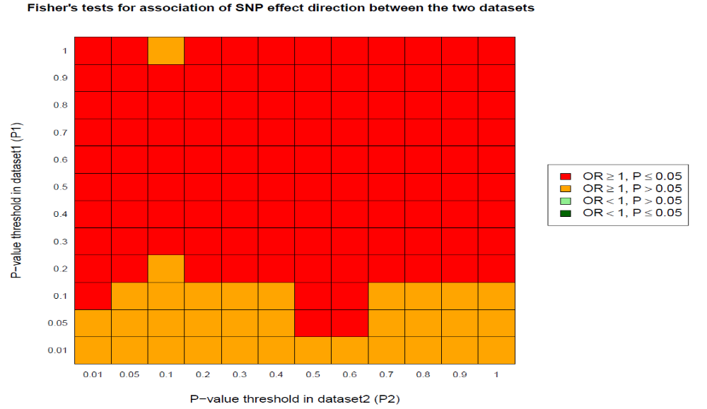

Supplementary Note Figure 13: Heatmap: genetic overlap between AD (P1) and Diverticular disease (P2)

Supplementary Note Table 15: Genetic overlap between Diverticular (P) and AD (P1)
P1 | P2 | P1P2snp | Concord | Prop | FtestOR | FtestPval
1 | 1 | 54508 | 27659 | 0.51 | 1.07 | 1.14E-04
0.9 | 0.9 | 48421 | 24645 | 0.51 | 1.07 | 8.30E-05
0.8 | 0.8 | 42365 | 21597 | 0.51 | 1.08 | 5.99E-05
0.7 | 0.7 | 36261 | 18500 | 0.51 | 1.08 | 1.06E-04
0.6 | 0.6 | 30102 | 15301 | 0.51 | 1.07 | 4.10E-03
0.5 | 0.5 | 24168 | 12331 | 0.51 | 1.09 | 1.48E-03
0.4 | 0.4 | 18459 | 9433 | 0.51 | 1.09 | 2.94E-03
0.3 | 0.3 | 12833 | 6572 | 0.51 | 1.1 | 6.20E-03
0.2 | 0.2 | 7725 | 3954 | 0.51 | 1.1 | 4.06E-02
0.1 | 0.1 | 3112 | 1622 | 0.52 | 1.19 | 1.98E-02
0.05 | 0.05 | 1205 | 619 | 0.51 | 1.12 | 3.57E-01
0.01 | 0.01 | 135 | 70 | 0.52 | 1.2 | 7.30E-01
AD: Alzheimer’s disease, P1: P-value for the dataset, P2: P-value for dataset 2, P1P2snp: Independent SNPs overlapping Diverticular disease (P1) and AD (P2) at each of the SNP subsets, Concord: number of concordant SNPs, SNP: Single Nucleotide Polymorphism, Ftest: Fisher’s Exact test, OR: Odds ratio for the effect direction concordance association test for P1 and P2. Pval: Fisher’s exact P-value for the effect direction concordance association test between Diverticular disease (P1) and AD (P2)

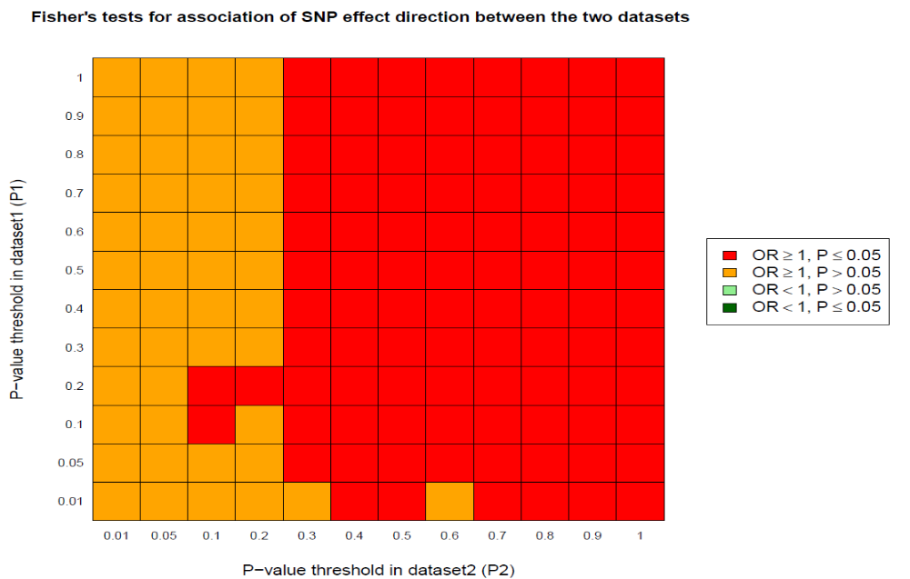

Supplementary Note Figure 14: Heatmap: genetic overlap between Diverticular disease (P1) and AD (P2)

SECA Results: AD vs Inflammatory Bowel Disease

Supplementary Note Table 16: Genetic overlap between AD (P1) and Inflammatory Bowel Disease^{b} (P2)
P1 | P2 | P1P2snp | Concord | Prop | FtestOR | FtestPval
1 | 1 | 62717 | 31499 | 0.50 | 1.02 | 1.23E-01
0.9 | 0.9 | 55771 | 28112 | 0.50 | 1.03 | 5.67E-02
0.8 | 0.8 | 48966 | 24653 | 0.50 | 1.03 | 1.27E-01
0.7 | 0.7 | 42227 | 21270 | 0.50 | 1.03 | 1.29E-01
0.6 | 0.6 | 35493 | 17934 | 0.51 | 1.04 | 4.83E-02
0.5 | 0.5 | 28807 | 14594 | 0.51 | 1.05 | 2.52E-02
0.4 | 0.4 | 22176 | 11259 | 0.51 | 1.06 | 2.16E-02
0.3 | 0.3 | 15895 | 8100 | 0.51 | 1.08 | 1.66E-02
0.2 | 0.2 | 9809 | 4999 | 0.51 | 1.08 | 5.77E-02
0.1 | 0.1 | 4216 | 2158 | 0.51 | 1.1 | 1.31E-01
0.05 | 0.05 | 1768 | 899 | 0.51 | 1.07 | 4.76E-01
0.01 | 0.01 | 236 | 120 | 0.52 | 1.07 | 8.96E-01
AD: Alzheimer’s disease, P1: P-value for the dataset, P2: P-value for dataset 2, P1P2snp: Independent SNPs overlapping AD (P1) and Inflammatory Bowel Disease (P2) at each of the SNP subsets, Concord: number of concordant SNPs, SNP: Single Nucleotide Polymorphism, Ftest: Fisher’s Exact test, OR: Odds ratio for the effect direction concordance association test for P1 and P2. Pval: Fisher’s exact P-value for the effect direction concordance association test between AD (P1) and Inflammatory Bowel Disease (P2). ^{b}The GWAS for the inflammatory Bowel Disease was sourced from the GWAS atlas (ftp://ftp.sanger.ac.uk/pub/consortia/ibdgenetics/iibdgc-trans-ancestry-filtered-summary-stats.tgz) [6].

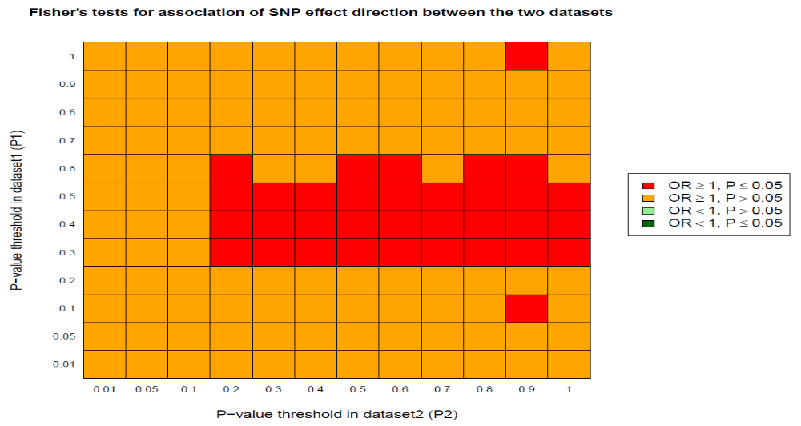

Supplementary Note Figure 15: Heatmap: genetic overlap between AD (P1) and Inflammatory Bowel Disease (P2).

Supplementary Note Table 17: Genetic overlap between Inflammatory Bowel Diseaseª (P1) and AD (P1)
P1 | P2 | P1P2snp | Concord | Prop | FtestOR | FtestPval
1 | 1 | 56450 | 28382 | 0.50 | 1.024 | 1.62E-01
0.9 | 0.9 | 50109 | 25234 | 0.50 | 1.029 | 1.12E-01
0.8 | 0.8 | 43823 | 22040 | 0.50 | 1.024 | 2.25E-01
0.7 | 0.7 | 37550 | 18890 | 0.50 | 1.025 | 2.39E-01
0.6 | 0.6 | 31183 | 15631 | 0.50 | 1.01 | 6.59E-01
0.5 | 0.5 | 25030 | 12623 | 0.50 | 1.035 | 1.76E-01
0.4 | 0.4 | 19062 | 9632 | 0.51 | 1.043 | 1.47E-01
0.3 | 0.3 | 13398 | 6821 | 0.51 | 1.076 | 3.65E-02
0.2 | 0.2 | 8049 | 4131 | 0.51 | 1.112 | 1.81E-02
0.1 | 0.1 | 3226 | 1671 | 0.52 | 1.155 | 4.48E-02
0.05 | 0.05 | 1256 | 649 | 0.52 | 1.136 | 2.84E-01
0.01 | 0.01 | 144 | 75 | 0.52 | 1.247 | 6.17E-01

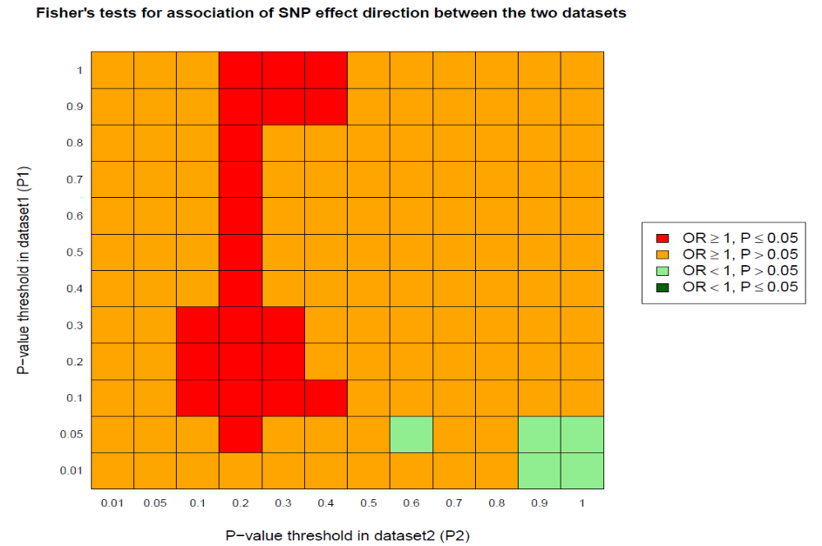

Supplementary Note Figure 16: Heatmap: genetic overlap between Inflammatory Bowel Disease (P1) and AD (P2).

Remark
- SECA reveals a significant concordance of SNP risk effects across the Alzheimer’s disease (AD) GWAS and each of Gastroesophageal reflux disease (GERD), peptic ulcer disease (PUD), Gastritis-Duodenitis, Medication use for GERD and PUD (PGM), Irritable bowel disease (IBS), and Diverticular disease GWAS. The findings indicate that a strong molecular genetic overlap exists between AD and each of the named traits.
- However, SECA only found a significant genetic overlap when AD was assessed as dataset 1 against IBD as dataset 2, and not the other way around. The results indicate that AD-associated SNPs affect IBD. The fact that IBD-associated SNPs do not affect AD may reflect the relatively smaller cases of IBD in the GWAS, given the results suggesting that the IBD GWAS having the greater sample size (for cases) produced improved overlap with AD. Thus, there is the need to further assess this finding when more powerful IBD GWAS are available.

Supplementary Note II: Causality assessment results (AD and GIT disorders)

We conducted bi-directional Mendelian randomisation analyses (MR) to assess a potential causal association between Alzheimer’s disease (AD) and gastro-intestinal (GIT) disorders using a two-sample MR method. Presented in this document are the various plots—scatter plot, forest plot, leave one out plot and funnel plot for the MR analyses.

A. Mendelian randomisation analysis: AD GWAS (exposure) vs PGM GWAS (outcome)

Scatter plot for AD and PGM MR analysis
AD: Alzheimer’s disease, PGM: GWAS of medication commonly used in the treatment of peptic ulcer, gastroesophageal reflux disease or gastritis, MR: Mendelian randomisation.

Forest plot for AD and PGM MR analysis
AD: Alzheimer’s disease, PGM: GWAS of medication commonly used in the treatment of peptic ulcer, gastroesophageal reflux disease or gastritis, MR: Mendelian randomisation.

Leave one out plot for AD and PGM MR analysis
AD: Alzheimer’s disease, PGM: GWAS of medication commonly used in the treatment of peptic ulcer, gastroesophageal reflux disease or gastritis, MR: Mendelian randomisation.

Funnel plot for AD and PGM MR analysis
AD: Alzheimer’s disease, PGM: GWAS of medication commonly used in the treatment of peptic ulcer, gastroesophageal reflux disease or gastritis, MR: Mendelian randomisation.

B. Mendelian randomisation analysis: PGM GWAS (exposure) vs AD (outcome)

Scatter plot for PGM and AD MR analysis
AD: Alzheimer’s disease, PGM: GWAS of medication commonly used in the treatment of peptic ulcer, gastroesophageal reflux disease or gastritis, MR: Mendelian randomisation.

Forest plot for PGM and AD MR analysis
AD: Alzheimer’s disease, PGM: GWAS of medication commonly used in the treatment of peptic ulcer, gastroesophageal reflux disease or gastritis, MR: Mendelian randomisation.

Leave one out plot for PGM and AD MR analysis
AD: Alzheimer’s disease, PGM: GWAS of medication commonly used in the treatment of peptic ulcer, gastroesophageal reflux disease or gastritis, MR: Mendelian randomisation.

Funnel plot for PGM and AD MR analysis
AD: Alzheimer’s disease, PGM: GWAS of medication commonly used in the treatment of peptic ulcer, gastroesophageal reflux disease or gastritis, MR: Mendelian randomisation.

C. Mendelian randomisation analysis of AD (exposure) vs GERD (outcome)

Scatter plot for AD and GERD MR analysis
AD: Alzheimer’s disease, GERD: gastroesophageal reflux disease, MR: Mendelian randomisation.

Forest plot for AD and GERD MR analysis
AD: Alzheimer’s disease, GERD: gastroesophageal reflux disease, MR: Mendelian randomisation.

Leave one out plot for AD and GERD MR analysis
AD: Alzheimer’s disease, GERD: gastroesophageal reflux disease, MR: Mendelian randomisation.

Funnel plot for AD and GERD MR analysis
AD: Alzheimer’s disease, GERD: gastroesophageal reflux disease, MR: Mendelian randomisation.

D. Mendelian randomisation analysis of GERD (exposure) vs AD (outcome)

Scatter plot for GERD and AD MR analysis
AD: Alzheimer’s disease, GERD: gastroesophageal reflux disease, MR: Mendelian randomisation.

Forest plot for GERD and AD MR analysis
AD: Alzheimer’s disease, GERD: gastroesophageal reflux disease, MR: Mendelian randomisation.

Leave one out plot for GERD and AD MR analysis
AD: Alzheimer’s disease, GERD: gastroesophageal reflux disease, MR: Mendelian randomisation.

Funnel plot for GERD and AD MR analysis
AD: Alzheimer’s disease, GERD: gastroesophageal reflux disease, MR: Mendelian randomisation.

E. Mendelian randomisation analysis of AD (exposure) vs PUD (outcome)

Scatter plot for AD and PUD MR analysis
AD: Alzheimer’s disease, PUD: peptic ulcer disease, MR: Mendelian randomisation.

Forest plot for AD and PUD MR analysis
AD: Alzheimer’s disease, PUD: peptic ulcer disease, MR: Mendelian randomisation.

Leave one out plot for AD and PUD MR analysis
AD: Alzheimer’s disease, PUD: peptic ulcer disease, MR: Mendelian randomisation.

Funnel plot for AD and PUD MR analysis
AD: Alzheimer’s disease, PUD: peptic ulcer disease, MR: Mendelian randomisation.

F. Mendelian randomisation analysis of PUD (exposure) vs AD (outcome)

Scatter plot for PUD and AD MR analysis
AD: Alzheimer’s disease, PUD: peptic ulcer disease, MR: Mendelian randomisation.

Forest plot for PUD and AD MR analysis
AD: Alzheimer’s disease, PUD: peptic ulcer disease, MR: Mendelian randomisation.

Leave one out plot for PUD and AD MR analysis
AD: Alzheimer’s disease, PUD: peptic ulcer disease, MR: Mendelian randomisation.

Funnel plot for PUD and AD MR analysis
AD: Alzheimer’s disease, PUD: peptic ulcer disease, MR: Mendelian randomisation.

G. Mendelian randomisation analysis of AD (exposure) vs IBS (outcome)

Scatter plot for AD and IBS MR analysis
AD: Alzheimer’s disease, IBS: Irritable bowel syndrome, MR: Mendelian randomisation.

Forest plot for AD and IBS MR analysis
AD: Alzheimer’s disease, IBS: Irritable bowel syndrome, MR: Mendelian randomisation.

Leave one out plot for AD and IBS MR analysis
AD: Alzheimer’s disease, IBS: Irritable bowel syndrome, MR: Mendelian randomisation.
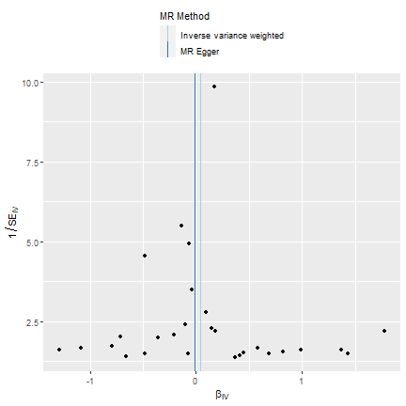

Funnel plot for AD and IBS MR analysis
AD: Alzheimer’s disease, IBS: Irritable bowel syndrome, MR: Mendelian randomisation.

H. Mendelian randomisation analysis of AD (exposure) vs IBD (outcome)

Scatter plot for AD and IBD MR analysis
AD: Alzheimer’s disease, IBD: Inflammatory bowel disease, MR: Mendelian randomisation.

Forest plot for AD and IBD MR analysis
AD: Alzheimer’s disease, IBD: Inflammatory bowel disease, MR: Mendelian randomisation.

Leave one out plot for AD and IBD MR analysis
AD: Alzheimer’s disease, IBD: Inflammatory bowel disease, MR: Mendelian randomisation.

Funnel plot for AD and IBD MR analysis
AD: Alzheimer’s disease, IBD: Inflammatory bowel disease, MR: Mendelian randomisation.

Mendelian randomisation analysis of IBD (exposure) vs AD (outcome)

Scatter plot for IBD and AD MR analysis
AD: Alzheimer’s disease, IBD: Inflammatory bowel disease, MR: Mendelian randomisation.

Forest plot for IBD and AD MR analysis
AD: Alzheimer’s disease, IBD: Inflammatory bowel disease, MR: Mendelian randomisation.

Leave one out plot for IBD and AD MR analysis
AD: Alzheimer’s disease, IBD: Inflammatory bowel disease, MR: Mendelian randomisation.

Funnel plot for IBD and AD MR analysis
AD: Alzheimer’s disease, IBD: Inflammatory bowel disease, MR: Mendelian randomisation.

Mendelian randomisation analysis of AD (exposure) vs Diverticular disease (outcome)

Scatter plot for AD and Diverticular disease MR analysis
AD: Alzheimer’s disease, MR: Mendelian randomisation.

Forest plot for AD and Diverticular disease MR analysis
AD: Alzheimer’s disease, MR: Mendelian randomisation.

Leave one out plot for AD and Diverticular disease MR analysis
AD: Alzheimer’s disease, MR: Mendelian randomisation.

Funnel plot for AD and Diverticular disease MR analysis
AD: Alzheimer’s disease, MR: Mendelian randomisation.

Mendelian randomisation analysis of Diverticular disease (exposure) vs AD (outcome)

Scatter plot for Diverticular disease and AD MR analysis
AD: Alzheimer’s disease, MR: Mendelian randomisation.

Forest plot for Diverticular disease and AD MR analysis
AD: Alzheimer’s disease, MR: Mendelian randomisation.

Leave one out plot for Diverticular disease and AD MR analysis
AD: Alzheimer’s disease, MR: Mendelian randomisation.

Funnel plot for Diverticular disease and AD MR analysis
AD: Alzheimer’s disease, MR: Mendelian randomisation.

Supplementary Note III: Pathway-based analysis of AD and PGM GWAS

We performed pathway-based analysis using the ordered function of the software in which the most significant genes overlapping the two traits were prioritised in analysis.
- Results for Gene Ontology (GO)
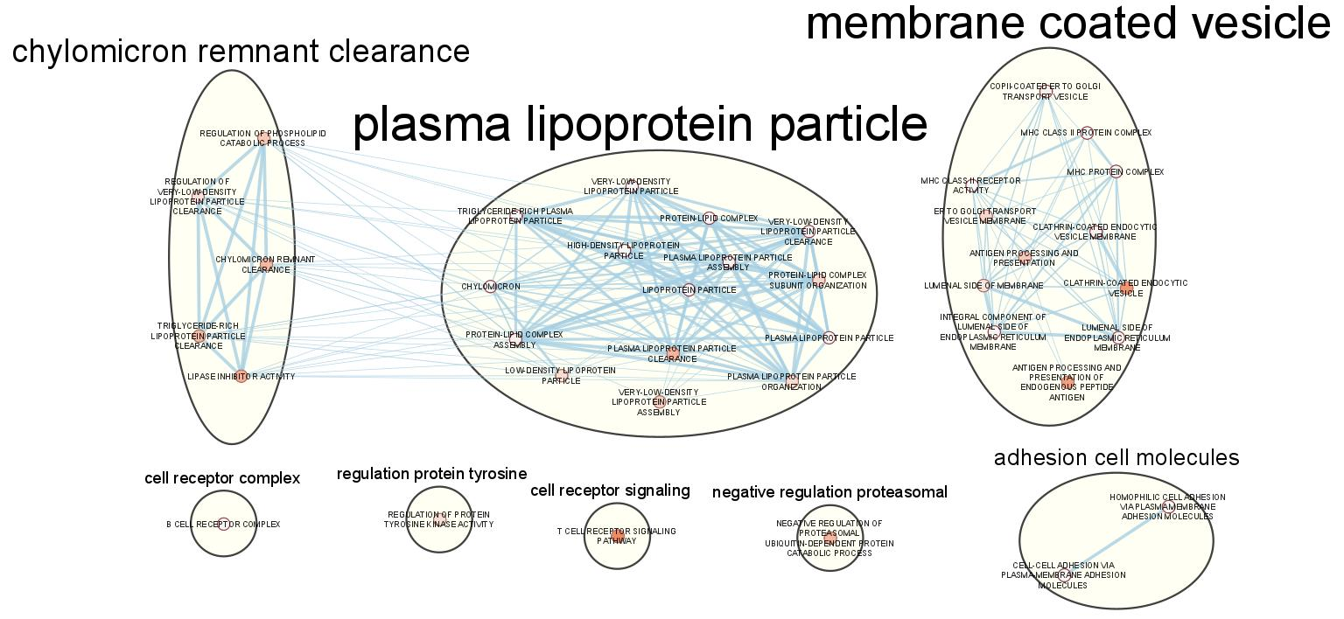

- Results for KEGG and others
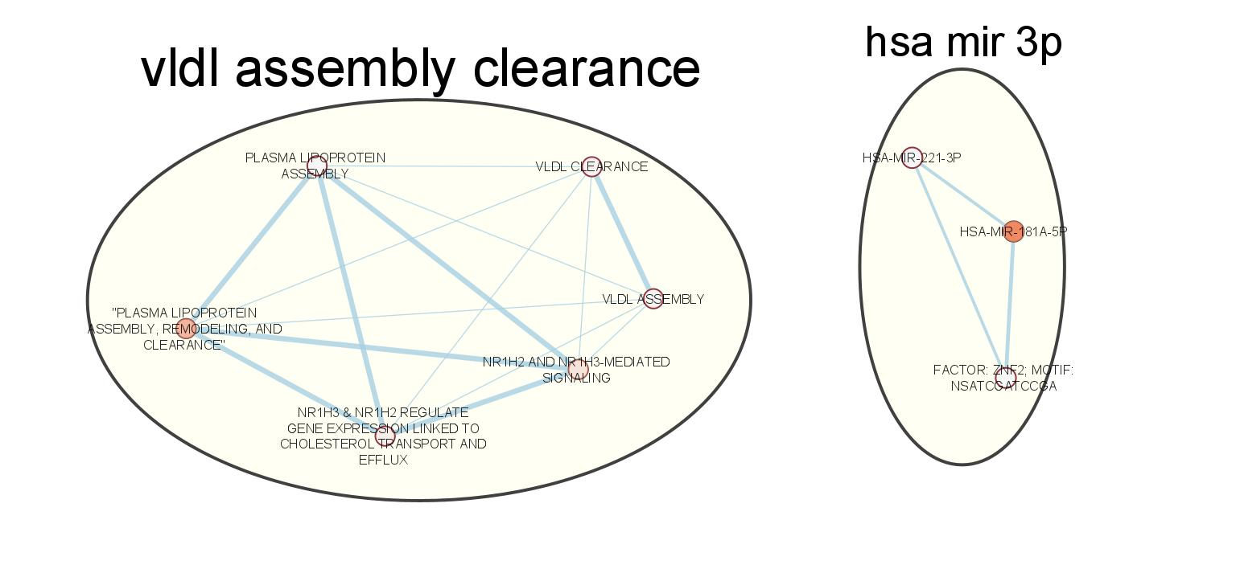

- Secondly, we performed the same analysis without prioritising the genes (unordered function).
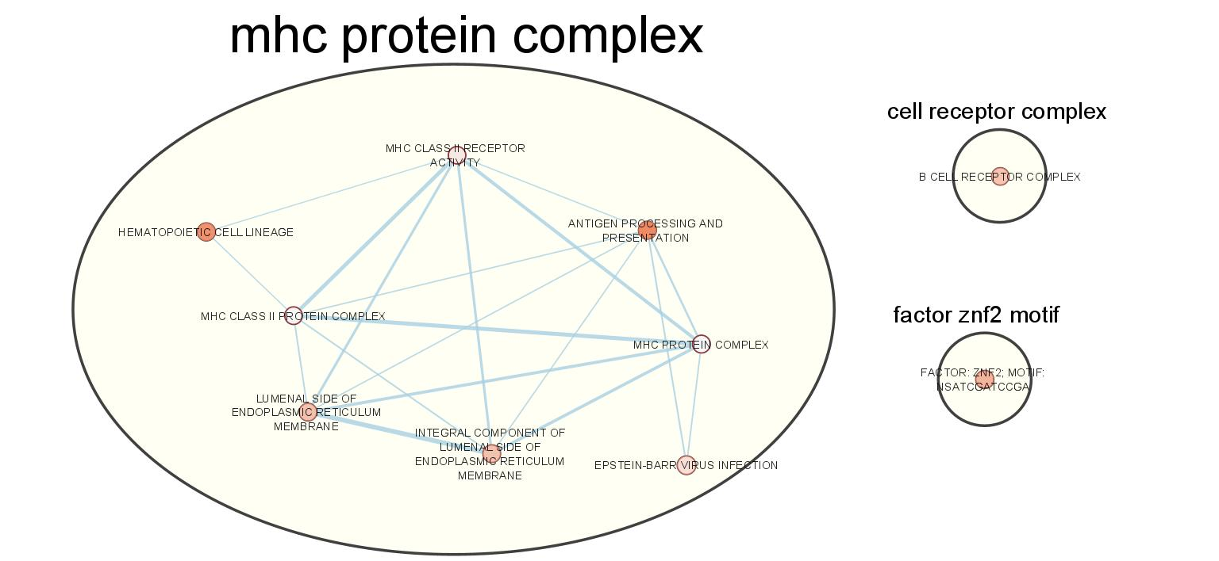

References

1. Jansen IE, Savage JE, Watanabe K, Bryois J, Williams DM, Steinberg S, Sealock J, Karlsson IK, Hägg S, Athanasiu L: Genome-wide meta-analysis identifies new loci and functional pathways influencing Alzheimer’s disease risk. Nature genetics 2019, 51(3):404-413.
2. Wu Y, Murray GK, Byrne EM, Sidorenko J, Visscher PM, Wray NR: GWAS of peptic ulcer disease implicates Helicobacter pylori infection, other gastrointestinal disorders and depression. Nature Communications 2021, 12(1):1146.
3. Nyholt DR: SECA: SNP effect concordance analysis using genome-wide association summary results. Bioinformatics 2014, 30(14):2086-2088.
4. An J, Gharahkhani P, Law MH, Ong J-S, Han X, Olsen CM, Neale RE, Lai J, Vaughan TL, Gockel I et al: Gastroesophageal reflux GWAS identifies risk loci that also associate with subsequent severe esophageal diseases. Nature Communications 2019, 10(1):4219.
5. Watanabe K, Stringer S, Frei O, Umicevic Mirkov M, de Leeuw C, Polderman TJC, van der Sluis S, Andreassen OA, Neale BM, Posthuma D: A global overview of pleiotropy and genetic architecture in complex traits. Nat Genet 2019, 51(9):1339-1348.
6. Watanabe K, Stringer S, Frei O, Umićević Mirkov M, de Leeuw C, Polderman TJC, van der Sluis S, Andreassen OA, Neale BM, Posthuma D: A global overview of pleiotropy and genetic architecture in complex traits. Nat Genet 2019, 51(9):1339-1348.

