Annex i: Ethical clearance _ERES Converge IRB
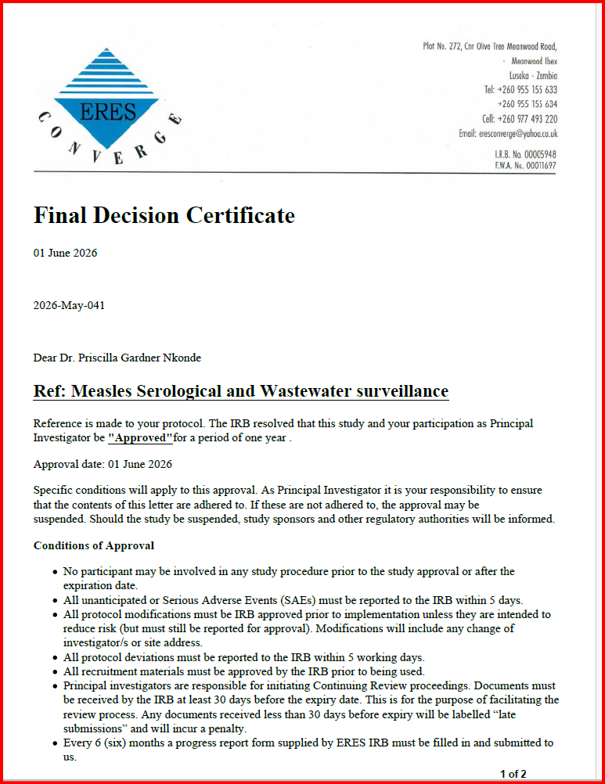

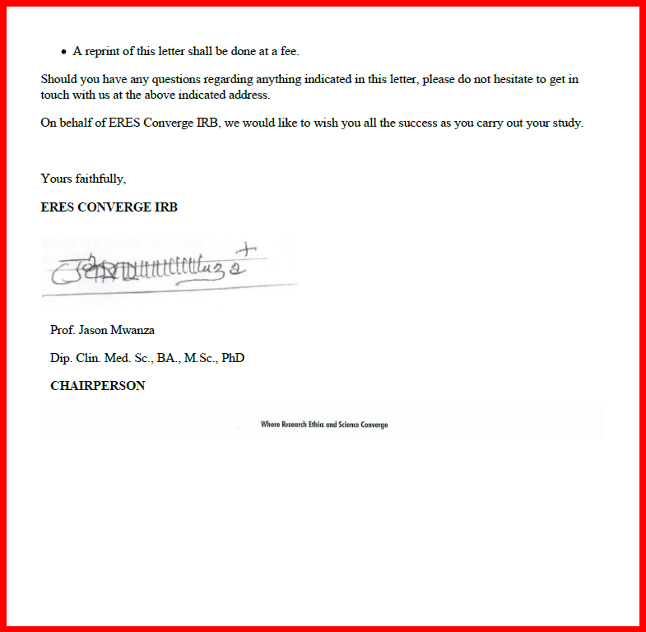

Annex ii: National Health Research Authority Clearance (NHRA)
