Appendix A — Mathematical Foundations of Ethical Field Dynamics

A1. Ethical Dynamical State Representation
Within the EFT framework, each agent is represented by a three-component recursive state vector:
x_i(t) = ( nP_i(t), n0_i(t), nN_i(t) )
where nP_i represents constructive activation, n0_i represents regulatory awareness, and nN_i represents destabilizing activation. These quantities are treated as phenomenological dynamical variables describing recursive interaction behavior within multi-agent systems, not direct psychological observables. Each component of the state vector is defined on the bounded domain nP_i, n0_i, nN_i in [0, 1]. The full domain specification, boundary handling, and well-posedness conditions for the discrete-time update rule are given in A10.

A2. Ethical Mass Functional
M_i = 3*nP_i + 2*n0_i - (nN_i)^1.5
The nonlinear exponent (nN_i)^1.5 introduces superlinear instability amplification, reflecting that destabilizing recursive propagation may grow disproportionately once instability exceeds local regulatory capacity.

A3. Collapse Boundary Condition
nN_i > nP_i + n0_i
This boundary condition defines the onset of recursive instability dominance. The global collapse ratio is:
CR(t) = |{ i : collapse_i }| / N

A4. Recursive Destabilization Propagation
DnN_j = alpha * Sum_i(w_i * w_ij * nN_i) - beta * n0_j + xi_j(t)
where alpha = recursive amplification coefficient, beta = regulatory damping coefficient, w_i = agent influence weight, w_ij = interaction pathway weight, xi_j(t) = stochastic perturbation.

A5. Constructive Propagation Dynamics
DnP_j = gamma * Sum_i(w_i * w_ij * nP_i) - lambda * nN_j
gamma = constructive propagation coefficient, lambda = destabilization suppression coefficient.

A6. Regulatory Awareness Evolution
Dn0_j = eta * C_j - mu * nN_j
eta = regulatory reinforcement coefficient, C_j = corrective stabilization input, mu = destabilization-induced regulatory degradation.

A7. Network Stability Functional
S_network = Sum(w_i*n0_i) / Sum(w_i*(nP_i+nN_i))

A8. Recursive Risk Functional
R_i = sigma( nN_i - (nP_i+n0_i) ) * w_i

A9. Amplification Rate and Cluster Velocity
A_rec(t) = d(nN_total)/dt V_cluster(t) = d(Size_cluster)/dt

A10. State Domain, Boundary Conditions, and Well-Posedness
For every agent i and timestep t, the state variables are restricted to the bounded domain n_{P,i}(t), n_{0,i}(t), n_{N,i}(t) in [0, 1]. Interaction weights satisfy w_ij in [0, 1] and w_i in [0, 1]. After each discrete update, state variables are projected onto the admissible domain using
n_{X,i}(t+1) = Pi_[0,1][ n_{X,i}(t) + Dn_{X,i}(t) ], X in {P, 0, N}
where Pi_[0,1][.] denotes clipping (projection) onto the interval [0, 1], applied componentwise to each of nP, n0, and nN after every timestep. Because the network is finite, all coefficients and interaction weights are bounded, and the update map is explicitly defined at each timestep, the discrete-time trajectory {x_i(t)}_{t=0}^{T} exists for every finite simulation horizon T. For a fixed initial condition and a fixed realization of the stochastic perturbation term xi_j(t), the update at each timestep is a deterministic, well-defined function of the current state, and is therefore unique at each step. These conditions establish computational well-posedness of the discrete-time simulation used throughout Sections 8-11 and Appendix B, although no claim is made regarding a general continuous-time existence or uniqueness theorem (e.g., Lipschitz continuity of a continuous-time analogue of the update rule); such an analysis lies outside the present scope, which is restricted to the discrete-time system as simulated.

A11. Relation to Complex Systems Theory
The EFT formalism shares conceptual similarities with nonlinear propagation theory, contagion dynamics, synchronization theory, adaptive network systems, and recursive criticality. It should be interpreted as an exploratory phenomenological systems model rather than a fundamental physical theory of cognition or intelligence.

Appendix B — Computational Simulation Architecture

B1. Computational Environment
All simulations were performed using Python 3.x, NumPy, Pandas, NetworkX, and Matplotlib. Simulations were executed within cloud-based computational notebook environments compatible with Google Colab and GPU-enabled notebook systems. The present simulations primarily relied on CPU-based recursive propagation computation.

B2. Random Seed Control and Reproducibility
Simulations employed deterministic seed initialization (SEED = 42). Independent realizations used topology-dependent seed variation:
sim_seed = SEED + repeat*1000 + hash(topology + policy)
allowing statistically independent realizations, controlled stochastic variation, and reproducible simulation trajectories.

B3. Simulation Scale
N = 5000 agents, T = 200 recursive timesteps, 20 independent realizations per topology-policy configuration.

B4. Network Topologies
Random directed graphs using Erdos-Renyi G(n,p) with sparse recursive connectivity approximate decentralized interaction ecosystems. Scale-free architectures using Barabasi-Albert preferential attachment [13] produce hub-dominated connectivity and heavy-tailed degree distributions approximating hierarchical AI ecosystems and recursive verifier hubs. Small-world architectures using Watts-Strogatz dynamics [14] combine strong local clustering with short global path lengths and rapid synchronization capability.

B5. Initialization Conditions
nP_i ~ U(0.40, 0.80) n0_i ~ U(0.30, 0.70) nN_i ~ U(0.00, 0.30)
Perturbative destabilization introduced into shock_fraction = 0.05 of agents with shock_strength = 0.75, acting as the recursive cascade initiation mechanism.

B6. Dynamical Coefficients
Primary coefficients: alpha (destabilization amplification) = 0.38; beta (regulatory damping) = 0.20; gamma (constructive propagation) = 0.08; lambda (destructive suppression) = 0.06; noise (stochastic amplitude) = 0.018. Selected phenomenologically to generate metastable dynamics and observable cascade behavior. Should be interpreted as exploratory simulation parameters, not empirically calibrated physical constants.

B7. Intervention Policies
No intervention: baseline dynamics without regulatory correction. Uniform regulation: uniform_eps = 0.008 applied globally to all agents. Targeted intervention: highest-risk fraction (target_k_fraction = 0.05) selected via risk functional R_i, receiving n0_boost = 0.09, nN_reduce = 0.13, nP_boost = 0.025.

B8. Statistical Averaging and Confidence Intervals
CI = 1.96 * sigma / sqrt(20)
Approximate 95% confidence intervals computed across 20 independent realizations, allowing evaluation of statistical consistency, repeatability, and stochastic robustness.

B9-B10. Outputs and Computational Limitations
Outputs: recursive trajectory datasets, collapse-ratio and network-stability evolution curves, final-state summaries, CSV datasets, and publication-quality figures. Limitations: simulations do not model semantic reasoning, real language-model cognition, autonomous goal formation, or real-world deployment environments. Interaction rules remain simplified recursive approximations. The framework should be interpreted as an exploratory recursive systems model rather than a predictive simulator of actual AI ecosystems.

Appendix C — Relation to the Broader Ethical Field Theory Framework

C1. Conceptual Position
The present study is conceptually and terminologically related to the author's earlier, non-peer-reviewed Ethical Field Theory (EFT) preprints [1, 2] (see Section C6), from which the framework's name and general orientation are drawn. The present work does not rely on those earlier, non-peer-reviewed formulations for any scientific or empirical claim: all mathematical formulations, simulations, and results reported here are developed and validated independently within this paper. Whereas the earlier preprints discussed recursive ethical dynamics, awareness-field interactions, and crisis-propagation structures at a conceptual level, the present work formulates and computationally validates a self-contained, testable dynamical model of recursive instability propagation within interacting multi-agent AI ecosystems.

C2. Relation Between Ethical Dynamics and Recursive AI Stability
Within the broader EFT interpretation, large-scale systems exhibit emergent behavior from recursive interaction between constructive propagation, regulatory stabilization, and destabilizing amplification. The present work applies this structure to multi-agent AI ecosystems, treating recursive instability as a network-level emergent dynamical phenomenon rather than solely an isolated agent-level property.

C3. Phenomenological Rather Than Ontological Interpretation
Consistent with the non-anthropomorphic interpretation established in Section 7.5, the EFT variables (nP, n0, nN) function as abstract recursive dynamical quantities describing stabilization, regulatory coordination, and destabilizing propagation within interacting agent networks, rather than as literal cognitive or neurological observables.

C4. Relation to Complex Systems and Network Criticality
The EFT framework shares similarities with nonlinear propagation theory, adaptive systems research, synchronization theory, contagion dynamics, and network criticality studies. It differs from traditional contagion models by explicitly incorporating recursive regulatory degradation, adaptive stabilizer intervention, and dynamically competing constructive versus destabilizing propagation fields — creating coupled recursive dynamics capable of generating delayed collapse transitions, metastable stabilization, and topology-sensitive cascade behavior.

C5. Recursive Stabilization as an Engineering Problem
Future AI alignment may increasingly require large-scale recursive stabilization engineering. Alignment becomes not solely a problem of local behavioral optimization or isolated safety filtering, but also a problem of maintaining dynamical coherence across recursively interacting intelligent systems — requiring adaptive oversight structures, recursive contradiction suppression, topology-aware stabilization, and dynamically coordinated verifier architectures.

C6. Note on the Origin of the EFT Name
The original formulation of EFT and its name originate from the author's earlier, non-peer-reviewed preprints, self-archived on Zenodo: [1] Ethical Field Theory: From Network Dynamics to a Unified Field-Theoretic Framework of Crisis-Awareness Systems with AI-Driven Stabilization, DOI: 10.5281/zenodo.19487858; and [2] The Algorithm of Existence (Physics Version), DOI: 10.5281/zenodo.18776837. These earlier works are cited solely to acknowledge the origin of the framework's name and terminology. They are not used as a scientific or empirical basis for any claim made in the present paper; every claim reported here is instead supported by the peer-reviewed literature cited in Section 2.1 and by the computational simulations and statistical analyses presented in Sections 3–12.

C7. Scope and Scientific Position
The simulations do not establish predictive certainty regarding future AI behavior, empirical laws of machine cognition, or experimentally verified mechanisms of recursive intelligence. The study is best interpreted as a conceptual and computational AI-systems stability investigation rather than a definitive theory of intelligence or consciousness.

Appendix D — Parameter Sensitivity and Robustness Analysis

D1. Motivation
Because the present framework is exploratory and phenomenological, it is important to evaluate whether observed cascade behavior depends critically on specific parameter choices. Sensitivity analysis was performed across destabilization amplification, regulatory damping, perturbation strength, and intervention intensity to determine whether qualitative cascade behavior remains stable under moderate parameter variation.

D2. Destabilization Amplification Sensitivity
Small alpha values suppress large-scale cascade formation; intermediate values generate metastable propagation; large values produce rapid global destabilization. The transition between localized instability and systemic cascade propagation appears nonlinear, suggesting the existence of critical recursive amplification thresholds.

D3. Regulatory Damping Sensitivity
Small reductions in beta may significantly accelerate cascade propagation under highly recursive interaction conditions. Conversely, sufficiently strong regulatory damping may prevent recursive escalation, metastable accumulation, and large-scale collapse — suggesting recursive stability depends strongly on maintaining adequate regulatory-response capacity.

D4. Shock Strength Sensitivity
Larger perturbative shocks increase collapse velocity, instability synchronization, and recursive amplification probability. However, under targeted stabilization, many high-shock configurations still converged toward stable behavior — suggesting adaptive targeted stabilization may remain effective even under relatively severe perturbation conditions.

D5. Uniform Versus Targeted Intervention Robustness
Uniform regulation effectiveness degrades significantly under strong recursive amplification, dense interaction topology, and high perturbation intensity. Targeted stabilization achieved the lowest collapse ratio across most tested configurations; however, its advantage weakened or reversed in scale-free and small-world networks when regulatory damping was low and destabilization amplification was moderate to high, as detailed in the systematic scan reported in D11.

D6. Topology-Dependent Robustness
Random topologies tended toward rapid large-scale collapse once recursive destabilization exceeded damping capacity. Scale-free systems displayed partial resilience due to hub concentration. Small-world systems exhibited the strongest metastable behavior: delayed collapse onset followed by rapid synchronization-driven destabilization. These qualitative patterns remained stable across moderate parameter variation.

D7. Stability of the Main Qualitative Result
The systematic scan reported in D11 preserved the targeted-over-uniform ranking established in Section 11 in 33 of 45 topology-parameter combinations. The baseline conclusion is therefore robust across most, but not all, of the explored parameter region; the specific conditions under which the ranking does not hold are detailed in D11.

D8. Interpretation of Sensitivity Results
The sensitivity analysis suggests recursive AI-network stability may exhibit threshold behavior, metastable transition regions, and topology-sensitive amplification dynamics — resembling nonlinear criticality, adaptive contagion systems, and recursive synchronization phenomena in complex systems theory. Future large-scale AI ecosystems may require adaptive topology-aware stabilization mechanisms rather than purely static globally distributed safeguards.

D9-D10. Limitations and Future Extensions
Limitations: the systematic grid scan reported in D11 covers destabilization amplification and regulatory damping jointly; it does not yet cover the constructive-propagation, destabilization-suppression, or noise coefficients (gamma, lambda, noise), nor does it incorporate semantic reasoning, autonomous goal formation, adaptive memory persistence, or real language-model cognition. The scan remains computational rather than empirical, and used 10 realizations per configuration (rather than the 20 used for the main results in Section 11) to keep the 135-configuration grid computationally tractable; network size (N = 5000) was held fixed at the same value as the main simulations. Future extensions may include a full joint scan over all six dynamical coefficients, phase-transition mapping, bifurcation analysis, adaptive topology evolution, reinforcement-learning stabilizer agents, and real multi-agent LLM interaction experiments.

D11. Systematic Parameter-Space Scan
To directly address the request for systematic scan results (rather than only local, qualitative sensitivity commentary), we performed a full grid scan over the two dominant dynamical coefficients: destabilization amplification α ∈ {0.30, 0.34, 0.38, 0.42, 0.46} and regulatory damping β ∈ {0.15, 0.20, 0.25}, crossed with all three network topologies and all three stabilization policies, for a total of 5 × 3 × 3 × 3 = 135 configurations. Each configuration was run for 10 independent realizations at N = 5000 agents, T = 200 timesteps, using the same update rule, initialization procedure, and shock mechanism described in Appendix B, with all other coefficients (γ, λ, noise, shock parameters) held at their baseline values. The baseline point (α = 0.38, β = 0.20) reproduces the collapse ratios reported in Section 11 to within the expected variation from the smaller number of realizations (10 vs. 20), while retaining the same network size (N = 5000) as the main simulations.
Table 9. Final collapse ratio (mean of 10 realizations) under targeted stabilization across the α-β grid, by topology. α = destabilization amplification; β = regulatory damping.
alpha | beta | Random CR | Scale-free CR | Small-world CR
0.30 | 0.15 | 0.0013 | 0.0052 | 0.0039
0.30 | 0.20 | 0.0002 | 0.0012 | 0.0004
0.30 | 0.25 | 0.0001 | 0.0005 | 0.0001
0.34 | 0.15 | 0.0021 | 0.0234 | 0.4527
0.34 | 0.20 | 0.0002 | 0.0019 | 0.0009
0.34 | 0.25 | 0.0001 | 0.0006 | 0.0002
0.38 | 0.15 | 0.0457 | 0.5399 | 0.7568
0.38 | 0.20 | 0.0004 | 0.0034 | 0.0026
0.38 | 0.25 | 0.0001 | 0.0008 | 0.0003
0.42 | 0.15 | 0.9633 | 0.6517 | 0.8070
0.42 | 0.20 | 0.0007 | 0.0082 | 0.1705
0.42 | 0.25 | 0.0002 | 0.0014 | 0.0008
0.46 | 0.15 | 0.9701 | 0.7144 | 0.8312
0.46 | 0.20 | 0.0021 | 0.2783 | 0.6999
0.46 | 0.25 | 0.0003 | 0.0024 | 0.0019

Across the full 45 (α, β, topology) combinations, targeted stabilization achieved the lowest collapse ratio among the three policies in 33 cases (73%), consistent with the qualitative ranking reported in Section 11. However, the scan also reveals a substantive and previously unreported exception: at low regulatory damping (β = 0.15) combined with moderate-to-high destabilization amplification (α ≥ 0.34) on scale-free and small-world topologies, uniform regulation outperforms targeted intervention, in some cases substantially (e.g., at α = 0.42, β = 0.15, small-world: uniform CR = 0.788 vs. targeted CR = 0.807; at α = 0.38, β = 0.15, scale-free: uniform CR = 0.182 vs. targeted CR = 0.540). In these regimes, both policies still outperform no intervention, but the Top-K targeted mechanism, which concentrates regulatory reinforcement on a small fraction of high-risk nodes (Section 5.4), appears less effective than broad low-intensity reinforcement when baseline regulatory damping is weak and destabilization amplification is strong on highly clustered or hub-dominated networks. A plausible interpretation is that under these conditions, instability regenerates faster than the targeted mechanism's fixed intervention fraction (target_k_fraction = 0.05) can suppress it across the network, whereas uniform reinforcement, though individually weaker, is applied to every node and therefore scales with network size. We report this as an empirical qualification of the general claim that targeted stabilization outperforms uniform regulation (Sections 11.4, 12.8), rather than treating it as a counterexample to be omitted: the claim holds robustly across most of the tested parameter space but is not universal, and its boundary appears to depend on the interaction between regulatory damping strength and network topology. Beyond qualifying the generality of the claim, this boundary also functions as an operational map for parameter selection: it identifies, within the tested grid, the specific (alpha, beta) region in which targeted intervention is the preferred policy, and the region in which uniform regulation should be favored instead. We note that the parameter values used for the main results in Section 11 (alpha = 0.38, beta = 0.20) fall well inside the region favoring targeted intervention across all three topologies, so the qualitative claims reported there are not affected by this boundary. Figures 8–10 visualize the full targeted-policy collapse-ratio surface for each topology.
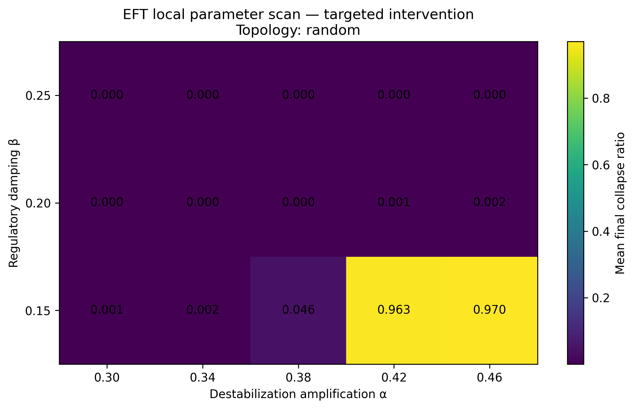
Figure 8. Final collapse ratio under targeted stabilization across the α-β grid, random topology. Darker regions indicate lower (better) collapse ratios; the sharp transition near α ≥ 0.42, β = 0.15 marks the local collapse boundary for this topology under the present intervention fraction.
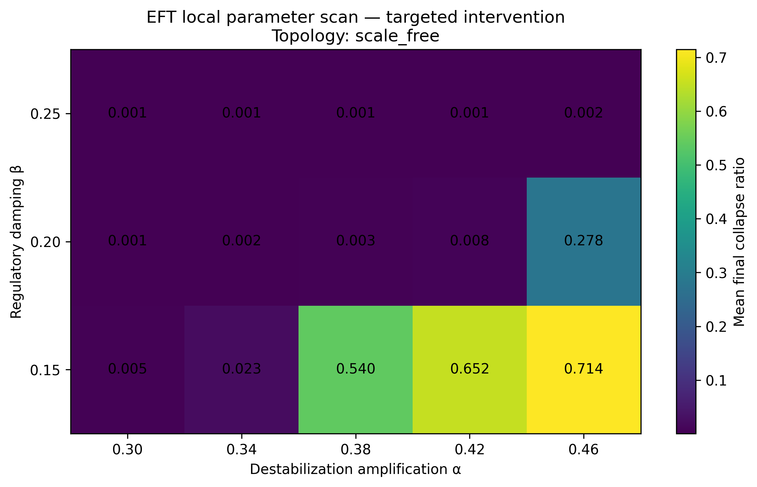
Figure 9. Final collapse ratio under targeted stabilization across the α-β grid, scale-free topology. Elevated collapse ratios at β = 0.15 across the tested α range correspond to the regime in which uniform regulation outperforms targeted intervention (see main text).
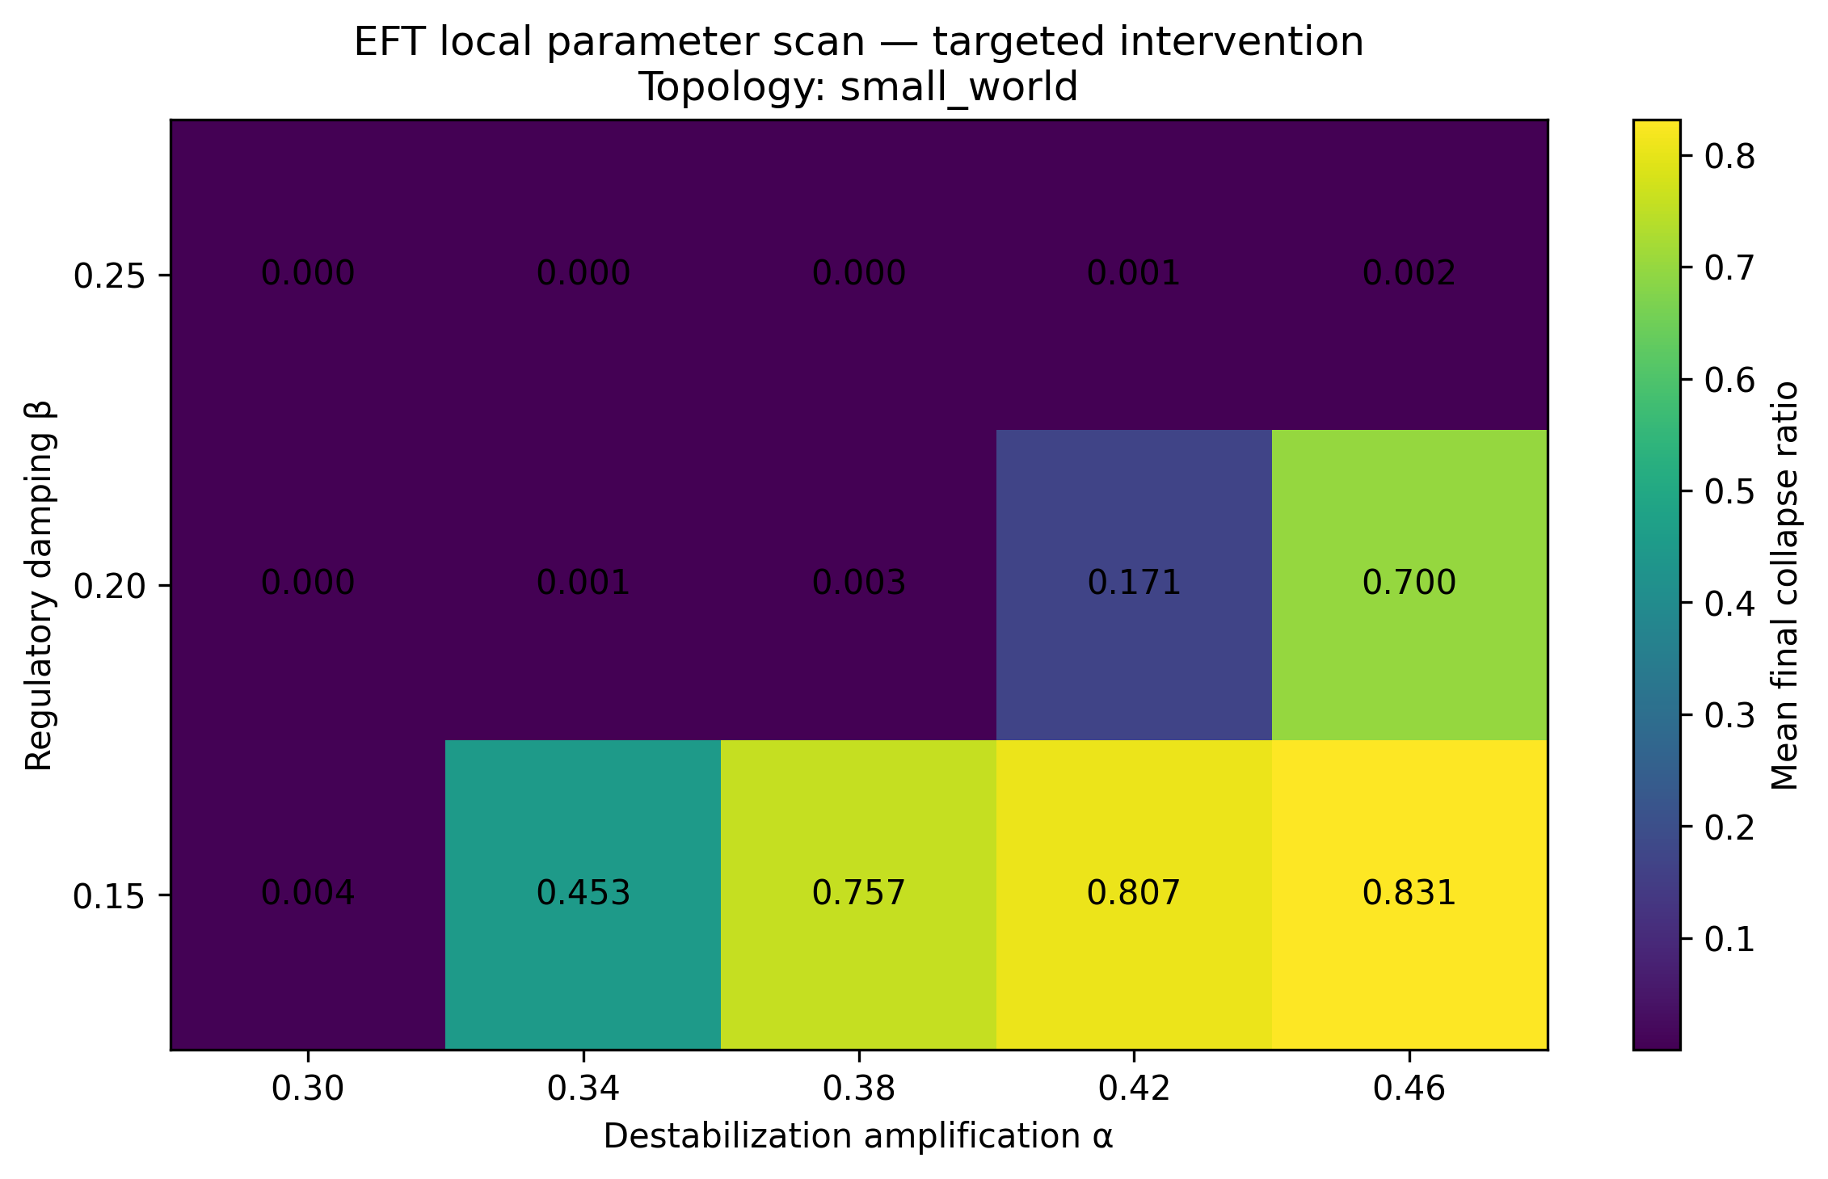
Figure 10. Final collapse ratio under targeted stabilization across the α-β grid, small-world topology. This topology shows the most pronounced low-β vulnerability of the three, consistent with its metastable transition behavior reported in Section 11.5.
Raw per-realization output, full per-configuration summaries (including network stability and ethical-mass statistics), and a policy-ranking table identifying the best-, second-, and worst-performing policy at each grid point are available as supplementary data alongside the code described in Section 12.11.

