Appendix A. Supplementary Materials
Supplementary A. Supplementary mathematical details, robustness analyses, ablation results, TCGA mapping sanity check, stage-specific terminal-toxicity-free diagnostics, full stage-stratified policy comparison, and state-conditioned action-profile diagnostics.
Supplementary Appendix
The following supplementary materials, tables, and figures provide supporting validation and diagnostic context for the TCGA-informed digital twin framework. They are reported separately from the main efficacy-safety results because they evaluate robustness summaries, simulation construction, training dynamics, and model-mismatch diagnostics rather than clinical treatment effects.

Supplementary Methods. Mathematical and Algorithmic Details
This supplementary section retains the mathematical details that were shortened in the main Methods. The implementation follows the archived project code and configuration used for the reported experiments.
Digital twin state and safety cost.
The simulator state was defined as:
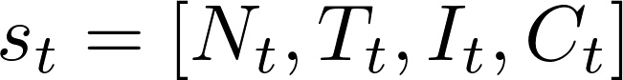
The binary per-step safety cost was defined as:
Constrained offline reinforcement learning objective.
The policy objective was to maximize expected discounted treatment reward while constraining expected discounted safety cost:
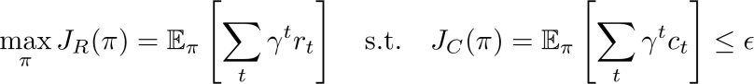

SafeCQL critic and policy updates.
Reward critics used conservative Q-learning with a temporal-difference target based on the minimum target reward critic. Cost critics used an analogous TD target with the maximum target cost critic, providing a risk-averse bootstrap estimate for cumulative cost.

Both reward and cost critics included a conservative penalty that discourages unsupported actions from receiving overly favorable value estimates:
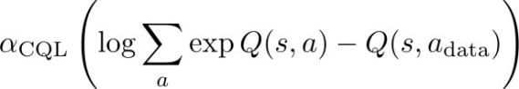
Thus, the displayed CQL term should be interpreted as the shared conservative regularizer applied to the critic updates. The full SafeCQL update combined reward temporal-difference learning, cost temporal-difference learning, conservative regularization, actor optimization under a bounded Lagrange multiplier, and multiplier updates driven by the estimated safety-budget violation. This description follows the archived implementation used for the reported experiments.

For ablation, two seed-15 variants were trained with the same offline dataset, network architecture, batch size, and 50,000 update budget as the representative SafeCQL checkpoint. The no-Lagrange variant retained cost critics but removed the Lagrangian cost term from the actor objective. The no-cost-branch variant removed both the cost branch and the Lagrangian actor penalty. These variants tested whether the observed safety behavior depended on the explicit safety channel rather than conservative reward learning alone.

Training configuration.
SafeCQL used one categorical actor, two reward critics, and two cost critics. All networks were multilayer perceptrons with two hidden layers of 64 ReLU units. Training used 50,000 gradient-update steps, batch size 1,024, gamma = 0.99, and alpha_CQL = 5.0. The representative checkpoint used cost limit epsilon = 0.1, actor learning rate 1e-4, critic learning rate 3e-4, Lagrange learning rate 1e-3, and target updates every 10 gradient steps.

Evaluation metrics.
For each rollout, cumulative return was the sum of observed step rewards. Average dose was the arithmetic mean of administered dose levels. Empirical violation rate was the fraction of rollout steps with binary safety cost equal to one. These summaries were computed from simulator rollouts and should not be interpreted as calibrated clinical risk probabilities.
epsilon | Return median [IQR] | Avg dose median [IQR] | Violation (%) median [IQR]
0.0 | -8.23 [-11.64, -8.08] | 0.99 [0.56, 1.01] | 9.59 [7.33, 9.84]
0.1 | -8.12 [-8.26, -6.63] | 1.00 [0.99, 1.44] | 9.80 [9.72, 11.57]
0.3 | -8.15 [-8.22, -6.60] | 1.00 [0.99, 1.44] | 9.84 [9.77, 11.54]
0.5 | -8.12 [-8.23, -6.54] | 1.04 [0.99, 1.46] | 9.84 [9.72, 11.62]
1.0 | -8.18 [-8.23, -6.73] | 1.00 [0.99, 1.43] | 9.80 [9.72, 11.33]
Appendix Table A1. Median and interquartile range summaries for the 21-seed SafeCQL safety-budget sweep.

Variant | Cost critic trained | Lagrange actor penalty | Return, mean +/- SD | Avg dose | Violation rate (%)
Full SafeCQL | Yes | Yes | -8.70 +/- 2.94 | 1.01 | 9.23
No Lagrange | Yes | No | -9.50 +/- 3.76 | 0.90 | 9.40
No cost branch | No | No | -9.50 +/- 3.76 | 0.90 | 9.40
Appendix Table A2. All variants used seed = 15, epsilon = 0.1, 50,000 updates, and the same offline training set.

This figure visualizes the deterministic clinical-to-mechanistic mapping used to construct held-out twins. Higher AJCC stage increases initial tumor burden and lowers the tumor-fatality threshold; older age lowers toxicity tolerance and immune reserve; and higher grade increases the tumor-growth parameter r1. The figure audits implementation plausibility and is not evidence of patient-level clinical calibration.
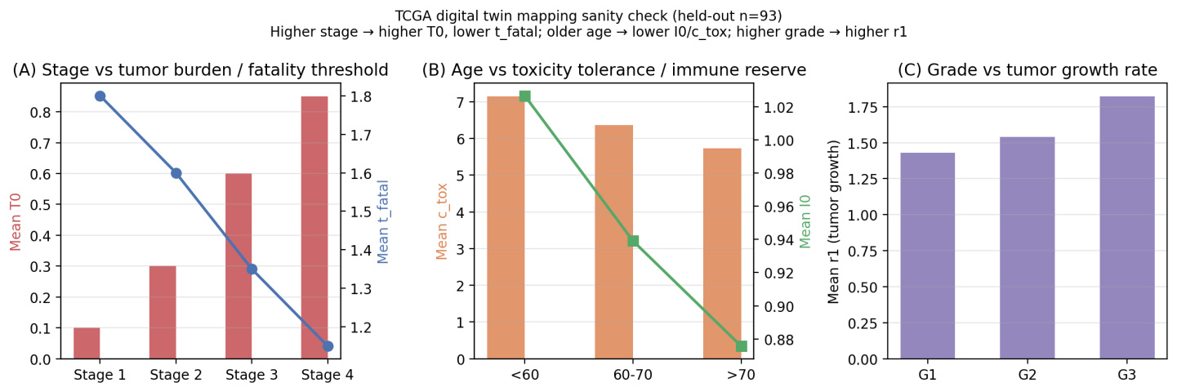
Appendix Figure A1. TCGA-informed digital twin mapping sanity check on 93 held-out twins. Panels show monotonic mappings from AJCC stage, age, and tumor grade to initial tumor burden, tumor-fatality threshold, toxicity tolerance, immune reserve, and r1.

This figure stratifies the simulator-defined terminal-toxicity-free time diagnostic by AJCC stage. It is reported as an in silico diagnostic only and should not be interpreted as observed clinical survival.
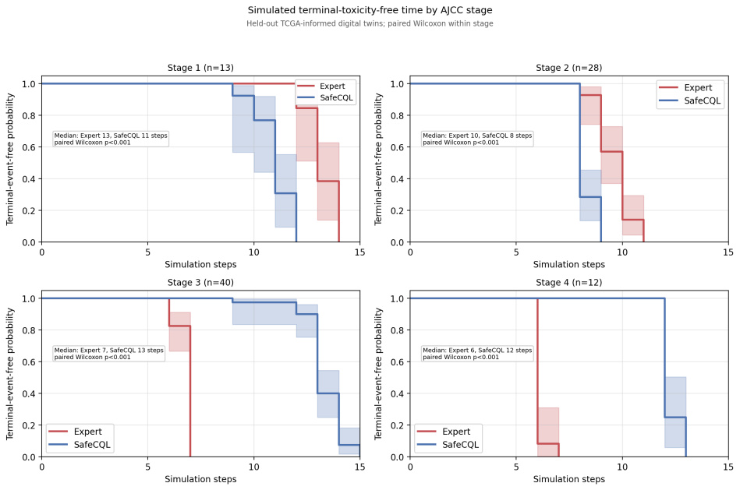
Appendix Figure A2. Simulated terminal-toxicity-free time by AJCC stage. Curves compare Expert and SafeCQL on matched held-out TCGA-informed twins within each stage stratum.

This figure supplements the main-text stage-stratified analysis by showing all evaluated policies, including the four fixed-dose comparators. It is reported in the appendix because the full policy set is visually dense; the main text uses the reduced Expert/BC/SafeCQL version for interpretability.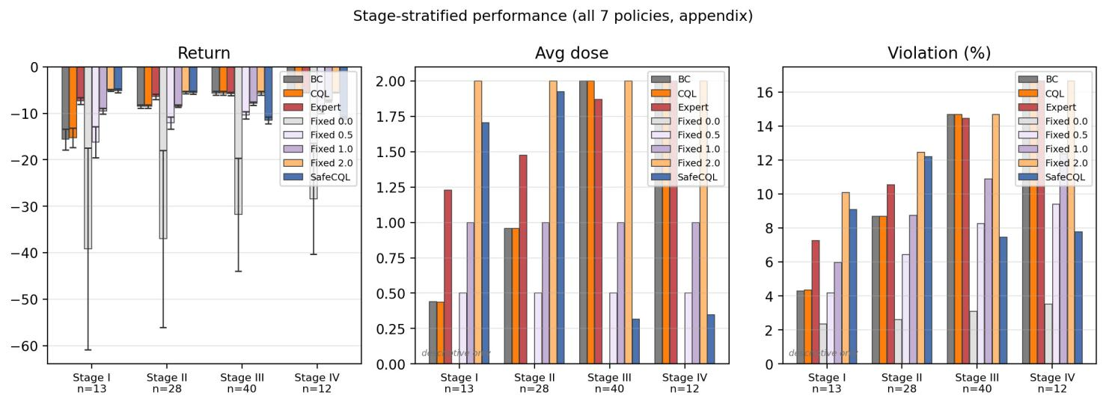
Appendix Figure A3. Full stage-stratified held-out evaluation across fixed-dose, expert, BC, CQL, and SafeCQL policies. Stage labels report held-out stratum sizes. The figure provides a complete comparator view for transparency.

This supplementary diagnostic repeats the state-conditioned action-profile analysis with the same held-out TCGA-informed twins. It is included to document that SafeCQL behavior is state-dependent rather than a uniform dose-reduction rule.
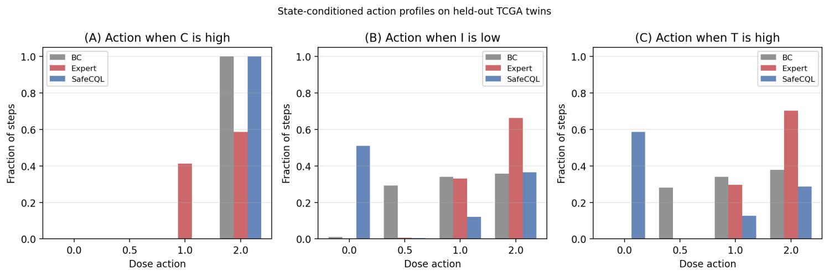
Appendix Figure A4. State-conditioned action profiles on held-out TCGA-informed twins. Bars show the fraction of rollout steps assigned to each discrete dose action within selected simulator state bins.
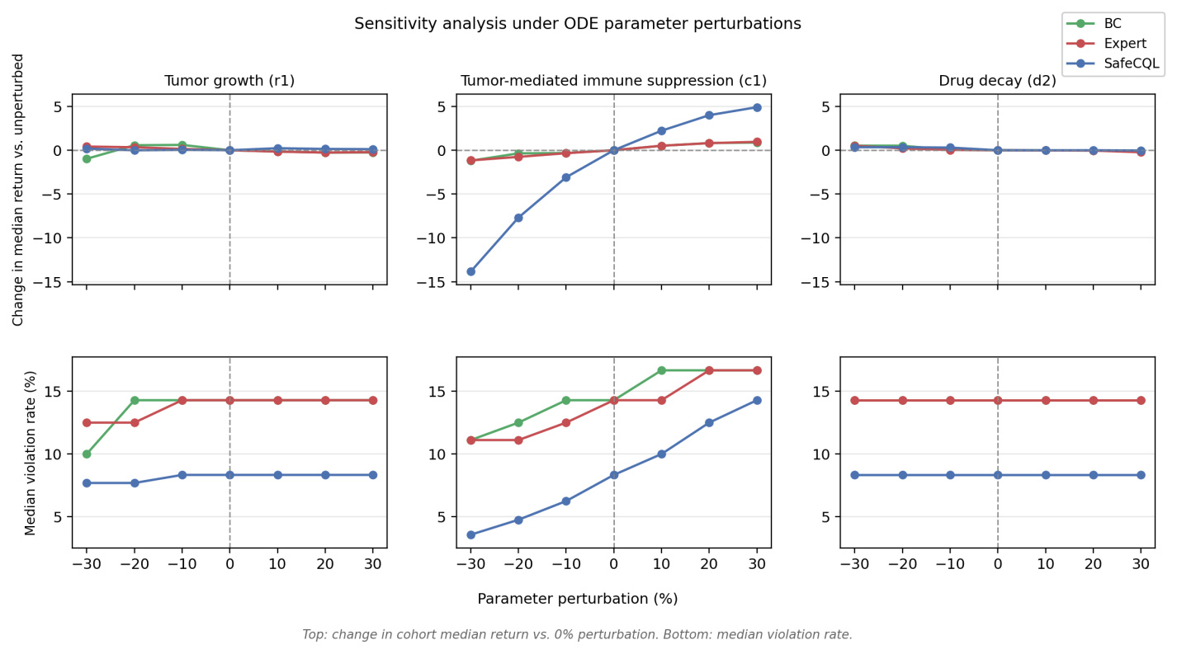
Appendix Figure A5. Complete local ODE-parameter sensitivity analysis. Tumor growth (r1), tumor-mediated immune suppression (c1), and drug decay (d2) were perturbed from -30% to +30% while patient-specific initial states and thresholds were fixed. The top row shows change in cohort median return versus the 0% perturbation setting. The bottom row shows median violation rate. This simulator stress test should not be interpreted as biological calibration or uniform robustness.

