Supporting Information For:

Methane emissions from inland waters are constrained by salinity

Authors:
Yang Deng¹, Xiang Zhu ¹, Lei Xie ¹, Fei Yang^{1,*}, Xiaoguang Xu², Yuying Ma¹, Fuquan Peng¹, Yaoqing Peng², Shunmei Zhu², Qinglong Yin³, Qiu Jin⁴, Liangang Chen⁴, Longmian Wang^{1,*}

Content:
Fig.S1 Locations of sampling points across the study area.

Fig.S2 Variations in DOM fluorescence components across the salinity gradient. Significant correlation at the **p < 0.01.

Fig.S3 Van Krevelen diagrams of DOM from FT-ICR MS analysis: (a) low-salinity (LS), (b) high-salinity (HS); (c)-(h) present the variations in each DOM component between the LS and HS groups. Significant correlation at the **p < 0.01; No significant correlation at the ns.

Fig.S4 Relationships of CH₄ with DOM content (a, e) and optical properties (b-d, f-h). Significant correlation at the **p < 0.01; No significant correlation at the p > 0.05.

Supporting Figures:
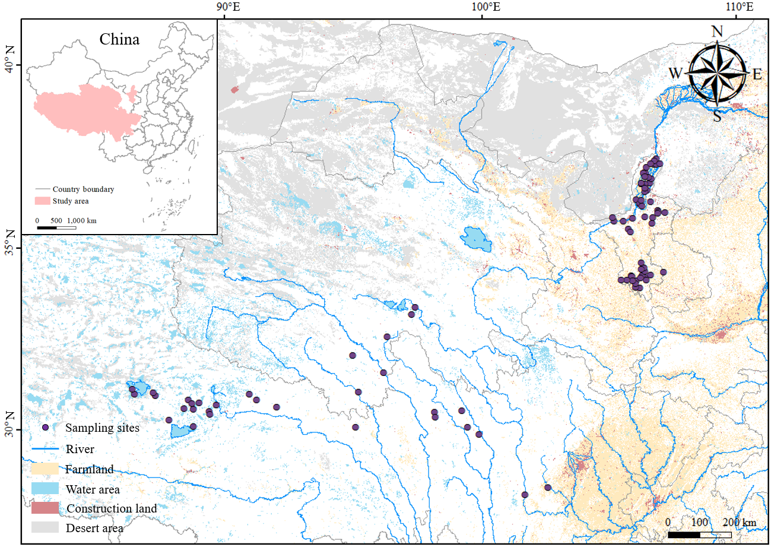
Fig.S1. Locations of sampling points across the study area.

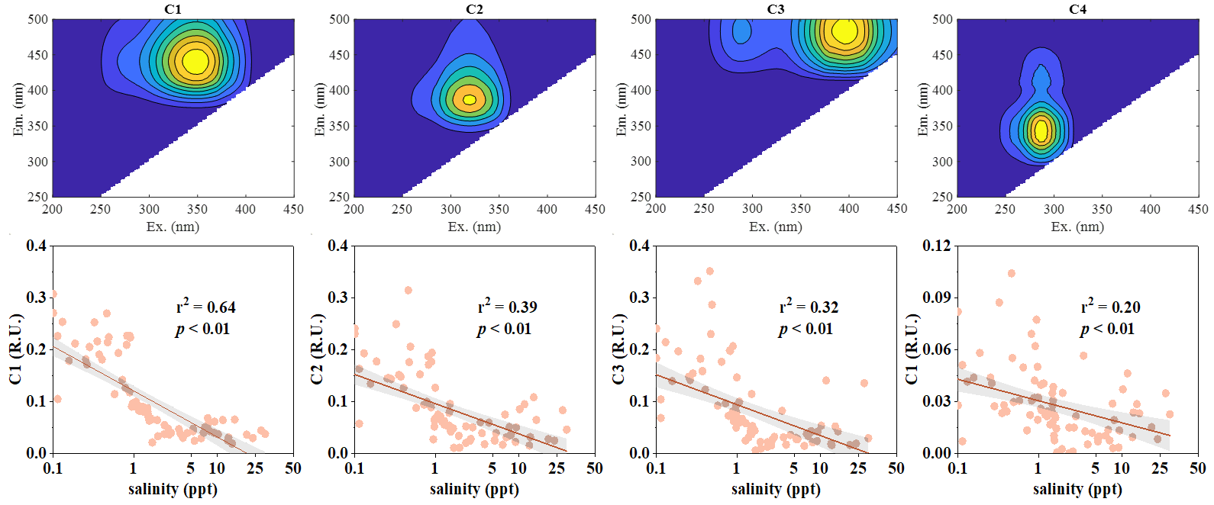
Fig.S2. Variations in DOM fluorescence components across the salinity gradient. Significant correlation at the **p < 0.01.

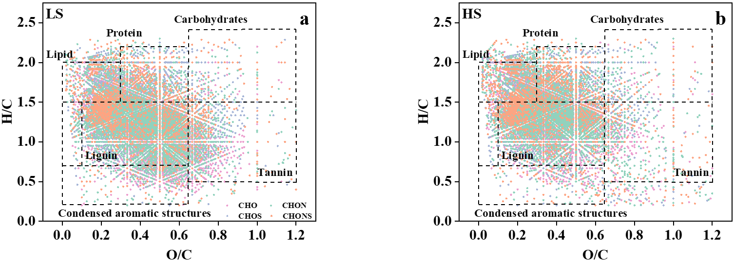
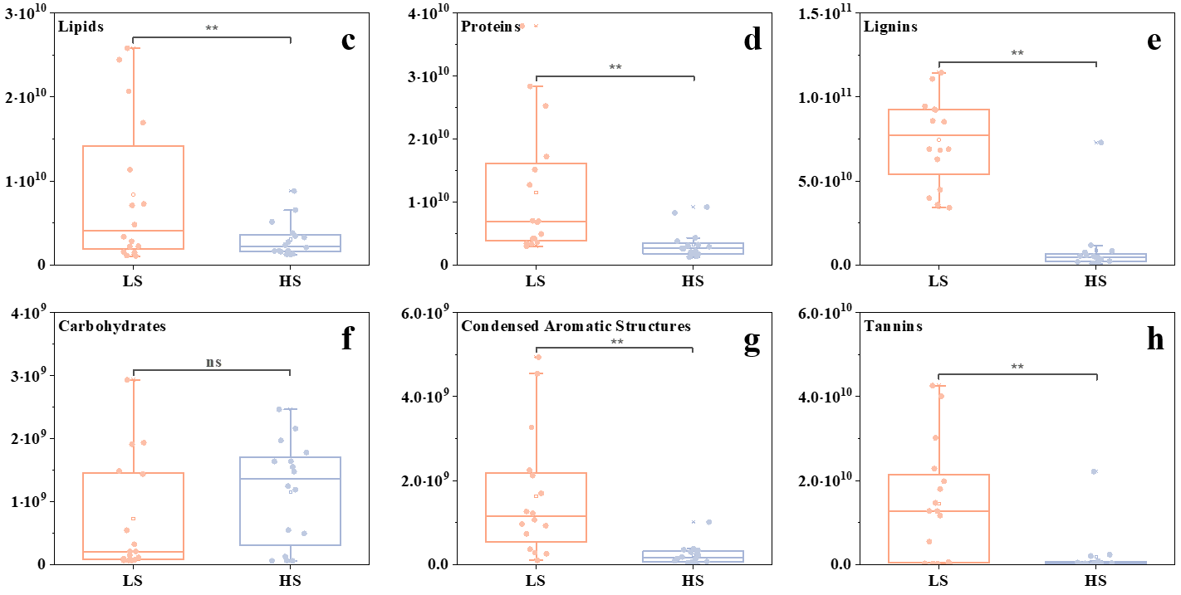
Fig.S3. Van Krevelen diagrams of DOM from FT-ICR MS analysis: (a) low-salinity (LS), (b) high-salinity (HS); (c)-(h) present the variations in each DOM component between the LS and HS groups. Significant correlation at the **p < 0.01; No significant correlation at the ns.

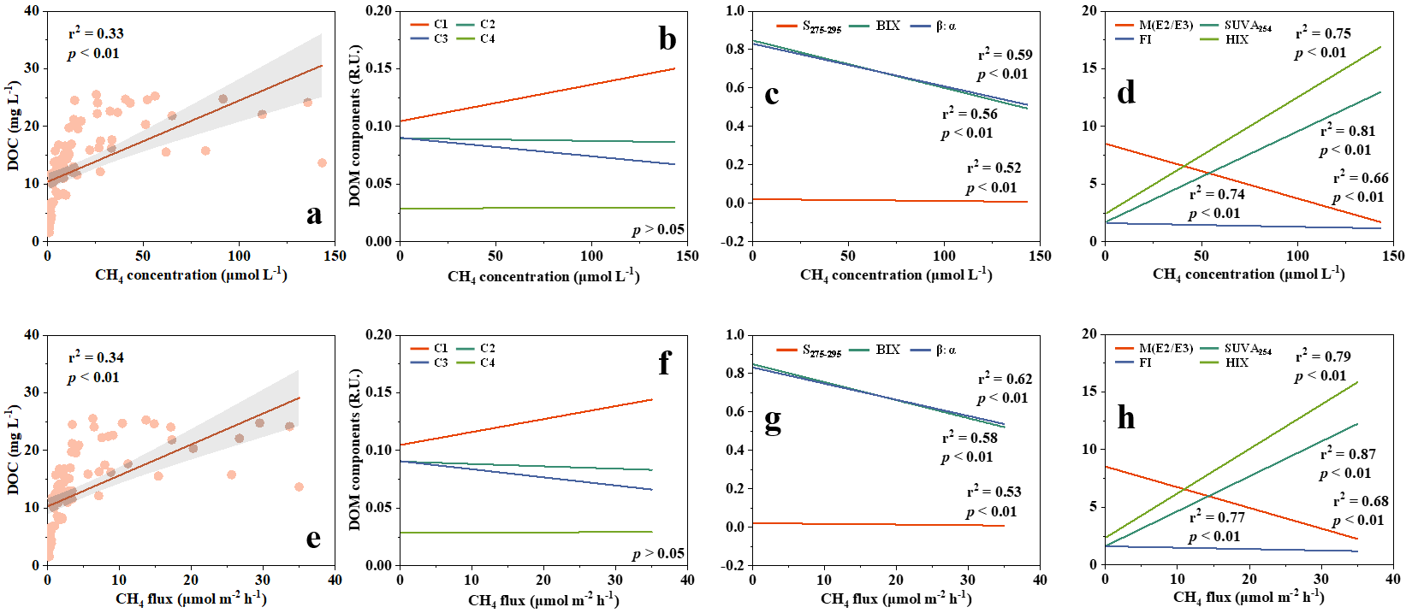
Fig.S4. Relationships of CH₄ with DOM content (a, e) and optical properties (b-d, f-h). Significant correlation at the **p < 0.01; No significant correlation at the p > 0.05.
Supporting Text:
Supporting Text S2. The relationship between DOM fluorescent components and salinity.

By combining 3D-EEM technology with the PARAFAC model, the fluorescence components of DOM in 90 water bodies were investigated (Fig.S1). A total of four fluorescence components were identified, accounting for more than 95% of the EEM variance. C1 (Ex: < 290 (330-400) nm; Em: 400-500 nm) was classified as a humic-like component of terrestrial origin¹. C2 (Ex_{max}: 318 nm; Em_{max}: 445 nm) was classified as a marine humic-like substance². C3 (Ex_{max}: 400 nm; Em_{max}: 477 nm) was identified as a terrestrial humic acid^{3,4}. C4 (Ex_{max}: 280 nm; Em_{max}: 340 nm) exhibited fluorescence similar to C5 reported in Menendez et al. (2024) and was associated with tryptophan-like substances⁵. The maximum fluorescence intensities (Fmax) of both the humic-like components (C1, C2, C3) and the protein-like component (C4) were negatively correlated with salinity. This suggests that increasing salinity may enhance the adsorption capacity of DOM onto sediment particles, promoting its burial in sediments and thereby contributing to carbon sink formation⁶. Furthermore, the negative correlation between the Fmax of C4 and salinity may also be attributed to salinity-induced changes in microbial community composition and activity, which may allow certain labile DOM components to be preferentially utilized by specific halotolerant microorganisms⁷.

Methods:
The three-dimensional excitation-emission matrix (3D-EEM) spectra of the water samples were measured using a steady-state fluorescence spectrometer (FM-4P-TCSPC). The excitation wavelength ranged from 200 to 500 nm, and the emission wavelength ranged from 250 to 550 nm, with a scanning interval of 5 nm. The excitation and emission slit widths were both set to 10 nm, and all measurements were performed at a scanning speed of 1200 nm/min. Background subtraction was carried out using ultrapure water to eliminate most of the Raman scattering from each DOM spectrum. Parallel factor analysis (PARAFAC) was conducted following Chen et al. (2021) using the DOM Fluor toolbox in MATLAB R2019a⁸. To ensure accurate fluorescence component identification, PARAFAC models with four to eight components were constructed, and the four-component model was validated through split-half analysis, residual analysis, and loading analysis. The maximum fluorescence intensity (Fmax) was used to represent the fluorescence information across all data⁹.
Supporting References:
- Shutova, Y., Baker, A., Bridgeman, J., et al. Spectroscopic characterisation of dissolved organic matter changes in drinking water treatment: From PARAFAC analysis to online monitoring wavelengths. Water Research 54, 159-169 (2014).
- Wünsch, U.J., Murphy, K. A simple method to isolate fluorescence spectra from small dissolved organic matter datasets. Water Research 190, 116730 (2021).
- Graeber, D., Tenzin, Y., Stutter, M., et al. Bioavailable DOC: reactive nutrient ratios control heterotrophic nutrient assimilation-An experimental proof of the macronutrient-access hypothesis. Biogeochemistry 155, 1-20 (2021).
- Liu, C., Shen, Q.S., Gu, X.Z., et al. Burial or mineralization: Origins and fates of organic matter in the water–suspended particulate matter-sediment of macrophyte- and algae-dominated areas in Lake Taihu. Water Research 243, 120414 (2023).
- Menendez, A., Tzortziou, M., et al. Driving factors of colored dissolved organic matter dynamics across a complex urbanized estuary. Science of The Total Environment 921, 171083 (2024).
- Xie, L., Zuo, D.Z., Ma, Y.S., et al. The bacterial influencing mechanisms of salinity fluctuations in a brackish-water lake on the dissolved organic matter characteristics of pore water. Organic Geochemistry 189, 104744 (2024).
- Yang, J., Jiang, H.C., Liu, W., et al. Potential utilization of terrestrially derived dissolved organic matter by aquatic microbial communities in saline lakes. The ISME Journal 14, 2313-2324 (2020).
- Chen, M.L., Li, C.L., Spencer, R.G.M., et al. Climatic, land cover, and anthropogenic controls on dissolved organic matter quantity and quality from major alpine rivers across the Himalayan-Tibetan Plateau. Science of the Total Environment 754, 142411 (2021).
- Jutaporn, P., Laolertworakul, W., Tungsudjawong, K., et al. Parallel factor analysis of fluorescence excitation emissions to identify seasonal and watershed differences in trihalomethane precursors. Chemosphere 282, 131061 (2021).

